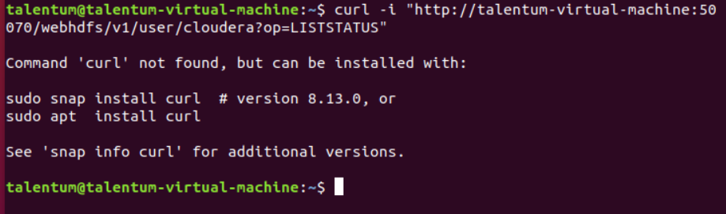
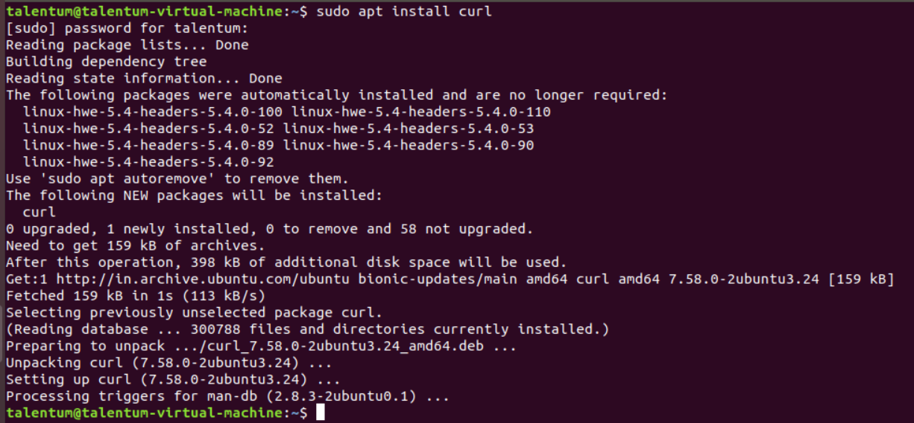
curl -i "http://talentum-virtual-machine:50070/webhdfs/v1/user/cloudera?op=LISTSTATUS"
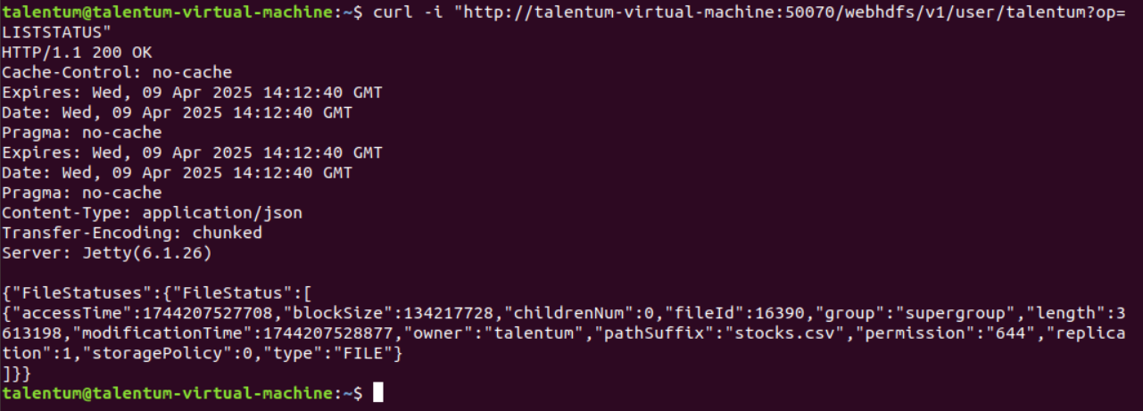
curl -i -L "http://talentum-virtual-machine:50070/webhdfs/v1/user/talentum/stocks.csv?op=OPEN"
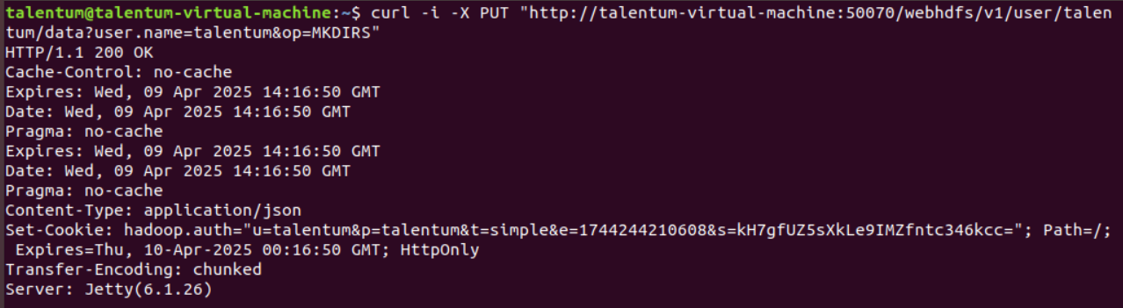
curl -i -X PUT "http://talentum-virtual-machine:50070/webhdfs/v1/user/talentum/data?user.name=talentum&op=MKDIRS"
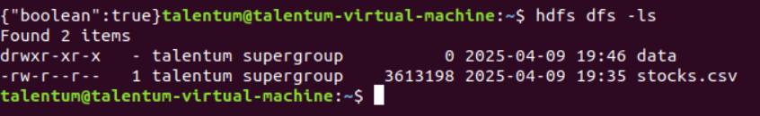

cd /home/talentum //Assuming that there is small_blocks.txt
curl -i -X PUT -T small_blocks.txt “http://talentum-virtual-machine:50075/webhdfs/v1/user/talentum/small_blocks.txt?op=CREATE&user.name=talentum&namenoderpcaddress=localhost:9000&overwrite=false”
