Explainable AI for Drift Detection

& Mitigation in Vision Transformers
Rikhil Singh

1. Introduction

1.1 Operational problem and thesis claim
Image classification systems are commonly developed under an implicit stationarity assumption: training, validation, and deployment images are expected to represent the same underlying distribution. That assumption is fragile in operational settings. Camera hardware and image-processing pipelines are replaced, illumination and weather vary, compression settings change, viewpoints and backgrounds evolve, and the prevalence of individual classes can shift. Datasets such as ImageNet-C shows how noise, blur, as well as digital degradation can reduce classification accuracy [1], while CLEAR records a different problem: the visual appearance of classes changes naturally over a decade [2]. WILDS reports related shifts across locations, institutions, and time [3]. These changes can leave a deployed classifier working well on average while failing on particular classes or acquisition conditions.
This thesis investigates a controlled alternative to wholesale model replacement. A frozen historical Vision Transformer (ViT) is retained as a behavioural reference, a second ViT is adapted on a later time window, and a transparent router decides which prediction to use for each image. The central claim is deliberately narrower than a claim of universal drift correction: when covariate drift changes where a ViT finds class evidence, an explanation-aware comparison can preserve much of the adapted model's benefit while making the cost of harmful replacements visible. The claim is tested through chronological holdouts, source-separated stress tests, matched ablations, and per-image route audits.

1.2 Research questions and measurable objectives
The objective is to measure both predictive improvement and update safety. Macro F1 and macro IoU quantify class-balanced classification performance; retained gain measures how much of the always-updated improvement survives routing; and helpful, harmful, and missed switches expose the decision trade-off hidden by an aggregate score. A three-point macro-F1 gain was predeclared as a stretch target for the combined condition, while clean degradation was limited to 0.50 points.
1. RQ1: Does temporal adaptation improve future-year macro F1 and macro IoU under natural and controlled image drift without materially degrading clean performance?
2. RQ2: Can a transparent router retain most of the newer model's improvement while avoiding cases where the historical model was already correct?
3. RQ3: Do the explicit saliency objectives add measurable value beyond the same architecture, data curriculum, trainable blocks, and epoch budget without those objectives?

1.3 Contributions and scope
The work contributes a ViT-only temporal prototype with an embedded patch-evidence gate, an asymmetric historical-versus-adapted comparison, an explicit four-feature routing policy, and a logged audit of route outcomes and saliency deletion behaviour. Its intended contribution is a reproducible decision framework and an analysis of where it succeeds or fails. It does not claim that saliency proves causality, that a single CLEAR-100 stream establishes generalisation, or that the router is universally preferable to always using the updated model.

2. Literature review and design rationale

2.1 Responses to distribution shift
Research on distribution shift spans several intervention levels. Robust training and corruption augmentation attempt to make the original model less sensitive before deployment [1, 17]. Test-time adaptation instead changes the deployed model using target batches: Tent minimises prediction entropy through normalization parameters [20], CoTTA uses averaged predictions and partial source-weight restoration to reduce error accumulation in changing environments [21], and EATA filters uninformative samples while regularising important weights to limit forgetting [22]. These methods are valuable when labels and source data are unavailable at deployment, but they require online optimisation and can still degrade in-distribution behaviour. This project studies a different operational point: a labelled update window is available, the historical model must remain recoverable, and every model switch should be auditable.
Continual-learning work addresses longer sequences through replay, regularisation, parameter-efficient updates, and representation correction. Wu et al. combine LoRA with mean-shift compensation, covariance calibration, and patch-token distillation to reduce semantic drift in class-incremental ViTs [24]. Such methods update a continuing learner and preserve old classes. The present study keeps class definitions fixed and instead asks whether two time-indexed models can be compared safely at inference. SelectiveNet's risk-coverage formulation is therefore closer to the decision problem [23], although the router here defers to another classifier rather than abstaining.

2.2 From post-hoc maps to saliency-guided learning
A post-hoc heatmap can describe a prediction without changing it. The stronger claim examined here is that explanation structure can participate in learning and model selection. SGAN constrains self-attention with saliency priors to reduce spread into irrelevant background [4]. XGD transfers class predictions and saliency-refined features, with ablations showing that the saliency term contributes separately from ordinary distillation [5]. Ismail et al. train models to preserve predictions after masking low-saliency features, linking the map to a behavioural perturbation [7]. Saliency Guided Image Warping uses source saliency to control which regions dominate domain alignment [8], while SGT removes low-saliency ViT patches to reduce background shortcuts [25]. Together these papers motivate using patch weights in the forward computation and checking them by deletion, while also warning that a cleaner map does not guarantee higher accuracy.

2.3 Why an asymmetric Siamese ViT comparison
Siamese architectures are useful when the decision depends on a relation between two observations rather than on either observation alone. Siamese-ViT shows that paired transformer branches can compare global and local evidence across views [9]. Yang et al. show that strict weight symmetry can be inappropriate when the two temporal inputs have different roles or distributions [10]. The analogy in this project is functional: the two branches share the same DINOv2-small architecture and initialization, but the historical branch is frozen while the newer branch is adapted. This holds backbone family constant and makes model age, training window, and evidence movement the variables under study.
The implementation is more accurately described as an asymmetric Siamese evaluation architecture than as a fully end-to-end Siamese metric network. It does not learn a hidden pair embedding or distance function. Instead, both ViTs expose predictions and normalized patch weights, and a logistic policy combines four named differences. This sacrifices some routing capacity compared with a learned mixture-of-experts gate, but it allows each switch to be reconstructed from stored coefficients and features. Always-new inference remains the performance ceiling; the router is justified only when auditability or avoidance of harmful updates is an operational requirement.

2.4 Quantitative context for expected improvements
Reported gains from saliency guidance and temporal correction vary widely with task, shift severity, and metric. The comparisons below are used to set expectations rather than to claim direct equivalence. Dense prediction, retrieval, and class-incremental accuracy are not interchangeable with CLEAR-100 macro F1.
Study | Setting | Reported absolute change | Interpretation for this thesis
SGAN [4] | Weakly supervised segmentation | 55.0→64.2 mIoU (+9.2) | Strong saliency prior; different task and supervision
XGD [5] | Teacher-student segmentation | 65.25→69.82 mIoU (+4.57); saliency-only +3.52 | Supports explicit saliency ablation
Saliency warping [8] | Unsupervised domain adaptation | +3.0 to +6.3 on several shifts; +0.6 on DarkZurich | Effects depend strongly on target domain
SGT [25] | ViT shortcut reduction | INbreast +2.41 accuracy, +3.06 F1; FIGRIM −0.32 accuracy | Interpretability may improve without accuracy gain
Semantic-drift ViT [24] | Class-incremental learning | 79.36→81.88 accuracy (+2.52) | Component increments include +0.28 for patch distillation
Siamese-ViT [9] | Cross-view retrieval | +2.33 Recall@1 and +1.38 AP vs TransGeo | Supports paired ViT comparison, not temporal routing
This project | Temporal classification | +3.45 routed under motion blur; +2.03 under mixed drift | Single seed; auxiliary saliency effect +0.90/+0.84
The table suggests two defensible expectations. First, a three-point target is ambitious but plausible under a shift that creates substantial headroom; it is not a minimum effect that every drift source should meet. Second, individual components often contribute less than the complete method. The project therefore reports percentage-point changes beside raw scores, separates updated-model gain from routing retention, and treats sub-point saliency effects as evidence that requires repeated seeds rather than as proof of a general mechanism.

2.5 Design decisions derived from the literature
Choice | Rationale | Implementation | Evidence required
DINOv2-small ViT | Strong pretrained patch and class tokens [13, 14] | Same backbone in both branches; final three blocks updated | Future-year macro F1 and training cost
Embedded saliency gate | Trainable saliency and perturbation evidence [4, 5, 7, 25] | Patch weights form the classified representation | Ablation gain and deletion margin
Asymmetric pair | Paired ViTs and unequal temporal roles [9, 10] | Frozen historical reference versus adapted candidate | Helpful, harmful, and missed switches
Explicit logistic router | Interpretable policies and selective risk [15, 23] | Four stored features plus thresholds | Retained gain and harmful-route count
Frozen future horizon | Temporal benchmarks and anti-forgetting concerns [2, 21, 22] | No updates on 2012–2014 | Year-specific clean and drift scores
Source-separated stressors | Corruption and natural-shift evidence [1, 3, 8, 19] | Optical, sensor, digital, geometric, and mixed shifts | Effect size by source
These choices make the prototype feasible on a single modest GPU and keep the decision trail compact. They do not establish superiority over end-to-end selective networks or continual test-time adaptation. The comparison is strongest when the requirement is a reviewable transition between two versioned ViTs with labelled update data.

3. System design
The prototype contains three ViT-only variants:
1. Baseline ViT: a frozen historical classifier.
2. XAI ViT: the same class of model with attention-derived saliency used during learning and evaluation.
3. XAI-Siamese ViT router (Routed XAI): a historical XAI ViT and a drift-adapted XAI ViT evaluated as a pair. A calibrated logistic rule selects the newer prediction only when its visible evidence passes the learned threshold and a minimum saliency-change floor.
All three variants use the same DINOv2-small transformer backbone. This controls architecture as a source of variation: the comparison changes the patch aggregation, temporal adaptation, and routing policy while keeping the underlying feature family fixed. The baseline is therefore a conventional ViT reference, not a CNN reference.
The router uses four signals. Jensen-Shannon divergence measures the difference between the historical and updated patch-weight distributions [11]. It is near zero when the models weigh the same patches and increases as their spatial evidence separates. Confidence gain is the change in maximum softmax probability. Entropy reduction is 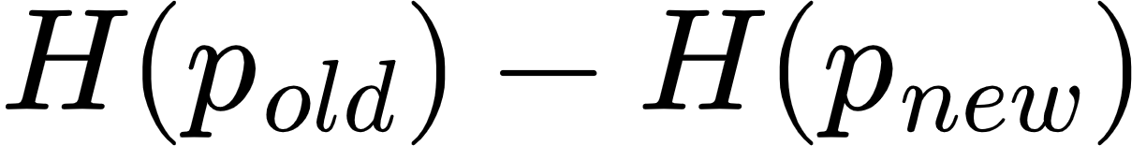, where [12]; a positive value means the updated prediction is more concentrated. Class-evidence gain compares support for the predicted class in the selected patches with support in their low-saliency complement [5, 7]. The raw values, route probability, chosen model, final class, correctness, and maps are saved for every image.
The baseline and historical XAI models are trained once in the historical period and then frozen. They are not retrained separately for every evaluation year. This ensures that the 2012, 2013, and 2014 scores measure increasing distance from the same deployed reference. The newer branch is also fixed after 2011 calibration, so the final horizon does not become another optimization loop.
The three classifier views serve different analytical roles. Baseline ViT measures a conventional transformer pipeline without the saliency-gated head. Historical XAI controls for the embedded explanation architecture. Updated XAI measures the maximum benefit available from adaptation when it is always selected. Routed XAI then measures how much of that benefit survives a conditional, inspectable decision policy.

3.1 ViT classifier and embedded explanation
DINOv2-small follows the Vision Transformer representation introduced by Dosovitskiy et al. [13] and the self-supervised DINOv2 pretraining procedure [14]. The local data pipeline first converts every image to RGB, resizes it deterministically to 224 × 224 pixels, converts channel values to the zero-to-one range, and normalizes them with ImageNet channel means (0.485, 0.456, 0.406) and standard deviations (0.229, 0.224, 0.225). A direct square resize was chosen to keep the prototype deterministic and inexpensive, although its possible aspect-ratio distortion is a limitation that should be tested against resize-and-crop preprocessing in later work.
The prepared image is divided into non-overlapping 14 × 14 pixel patches, producing a 16 × 16 grid, or 256 patch tokens. Each patch is projected into a 384-dimensional embedding. Positional information preserves where the patch came from, and repeated self-attention blocks allow every token to exchange information with every other token. This global token interaction is the main architectural difference from a CNN, which builds representations through local convolutional filters and progressively expanding receptive fields. A learned class token travels through the same transformer blocks and acts as a global image summary, while the 256 patch tokens retain a spatial index that can be reshaped back to the 16 × 16 grid.
The baseline classifier gives every patch equal weight. It averages the 256 patch vectors, concatenates that result with the global class token, and applies a linear 100-class head. The XAI variant replaces the uniform average with a learned gate. For patch representation hᵢ, a LayerNorm, linear layer, and sigmoid produce a non-negative gate gᵢ. Dividing each gate by the sum of all gates produces the normalized saliency weight sᵢ. The selected representation v is the weighted sum of all patch representations. In compact form, sᵢ = gᵢ / Σⱼgⱼ and v = Σᵢsᵢhᵢ. The classifier receives the class token and v together. Consequently, changing a patch weight changes the feature vector used to calculate the class logits. The displayed 16 × 16 heatmap is a resized view of these same normalized weights, rather than a separate visualization computed after prediction.
Figure 1 shows the complete forward path. DINOv2 returns one 384-dimensional class token and 256 patch tokens. The gate assigns one scalar to each patch, preserving the 16 × 16 spatial grid. These values are normalised to sum to one before the patch vectors are combined. The classifier receives the class token and the weighted patch sum. It is also run on a complementary sum made from 1 − sᵢ, using the same head so that both outputs are comparable in the same class-logit space.
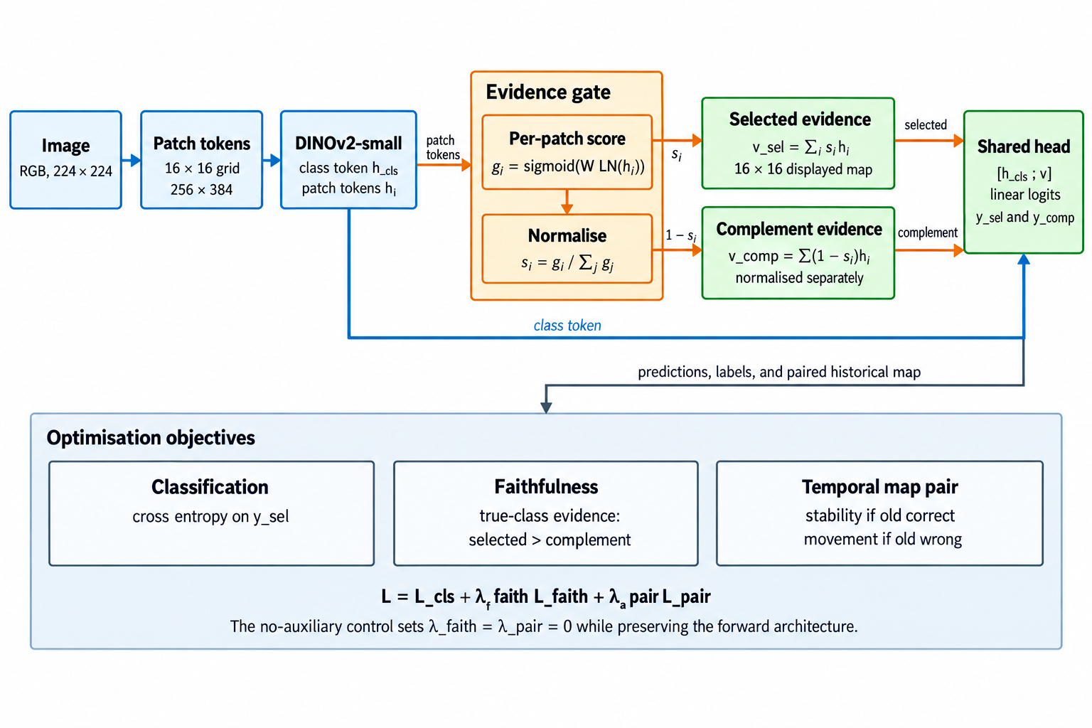
Figure 1. Embedded saliency-guided ViT forward computation and training signals
For faithfulness training, the model also classifies the complementary low-saliency patches. The loss rewards greater evidence for the true class in selected patches than in their complement. During update training, a pairwise term keeps the new and historical maps close when the historical prediction is correct and requires a minimum divergence when it is wrong.
The learned map answers a limited but concrete question: which ViT patch tokens received weight in the representation used for classification? It is not treated as a segmentation mask. A concentrated map can still be wrong, and a diffuse map can still support a correct prediction. The report therefore avoids interpreting visual neatness as proof of faithfulness.
The complementary path provides a simple testable expectation: the selected patches should support the correct class more strongly than the remaining patches. This is added as a soft loss so that useful contextual information is not excluded by a hard mask.
During adaptation, the frozen branch provides the reference map. If its prediction is correct, the new map is discouraged from moving unnecessarily. If it is wrong, the pairwise loss allows a larger change. The class label still determines whether an update succeeds; map divergence alone does not.

3.2 Asymmetric Siamese comparison and explicit routing rule
For each image, the old and new ViTs return a class distribution and a patch-weight distribution. Four differences are standardised and passed to a saved logistic equation. The new prediction can be selected only when the models disagree, saliency divergence exceeds a calibrated floor, and the logistic probability exceeds its threshold. The coefficients and thresholds are stored in router_policy.json.
Figure 2 uses two instances of the same XAI-guided ViT on the same image. The setup is asymmetric. Both branches begin from the historical checkpoint, but the old branch is frozen while the new branch adapts its final three transformer blocks, saliency gate, and classification head on the 2010 stream. During evaluation, both branches are fixed.
The models are compared at the prediction and patch levels. Prediction features describe class disagreement, confidence gain, and entropy reduction. Patch features describe Jensen-Shannon divergence and the change in selected-versus-complement class evidence. No learned routing embedding is used. The saved row for each image is enough to reconstruct the routing decision.
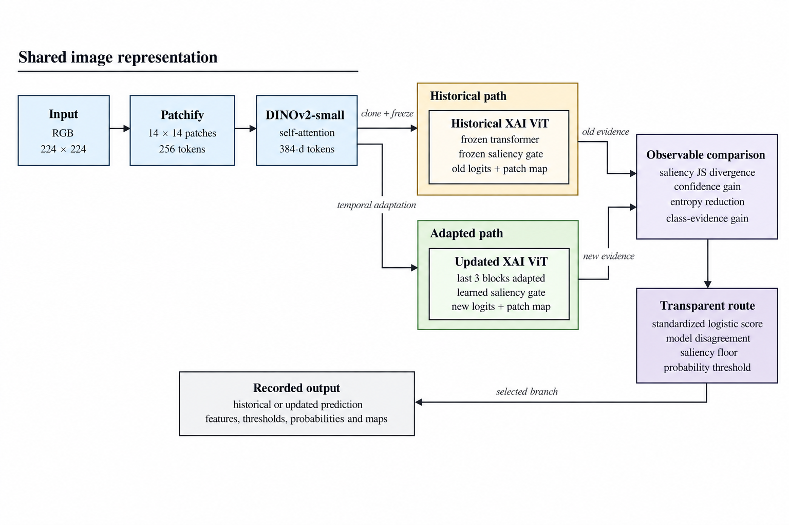
Figure 2. Asymmetric Siamese comparison between the frozen historical ViT and drift-adapted ViT
Logistic regression was chosen so that the route can be reproduced from a short coefficient vector [15]. A positive calibration target means that the historical model is wrong and the updated model is correct. The four inputs are standardised, and class-balanced fitting compensates for the smaller number of useful updates. The score is p(update | x) = sigmoid(b + wᵀz). Saving b, w, and the feature means and scales is sufficient to recalculate it.
Probability alone does not determine the route. The implementation searches saliency-floor quantiles and probability thresholds in 2011 only, choosing the pair with the highest calibration macro F1 and then fewer harmful routes as the tie-breaker. At inference, the newer branch is selected only if the branches disagree, saliency change exceeds the stored floor, and the fitted probability exceeds the stored threshold. This staged rule reflects the calibration literature's warning that a classifier score should not automatically be treated as a trustworthy probability without empirical checking [16]. It also keeps the final decision auditable: a reviewer can see the raw signals, standardized values, weighted sum, two eligibility checks, and selected branch for every image.
Saliency divergence measures how much the spatial evidence distribution changed. Confidence gain measures whether the newer branch is more certain in its selected class. Entropy reduction measures whether its full predictive distribution became more concentrated. Class-evidence gain measures whether the newer representation provides stronger support for the candidate class. No feature is assumed to be sufficient in isolation.
Coefficient signs describe associations in the 2011 calibration sample. A positive confidence coefficient means that confidence gain was associated with useful updates after the other features were considered. It does not prove that increasing confidence would cause correctness. The router is transparent as a policy, while its statistical relationships remain empirical.

4. Temporal protocol
Stage | Years | Role
Historical training | 2004-2008 | Fit the original ViT models
Model selection | 2009 | Choose checkpoints without touching future years
Drift adaptation | 2010 | Update the newer XAI ViT with a balanced clean/corrupted stream
Router calibration | 2011 | Archived run: select adapted checkpoint and fit router on shared labels; corrected code uses disjoint class-stratified partitions
Frozen evaluation | 2012–2014 | Test clean and drifted data once across a future horizon

The original comparison uses a frozen combined condition: modest saturation change, Gaussian sensor noise, and partial occlusion. Individual corruptions appear during adaptation and calibration, while their composition is withheld until final testing. The later source-separated evaluation keeps the same chronology and checkpoint but reports each acquisition change separately.

The clean stream and the corrupted stream answer different questions. Clean year-by-year evaluation measures performance on the naturally ordered dataset. Corruption tests measure sensitivity when plausible visual degradation is added to that chronology. Synthetic corruption is therefore not presented as the source of the underlying temporal drift.
Acquisition drift arises when the image-forming process changes while the class meaning remains stable. Replacing a camera can alter sensor noise, lens blur, colour response, resolution, and compression; moving that camera can change viewpoint and background; weather, season, and lighting alter illumination and white balance. These are covariate changes because the observed pixels change even when the depicted object retains the same label. ImageNet-C formalizes several sensor, optical, environmental, and digital failure modes [1]. WILDS records naturally occurring changes across camera locations, institutions, geography, and time [3], while camera-trap studies show that a classifier can rely on location-specific backgrounds and fail at unseen camera sites [18]. CLEAR supplies the separate chronological component by preserving real image years [2].
Within the original stress test, saturation represents illumination or camera colour processing, Gaussian noise approximates sensor and transmission degradation, and partial occlusion represents obstruction, cropping, dirt, or an intervening object. Severity is bounded and logged so that the stress test remains interpretable rather than making the original image unrecognizable. These perturbations are controlled proxies for acquisition mechanisms, not proof that a specific physical camera was replaced. Occlusion is only one possible acquisition shift and should not dominate the scientific claim.
The source-separated protocol covers illumination, white-balance change, sensor noise, defocus blur, motion blur, JPEG compression, resolution loss, mild viewpoint shift, and localized occlusion. A separate realistic mixture combines a small number of these changes at bounded severity, with occlusion limited to a minority of images.
This makes optical, sensor, digital, geometric, and obstruction-related shifts visible in separate rows instead of allowing one dramatic corruption to represent the whole problem. The protocol was run only after the checkpoints and routing rule had been fixed; its results appear in Section 5.3. Natural distribution-shift benchmarks also show that conclusions can differ across acquisition sources [19]. The combined condition is reserved for final evaluation. Adaptation and calibration use individual corruption families, so success on the composition measures limited generalization beyond the exact perturbation pattern seen during updating.

4.1 Enhanced correction experiment
The newly added --adaptation-profile enhanced mode is a predeclared attempt to increase the separation between the historical ViT and the saliency-responsive correction model without changing the test set. It changes only the 2010 adaptation procedure:
- 25% clean and 75% individually corrupted samples, spanning severities 1–3;
- the final three transformer blocks are trainable instead of only the final block;
- backbone learning rate remains 1e-5, while classifier and saliency heads use 5e-5;
- label smoothing is 0.05 and the saliency terms receive weight 0.25;
- the saliency divergence margin increases from 0.05 to 0.08;
- router calibration jointly selects a saliency-floor quantile and probability threshold on 2011 only.
The completed enhanced run used the same historical checkpoint, seed 42, and frozen 2012–2014 evaluation streams as its controls. Its adapted checkpoint and routing policy were both chosen using the 2011 sample. Epoch 4 was selected by 2011 macro F1 (94.39%); epoch 5 declined to 93.00%, indicating overfitting after the selected checkpoint. Training took approximately 138 seconds per epoch after warm-up. Combined corruption remained unavailable during adaptation and calibration. Because checkpoint selection and policy fitting share 2011 labels, all reported numerical results are exploratory rather than confirmatory.

4.1.1 Protocol correction for future runs
Reusing 2011 for both checkpoint selection and router calibration gives the policy information about the sample that already determined which adapted model survived. This can make route thresholds look better matched to that window than they would be on new data. The code now divides 2011 deterministically within each class: one partition selects the adapted checkpoint and the other fits logistic coefficients, the saliency floor, and the probability threshold. The default split is 50/50 and is recorded with both sample counts. A legacy flag reproduces the shared protocol for audit purposes. The tables in this paper were not recomputed after that correction, so the distinction is explicit rather than retroactively changing the meaning of the reported runs.

4.2 Hypotheses and success criteria
- H1: enhanced saliency adaptation improves 2014 combined-drift macro F1 by at least 3.00 percentage points over the original baseline ViT.
- H2: transparent routing retains at least 75% of the gain achieved by always using the updated model.
- H3: clean 2014 macro F1 does not fall by more than 0.50 points relative to the historical XAI model.
The 3-point value is a target fixed before viewing the enhanced results. Failure to reach it must be reported as a negative result rather than addressed by tuning on 2012–2014 labels.

4.3 Enhanced result against the hypotheses
- H1 not met: the updated model improved by 1.40 points over baseline ViT, below the 3.00-point target.
- H2 met: routing retained (91.85−90.34)/(91.99−90.34) = 91.5% of the newer model's gain over historical XAI.
- H3 met: routed clean 2014 macro F1 was 95.30%, 0.06 points above historical XAI.

4.4 Checkpoint and interruption recovery
Every evaluated epoch atomically replaces models/resume.pt and writes a small resume.json. The binary checkpoint contains the newer ViT parameters, optimizer state, completed epoch, and best validation score; the separate best-model file remains the checkpoint used for final evaluation. The matched standard run was deliberately stopped after epoch 2 and resumed at epoch 3. It retained the epoch-2 optimizer and best score, later selected epoch 4, and completed the frozen horizon normally. A local round-trip regression test independently reloads and compares weights, optimizer state, epoch, score, and metadata.

5. Main results
Macro F1 is shown as a percentage. Helpful and harmful routes count cases where choosing the newer model corrected or introduced an error, respectively.
Scenario | Year | Baseline | Historical XAI | Routed | Helpful | Harmful
Clean | 2012 | 95.86 | 95.96 | 96.40 | 30 | 8
Clean | 2013 | 95.27 | 95.23 | 95.79 | 40 | 12
Clean | 2014 | 95.13 | 95.24 | 95.46 | 30 | 18
Combined | 2012 | 95.47 | 95.47 | 96.08 | 45 | 14
Combined | 2013 | 93.75 | 93.81 | 94.55 | 72 | 32
Combined | 2014 | 90.59 | 90.34 | 91.50 | 120 | 48

On 2014 combined drift, the baseline reached 90.59%, the historical XAI model 90.34%, the updated XAI model 91.75%, and the transparent router 91.50% macro F1. The router captures (91.50−90.34)/(91.75−90.34) = 82.3% of the available update gain. The updated model also remains stronger on clean images, although the router becomes more conservative and records 18 harmful routes against 30 helpful routes in 2014.

5.1 Enhanced profile results
Scenario | Year | Historical XAI | Enhanced XAI | Enhanced routed | Helpful | Harmful
Clean | 2012 | 95.96 | 95.89 | 96.03 | 65 | 62
Clean | 2013 | 95.23 | 95.49 | 95.55 | 60 | 44
Clean | 2014 | 95.24 | 95.47 | 95.30 | 69 | 64
Combined | 2012 | 95.47 | 95.71 | 95.81 | 76 | 58
Combined | 2013 | 93.81 | 94.43 | 94.44 | 101 | 66
Combined | 2014 | 90.34 | 91.99 | 91.85 | 188 | 90

The enhanced curriculum improved the always-new 2014 combined score from 91.75% to 91.99%, a further 0.24 points. The routed score increased from 91.50% to 91.85%, a further 0.35 points. The modest change indicates that simply increasing adaptation capacity is insufficient to create a 3-point separation.

5.2 Controlled five-epoch ablation
The matched run removes the earlier three-versus-five-epoch imbalance. The auxiliary-loss control keeps the enhanced curriculum, trainable blocks, learning rates, and saliency-gated classifier fixed, but sets the pairwise saliency-divergence and complementary-evidence loss weights to zero. It therefore isolates the explicit saliency supervision while retaining saliency inside the forward pass.
Configuration | 2014 clean routed | Combined old | Combined new | Combined routed | Helpful | Harmful
Matched standard (5 epochs) | 95.78 | 90.34 | 91.68 | 91.72 | 144 | 57
Enhanced with auxiliary saliency losses | 95.30 | 90.34 | 91.99 | 91.85 | 188 | 90
Enhanced without auxiliary saliency losses | 95.45 | 90.34 | 91.86 | 91.62 | 125 | 43

Bold type marks the best value in each evaluation column across the three matched configurations; ties are bolded together. Helpful and harmful counts describe route composition rather than interchangeable accuracy measures, so the most helpful and least harmful counts are emphasized separately.
Against the matched enhanced control, the explicit auxiliary saliency objectives changed 2014 combined macro F1 by +0.13 points for always-new inference and +0.23 points after routing. These are single-run paired differences, not confidence-bounded causal estimates.

5.3 Source-separated drift evaluation
The broader protocol evaluates the same saved historical checkpoint, adapted checkpoint, and 2011 routing policy across 11 independently named 2014 conditions. Each row contains the frozen historical score, the always-updated score, the transparent routed score, and the routed change from the historical branch. This separation prevents a favourable occlusion example from standing in for unrelated acquisition changes.
2014 condition | Historical | Updated | Routed | Routed change
Clean | 95.24 | 95.54 | 95.36 | +0.12
Illumination | 95.13 | 95.46 | 95.24 | +0.11
White balance | 95.16 | 95.61 | 95.43 | +0.27
Sensor noise | 94.20 | 94.72 | 94.44 | +0.24
Defocus blur | 94.41 | 94.93 | 94.75 | +0.34
Motion blur | 83.17 | 87.13 | 86.62 | +3.45
JPEG compression | 93.64 | 94.27 | 94.09 | +0.45
Resolution loss | 93.69 | 94.26 | 94.10 | +0.41
Viewpoint shift | 94.32 | 95.09 | 94.91 | +0.59
Occlusion | 93.93 | 94.74 | 94.68 | +0.75
Realistic mixture | 86.41 | 88.62 | 88.44 | +2.03

Motion blur produces the largest routed gain: +3.45 percentage points, from 357 helpful and 90 harmful switches. The realistic mixture gains +2.03 points, with 261 helpful and 95 harmful switches. Occlusion gains +0.75 points. The method is therefore not limited to occlusion, but its effect is clearly source dependent. It helps most when motion or several acquisition changes produce a sizable failure in the historical model. Mild colour and illumination changes leave much less room for improvement
.
Matched 2014 condition | Saliency routed change | No-aux routed change | Auxiliary effect on route
Clean | +0.12 | +0.30 | −0.18
Motion blur | +3.45 | +2.55 | +0.90
Viewpoint shift | +0.59 | +0.53 | +0.06
Occlusion | +0.75 | +0.69 | +0.06
Realistic mixture | +2.03 | +1.19 | +0.84

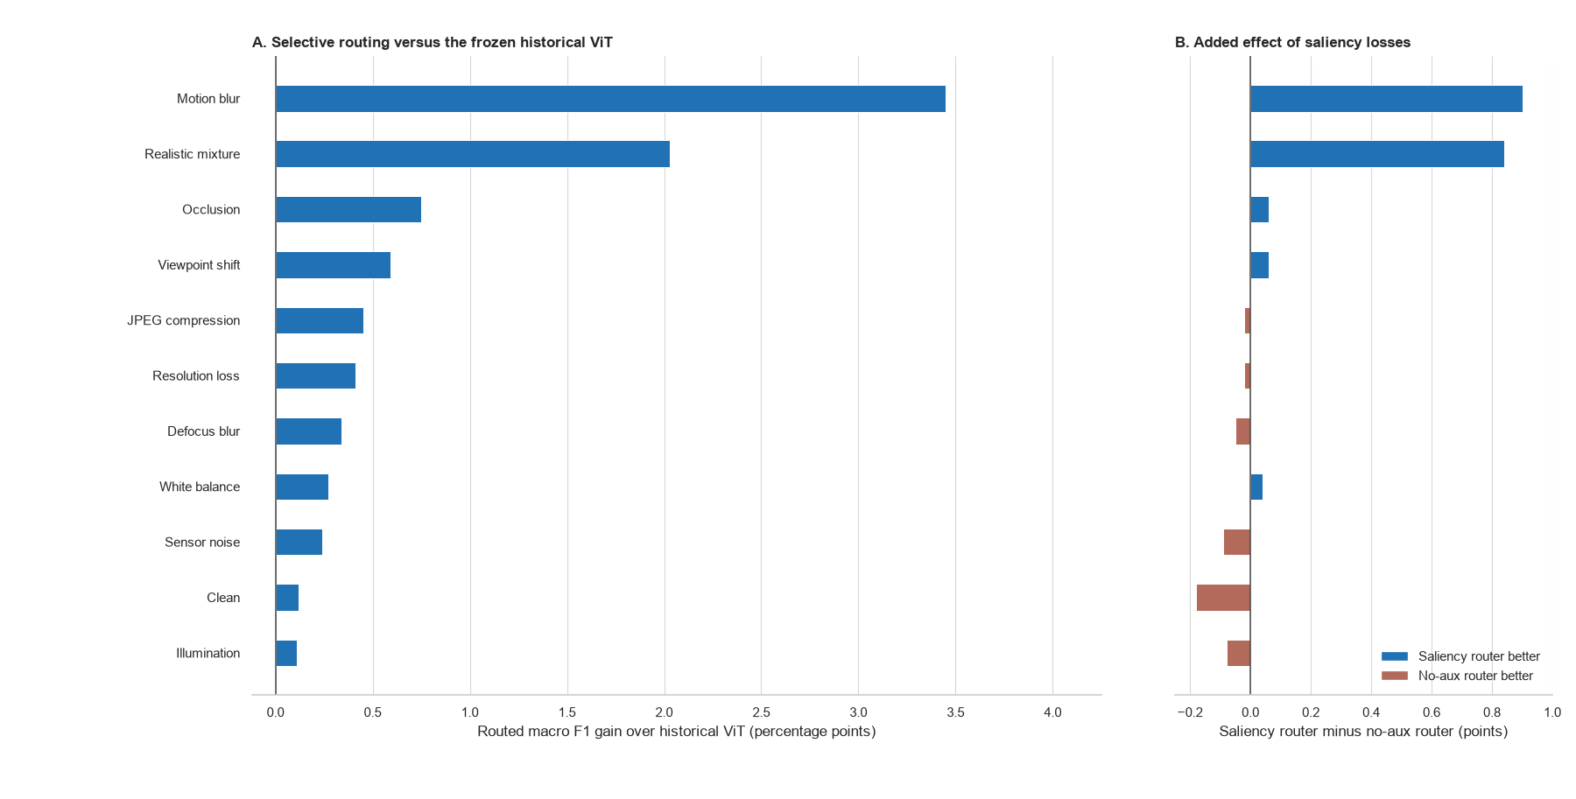
Figure 3. Selective-routing gain over the historical ViT and the added effect of saliency losses
Figure 3 evaluates routing against its intended deployment baseline, the frozen historical ViT. Every routed result is positive, led by motion blur (+3.45 points) and the realistic mixture (+2.03 points). Relative to the matched no-auxiliary router, saliency losses add +0.90 and +0.84 points in those conditions. Routing also prevents 16 and 20 harmful replacements, although it misses 47 and 30 beneficial updates. The updated ViT remains a performance ceiling: routing is 0.06–0.51 points lower overall, yet retains 87.1% and 91.9% of its gain in the two hardest conditions while making model switches explicit and reviewable.

6. Saliency and routing analysis
Each audit row shows the clean reference, drifted input, historical and updated saliency overlays, and signed map change. Robust 5th–95th percentile scaling and a stronger blend make spatial evidence visible. Red indicates gained updated-model weight and blue lost weight; Jensen–Shannon divergence and the deletion margin quantify magnitude and behavioural relevance.
Figure 4 contains one helpful route from each of three drift families. The examples were selected for inspection and are not used to estimate performance; the aggregate counts below provide that evidence.
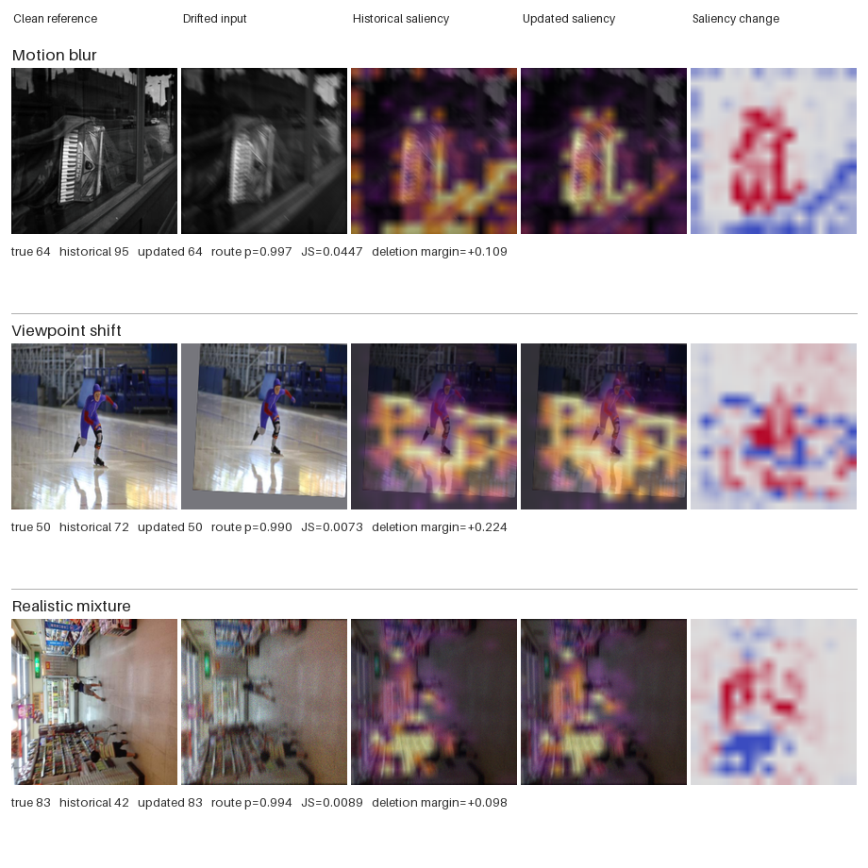
Figure 4. Helpful routed corrections with historical, updated, and signed saliency-change maps

6.1 Quantitative saliency outcome analysis
For the 2014 combined-drift auxiliary-loss control, helpful routes had mean saliency Jensen-Shannon divergence 0.0607, compared with 0.0512 for harmful routes and 0.0473 when the historical prediction was retained. Mean route probability was 0.821 for helpful routes, 0.767 for harmful routes, and 0.310 for retained historical predictions. There were 125 helpful versus 43 harmful routes (ratio 2.91). The matched standard run showed the same within-run ordering for helpful versus harmful divergence (0.00759 versus 0.00651), although raw divergence magnitudes should not be compared across differently adapted models.
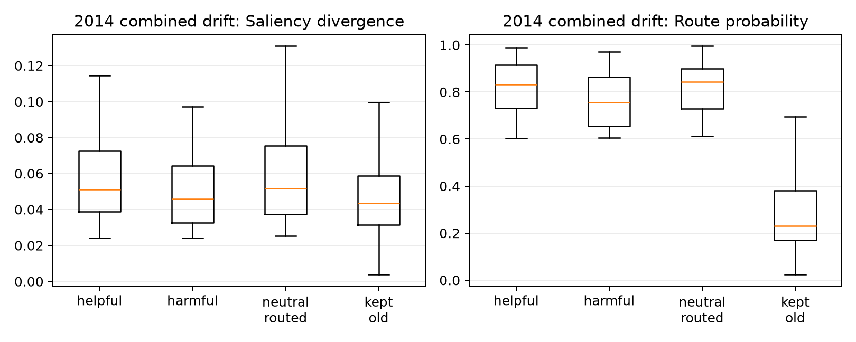
Saliency and route probability by outcome
The distributions overlap. Routed and retained images separate partly because the policy itself requires a minimum saliency change. That confirms the gate is being applied, but it does not show that a large map change predicts correctness. Helpful routes have somewhat larger divergence and route probability on average, yet many harmful routes fall in the same range. Saliency movement is therefore useful as a filter, but not as a decision rule by itself.

Map change measures difference, not improvement. A new model can move its attention and still be wrong, or become highly confident in the wrong class. CLEAR also provides image labels rather than object masks. Context such as a bowling lane, kitchen surface, or display frame may be useful in one image and a shortcut in another. Since both models share their pretraining and initialization, some correct updates also require only a small redistribution of patch weights.
The maps are best read as evidence-allocation diagnostics: they show which encoded patches received weight in the classifier. They are not object masks and do not establish that the map change caused a correction. The deletion audit adds a behavioural check by comparing the effect of removing highly weighted and weakly weighted patches. Even this test is limited because the deleted image is outside the original data distribution.

6.2 Counterexample and faithfulness audit
The source-specific audit applies the same top-versus-bottom 20% deletion test whenever one model is correct and the other is wrong. A positive margin means that removing the most highly weighted patches reduces true-class probability more than removing the least-weighted patches.
2014 source | Helpful routed | Harmful routed | Missed helpful | Net corrections | New-map margin, helpful | New-map margin, harmful
Motion blur | 357 | 90 | 47 | 267 | 0.147 | 0.031
Viewpoint shift | 88 | 56 | 17 | 32 | 0.190 | −0.053
Realistic mixture | 261 | 95 | 30 | 166 | 0.188 | 0.014

For the updated model, positive margins are more common on helpful than harmful routes: 70.0% versus 61.1% for motion blur, 72.7% versus 44.6% for viewpoint shift, and 76.6% versus 60.0% for the realistic mixture. The historical map shows the reverse pattern. Its mean margin is larger on harmful routes, where the historical prediction was correct. The reversal is consistent with the routing idea, although the overlap explains why errors remain.
The full 2014 combined-drift stream contains 4,999 images. The enhanced router makes 188 helpful switches where the historical model is wrong and the newer model is correct, 90 harmful switches in the opposite direction, and misses 17 available corrections. It therefore produces 98 net corrected predictions. These counts explain why the overall score changes modestly even though some individual decisions change substantially.
For every one of the 304 samples where one model is correct and the other is wrong, the audit deletes the top 20% and bottom 20% of patches under each model's own saliency map. The faithfulness margin is the drop in true-class probability after high-saliency deletion minus the drop after low-saliency deletion. For helpful routed cases, the newer model has a mean margin of 0.175, compared with 0.010 on harmful routed cases; 72.3% of helpful routes have a positive new-model margin, compared with 57.8% of harmful routes. Conversely, the historical model's mean margin is 0.048 on helpful routes and 0.182 on harmful routes. This reversal is consistent with the intuitive routing goal: the model that is correct tends to have the more behaviourally consequential map.
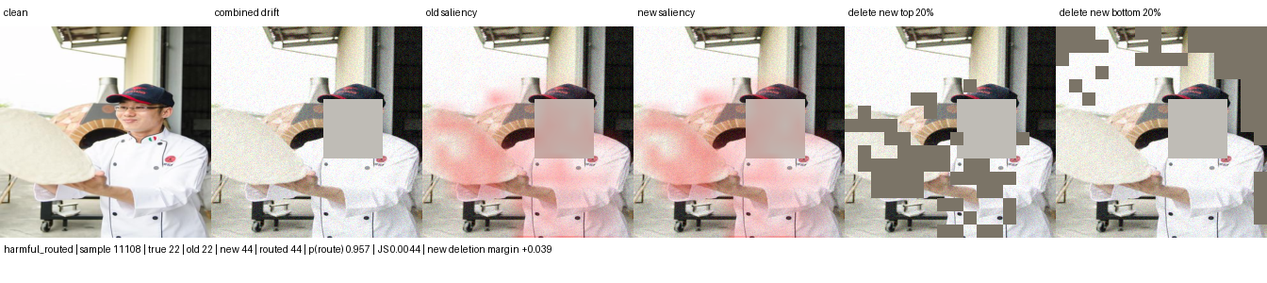
Harmful switch: correct historical class 22 is replaced by class 44
The harmful example shows why saliency change alone is insufficient: the historical model was already correct and its map had the stronger deletion response. Patch deletion is still an artificial intervention, so this result does not prove that the highlighted pixels caused the model update.

6.3 Scope of the method
The intended setting is covariate drift: the label keeps the same meaning while the image-forming process or context changes. Examples include camera replacement, compression, sensor noise, white balance, illumination, viewpoint, and partial obstruction. Saliency can help only when useful class evidence remains visible and the updated model learns to weigh it differently.
The source-separated results show the largest gains under motion blur and mixed drift. Viewpoint, occlusion, and digital degradation produce smaller gains, while mild colour and illumination shifts change little. The method is neither an occlusion-specific fix nor a general solution to every form of drift.
The method should not be expected to solve concept drift where the label meaning changes, new-class emergence, extreme occlusion, or systematic dataset errors. In those cases the saliency map may faithfully explain a wrong premise. A stronger next experiment should therefore add a matched random-mask control and an external temporal dataset, then compare confidence-only, saliency-only, and deletion-aware routers without tuning on the final horizon.

7. Discussion, limitations, and conclusion

7.1 What the experiment establishes
The experiment establishes that update value depends on the drift source. Routing improves over the frozen historical ViT in all eleven 2014 conditions, but the magnitude ranges from +0.11 points under illumination to +3.45 under motion blur. Under motion blur and the realistic mixture, routing retains 87.1% and 91.9% of the always-updated gain. This is evidence that a transparent branch-selection rule can preserve most of an adapted ViT's benefit when the historical model has genuinely degraded. It is not evidence that routing beats always using the updated model; the updated branch remains 0.06–0.51 points higher across the source-separated tests.

7.2 Negative results and failure modes
The predeclared three-point target was not met on the original combined condition: the enhanced updated model gained 1.40 points over the baseline and routed inference gained 1.51 points over historical XAI. In the matched ablation, the explicit auxiliary saliency objectives added only +0.23 routed points on combined drift and reduced clean routed performance by 0.18 points. These outcomes show that increasing adaptation capacity and encouraging map movement do not automatically produce a large or uniformly safe correction.
The route audit explains part of the gap. Helpful and harmful decisions overlap in saliency divergence and route probability, so the four features do not cleanly identify correctness. A map can change because the updated model has found better evidence, because it has shifted to a different shortcut, or because blur has redistributed all patch weights. The logistic router is deliberately simple and may underfit these interactions; a more expressive gate may improve accuracy but would weaken the direct coefficient-level explanation that motivates the design.

7.3 Validity threats and implemented correction
The evidence is limited by one random seed, one temporal dataset, synthetic stressors layered over natural chronology, and one fitted policy. The reported runs also reuse 2011 labels for adapted-checkpoint selection and router calibration. That reuse is a material selection-bias risk and has been corrected in the code through disjoint class-stratified partitions, but the existing figures have not been relabelled as corrected results. No confidence intervals or external validation dataset are available, and deletion creates out-of-distribution images. Saliency maps should therefore be interpreted as evidence-allocation diagnostics rather than causal or spatial ground truth.

7.4 Feasible next evaluation
A confirmatory run should use the corrected 2011 split, at least three matched seeds, and paired per-image bootstrap intervals. It should compare confidence-only, saliency-only, combined, and end-to-end selective gates at matched route coverage, while retaining always-historical and always-updated baselines. A random-patch intervention should accompany saliency-guided deletion, and a second temporal image dataset should test transfer. These additions are feasible because the existing run store already records per-image decisions, timing, checkpoints, and source-specific scenarios.

7.5 Conclusion
The thesis therefore supports a qualified conclusion. An asymmetric historical-versus-adapted ViT pair is a useful way to frame model updates when traceability matters, and embedded saliency supplies inspectable evidence that can influence both learning and routing. The current router improves over the historical model most clearly under motion and mixed acquisition drift, but its saliency-specific contribution is modest and source dependent. The method is best presented as a feasible, auditable prototype whose strongest value is exposing update decisions and failure modes, pending corrected multi-seed validation.

Appendix A. Metric and routing glossary
Macro F1 calculates F1 independently for every class and then gives each class equal weight. It is the principal classification measure because a large class cannot dominate the reported result. Macro IoU applies the same equal-class principle to one-versus-rest intersection over union. It remains a classification-set measure in this project and must not be confused with spatial mask IoU.
Helpful route means that the historical prediction was wrong, the newer prediction was correct, and the policy selected the newer branch. Harmful route means that the historical prediction was correct but the selected newer prediction was wrong. Missed helpful case means that a correct newer prediction was available but the policy retained an incorrect historical answer.
Saliency Jensen-Shannon divergence measures the bounded difference between the old and new normalized patch-weight distributions. Confidence gain compares the selected class probabilities. Entropy reduction measures whether the newer predictive distribution is more concentrated. Class-evidence gain compares the evidence produced for the candidate class.
Retained gain measures how much of the always-new improvement survives routing: (routed − old) / (new − old). A value near one means routing preserves most of the candidate model's benefit. The ratio becomes unstable when the new and old scores are nearly equal, so the underlying scores must always be reported beside it.
These definitions are fixed across the report. They make clear which measures evaluate classification, which evaluate the decision policy, and which describe explanation change. None of the routing features is itself a ground-truth measure of drift.

References
1. Hendrycks and Dietterich (2019), Benchmarking Neural Network Robustness to Common Corruptions and Perturbations. https://arxiv.org/abs/1903.12261
2. Lin et al. (2021), CLEAR: A Benchmark for Continual Learning on Real-World Imagery. https://clear-benchmark.github.io/
3. Koh et al. (2021), WILDS: A Benchmark of in-the-Wild Distribution Shifts. Proceedings of the 38th International Conference on Machine Learning. https://arxiv.org/abs/2012.07421
4. Yao and Gong (2020), Saliency Guided Self-attention Network for Weakly and Semi-supervised Semantic Segmentation. https://arxiv.org/abs/1910.05475
5. Nguyen et al. (2025), XGD: Explainable AI-Guided Knowledge Distillation with Feature Refinement for Semantic Segmentation. 38th Canadian Conference on Artificial Intelligence. https://www.researchgate.net/publication/389169277_XGD_Explainable_AI-Guided_Knowledge_Distillation_with_Feature_Refinement_for_Semantic_Segmentation
6. Cantini, Orsino, and Talia (2024), XAI-driven knowledge distillation of large language models for efficient deployment on low-resource devices. Journal of Big Data, 11, 63. https://doi.org/10.1186/s40537-024-00928-3
7. Ismail, Feizi, and Corrada Bravo (2021), Improving Deep Learning Interpretability by Saliency Guided Training. Advances in Neural Information Processing Systems. https://arxiv.org/abs/2111.14338
8. Zheng, Ghosh, and Narasimhan (2024), Saliency Guided Image Warping for Unsupervised Domain Adaptation. https://arxiv.org/abs/2403.12712
9. Cheng et al. (2026), Siamese-ViT: A Local–Global Feature Fusion Method for Real-Time Visual Navigation of UAVs in Real-World Environments. Remote Sensing, 18, 1556. https://www.mdpi.com/2072-4292/18/10/1556
10. Yang et al. (2021), Semantic Change Detection with Asymmetric Siamese Networks. https://arxiv.org/abs/2010.05687
11. Lin (1991), Divergence Measures Based on the Shannon Entropy. IEEE Transactions on Information Theory, 37(1), 145–151. https://ieeexplore.ieee.org/document/61115
12. Shannon (1948), A Mathematical Theory of Communication. Bell System Technical Journal, 27, 379–423 and 623–656. https://ieeexplore.ieee.org/document/6773024
13. Dosovitskiy et al. (2020), An Image is Worth 16×16 Words: Transformers for Image Recognition at Scale. https://arxiv.org/abs/2010.11929
14. Oquab et al. (2023), DINOv2: Learning Robust Visual Features without Supervision. https://arxiv.org/abs/2304.07193
15. Rudin (2019), Stop Explaining Black Box Machine Learning Models for High Stakes Decisions and Use Interpretable Models Instead. Nature Machine Intelligence, 1, 206–215. https://doi.org/10.1038/s42256-019-0048-x
16. Niculescu-Mizil and Caruana (2005), Predicting Good Probabilities with Supervised Learning. Proceedings of the 22nd International Conference on Machine Learning, 625–632. https://doi.org/10.1145/1102351.1102430
17. Hendrycks et al. (2019), AugMix: A Simple Data Processing Method to Improve Robustness and Uncertainty. https://arxiv.org/abs/1912.02781
18. Beery, Van Horn, and Perona (2018), Recognition in Terra Incognita. Proceedings of the European Conference on Computer Vision. https://doi.org/10.1007/978-3-030-01270-0_28
19. Taori et al. (2020), Measuring Robustness to Natural Distribution Shifts in Image Classification. Advances in Neural Information Processing Systems, 33.
20. Wang et al. (2021), Tent: Fully Test-Time Adaptation by Entropy Minimization. International Conference on Learning Representations. https://openreview.net/forum?id=uXl3bZLkr3c
21. Wang et al. (2022), Continual Test-Time Domain Adaptation. Proceedings of the IEEE/CVF Conference on Computer Vision and Pattern Recognition, 7201–7211. https://openaccess.thecvf.com/content/CVPR2022/html/Wang_Continual_Test-Time_Domain_Adaptation_CVPR_2022_paper.html
22. Niu et al. (2022), Efficient Test-Time Model Adaptation without Forgetting. Proceedings of the 39th International Conference on Machine Learning, 16888–16905. https://proceedings.mlr.press/v162/niu22a.html
23. Geifman and El-Yaniv (2019), SelectiveNet: A Deep Neural Network with an Integrated Reject Option. Proceedings of the 36th International Conference on Machine Learning, 2151–2159. https://proceedings.mlr.press/v97/geifman19a.html
24. Wu et al. (2025), Navigating Semantic Drift in Task-Agnostic Class-Incremental Learning. https://arxiv.org/abs/2503.11756
25. Ma et al. (2022), Rectify ViT Shortcut Learning by Visual Saliency. https://arxiv.org/abs/2206.08567

