Saliency as an Operational Signal for Drift-Aware Vision Model Updating

Evidence from CLEAR-100 and Wild-Time Yearbook
Rikhil Singh

Abstract
This study tests whether saliency can help correct predictive errors under image distribution shift, rather than serving only as a post-hoc display. On CLEAR-100, frozen DINOv2 features detect the controlled acquisition changes, while the sampled clean-year comparison does not show reliable separation. The main archived CLEAR comparison reports 82.75% macro F1 for saliency-guided updating, 81.55% for conventional fine-tuning, and 79.42% for the shared historical reference on the 2014 evidence-ranked mixture. A corrected-split, single-seed run reverses that comparison: the saliency update scores 80.78%, 0.77 points below conventional fine-tuning. A shared-checkpoint patch-weight intervention also found near-identical predictions after learned weights were replaced by uniform, shuffled, or inverted weights. A separate chronological Wild-Time Yearbook pilot found that saliency-mask LoRA exceeded an equal-area random-mask control by a mean 0.90 macro-F1 points across three seeds under an injected center occlusion; it exceeded ordinary LoRA in two seeds. It did not improve results under blur or noise, and the natural Yearbook chronology did not harm the historical model in this sample. The evidence therefore supports a narrow, exploratory occlusion-robustness signal, not a general saliency-specific correction of natural temporal drift. The paired router adds an inspectable fallback but has not shown reliable selection value beyond confidence. A planned iWildCam time-by-camera replication remains pending; this draft reports no iWildCam results.

1. Introduction

1.1 Operational problem and paper claim
Image classifiers are usually evaluated on data collected during development, but deployment continues after that snapshot. Changes in cameras, environments, compression pipelines, and scene composition can alter the input distribution even when class definitions remain fixed. CLEAR records natural visual change from 2004 to 2014 [1], WILDS documents shifts across locations and institutions [2], and Wild-Time studies temporal change across applications [3]. The study first asks whether limited incoming images reveal a detectable distributional change without their labels. It then tests whether saliency-guided updating improves future predictions and, as a separate decision experiment, whether routing adds value when both model versions are available.
Existing responses intervene at different points in the model lifecycle. Corruption augmentation tries to reduce sensitivity before deployment [5]. Tent adapts selected parameters on target batches [6], while CoTTA restores parts of the source model [7] and EATA filters unsuitable updates to reduce forgetting [8]. Continual-learning methods preserve knowledge across longer sequences [9], and SelectiveNet frames model use as a risk-coverage decision [10]. These approaches show that an update must be judged by more than its peak accuracy: it also matters whether the update damages previously reliable cases and whether its use can be controlled.
The study combines four distinct evaluations. First, it tests unlabelled feature drift with MMD and a domain classifier, separating clean-year comparisons from controlled image changes. Second, it compares the archived CLEAR update strategies and reports the later corrected-split and shared-checkpoint controls. Third, it measures selective routing separately from always-updated accuracy. Fourth, it tests a saliency-mask LoRA intervention on chronological Yearbook data and on fixed, injected blur, occlusion, and noise. These evaluations distinguish measurable feature change, task harm, and the value of a saliency intervention; none is treated as proof of another.

1.2 Research questions and measurable objectives
The research questions use separate evidence. RQ1 tests whether unlabelled samples show measurable feature-distribution change and whether that change coincides with a task-performance drop. RQ2 asks whether saliency-guided adaptation improves over ordinary fine-tuning and matched random controls, with clean performance reported alongside shifted performance. RQ3 asks whether the router improves decisions over always-updated and confidence-only policies. The 2.00-point gain, 75% retention, and 0.50-point clean-loss values in the original CLEAR audit were chosen after initial results as descriptive engineering references; they are not prospective hypotheses or safety standards.
1. RQ1: Can distributional change be detected from limited unlabelled incoming image samples, independently of model accuracy, and how sensitive are MMD and a domain-classifier check to controlled versus clean-year change?
2. RQ2: Does saliency-guided updating improve future macro F1 beyond conventional fine-tuning, and what separate evidence supports learned patch weighting and its auxiliary objectives?
3. RQ3: Given fixed historical and updated saliency models, does a transparent paired router add decision value beyond always-updated or confidence-only choices while exposing helpful, harmful, and missed replacements?

1.3 Contributions in relation to the research questions
The report contributes a reproducible drift-screening protocol, an audit of the original saliency-weighted ViT and paired router, and a matched saliency-mask adaptation pilot on chronological images. The component tests include uniform, shuffled, and inverted pooling weights on a fixed checkpoint, as well as equal-area random masking during LoRA adaptation. The results include both positive and negative outcomes: saliency masking shows a small repeated advantage over random masking under one injected occlusion, while ordinary LoRA is better on clean data and saliency does not help consistently under blur or noise. The router remains a secondary mechanism whose incremental decision value is not established.

2. Literature review and design rationale

2.1 Responses to distribution shift
Research on distribution shift spans several intervention levels. Robust training and corruption augmentation try to reduce sensitivity before deployment [4] [5]. Test-time adaptation changes the deployed model using target batches: Tent minimises prediction entropy through normalisation parameters [6], Continual Test-Time Adaptation (CoTTA) uses averaged predictions and partial source-weight restoration to reduce error accumulation [7], and Efficient Test-Time Adaptation (EATA) filters uninformative samples while regularising important weights [8]. These methods suit settings where labels and source data are unavailable at deployment, but they require online optimisation and can degrade in-distribution behaviour. This paper considers a labelled update window, a recoverable historical model, and an auditable decision for each switch.
Continual-learning research addresses longer sequences through replay, regularisation, parameter-efficient updates, and representation correction. Wu et al. combine low-rank adaptation with mean-shift compensation, covariance calibration, and patch-token distillation to reduce semantic drift in class-incremental ViTs [9]. Such methods update a continuing learner and preserve old classes. This paper keeps class definitions fixed and compares two time-indexed models at inference. SelectiveNet's risk-coverage formulation is closer to this decision problem [10], although the present router defers to another classifier rather than abstaining.
Temporal benchmarks also differ in what they test. CLEAR supplies a decade-long image stream with a fixed 100-class vocabulary and a near-future protocol [1]. WILDS includes shifts across satellite time and location, camera-trap locations, and hospitals [2]. Wild-Time covers several temporal domains and reports large average in-distribution to out-of-distribution losses [3]. CLEAR was selected because its year labels, stable class set, and accessible images fit the frozen historical-versus-updated design. The external screens deliberately span three different mechanisms: temporal portrait change, independent image recollection, and hospital acquisition shift. They test whether the same frozen feature and matched-head procedure runs beyond CLEAR; they do not reproduce the full temporal router.

2.2 Why saliency must be operational
Most saliency work begins after a prediction has been made: a map is generated to help a person inspect the decision. That use is valuable, but it leaves a gap for temporal model maintenance. A post-hoc map does not determine how patch evidence enters the classifier, whether that evidence should remain stable during adaptation, or when a later model should replace a historical decision. This study targets that gap by using one normalised patch-weight distribution in four connected roles: representation pooling, adaptation objectives, model-version comparison, and route auditing.
Prior work supports each part of this operational use without establishing the complete pipeline. SGAN constrains self-attention with saliency priors to reduce attention paid to irrelevant background [11]. Explainable AI-Guided Knowledge Distillation transfers class predictions and saliency-refined features, with an ablation that separates the saliency term from ordinary distillation [12]. Saliency Guided Training perturbs low-saliency features while preserving model outputs, linking explanation to intervention [13]. Saliency Guided Image Warping uses source saliency to control geometric adaptation [14], and visual-saliency work on ViTs uses patch evidence to reduce shortcut learning [15]. The present work joins these ideas to temporal update selection: saliency is used to adapt a ViT, compare two model states, constrain route eligibility, and investigate harmful switches.

2.3 Why an asymmetric Siamese ViT comparison
A paired architecture is useful when the decision depends on how two model states differ. Siamese-ViT demonstrates that two transformer branches can compare global and local evidence across views [16]. Yang et al. show that temporal branches need not play identical roles when their input distributions differ [17]. This paper applies the same relational idea to model versions: both branches share the DINOv2-small architecture and historical initialisation, but one remains frozen while the other learns from the update window. Holding the backbone family constant makes model age, adaptation, prediction change, and evidence movement the quantities under study.
The implementation is a historical-versus-updated paired comparison rather than a conventional Siamese metric network. It does not learn an opaque pair embedding or distance score. Each ViT returns class probabilities and a normalised patch-weight map, and a logistic policy combines four named differences between them. This simpler policy has less capacity than a learned mixture-of-experts gate, and its stored coefficients and thresholds make the policy inspectable. The decision CSV records rounded scalar features; exact near-threshold replay may require inference from the saved checkpoints. In the archived aggregate results the always-updated ViT scores highest, while the router supplies a historical fallback and a record of attempted replacements.

2.4 Quantitative context for expected improvements
Reported gains from saliency guidance and temporal correction vary widely with task, shift severity, and metric. The comparisons below are used to set expectations rather than to claim direct equivalence. Dense prediction, retrieval, and class-incremental accuracy are not interchangeable with CLEAR-100 macro F1.
Table 1. Reported improvements in related saliency and temporal-learning studies
Study | Setting | Reported absolute change | Interpretation for this paper
SGAN [11] | Weakly supervised segmentation | 55.0→64.2 mIoU (+9.2) | Strong saliency prior; different task and supervision
XGD [12] | Teacher-student segmentation | 65.25→69.82 mIoU (+4.57); saliency-only +3.52 | Supports explicit saliency ablation
Saliency warping [14] | Unsupervised domain adaptation | +3.0 to +6.3 on several shifts; +0.6 on DarkZurich | Effects depend strongly on target domain
SGT [15] | ViT shortcut reduction | INbreast +2.41 accuracy, +3.06 F1; FIGRIM -0.32 accuracy | Interpretability may improve without accuracy gain
Semantic-drift ViT [9] | Class-incremental learning | 79.36→81.88 accuracy (+2.52) | Component increments include +0.28 for patch distillation
Siamese-ViT [16] | Cross-view retrieval | +2.33 Recall@1 and +1.38 AP vs TransGeo | Supports paired ViT comparison, not temporal routing
Table 1 shows that related component effects range from about 0.28 points for patch distillation to roughly 3.0-3.5 points for some saliency-guided settings, while complete methods can report larger gains on different tasks. These values are contextual rather than directly transferable to CLEAR-100 classification. The two-point reference was adopted after the initial results were seen; related work contextualises its scale but does not make it a prospective hypothesis or a test of statistical significance. Smaller effects are still reported, but require repeated seeds and uncertainty estimates before they can be treated as stable.

2.5 Design decisions derived from the literature
Table 2. Design decisions and their evidential requirements
Choice | Rationale | Implementation | Evidence required
DINOv2-small ViT | Strong pretrained patch and class tokens [18] [19] | Same backbone in both branches; final three blocks updated | Future-year macro F1 and training cost
Embedded saliency gate | Trainable saliency and perturbation evidence [11] [12] [13] [15] | Patch weights form the classified representation | Ablation gain and deletion margin
Asymmetric pair | Paired ViTs and unequal temporal roles [16] [17] | Frozen historical reference versus adapted candidate | Helpful, harmful, and missed switches
Explicit logistic router | Interpretable policies and selective risk [20] [10] | Four stored features plus thresholds | Retained gain and harmful-route count
Frozen future horizon | Temporal benchmarks and anti-forgetting concerns [1] [7] [8] | No updates on 2012-2014 | Year-specific clean and drift scores
Source-separated stressors | Corruption and natural-shift evidence [4] [2] [14] [21] | Optical, sensor, digital, geometric, and mixed shifts | Effect size by source
These choices keep the prototype feasible on the available single Tesla T4 and make each decision trace compact enough for per-image review. The hardware constraint favours DINOv2-small, partial backbone adaptation, and logistic routing over full dual-model fine-tuning or a large learned gate. This is a scope decision rather than evidence of architectural superiority. The comparison is strongest when the operational requirement is a reviewable transition between two versioned ViTs with labelled update data.

3. System design
The prototype evaluates four ViT-only deployment strategies. These strategies are produced by four model checkpoints and one routing policy:
1. Historical uniform ViT: the frozen deployed reference, which pools patch tokens uniformly and supplies the common baseline for the primary results.
2. Conventionally fine-tuned ViT: an adapted copy of the uniform-pooling historical checkpoint trained with classification loss only.
3. Updated saliency-guided ViT: an adapted checkpoint whose learned patch weights form the pooled representation and enter the auxiliary adaptation losses.
4. Saliency-guided router: one deployment output formed by a fitted policy that selects between frozen historical and updated saliency-guided checkpoints for each image.
All four strategies use the DINOv2-small transformer backbone. The first three return the output of one checkpoint. The fourth returns one routed output from two saliency-guided checkpoints. The historical saliency-guided checkpoint is therefore an internal router component and a secondary diagnostic reference; it is not a fifth strategy in the primary comparison. Both adaptation arms update the final three transformer blocks and their classification head with the same learning rates, epoch budget, temporal windows, and seed. The saliency-guided arm also trains the patch gate and auxiliary objectives. Different pooling heads and the archived checkpoint-selection protocol prevent this comparison from serving as a perfect factorial ablation.
The router uses four signals. Jensen-Shannon (JS) divergence measures the bounded difference between the historical and updated patch-weight distributions [22]. A value near zero means that both models allocate similar spatial weight; a larger value records redistribution but does not establish that the new allocation is better. Confidence gain is the change in maximum softmax probability. Entropy reduction uses Shannon entropy to measure whether the full updated prediction is more concentrated [23]. Class-evidence gain compares support for the selected class in highly weighted patches with support in the complementary low-weight patches [12] [13]. The route CSV stores six-decimal scalar features, a logistic routing score, its threshold, the selected model, final class, and correctness. It does not store full patch maps; selected visual audit examples are generated separately from the saved checkpoints.
The implementation stores four checkpoints: historical uniform, fine-tuned uniform, historical saliency-guided, and updated saliency-guided. The uniform and saliency-guided historical checkpoints are trained once on 2004-2008, selected before adaptation, and then frozen. Their updated copies use the 2010 adaptation data and are selected before the 2012-2014 horizon. The routing policy is calibrated before that horizon and remains fixed throughout it.
The primary results contain four rows, one for each deployment strategy. Historical uniform supplies the common reference, conventional fine-tuning provides the classification-only adaptation benchmark, the updated saliency-guided ViT measures always-updated performance, and routing measures the performance retained by an inspectable selection policy. Secondary router analyses report the historical saliency-guided branch because helpful, harmful, and missed switches can only be attributed relative to the branch that the policy can retain. This diagnostic branch does not change the four-strategy headline comparison.

3.1 ViT classifier and operational saliency
DINOv2-small follows the Vision Transformer representation introduced by Dosovitskiy et al. [18] and the self-supervised DINOv2 pretraining procedure [19]. The local data pipeline first converts every image to RGB, resizes it deterministically to 224 × 224 pixels, converts channel values to the zero-to-one range, and normalises them with ImageNet channel means (0.485, 0.456, 0.406) and standard deviations (0.229, 0.224, 0.225). A direct square resize was chosen to keep the prototype deterministic and inexpensive, although its possible aspect-ratio distortion is a limitation that should be tested against resize-and-crop preprocessing in later work. DINOv2-small was selected because it exposes both class and patch tokens while keeping adaptation and paired inference feasible on the available Tesla T4. Using the same pretrained backbone family reduces capacity differences, but the heads, losses, and archived checkpoint-selection protocols also differ; the four-strategy comparison therefore measures complete deployment strategies rather than isolating each component. This design does not establish that the small backbone is optimal.
The prepared image is divided into non-overlapping 14 × 14 pixel patches, producing a 16 × 16 grid, or 256 patch tokens. Each patch is projected into a 384-dimensional embedding. Positional information preserves where the patch came from, and repeated self-attention blocks allow every token to exchange information with every other token. This global token interaction is the main architectural difference from a CNN, which builds representations through local convolutional filters and progressively expanding receptive fields. A learned class token travels through the same transformer blocks and acts as a global image summary, while the 256 patch tokens retain a spatial index that can be reshaped back to the 16 × 16 grid.
The uniform classifier gives every patch equal weight. It averages the 256 patch vectors, concatenates that result with the global class token, and applies a linear 100-class head. The saliency-guided variant replaces the uniform average with a learned gate, following evidence that saliency can shape the representation used for prediction [11] [12] [13] [15]. For patch representation hᵢ, LayerNorm and a linear layer followed by a sigmoid produce a non-negative gate gᵢ. The gate values are normalised across patches to give sᵢ, and the weighted sum of patch representations is concatenated with the class token. A patch with a larger sᵢ contributes more to the patch-summary input, and the displayed map uses those same weights. The unrestricted class token is also passed to the linear head, so the model can in principle make a prediction with little dependence on the patch summary. An inference intervention is needed to measure that dependence.
$g_{i}=sigmoid(w^{T}LayerNorm(h_{i})+b),s_{i}=\frac{g_{i}}{\sum_{j}{g_{j}}},v=\sum_{i}{s_{i}h_{i}}$
Figure 1 shows the original forward path, including the direct class-token branch that can bypass the gate. DINOv2 returns one 384-dimensional class token and 256 patch tokens. The gate assigns one scalar to each patch, preserving the 16 × 16 spatial grid. These values are normalised to sum to one before the patch vectors are combined. The classifier receives the class token and the weighted patch sum. The raw sigmoid gates gᵢ are also inverted as 1 − gᵢ and renormalised to form a complementary patch sum. The same classifier head scores both sums in the same class-logit space.
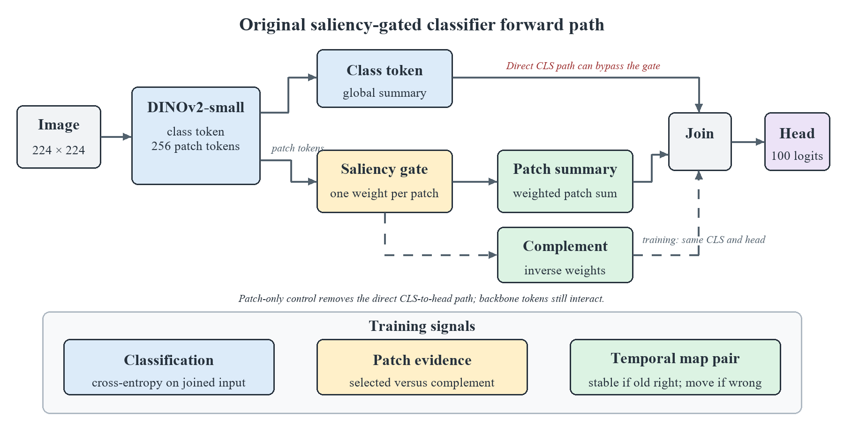
Figure 1. Original saliency-gated ViT forward computation, direct class-token path, and training signals
Faithfulness in this paper means that the reported patch importance has a measurable relationship with the model's prediction. The model classifies both the saliency-weighted representation and its low-saliency complement. The loss rewards stronger true-class evidence in the selected patches than in the complement, adapting the perturbation principle used in saliency-guided training [13]. During temporal adaptation, a pairwise term discourages unnecessary map movement when the historical model is correct and permits a minimum divergence when it is wrong. The selected and complementary paths share the same class token. The objective can therefore constrain the patch contribution without proving that the final prediction depends on the map. Matched patch-weight interventions and deletion controls are needed for that stronger mechanism claim.
$L=L_{cls}+λ_{faith}L_{faith}+λ_{pair}L_{pair}$
The learned map answers a limited but concrete question: which ViT patch tokens received weight in the representation used for classification? It is not treated as a segmentation mask. A concentrated map can still be wrong, and a diffuse map can still support a correct prediction. The report therefore avoids interpreting visual neatness as proof of faithfulness.
The complementary path provides a simple testable expectation: the selected patches should support the correct class more strongly than the remaining patches. This is added as a soft loss so that useful contextual information is not excluded by a hard mask.
During adaptation, the frozen branch provides the reference map. If its prediction is correct, the new map is discouraged from moving unnecessarily. If it is wrong, the pairwise loss allows a larger change. The class label still determines whether an update succeeds; map divergence alone does not.

3.1.1 Why saliency is an operational signal
If the saliency map were drawn only after prediction, the experiment would reduce to ordinary model replacement with an illustration attached. Here, the patch weights form the classified representation, auxiliary losses shape their behaviour during adaptation, the historical-versus-updated comparison reads the same weights at inference, and deletion analysis checks whether high-weight patches affect the true-class score more than low-weight patches. This connects one patch-weight signal to computation, update training, route eligibility, and post-run audit. The class-token pathway may still dominate a prediction, so the intervention experiment measures the signal's actual contribution rather than inferring it from that connection.
The need for this design depends on the deployment objective. If aggregate accuracy is the only criterion, the always-updated model should be used whenever validation supports it. A model-maintenance system may also need a recoverable historical version, a per-image account of why a replacement was attempted, and evidence for investigating negative transfer. Saliency supplies spatial evidence for those purposes, but it cannot identify correctness by itself. The router therefore combines map change with prediction features, and the evaluation reports route regret and harmful switches alongside deletion-based faithfulness.

3.2 Asymmetric Siamese comparison and explicit routing rule
For each image, the old and new ViTs return a class distribution and a patch-weight distribution. Four differences are standardised and passed to a saved logistic equation. The new prediction can be selected only when the models disagree, saliency divergence exceeds a calibrated floor, and the logistic routing score exceeds its threshold. The coefficients and thresholds are stored in router_policy.json.
Figure 2 uses two instances of the same saliency-guided ViT on the same image. The setup is asymmetric. Both branches begin from the historical checkpoint, but the old branch is frozen while the new branch adapts its final three transformer blocks, saliency gate, and classification head on the 2010 stream. During evaluation, both branches are fixed. Retaining both branches is necessary because update safety is comparative: a single updated model cannot reveal which historical predictions were displaced or which patch evidence moved.
The models are compared at the prediction and patch levels. Prediction features describe class disagreement, confidence gain, and entropy reduction. Patch features describe Jensen-Shannon divergence and the change in selected-versus-complement class evidence. No learned routing embedding is used. The saved row supports inspection of the decision; its rounded values may need to be regenerated at full precision from the checkpoints for exact near-threshold replay.
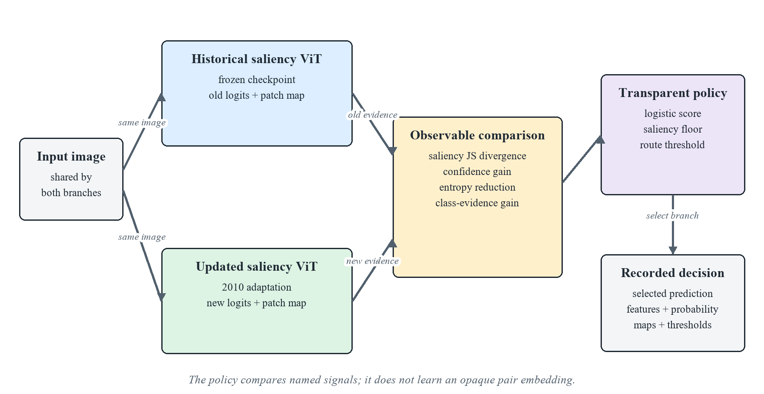
Figure 2. Asymmetric Siamese comparison between the frozen historical ViT and drift-adapted ViT
Logistic regression was chosen so that the route can be reproduced from a short coefficient vector [20]. A positive calibration target means that the historical model is wrong and the updated model is correct. The four inputs are standardised, and class-balanced fitting compensates for the smaller number of useful updates. The fitted logistic routing score is defined below; its reliability as a probability of a beneficial switch has not been established. Saving b, w, and the feature means and scales is sufficient to recalculate it.
$p(update|x)=sigmoid(b+w^{T}z)$
The logistic score alone does not determine the route. The implementation searches saliency-floor quantiles and score thresholds on 2011 routing-calibration labels, choosing the pair with the highest calibration macro F1 and then fewer harmful routes as the tie-breaker. At inference, the newer branch is selected only if the branches disagree, saliency change exceeds the stored floor, and the fitted score exceeds the stored threshold. This search chooses an empirical decision rule; it does not calibrate the score as a probability [24]. The CSV records rounded signals, score, threshold, and decision, while full-precision replay uses the saved models and policy.
Saliency divergence measures how much the spatial evidence distribution changed. Confidence gain measures whether the newer branch is more certain in its selected class. Entropy reduction measures whether its full predictive distribution became more concentrated. Class-evidence gain measures whether the newer representation provides stronger support for the candidate class. No feature is assumed to be sufficient in isolation.
Coefficient signs describe associations in the 2011 calibration sample. A positive confidence coefficient means that confidence gain was associated with useful updates after the other selected features were considered. It does not show that increasing confidence would cause correctness. The router is transparent as a policy, while its statistical relationships remain empirical.
The code exposes confidence-only, saliency-only, and combined router calibrations. Confidence-only uses confidence gain and entropy reduction. Saliency-only uses Jensen-Shannon divergence and class-evidence gain. Combined routing uses all four. Prediction-only calibration omits the saliency floor, while the other two retain it. These options support the corrected single-seed ablation reported in Section 7.4 at matched route coverage; the present main comparison uses the saved combined policy and treats the auxiliary-loss comparison as supporting evidence rather than as a substitute for the conventional fine-tuning control.

4. Temporal protocol
Table 3. Chronological training, adaptation, calibration, and evaluation protocol
Stage | Years | Role
Historical training | 2004-2008 | Fit the original ViT models
Model selection | 2009 | Choose checkpoints without touching future years
Drift adaptation | 2010 | Adapt saliency-guided ViT on balanced clean/corrupted data
Router calibration | 2011 | Archived run: select adapted checkpoint and fit router on shared labels; corrected code uses disjoint class-stratified partitions
Frozen evaluation | 2012-2014 | Test clean and drifted data once across a future horizon

4.1 Dataset selection and external validity
CLEAR-100 is the primary dataset because it preserves a fixed 100-class image task across upload years from 2004 to 2014 and supports near-future evaluation [1]. The protocol trains the historical model on 2004-2008, selects it in 2009, adapts the newer branch in 2010, calibrates routing in 2011, and freezes every component before the 2012-2014 horizon. This order represents one deploy-update-observe cycle rather than annual retraining.
The installed dataset was audited before the statistical rerun. The manifest contains 164,821 unique paths and image identifiers, maps every bucket to 2004-2014 consistently, contains all 100 classes in every train and test bucket, and has no missing files. The train and test archive SHA-256 values match the configured CLEAR-100 releases. These checks rule out duplicate identifiers, missing images, and year or label remapping errors in the local pipeline; they do not rule out annotation noise in the source dataset.
Supplementary datasets test specific transfer boundaries. Wild-Time Yearbook provides a low-resolution chronological portrait stream [3]; CIFAR-10.1 provides an independently recollected test set [31]; and Camelyon17-WILDS tests hospital acquisition shift [2, 32]. FMoW-WILDS and iWildCam-WILDS offer useful time-and-location metadata for future satellite and camera-trap studies. The iWildCam time-by-camera replication remains planned and has not produced results for this draft. Each benchmark requires its own chronology, group constraints, and drift verification; results are not pooled across datasets.

4.2 Independent verification of declared drift
The audit tests controlled conditions and natural-year comparisons before interpreting classification differences. The reported 300-image groups were selected with class labels to balance this retrospective test; neither drift detector receives those labels. Images are embedded with the frozen DINOv2 backbone used by the classifier. Radial-basis-function maximum mean discrepancy (MMD) measures distributional separation without assuming Gaussian features [26]. Using a kernel test alongside a domain classifier follows comparative evidence that no single drift detector is uniformly reliable [29]. For clean and shifted views of the same image, the permutation test swaps the domain label within each image pair; an independent pooled-label permutation would discard that pairing and test a different null hypothesis. A balanced logistic domain classifier supplies the complementary measure under five-fold cross-validation [27]. Paired views retain a common group identifier so that both remain in the same fold and image identity cannot leak between fitting and evaluation. The public Alibi Detect MMD implementation provides a reproducible external software reference [30], while the within-pair randomisation used here remains specific to this matched-image design.
For the Yearbook injected-shift screen, all model arms are evaluated on the same later-year images before and after three fixed transformations: Gaussian blur (17-pixel kernel, sigma 3), a centered square occlusion covering one-third of image width and height, and additive Gaussian noise with standard deviation 0.6 in normalised pixel units. A seeded clean split-half comparison provides the null control. Feature MMD uses 499 paired within-image permutations and the domain classifier uses pair-grouped five-fold cross-validation. Because these perturbations are synthetic, their detectability does not establish their prevalence in natural Yearbook data.
The two measures answer different questions. For controlled conditions, the paired MMD permutation test assesses whether the frozen representation changes consistently within the same image; natural-year and split-half comparisons use unpaired groups. The audit uses a significance level of α = 0.05. MMD squared describes the magnitude of distributional separation, but its scale depends on the representation and kernel and therefore has no universal 0.05 decision threshold. The full MMD estimate uses 300 images per group, while each permutation test subsamples 200 per group. The audit uses 499 randomisations on those 200-image groups with the add-one correction, giving a minimum attainable p value of 1 ÷ (499 + 1) = 0.002. A result at this floor means that none of the permitted randomisations produced a statistic at least as large as the observed value; it does not rank the controlled conditions by strength.
Raw grouped domain-classifier ROC AUC measures how the fitted linear score ranks clean and shifted features. An AUC of 0.50 represents chance ranking; a value below 0.50 means the held-out score ranked domains in the reverse direction. The figure marks AUC = 0.70 as a practical interpretation boundary because values from 0.70 to 0.80 are conventionally described as acceptable discrimination [28]. This convention is used to describe separability, not as a formal drift hypothesis test or proof that classification performance has deteriorated. A condition is treated as operationally material only when the permutation test detects change, the magnitude measures show meaningful separation, and task performance changes.
Table 4. Frozen-feature drift verification on 300 class-balanced CLEAR-100 images per condition; permutation tests use 200 images per group and 499 randomisations
Comparison | MMD squared | p value | Raw domain AUC | Interpretation
Clean split-half control | 0.00378 | 1.000 | 0.398 | Finite-sample null
2009 to 2012 clean | 0.00186 | 1.000 | 0.442 | Not detected
2009 to 2013 clean | 0.00183 | 0.954 | 0.457 | Not detected
2009 to 2014 clean | 0.00195 | 0.960 | 0.470 | Not detected
Illumination | 0.00002 | 0.002 | 0.519 | Detectable, negligible separation
White balance | 0.00017 | 0.002 | 0.601 | Small paired shift
Sensor noise | 0.00395 | 0.002 | 0.948 | Large separability
Defocus blur | 0.00112 | 0.002 | 0.787 | Moderate separability
Motion blur | 0.02271 | 0.002 | 0.993 | Second-largest MMD
JPEG compression | 0.00233 | 0.002 | 0.971 | Large linear separation
Resolution loss | 0.00078 | 0.002 | 0.743 | Moderate separability
Viewpoint shift | 0.00300 | 0.002 | 0.851 | Large separability
Occlusion | 0.00212 | 0.002 | 0.824 | Large separability
Evidence-ranked mixture | 0.02804 | 0.002 | 0.999 | Largest measured shift
The p column in Table 4 reports the Monte Carlo estimate from 499 randomisations. Every controlled condition reaches the 0.002 resolution limit, while the MMD tests do not detect the natural-year comparisons or split-half control in this sample. The displayed AUC values are raw, not symmetrised; sub-0.50 values do not prove an absence of natural shift. The paired design preserves each clean-shifted image pair during permutation and keeps paired observations in the same domain-classifier fold. Because all controlled p values reach the same floor, MMD squared and domain AUC provide the comparison of practical separation across conditions.
A separate sensitivity audit selects raw CLEAR images randomly within each year without class labels, then embeds them with the same frozen DINOv2 backbone. At 100, 300, and 500 images per group, paired MMD detects 2014 motion blur and the evidence-ranked mixture in every comparison (all p = 0.002 with 499 within-image randomisations). Clean 2009 versus clean 2014 yields p = 0.268, 0.058, and 0.136; disjoint clean-2014 null groups yield p = 0.898, 0.514, and 0.678. Domain-classifier AUC for motion blur is 0.989–0.994 and for the mixture 0.999–1.000, compared with 0.457–0.565 for the clean-year comparison. This run uses the full sampled groups in each permutation test, unlike Table 4's 200-per-group permutation cap. The single random draw and fixed representation limit generalisation, and random sampling may vary class composition. Full results are saved in results/validation-20261031/drift-sample-size-100-300-500.json.
Drift existence and drift mitigation remain separate claims. Table 4 verifies that the declared controlled conditions alter the frozen DINOv2 representation. It does not show that the classifier is harmed or that adaptation reverses the shift. Task-level mitigation is therefore assessed separately through macro F1 against the frozen historical ViT. Representation-level mitigation would require matched embeddings from before and after adaptation and a predeclared reduction criterion; the present experiment does not make that stronger claim.
Task-level mitigation requires adverse-condition macro F1 to improve over the shared historical uniform ViT while clean performance remains within the 0.50 percentage point safety bound. Re-evaluation on the 2014 evidence-ranked mixture produced macro F1 scores of 79.42% for the shared historical reference, 82.75% for the updated saliency-guided ViT, and 82.36% for routing. The router audit separately uses its 79.33% historical saliency branch to attribute accepted, rejected, helpful, and harmful switches. Neither classifier nor the router was refitted during this re-evaluation.
Figure 3 compares the two magnitude measures from Table 4. The dashed MMD squared line at 0.05 is a scale reference only; the statistical decision is made by the paired permutation test at α = 0.05. The domain-classifier panel marks chance separation at AUC = 0.50 and the literature-based acceptable discrimination boundary at AUC = 0.70 [28]. The evidence-ranked mixture is largest on both measures, followed by motion blur. Illumination is statistically detectable but remains close to chance on domain AUC, demonstrating why detectability alone is insufficient evidence of operationally important drift.
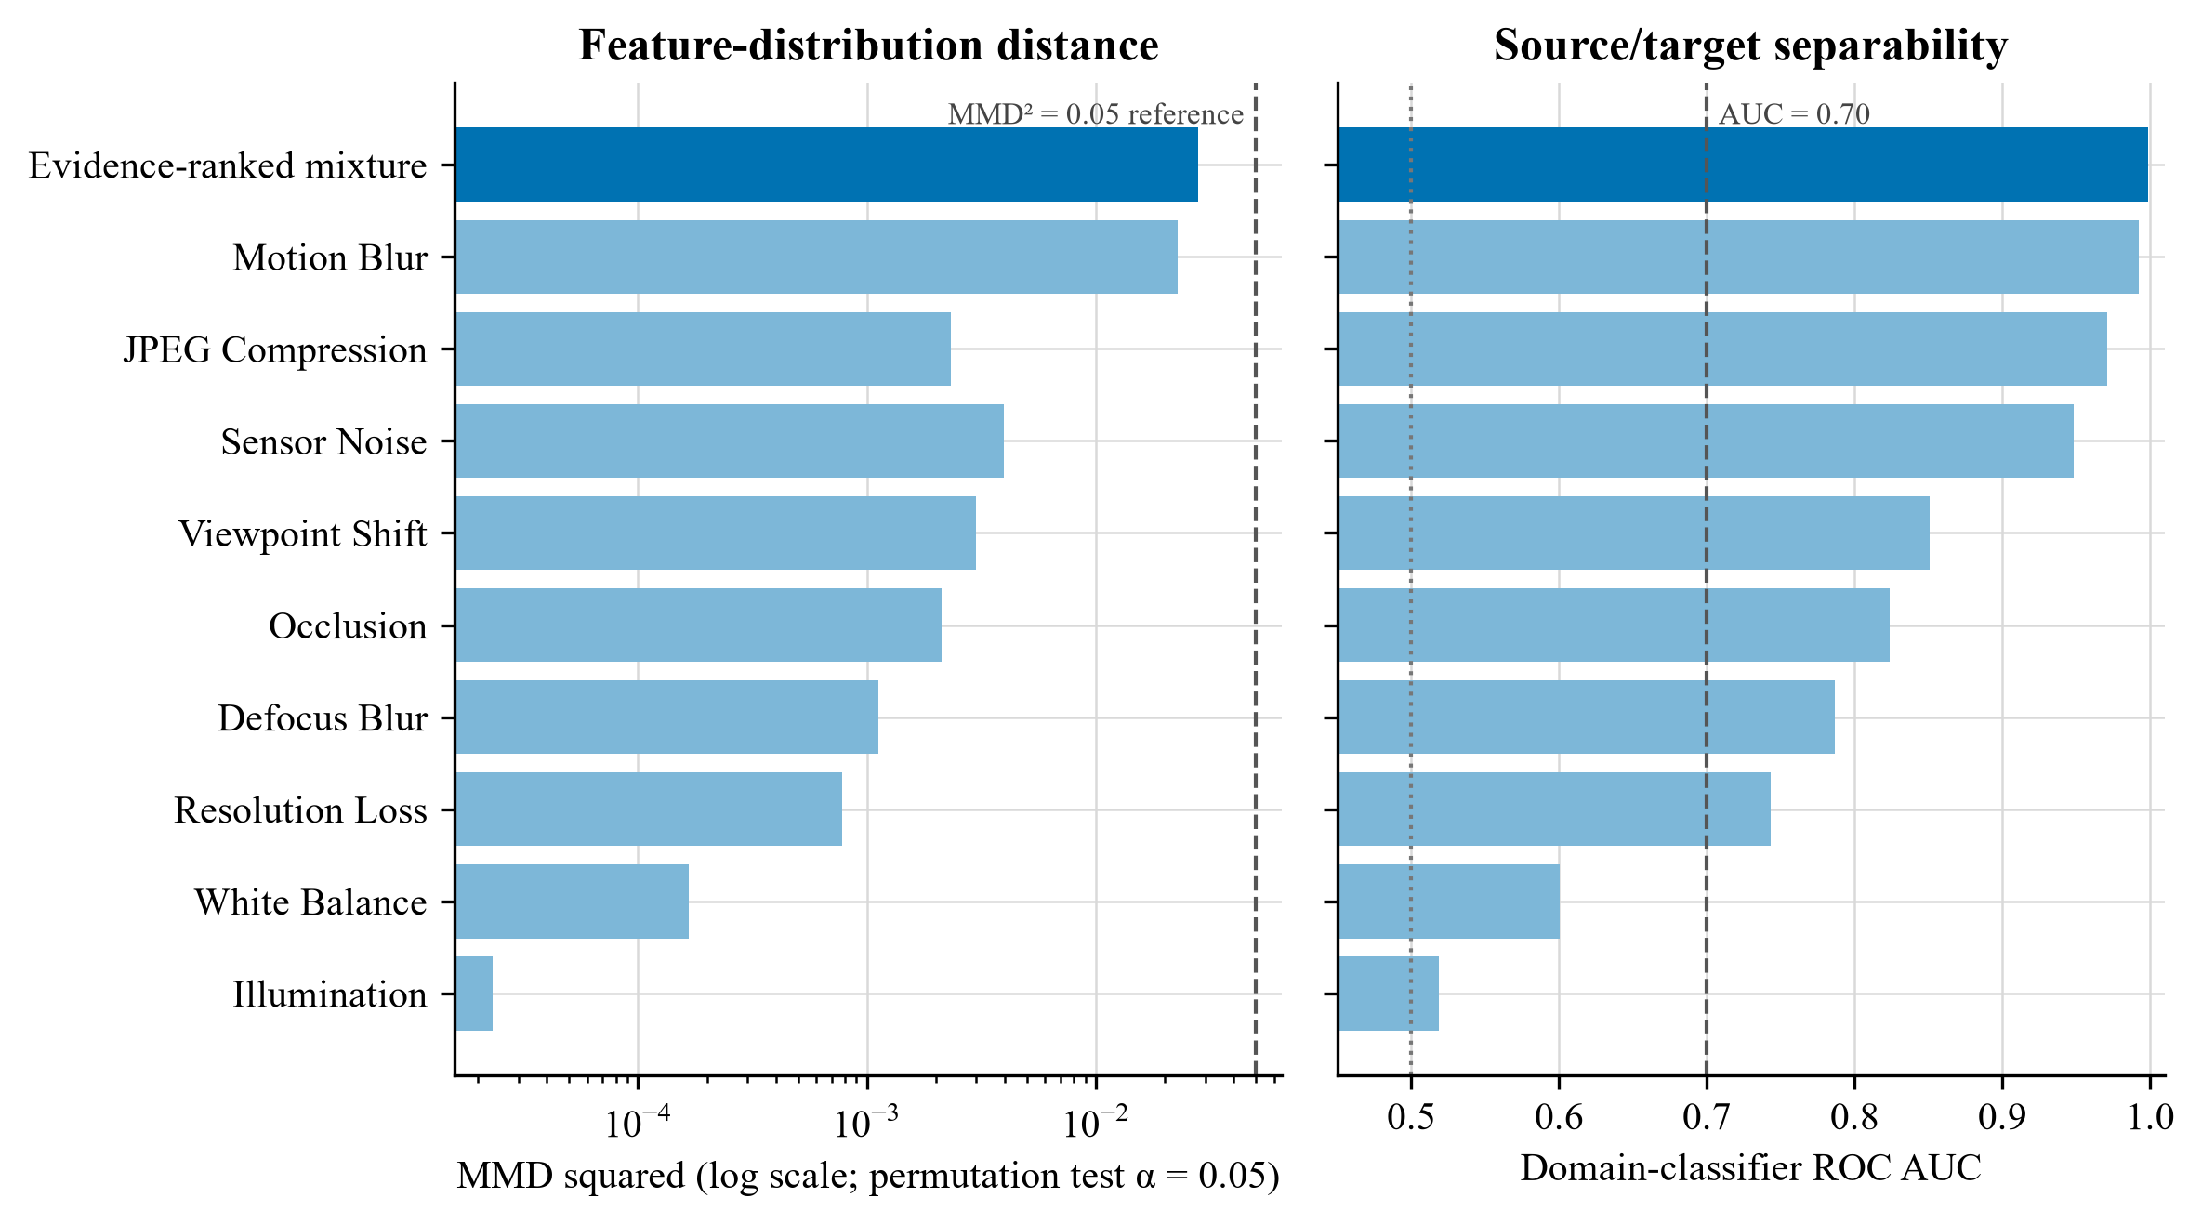
Figure 3. Independent drift evidence for the controlled 2014 conditions. The evidence-ranked mixture contains the top three sources selected on 2011 calibration data.
The measures agree on the strongest shifts. The evidence-ranked mixture has MMD squared 0.02804 and domain AUC 0.999, while motion blur has MMD squared 0.02271 and domain AUC 0.993. Sensor noise and JPEG compression are less distant by MMD but remain readily separable. Illumination is detectable within pairs yet has domain AUC 0.519 and negligible MMD. In Figure 3, the dotted AUC = 0.50 line denotes chance separation, the dashed AUC = 0.70 line denotes the practical interpretation boundary, and the MMD squared = 0.05 line is a scale reference rather than a significance threshold.

4.3 Operational definitions of drift conditions
Clean stream. The model receives the unaltered CLEAR-100 image from the named calendar year. Any change across 2012, 2013, and 2014 comes from the dataset's natural temporal ordering, with no synthetic transform added.
Legacy combined condition. Every image receives the same three transformation families: saturation reduction, Gaussian noise, and one square local-mean occlusion. The severity rises with the test year. This deterministic condition reproduces the original experiment, but it overrepresents occlusion and does not identify which acquisition change caused a score difference.
Source-separated conditions apply one named transformation at a time so its effect remains identifiable. ImageNet-C motivates the broad noise, blur, weather, and digital families [4]. Gaussian noise is retained as a tractable proxy for sensor read noise and low-light acquisition error, but independent, identically distributed Gaussian pixels are an approximation rather than a model of every camera sensor. Motion blur represents relative camera or object movement during exposure, although a fixed digital kernel simplifies real trajectories, shutter timing, and depth. JPEG compression and resolution loss represent changes in storage, transmission, or imaging pipelines. Illumination and white balance approximate environmental and camera-processing change. Viewpoint shift and localised occlusion represent changes in capture geometry or visibility, motivated by operational image studies in WILDS and camera traps [2] [25]. Each transform is therefore a controlled stressor with a stated physical rationale. None is labelled natural temporal drift merely because it lowers accuracy; CLEAR supplies the calendar-year chronology [1].
Evidence-ranked realistic mixture (implementation label: realistic_mix). The mixture is a reproducible compound acquisition stress test, not an estimate of field prevalence. Candidate sources were screened on 300 class-balanced images from the 2011 calibration year at severity three. Sources were ranked separately by descending MMD squared and domain AUC, and the mean of those two ranks determined the frozen order. Motion blur ranked first, sensor noise second, and JPEG compression third. Severity one applies the first source, severity two applies the first two, and severity three applies all three. The selection used no 2012-2014 labels or predictive results. This top-N rule makes the composition auditable and prevents the final evaluation horizon from determining its own test condition.
The word realistic refers to plausible acquisition and imaging mechanisms at bounded magnitudes. It does not assert their prevalence, co-occurrence, or independence in a particular deployment. Motion blur represents relative camera or subject movement, sensor noise represents photon and read noise, and JPEG compression represents an image-pipeline change. Occlusion remains a separate stressor because its calibration rank did not place it in the top three and because content obstruction has a different causal interpretation. A visible perturbation is not automatically dataset drift; the independent MMD and domain-classifier tests in Section 4.2 verify whether each declared condition changes the frozen feature distribution.
Adaptation and calibration use 25% clean images and 75% images carrying one individual source. Each of the nine source types occupies one twelfth of the stream, so compound test images are withheld from model updating. This separation asks whether learning from identifiable single-source changes transfers to a later compound condition. It also avoids training directly on the exact evidence-ranked test composition.

4.4 Cross-dataset replication protocol
Supplementary testing uses a dataset-specific split rather than applying the CLEAR corruption mixture to unrelated domains. A frozen DINOv2-small backbone supplies patch tokens. A linear probe measures the task difference between an in-distribution holdout and the external split, while MMD and held-out domain-classifier AUC assess feature separation. These measures answer different questions: the probe measures predictive change, MMD measures distribution discrepancy, and domain AUC measures separability.
The architecture screen trains matched uniform-patch and saliency-gated classifier heads over the same frozen backbone, sampled images, seed, two-epoch budget, and optimiser settings. This isolates the head design within a small external screen. It does not test temporal fine-tuning, auxiliary saliency losses, router calibration, or historical fallback. A positive head difference would support transfer of one component; a negative result would delimit the claim without contradicting a CLEAR routing gain.
The Yearbook feasibility screen uses portraits from 1930-1989 for training, 1980-1989 for an in-distribution holdout, and 2004-2013 for the later window [3]. This is a deliberately separated internal screen rather than Wild-Time's official Eval-Fix protocol. CIFAR-10.1 uses the recommended class-balanced v6 recollection of 2,000 images [31]. Camelyon17-WILDS uses lymph-node histopathology from multiple hospitals, where scanner, staining, and institutional acquisition differences form a clinically meaningful source of covariate shift [32]. The Camelyon screen uses a patient-disjoint source-hospital holdout and the validation hospital as the external domain.
The three screens are feasibility experiments, not benchmark submissions. The Camelyon17 run uses a 10.7 GB public mirror, a balanced 5,000-image training sample, three seeds, and DINOv2 pre-training. WILDS evaluation guidance asks for ten Camelyon runs and prohibits external pre-training for leaderboard comparison [33]. The reported Camelyon values must therefore be read as internal architecture evidence only.
A separate Yearbook saliency-mask pilot uses native time buckets and split roles: the historical head trains on 1930-1989 train images and is selected on 1980-1989 test images; adaptation uses 1990-1999 train images; epoch selection uses 2000-2003 test images; and final evaluation uses 2004-2013 test images. The future test contains 335 images, all available under the configured sample limit. The three adaptation arms use the same historical initialization, rank-4 query/value LoRA modules, 1,000 adaptation images, and two epochs: ordinary LoRA, equal-area random masking plus masked-view classification loss, and saliency-ranked masking plus the same loss. The two masking arms have 19,202 trainable parameters and a masked-view loss weight of 0.5. A frozen historical model estimates patch saliency from its predicted class; future labels are never used to form the masks or choose epochs. This screen is separate from the previous Yearbook frozen-head comparison.

4.5 Enhanced correction experiment
The enhanced saliency-guided profile and the conventional fine-tuning control were designed to separate adaptation capacity from the proposed saliency mechanism. Both expose the final three transformer blocks to the 2010 adaptation stream for five epochs, use a backbone learning rate of 1e-5 and a head learning rate of 5e-5, apply label smoothing of 0.05, and preserve the same 25% clean share. The conventional arm uses uniform pooling and classification loss only. The saliency-guided arm also learns the patch gate and applies complementary-evidence and temporal-map objectives.
- 25% clean and 75% individually corrupted samples, spanning severities 1-3;
- the final three transformer blocks are trainable instead of only the final block;
- backbone learning rate remains 1e-5, while classifier and saliency heads use 5e-5;
- label smoothing is 0.05 and the saliency terms receive weight 0.25;
- the saliency divergence margin increases from 0.05 to 0.08;
- router calibration jointly selects a saliency-floor quantile and routing-score threshold on 2011 only.
Each change in the enhanced profile addresses a specific constraint. The 25% clean share limits forgetting, while individual corruption families expose the updated branch to plausible acquisition changes without revealing the held-out compound test. Unfreezing three transformer blocks adds adaptation capacity, but the lower backbone learning rate protects pretrained features. The higher head rate lets the classifier and saliency gate respond faster, and the increased saliency weight tests whether explanation guidance adds value beyond that extra capacity. The matched no-saliency-loss control estimates the pipeline-level effect of those auxiliary objectives: both the updated model and its subsequently fitted routing policy may change.
The completed saliency-guided run selected epoch 4 at 94.39% macro F1; epoch 5 declined to 93.00%. Its epochs took about 138 seconds after warm-up. The conventional control selected epoch 2 at 93.90%; later epochs fell to 93.45%, 93.21%, and 93.03% while training loss continued to decrease. Its first epoch took 151 seconds and later epochs took about 132 seconds. Both patterns show why the validation-selected checkpoint, rather than the last epoch, is used for future evaluation. The archived saliency run predates the corrected split of 2011 selection and calibration data, so its direct comparison with the corrected conventional run is exploratory and must be rerun under an identical split for confirmatory inference.

4.6 Protocol correction for future runs
Reusing 2011 for both checkpoint selection and router calibration gives the policy information about the sample that already determined which adapted model survived. The code divides 2011 deterministically within each class: one partition selects the adapted checkpoint and the other fits the logistic coefficients, saliency floor, and routing threshold. The default split is 50/50 and is recorded with both sample counts. A legacy flag reproduces the shared protocol for audit purposes. Coefficients and threshold are still selected on the same routing-calibration partition, which can make its calibration score optimistic without using future labels. Tables 5-13 retain the archived protocol; Section 7.4 reports the separate corrected-split validation, and neither replaces the other retrospectively.

4.7 Retrospective engineering checks
- C1: on the severe 2014 evidence-ranked mixture, the updated saliency-guided ViT and the saliency-guided router each improve macro F1 by at least 2.00 percentage points over the shared historical uniform ViT.
- C2: relative to the shared historical uniform ViT, transparent routing retains at least 75% of the gain achieved by always using the updated saliency-guided ViT.
- C3: clean 2014 macro F1 does not fall by more than 0.50 points relative to the shared historical uniform ViT.
The two-point reference was adopted after initial results and is a descriptive engineering check, not a prospective hypothesis or statistical decision rule. It remains useful for comparing the archived strategies, but repeated seeds and paired confidence intervals are required before a small difference can be treated as stable.

4.8 Descriptive results against the checks and conventional control
- C1 is exceeded by the archived 2014 evidence-ranked mixture scores. Relative to the historical uniform ViT at 79.42%, conventional fine-tuning gains 2.13 points, the updated saliency-guided ViT gains 3.33 points, and routing gains 2.94 points. A secondary within-router diagnostic records a 3.45-point routed gain under motion blur and a 3.03-point gain on the mixture relative to the internal historical saliency branch; these values explain router behaviour but do not add a fifth deployment strategy.
- C2 describes the observed retention on the evidence-ranked mixture: routing retains (82.36 - 79.42) / (82.75 - 79.42) = 88.3% of the always-updated gain relative to the shared historical reference. Route regret, defined as the difference between always-updated and routed macro F1, is 0.39 points. Retention is a strategy-level description, not proof that the route selects the safer branch per image.
- C3 is satisfied by the archived clean scores for all three candidate deployment strategies. Against the clean historical uniform score of 95.13%, conventional fine-tuning changes macro F1 by -0.20 points, the updated saliency-guided ViT by +0.41 points, and routing by +0.23 points. Only decreases count against the 0.50-point tolerance; the result remains conditional on one seed and the archived selection protocol.

4.9 Checkpoint and interruption recovery
Every evaluated epoch atomically replaces models/resume.pt and writes a small resume.json. The binary checkpoint contains the newer ViT parameters, optimiser state, completed epoch, and best validation score; the separate best-model file remains the checkpoint used for final evaluation. The matched standard run was deliberately stopped after epoch 2 and resumed at epoch 3. It retained the epoch-2 optimiser and best score, later selected epoch 4, and completed the frozen horizon normally. A local round-trip regression test independently reloads and compares weights, optimiser state, epoch, score, and metadata.

5. Main results
Macro F1 is shown as a percentage. A helpful route replaces an incorrect historical prediction with a correct updated prediction. A harmful route replaces a correct historical prediction with an incorrect updated prediction. A missed helpful case occurs when the updated model is correct but the policy retains an incorrect historical answer. Helpful and harmful counts must be read together because greater route coverage can increase both.
Table 5. Original temporal evaluation results
Scenario | Year | Historical uniform | Historical saliency | Saliency routed | Helpful | Harmful
Clean | 2012 | 95.86 | 95.96 | 96.40 | 30 | 8
Clean | 2013 | 95.27 | 95.23 | 95.79 | 40 | 12
Clean | 2014 | 95.13 | 95.24 | 95.46 | 30 | 18
Combined | 2012 | 95.47 | 95.47 | 96.08 | 45 | 14
Combined | 2013 | 93.75 | 93.81 | 94.55 | 72 | 32
Combined | 2014 | 90.59 | 90.34 | 91.50 | 120 | 48

The original combined-drift experiment is retained as a legacy router diagnostic. It reports the historical uniform ViT at 90.59%, the internal historical saliency branch at 90.34%, the updated saliency-guided branch at 91.75%, and the routed output at 91.50%. Because it lacks the conventional fine-tuning arm, it is not the primary four-strategy comparison. Table 6 uses the evidence-ranked mixture and reports all four deployment strategies over the frozen horizon.

5.1 Four-strategy temporal comparison
Table 6. Historical, conventional, saliency-guided, and routed macro F1 across the frozen horizon
Condition | Year | Historical uniform | Fine-tuned uniform | Saliency update | Saliency routed
Clean | 2012 | 95.86 | 95.86 | 95.89 | 96.03
Clean | 2013 | 95.27 | 95.54 | 95.49 | 95.55
Clean | 2014 | 95.13 | 94.93 | 95.54 | 95.36
Evidence-ranked mixture | 2012 | 94.36 | 94.71 | 95.27 | 95.23
Evidence-ranked mixture | 2013 | 89.79 | 90.84 | 91.55 | 91.19
Evidence-ranked mixture | 2014 | 79.42 | 81.55 | 82.75 | 82.36

Table 6 and Figure 4 compare the four deployment strategies against the same historical uniform reference. Under the evidence-ranked mixture, conventional fine-tuning gains 0.35, 1.05, and 2.13 points in 2012, 2013, and 2014. The updated saliency-guided ViT gains 0.91, 1.76, and 3.33 points, while routing gains 0.87, 1.40, and 2.94 points. The updated saliency-guided ViT exceeds conventional fine-tuning by 0.56, 0.71, and 1.20 points. Routing trails the updated branch by 0.04, 0.36, and 0.39 points but remains above conventional fine-tuning by 0.52, 0.35, and 0.81 points. Year, imposed severity, and the number of mixture components change together, so this sequence cannot isolate a natural temporal effect.
Figure 4 shows the archived four-strategy trajectories as the evidence-ranked mixture becomes more severe across the frozen horizon. The clean panel uses a narrow vertical scale because all four scores remain near 95%; the reported values therefore matter more than the apparent line slopes. In this single-seed archived comparison, the updated saliency-guided ViT produces the highest macro F1 in each future year. This advantage is not reproduced by the corrected-split comparison in Section 7.4, which uses a different historical head and selection partition.
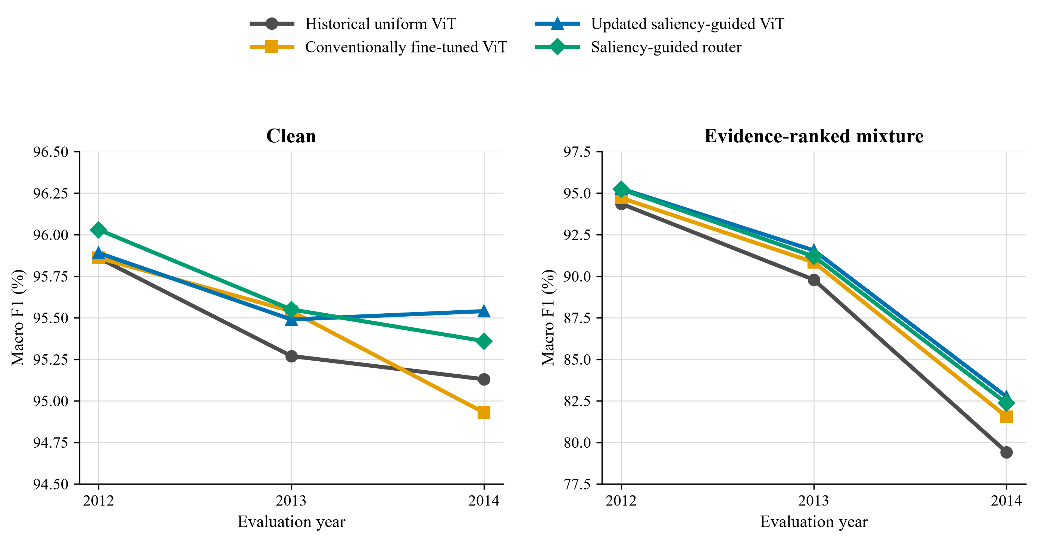
Figure 4. Macro F1 for historical, conventional, saliency-guided, and routed strategies across the frozen future horizon
On clean data, the four strategies remain within 1.10 points across the full horizon. In 2014, conventional fine-tuning changes macro F1 by -0.20 points, the updated saliency-guided ViT by +0.41 points, and routing by +0.23 points relative to the shared historical uniform score. Under the evidence-ranked mixture, always-updated saliency guidance provides the highest aggregate score. Routing supplies fallback and decision logging, but its deployment value depends on the cost of harmful switches relative to missed beneficial updates. These results do not show an accuracy advantage over always-updated inference.

5.2 Controlled five-epoch ablation
The matched run removes the earlier three-versus-five-epoch imbalance. The auxiliary-loss control keeps the enhanced curriculum, trainable blocks, learning rates, and saliency-gated classifier fixed, but sets the pairwise saliency-divergence and complementary-evidence loss weights to zero. It therefore tests the effect of explicit saliency supervision within the same architecture and budget; the updated predictions and fitted policy can both change.
Table 7. Controlled five-epoch ablation
Variant | 2014 clean routed | Combined old | Combined new | Combined routed | Helpful | Harmful
Matched standard (5 epochs) | 95.78 | 90.34 | 91.68 | 91.72 | 144 | 57
Enhanced with auxiliary losses | 95.30 | 90.34 | 91.99 | 91.85 | 188 | 90
Enhanced without auxiliary losses | 95.45 | 90.34 | 91.86 | 91.62 | 125 | 43

Bold type marks the best value in each evaluation column across the three matched configurations; ties are bolded together. Helpful and harmful counts describe route composition rather than interchangeable accuracy measures, so the most helpful and least harmful counts are emphasised separately. Table 7 is the earlier combined-condition ablation snapshot; its clean scores should not be substituted for the later source-separated reevaluation in Tables 6 and 8.
Against the matched saliency-head control, the auxiliary saliency objectives change 2014 combined macro F1 by +0.13 points for always-updated inference and +0.23 points after routing. Under the evidence-ranked mixture, they change routed macro F1 by +1.36 points. Across all eleven 2014 conditions the routed effect is positive in five and negative in six, with a median of -0.02 points. These are source-dependent, pipeline-level ablations within the saliency architecture, not an isolated test of saliency features in the gate. The conventional fine-tuning control in Table 6 answers the broader question of whether ordinary classification-only adaptation is sufficient.
The ablations address three different questions. The uniform-pooling arm benchmarks ordinary temporal fine-tuning, although its head and historical checkpoint differ from the saliency arm. Within the saliency architecture, the no-auxiliary-loss arm retains forward-pass patch weighting, and its comparison with the auxiliary-loss arm estimates the effect of explicit saliency supervision on the updated model and fitted policy together. These rows do not isolate router-feature value. Section 7.4 reports the fixed-model router-feature ablation separately, and its equal-coverage comparison does not show an advantage over confidence-only routing.

5.3 Source-separated drift evaluation
The broader protocol evaluates the same saved historical checkpoint, adapted checkpoint, and 2011 routing policy across 11 independently named 2014 conditions. Each row contains the frozen historical score, the always-updated score, the transparent routed score, and the routed change from the historical branch. This separation prevents a favourable occlusion example from standing in for unrelated acquisition changes.
Table 8. Source-separated 2014 drift results
2014 condition | Historical | Updated | Routed | Routed change
Clean | 95.24 | 95.54 | 95.36 | +0.12
Illumination | 95.13 | 95.46 | 95.24 | +0.11
White balance | 95.16 | 95.61 | 95.43 | +0.27
Sensor noise | 94.20 | 94.72 | 94.44 | +0.24
Defocus blur | 94.41 | 94.93 | 94.75 | +0.34
Motion blur | 83.17 | 87.13 | 86.62 | +3.45
JPEG compression | 93.64 | 94.27 | 94.09 | +0.45
Resolution loss | 93.69 | 94.26 | 94.10 | +0.41
Viewpoint shift | 94.32 | 95.09 | 94.91 | +0.59
Occlusion | 93.93 | 94.74 | 94.68 | +0.75
Evidence-ranked mixture | 79.33 | 82.75 | 82.36 | +3.03

The secondary source-specific audit uses the router's internal historical saliency branch because it attributes per-image switches between that branch and the updated branch. Motion blur produces its largest routed gain, +3.45 points, from 357 helpful and 90 harmful switches. On the 2014 evidence-ranked mixture, the same internal comparison gives +3.03 points from 375 helpful and 117 harmful switches. The primary four-strategy comparison instead uses the shared historical uniform reference and reports a +2.94-point routed gain. The mixture composition was selected from 2011 calibration data through frozen MMD and domain-classifier rankings; no 2012-2014 labels or predictive results entered that selection.
Table 9. Effect of auxiliary saliency objectives on routed performance
Matched 2014 condition | Saliency routed change | No-aux routed change | Auxiliary effect on route
Clean | +0.12 | +0.30 | -0.18
Motion blur | +3.45 | +2.55 | +0.90
Viewpoint shift | +0.59 | +0.53 | +0.06
Occlusion | +0.75 | +0.69 | +0.06
Evidence-ranked mixture | +3.03 | +1.67 | +1.36

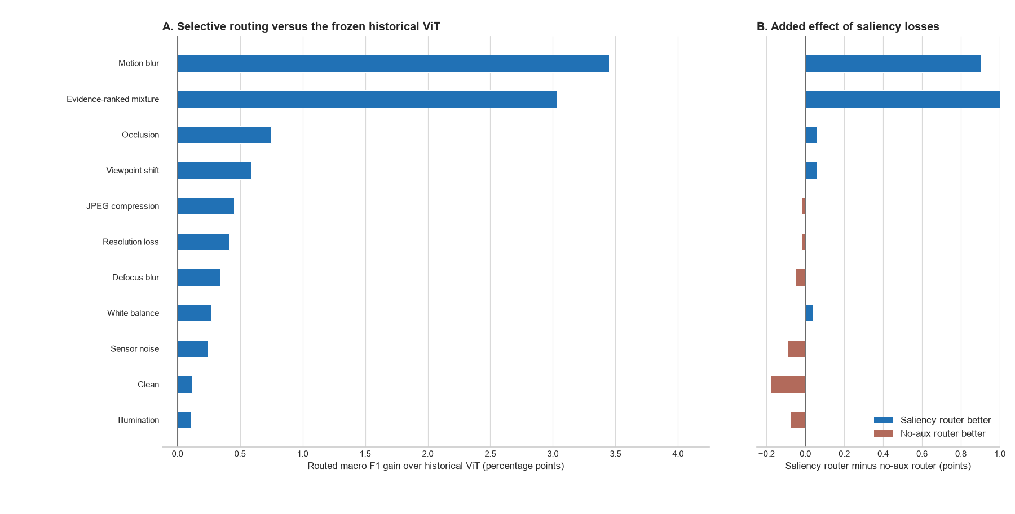
Figure 5. Selective-routing gain over the historical ViT and the added effect of saliency losses
Figure 5 is a secondary router diagnostic measured against the frozen historical saliency-guided branch. Positive bars show where routing improves over the branch it can retain; they do not define an additional deployment strategy or show that routing beats the always-updated ViT. The largest internal gains occur under motion blur (+3.45 points) and the evidence-ranked mixture (+3.03 points). Relative to a matched saliency head without auxiliary losses, the auxiliary objectives add +0.90 and +1.36 points in those conditions. Table 6 provides the primary comparison, where routing exceeds conventional fine-tuning by 0.81 points on the 2014 mixture.

5.4 Class-level and historical-difficulty analysis
Overall macro F1 can conceal whether an update helps many classes slightly, rescues a small number of difficult classes, or transfers errors between classes. The saved 2014 mixture decisions were therefore rescored one class against the remaining 99 classes. The 4,999-image mixture has 49-50 examples per class, all above the minimum support of 20. Within each condition, classes are ranked by the historical model's F1 on the same 2014 evaluation set and divided into four equal groups. This retrospective grouping describes where the observed change occurred; it does not establish that the router prospectively targeted weak classes.
Table 10. Routed macro F1 change by historical class-performance quartile on CLEAR-100 in 2014 (percentage points)
Condition | Variant | Q1 weakest | Q2 | Q3 | Q4 strongest
Clean | Saliency supervised | +1.87 | -0.46 | -0.46 | -0.47
Clean | No auxiliary loss | +2.07 | +0.02 | -0.32 | -0.54
Evidence-ranked mixture | Saliency supervised | +8.96 | +1.98 | +1.45 | -0.26
Evidence-ranked mixture | No auxiliary loss | +5.44 | +1.15 | +0.78 | -0.69
In the 2014 evidence-ranked mixture, the saliency-supervised router changes historical macro F1 by +8.96, +1.98, +1.45, and -0.26 points from the weakest to strongest historical quartile. The matched no-auxiliary-loss router changes the same strata by +5.44, +1.15, +0.78, and -0.69 points. Across all classes the respective routed changes are +3.03 and +1.67 points; 71 classes improve, 26 worsen, and three tie under saliency supervision, compared with 61, 35, and four for the control. These strata use historical F1 measured on the evaluation set itself, so lower-baseline classes have more headroom and are susceptible to regression-to-the-mean interpretations. A pre-2012 class ranking would be needed to test prospective targeting. The strongest quartile's negative change also shows that fallback does not fully protect previously reliable classes.
On clean data, both routers again help Q1 while the remaining groups are flat or slightly worse. The saliency-supervised clean mean is +0.12 points across classes, compared with +0.30 points for the control. These strata are descriptive evidence from one seed. Per-class F1 depends on false positives arriving from other classes as well as decisions made on the class itself, so helpful and harmful route counts cannot explain every class change in isolation. Repeated seeds and class-level confidence intervals remain necessary before claiming stable class-specific benefits.

5.4.1 Interpretation in relation to prior work
The concentration of improvement in Q1 is compatible with the mechanism proposed by saliency-guided training, although it does not prove that mechanism. SGAN uses saliency priors to constrain attention away from irrelevant regions [11]. Saliency Guided Training perturbs low-saliency features while preserving the model output, turning an explanation into a training intervention [13]. Ma et al. similarly remove low-saliency ViT patches to reduce reliance on background shortcuts [15]. In the present architecture, learned patch weights enter the pooled representation and the auxiliary losses reward separation between useful and weak evidence. One possible interpretation is that compound shift exposes shortcut dependence in weak classes, leaving recoverable headroom when patch evidence is reweighted. Ordinary robustness training and the baseline-coupled quartile definition are competing explanations. The quartile analysis measures performance rather than shortcut use, however, and CLEAR has no object masks. The pattern is compatible with this interpretation but cannot distinguish it from those competing explanations.
The asymmetric Siamese design gives that result a different meaning from ordinary retraining. Siamese-ViT work shows how paired transformer branches can compare local and global visual information [16], while asymmetric Siamese change detection preserves distinct roles for the two observations being compared [17]. Here the pair consists of model states rather than two scenes: the frozen branch represents the deployed historical decision and the adapted branch represents a candidate correction on the same image. The architecture therefore does not create a new label from similarity alone. It frames every update as a paired choice whose evidence can be inspected. The retrospective Q1 gain identifies where routed predictions improved, while the Q4 loss exposes negative transfer that an aggregate score would obscure. Neither stratum establishes that the candidate branch used new object evidence.
This fallback role also connects the router to selective prediction and conservative test-time adaptation. SelectiveNet learns when a classifier should abstain rather than force an unreliable decision [10]. CoTTA reduces accumulated error through partial restoration of source weights [7], and EATA filters unsuitable updates to limit forgetting [8]. The present router makes a narrower intervention: it does not adapt on the test stream or abstain from classification, but chooses between an immutable historical branch and a separately adapted branch. The frozen branch is an exact recoverable reference, while the logistic rule keeps the selection traceable. The negative Q4 result shows that this safeguard is incomplete. A class-conditional threshold or a veto based on historical reliability is a defensible next modification, but it must be fitted on the calibration period and compared at equal route coverage to avoid using the final test classes to tune the rule.

5.5 Cross-dataset external screens
The external screens separate evidence of shift from evidence of architectural benefit. Table 11 records the native split and sampling protocol. Table 12 shows whether each external domain is both distinguishable and harder for a simple probe. Table 13 then compares matched heads over the same frozen features. The rows are reported separately because the tasks, class counts, shift mechanisms, and sample sizes differ; pooling them into one average would hide that heterogeneity.
Table 11. External dataset protocols and claim boundaries
Dataset | Native shift | Train / ID / OOD | Seeds | Scope
Wild-Time Yearbook | Later portrait years | 3,000 / 500 / 335 | 1 | Drift tests and matched heads
CIFAR-10.1 v6 | Independent recollection | 5,000 / 1,000 / 1,000 | 3 | Drift tests and matched heads
Camelyon17-WILDS | Held-out hospital | 5,000 / 1,000 / 1,000 | 3 | Exploratory, non-standard WILDS screen
Table 12. External drift evidence from frozen DINOv2 features
Dataset | Run | Probe ID | Probe OOD | Change (pp) | MMD2 | p* | AUC
Wild-Time Yearbook | 42 | 89.40 | 92.53 | +3.14 | 0.0394 | 0.005 | 0.954
CIFAR-10.1 v6 | 42 | 93.84 | 88.48 | -5.35 | 0.0028 | 0.005 | 0.606
CIFAR-10.1 v6 | 43 | 95.00 | 86.69 | -8.31 | 0.0022 | 0.005 | 0.600
CIFAR-10.1 v6 | 44 | 92.79 | 87.31 | -5.49 | 0.0023 | 0.005 | 0.589
Camelyon17-WILDS | 42 | 84.70 | 68.01 | -16.69 | 0.0237 | 0.005 | 0.950
Camelyon17-WILDS | 43 | 93.58 | 73.12 | -20.46 | 0.0328 | 0.005 | 0.941
Camelyon17-WILDS | 44 | 84.43 | 83.14 | -1.30 | 0.0566 | 0.005 | 0.995
The asterisk in Table 12 marks the same 199-randomisation limit. All seven external runs reach p = 0.005, the minimum attainable value with their archived 199-randomisation tests. The p values establish detectable separation at that resolution but do not rank datasets or seeds. CIFAR-10.1 has only modest domain separability, with AUC from 0.589 to 0.606, while the probe loses about five to eight points. Yearbook and Camelyon show much stronger separability, with AUC above 0.94, and larger or more variable task changes. These tests verify that the selected external splits contain feature shift and task consequences; they do not imply that saliency should correct either one.
Table 13. Dataset-level matched-head macro F1 on external test distributions
Dataset | Runs | Uniform OOD | Saliency OOD | Difference (pp) | Interpretation
Wild-Time Yearbook | 1 | 78.13 | 77.81 | -0.33 | Temporal decline
CIFAR-10.1 v6 | 3 | 73.97 | 74.27 | +0.30 ± 0.11 | Positive in 3/3 seeds
Camelyon17-WILDS | 3 | 77.31 | 77.24 | -0.07 ± 0.12 | Neutral to negative
At dataset level, the matched frozen-head result is positive only on CIFAR-10.1 (+0.30 ± 0.11 macro-F1 points across three seeds); Yearbook is -0.33 points in the original single-run head screen, and Camelyon17 is -0.07 ± 0.12 points. These screens do not show a universal benefit. The later Yearbook saliency-mask experiment is a separate method and split: it yields a small advantage over random masking only under injected occlusion. The two Yearbook results answer different questions and should not be collapsed into one estimate.

5.6 Chronological Yearbook saliency-mask experiment
The natural temporal comparison did not show historical-model harm: the frozen head scored 87.62% macro F1 on the 1980-1989 selection sample and 93.13% on the 2004-2013 future sample. This later window is easier for this trained head, so chronological separation alone is not evidence of harmful drift. The injected-shift test therefore asks a different question: whether a known image change is measurable and reduces accuracy on those same future examples.
Table 16 reports all three seeds for occlusion and seed 42 for blur and noise. Under center occlusion, saliency-mask LoRA beats the equal-area random-mask control by 0.30 to 1.49 macro-F1 points (mean 0.90) in all three seeds. It beats ordinary LoRA by 1.20 and 3.93 points in seeds 43 and 42, then trails ordinary LoRA by 0.29 points in seed 44. On clean images it trails ordinary LoRA by 0.90 to 1.50 points. Under blur it trails random masking in all seeds, and under noise its effect varies substantially. The same 335-image test set is used in all seeds, so seed variation does not create independent test samples. These results are exploratory, and the occlusion condition was examined before the three-seed repeat rather than preregistered as the primary endpoint.
The clean split-half control is non-significant in all three seeds (MMD p = 0.272-0.994). Center occlusion produces MMD p = 0.002, domain-classifier AUC = 1.00, and a 4.78-7.16 point historical accuracy drop. Blur is highly detectable but causes little historical-model harm (accuracy change ranges from a 1.19-point improvement to a 1.20-point drop across seeds). Noise produces a 8.35-10.15 point drop and AUC = 1.00, yet saliency masking does not reliably correct it. Detectability and saliency benefit are therefore condition-specific. The test concerns controlled perturbations applied to later-year images, not natural Yearbook corruption or natural drift correction.
Table 16. Yearbook historical-model harm and future macro F1 under paired injected shifts (occlusion: three seeds; blur and noise: seed 42; same 335 future images)
Seed | Injected shift | Historical accuracy drop | Ordinary LoRA F1 | Random / saliency mask F1
42 | Center occlusion | 7.16 points | 89.20% | 91.64% / 93.13%
43 | Center occlusion | 4.78 points | 89.53% | 90.43% / 90.73%
44 | Center occlusion | 5.08 points | 91.93% | 90.74% / 91.64%
42 | Gaussian blur | 0.29 points | 96.12% | 94.63% / 94.33%
42 | Gaussian noise | 8.35 points | 85.45% | 89.20% / 85.18%

6. Saliency and routing analysis
Each audit row shows a clean reference, the drifted input, historical and updated saliency overlays, and the signed change map. The revised figure is exported at 300 dots per inch. Red marks patches that gain weight in the updated model and blue marks patches that lose weight. A more localised updated map means that high weight occupies a smaller, coherent part of the 16 x 16 patch grid, but localisation is interpreted only alongside the class prediction and deletion margin.
Figure 6 contains one helpful route from each of three drift families. The examples were selected for inspection and are not used to estimate performance; the aggregate counts below provide that evidence.
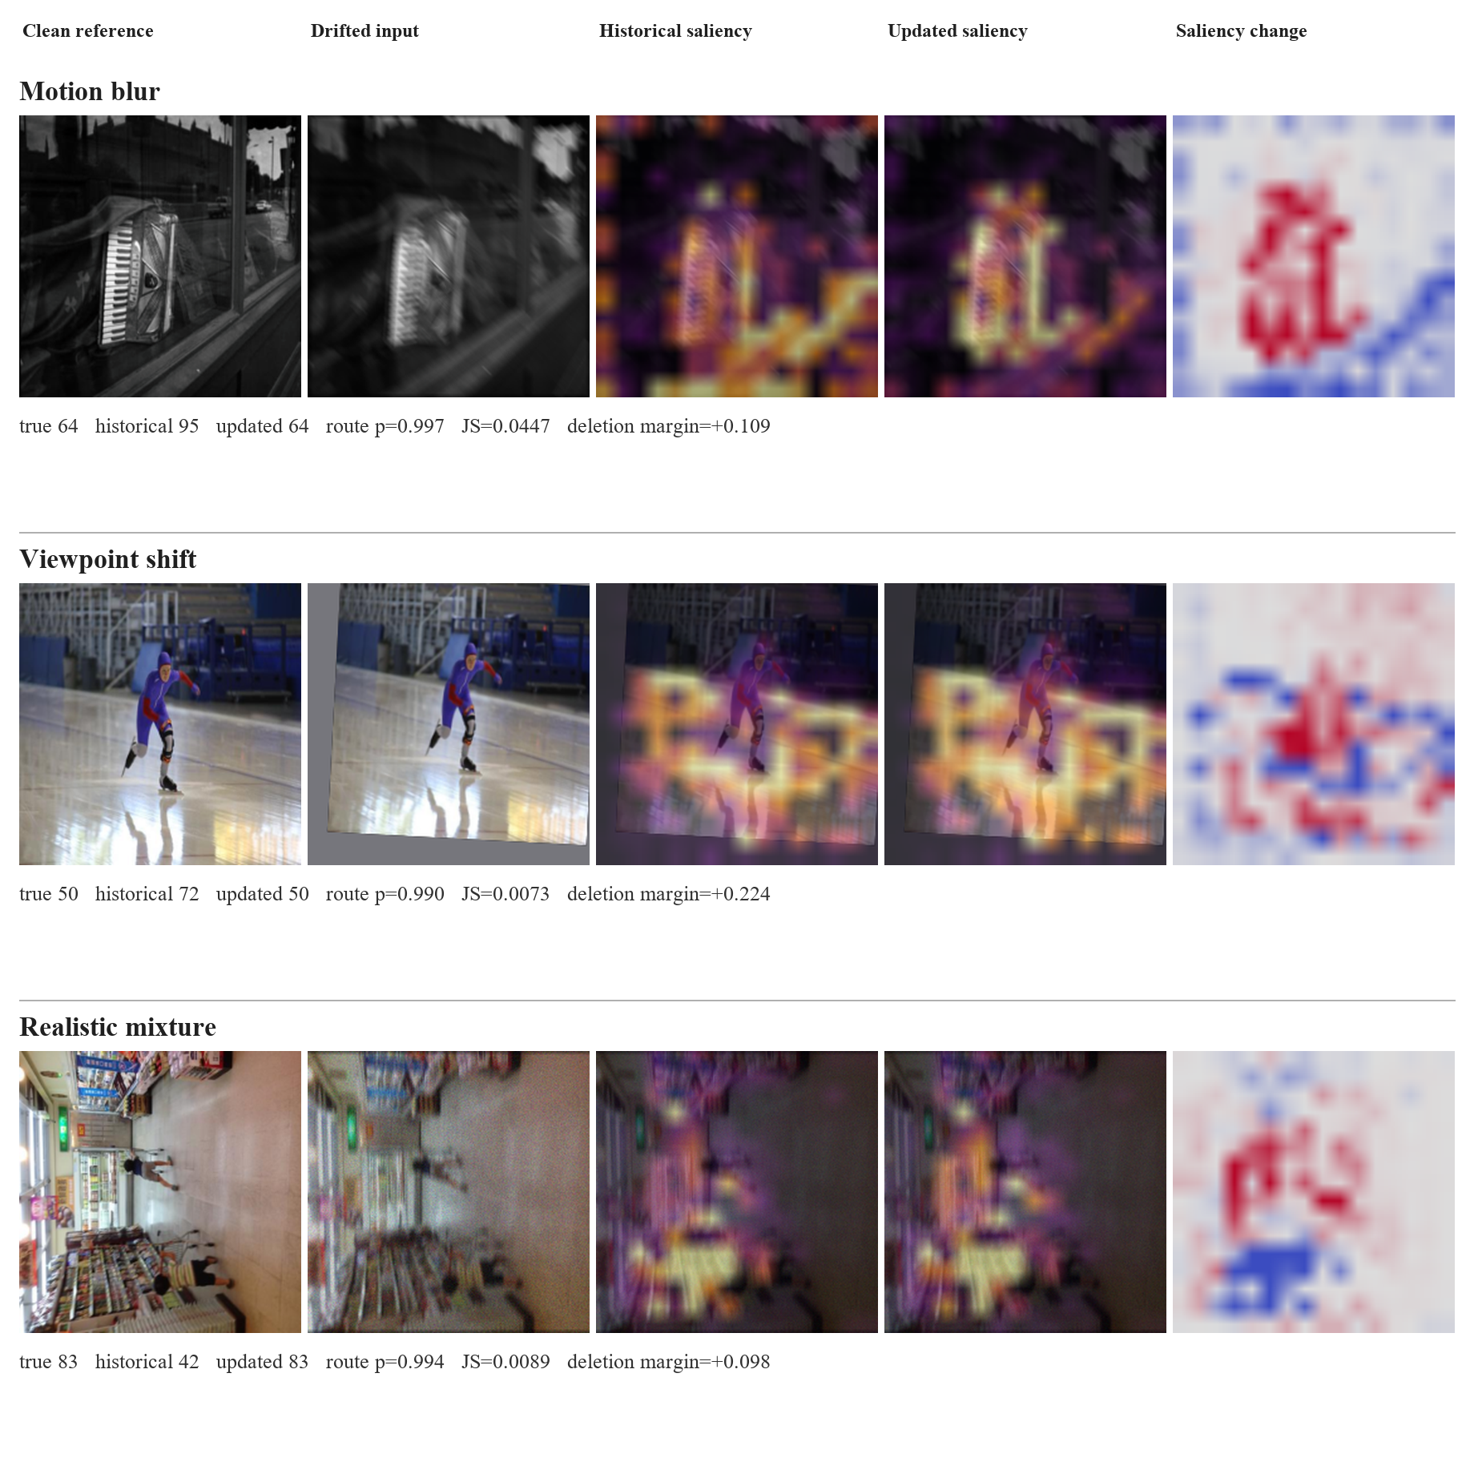
Figure 6. Helpful routed corrections with historical, updated, and signed saliency-change maps (plot annotations show uncalibrated logistic routing scores as p)

6.1 Quantitative saliency outcome analysis
For the 2014 combined-drift auxiliary-loss control, helpful routes have mean JS divergence 0.0607, compared with 0.0512 for harmful routes and 0.0473 when the historical prediction is retained. Mean logistic routing score is 0.821 for helpful routes, 0.767 for harmful routes, and 0.310 for retained historical predictions; these are not validated probabilities of a correct switch. Higher values are useful only in a relative sense: they indicate stronger model disagreement and stronger fitted support for an update. The overlap between helpful and harmful groups shows that neither value is a correctness score. There are 125 helpful and 43 harmful routes, a ratio of 2.91.
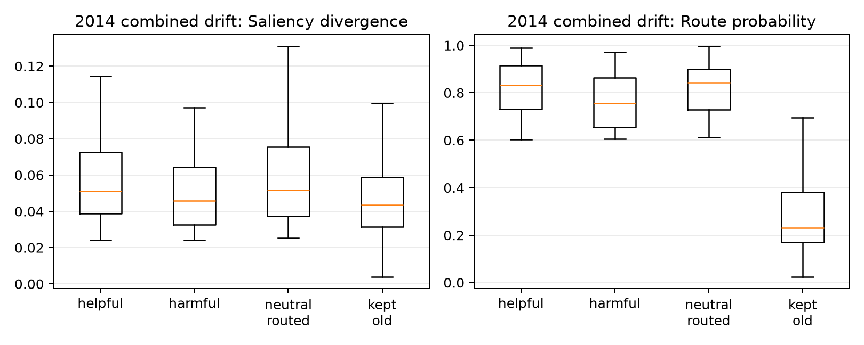
Figure 7. Saliency divergence and logistic routing score by routing outcome
Figure 7 shows substantial overlap between outcomes. Its archived right-panel title calls the fitted logistic score 'route probability'; no separate reliability test establishes probability calibration. Routed and retained images separate partly because the policy requires a minimum saliency change, so that separation confirms that the gate is operating. Helpful routes have somewhat larger JS divergence and logistic routing score on average, which is favourable, but many harmful routes occupy the same range. Large divergence can mean better evidence, a new shortcut, or a general redistribution caused by blur. The logistic routing score was fitted on the 2011 sample; no separate reliability test establishes probability calibration or guarantees that an individual switch is correct. These limitations motivate the prediction-only, saliency-only, and combined ablations added to the code.
Map change measures difference, not improvement. A new model can move its attention and still be wrong, or become highly confident in the wrong class. CLEAR also provides image labels rather than object masks. Context such as a bowling lane, kitchen surface, or display frame may be useful in one image and a shortcut in another. Since both models share their pretraining and initialisation, some correct updates also require only a small redistribution of patch weights.
The maps are best read as evidence-allocation diagnostics: they show which encoded patches received weight in the classifier. They are not object masks and do not establish that the map change caused a correction. The deletion audit adds a behavioural check by comparing the effect of removing highly weighted and weakly weighted patches. Even this test is limited because the deleted image is outside the original data distribution.
The report uses saliency-guided to describe this complete chain. Patch weights enter the classified representation, supervised terms constrain their behaviour, differences between historical and updated maps enter the route calculation, and deletion tests check whether weighted patches affect the true-class score. Because the head also receives an unrestricted class token, the degree of prediction dependence on those weights must be measured by the fixed-checkpoint intervention. The image overlay is one inspectable artefact from that chain. It is neither the complete decision rule nor proof that highlighted pixels caused the prediction.

6.2 Counterexample and faithfulness audit
The source-specific audit applies the same top-versus-bottom 20% deletion test whenever one model is correct and the other is wrong. A positive margin means that removing the most highly weighted patches reduces true-class probability more than removing the least-weighted patches.
Table 14. Source-specific counterexample and deletion-audit results
2014 source | Helpful routed | Harmful routed | Missed helpful | Net corrections | New-map margin, helpful | New-map margin, harmful
Motion blur | 357 | 90 | 47 | 267 | 0.147 | 0.031
Viewpoint shift | 88 | 56 | 17 | 32 | 0.190 | -0.053
Evidence-ranked mixture | 375 | 117 | 50 | 258 | 0.182 | 0.009

For the updated model, positive deletion margins are more common on helpful than harmful routes: 70.0% versus 61.1% for motion blur, 72.7% versus 44.6% for viewpoint shift, and 74.7% versus 62.4% for the evidence-ranked mixture. In the mixture audit, the updated map's mean deletion margin is 0.182 on helpful routes but 0.009 on harmful routes. The historical map shows the complementary pattern: its mean margin is 0.056 on helpful routes and 0.238 on harmful routes, where its original prediction was correct. This reversal is compatible with the routing rationale, but these groups are defined after observing which branch was correct, so it does not show that deletion margin predicts the safer branch before labels arrive. The distributions still overlap. This true-class deletion margin uses labels unavailable to the deployed router and images altered outside the original distribution, so it is a retrospective faithfulness audit rather than an online correctness signal or proof that the highlighted patches caused the prediction.
The full 2014 combined-drift stream contains 4,999 images. The enhanced router makes 188 helpful switches where the historical model is wrong and the newer model is correct, 90 harmful switches in the opposite direction, and misses 17 available corrections. It therefore produces 98 net corrected predictions. The 98 is a net count of image-level correct predictions relative to the historical branch; it does not determine the macro-F1 change, which also depends on each class's precision and recall.
For every one of the 304 samples where one model is correct and the other is wrong, the audit deletes the top 20% and bottom 20% of patches under each model's own saliency map. The faithfulness margin is the drop in true-class probability after high-saliency deletion minus the drop after low-saliency deletion. For helpful routed cases, the newer model has a mean margin of 0.175, compared with 0.010 on harmful routed cases; 72.3% of helpful routes have a positive new-model margin, compared with 57.8% of harmful routes. Conversely, the historical model's mean margin is 0.048 on helpful routes and 0.182 on harmful routes. Within these outcome-defined groups, the correct branch tends to have a larger deletion margin. This retrospective association cannot establish prospective route discrimination or map causality without matched deletion controls.
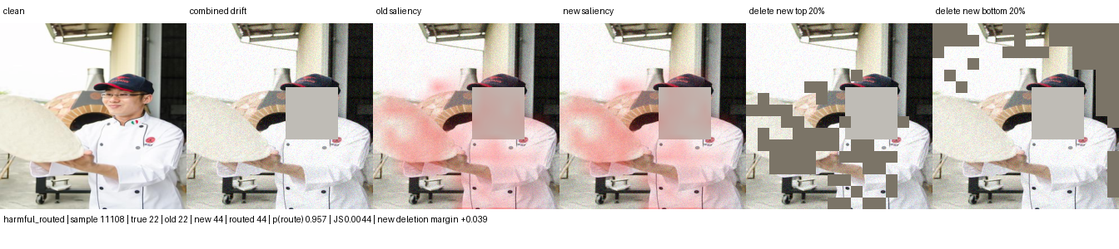
Figure 8. Harmful routed switch: correct historical class 22 is replaced by class 44
The harmful example shows why saliency change alone is insufficient: the historical model was already correct and its map had the stronger deletion response. Patch deletion is still an artificial intervention, so this result does not prove that the highlighted pixels caused the model update.

6.3 Scope of the method
The intended setting is covariate shift, where class meaning remains stable while image acquisition or context changes. Candidate causes include camera replacement, illumination, weather, compression, sensor noise, and partial obstruction. The present evidence does not show that saliency solves these causes generally. In CLEAR, the learned gate contributes little under direct weight replacement. In Yearbook, saliency-ranked masking helps relative to random masking under one centered occlusion, but not under blur or noise. Camera traps provide a plausible application for partial visibility and changing vegetation; hospital images more often motivate tests of scanner, protocol, staining, and site changes. A domain-specific temporal dataset must verify which interference actually occurs and harms predictions before saliency is claimed to correct it.
The current results do not support a general statement that saliency helps under other interferences. In the new Yearbook screen, saliency masking is below random masking under blur in all three seeds. Under noise it trails random masking by 4.02 and 5.84 points in two seeds and is 0.31 points higher in the third. This conflicts with the broad robustness interpretation one might draw from the occlusion result. The next test should use a real time-by-camera or time-by-acquisition dataset and should freeze a harmful shift before comparing saliency-guided adaptation with ordinary fine-tuning and matched controls.
The method should not be expected to solve concept drift where the label meaning changes, new-class emergence, extreme occlusion, or systematic dataset errors. In those cases the saliency map may faithfully explain a wrong premise. A stronger next experiment should therefore add a matched random-mask control and an external temporal dataset, then compare confidence-only, saliency-only, and deletion-aware routers without tuning on the final horizon.

7. Discussion and limitations

7.1 What the experiment establishes
For RQ1, the CLEAR random-sample audit detects motion blur and the evidence-ranked mixture at 100, 300, and 500 images per group, while the sampled clean 2009-to-2014 comparison remains non-significant. In Yearbook, injected occlusion, blur, and noise are all detectable in frozen features (paired MMD p = 0.002; domain AUC about 1.00), but the clean split-half control is not. Only occlusion causes a repeated, substantial historical-model drop alongside a saliency-mask advantage over random masking. The natural Yearbook historical model scores higher on the later sample than on the earlier selection sample. Drift detection, task harm, and saliency benefit therefore remain distinct.
The class-level analysis narrows the aggregate claim. Under the 2014 evidence-ranked mixture, saliency-guided routing provides its largest benefit in the weakest historical quartile (+8.96 points), followed by +1.98 and +1.45 points in the middle quartiles, while the strongest quartile changes by -0.26 points. The matched no-auxiliary-loss router changes the same strata by +5.44, +1.15, +0.78, and -0.69 points. The observed benefit is concentrated in classes with weak historical performance measured on that same test set. This is a descriptive stratum, not prospective evidence that the router recognises weak classes before their labels are known.
The evidence supports different claims at different strengths. CLEAR verifies several controlled feature shifts, but does not detect the sampled clean-year change. Its archived one-seed comparison favours saliency over conventional fine-tuning, while the corrected-split comparison reverses by 0.77 points and the learned-weight intervention finds little causal dependence on the gate. The Yearbook pilot detects injected occlusion, blur, and noise; only occlusion yields a repeated saliency advantage over random masking, and ordinary LoRA remains competitive. Natural Yearbook chronology produces no historical-model performance decline in the sampled windows. Routing remains a separate audit mechanism without established incremental selection value. These findings do not establish saliency correction of natural temporal drift.

7.2 Negative results and failure modes
The two-point benchmark is not met on the legacy combined condition, but it is met by both adaptation arms on the 2014 evidence-ranked mixture. The saliency-guided updated model is 1.20 points above conventional fine-tuning, while the router is 0.81 points above it. Those archived differences are single-seed descriptive estimates; the corrected-split conventional arm reverses the 2014 mixture comparison by 0.77 points. The auxiliary saliency objectives add +0.23 routed points on the earlier combined condition, +0.90 under motion blur, and +1.36 under the evidence-ranked mixture relative to the same head without those objectives. The full eleven-condition source audit is mixed: five routed effects are positive and six negative, with a median of -0.02 points.
The controls clarify why the argument cannot rest on a single favourable comparison. XGD attributes gains through a saliency ablation [12], and Saliency Guided Training tests explanation quality through controlled perturbation [13]. Following the same logic, this paper includes both a conventional fine-tuning arm and a no-auxiliary saliency arm. The first tests whether ordinary updating is enough; the second tests whether explicit saliency objectives add value beyond patch weighting. The archived severe-mixture pipeline comparison favours the auxiliary-loss variant, but the corrected-split conventional arm exceeds the saliency-guided update on the same 2014 mixture. Different historical heads and one seed prevent a causal or general claim. The no-auxiliary-loss comparison also changes the updated model and fitted router together, so it does not isolate the value of saliency features beyond confidence.
The route audit explains part of the gap. Helpful and harmful decisions overlap in saliency divergence and logistic routing score, so the four features do not cleanly identify correctness. A map can change because the updated model has found better evidence, because it has shifted to a different shortcut, or because blur has redistributed all patch weights. The logistic router is deliberately simple and may underfit these interactions; a more expressive gate could change accuracy but would need its own calibration and transparency audit. The existing router trails always-updated inference in all eleven reported 2014 conditions.
The archived source pattern challenges the proposed object-evidence mechanism. Its largest auxiliary-loss effects occur under global motion blur and the blur-noise-JPEG mixture, whereas viewpoint and occlusion effects are small. Ordinary robustness training or changes in the routing-score distribution could produce this pattern without restoring object evidence. The corrected feature comparison in Section 7.4 does not establish a saliency-specific gate benefit. An intervention that replaces learned patch weights with uniform or shuffled weights while preserving the classifier would further distinguish these explanations.
Fallback has operational value only if the harmful switches it prevents outweigh the beneficial updates it misses under an explicit cost model. On the 2014 mixture, the router avoids 27 harmful candidate switches but misses 50 beneficial ones; an always-updated system could also retain logs for audit. The present result therefore establishes a recoverable choice and an inspectable trace, while the incremental safety benefit remains an open empirical and deployment question.

7.3 Validity threats and implemented correction
The CLEAR evidence uses one random seed, one temporal dataset, synthetic stressors layered over natural chronology, and one fitted policy. The archived CLEAR arms and corrected-split arms differ in the historical head and selection protocol. Yearbook adds three training seeds for injected perturbations, but all use the same 335 future images and the occlusion condition was explored before those repeats. Yearbook is a low-resolution binary portrait task; its sampled chronology does not show task harm. The planned iWildCam screen is not yet complete because the public 12 GB archive could not be retrieved quickly from the server. CIFAR-10.1 tests recollection, while Camelyon17 tests hospital shift rather than chronology. These limitations preclude a claim of general saliency benefit or natural drift correction.

7.4 Corrected single-seed validation (31 October 2026)
A separate corrected-split server run trained a conventional uniform-pooling arm and a historical saliency checkpoint with two five-epoch adapted saliency arms. All used the fixed chronology, seed 42, and disjoint class-stratified 2011 checkpoint-selection and router-calibration partitions. On the 2014 evidence-ranked mixture, the conventional update scores 81.55% macro F1; the historical saliency branch scores 79.33%, the auxiliary-loss update 80.78%, and the no-auxiliary update 80.81%. The saliency update is therefore 0.77 points below conventional fine-tuning in this corrected run, reversing the archived 1.20-point advantage. Across the eleven named 2014 conditions, updated saliency is lower in nine, tied in one, and higher in one; clean 2014 is tied at 94.93%. These arms still begin from differently trained historical heads, so they compare strategies rather than isolate saliency. The auxiliary-loss arm scores 79.75% routed versus 79.60% for no-auxiliary, but its always-updated score is 0.03 points lower. Its routed score trails its own always-updated score by 1.03 points, and routed auxiliary-loss effects are positive in five and negative in six conditions. One seed and the architecture difference limit inference; the shared-checkpoint patch-only factorial is the mechanism control.
Table 15. Corrected-split 2014 macro F1 for conventional and saliency-guided updating (one seed; percentage points)
Condition | Conventional | Saliency guided | Difference
clean | 94.93% | 94.93% | +0.00
illumination | 94.88% | 94.83% | -0.05
white balance | 94.90% | 94.83% | -0.07
sensor noise | 93.91% | 93.78% | -0.13
defocus blur | 94.20% | 93.93% | -0.27
motion blur | 85.96% | 85.67% | -0.29
jpeg compression | 93.97% | 93.74% | -0.23
resolution loss | 93.70% | 93.72% | +0.02
viewpoint shift | 94.37% | 94.32% | -0.05
occlusion | 94.55% | 94.49% | -0.06
realistic mix | 81.55% | 80.78% | -0.77
Using the same frozen historical and updated saliency model pair, 2011 calibration rows, and 164,945 saved future decisions, the routing-feature ablation exactly replays the source policy. On the 2014 mixture, native confidence-only, saliency-only, and combined policies score 79.72%, 79.98%, and 79.75% routed macro F1, but they route different shares of model disagreements (22.9%, 65.4%, and 53.0%). At a common 50% disagreement coverage, their scores are 79.98%, 79.73%, and 79.74%. The matched comparison supplies no evidence here that adding saliency features improves routing beyond confidence. Fixed-coverage ranking uses the whole unlabelled test group to set a quota, so it is a diagnostic rather than a deployable streaming policy; no future labels fit the policies. Repeated seeds and paired uncertainty remain necessary.
The third experiment also examines routing as a decision under an explicit hypothetical cost. In the corrected 2014 mixture, the fixed historical and updated model pair offers 379 beneficial and 198 harmful possible replacements. At native policy settings, confidence-only accepts 86 helpful and 32 harmful replacements; saliency-only accepts 235 and 126; the combined gate accepts 186 and 92. Define net corrected-image equivalents relative to always-historical as helpful replacements minus lambda times harmful replacements. At lambda = 1, always-updated scores 181, compared with 54 for confidence-only, 109 for saliency-only, and 94 for the combined gate. At lambda = 2, confidence-only scores 22, the combined gate 2, always-updated and saliency-only -17, and always-historical 0. At lambda = 3, always-historical leads. The 50%-coverage comparison reaches the same winning choices for these three costs. These values use future labels only for retrospective evaluation; lambda was not chosen before testing and does not represent a measured deployment cost. They show a decision trade-off, not a saliency-specific routing benefit. Full condition-level values are saved in results/validation-20261031/routing_utility.json.

7.5 Feasible next evaluation
The next experiment should use iWildCam-WILDS as a separate dataset and branch. First inspect the metadata for supported year-by-camera-by-species cells, then freeze a chronology that keeps sequence bursts together and reports both within-camera temporal change and held-out-camera performance. Measure clean split-half MMD, chronological MMD, domain AUC, and historical-model harm before any adaptation. If a harmful period exists, compare ordinary LoRA, saliency-guided adaptation, and a matched random spatial control across the same update IDs and seeds. Report day/night, illumination, blur, weather, and vegetation proxies only where metadata or visual audits support them. If the historical model has no chronological performance decline, do not move the test window after observing model scores; use the benchmark's native camera split as a separate acquisition-shift analysis.
ACDC is the strongest next paired-condition dataset for this purpose. It contains 4,006 adverse-condition driving images distributed across fog, night, rain, and snow; each adverse image has a fine pixel annotation, an uncertain-region mask, and a corresponding normal-condition view of the same scene [34]. These correspondences permit per-scene comparisons that CLEAR cannot provide. They also match the normal-to-adverse model-adaptation setting studied by Contrastive Model Adaptation, which uses aligned image pairs to learn condition-invariant semantic features [35].
ACDC would complement rather than replace CLEAR. It is a semantic-segmentation benchmark organised by acquisition condition, not an eleven-year classification stream. The existing classifier can support a representation-only screen, but a task-level claim requires a ViT segmentation head over the benchmark's classes and native train, validation, and test protocol. Normal and adverse frames should be paired before calculating the mitigation tests above; saliency maps should be compared only after correspondence warping and exclusion of uncertain pixels. A favourable task result would require improved adverse-condition segmentation with bounded normal-condition loss and uncertainty grouped by scene. Residual MMD and domain AUC would be reported separately: lower domain separability is not automatically better if the representation also discards class information. This design would test the relation between condition invariance and task performance rather than assume that one metric proves the other.

8. Conclusion

8.1 Answers to the research questions
RQ1 asked whether limited incoming images reveal drift independently of task performance. The CLEAR unlabelled audit detects controlled motion blur and the evidence-ranked mixture at 100-500 images per group but does not detect the sampled clean-year difference. On Yearbook, paired MMD and domain AUC detect injected blur, occlusion, and noise, while the clean split-half control remains non-significant. Detection does not guarantee harm: Yearbook blur barely changes historical accuracy, while occlusion and noise reduce it by 4.78-7.16 and 8.35-10.15 points respectively. Natural chronological Yearbook performance does not decline in the sampled windows.
RQ2 asked whether saliency adds value beyond ordinary fine-tuning and generic spatial regularisation. The CLEAR archived gain over conventional fine-tuning is not reproduced by the corrected split, and learned-weight interventions leave predictions almost unchanged. In the separate Yearbook adaptation, saliency masking exceeds equal-area random masking by 0.30-1.49 macro-F1 points under one injected occlusion in all three seeds (mean +0.90), but trails ordinary LoRA in one seed and loses under blur and usually noise. This is a narrow signal for one perturbation, not a general saliency-specific improvement.
RQ3 is a separate decision experiment using fixed historical and updated saliency models. Relative to the archived shared historical uniform reference, routing retains 88.3% of the always-updated gain and gives up 0.39 macro-F1 points. Its branch comparison accepts 375 helpful and 117 harmful switches, prevents 27 of 144 available harmful replacements, and misses 50 of 425 available corrections. In the corrected fixed-model comparison at matched 50% disagreement coverage, confidence-only exceeds the combined gate on the 2014 mixture. A hypothetical per-image cost analysis shows why a risk preference matters: with equal helpful and harmful switch value, always-updated has the highest net corrected-image equivalent on that mixture; when a harmful replacement costs twice a helpful correction, confidence-only leads. This is retrospective cost sensitivity, not a prospectively calibrated deployment utility or a demonstrated advantage for saliency routing.

8.2 Contribution to drift-aware vision classification
This project provides a controlled audit of saliency as a model-maintenance signal. The existing CLEAR architecture, weight-swap intervention, router comparisons, and three-seed Yearbook mask experiment show why saliency must be tested against ordinary updating and matched spatial controls. The strongest new positive finding is a small advantage over random masking under one injected Yearbook occlusion; the result is not consistent across blur, noise, or ordinary LoRA. Natural temporal harm has not been demonstrated in the current Yearbook split, and the corrected CLEAR run does not show a saliency-specific advantage. The contribution is therefore a carefully delimited feasibility study and an evaluation protocol, with iWildCam as the next independent test.

8.3 Evidence boundary and next decision
The current evidence does not establish correction of natural temporal drift. CLEAR's archived saliency advantage reverses under the corrected split, and its gate intervention has near-zero effect. Yearbook shows a repeated 0.30-1.49 point advantage over a random-mask control under centered occlusion, but the test condition is synthetic and the mean advantage is only 0.90 points across three training seeds on one shared future sample. Under blur and noise the saliency method is not consistently competitive. The router also trails always-updated inference in the archived main comparison. These findings justify testing saliency as a targeted adaptation prior when a measured shift threatens class evidence, while keeping ordinary fine-tuning as the baseline.
The next decision is whether iWildCam's public metadata support a defensible time-by-camera experiment with measurable chronological harm. If they do, run MMD and domain-classifier checks before adaptation and evaluate the same later images under the native chronology. Compare saliency-mask adaptation with random masks and ordinary LoRA at matched IDs, parameter budgets, and seeds. If access remains too slow, record the blocker and proceed with the largest locally available time-indexed image benchmark. Keep hospital and camera datasets separate, and reserve the router for a later evaluation after the saliency intervention shows repeatable task value.

Appendix A. Metric and routing glossary
Macro F1 calculates F1 independently for every class and then gives each class equal weight. It is the principal classification measure because a large class cannot dominate the reported result. Macro IoU applies the same equal-class principle to one-versus-rest intersection over union. It remains a classification-set measure in this project and must not be confused with spatial mask IoU.
Helpful route means that the historical prediction was wrong, the newer prediction was correct, and the policy selected the newer branch. Harmful route means that the historical prediction was correct but the selected newer prediction was wrong. Missed helpful case means that a correct newer prediction was available but the policy retained an incorrect historical answer.
Saliency Jensen-Shannon divergence measures the bounded difference between the old and new normalised patch-weight distributions. Confidence gain compares the selected class probabilities. Entropy reduction measures whether the newer predictive distribution is more concentrated. Class-evidence gain compares the evidence produced for the candidate class.
Saliency-guided. A learned patch-weight distribution affects model computation or routing and remains available for audit. In this prototype, the weights form the pooled representation, auxiliary losses shape their behaviour, historical-versus-updated divergence constrains route eligibility, and deletion analysis tests their relationship with class evidence.
Evidence-ranked realistic mixture. A deterministic composition selected from the 2011 calibration year. Severity one applies motion blur, severity two adds sensor noise, and severity three adds JPEG compression. The top-N order is frozen before evaluation on 2012-2014 and does not claim measured field prevalence.
Retained gain measures how much of the always-new improvement survives routing: (routed - old) / (new - old). A value near one means routing preserves most of the candidate model's benefit. The ratio becomes unstable when the new and old scores are nearly equal, so the underlying scores must always be reported beside it.
These definitions are fixed across the report. They make clear which measures evaluate classification, which evaluate the decision policy, and which describe explanation change. None of the routing features is itself a ground-truth measure of drift.

References
1. Lin et al. (2021), CLEAR: A Benchmark for Continual Learning on Real-World Imagery. https://clear-benchmark.github.io/
2. Koh et al. (2021), WILDS: A Benchmark of in-the-Wild Distribution Shifts. Proceedings of the 38th International Conference on Machine Learning. https://arxiv.org/abs/2012.07421
3. Yao et al. (2022), Wild-Time: A Benchmark of in-the-Wild Distribution Shift over Time. Advances in Neural Information Processing Systems, 35. https://papers.neurips.cc/paper_files/paper/2022/hash/43119db5d59f07cc08fca7ba6820179a-Abstract-Datasets_and_Benchmarks.html
4. Hendrycks and Dietterich (2019), Benchmarking Neural Network Robustness to Common Corruptions and Perturbations. https://arxiv.org/abs/1903.12261
5. Hendrycks et al. (2019), AugMix: A Simple Data Processing Method to Improve Robustness and Uncertainty. https://arxiv.org/abs/1912.02781
6. Wang et al. (2021), Tent: Fully Test-Time Adaptation by Entropy Minimization. International Conference on Learning Representations. https://openreview.net/forum?id=uXl3bZLkr3c
7. Wang et al. (2022), Continual Test-Time Domain Adaptation. Proceedings of the IEEE/CVF Conference on Computer Vision and Pattern Recognition, 7201-7211. https://openaccess.thecvf.com/content/CVPR2022/html/Wang_Continual_Test-Time_Domain_Adaptation_CVPR_2022_paper.html
8. Niu et al. (2022), Efficient Test-Time Model Adaptation without Forgetting. Proceedings of the 39th International Conference on Machine Learning, 16888-16905. https://proceedings.mlr.press/v162/niu22a.html
9. Wu et al. (2025), Navigating Semantic Drift in Task-Agnostic Class-Incremental Learning. https://arxiv.org/abs/2503.11756
10. Geifman and El-Yaniv (2019), SelectiveNet: A Deep Neural Network with an Integrated Reject Option. Proceedings of the 36th International Conference on Machine Learning, 2151-2159. https://proceedings.mlr.press/v97/geifman19a.html
11. Yao and Gong (2020), Saliency Guided Self-attention Network for Weakly and Semi-supervised Semantic Segmentation. https://arxiv.org/abs/1910.05475
12. Nguyen et al. (2025), XGD: Explainable AI-Guided Knowledge Distillation with Feature Refinement for Semantic Segmentation. 38th Canadian Conference on Artificial Intelligence. https://www.researchgate.net/publication/389169277_XGD_Explainable_AI-Guided_Knowledge_Distillation_with_Feature_Refinement_for_Semantic_Segmentation
13. Ismail, Feizi, and Corrada Bravo (2021), Improving Deep Learning Interpretability by Saliency Guided Training. Advances in Neural Information Processing Systems. https://arxiv.org/abs/2111.14338
14. Zheng, Ghosh, and Narasimhan (2024), Saliency Guided Image Warping for Unsupervised Domain Adaptation. https://arxiv.org/abs/2403.12712
15. Ma et al. (2022), Rectify ViT Shortcut Learning by Visual Saliency. https://arxiv.org/abs/2206.08567
16. Cheng et al. (2026), Siamese-ViT: A Local-Global Feature Fusion Method for Real-Time Visual Navigation of UAVs in Real-World Environments. Remote Sensing, 18, 1556. https://www.mdpi.com/2072-4292/18/10/1556
17. Yang et al. (2021), Semantic Change Detection with Asymmetric Siamese Networks. https://arxiv.org/abs/2010.05687
18. Dosovitskiy et al. (2020), An Image is Worth 16 x 16 Words: Transformers for Image Recognition at Scale. https://arxiv.org/abs/2010.11929
19. Oquab et al. (2023), DINOv2: Learning Robust Visual Features without Supervision. https://arxiv.org/abs/2304.07193
20. Rudin (2019), Stop Explaining Black Box Machine Learning Models for High Stakes Decisions and Use Interpretable Models Instead. Nature Machine Intelligence, 1, 206-215. https://doi.org/10.1038/s42256-019-0048-x
21. Taori et al. (2020), Measuring Robustness to Natural Distribution Shifts in Image Classification. Advances in Neural Information Processing Systems, 33.
22. Lin (1991), Divergence Measures Based on the Shannon Entropy. IEEE Transactions on Information Theory, 37(1), 145-151. https://ieeexplore.ieee.org/document/61115
23. Shannon (1948), A Mathematical Theory of Communication. Bell System Technical Journal, 27, 379-423 and 623-656. https://ieeexplore.ieee.org/document/6773024
24. Niculescu-Mizil and Caruana (2005), Predicting Good Probabilities with Supervised Learning. Proceedings of the 22nd International Conference on Machine Learning, 625-632. https://doi.org/10.1145/1102351.1102430
25. Beery, Van Horn, and Perona (2018), Recognition in Terra Incognita. Proceedings of the European Conference on Computer Vision. https://doi.org/10.1007/978-3-030-01270-0_28
26. Gretton et al. (2012), A Kernel Two-Sample Test. Journal of Machine Learning Research, 13, 723-773. https://www.jmlr.org/papers/v13/gretton12a.html
27. Lopez-Paz and Oquab (2017), Revisiting Classifier Two-Sample Tests. International Conference on Learning Representations. https://arxiv.org/abs/1610.06545
28. Hosmer, Lemeshow, and Sturdivant (2013), Applied Logistic Regression, third edition. Wiley. https://doi.org/10.1002/9781118548387
29. Rabanser, Gunnemann, and Lipton (2019), Failing Loudly: An Empirical Study of Methods for Detecting Dataset Shift. Advances in Neural Information Processing Systems, 32. https://arxiv.org/abs/1810.11953
30. Seldon Technologies (2026), Alibi Detect: Algorithms for Outlier, Adversarial and Drift Detection. https://github.com/SeldonIO/alibi-detect
31. Recht, Roelofs, Schmidt, and Shankar (2018), Do CIFAR-10 Classifiers Generalize to CIFAR-10? https://arxiv.org/abs/1806.00451
32. Bandi et al. (2019), From Detection of Individual Metastases to Classification of Lymph Node Status at the Patient Level: The CAMELYON17 Challenge. IEEE Transactions on Medical Imaging, 38(2), 550-560. https://doi.org/10.1109/TMI.2018.2867350
33. WILDS (2026), Submission and evaluation guidance. https://wilds.stanford.edu/submit/
34. Sakaridis, Dai, and Van Gool (2021), ACDC: The Adverse Conditions Dataset with Correspondences for Semantic Driving Scene Understanding. Proceedings of the IEEE/CVF International Conference on Computer Vision, 10765-10775. https://openaccess.thecvf.com/content/ICCV2021/html/Sakaridis_ACDC_The_Adverse_Conditions_Dataset_With_Correspondences_for_Semantic_Driving_ICCV_2021_paper.html
35. Bruggemann, Sakaridis, Brodermann, and Van Gool (2023), Contrastive Model Adaptation for Cross-Condition Robustness in Semantic Segmentation. Proceedings of the IEEE/CVF International Conference on Computer Vision. https://openaccess.thecvf.com/content/ICCV2023/html/Bruggemann_Contrastive_Model_Adaptation_for_Cross-Condition_Robustness_in_Semantic_Segmentation_ICCV_2023_paper.html

