Saliency-Guided Vision Transformers for Temporal Drift

Adaptation, Transparent Routing and Auditable Model Updates
Rikhil Singh

Abstract
This study addresses a gap between Vision Transformer (ViT) saliency as a post-hoc visualisation and saliency as an operational signal for model updating. A DINOv2-small classifier is frozen after historical training on CLEAR-100 images from 2004-2008. Two candidate updates are then compared: conventional classification-only fine-tuning with uniform patch pooling, and a saliency-guided ViT whose learned patch weights form the classified representation and enter its adaptation losses. A transparent paired router compares the historical and updated saliency-guided ViTs using saliency Jensen-Shannon divergence, confidence gain, entropy reduction, and class-evidence gain. All checkpoints and thresholds are frozen before evaluation on 2012-2014. On the 2014 evidence-ranked mixture, conventional fine-tuning improves macro F1 from 79.42% to 81.55%, the always-used saliency-guided update reaches 82.75%, and routing reaches 82.36%. The saliency-guided update therefore exceeds conventional fine-tuning by 1.20 percentage points, while routing gives up 0.39 points to preserve a historical fallback and a reconstructible decision record. Clean 2014 macro F1 is 95.13%, 94.93%, 95.54%, and 95.36% for those four strategies respectively. These single-seed results support the feasibility of operational saliency for adaptation and audit, but they do not establish a universal advantage or a causal benefit from saliency alone.

1. Introduction

1.1 Operational problem and paper claim
Image classifiers are usually evaluated on data collected during development, but deployment continues after that snapshot. Changes in cameras, environments, user behaviour, compression pipelines, and scene composition can alter the input distribution even when class definitions remain fixed. CLEAR records natural visual change from 2004 to 2014 [1], WILDS documents shifts across locations and institutions [2], and Wild-Time studies temporal change across several applications [3]. The operational problem is therefore twofold: determine whether a later model should replace a historical one, and retain evidence that allows each replacement to be inspected.
Existing responses intervene at different points in the model lifecycle. Corruption augmentation tries to reduce sensitivity before deployment [5]. Tent adapts selected parameters on target batches [6], while CoTTA restores parts of the source model [7] and EATA filters unsuitable updates to reduce forgetting [8]. Continual-learning methods preserve knowledge across longer sequences [9], and SelectiveNet frames model use as a risk-coverage decision [10]. These approaches show that an update must be judged by more than its peak accuracy: it also matters whether the update damages previously reliable cases and whether its use can be controlled.
This paper studies a controlled update process for image classification under temporal data shift. A frozen historical ViT provides the recoverable deployed reference. A conventional update tests what classification-only fine-tuning can achieve. A saliency-guided update tests whether patch evidence can support both prediction and adaptation, and a transparent paired router decides whether the historical or updated saliency-guided prediction should be used for each image. Update safety is assessed through future-year macro F1, clean-data retention, route regret, helpful and harmful replacements, and a deletion-based saliency audit.

1.2 Research questions and measurable objectives
The measurable definition of update safety translates restoration, filtering, and selective-risk ideas into four checks for this prototype [7] [8] [10]. First, the frozen historical branches must remain recoverable. Second, clean-stream macro F1 may fall by no more than 0.50 percentage points. Third, a saliency-guided update should be compared with conventional classification-only fine-tuning under the same temporal windows and adaptation budget. Fourth, routing should retain at least 75% of the always-updated saliency gain while logging the evidence behind accepted and rejected replacements. These thresholds are study-specific engineering criteria rather than universal safety standards.
1. RQ1: How much future-year performance is recovered by conventional fine-tuning and by saliency-guided temporal adaptation relative to their frozen historical models?
2. RQ2: Does the saliency-guided updated ViT provide additional macro F1 over conventional classification-only fine-tuning under clean and evidence-ranked drift?
3. RQ3: Can a transparent paired router retain most of the saliency-guided update's benefit while preserving a historical fallback and exposing helpful, harmful, and missed replacements?

1.3 Contributions in relation to the research questions
The contributions follow the three research questions. For RQ1, a fixed chronology compares frozen historical models with conventional and saliency-guided updates without annual retraining. For RQ2, the conventional control removes the saliency gate and auxiliary objectives while retaining the adaptation year, trainable backbone depth, optimiser rates, epoch budget, and seed. For RQ3, the paired historical and updated saliency-guided ViTs retain a deployable fallback and make each route reconstructible from four named inputs. Source-separated drift tests, MMD, domain-classifier AUC, class-stratified metrics, and deletion audits keep predictive improvement, drift evidence, and saliency faithfulness as separate claims.

2. Literature review and design rationale

2.1 Responses to distribution shift
Research on distribution shift spans several intervention levels. Robust training and corruption augmentation try to reduce sensitivity before deployment [4] [5]. Test-time adaptation changes the deployed model using target batches: Tent minimises prediction entropy through normalisation parameters [6], Continual Test-Time Adaptation (CoTTA) uses averaged predictions and partial source-weight restoration to reduce error accumulation [7], and Efficient Test-Time Adaptation (EATA) filters uninformative samples while regularising important weights [8]. These methods suit settings where labels and source data are unavailable at deployment, but they require online optimisation and can degrade in-distribution behaviour. This paper considers a labelled update window, a recoverable historical model, and an auditable decision for each switch.
Continual-learning research addresses longer sequences through replay, regularisation, parameter-efficient updates, and representation correction. Wu et al. combine low-rank adaptation with mean-shift compensation, covariance calibration, and patch-token distillation to reduce semantic drift in class-incremental ViTs [9]. Such methods update a continuing learner and preserve old classes. This paper keeps class definitions fixed and compares two time-indexed models at inference. SelectiveNet's risk-coverage formulation is closer to this decision problem [10], although the present router defers to another classifier rather than abstaining.
Temporal benchmarks also differ in what they test. CLEAR supplies a decade-long image stream with a fixed 100-class vocabulary and a near-future protocol [1]. WILDS includes shifts across satellite time and location, camera-trap locations, and hospitals [2]. Wild-Time covers several temporal domains and reports large average in-distribution to out-of-distribution losses [3]. CLEAR was selected because its year labels, stable class set, and accessible images fit the frozen historical-versus-updated design. The external screens deliberately span three different mechanisms: temporal portrait change, independent image recollection, and hospital acquisition shift. They test whether the same frozen feature and matched-head procedure runs beyond CLEAR; they do not reproduce the full temporal router.

2.2 Why saliency must be operational
Most saliency work begins after a prediction has been made: a map is generated to help a person inspect the decision. That use is valuable, but it leaves a gap for temporal model maintenance. A post-hoc map does not determine how patch evidence enters the classifier, whether that evidence should remain stable during adaptation, or when a later model should replace a historical decision. This study targets that gap by using one normalised patch-weight distribution in four connected roles: representation pooling, adaptation objectives, model-version comparison, and route auditing.
Prior work supports each part of this operational use without establishing the complete pipeline. SGAN constrains self-attention with saliency priors to reduce attention paid to irrelevant background [11]. Explainable AI-Guided Knowledge Distillation transfers class predictions and saliency-refined features, with an ablation that separates the saliency term from ordinary distillation [12]. Saliency Guided Training perturbs low-saliency features while preserving model outputs, linking explanation to intervention [13]. Saliency Guided Image Warping uses source saliency to control geometric adaptation [14], and visual-saliency work on ViTs uses patch evidence to reduce shortcut learning [15]. The present work joins these ideas to temporal update selection: saliency is used to adapt a ViT, compare two model states, constrain route eligibility, and investigate harmful switches.

2.3 Why an asymmetric Siamese ViT comparison
A paired architecture is useful when the decision depends on how two model states differ. Siamese-ViT demonstrates that two transformer branches can compare global and local evidence across views [16]. Yang et al. show that temporal branches need not play identical roles when their input distributions differ [17]. This paper applies the same relational idea to model versions: both branches share the DINOv2-small architecture and historical initialisation, but one remains frozen while the other learns from the update window. Holding the backbone family constant makes model age, adaptation, prediction change, and evidence movement the quantities under study.
The implementation is a historical-versus-updated paired comparison rather than a conventional Siamese metric network. It does not learn an opaque pair embedding or distance score. Each ViT returns class probabilities and a normalised patch-weight map, and a logistic policy combines four named differences between them. This simpler policy has less capacity than a learned mixture-of-experts gate, but a reviewer can reproduce every switch from the stored coefficients, thresholds, and feature values. The updated ViT remains the performance ceiling; the router is useful when a deployment also requires a historical fallback and a record of why each replacement occurred.

2.4 Quantitative context for expected improvements
Reported gains from saliency guidance and temporal correction vary widely with task, shift severity, and metric. The comparisons below are used to set expectations rather than to claim direct equivalence. Dense prediction, retrieval, and class-incremental accuracy are not interchangeable with CLEAR-100 macro F1.
Table 1. Reported improvements in related saliency and temporal-learning studies
Study | Setting | Reported absolute change | Interpretation for this paper
SGAN [11] | Weakly supervised segmentation | 55.0→64.2 mIoU (+9.2) | Strong saliency prior; different task and supervision
XGD [12] | Teacher-student segmentation | 65.25→69.82 mIoU (+4.57); saliency-only +3.52 | Supports explicit saliency ablation
Saliency warping [14] | Unsupervised domain adaptation | +3.0 to +6.3 on several shifts; +0.6 on DarkZurich | Effects depend strongly on target domain
SGT [15] | ViT shortcut reduction | INbreast +2.41 accuracy, +3.06 F1; FIGRIM -0.32 accuracy | Interpretability may improve without accuracy gain
Semantic-drift ViT [9] | Class-incremental learning | 79.36→81.88 accuracy (+2.52) | Component increments include +0.28 for patch distillation
Siamese-ViT [16] | Cross-view retrieval | +2.33 Recall@1 and +1.38 AP vs TransGeo | Supports paired ViT comparison, not temporal routing
Table 1 shows that related component effects range from about 0.28 points for patch distillation to roughly 3.0-3.5 points for some saliency-guided settings, while complete methods can report larger gains on different tasks. These values are contextual rather than directly transferable to CLEAR-100 classification. Based on that range, this paper uses a two-point improvement as its sole practical benchmark for a severe condition with sufficient headroom. The benchmark is an engineering expectation rather than a test of statistical significance. Smaller effects are still reported, but require repeated seeds and uncertainty estimates before they can be treated as stable.

2.5 Design decisions derived from the literature
Table 2. Design decisions and their evidential requirements
Choice | Rationale | Implementation | Evidence required
DINOv2-small ViT | Strong pretrained patch and class tokens [18] [19] | Same backbone in both branches; final three blocks updated | Future-year macro F1 and training cost
Embedded saliency gate | Trainable saliency and perturbation evidence [11] [12] [13] [15] | Patch weights form the classified representation | Ablation gain and deletion margin
Asymmetric pair | Paired ViTs and unequal temporal roles [16] [17] | Frozen historical reference versus adapted candidate | Helpful, harmful, and missed switches
Explicit logistic router | Interpretable policies and selective risk [20] [10] | Four stored features plus thresholds | Retained gain and harmful-route count
Frozen future horizon | Temporal benchmarks and anti-forgetting concerns [1] [7] [8] | No updates on 2012-2014 | Year-specific clean and drift scores
Source-separated stressors | Corruption and natural-shift evidence [4] [2] [14] [21] | Optical, sensor, digital, geometric, and mixed shifts | Effect size by source
These choices keep the prototype feasible on the available single Tesla T4 and make each decision trace compact enough for per-image review. The hardware constraint favours DINOv2-small, partial backbone adaptation, and logistic routing over full dual-model fine-tuning or a large learned gate. This is a scope decision rather than evidence of architectural superiority. The comparison is strongest when the operational requirement is a reviewable transition between two versioned ViTs with labelled update data.

3. System design
The prototype evaluates four ViT-only strategies:
1. Historical uniform ViT: the frozen deployed classifier, which pools patch tokens uniformly.
2. Conventionally fine-tuned ViT: a copy of the uniform-pooling historical model, updated with classification loss only.
3. Saliency-guided updated ViT: learned patch weights form the pooled representation and drive the auxiliary adaptation losses.
4. Saliency-guided paired router: a frozen historical saliency-guided ViT and its adapted counterpart are evaluated together. A calibrated logistic rule selects the updated prediction only when the saved evidence conditions are met.
All strategies use the DINOv2-small transformer backbone. The conventional comparison retains uniform patch pooling, while the saliency-guided comparison replaces that average with learned patch weights. Both adaptation arms update the final three transformer blocks and their classification head with the same learning rates, epoch budget, temporal windows, and seed. The saliency-guided arm additionally trains the patch gate and its auxiliary objectives. This design holds the feature family and adaptation capacity broadly constant, while the different heads and archived checkpoint-selection protocol prevent the comparison from being interpreted as a perfect factorial ablation.
The router uses four signals. Jensen-Shannon (JS) divergence measures the bounded difference between the historical and updated patch-weight distributions [22]. A value near zero means that both models allocate similar spatial weight; a larger value records redistribution but does not establish that the new allocation is better. Confidence gain is the change in maximum softmax probability. Entropy reduction uses Shannon entropy to measure whether the full updated prediction is more concentrated [23]. Class-evidence gain compares support for the selected class in highly weighted patches with support in the complementary low-weight patches [12] [13]. The route log stores these raw values, the fitted probability, selected model, final class, correctness, and maps.
The uniform-pooling and saliency-guided historical models are trained once on 2004-2008, selected before adaptation, and then frozen. They are not retrained for each evaluation year. Their updated copies are adapted on 2010 and selected before the 2012-2014 horizon. The saliency router is calibrated before that horizon and remains fixed throughout it.
Five analytical rows are retained in the results. Historical uniform and historical saliency-guided ViTs establish the reference performance of each head. Conventional fine-tuning measures classification-only adaptation. Always using the updated saliency-guided ViT measures its maximum observed predictive benefit. Saliency-guided routing measures how much of that benefit survives an inspectable model-selection policy. Reporting both historical heads prevents a head difference from being mistaken for an adaptation gain.

3.1 ViT classifier and operational saliency
DINOv2-small follows the Vision Transformer representation introduced by Dosovitskiy et al. [18] and the self-supervised DINOv2 pretraining procedure [19]. The local data pipeline first converts every image to RGB, resizes it deterministically to 224 × 224 pixels, converts channel values to the zero-to-one range, and normalises them with ImageNet channel means (0.485, 0.456, 0.406) and standard deviations (0.229, 0.224, 0.225). A direct square resize was chosen to keep the prototype deterministic and inexpensive, although its possible aspect-ratio distortion is a limitation that should be tested against resize-and-crop preprocessing in later work. DINOv2-small was selected because it exposes both class and patch tokens while keeping adaptation and paired inference feasible on the available Tesla T4. Using the same pretrained backbone in every branch controls model capacity, so the comparison isolates patch aggregation, temporal adaptation, and routing. This design does not establish that the small backbone is optimal.
The prepared image is divided into non-overlapping 14 × 14 pixel patches, producing a 16 × 16 grid, or 256 patch tokens. Each patch is projected into a 384-dimensional embedding. Positional information preserves where the patch came from, and repeated self-attention blocks allow every token to exchange information with every other token. This global token interaction is the main architectural difference from a CNN, which builds representations through local convolutional filters and progressively expanding receptive fields. A learned class token travels through the same transformer blocks and acts as a global image summary, while the 256 patch tokens retain a spatial index that can be reshaped back to the 16 × 16 grid.
The uniform classifier gives every patch equal weight. It averages the 256 patch vectors, concatenates that result with the global class token, and applies a linear 100-class head. The saliency-guided variant replaces the uniform average with a learned gate, following evidence that saliency can shape the representation used for prediction [11] [12] [13] [15]. For patch representation h_i, LayerNorm and a linear layer followed by a sigmoid produce a non-negative gate g_i. The gate values are normalised across patches to give s_i, and the weighted sum of patch representations is concatenated with the class token. A patch with a larger s_i therefore contributes more directly to the logits; the displayed map is derived from the same weights rather than from a detached visualisation.
g_i = sigmoid(w^T LayerNorm(h_i) + b); s_i = g_i / sum_j(g_j); v = sum_i(s_i h_i).
Figure 1 shows the complete forward path. DINOv2 returns one 384-dimensional class token and 256 patch tokens. The gate assigns one scalar to each patch, preserving the 16 × 16 spatial grid. These values are normalised to sum to one before the patch vectors are combined. The classifier receives the class token and the weighted patch sum. It is also run on a complementary sum made from 1 - sᵢ, using the same head so that both outputs are comparable in the same class-logit space.
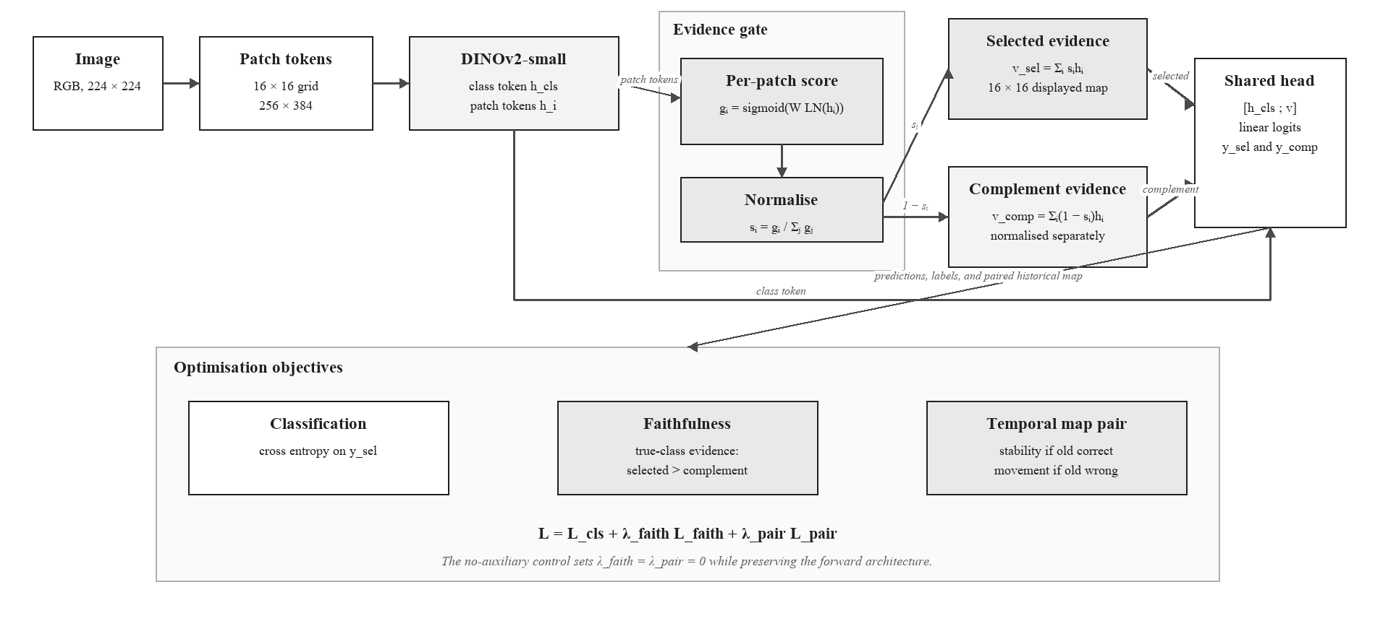
Figure 1. Embedded saliency-guided ViT forward computation and training signals
Faithfulness in this paper means that the reported patch importance has a measurable relationship with the model's prediction. The model classifies both the saliency-weighted representation and its low-saliency complement. The loss rewards stronger true-class evidence in the selected patches than in the complement, adapting the perturbation principle used in saliency-guided training [13]. During temporal adaptation, a pairwise term discourages unnecessary map movement when the historical model is correct and permits a minimum divergence when it is wrong. This objective does not prove causality, but it creates a behaviour that can be checked through matched deletion tests.
The learned map answers a limited but concrete question: which ViT patch tokens received weight in the representation used for classification? It is not treated as a segmentation mask. A concentrated map can still be wrong, and a diffuse map can still support a correct prediction. The report therefore avoids interpreting visual neatness as proof of faithfulness.
The complementary path provides a simple testable expectation: the selected patches should support the correct class more strongly than the remaining patches. This is added as a soft loss so that useful contextual information is not excluded by a hard mask.
During adaptation, the frozen branch provides the reference map. If its prediction is correct, the new map is discouraged from moving unnecessarily. If it is wrong, the pairwise loss allows a larger change. The class label still determines whether an update succeeds; map divergence alone does not.

3.1.1 Why saliency is an operational signal
If the saliency map were drawn only after prediction, the experiment would reduce to ordinary model replacement with an illustration attached. Here, the patch weights form the classified representation, auxiliary losses shape their behaviour during adaptation, the historical-versus-updated comparison reads the same weights at inference, and deletion analysis checks whether high-weight patches affect the true-class score more than low-weight patches. Saliency therefore connects model computation, update training, route eligibility, and post-run audit.
The need for this design depends on the deployment objective. If aggregate accuracy is the only criterion, the always-updated model should be used whenever validation supports it. A model-maintenance system may also need a recoverable historical version, a per-image account of why a replacement was attempted, and evidence for investigating negative transfer. Saliency supplies spatial evidence for those purposes, but it cannot identify correctness by itself. The router therefore combines map change with prediction features, and the evaluation reports route regret and harmful switches alongside deletion-based faithfulness.

3.2 Asymmetric Siamese comparison and explicit routing rule
For each image, the old and new ViTs return a class distribution and a patch-weight distribution. Four differences are standardised and passed to a saved logistic equation. The new prediction can be selected only when the models disagree, saliency divergence exceeds a calibrated floor, and the logistic probability exceeds its threshold. The coefficients and thresholds are stored in router_policy.json.
Figure 2 uses two instances of the same saliency-guided ViT on the same image. The setup is asymmetric. Both branches begin from the historical checkpoint, but the old branch is frozen while the new branch adapts its final three transformer blocks, saliency gate, and classification head on the 2010 stream. During evaluation, both branches are fixed. Retaining both branches is necessary because update safety is comparative: a single updated model cannot reveal which historical predictions were displaced or which patch evidence moved.
The models are compared at the prediction and patch levels. Prediction features describe class disagreement, confidence gain, and entropy reduction. Patch features describe Jensen-Shannon divergence and the change in selected-versus-complement class evidence. No learned routing embedding is used. The saved row for each image is enough to reconstruct the routing decision.
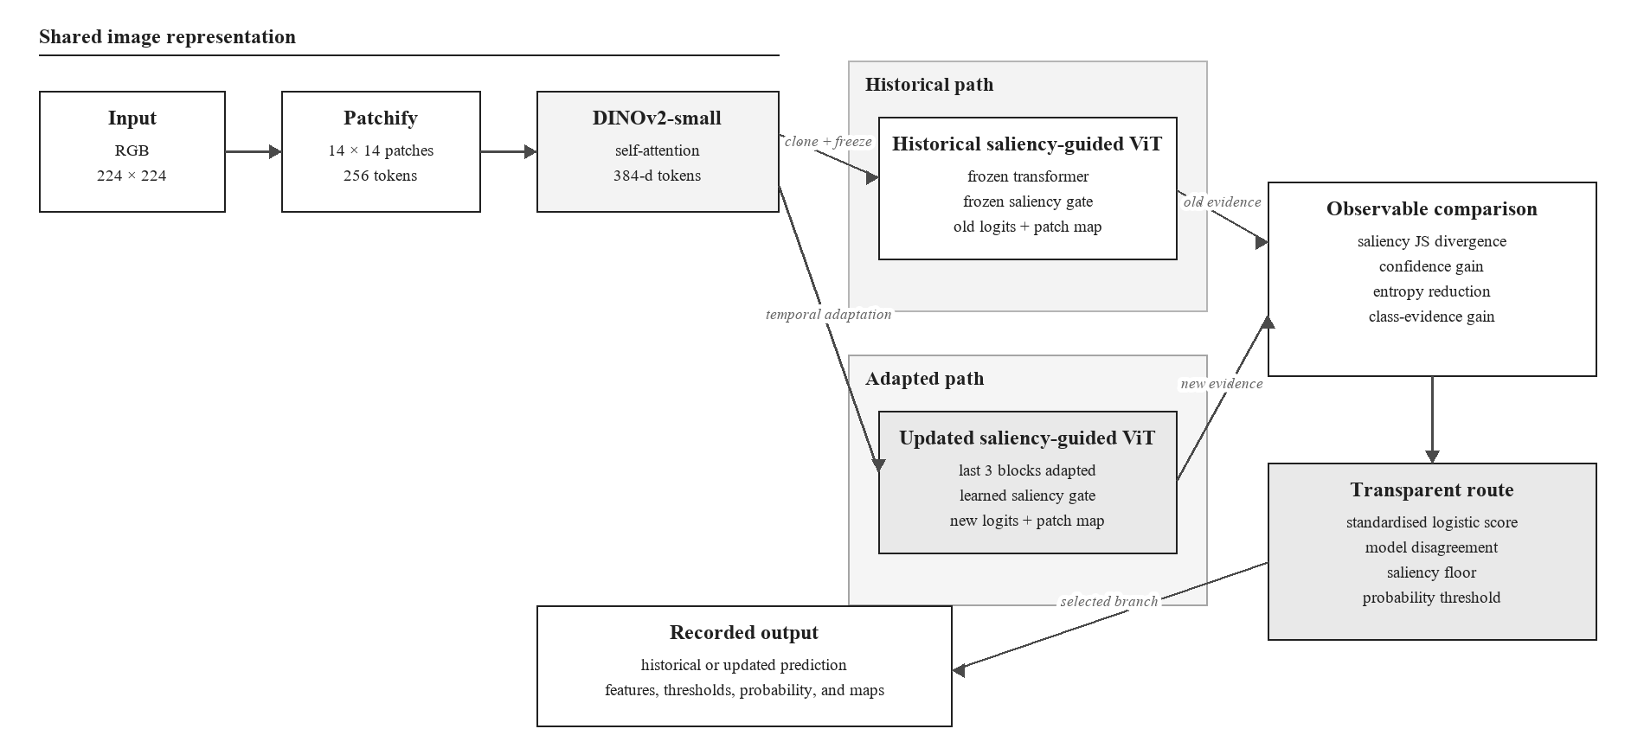
Figure 2. Asymmetric Siamese comparison between the frozen historical ViT and drift-adapted ViT
Logistic regression was chosen so that the route can be reproduced from a short coefficient vector [20]. A positive calibration target means that the historical model is wrong and the updated model is correct. The four inputs are standardised, and class-balanced fitting compensates for the smaller number of useful updates. The score is p(update | x) = sigmoid(b + wᵀz). Saving b, w, and the feature means and scales is sufficient to recalculate it.
Probability alone does not determine the route. The implementation searches saliency-floor quantiles and probability thresholds in 2011 only, choosing the pair with the highest calibration macro F1 and then fewer harmful routes as the tie-breaker. At inference, the newer branch is selected only if the branches disagree, saliency change exceeds the stored floor, and the fitted probability exceeds the stored threshold. This staged rule reflects the calibration literature's warning that a classifier score should not automatically be treated as a trustworthy probability without empirical checking [24]. It also keeps the final decision auditable: a reviewer can see the raw signals, standardised values, weighted sum, two eligibility checks, and selected branch for every image.
Saliency divergence measures how much the spatial evidence distribution changed. Confidence gain measures whether the newer branch is more certain in its selected class. Entropy reduction measures whether its full predictive distribution became more concentrated. Class-evidence gain measures whether the newer representation provides stronger support for the candidate class. No feature is assumed to be sufficient in isolation.
Coefficient signs describe associations in the 2011 calibration sample. A positive confidence coefficient means that confidence gain was associated with useful updates after the other selected features were considered. It does not show that increasing confidence would cause correctness. The router is transparent as a policy, while its statistical relationships remain empirical.
The code exposes confidence-only, saliency-only, and combined router calibrations. Confidence-only uses confidence gain and entropy reduction. Saliency-only uses Jensen-Shannon divergence and class-evidence gain. Combined routing uses all four. Prediction-only calibration omits the saliency floor, while the other two retain it. These options support later ablation at matched route coverage; the present main comparison uses the saved combined policy and treats the auxiliary-loss comparison as supporting evidence rather than as a substitute for the conventional fine-tuning control.

4. Temporal protocol
Table 3. Chronological training, adaptation, calibration, and evaluation protocol
Stage | Years | Role
Historical training | 2004-2008 | Fit the original ViT models
Model selection | 2009 | Choose checkpoints without touching future years
Drift adaptation | 2010 | Adapt saliency-guided ViT on balanced clean/corrupted data
Router calibration | 2011 | Archived run: select adapted checkpoint and fit router on shared labels; corrected code uses disjoint class-stratified partitions
Frozen evaluation | 2012-2014 | Test clean and drifted data once across a future horizon

4.1 Dataset selection and external validity
CLEAR-100 is the primary dataset because it preserves a fixed 100-class image task across upload years from 2004 to 2014 and supports near-future evaluation [1]. The protocol trains the historical model on 2004-2008, selects it in 2009, adapts the newer branch in 2010, calibrates routing in 2011, and freezes every component before the 2012-2014 horizon. This order represents one deploy-update-observe cycle rather than annual retraining.
The installed dataset was audited before the statistical rerun. The manifest contains 164,821 unique paths and image identifiers, maps every bucket to 2004-2014 consistently, contains all 100 classes in every train and test bucket, and has no missing files. The train and test archive SHA-256 values match the configured CLEAR-100 releases. These checks rule out duplicate identifiers, missing images, and year or label remapping errors in the local pipeline; they do not rule out annotation noise in the source dataset.
Supplementary datasets assess the extension capability of individual parts of the approach. Yearbook adds a second temporal image stream, CIFAR-10.1 adds an independently recollected test set, and Camelyon17-WILDS adds institution and scanner shift. FMoW-WILDS and iWildCam-WILDS remain useful future directions for satellite time and location change and camera-location change [2]. Their domains, class structures, storage requirements, and split definitions differ from CLEAR, so each needs a separately specified protocol. These screens test transfer boundaries; they do not convert the CLEAR correction experiment into a multi-dataset router benchmark.

4.2 Independent verification of declared drift
The experiment verifies every declared condition before interpreting a classification difference. Images are embedded with the frozen DINOv2 backbone used by the classifier. Radial-basis-function maximum mean discrepancy (MMD) measures distributional separation without assuming Gaussian features [26]. For clean and shifted views of the same image, the permutation test swaps the domain label within each image pair; an independent pooled-label permutation would discard that pairing and test a different null hypothesis. A balanced logistic domain classifier supplies a complementary measure under five-fold cross-validation [27]. Paired views retain a common group identifier so that both remain in the same fold and image identity cannot leak between fitting and evaluation.
The two measures answer different questions. The paired MMD permutation test assesses whether the frozen representation changes consistently within the same image, using a predeclared significance level of alpha = 0.05. MMD squared then describes the magnitude of distributional separation, but its numerical scale depends on the representation and kernel and therefore has no universal 0.05 decision threshold. The final audit uses 499 randomisations with the add-one correction, giving a minimum attainable p value of 1 / (499 + 1) = 0.002. A result at this floor means that none of the permitted randomisations produced a statistic at least as large as the observed value; it does not rank the controlled conditions by strength.
Grouped domain-classifier ROC AUC measures how readily a linear classifier separates clean from shifted features. An AUC of 0.50 represents chance discrimination. The figure marks AUC = 0.70 as a practical interpretation boundary because values from 0.70 to 0.80 are conventionally described as acceptable discrimination [28]. This convention is used to describe separability, not as a formal drift hypothesis test or proof that classification performance has deteriorated. A condition is treated as operationally material only when the permutation test detects change, the magnitude measures show meaningful separation, and task performance changes.
Table 4. Frozen-feature drift verification on 300 CLEAR-100 samples per condition using 499 randomisations
Comparison | MMD squared | p value | Domain AUC | Interpretation
Clean split-half control | 0.00378 | 1.000 | 0.398 | Finite-sample null
2009 to 2012 clean | 0.00186 | 1.000 | 0.442 | Not detected
2009 to 2013 clean | 0.00183 | 0.954 | 0.457 | Not detected
2009 to 2014 clean | 0.00195 | 0.960 | 0.470 | Not detected
Illumination | 0.00002 | 0.002 | 0.519 | Detectable, negligible separation
White balance | 0.00017 | 0.002 | 0.601 | Small paired shift
Sensor noise | 0.00395 | 0.002 | 0.948 | Large separability
Defocus blur | 0.00112 | 0.002 | 0.787 | Moderate separability
Motion blur | 0.02271 | 0.002 | 0.993 | Second-largest MMD
JPEG compression | 0.00233 | 0.002 | 0.971 | Large linear separation
Resolution loss | 0.00078 | 0.002 | 0.743 | Moderate separability
Viewpoint shift | 0.00300 | 0.002 | 0.851 | Large separability
Occlusion | 0.00212 | 0.002 | 0.824 | Large separability
Evidence-ranked mixture | 0.02804 | 0.002 | 0.999 | Largest measured shift
The p column in Table 4 reports the Monte Carlo estimate from 499 randomisations. Every controlled condition reaches the 0.002 resolution limit, while the natural year comparisons and the split-half control are not detected. The paired design preserves each clean-shifted image pair during permutation and keeps paired observations in the same domain-classifier fold. Because all controlled p values reach the same floor, MMD squared and domain AUC provide the comparison of practical separation across conditions.
Drift existence and drift mitigation remain separate claims. Table 4 verifies that the declared controlled conditions alter the frozen DINOv2 representation. It does not show that the classifier is harmed or that adaptation reverses the shift. Task-level mitigation is therefore assessed separately through macro F1 against the frozen historical ViT. Representation-level mitigation would require matched embeddings from before and after adaptation and a predeclared reduction criterion; the present experiment does not make that stronger claim.
Task-level mitigation requires adverse-condition macro F1 to improve over the historical branch while clean performance remains within the 0.50 percentage point safety bound. Re-evaluation of the saved checkpoints and fixed router policies on the evidence-ranked mixture produced a 2014 historical macro F1 of 79.33%, an updated-model score of 82.75%, and a routed score of 82.36%. This evaluation did not retrain either classifier or refit the router. It therefore isolates the effect of changing the test condition from the archived compound mixture to the predeclared evidence-ranked mixture.
Figure 3 compares the two magnitude measures from Table 4. The dashed MMD squared line at 0.05 is a scale reference only; the statistical decision is made by the paired permutation test at alpha = 0.05. The domain-classifier panel marks chance separation at AUC = 0.50 and the literature-based acceptable discrimination boundary at AUC = 0.70 [28]. The evidence-ranked mixture is largest on both measures, followed by motion blur. Illumination is statistically detectable but remains close to chance on domain AUC, demonstrating why detectability alone is insufficient evidence of operationally important drift.
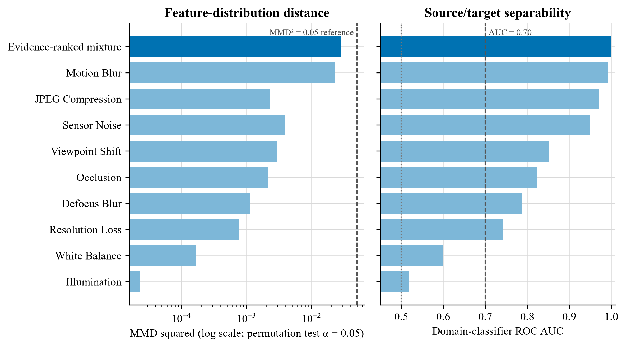
Figure 3. Independent drift evidence for the controlled 2014 conditions. The evidence-ranked mixture contains the top three sources selected on 2011 calibration data.
The measures agree on the strongest shifts. The evidence-ranked mixture has MMD squared 0.02804 and domain AUC 0.999, while motion blur has MMD squared 0.02271 and domain AUC 0.993. Sensor noise and JPEG compression are less distant by MMD but remain readily separable. Illumination is detectable within pairs yet has domain AUC 0.519 and negligible MMD. In Figure 3, the dotted AUC = 0.50 line denotes chance separation, the dashed AUC = 0.70 line denotes the practical interpretation boundary, and the MMD squared = 0.05 line is a scale reference rather than a significance threshold.

4.3 Operational definitions of drift conditions
Clean stream. The model receives the unaltered CLEAR-100 image from the named calendar year. Any change across 2012, 2013, and 2014 comes from the dataset's natural temporal ordering, with no synthetic transform added.
Legacy combined condition. Every image receives the same three transformation families: saturation reduction, Gaussian noise, and one square local-mean occlusion. The severity rises with the test year. This deterministic condition reproduces the original experiment, but it overrepresents occlusion and does not identify which acquisition change caused a score difference.
Source-separated conditions apply one named transformation at a time so its effect remains identifiable. ImageNet-C motivates the broad noise, blur, weather, and digital families [4]. Gaussian noise is retained as a tractable proxy for sensor read noise and low-light acquisition error, but independent, identically distributed Gaussian pixels are an approximation rather than a model of every camera sensor. Motion blur represents relative camera or object movement during exposure, although a fixed digital kernel simplifies real trajectories, shutter timing, and depth. JPEG compression and resolution loss represent changes in storage, transmission, or imaging pipelines. Illumination and white balance approximate environmental and camera-processing change. Viewpoint shift and localised occlusion represent changes in capture geometry or visibility, motivated by operational image studies in WILDS and camera traps [2] [25]. Each transform is therefore a controlled stressor with a stated physical rationale. None is labelled natural temporal drift merely because it lowers accuracy; CLEAR supplies the calendar-year chronology [1].
Evidence-ranked realistic mixture (implementation label: realistic_mix). The mixture is a reproducible compound acquisition stress test, not an estimate of field prevalence. Candidate sources were screened on 300 class-balanced images from the 2011 calibration year at severity three. Sources were ranked separately by descending MMD squared and domain AUC, and the mean of those two ranks determined the frozen order. Motion blur ranked first, sensor noise second, and JPEG compression third. Severity one applies the first source, severity two applies the first two, and severity three applies all three. The selection used no 2012-2014 labels or predictive results. This top-N rule makes the composition auditable and prevents the final evaluation horizon from determining its own test condition.
The word realistic refers to plausible acquisition and imaging mechanisms at bounded magnitudes. It does not assert their prevalence, co-occurrence, or independence in a particular deployment. Motion blur represents relative camera or subject movement, sensor noise represents photon and read noise, and JPEG compression represents an image-pipeline change. Occlusion remains a separate stressor because its calibration rank did not place it in the top three and because content obstruction has a different causal interpretation. A visible perturbation is not automatically dataset drift; the independent MMD and domain-classifier tests in Section 4.2 verify whether each declared condition changes the frozen feature distribution.
Adaptation and calibration use 25% clean images and 75% images carrying one individual source. Each of the nine source types occupies one twelfth of the stream, so compound test images are withheld from model updating. This separation asks whether learning from identifiable single-source changes transfers to a later compound condition. It also avoids training directly on the exact evidence-ranked test composition.

4.4 Cross-dataset replication protocol
Supplementary testing uses a dataset-specific split rather than applying the CLEAR corruption mixture to unrelated domains. A frozen DINOv2-small backbone supplies patch tokens. A linear probe measures the task difference between an in-distribution holdout and the external split, while MMD and held-out domain-classifier AUC assess feature separation. These measures answer different questions: the probe measures predictive change, MMD measures distribution discrepancy, and domain AUC measures separability.
The architecture screen trains matched uniform-patch and saliency-gated classifier heads over the same frozen backbone, sampled images, seed, two-epoch budget, and optimiser settings. This isolates the head design within a small external screen. It does not test temporal fine-tuning, auxiliary saliency losses, router calibration, or historical fallback. A positive head difference would support transfer of one component; a negative result would delimit the claim without contradicting a CLEAR routing gain.
The Yearbook feasibility screen uses portraits from 1930-1989 for training, 1980-1989 for an in-distribution holdout, and 2004-2013 for the later window [3]. This is a deliberately separated internal screen rather than Wild-Time's official Eval-Fix protocol. CIFAR-10.1 uses the recommended class-balanced v6 recollection of 2,000 images [31]. Camelyon17-WILDS uses lymph-node histopathology from multiple hospitals, where scanner, staining, and institutional acquisition differences form a clinically meaningful source of covariate shift [32]. The Camelyon screen uses a patient-disjoint source-hospital holdout and the validation hospital as the external domain.
The three screens are feasibility experiments, not benchmark submissions. The Camelyon17 run uses a 10.7 GB public mirror, a balanced 5,000-image training sample, three seeds, and DINOv2 pre-training. WILDS evaluation guidance asks for ten Camelyon runs and prohibits external pre-training for leaderboard comparison [33]. The reported Camelyon values must therefore be read as internal architecture evidence only.

4.5 Enhanced correction experiment
The enhanced saliency-guided profile and the conventional fine-tuning control were designed to separate adaptation capacity from the proposed saliency mechanism. Both expose the final three transformer blocks to the 2010 adaptation stream for five epochs, use a backbone learning rate of 1e-5 and a head learning rate of 5e-5, apply label smoothing of 0.05, and preserve the same 25% clean share. The conventional arm uses uniform pooling and classification loss only. The saliency-guided arm also learns the patch gate and applies complementary-evidence and temporal-map objectives.
- 25% clean and 75% individually corrupted samples, spanning severities 1-3;
- the final three transformer blocks are trainable instead of only the final block;
- backbone learning rate remains 1e-5, while classifier and saliency heads use 5e-5;
- label smoothing is 0.05 and the saliency terms receive weight 0.25;
- the saliency divergence margin increases from 0.05 to 0.08;
- router calibration jointly selects a saliency-floor quantile and probability threshold on 2011 only.
Each change in the enhanced profile addresses a specific constraint. The 25% clean share limits forgetting, while individual corruption families expose the updated branch to plausible acquisition changes without revealing the held-out compound test. Unfreezing three transformer blocks adds adaptation capacity, but the lower backbone learning rate protects pretrained features. The higher head rate lets the classifier and saliency gate respond faster, and the increased saliency weight tests whether explanation guidance adds value beyond that extra capacity. The matched no-saliency-loss control isolates the contribution of those auxiliary objectives.
The completed saliency-guided run selected epoch 4 at 94.39% macro F1; epoch 5 declined to 93.00%. Its epochs took about 138 seconds after warm-up. The conventional control selected epoch 2 at 93.90%; later epochs fell to 93.45%, 93.21%, and 93.03% while training loss continued to decrease. Its first epoch took 151 seconds and later epochs took about 132 seconds. Both patterns show why the validation-selected checkpoint, rather than the last epoch, is used for future evaluation. The archived saliency run predates the corrected split of 2011 selection and calibration data, so its direct comparison with the corrected conventional run is exploratory and must be rerun under an identical split for confirmatory inference.

4.6 Protocol correction for future runs
Reusing 2011 for both checkpoint selection and router calibration gives the policy information about the sample that already determined which adapted model survived. This can make route thresholds look better matched to that window than they would be on new data. The code now divides 2011 deterministically within each class: one partition selects the adapted checkpoint and the other fits logistic coefficients, the saliency floor, and the probability threshold. The default split is 50/50 and is recorded with both sample counts. A legacy flag reproduces the shared protocol for audit purposes. The tables in this paper were not recomputed after that correction, so the distinction is explicit rather than retroactively changing the meaning of the reported runs.

4.7 Hypotheses and success criteria
- H1: under at least one severe, high-headroom 2014 condition, saliency-guided routing improves macro F1 by at least 2.00 percentage points over the historical saliency-guided ViT.
- H2: transparent routing retains at least 75% of the gain achieved by always using the updated model.
- H3: clean 2014 macro F1 does not fall by more than 0.50 points relative to the historical saliency-guided ViT.
The two-point value is the sole practical benchmark used in this paper. It is grounded in the range of effects reported by the closest saliency and temporal-learning studies, but it is not a statistical decision rule. Repeated seeds and paired confidence intervals are still required before a small difference can be treated as stable.

4.8 Results against the criteria and conventional control
- H1 is met for two severe source-separated tests: saliency-guided routing gains 3.45 percentage points under motion blur and 3.03 points under the evidence-ranked mixture relative to the historical saliency-guided ViT. Conventional fine-tuning also mitigates the 2014 mixture, improving from 79.42% to 81.55%, a 2.13-point gain over its historical uniform ViT.
- H2 is met on the evidence-ranked mixture: routing retains (82.36-79.33)/(82.75-79.33) = 88.6% of the always-updated saliency-guided gain. The resulting route regret is 0.39 points.
- H3 is met for saliency-guided routing: clean 2014 macro F1 is 95.36%, 0.12 points above its historical saliency-guided reference. Conventional fine-tuning reaches 94.93%, which is 0.20 points below its historical uniform reference but remains inside the 0.50-point tolerance.

4.9 Checkpoint and interruption recovery
Every evaluated epoch atomically replaces models/resume.pt and writes a small resume.json. The binary checkpoint contains the newer ViT parameters, optimiser state, completed epoch, and best validation score; the separate best-model file remains the checkpoint used for final evaluation. The matched standard run was deliberately stopped after epoch 2 and resumed at epoch 3. It retained the epoch-2 optimiser and best score, later selected epoch 4, and completed the frozen horizon normally. A local round-trip regression test independently reloads and compares weights, optimiser state, epoch, score, and metadata.

5. Main results
Macro F1 is shown as a percentage. A helpful route replaces an incorrect historical prediction with a correct updated prediction. A harmful route replaces a correct historical prediction with an incorrect updated prediction. A missed helpful case occurs when the updated model is correct but the policy retains an incorrect historical answer. Helpful and harmful counts must be read together because greater route coverage can increase both.
Table 5. Original temporal evaluation results
Scenario | Year | Historical uniform | Historical saliency | Saliency routed | Helpful | Harmful
Clean | 2012 | 95.86 | 95.96 | 96.40 | 30 | 8
Clean | 2013 | 95.27 | 95.23 | 95.79 | 40 | 12
Clean | 2014 | 95.13 | 95.24 | 95.46 | 30 | 18
Combined | 2012 | 95.47 | 95.47 | 96.08 | 45 | 14
Combined | 2013 | 93.75 | 93.81 | 94.55 | 72 | 32
Combined | 2014 | 90.59 | 90.34 | 91.50 | 120 | 48

On 2014 combined drift, the historical uniform ViT reached 90.59%, the historical saliency-guided ViT 90.34%, the updated saliency-guided ViT 91.75%, and routing 91.50% macro F1. Routing retained 82.3% of the available saliency-guided update gain. The later evidence-ranked mixture produces a larger and more operationally relevant separation, so Table 6 provides the primary four-strategy comparison.

5.1 Four-strategy temporal comparison
Table 6. Historical, conventional, saliency-guided, and routed macro F1 across the frozen horizon
Condition | Year | Historical uniform | Fine-tuned uniform | Historical saliency | Saliency update | Saliency routed
Clean | 2012 | 95.86 | 95.86 | 95.96 | 95.89 | 96.03
Clean | 2013 | 95.27 | 95.54 | 95.23 | 95.49 | 95.55
Clean | 2014 | 95.13 | 94.93 | 95.24 | 95.54 | 95.36
Evidence-ranked mixture | 2012 | 94.36 | 94.71 | 94.19 | 95.27 | 95.23
Evidence-ranked mixture | 2013 | 89.79 | 90.84 | 89.93 | 91.55 | 91.19
Evidence-ranked mixture | 2014 | 79.42 | 81.55 | 79.33 | 82.75 | 82.36

Table 6 and Figure 4 compare the update strategies over the same future years. Under the evidence-ranked mixture, conventional fine-tuning improves on its historical uniform reference by 0.35, 1.05, and 2.13 points in 2012, 2013, and 2014. The always-used saliency-guided update improves on its own historical reference by 1.08, 1.62, and 3.42 points. It exceeds conventional fine-tuning by 0.56, 0.71, and 1.20 points respectively. The saliency-guided router remains 0.04, 0.36, and 0.39 points below the always-updated branch, but still exceeds conventional fine-tuning by 0.52, 0.35, and 0.81 points.
Figure 4 shows how the separation grows as the declared compound severity rises. The clean panel uses a narrow vertical scale because all five rows remain close to 95%; it should therefore be read from the reported values rather than from visual slope alone. The mixture panel shows the substantive result: both update methods mitigate degradation, while the saliency-guided update retains the highest macro F1 across all three future years.
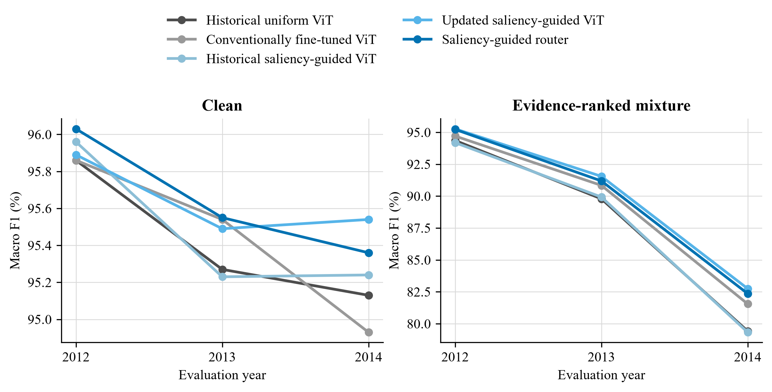
Figure 4. Macro F1 for historical, conventional, saliency-guided, and routed strategies across the frozen future horizon
On clean data, every strategy remains within 1.10 points across the full horizon. In 2014, conventional fine-tuning loses 0.20 points relative to the historical uniform ViT, while the updated and routed saliency-guided strategies gain 0.30 and 0.12 points over their historical saliency-guided reference. Under the evidence-ranked mixture, always-updated saliency guidance provides the best aggregate score. Routing is justified by fallback, decision logging, and harmful-update analysis rather than by a claim that it must outperform the updated model.

5.2 Controlled five-epoch ablation
The matched run removes the earlier three-versus-five-epoch imbalance. The auxiliary-loss control keeps the enhanced curriculum, trainable blocks, learning rates, and saliency-gated classifier fixed, but sets the pairwise saliency-divergence and complementary-evidence loss weights to zero. It therefore isolates the explicit saliency supervision while retaining saliency inside the forward pass.
Table 7. Controlled five-epoch ablation
Variant | 2014 clean routed | Combined old | Combined new | Combined routed | Helpful | Harmful
Matched standard (5 epochs) | 95.78 | 90.34 | 91.68 | 91.72 | 144 | 57
Enhanced with auxiliary losses | 95.30 | 90.34 | 91.99 | 91.85 | 188 | 90
Enhanced without auxiliary losses | 95.45 | 90.34 | 91.86 | 91.62 | 125 | 43

Bold type marks the best value in each evaluation column across the three matched configurations; ties are bolded together. Helpful and harmful counts describe route composition rather than interchangeable accuracy measures, so the most helpful and least harmful counts are emphasised separately.
Against the matched saliency-head control, the auxiliary saliency objectives change 2014 combined macro F1 by +0.13 points for always-updated inference and +0.23 points after routing. Under the evidence-ranked mixture, they change routed macro F1 by +1.36 points. These are supporting ablations within the saliency architecture. The conventional fine-tuning control in Table 6 answers the broader question of whether ordinary classification-only adaptation is sufficient.
The ablations separate three questions. The uniform-pooling control measures ordinary temporal fine-tuning. The no-auxiliary saliency head tests whether forward-pass patch weighting alone is sufficient. The auxiliary-loss row tests whether explicit saliency supervision adds value once that head is present. This hierarchy prevents the audit value of saliency from being conflated with an unsupported claim that every saliency component raises aggregate accuracy.

5.3 Source-separated drift evaluation
The broader protocol evaluates the same saved historical checkpoint, adapted checkpoint, and 2011 routing policy across 11 independently named 2014 conditions. Each row contains the frozen historical score, the always-updated score, the transparent routed score, and the routed change from the historical branch. This separation prevents a favourable occlusion example from standing in for unrelated acquisition changes.
Table 8. Source-separated 2014 drift results
2014 condition | Historical | Updated | Routed | Routed change
Clean | 95.24 | 95.54 | 95.36 | +0.12
Illumination | 95.13 | 95.46 | 95.24 | +0.11
White balance | 95.16 | 95.61 | 95.43 | +0.27
Sensor noise | 94.20 | 94.72 | 94.44 | +0.24
Defocus blur | 94.41 | 94.93 | 94.75 | +0.34
Motion blur | 83.17 | 87.13 | 86.62 | +3.45
JPEG compression | 93.64 | 94.27 | 94.09 | +0.45
Resolution loss | 93.69 | 94.26 | 94.10 | +0.41
Viewpoint shift | 94.32 | 95.09 | 94.91 | +0.59
Occlusion | 93.93 | 94.74 | 94.68 | +0.75
Evidence-ranked mixture | 79.33 | 82.75 | 82.36 | +3.03

Motion blur produces the largest routed gain: +3.45 percentage points, from 357 helpful and 90 harmful switches. The 2014 evidence-ranked mixture is the level-three compound condition defined in Section 4.3. Its components were selected only from the 2011 calibration partition by averaging each candidate corruption's MMD and domain-classification ranks. Motion blur, sensor noise, and JPEG compression ranked highest and were then applied in that fixed order across severity levels. No 2012 to 2014 labels or predictive results entered the selection. On the final 2014 partition, the mixture gains +3.03 points, with 375 helpful and 117 harmful switches. The result is therefore tied to a reproducible acquisition-degradation mixture rather than to occlusion alone, although the synthetic construction still limits external validity.
Table 9. Effect of auxiliary saliency objectives on routed performance
Matched 2014 condition | Saliency routed change | No-aux routed change | Auxiliary effect on route
Clean | +0.12 | +0.30 | -0.18
Motion blur | +3.45 | +2.55 | +0.90
Viewpoint shift | +0.59 | +0.53 | +0.06
Occlusion | +0.75 | +0.69 | +0.06
Evidence-ranked mixture | +3.03 | +1.67 | +1.36

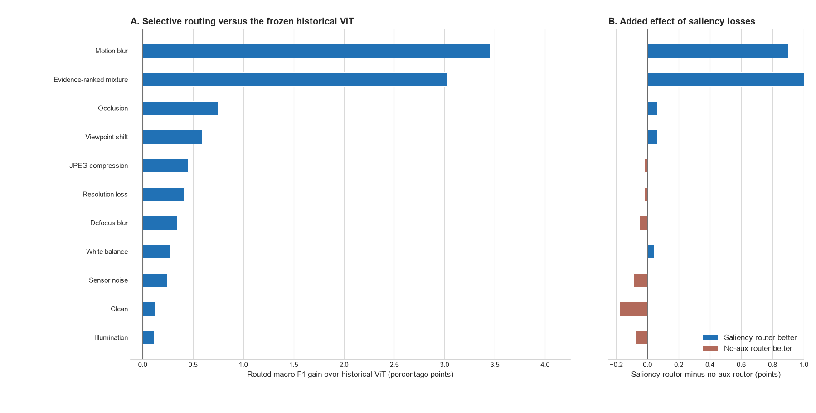
Figure 5. Selective-routing gain over the historical ViT and the added effect of saliency losses
Figure 5 evaluates routing against the frozen historical saliency-guided ViT. A positive bar means that routing improves macro F1 over that deployed reference; it does not mean that routing outperforms the always-updated ViT. The largest routed gains occur under motion blur (+3.45 points) and the evidence-ranked mixture (+3.03 points). Relative to a matched saliency head without auxiliary losses, the auxiliary objectives add +0.90 and +1.36 points in those conditions. Table 6 separately shows that the routed system exceeds conventional fine-tuning by 0.81 points on the 2014 mixture.

5.4 Class-level and historical-difficulty analysis
Overall macro F1 can conceal whether an update helps many classes slightly, rescues a small number of difficult classes, or transfers errors between classes. The saved 2014 decisions were therefore rescored one class against the remaining 99 classes. Every class has 50 test examples and exceeds the minimum support of 20. Within each condition, classes are ranked by the historical model's F1 and divided into four equal groups from Q1, the weakest 25 classes, to Q4, the strongest 25 classes.
Table 10. Routed macro F1 change by historical class-performance quartile on CLEAR-100 in 2014 (percentage points)
Condition | Variant | Q1 weakest | Q2 | Q3 | Q4 strongest
Clean | Saliency supervised | +1.87 | -0.46 | -0.46 | -0.47
Clean | No auxiliary loss | +2.07 | +0.02 | -0.32 | -0.54
Evidence-ranked mixture | Saliency supervised | +8.96 | +1.98 | +1.45 | -0.26
Evidence-ranked mixture | No auxiliary loss | +5.44 | +1.15 | +0.78 | -0.69
The realistic-mixture result is concentrated in classes that the historical model found difficult. The saliency-supervised router gains 5.91 points in Q1, compared with 2.91 points for the matched no-auxiliary-loss router. It improves 65 classes and worsens 35, giving a mean per-class change of +2.04 points. The control improves 61 classes, leaves three unchanged, and worsens 36, for a +1.19-point mean change. In Q4, both variants lose performance, with changes of -0.81 and -0.44 points respectively. The result supports targeted correction of weak classes under compound drift, but it also shows that the present rule does not fully protect classes that were already reliable. Bold values mark the larger routed change within each matched pair.
On clean data, both routers again help Q1 while the remaining groups are flat or slightly worse. The saliency-supervised clean mean is +0.12 points across classes, compared with +0.30 points for the control. These strata are descriptive evidence from one seed. Per-class F1 depends on false positives arriving from other classes as well as decisions made on the class itself, so helpful and harmful route counts cannot explain every class change in isolation. Repeated seeds and class-level confidence intervals remain necessary before claiming stable class-specific benefits.

5.4.1 Interpretation in relation to prior work
The concentration of improvement in Q1 is compatible with the mechanism proposed by saliency-guided training, although it does not prove that mechanism. SGAN uses saliency priors to constrain attention away from irrelevant regions [11]. Saliency Guided Training perturbs low-saliency features while preserving the model output, turning an explanation into a training intervention [13]. Ma et al. similarly remove low-saliency ViT patches to reduce reliance on background shortcuts [15]. In the present architecture, learned patch weights enter the pooled representation and the auxiliary losses reward separation between useful and weak evidence. A plausible interpretation is therefore that compound drift exposes shortcut dependence most severely in historically weak classes, leaving more recoverable headroom when patch evidence is reweighted. The quartile analysis measures performance rather than shortcut use, however, and CLEAR has no object masks. It is convergent evidence for this interpretation, not a causal demonstration of it.
The asymmetric Siamese design gives that result a different meaning from ordinary retraining. Siamese-ViT work shows how paired transformer branches can compare local and global visual information [16], while asymmetric Siamese change detection preserves distinct roles for the two observations being compared [17]. Here the pair consists of model states rather than two scenes: the frozen branch represents the deployed historical decision and the adapted branch represents a candidate correction on the same image. The architecture therefore does not create a new label from similarity alone. It frames every update as a paired choice whose evidence can be inspected. The Q1 gain shows where the candidate branch contributes useful new evidence; the Q4 loss exposes negative transfer that a single updated model would hide inside its aggregate score.
This fallback role also connects the router to selective prediction and conservative test-time adaptation. SelectiveNet learns when a classifier should abstain rather than force an unreliable decision [10]. CoTTA reduces accumulated error through partial restoration of source weights [7], and EATA filters unsuitable updates to limit forgetting [8]. The present router makes a narrower intervention: it does not adapt on the test stream or abstain from classification, but chooses between an immutable historical branch and a separately adapted branch. The frozen branch is an exact recoverable reference, while the logistic rule keeps the selection traceable. The negative Q4 result shows that this safeguard is incomplete. A class-conditional threshold or a veto based on historical reliability is a defensible next modification, but it must be fitted on the calibration period and compared at equal route coverage to avoid using the final test classes to tune the rule.

5.5 Cross-dataset external screens
The external screens separate evidence of shift from evidence of architectural benefit. Table 11 records the native split and sampling protocol. Table 12 shows whether each external domain is both distinguishable and harder for a simple probe. Table 13 then compares matched heads over the same frozen features. The rows are reported separately because the tasks, class counts, shift mechanisms, and sample sizes differ; pooling them into one average would hide that heterogeneity.
Table 11. External dataset protocols and claim boundaries
Dataset | Native shift | Train / ID / OOD | Seeds | Scope
Wild-Time Yearbook | Later portrait years | 3,000 / 500 / 335 | 1 | Drift tests and matched heads
CIFAR-10.1 v6 | Independent recollection | 5,000 / 1,000 / 1,000 | 3 | Drift tests and matched heads
Camelyon17-WILDS | Held-out hospital | 5,000 / 1,000 / 1,000 | 3 | Exploratory, non-standard WILDS screen
Table 12. External drift evidence from frozen DINOv2 features
Dataset | Seed | Probe ID | Probe OOD | Change (pp) | MMD2 | p* | AUC
Wild-Time Yearbook | 42 | 89.40 | 92.53 | +3.14 | 0.0394 | 0.005 | 0.954
CIFAR-10.1 v6 | 42 | 93.84 | 88.48 | -5.35 | 0.0028 | 0.005 | 0.606
CIFAR-10.1 v6 | 43 | 95.00 | 86.69 | -8.31 | 0.0022 | 0.005 | 0.600
CIFAR-10.1 v6 | 44 | 92.79 | 87.31 | -5.49 | 0.0023 | 0.005 | 0.589
Camelyon17-WILDS | 42 | 84.70 | 68.01 | -16.69 | 0.0237 | 0.005 | 0.950
Camelyon17-WILDS | 43 | 93.58 | 73.12 | -20.46 | 0.0328 | 0.005 | 0.941
Camelyon17-WILDS | 44 | 84.43 | 83.14 | -1.30 | 0.0566 | 0.005 | 0.995
The asterisk in Table 12 marks the same 199-randomisation limit. All seven external runs reach p = 0.005, the minimum attainable value with their archived 199-randomisation tests. The p values establish detectable separation at that resolution but do not rank datasets or seeds. CIFAR-10.1 has only modest domain separability, with AUC from 0.589 to 0.606, while the probe loses about five to eight points. Yearbook and Camelyon show much stronger separability, with AUC above 0.94, and larger or more variable task changes. These tests verify that the selected external splits contain feature shift and task consequences; they do not imply that saliency should correct either one.
Table 13. Matched baseline and saliency-head macro F1 on external datasets
Dataset | Seed | Uniform ID | Uniform OOD | Saliency ID | Saliency OOD | Delta OOD (pp)
Wild-Time Yearbook | 42 | 85.20 | 78.13 | 85.20 | 77.81 | -0.33
CIFAR-10.1 v6 | 42 | 83.09 | 73.35 | 83.18 | 73.65 | +0.30
CIFAR-10.1 v6 | 43 | 81.77 | 73.43 | 82.05 | 73.63 | +0.20
CIFAR-10.1 v6 | 44 | 81.64 | 75.12 | 82.95 | 75.54 | +0.41
Camelyon17-WILDS | 42 | 78.39 | 71.55 | 77.82 | 71.55 | +0.00
Camelyon17-WILDS | 43 | 89.18 | 75.82 | 89.07 | 75.62 | -0.21
Camelyon17-WILDS | 44 | 94.10 | 84.56 | 94.20 | 84.56 | -0.00
The matched-head result is positive only on CIFAR-10.1: the saliency head gains 0.30 +/- 0.11 macro-F1 points across three seeds. Yearbook changes by -0.33 points in its single run. Camelyon changes by -0.07 +/- 0.12 points across three seeds, including one tie and two small losses. These results do not support a universal saliency-head advantage. They instead indicate that the CLEAR gains depend on temporal adaptation and selective routing, or on properties of that image domain, rather than on the head alone. The external evidence also shows why a router needs direct ablation: a head can move saliency without improving the prediction.

6. Saliency and routing analysis
Each audit row shows a clean reference, the drifted input, historical and updated saliency overlays, and the signed change map. The revised figure is exported at 300 dots per inch. Red marks patches that gain weight in the updated model and blue marks patches that lose weight. A more localised updated map means that high weight occupies a smaller, coherent part of the 16 x 16 patch grid, but localisation is interpreted only alongside the class prediction and deletion margin.
Figure 6 contains one helpful route from each of three drift families. The examples were selected for inspection and are not used to estimate performance; the aggregate counts below provide that evidence.
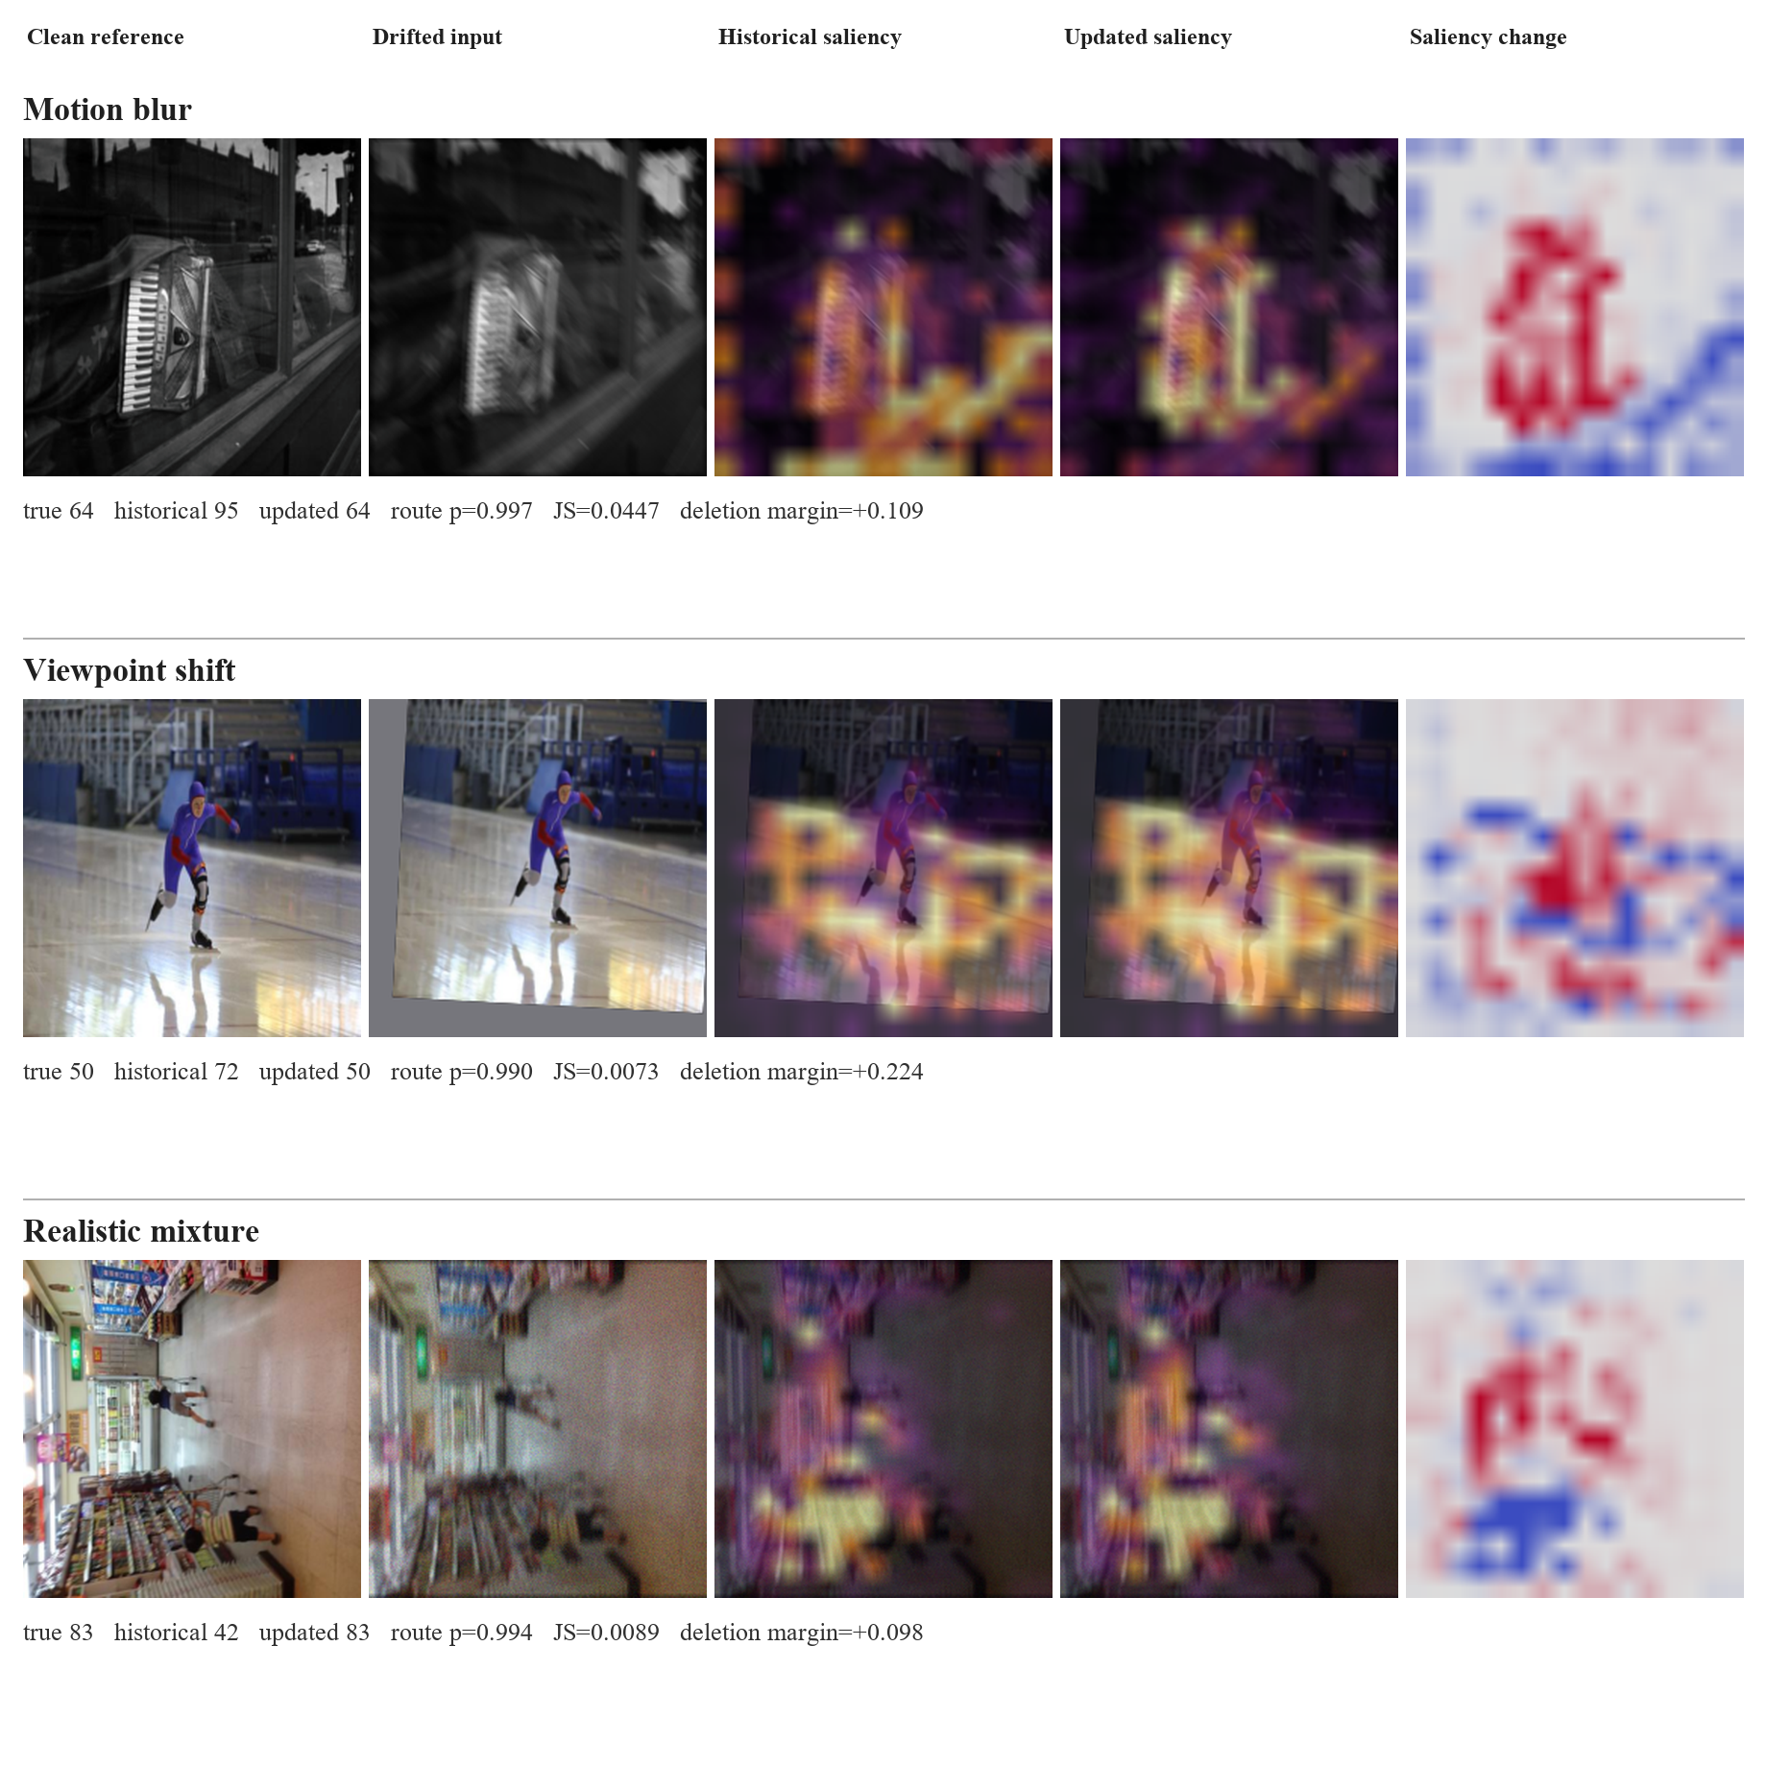
Figure 6. Helpful routed corrections with historical, updated, and signed saliency-change maps

6.1 Quantitative saliency outcome analysis
For the 2014 combined-drift auxiliary-loss control, helpful routes have mean JS divergence 0.0607, compared with 0.0512 for harmful routes and 0.0473 when the historical prediction is retained. Mean route probability is 0.821 for helpful routes, 0.767 for harmful routes, and 0.310 for retained historical predictions. Higher values are useful only in a relative sense: they indicate stronger model disagreement and stronger fitted support for an update. The overlap between helpful and harmful groups shows that neither value is a correctness score. There are 125 helpful and 43 harmful routes, a ratio of 2.91.
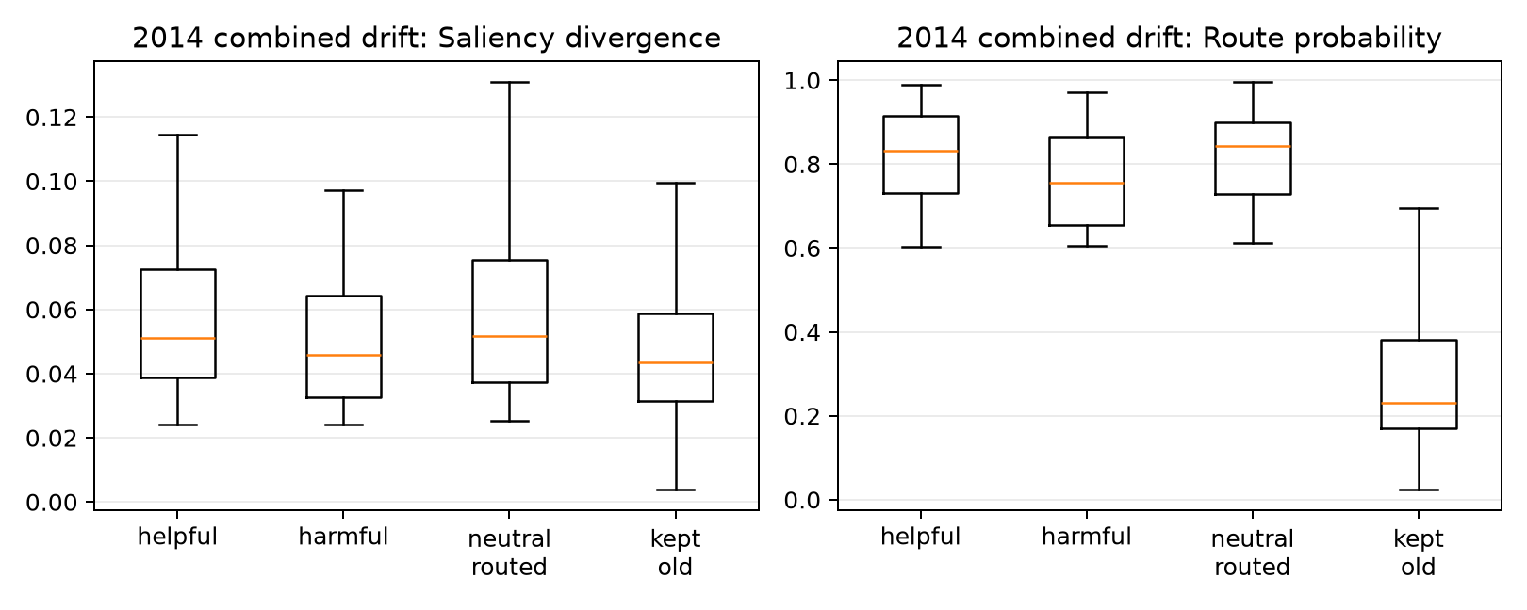
Figure 7. Saliency divergence and route probability by routing outcome
Figure 7 shows substantial overlap between outcomes. Routed and retained images separate partly because the policy requires a minimum saliency change, so that separation confirms that the gate is operating. Helpful routes have somewhat larger JS divergence and route probability on average, which is favourable, but many harmful routes occupy the same range. Large divergence can mean better evidence, a new shortcut, or a general redistribution caused by blur. Route probability is the logistic model's calibrated ranking signal on the 2011 sample, not a guarantee that an individual switch is correct. These limitations motivate the prediction-only, saliency-only, and combined ablations added to the code.
Map change measures difference, not improvement. A new model can move its attention and still be wrong, or become highly confident in the wrong class. CLEAR also provides image labels rather than object masks. Context such as a bowling lane, kitchen surface, or display frame may be useful in one image and a shortcut in another. Since both models share their pretraining and initialisation, some correct updates also require only a small redistribution of patch weights.
The maps are best read as evidence-allocation diagnostics: they show which encoded patches received weight in the classifier. They are not object masks and do not establish that the map change caused a correction. The deletion audit adds a behavioural check by comparing the effect of removing highly weighted and weakly weighted patches. Even this test is limited because the deleted image is outside the original data distribution.
The report uses saliency-guided to describe this complete chain. Patch weights influence class logits, supervised terms constrain their behaviour, differences between historical and updated maps enter the route calculation, and deletion tests check whether weighted patches affect the true-class score. The image overlay is one inspectable artefact from that chain. It is neither the complete decision rule nor proof that highlighted pixels caused the prediction.

6.2 Counterexample and faithfulness audit
The source-specific audit applies the same top-versus-bottom 20% deletion test whenever one model is correct and the other is wrong. A positive margin means that removing the most highly weighted patches reduces true-class probability more than removing the least-weighted patches.
Table 14. Source-specific counterexample and deletion-audit results
2014 source | Helpful routed | Harmful routed | Missed helpful | Net corrections | New-map margin, helpful | New-map margin, harmful
Motion blur | 357 | 90 | 47 | 267 | 0.147 | 0.031
Viewpoint shift | 88 | 56 | 17 | 32 | 0.190 | -0.053
Evidence-ranked mixture | 375 | 117 | 50 | 258 | 0.182 | 0.009

For the updated model, positive deletion margins are more common on helpful than harmful routes: 70.0% versus 61.1% for motion blur, 72.7% versus 44.6% for viewpoint shift, and 74.7% versus 62.4% for the evidence-ranked mixture. In the mixture audit, the updated map's mean deletion margin is 0.182 on helpful routes but 0.009 on harmful routes. The historical map shows the complementary pattern: its mean margin is 0.056 on helpful routes and 0.238 on harmful routes, where its original prediction was correct. This reversal is consistent with the routing rationale because the branch with stronger task-relevant evidence usually corresponds to the safer prediction. The distributions still overlap, so deletion response cannot serve as an error-free routing rule or as proof that the highlighted patches caused the prediction.
The full 2014 combined-drift stream contains 4,999 images. The enhanced router makes 188 helpful switches where the historical model is wrong and the newer model is correct, 90 harmful switches in the opposite direction, and misses 17 available corrections. It therefore produces 98 net corrected predictions. These counts explain why the overall score changes modestly even though some individual decisions change substantially.
For every one of the 304 samples where one model is correct and the other is wrong, the audit deletes the top 20% and bottom 20% of patches under each model's own saliency map. The faithfulness margin is the drop in true-class probability after high-saliency deletion minus the drop after low-saliency deletion. For helpful routed cases, the newer model has a mean margin of 0.175, compared with 0.010 on harmful routed cases; 72.3% of helpful routes have a positive new-model margin, compared with 57.8% of harmful routes. Conversely, the historical model's mean margin is 0.048 on helpful routes and 0.182 on harmful routes. This reversal is consistent with the intuitive routing goal: the model that is correct tends to have the more behaviourally consequential map.
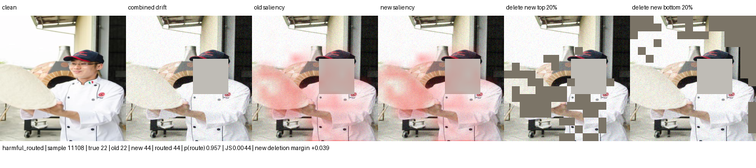
Figure 8. Harmful routed switch: correct historical class 22 is replaced by class 44
The harmful example shows why saliency change alone is insufficient: the historical model was already correct and its map had the stronger deletion response. Patch deletion is still an artificial intervention, so this result does not prove that the highlighted pixels caused the model update.

6.3 Scope of the method
The intended setting is covariate drift: the label keeps the same meaning while the image-forming process or context changes. Examples include camera replacement, compression, sensor noise, white balance, illumination, viewpoint, and partial obstruction. Saliency can help only when useful class evidence remains visible and the updated model learns to weigh it differently.
The source-separated results show the largest gains under motion blur and mixed drift. Viewpoint, occlusion, and digital degradation produce smaller gains, while mild colour and illumination shifts change little. The method is neither an occlusion-specific fix nor a general solution to every form of drift.
The method should not be expected to solve concept drift where the label meaning changes, new-class emergence, extreme occlusion, or systematic dataset errors. In those cases the saliency map may faithfully explain a wrong premise. A stronger next experiment should therefore add a matched random-mask control and an external temporal dataset, then compare confidence-only, saliency-only, and deletion-aware routers without tuning on the final horizon.

7. Discussion and limitations

7.1 What the experiment establishes
For RQ1, both update methods mitigate the strongest 2014 CLEAR condition. Conventional fine-tuning gains 2.13 points over the historical uniform ViT on the evidence-ranked mixture. The always-used saliency-guided update gains 3.42 points over its historical saliency-guided ViT, and routing retains a 3.03-point gain. Mild conditions remain close to their historical scores, so the result is conditional on sufficient headroom rather than a general improvement on every input shift.
The class-level analysis narrows the aggregate claim. Under the 2014 evidence-ranked mixture, saliency-guided routing provides its largest benefit in the weakest historical quartile (+8.96 points), followed by +1.98 and +1.45 points in the middle quartiles, while the strongest quartile changes by -0.26 points. The matched no-auxiliary-loss router changes the same strata by +5.44, +1.15, +0.78, and -0.69 points. The apparent benefit is therefore concentrated in classes with weak historical performance rather than distributed evenly.

7.2 Negative results and failure modes
The two-point benchmark is not met on the legacy combined condition, but it is met by both adaptation arms on the 2014 evidence-ranked mixture. The saliency-guided updated model is 1.20 points above conventional fine-tuning, while the router is 0.81 points above it. Those differences are meaningful for this prototype but remain single-seed estimates. The auxiliary saliency objectives add +0.23 routed points on combined drift, +0.90 under motion blur, and +1.36 under the evidence-ranked mixture relative to the same saliency head without those objectives.
The controls clarify why the argument cannot rest on a single favourable comparison. XGD attributes gains through a saliency ablation [12], and Saliency Guided Training tests explanation quality through controlled perturbation [13]. Following the same logic, this paper includes both a conventional fine-tuning arm and a no-auxiliary saliency arm. The first tests whether ordinary updating is enough; the second tests whether explicit saliency objectives add value beyond patch weighting. The results favour saliency guidance on the severe mixture, but the unequal archived checkpoint-selection protocol and one seed prevent a causal or universal claim.
The route audit explains part of the gap. Helpful and harmful decisions overlap in saliency divergence and route probability, so the four features do not cleanly identify correctness. A map can change because the updated model has found better evidence, because it has shifted to a different shortcut, or because blur has redistributed all patch weights. The logistic router is deliberately simple and may underfit these interactions; a more expressive gate may improve accuracy but would weaken the direct coefficient-level explanation that motivates the design.

7.3 Validity threats and implemented correction
The main CLEAR evidence is limited by one random seed, one temporal dataset, synthetic stressors layered over natural chronology, and one fitted policy. The reported CLEAR runs also reuse 2011 labels for adapted-checkpoint selection and router calibration; the corrected code now separates those functions, but the archived result has not been rerun under that correction. External evidence remains deliberately small: Yearbook has one seed, CIFAR-10.1 tests recollection rather than time, and the Camelyon screen uses three rather than ten runs, a public mirror, and externally pretrained DINOv2 features. Patch-level observations are also correlated within patients and slides, so a confirmatory pathology study should resample and report uncertainty at the patient or slide level.

7.4 Feasible next evaluation
A confirmatory CLEAR run should use the corrected 2011 split, at least three matched seeds, and paired per-image bootstrap intervals. It should compare confidence-only, saliency-only, combined, and end-to-end selective gates at matched route coverage, while retaining always-historical and always-updated baselines. Each controlled source should first pass the MMD and classifier two-sample checks against the clean null, and a random-patch intervention should accompany saliency-guided deletion. The next external study should retain the three-seed CIFAR protocol and add a complex native temporal dataset. Full router replication should be attempted only where defensible update, calibration, and later test windows exist.
ACDC is the strongest next paired-condition dataset for this purpose. It contains 4,006 adverse-condition driving images distributed across fog, night, rain, and snow; each adverse image has a fine pixel annotation, an uncertain-region mask, and a corresponding normal-condition view of the same scene [34]. These correspondences permit per-scene comparisons that CLEAR cannot provide. They also match the normal-to-adverse model-adaptation setting studied by Contrastive Model Adaptation, which uses aligned image pairs to learn condition-invariant semantic features [35].
ACDC would complement rather than replace CLEAR. It is a semantic-segmentation benchmark organised by acquisition condition, not an eleven-year classification stream. The existing classifier can support a representation-only screen, but a task-level claim requires a ViT segmentation head over the benchmark's classes and native train, validation, and test protocol. Normal and adverse frames should be paired before calculating the mitigation tests above; saliency maps should be compared only after correspondence warping and exclusion of uncertain pixels. A favourable result would require lower residual MMD and domain AUC, preserved feature rank, improved adverse-condition segmentation, and bounded normal-condition loss. This design would test whether the model becomes less condition-dependent rather than merely more accurate on one corruption.

8. Conclusion

8.1 Answers to the research questions
RQ1 asked how much performance is recovered by conventional and saliency-guided temporal adaptation. On the 2014 evidence-ranked mixture, conventional fine-tuning improves macro F1 by 2.13 points over the historical uniform ViT. The saliency-guided updated ViT improves by 3.42 points over its historical saliency-guided reference, and routed inference retains a 3.03-point gain. Clean performance changes by -0.20 points for conventional fine-tuning, +0.30 for the always-updated saliency-guided model, and +0.12 for routing.
RQ2 asked whether saliency guidance adds value beyond classification-only fine-tuning. The always-used saliency-guided model exceeds the conventional model by 0.56, 0.71, and 1.20 macro-F1 points on the 2012, 2013, and 2014 evidence-ranked mixtures. The increasing separation is consistent with the intended mechanism, but it is not yet causal evidence because the historical heads differ and the archived saliency checkpoint used the earlier 2011 selection protocol. A rerun with identical selection partitions and repeated seeds is required for confirmation.
RQ3 asked whether transparent paired routing preserves useful adaptation while exposing negative transfer. The router retains 88.6% of the always-updated gain on the 2014 mixture, giving up 0.39 macro-F1 points. It accepts 375 helpful and 117 harmful switches, prevents 27 of 144 available harmful replacements, and misses 50 of 425 available corrections. These counts show both sides of the decision: the policy supplies fallback and an audit trail, while its current features do not identify harmful updates reliably enough to beat always using the updated model.

8.2 Contribution to drift-aware vision classification
The principal contribution is a saliency-guided model-update procedure in which one patch-weight signal serves prediction, temporal adaptation, paired model comparison, and audit. The study begins from a specific gap: ViT saliency is commonly presented after prediction, while temporal deployment requires evidence that can also support update decisions. The proposed system makes the patch map operational without claiming that saliency alone proves correctness. The conventional fine-tuning arm shows the value of ordinary adaptation, the saliency-guided arm measures the additional predictive effect, and the router records where an updated decision is accepted or rejected.

8.3 Evidence boundary and next decision
The strongest positive result still concerns one CLEAR-100 seed and severe source-specific conditions. The 1.20-point advantage over conventional fine-tuning on the 2014 mixture is encouraging, while the 0.39-point route regret shows that the present policy trades some accuracy for fallback and traceability. Gaussian noise, motion blur, compression, viewpoint change, and occlusion remain controlled approximations whose role is to isolate failure mechanisms rather than reproduce a measured deployment frequency. External screens do not support a universal saliency-head advantage, so the claim remains confined to this temporal adaptation setting.
The next acceptance decision should rerun conventional and saliency-guided adaptation with identical disjoint 2011 selection partitions, at least three matched seeds, and paired bootstrap intervals. Routing should then be compared with always-updated inference at matched coverage, reporting route regret, harmful replacements avoided, and helpful replacements missed. External confirmation should use each benchmark's native protocol. ACDC is a suitable paired-condition extension for representation and segmentation tests, while a separate temporal classification dataset is needed to test whether the CLEAR finding transfers.

Appendix A. Metric and routing glossary
Macro F1 calculates F1 independently for every class and then gives each class equal weight. It is the principal classification measure because a large class cannot dominate the reported result. Macro IoU applies the same equal-class principle to one-versus-rest intersection over union. It remains a classification-set measure in this project and must not be confused with spatial mask IoU.
Helpful route means that the historical prediction was wrong, the newer prediction was correct, and the policy selected the newer branch. Harmful route means that the historical prediction was correct but the selected newer prediction was wrong. Missed helpful case means that a correct newer prediction was available but the policy retained an incorrect historical answer.
Saliency Jensen-Shannon divergence measures the bounded difference between the old and new normalised patch-weight distributions. Confidence gain compares the selected class probabilities. Entropy reduction measures whether the newer predictive distribution is more concentrated. Class-evidence gain compares the evidence produced for the candidate class.
Saliency-guided. A learned patch-weight distribution affects model computation or routing and remains available for audit. In this prototype, the weights form the pooled representation, auxiliary losses shape their behaviour, historical-versus-updated divergence constrains route eligibility, and deletion analysis tests their relationship with class evidence.
Evidence-ranked realistic mixture. A deterministic composition selected from the 2011 calibration year. Severity one applies motion blur, severity two adds sensor noise, and severity three adds JPEG compression. The top-N order is frozen before evaluation on 2012-2014 and does not claim measured field prevalence.
Retained gain measures how much of the always-new improvement survives routing: (routed - old) / (new - old). A value near one means routing preserves most of the candidate model's benefit. The ratio becomes unstable when the new and old scores are nearly equal, so the underlying scores must always be reported beside it.
These definitions are fixed across the report. They make clear which measures evaluate classification, which evaluate the decision policy, and which describe explanation change. None of the routing features is itself a ground-truth measure of drift.

References
1. Lin et al. (2021), CLEAR: A Benchmark for Continual Learning on Real-World Imagery. https://clear-benchmark.github.io/
2. Koh et al. (2021), WILDS: A Benchmark of in-the-Wild Distribution Shifts. Proceedings of the 38th International Conference on Machine Learning. https://arxiv.org/abs/2012.07421
3. Yao et al. (2022), Wild-Time: A Benchmark of in-the-Wild Distribution Shift over Time. Advances in Neural Information Processing Systems, 35. https://papers.neurips.cc/paper_files/paper/2022/hash/43119db5d59f07cc08fca7ba6820179a-Abstract-Datasets_and_Benchmarks.html
4. Hendrycks and Dietterich (2019), Benchmarking Neural Network Robustness to Common Corruptions and Perturbations. https://arxiv.org/abs/1903.12261
5. Hendrycks et al. (2019), AugMix: A Simple Data Processing Method to Improve Robustness and Uncertainty. https://arxiv.org/abs/1912.02781
6. Wang et al. (2021), Tent: Fully Test-Time Adaptation by Entropy Minimization. International Conference on Learning Representations. https://openreview.net/forum?id=uXl3bZLkr3c
7. Wang et al. (2022), Continual Test-Time Domain Adaptation. Proceedings of the IEEE/CVF Conference on Computer Vision and Pattern Recognition, 7201-7211. https://openaccess.thecvf.com/content/CVPR2022/html/Wang_Continual_Test-Time_Domain_Adaptation_CVPR_2022_paper.html
8. Niu et al. (2022), Efficient Test-Time Model Adaptation without Forgetting. Proceedings of the 39th International Conference on Machine Learning, 16888-16905. https://proceedings.mlr.press/v162/niu22a.html
9. Wu et al. (2025), Navigating Semantic Drift in Task-Agnostic Class-Incremental Learning. https://arxiv.org/abs/2503.11756
10. Geifman and El-Yaniv (2019), SelectiveNet: A Deep Neural Network with an Integrated Reject Option. Proceedings of the 36th International Conference on Machine Learning, 2151-2159. https://proceedings.mlr.press/v97/geifman19a.html
11. Yao and Gong (2020), Saliency Guided Self-attention Network for Weakly and Semi-supervised Semantic Segmentation. https://arxiv.org/abs/1910.05475
12. Nguyen et al. (2025), XGD: Explainable AI-Guided Knowledge Distillation with Feature Refinement for Semantic Segmentation. 38th Canadian Conference on Artificial Intelligence. https://www.researchgate.net/publication/389169277_XGD_Explainable_AI-Guided_Knowledge_Distillation_with_Feature_Refinement_for_Semantic_Segmentation
13. Ismail, Feizi, and Corrada Bravo (2021), Improving Deep Learning Interpretability by Saliency Guided Training. Advances in Neural Information Processing Systems. https://arxiv.org/abs/2111.14338
14. Zheng, Ghosh, and Narasimhan (2024), Saliency Guided Image Warping for Unsupervised Domain Adaptation. https://arxiv.org/abs/2403.12712
15. Ma et al. (2022), Rectify ViT Shortcut Learning by Visual Saliency. https://arxiv.org/abs/2206.08567
16. Cheng et al. (2026), Siamese-ViT: A Local-Global Feature Fusion Method for Real-Time Visual Navigation of UAVs in Real-World Environments. Remote Sensing, 18, 1556. https://www.mdpi.com/2072-4292/18/10/1556
17. Yang et al. (2021), Semantic Change Detection with Asymmetric Siamese Networks. https://arxiv.org/abs/2010.05687
18. Dosovitskiy et al. (2020), An Image is Worth 16 x 16 Words: Transformers for Image Recognition at Scale. https://arxiv.org/abs/2010.11929
19. Oquab et al. (2023), DINOv2: Learning Robust Visual Features without Supervision. https://arxiv.org/abs/2304.07193
20. Rudin (2019), Stop Explaining Black Box Machine Learning Models for High Stakes Decisions and Use Interpretable Models Instead. Nature Machine Intelligence, 1, 206-215. https://doi.org/10.1038/s42256-019-0048-x
21. Taori et al. (2020), Measuring Robustness to Natural Distribution Shifts in Image Classification. Advances in Neural Information Processing Systems, 33.
22. Lin (1991), Divergence Measures Based on the Shannon Entropy. IEEE Transactions on Information Theory, 37(1), 145-151. https://ieeexplore.ieee.org/document/61115
23. Shannon (1948), A Mathematical Theory of Communication. Bell System Technical Journal, 27, 379-423 and 623-656. https://ieeexplore.ieee.org/document/6773024
24. Niculescu-Mizil and Caruana (2005), Predicting Good Probabilities with Supervised Learning. Proceedings of the 22nd International Conference on Machine Learning, 625-632. https://doi.org/10.1145/1102351.1102430
25. Beery, Van Horn, and Perona (2018), Recognition in Terra Incognita. Proceedings of the European Conference on Computer Vision. https://doi.org/10.1007/978-3-030-01270-0_28
26. Gretton et al. (2012), A Kernel Two-Sample Test. Journal of Machine Learning Research, 13, 723-773. https://www.jmlr.org/papers/v13/gretton12a.html
27. Lopez-Paz and Oquab (2017), Revisiting Classifier Two-Sample Tests. International Conference on Learning Representations. https://arxiv.org/abs/1610.06545
28. Hosmer, Lemeshow, and Sturdivant (2013), Applied Logistic Regression, third edition. Wiley. https://doi.org/10.1002/9781118548387
29. Rabanser, Gunnemann, and Lipton (2019), Failing Loudly: An Empirical Study of Methods for Detecting Dataset Shift. Advances in Neural Information Processing Systems, 32. https://arxiv.org/abs/1810.11953
30. Seldon Technologies (2026), Alibi Detect: Algorithms for Outlier, Adversarial and Drift Detection. https://github.com/SeldonIO/alibi-detect
31. Recht, Roelofs, Schmidt, and Shankar (2018), Do CIFAR-10 Classifiers Generalize to CIFAR-10? https://arxiv.org/abs/1806.00451
32. Bandi et al. (2019), From Detection of Individual Metastases to Classification of Lymph Node Status at the Patient Level: The CAMELYON17 Challenge. IEEE Transactions on Medical Imaging, 38(2), 550-560. https://doi.org/10.1109/TMI.2018.2867350
33. WILDS (2026), Submission and evaluation guidance. https://wilds.stanford.edu/submit/
34. Sakaridis, Dai, and Van Gool (2021), ACDC: The Adverse Conditions Dataset with Correspondences for Semantic Driving Scene Understanding. Proceedings of the IEEE/CVF International Conference on Computer Vision, 10765-10775. https://openaccess.thecvf.com/content/ICCV2021/html/Sakaridis_ACDC_The_Adverse_Conditions_Dataset_With_Correspondences_for_Semantic_Driving_ICCV_2021_paper.html
35. Bruggemann, Sakaridis, Brodermann, and Van Gool (2023), Contrastive Model Adaptation for Cross-Condition Robustness in Semantic Segmentation. Proceedings of the IEEE/CVF International Conference on Computer Vision. https://openaccess.thecvf.com/content/ICCV2023/html/Bruggemann_Contrastive_Model_Adaptation_for_Cross-Condition_Robustness_in_Semantic_Segmentation_ICCV_2023_paper.html

