Explainable Artificial Intelligence for Drift

Detection and Mitigation in Vision Transformers
Rikhil Singh

Abstract
This study examines whether an explainability-guided update policy can correct a Vision Transformer (ViT) under temporal and acquisition-related distribution shift without concealing when the update fails. A DINOv2-small historical classifier is frozen after training on CLEAR-100 images from 2004-2008. A saliency-gated ViT is adapted on 2010 data, and an explainability-guided paired router is calibrated before a fixed 2012-2014 test horizon. The learned patch weights contribute directly to the classified representation and to four logged routing features. Corrected paired MMD and grouped classifier two-sample tests verify which declared stressors produce measurable feature change. Routed macro F1 improves by 3.45 percentage points under motion blur and 2.03 points under the declared compound mixture, while clean 2014 performance remains 0.06 points above the historical XAI model. Under the compound mixture, the routed gain is concentrated in the weakest historical class quartile (+5.91 points) and becomes negative in the strongest quartile (-0.81 points). A matched auxiliary-loss control confirms that explanation supervision adds most of its benefit among weak classes, while offering no uniform protection against negative transfer. Supplementary frozen-head screens remain mixed across CIFAR-10.1, Camelyon17-WILDS, and Yearbook. The evidence supports a reviewable correction process for selected CLEAR conditions, but does not establish universal accuracy gains, causal saliency, or representation-level drift mitigation.

1. Introduction

1.1 Operational problem and paper claim
Image classifiers are usually evaluated on data collected during development, but deployment continues after that snapshot. As cameras, environments, user behaviour, and data pipelines change, later images may no longer resemble the training, validation, and test distributions, and predictive performance can decline. CLEAR records natural visual change from 2004 to 2014 [1], WILDS documents shifts across locations and institutions [2], and Wild-Time studies temporal change across several application domains [3]. These benchmarks frame the problem as distribution shift: the joint distribution that generates observations and labels differs from the distribution available during development. In this study, covariate shift changes P(X) while the relationship between visible evidence and the intended class is assumed to remain stable. Class-prior shift changes P(Y), and concept shift changes P(Y|X), for example when a class definition or annotation rule changes. Controlled corruption benchmarks provide a separate way to isolate sensitivity to noise, blur, and digital degradation [4]. The project addresses covariate shift within a fixed 100-class vocabulary. It does not claim to solve concept shift or the arrival of new classes.
Existing responses intervene at different points in the model lifecycle. Corruption augmentation tries to reduce sensitivity before deployment [5]. Tent adapts selected parameters on target batches [6], while CoTTA restores parts of the source model [7] and EATA filters unsuitable updates to reduce forgetting [8]. Continual-learning methods preserve knowledge across longer sequences [9], and SelectiveNet frames model use as a risk-coverage decision [10]. These approaches show that an update must be judged by more than its peak accuracy: it also matters whether the update damages previously reliable cases and whether its use can be controlled.
This paper therefore studies a controlled update process for an image classifier under temporal data shift. A frozen historical Vision Transformer (ViT) provides the recoverable deployed reference, a second ViT adapts on a later window, and an explainability-guided router decides which prediction to use for each image. In this setting, update safety means improving drifted cases while bounding regression on the clean stream, retaining the historical fallback, and recording why each replacement was made. Learned patch weights affect the classified representation, explanation-guided losses shape adaptation, differences between historical and updated maps enter the route, and deletion tests check whether highly weighted patches influence the true-class score. The explanation signal therefore participates in prediction and model selection rather than being added as a heatmap after inference.

1.2 Research questions and measurable objectives
The measurable definition of update safety translates the restoration, filtering, and selective-risk ideas above into four checks for this prototype [7] [8] [10]. First, the frozen historical branch must remain recoverable. Second, clean-stream macro F1 may fall by no more than 0.50 percentage points. This is a study-specific engineering tolerance, chosen before evaluation, rather than a universal safety standard: it limits clean regression to one quarter of the 2.00-point target gain used for severe conditions. A loss greater than 0.50 points fails the clean-performance criterion even if the drifted score improves. Third, every replacement decision must be logged. Fourth, helpful, harmful, and missed switches must be counted separately. Helpful switches correct a historical error, harmful switches replace a correct historical decision, and missed switches leave an available correction unused. Predictive change is measured with macro F1 and macro intersection over union (IoU), which give every class equal weight. Retained gain measures the proportion of the always-updated improvement preserved by routing; values closer to 100% are preferable, and the predeclared target is at least 75%. The separate 2.00-point benchmark asks whether routing produces a practically visible gain in at least one severe, high-headroom condition. Neither engineering threshold is a statistical significance test.
1. RQ1: Does temporal adaptation improve future-year macro F1 and macro IoU under natural and controlled image drift without materially degrading clean performance?
2. RQ2: Can a transparent router retain most of the newer model's improvement while avoiding cases where the historical model was already correct?
3. RQ3: Do the explicit saliency objectives add measurable value beyond the same architecture, data curriculum, trainable blocks, and epoch budget without those objectives?

1.3 Contributions in relation to the research questions
The contributions are organised around the evidence needed to answer each research question. For RQ1, the frozen chronology and source-separated stress suite prevent later test images from migrating into training and show where adaptation helps or fails. For RQ2, the paired historical and adapted ViTs preserve a deployable fallback while making each switch reconstructible from four named inputs. For RQ3, patch weights enter the forward pass and auxiliary losses, so the study can compare an explanation-guided mechanism with the same architecture and curriculum without those losses. This design was chosen because an accuracy-only replacement cannot show which spatial evidence changed or why a previously deployed prediction was overridden. The supplementary datasets assess whether the frozen saliency-head component extends beyond CLEAR; their mixed results reject a claim of general superiority.

2. Literature review and design rationale

2.1 Responses to distribution shift
Research on distribution shift spans several intervention levels. Robust training and corruption augmentation try to reduce sensitivity before deployment [4] [5]. Test-time adaptation changes the deployed model using target batches: Tent minimises prediction entropy through normalisation parameters [6], Continual Test-Time Adaptation (CoTTA) uses averaged predictions and partial source-weight restoration to reduce error accumulation [7], and Efficient Test-Time Adaptation (EATA) filters uninformative samples while regularising important weights [8]. These methods suit settings where labels and source data are unavailable at deployment, but they require online optimisation and can degrade in-distribution behaviour. This paper considers a labelled update window, a recoverable historical model, and an auditable decision for each switch.
Continual-learning research addresses longer sequences through replay, regularisation, parameter-efficient updates, and representation correction. Wu et al. combine low-rank adaptation with mean-shift compensation, covariance calibration, and patch-token distillation to reduce semantic drift in class-incremental ViTs [9]. Such methods update a continuing learner and preserve old classes. This paper keeps class definitions fixed and compares two time-indexed models at inference. SelectiveNet's risk-coverage formulation is closer to this decision problem [10], although the present router defers to another classifier rather than abstaining.
Temporal benchmarks also differ in what they test. CLEAR supplies a decade-long image stream with a fixed 100-class vocabulary and a near-future protocol [1]. WILDS includes shifts across satellite time and location, camera-trap locations, and hospitals [2]. Wild-Time covers several temporal domains and reports large average in-distribution to out-of-distribution losses [3]. CLEAR was selected because its year labels, stable class set, and accessible images fit the frozen historical-versus-updated design. The external screens deliberately span three different mechanisms: temporal portrait change, independent image recollection, and hospital acquisition shift. They test whether the same frozen feature and matched-head procedure runs beyond CLEAR; they do not reproduce the full temporal router.

2.2 Why saliency must be operational
Saliency was first considered as a diagnostic for real-world interpretability. Under drift, a prediction can change even when the class label keeps the same meaning, so comparing the historical and updated patch maps offers a direct way to inspect which spatial evidence moved. A detached heatmap would support review, but it would not show that the highlighted patches affected the prediction or the update decision. The literature suggests a stronger use: saliency can constrain self-attention [11], refine knowledge transfer [12], define controlled perturbations during training [13], guide domain alignment [14], and reduce ViT shortcut dependence [15]. These findings motivated the progression from saliency as an explanatory display to saliency as a trainable constraint and an explicit routing input.
SGAN constrains self-attention with saliency priors to reduce attention paid to irrelevant background [11]. Explainable AI-Guided Knowledge Distillation transfers class predictions and saliency-refined features, with an ablation that separates the saliency term from ordinary distillation [12]. Saliency Guided Training masks low-saliency features while preserving model outputs, linking an explanation to a controlled intervention [13]. Saliency Guided Image Warping uses source saliency to control domain alignment [14], while saliency-guided transformer training removes low-saliency ViT patches to reduce background shortcuts [15]. These studies justify operational use of saliency, but they do not make visual neatness evidence of correctness or causality.

2.3 Why an asymmetric Siamese ViT comparison
A paired architecture is useful when the decision depends on how two model states differ. Siamese-ViT demonstrates that two transformer branches can compare global and local evidence across views [16]. Yang et al. show that temporal branches need not play identical roles when their input distributions differ [17]. This paper applies the same relational idea to model versions: both branches share the DINOv2-small architecture and historical initialisation, but one remains frozen while the other learns from the update window. Holding the backbone family constant makes model age, adaptation, prediction change, and evidence movement the quantities under study.
The implementation is a historical-versus-updated paired comparison rather than a conventional Siamese metric network. It does not learn an opaque pair embedding or distance score. Each ViT returns class probabilities and a normalised patch-weight map, and a logistic policy combines four named differences between them. This simpler policy has less capacity than a learned mixture-of-experts gate, but a reviewer can reproduce every switch from the stored coefficients, thresholds, and feature values. The updated ViT remains the performance ceiling; the router is useful when a deployment also requires a historical fallback and a record of why each replacement occurred.

2.4 Quantitative context for expected improvements
Reported gains from saliency guidance and temporal correction vary widely with task, shift severity, and metric. The comparisons below are used to set expectations rather than to claim direct equivalence. Dense prediction, retrieval, and class-incremental accuracy are not interchangeable with CLEAR-100 macro F1.
Table 1. Reported improvements in related saliency and temporal-learning studies
Study | Setting | Reported absolute change | Interpretation for this paper
SGAN [11] | Weakly supervised segmentation | 55.0→64.2 mIoU (+9.2) | Strong saliency prior; different task and supervision
XGD [12] | Teacher-student segmentation | 65.25→69.82 mIoU (+4.57); saliency-only +3.52 | Supports explicit saliency ablation
Saliency warping [14] | Unsupervised domain adaptation | +3.0 to +6.3 on several shifts; +0.6 on DarkZurich | Effects depend strongly on target domain
SGT [15] | ViT shortcut reduction | INbreast +2.41 accuracy, +3.06 F1; FIGRIM -0.32 accuracy | Interpretability may improve without accuracy gain
Semantic-drift ViT [9] | Class-incremental learning | 79.36→81.88 accuracy (+2.52) | Component increments include +0.28 for patch distillation
Siamese-ViT [16] | Cross-view retrieval | +2.33 Recall@1 and +1.38 AP vs TransGeo | Supports paired ViT comparison, not temporal routing
Table 1 shows that related component effects range from about 0.28 points for patch distillation to roughly 3.0-3.5 points for some saliency-guided settings, while complete methods can report larger gains on different tasks. These values are contextual rather than directly transferable to CLEAR-100 classification. Based on that range, this paper uses a two-point improvement as its sole practical benchmark for a severe condition with sufficient headroom. The benchmark is an engineering expectation rather than a test of statistical significance. Smaller effects are still reported, but require repeated seeds and uncertainty estimates before they can be treated as stable.

2.5 Design decisions derived from the literature
Table 2. Design decisions and their evidential requirements
Choice | Rationale | Implementation | Evidence required
DINOv2-small ViT | Strong pretrained patch and class tokens [18] [19] | Same backbone in both branches; final three blocks updated | Future-year macro F1 and training cost
Embedded saliency gate | Trainable saliency and perturbation evidence [11] [12] [13] [15] | Patch weights form the classified representation | Ablation gain and deletion margin
Asymmetric pair | Paired ViTs and unequal temporal roles [16] [17] | Frozen historical reference versus adapted candidate | Helpful, harmful, and missed switches
Explicit logistic router | Interpretable policies and selective risk [20] [10] | Four stored features plus thresholds | Retained gain and harmful-route count
Frozen future horizon | Temporal benchmarks and anti-forgetting concerns [1] [7] [8] | No updates on 2012-2014 | Year-specific clean and drift scores
Source-separated stressors | Corruption and natural-shift evidence [4] [2] [14] [21] | Optical, sensor, digital, geometric, and mixed shifts | Effect size by source
These choices keep the prototype feasible on the available single Tesla T4 and make each decision trace compact enough for per-image review. The hardware constraint favours DINOv2-small, partial backbone adaptation, and logistic routing over full dual-model fine-tuning or a large learned gate. This is a scope decision rather than evidence of architectural superiority. The comparison is strongest when the operational requirement is a reviewable transition between two versioned ViTs with labelled update data.

3. System design
The prototype contains three ViT-only variants:
1. Baseline ViT: a frozen historical classifier.
2. XAI ViT: the same backbone with learned patch saliency that weights the pooled representation, participates in auxiliary losses, and remains available for evaluation.
3. Explainability-guided Siamese ViT router (Routed XAI): a historical XAI ViT and a drift-adapted XAI ViT evaluated as a pair. A calibrated logistic rule selects the newer prediction only when its visible evidence passes the learned threshold and a minimum saliency-change floor.
All three variants use the same DINOv2-small transformer backbone. This controls architecture as a source of variation: the comparison changes the patch aggregation, temporal adaptation, and routing policy while keeping the underlying feature family fixed. The baseline is therefore a conventional ViT reference, not a CNN reference.
The router uses four signals. Jensen-Shannon (JS) divergence measures the bounded difference between the historical and updated patch-weight distributions [22]. A value near zero means that both models allocate similar spatial weight; a larger value records redistribution but does not establish that the new allocation is better. Confidence gain is the change in maximum softmax probability. Entropy reduction uses Shannon entropy to measure whether the full updated prediction is more concentrated [23]. Class-evidence gain compares support for the selected class in highly weighted patches with support in the complementary low-weight patches [12] [13]. The route log stores these raw values, the fitted probability, selected model, final class, correctness, and maps.
The baseline and historical XAI models are trained once in the historical period and then frozen. They are not retrained separately for every evaluation year. This ensures that the 2012, 2013, and 2014 scores measure increasing distance from the same deployed reference. The newer branch is also fixed after 2011 calibration, so the final horizon does not become another optimisation loop.
The three classifier views serve different analytical roles. Baseline ViT measures a conventional transformer pipeline without the saliency-gated head. Historical XAI controls for the embedded explanation architecture. Updated XAI measures the maximum benefit available from adaptation when it is always selected. Routed XAI measures how much of that benefit survives a conditional, inspectable decision policy. This four-view comparison separates ordinary adaptation gain from effects associated with the embedded explanation and the routing rule.

3.1 ViT classifier and embedded explanation
DINOv2-small follows the Vision Transformer representation introduced by Dosovitskiy et al. [18] and the self-supervised DINOv2 pretraining procedure [19]. The local data pipeline first converts every image to RGB, resizes it deterministically to 224 × 224 pixels, converts channel values to the zero-to-one range, and normalises them with ImageNet channel means (0.485, 0.456, 0.406) and standard deviations (0.229, 0.224, 0.225). A direct square resize was chosen to keep the prototype deterministic and inexpensive, although its possible aspect-ratio distortion is a limitation that should be tested against resize-and-crop preprocessing in later work. DINOv2-small was selected because it exposes both class and patch tokens while keeping adaptation and paired inference feasible on the available Tesla T4. Using the same pretrained backbone in every branch controls model capacity, so the comparison isolates patch aggregation, temporal adaptation, and routing. This design does not establish that the small backbone is optimal.
The prepared image is divided into non-overlapping 14 × 14 pixel patches, producing a 16 × 16 grid, or 256 patch tokens. Each patch is projected into a 384-dimensional embedding. Positional information preserves where the patch came from, and repeated self-attention blocks allow every token to exchange information with every other token. This global token interaction is the main architectural difference from a CNN, which builds representations through local convolutional filters and progressively expanding receptive fields. A learned class token travels through the same transformer blocks and acts as a global image summary, while the 256 patch tokens retain a spatial index that can be reshaped back to the 16 × 16 grid.
The baseline classifier gives every patch equal weight. It averages the 256 patch vectors, concatenates that result with the global class token, and applies a linear 100-class head. The XAI variant replaces the uniform average with a learned gate, following the principle that saliency can shape the representation used for prediction [11] [12] [13] [15]. For patch representation h_i, a LayerNorm and linear layer followed by a sigmoid produce a non-negative gate g_i. The gate values are normalised into patch weights s_i, and their weighted sum gives the selected patch representation v. The classifier receives the class token and v together. Changing a patch weight therefore changes the feature vector used to calculate the logits. The displayed 16 x 16 map contains these same weights rather than a separate post-hoc explanation.
g_{i} = sigmoid(w^{T} LayerNorm(h_{i}) + b)
s_{i} = g_{i} / Σg_{j}
v = Σ s_{i} h_{i}
Figure 1 shows the complete forward path. DINOv2 returns one 384-dimensional class token and 256 patch tokens. The gate assigns one scalar to each patch, preserving the 16 × 16 spatial grid. These values are normalised to sum to one before the patch vectors are combined. The classifier receives the class token and the weighted patch sum. It is also run on a complementary sum made from 1 - sᵢ, using the same head so that both outputs are comparable in the same class-logit space.
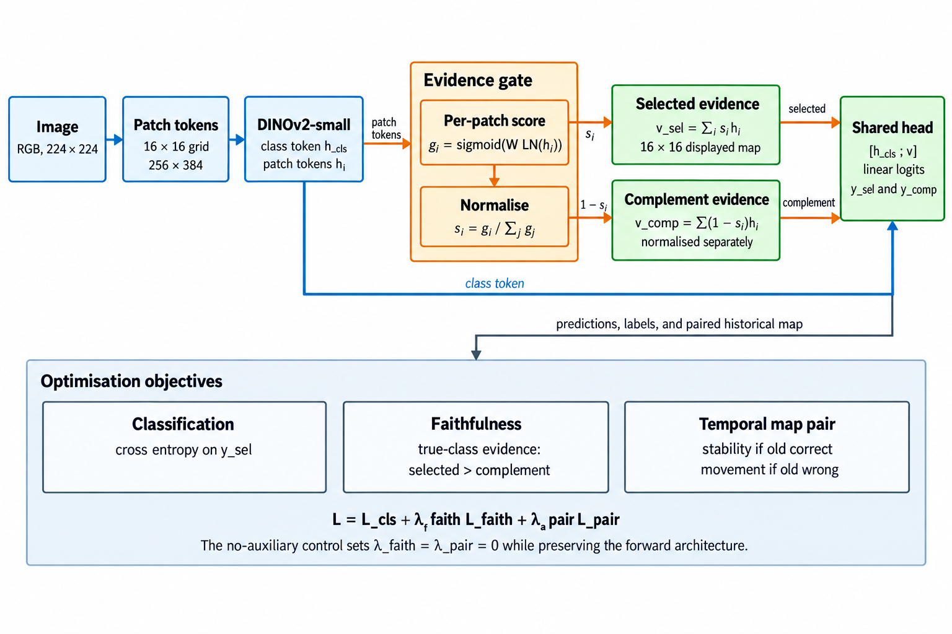
Figure 1. Embedded saliency-guided ViT forward computation and training signals
Faithfulness in this paper means that the reported patch importance has a measurable relationship with the model's prediction. The model classifies both the saliency-weighted representation and its low-saliency complement. The loss rewards stronger true-class evidence in the selected patches than in the complement, adapting the perturbation principle used in saliency-guided training [13]. During temporal adaptation, a pairwise term discourages unnecessary map movement when the historical model is correct and permits a minimum divergence when it is wrong. This objective does not prove causality, but it creates a behaviour that can be checked through matched deletion tests.
The learned map answers a limited but concrete question: which ViT patch tokens received weight in the representation used for classification? It is not treated as a segmentation mask. A concentrated map can still be wrong, and a diffuse map can still support a correct prediction. The report therefore avoids interpreting visual neatness as proof of faithfulness.
The complementary path provides a simple testable expectation: the selected patches should support the correct class more strongly than the remaining patches. This is added as a soft loss so that useful contextual information is not excluded by a hard mask.
During adaptation, the frozen branch provides the reference map. If its prediction is correct, the new map is discouraged from moving unnecessarily. If it is wrong, the pairwise loss allows a larger change. The class label still determines whether an update succeeds; map divergence alone does not.

3.1.1 Why the XAI signal is required
If the saliency map were drawn only after prediction, the experiment would reduce to ordinary model replacement with an illustration attached. In the implemented model, the patch weights form the representation used for classification, the auxiliary losses shape those weights during adaptation, and the historical-versus-updated comparison reads the same weights at inference. The explanation therefore forms part of the model state and the update policy.
The need for this design depends on the deployment objective. An accuracy-only system can select the updated ViT for every image when validation supports that choice. This project instead requires a recoverable historical model, a per-image reason for each switch, and evidence for investigating harmful replacements. Saliency cannot satisfy those requirements alone, so the router combines map change with prediction features and the evaluation adds a deletion-based faithfulness check.

3.2 Asymmetric Siamese comparison and explicit routing rule
For each image, the old and new ViTs return a class distribution and a patch-weight distribution. Four differences are standardised and passed to a saved logistic equation. The new prediction can be selected only when the models disagree, saliency divergence exceeds a calibrated floor, and the logistic probability exceeds its threshold. The coefficients and thresholds are stored in router_policy.json.
Figure 2 uses two instances of the same XAI-guided ViT on the same image. The setup is asymmetric. Both branches begin from the historical checkpoint, but the old branch is frozen while the new branch adapts its final three transformer blocks, saliency gate, and classification head on the 2010 stream. During evaluation, both branches are fixed. Retaining both branches is necessary because update safety is comparative: a single updated model cannot show which predictions or evidence maps changed relative to the deployed model. The resulting traceability requires two ViT forward passes for each routed image.
The models are compared at the prediction and patch levels. Prediction features describe class disagreement, confidence gain, and entropy reduction. Patch features describe Jensen-Shannon divergence and the change in selected-versus-complement class evidence. No learned routing embedding is used. The saved row for each image is enough to reconstruct the routing decision.
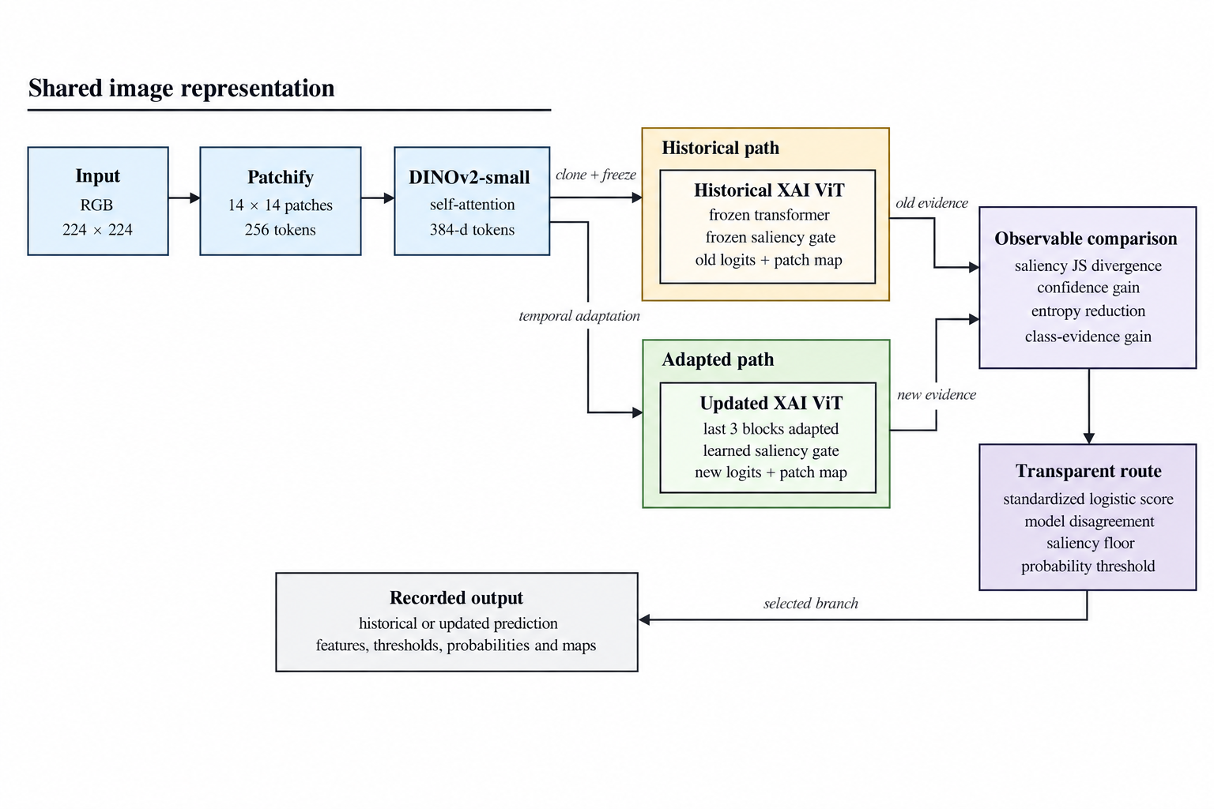
Figure 2. Asymmetric Siamese comparison between the frozen historical ViT and drift-adapted ViT
Logistic regression was chosen so that the route can be reproduced from a short coefficient vector [20]. A positive calibration target means that the historical model is wrong and the updated model is correct. The four inputs are standardised, and class-balanced fitting compensates for the smaller number of useful updates. The score is p(update | x) = sigmoid(b + wᵀz). Saving b, w, and the feature means and scales is sufficient to recalculate it.
Probability alone does not determine the route. The implementation searches saliency-floor quantiles and probability thresholds in 2011 only, choosing the pair with the highest calibration macro F1 and then fewer harmful routes as the tie-breaker. At inference, the newer branch is selected only if the branches disagree, saliency change exceeds the stored floor, and the fitted probability exceeds the stored threshold. This staged rule reflects the calibration literature's warning that a classifier score should not automatically be treated as a trustworthy probability without empirical checking [24]. It also keeps the final decision auditable: a reviewer can see the raw signals, standardised values, weighted sum, two eligibility checks, and selected branch for every image.
Saliency divergence measures how much the spatial evidence distribution changed. Confidence gain measures whether the newer branch is more certain in its selected class. Entropy reduction measures whether its full predictive distribution became more concentrated. Class-evidence gain measures whether the newer representation provides stronger support for the candidate class. No feature is assumed to be sufficient in isolation.
Coefficient signs describe associations in the 2011 calibration sample. A positive confidence coefficient means that confidence gain was associated with useful updates after the other selected features were considered. It does not show that increasing confidence would cause correctness. The router is transparent as a policy, while its statistical relationships remain empirical.
The code now exposes three matched router calibrations: confidence-only uses confidence gain and entropy reduction; saliency-only uses JS divergence and class-evidence gain; combined uses all four. Prediction-only calibration omits the saliency floor, while the other two retain it. These options address RQ3 directly, but the current tables predate this addition and do not report their comparative results.

4. Temporal protocol
Table 3. Chronological training, adaptation, calibration, and evaluation protocol
Stage | Years | Role
Historical training | 2004-2008 | Fit the original ViT models
Model selection | 2009 | Choose checkpoints without touching future years
Drift adaptation | 2010 | Adapt XAI ViT on balanced clean/corrupted data
Router calibration | 2011 | Archived run: select adapted checkpoint and fit router on shared labels; corrected code uses disjoint class-stratified partitions
Frozen evaluation | 2012-2014 | Test clean and drifted data once across a future horizon

4.1 Dataset selection and external validity
CLEAR-100 is the primary dataset because it preserves a fixed 100-class image task across upload years from 2004 to 2014 and supports near-future evaluation [1]. The protocol trains the historical model on 2004-2008, selects it in 2009, adapts the newer branch in 2010, calibrates routing in 2011, and freezes every component before the 2012-2014 horizon. This order represents one deploy-update-observe cycle rather than annual retraining.
The installed dataset was audited before the statistical rerun. The manifest contains 164,821 unique paths and image identifiers, maps every bucket to 2004-2014 consistently, contains all 100 classes in every train and test bucket, and has no missing files. The train and test archive SHA-256 values match the configured CLEAR-100 releases. These checks rule out duplicate identifiers, missing images, and year or label remapping errors in the local pipeline; they do not rule out annotation noise in the source dataset.
Supplementary datasets assess the extension capability of individual parts of the approach. Yearbook adds a second temporal image stream, CIFAR-10.1 adds an independently recollected test set, and Camelyon17-WILDS adds institution and scanner shift. FMoW-WILDS and iWildCam-WILDS remain useful future directions for satellite time and location change and camera-location change [2]. Their domains, class structures, storage requirements, and split definitions differ from CLEAR, so each needs a separately specified protocol. These screens test transfer boundaries; they do not convert the CLEAR correction experiment into a multi-dataset router benchmark.

4.2 Operational definitions of drift conditions
Clean stream. The model receives the unaltered CLEAR-100 image from the named calendar year. Any change across 2012, 2013, and 2014 comes from the dataset's natural temporal ordering, with no synthetic transform added.
Legacy combined condition. Every image receives the same three transformation families: saturation reduction, Gaussian noise, and one square local-mean occlusion. The severity rises with the test year. This deterministic condition reproduces the original experiment, but it overrepresents occlusion and does not identify which acquisition change caused a score difference.
Source-separated conditions apply one named transformation at a time so its effect remains identifiable. ImageNet-C motivates the broad noise, blur, weather, and digital families [4]. Gaussian noise is retained as a tractable proxy for sensor read noise and low-light acquisition error, but independent, identically distributed Gaussian pixels are an approximation rather than a model of every camera sensor. Motion blur represents relative camera or object movement during exposure, although a fixed digital kernel simplifies real trajectories, shutter timing, and depth. JPEG compression and resolution loss represent changes in storage, transmission, or imaging pipelines. Illumination and white balance approximate environmental and camera-processing change. Viewpoint shift and localised occlusion represent changes in capture geometry or visibility, motivated by operational image studies in WILDS and camera traps [2] [25]. Each transform is therefore a controlled stressor with a stated physical rationale. None is labelled natural temporal drift merely because it lowers accuracy; CLEAR supplies the calendar-year chronology [1].
Realistic mixture (implementation label: realistic_mix). This is a reproducible compound acquisition stress test, not an estimate of how often these conditions occur in industry. Its source families follow the corruption mechanisms used in ImageNet-C [4] and the capture changes represented in WILDS [2]. A fixed seed assigns one non-occlusion source at severity one, two at severity two, or three at severity three, so the 2014 condition applies three bounded level-three acquisition changes to each image. A localised occlusion covering 5% of the image is added to 10% of samples. This minority rate prevents obstruction from dominating the mixture; it is a design choice rather than a measured prevalence. Every component is written to the decision log, and the experiment reports each source separately before interpreting the mixture. Occlusion is treated as sample corruption unless its frequency or geometry changes across the stream; only then does it contribute to distribution shift.
The word realistic refers to plausible mechanisms and bounded magnitudes, not to measured prevalence or dependence within a particular camera fleet. A visible perturbation is not automatically evidence of dataset drift. The verification stage must show that a transformed sample changes the frozen feature distribution beyond a clean within-year control, and the classifier evaluation must then show whether that shift is harmful. Natural-shift research also shows that rankings can change across sources and datasets [21]. Synthetic stressors are therefore reported beside, rather than substituted for, natural temporal and native benchmark shifts.
Adaptation and calibration use 25% clean images and 75% images with one individual source. Each of the nine source types occupies one twelfth of the full stream, so occlusion accounts for 8.3% rather than every image. Compound mixtures remain withheld until final evaluation. This design tests limited generalisation beyond the exact single-source pattern used during updating while keeping the historical checkpoint and routing rule fixed.

4.3 Independent verification of declared drift
The experiment verifies every declared condition before interpreting a classification difference. Images are embedded with the frozen DINOv2 backbone used by the classifier. Radial-basis-function maximum mean discrepancy (MMD) measures distributional separation without assuming Gaussian features [26]. For clean and corrupted views of the same image, the permutation test now swaps the domain label within each image pair; independent pooled-label permutation would break the pairing and answer a different question. A balanced logistic domain classifier provides a second measure under five-fold cross-validation [27]. Paired views share a group identifier, so both views remain in the same fold and image identity cannot leak between fitting and evaluation. The reported AUC keeps its observed orientation rather than reflecting values below 0.5 after inspection.
The tests separate statistical detectability from practical magnitude. A paired p value asks whether a consistent within-image feature change is present; MMD squared and grouped domain AUC describe the size and linear separability of that change. Accuracy and macro F1 then show whether it damages the classification task. The archived audit used 199 randomisations, so its Monte Carlo p values change in increments of 1 / (199 + 1) = 0.005. A reported value of 0.005 is therefore the smallest value that run could produce, not an exact tail probability and not evidence that every transform has the same effect. The code therefore uses 499 randomisations for routine and frozen audits in this study (minimum p = 0.002), and every report records that resolution alongside the test result. A clean 2014 class-stratified split-half comparison remains an unpaired finite-sample null, while clean-to-corrupted comparisons preserve image pairs. Natural 2009 and 2012-2014 comparisons use independent samples from the same held-out test archive. Pretrained representations can be more sensitive than raw pixels [28], and the public MMDDrift and ClassifierDrift implementations in Alibi Detect provide an independent software reference [29].
A controlled condition is reported as a detectable paired feature change when the within-pair permutation test rejects exchangeability. It is described as operationally material only when the effect size or domain separability is also substantial and task performance changes. This distinction prevents a tiny but consistent transform from being presented as a large deployment shift. Natural temporal drift is assessed with the unpaired test and is not claimed when both MMD and domain AUC remain near the clean control.
Table 4. Corrected frozen-feature drift verification on 300 CLEAR-100 samples per condition
Comparison | MMD squared | p* | Domain AUC | Interpretation
Clean split-half control | 0.00378 | 1.000 | 0.398 | Finite-sample null
2009 to 2012 clean | 0.00186 | 0.995 | 0.442 | Not detected
2009 to 2013 clean | 0.00183 | 0.940 | 0.457 | Not detected
2009 to 2014 clean | 0.00195 | 0.930 | 0.470 | Not detected
Illumination | 0.00002 | 0.005 | 0.519 | Detectable, negligible separation
White balance | 0.00017 | 0.005 | 0.601 | Small paired shift
Sensor noise | 0.00395 | 0.005 | 0.948 | Large separability
Defocus blur | 0.00112 | 0.005 | 0.787 | Moderate separability
Motion blur | 0.02271 | 0.005 | 0.993 | Largest measured shift
JPEG compression | 0.00233 | 0.005 | 0.971 | Large linear separation
Resolution loss | 0.00078 | 0.005 | 0.743 | Moderate separability
Viewpoint shift | 0.00300 | 0.005 | 0.851 | Large separability
Occlusion | 0.00212 | 0.005 | 0.824 | Large separability
Realistic mixture | 0.01138 | 0.005 | 0.943 | Second-largest MMD
The asterisk in Table 4 marks the Monte Carlo resolution limit. The corrected seed-42 run resolves the earlier high-AUC, non-significant-MMD disparity. That disparity arose because paired views were independently permuted and could be placed in different domain-classifier folds. Within-pair permutation and grouped cross-validation now test the paired design. Every controlled transform reached p = 0.005, the 199-randomisation floor, so the p column establishes detectability but cannot rank the transforms. Effect size and separability provide that distinction. Illumination has negligible MMD and near-chance AUC, whereas motion blur and the realistic mixture have the two largest MMD values. Sensor noise, JPEG compression, viewpoint shift, and occlusion are also strongly separable. After holding the archive partition constant, the clean 2009-to-2014 comparisons remain non-significant with AUC values from 0.442 to 0.470. This 300-sample audit therefore does not independently verify natural temporal feature drift in CLEAR.
Drift existence and drift mitigation remain separate claims. Table 4 verifies systematic feature change for the paired stressors and shows which changes have material effect sizes. A representation-level mitigation claim must repeat the same paired tests after adaptation using one common kernel bandwidth for the historical and adapted features. It also requires lower MMD, lower grouped domain AUC, and a reduction in paired normal-to-adverse cosine distance whose 95% bootstrap interval excludes zero. Retained feature variance and effective rank must each remain at least 80% of the historical value so that feature collapse cannot appear invariant. The corrected implementation now enforces the pairing, grouped folds, and common bandwidth required by this test.
Task-level mitigation is assessed separately: adverse-condition macro F1 must improve over the historical branch while clean performance stays within the existing 0.50-point safety bound. The archived CLEAR results satisfy this predictive criterion for motion blur and the realistic mixture, and Table 4 verifies that both conditions shift the historical feature distribution. The runs did not preserve matched historical and adapted embedding archives, so they do not yet show that adaptation reduces MMD or domain separability. The present paper therefore demonstrates detected drift and successful predictive correction under selected conditions, while treating representation-level mitigation as an untested hypothesis.
Figure 3 provides a visual comparison of the two drift measures in Table 4. MMD records the distance between frozen feature distributions, whereas the domain classifier tests how readily source and target samples can be distinguished.
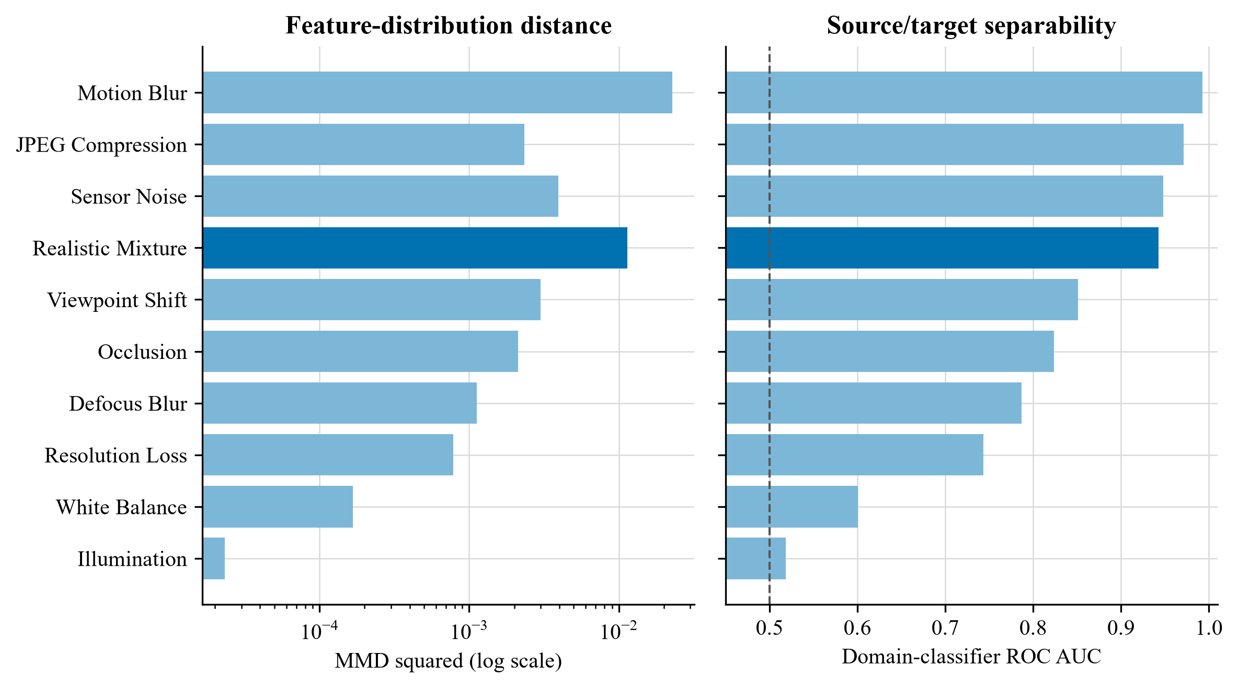
Figure 3. Independent drift evidence for the controlled 2014 conditions
The measures broadly agree on the ordering of severe shifts: motion blur and the realistic mixture produce both large feature distances and high domain separability. Illumination is detectable by the paired test but remains close to chance-level separability, so it should be described as a weak controlled shift rather than strong deployment drift. The dashed line marks chance discrimination at an AUC of 0.50.

4.4 Cross-dataset replication protocol
Supplementary testing uses a dataset-specific split rather than applying the CLEAR corruption mixture to unrelated domains. A frozen DINOv2-small backbone supplies patch tokens. A linear probe measures the task difference between an in-distribution holdout and the external split, while MMD and held-out domain-classifier AUC assess feature separation. These measures answer different questions: the probe measures predictive change, MMD measures distribution discrepancy, and domain AUC measures separability.
The architecture screen trains matched uniform-patch and saliency-gated classifier heads over the same frozen backbone, sampled images, seed, two-epoch budget, and optimiser settings. This isolates the head design within a small external screen. It does not test temporal fine-tuning, auxiliary saliency losses, router calibration, or historical fallback. A positive head difference would support transfer of one component; a negative result would delimit the claim without contradicting a CLEAR routing gain.
The Yearbook feasibility screen uses portraits from 1930-1989 for training, 1980-1989 for an in-distribution holdout, and 2004-2013 for the later window [3]. This is a deliberately separated internal screen rather than Wild-Time's official Eval-Fix protocol. CIFAR-10.1 uses the recommended class-balanced v6 recollection of 2,000 images [30]. Camelyon17-WILDS uses lymph-node histopathology from multiple hospitals, where scanner, staining, and institutional acquisition differences form a clinically meaningful source of covariate shift [31]. The Camelyon screen uses a patient-disjoint source-hospital holdout and the validation hospital as the external domain.
The three screens are feasibility experiments, not benchmark submissions. The Camelyon17 run uses a 10.7 GB public mirror, a balanced 5,000-image training sample, three seeds, and DINOv2 pre-training. WILDS evaluation guidance asks for ten Camelyon runs and prohibits external pre-training for leaderboard comparison [32]. The reported Camelyon values must therefore be read as internal architecture evidence only.

4.5 Enhanced correction experiment
The --adaptation-profile enhanced mode was defined before the enhanced run to increase the separation between the historical ViT and the saliency-responsive correction model without changing the test set. It changes only training exposure, optimisation, and calibration:
- 25% clean and 75% individually corrupted samples, spanning severities 1-3;
- the final three transformer blocks are trainable instead of only the final block;
- backbone learning rate remains 1e-5, while classifier and saliency heads use 5e-5;
- label smoothing is 0.05 and the saliency terms receive weight 0.25;
- the saliency divergence margin increases from 0.05 to 0.08;
- router calibration jointly selects a saliency-floor quantile and probability threshold on 2011 only.
Each change in the enhanced profile addresses a specific constraint. The 25% clean share limits forgetting, while individual corruption families expose the updated branch to plausible acquisition changes without revealing the held-out compound test. Unfreezing three transformer blocks adds adaptation capacity, but the lower backbone learning rate protects pretrained features. The higher head rate lets the classifier and saliency gate respond faster, and the increased saliency weight tests whether explanation guidance adds value beyond that extra capacity. The matched no-saliency-loss control isolates the contribution of those auxiliary objectives.
The completed enhanced run used the same historical checkpoint, seed 42, and frozen 2012-2014 evaluation streams as its controls. Its adapted checkpoint and routing policy were both chosen using the 2011 sample. Epoch 4 was selected by 2011 macro F1 (94.39%); epoch 5 declined to 93.00%, indicating overfitting after the selected checkpoint. Training took approximately 138 seconds per epoch after warm-up. Combined corruption remained unavailable during adaptation and calibration. Because checkpoint selection and policy fitting share 2011 labels, all reported numerical results are exploratory rather than confirmatory.

4.6 Protocol correction for future runs
Reusing 2011 for both checkpoint selection and router calibration gives the policy information about the sample that already determined which adapted model survived. This can make route thresholds look better matched to that window than they would be on new data. The code now divides 2011 deterministically within each class: one partition selects the adapted checkpoint and the other fits logistic coefficients, the saliency floor, and the probability threshold. The default split is 50/50 and is recorded with both sample counts. A legacy flag reproduces the shared protocol for audit purposes. The tables in this paper were not recomputed after that correction, so the distinction is explicit rather than retroactively changing the meaning of the reported runs.

4.7 Hypotheses and success criteria
- H1: under at least one severe, high-headroom 2014 condition, routed XAI improves macro F1 by at least 2.00 percentage points over the historical ViT.
- H2: transparent routing retains at least 75% of the gain achieved by always using the updated model.
- H3: clean 2014 macro F1 does not fall by more than 0.50 points relative to the historical XAI model.
The two-point value is the sole practical benchmark used in this paper. It is grounded in the range of effects reported by the closest saliency and temporal-learning studies, but it is not a statistical decision rule. Repeated seeds and paired confidence intervals are still required before a small difference can be treated as stable.

4.8 Enhanced results against the criteria
- H1 met for two severe source-separated tests: routed XAI gained 3.45 points under motion blur and 2.03 points under the realistic mixture. The benchmark was not met on the legacy combined condition or the milder individual shifts.
- H2 met: routing retained (91.85-90.34)/(91.99-90.34) = 91.5% of the newer model's gain over historical XAI.
- H3 met: routed clean 2014 macro F1 was 95.30%, 0.06 points above historical XAI.

4.9 Checkpoint and interruption recovery
Every evaluated epoch atomically replaces models/resume.pt and writes a small resume.json. The binary checkpoint contains the newer ViT parameters, optimiser state, completed epoch, and best validation score; the separate best-model file remains the checkpoint used for final evaluation. The matched standard run was deliberately stopped after epoch 2 and resumed at epoch 3. It retained the epoch-2 optimiser and best score, later selected epoch 4, and completed the frozen horizon normally. A local round-trip regression test independently reloads and compares weights, optimiser state, epoch, score, and metadata.

5. Main results
Macro F1 is shown as a percentage. A helpful route replaces an incorrect historical prediction with a correct updated prediction. A harmful route replaces a correct historical prediction with an incorrect updated prediction. A missed helpful case occurs when the updated model is correct but the policy retains an incorrect historical answer. Helpful and harmful counts must be read together because greater route coverage can increase both.
Table 5. Original temporal evaluation results
Scenario | Year | Baseline | Historical XAI | Routed | Helpful | Harmful
Clean | 2012 | 95.86 | 95.96 | 96.40 | 30 | 8
Clean | 2013 | 95.27 | 95.23 | 95.79 | 40 | 12
Clean | 2014 | 95.13 | 95.24 | 95.46 | 30 | 18
Combined | 2012 | 95.47 | 95.47 | 96.08 | 45 | 14
Combined | 2013 | 93.75 | 93.81 | 94.55 | 72 | 32
Combined | 2014 | 90.59 | 90.34 | 91.50 | 120 | 48

On 2014 combined drift, the baseline reached 90.59%, the historical XAI model 90.34%, the updated XAI model 91.75%, and the transparent router 91.50% macro F1. The router captures (91.50-90.34)/(91.75-90.34) = 82.3% of the available update gain. The updated model also remains stronger on clean images, although the router becomes more conservative and records 18 harmful routes against 30 helpful routes in 2014.

5.1 Enhanced profile results
Table 6. Enhanced adaptation profile results
Scenario | Year | Historical XAI | Enhanced XAI | Enhanced routed | Helpful | Harmful
Clean | 2012 | 95.96 | 95.89 | 96.03 | 65 | 62
Clean | 2013 | 95.23 | 95.49 | 95.55 | 60 | 44
Clean | 2014 | 95.24 | 95.47 | 95.30 | 69 | 64
Combined | 2012 | 95.47 | 95.71 | 95.81 | 76 | 58
Combined | 2013 | 93.81 | 94.43 | 94.44 | 101 | 66
Combined | 2014 | 90.34 | 91.99 | 91.85 | 188 | 90

The enhanced curriculum improved the always-new 2014 combined score from 91.75% to 91.99%, a further 0.24 points. The routed score increased from 91.50% to 91.85%, a further 0.35 points. This modest change does not meet the two-point practical benchmark and shows that additional adaptation capacity alone is insufficient.
Figure 4 places the enhanced results on the complete frozen 2012-2014 horizon.
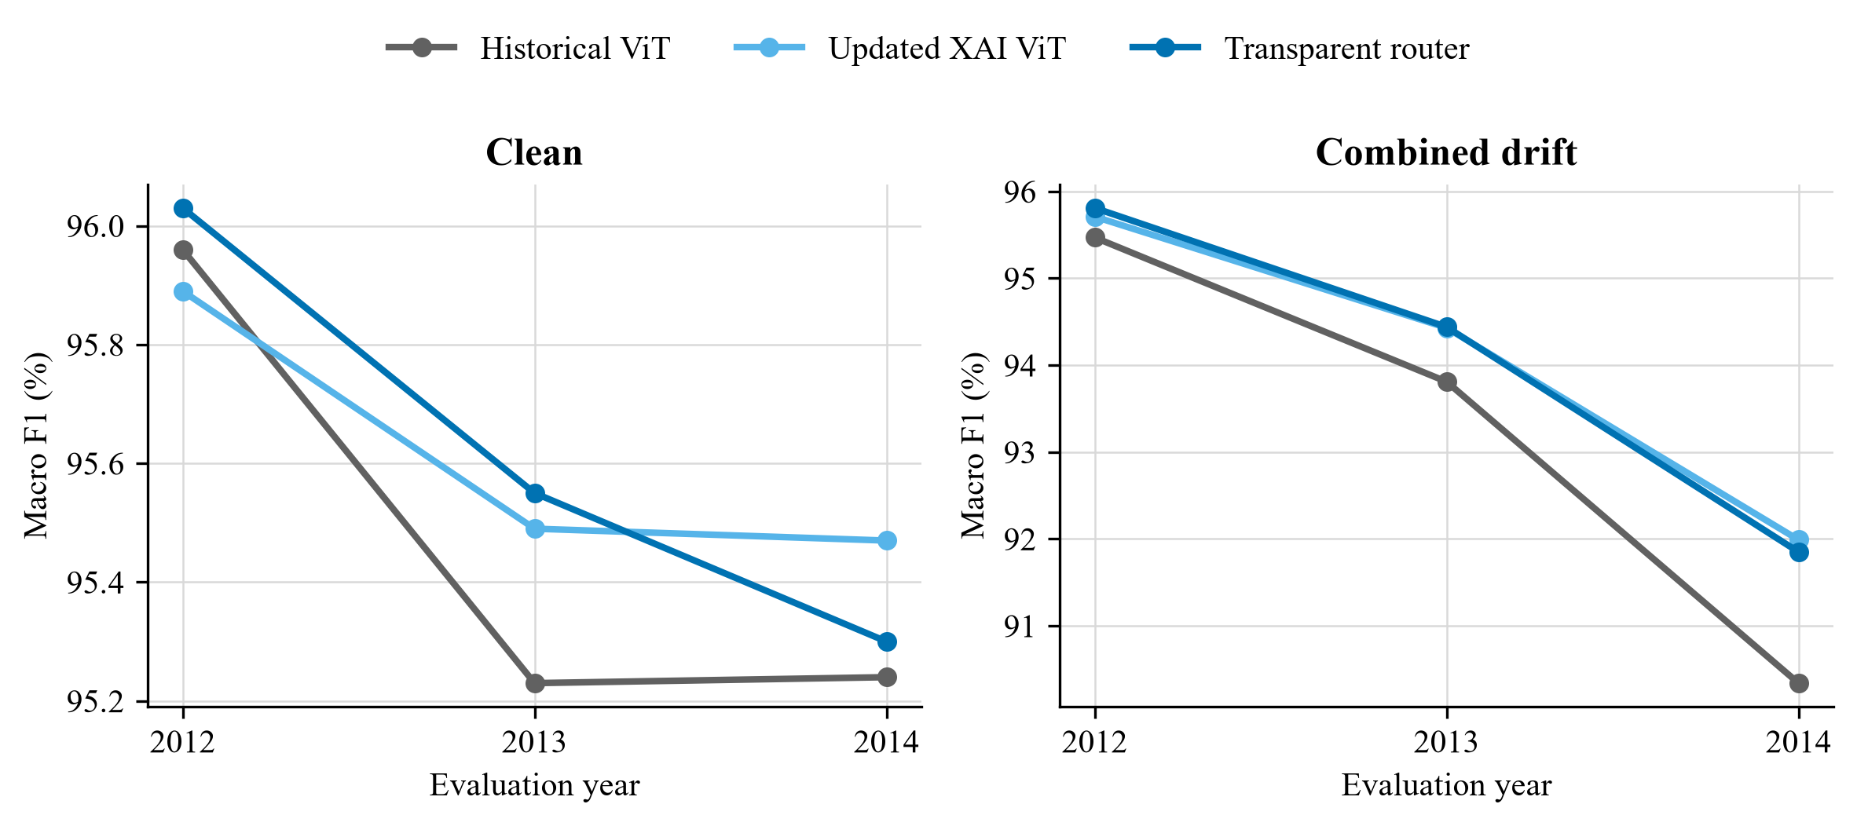
Figure 4. Macro F1 across the frozen future evaluation horizon
On clean data, all three branches remain within a narrow 0.73-point range across the horizon. Under combined drift, the historical ViT falls more sharply, while the updated and routed variants retain 1.65 and 1.51 points respectively in 2014. The router is slightly below always-updated inference in 2014, which shows that its value is selective replacement and auditability rather than a universal accuracy advantage.

5.2 Controlled five-epoch ablation
The matched run removes the earlier three-versus-five-epoch imbalance. The auxiliary-loss control keeps the enhanced curriculum, trainable blocks, learning rates, and saliency-gated classifier fixed, but sets the pairwise saliency-divergence and complementary-evidence loss weights to zero. It therefore isolates the explicit saliency supervision while retaining saliency inside the forward pass.
Table 7. Controlled five-epoch ablation
Variant | 2014 clean routed | Combined old | Combined new | Combined routed | Helpful | Harmful
Matched standard (5 epochs) | 95.78 | 90.34 | 91.68 | 91.72 | 144 | 57
Enhanced with auxiliary losses | 95.30 | 90.34 | 91.99 | 91.85 | 188 | 90
Enhanced without auxiliary losses | 95.45 | 90.34 | 91.86 | 91.62 | 125 | 43

Bold type marks the best value in each evaluation column across the three matched configurations; ties are bolded together. Helpful and harmful counts describe route composition rather than interchangeable accuracy measures, so the most helpful and least harmful counts are emphasised separately.
Against the matched enhanced control, the auxiliary saliency objectives changed 2014 combined macro F1 by +0.13 points for always-updated inference and +0.23 points after routing. The positive signs favour the saliency-supervised run, but the magnitudes are small and come from one paired seed. The same objectives also increased route coverage, producing more helpful and more harmful switches. These results support further testing of explanation guidance rather than a claim of reliable accuracy improvement.
The ablation separates predictive gain from the reason for retaining XAI guidance. The saliency-gated head remains part of the forward pass in both enhanced variants, while the auxiliary-loss row tests whether explicit explanation supervision adds value. Its +0.23-point routed effect is modest and comes from one run. The stronger practical case for the XAI design is that it records which evidence changed, uses that change in a reviewable policy, and exposes harmful switches for inspection. The experiment does not show that XAI is required for maximum classification accuracy.

5.3 Source-separated drift evaluation
The broader protocol evaluates the same saved historical checkpoint, adapted checkpoint, and 2011 routing policy across 11 independently named 2014 conditions. Each row contains the frozen historical score, the always-updated score, the transparent routed score, and the routed change from the historical branch. This separation prevents a favourable occlusion example from standing in for unrelated acquisition changes.
Table 8. Source-separated 2014 drift results
2014 condition | Historical | Updated | Routed | Routed change
Clean | 95.24 | 95.54 | 95.36 | +0.12
Illumination | 95.13 | 95.46 | 95.24 | +0.11
White balance | 95.16 | 95.61 | 95.43 | +0.27
Sensor noise | 94.20 | 94.72 | 94.44 | +0.24
Defocus blur | 94.41 | 94.93 | 94.75 | +0.34
Motion blur | 83.17 | 87.13 | 86.62 | +3.45
JPEG compression | 93.64 | 94.27 | 94.09 | +0.45
Resolution loss | 93.69 | 94.26 | 94.10 | +0.41
Viewpoint shift | 94.32 | 95.09 | 94.91 | +0.59
Occlusion | 93.93 | 94.74 | 94.68 | +0.75
Realistic mixture | 86.41 | 88.62 | 88.44 | +2.03

Motion blur produces the largest routed gain: +3.45 percentage points, from 357 helpful and 90 harmful switches. The 2014 realistic mixture is the level-three compound condition defined in Section 4.2: each image receives three deterministic non-occlusion transformations, and 10% receive an additional localised occlusion covering 5% of the image. It gains +2.03 points, with 261 helpful and 95 harmful switches. Occlusion alone gains +0.75 points. The result is therefore driven by a broader acquisition mixture rather than by universal obstruction, although the synthetic construction still limits external validity.
Table 9. Effect of auxiliary saliency objectives on routed performance
Matched 2014 condition | Saliency routed change | No-aux routed change | Auxiliary effect on route
Clean | +0.12 | +0.30 | -0.18
Motion blur | +3.45 | +2.55 | +0.90
Viewpoint shift | +0.59 | +0.53 | +0.06
Occlusion | +0.75 | +0.69 | +0.06
Realistic mixture | +2.03 | +1.19 | +0.84

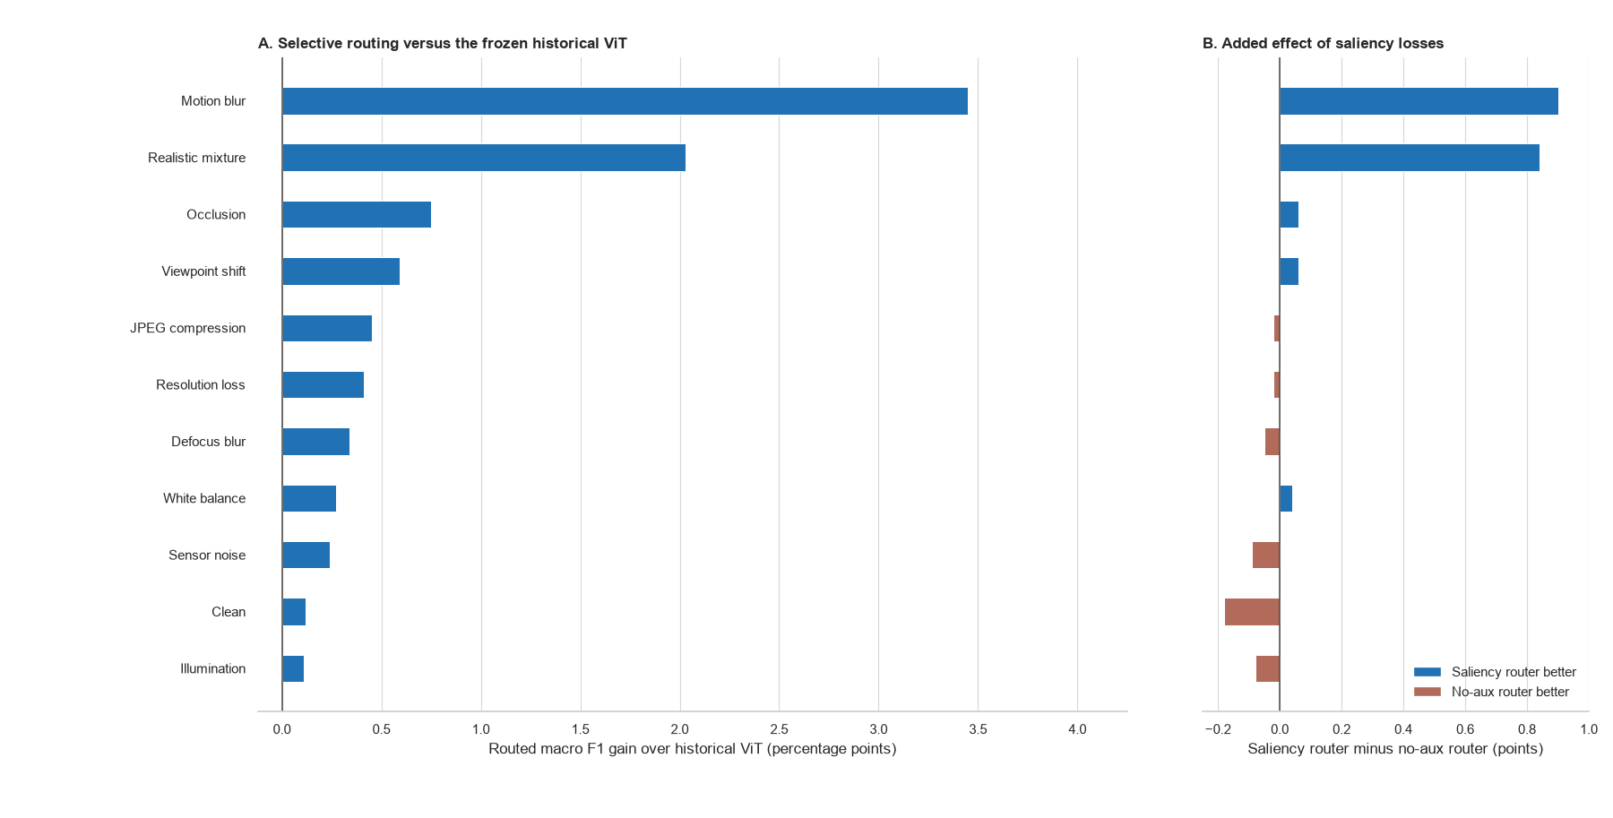
Figure 5. Selective-routing gain over the historical ViT and the added effect of saliency losses
Figure 5 evaluates routing against the frozen historical ViT. A positive bar means that routing improves macro F1 over the deployed reference; it does not mean that routing outperforms the always-updated ViT. The largest routed gains occur under motion blur (+3.45 points) and the realistic mixture (+2.03 points). Relative to a matched router without auxiliary saliency losses, the explanation-guided losses add +0.90 and +0.84 points in those conditions. Routing prevents 16 and 20 harmful replacements compared with the matched control, but it also misses 47 and 30 available corrections. The updated ViT remains 0.06-0.51 points higher overall. The router trades that small amount of peak accuracy for a historical fallback and an inspectable decision record.

5.4 Class-level and historical-difficulty analysis
Overall macro F1 can conceal whether an update helps many classes slightly, rescues a small number of difficult classes, or transfers errors between classes. The saved 2014 decisions were therefore rescored one class against the remaining 99 classes. Every class has 50 test examples and exceeds the minimum support of 20. Within each condition, classes are ranked by the historical model's F1 and divided into four equal groups from Q1, the weakest 25 classes, to Q4, the strongest 25 classes.
Table 10. Routed macro F1 change by historical class-performance quartile on CLEAR-100 in 2014 (percentage points)
Condition | Variant | Q1 weakest | Q2 | Q3 | Q4 strongest
Clean | Saliency supervised | +1.87 | -0.46 | -0.46 | -0.47
Clean | No auxiliary loss | +2.07 | +0.02 | -0.32 | -0.54
Realistic mixture | Saliency supervised | +5.91 | +2.00 | +1.06 | -0.81
Realistic mixture | No auxiliary loss | +2.91 | +1.14 | +1.16 | -0.44
The realistic-mixture result is concentrated in classes that the historical model found difficult. The saliency-supervised router gains 5.91 points in Q1, compared with 2.91 points for the matched no-auxiliary-loss router. It improves 65 classes and worsens 35, giving a mean per-class change of +2.04 points. The control improves 61 classes, leaves three unchanged, and worsens 36, for a +1.19-point mean change. In Q4, both variants lose performance, with changes of -0.81 and -0.44 points respectively. The result supports targeted correction of weak classes under compound drift, but it also shows that the present rule does not fully protect classes that were already reliable. Bold values mark the larger routed change within each matched pair.
On clean data, both routers again help Q1 while the remaining groups are flat or slightly worse. The saliency-supervised clean mean is +0.12 points across classes, compared with +0.30 points for the control. These strata are descriptive evidence from one seed. Per-class F1 depends on false positives arriving from other classes as well as decisions made on the class itself, so helpful and harmful route counts cannot explain every class change in isolation. Repeated seeds and class-level confidence intervals remain necessary before claiming stable class-specific benefits.

5.4.1 Interpretation in relation to prior work
The concentration of improvement in Q1 is compatible with the mechanism proposed by saliency-guided training, although it does not prove that mechanism. SGAN uses saliency priors to constrain attention away from irrelevant regions [11]. Saliency Guided Training perturbs low-saliency features while preserving the model output, turning an explanation into a training intervention [13]. Ma et al. similarly remove low-saliency ViT patches to reduce reliance on background shortcuts [15]. In the present architecture, learned patch weights enter the pooled representation and the auxiliary losses reward separation between useful and weak evidence. A plausible interpretation is therefore that compound drift exposes shortcut dependence most severely in historically weak classes, leaving more recoverable headroom when patch evidence is reweighted. The quartile analysis measures performance rather than shortcut use, however, and CLEAR has no object masks. It is convergent evidence for this interpretation, not a causal demonstration of it.
The asymmetric Siamese design gives that result a different meaning from ordinary retraining. Siamese-ViT work shows how paired transformer branches can compare local and global visual information [16], while asymmetric Siamese change detection preserves distinct roles for the two observations being compared [17]. Here the pair consists of model states rather than two scenes: the frozen branch represents the deployed historical decision and the adapted branch represents a candidate correction on the same image. The architecture therefore does not create a new label from similarity alone. It frames every update as a paired choice whose evidence can be inspected. The Q1 gain shows where the candidate branch contributes useful new evidence; the Q4 loss exposes negative transfer that a single updated model would hide inside its aggregate score.
This fallback role also connects the router to selective prediction and conservative test-time adaptation. SelectiveNet learns when a classifier should abstain rather than force an unreliable decision [10]. CoTTA reduces accumulated error through partial restoration of source weights [7], and EATA filters unsuitable updates to limit forgetting [8]. The present router makes a narrower intervention: it does not adapt on the test stream or abstain from classification, but chooses between an immutable historical branch and a separately adapted branch. The frozen branch is an exact recoverable reference, while the logistic rule keeps the selection traceable. The negative Q4 result shows that this safeguard is incomplete. A class-conditional threshold or a veto based on historical reliability is a defensible next modification, but it must be fitted on the calibration period and compared at equal route coverage to avoid using the final test classes to tune the rule.

5.5 Cross-dataset external screens
The external screens separate evidence of shift from evidence of architectural benefit. Table 11 records the native split and sampling protocol. Table 12 shows whether each external domain is both distinguishable and harder for a simple probe. Table 13 then compares matched heads over the same frozen features. The rows are reported separately because the tasks, class counts, shift mechanisms, and sample sizes differ; pooling them into one average would hide that heterogeneity.
Table 11. External dataset protocols and claim boundaries
Dataset | Native shift | Train / ID / OOD | Seeds | Scope
Wild-Time Yearbook | Later portrait years | 3,000 / 500 / 335 | 1 | Drift tests and matched heads
CIFAR-10.1 v6 | Independent recollection | 5,000 / 1,000 / 1,000 | 3 | Drift tests and matched heads
Camelyon17-WILDS | Held-out hospital | 5,000 / 1,000 / 1,000 | 3 | Exploratory, non-standard WILDS screen
Table 12. External drift evidence from frozen DINOv2 features
Dataset | Seed | Probe ID | Probe OOD | Change (pp) | MMD2 | p* | AUC
Wild-Time Yearbook | 42 | 89.40 | 92.53 | +3.14 | 0.0394 | 0.005 | 0.954
CIFAR-10.1 v6 | 42 | 93.84 | 88.48 | -5.35 | 0.0028 | 0.005 | 0.606
CIFAR-10.1 v6 | 43 | 95.00 | 86.69 | -8.31 | 0.0022 | 0.005 | 0.600
CIFAR-10.1 v6 | 44 | 92.79 | 87.31 | -5.49 | 0.0023 | 0.005 | 0.589
Camelyon17-WILDS | 42 | 84.70 | 68.01 | -16.69 | 0.0237 | 0.005 | 0.950
Camelyon17-WILDS | 43 | 93.58 | 73.12 | -20.46 | 0.0328 | 0.005 | 0.941
Camelyon17-WILDS | 44 | 84.43 | 83.14 | -1.30 | 0.0566 | 0.005 | 0.995
The asterisk in Table 12 marks the same 199-randomisation limit. All seven external runs reach p = 0.005, the minimum attainable value with their archived 199-randomisation tests. The p values establish detectable separation at that resolution but do not rank datasets or seeds. CIFAR-10.1 has only modest domain separability, with AUC from 0.589 to 0.606, while the probe loses about five to eight points. Yearbook and Camelyon show much stronger separability, with AUC above 0.94, and larger or more variable task changes. These tests verify that the selected external splits contain feature shift and task consequences; they do not imply that saliency should correct either one.
Table 13. Matched baseline and saliency-head macro F1 on external datasets
Dataset | Seed | Base ID | Base OOD | XAI ID | XAI OOD | Delta OOD (pp)
Wild-Time Yearbook | 42 | 85.20 | 78.13 | 85.20 | 77.81 | -0.33
CIFAR-10.1 v6 | 42 | 83.09 | 73.35 | 83.18 | 73.65 | +0.30
CIFAR-10.1 v6 | 43 | 81.77 | 73.43 | 82.05 | 73.63 | +0.20
CIFAR-10.1 v6 | 44 | 81.64 | 75.12 | 82.95 | 75.54 | +0.41
Camelyon17-WILDS | 42 | 78.39 | 71.55 | 77.82 | 71.55 | +0.00
Camelyon17-WILDS | 43 | 89.18 | 75.82 | 89.07 | 75.62 | -0.21
Camelyon17-WILDS | 44 | 94.10 | 84.56 | 94.20 | 84.56 | -0.00
The matched-head result is positive only on CIFAR-10.1: the saliency head gains 0.30 +/- 0.11 macro-F1 points across three seeds. Yearbook changes by -0.33 points in its single run. Camelyon changes by -0.07 +/- 0.12 points across three seeds, including one tie and two small losses. These results do not support a universal saliency-head advantage. They instead indicate that the CLEAR gains depend on temporal adaptation and selective routing, or on properties of that image domain, rather than on the head alone. The external evidence also shows why a router needs direct ablation: a head can move saliency without improving the prediction.

6. Saliency and routing analysis
Each audit row shows a clean reference, the drifted input, historical and updated saliency overlays, and the signed change map. The revised figure is exported at 300 dots per inch. Red marks patches that gain weight in the updated model and blue marks patches that lose weight. A more localised updated map means that high weight occupies a smaller, coherent part of the 16 x 16 patch grid, but localisation is interpreted only alongside the class prediction and deletion margin.
Figure 6 contains one helpful route from each of three drift families. The examples were selected for inspection and are not used to estimate performance; the aggregate counts below provide that evidence.
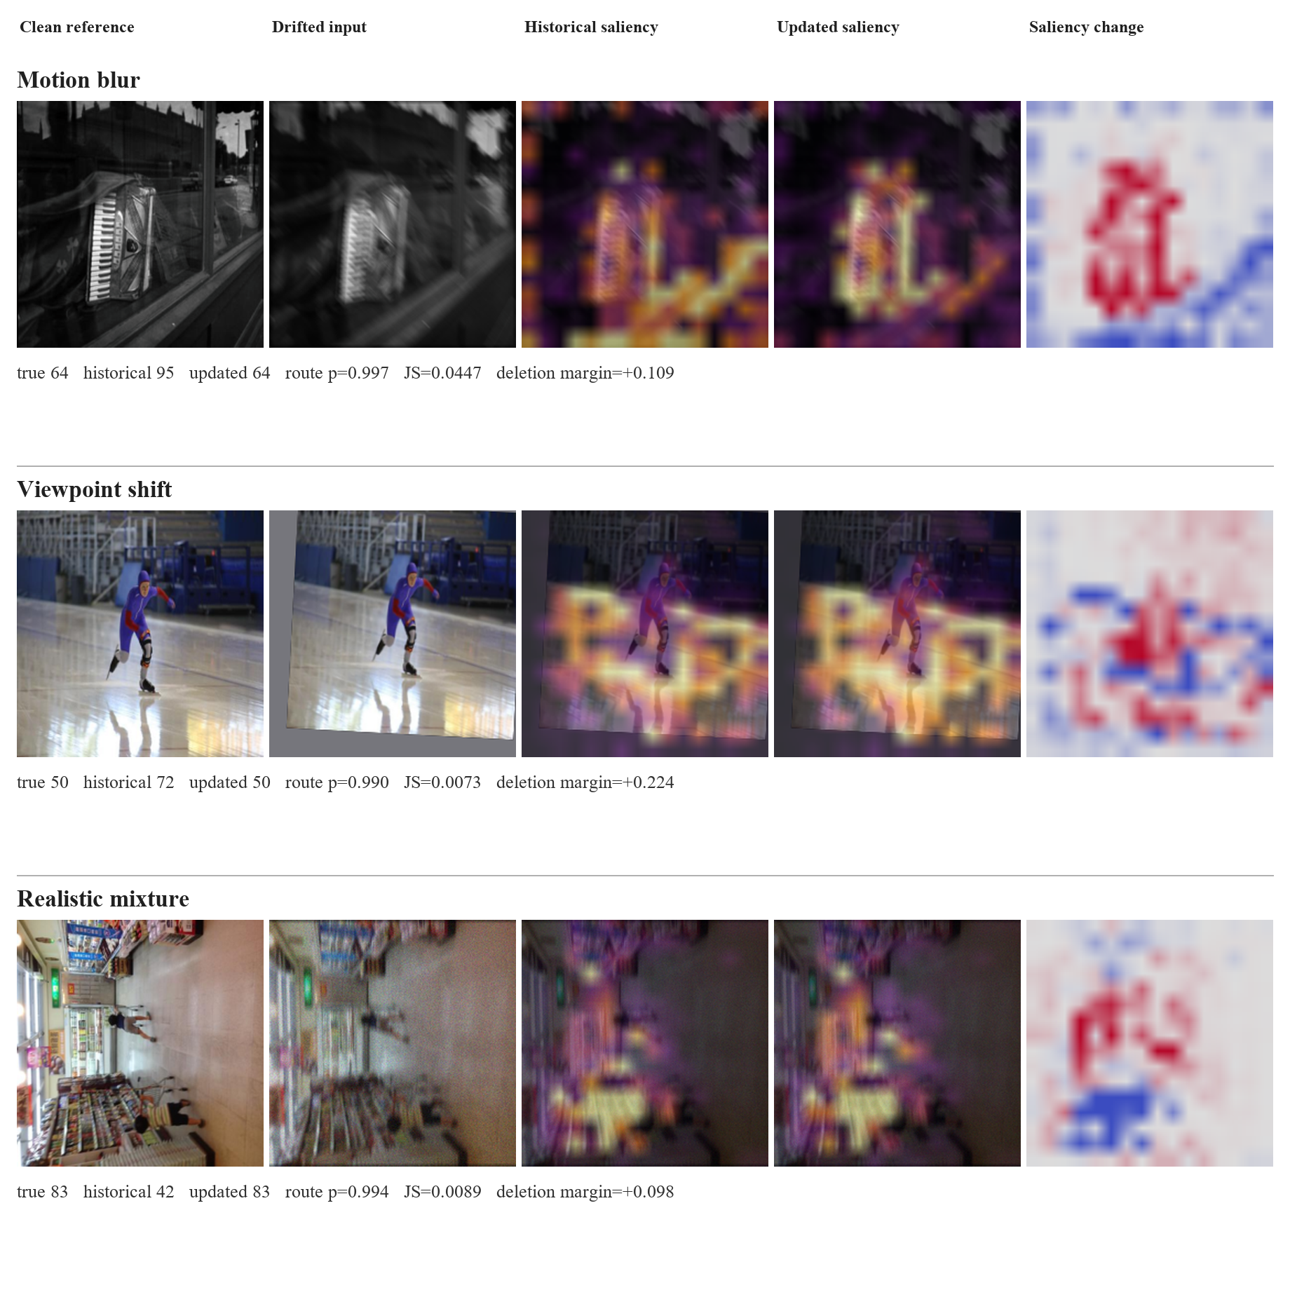
Figure 6. Helpful routed corrections with historical, updated, and signed saliency-change maps

6.1 Quantitative saliency outcome analysis
For the 2014 combined-drift auxiliary-loss control, helpful routes have mean JS divergence 0.0607, compared with 0.0512 for harmful routes and 0.0473 when the historical prediction is retained. Mean route probability is 0.821 for helpful routes, 0.767 for harmful routes, and 0.310 for retained historical predictions. Higher values are useful only in a relative sense: they indicate stronger model disagreement and stronger fitted support for an update. The overlap between helpful and harmful groups shows that neither value is a correctness score. There are 125 helpful and 43 harmful routes, a ratio of 2.91.
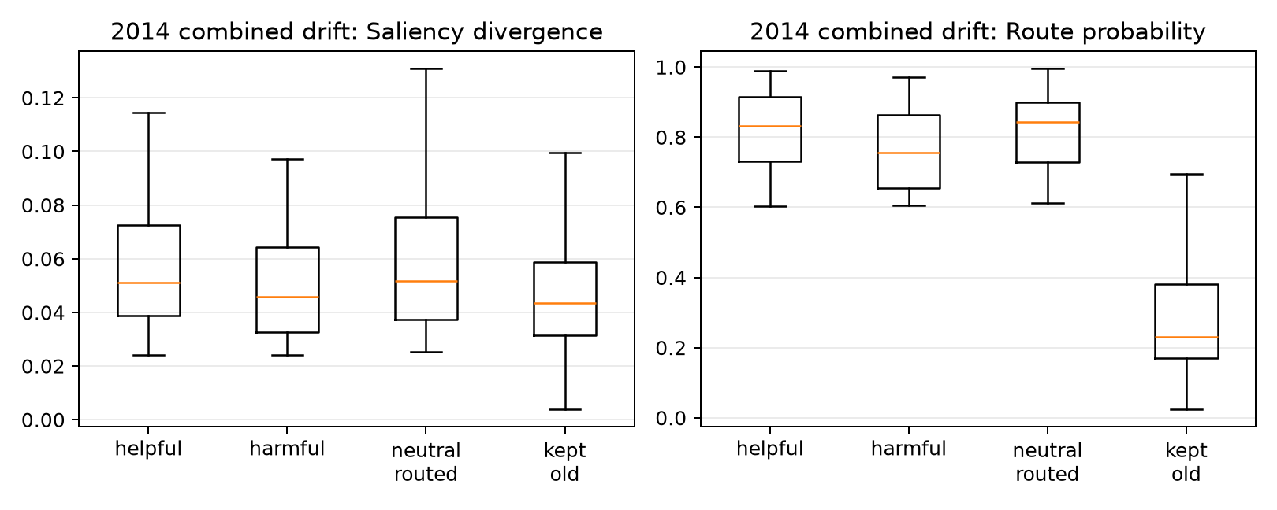
Figure 7. Saliency divergence and route probability by routing outcome
Figure 7 shows substantial overlap between outcomes. Routed and retained images separate partly because the policy requires a minimum saliency change, so that separation confirms that the gate is operating. Helpful routes have somewhat larger JS divergence and route probability on average, which is favourable, but many harmful routes occupy the same range. Large divergence can mean better evidence, a new shortcut, or a general redistribution caused by blur. Route probability is the logistic model's calibrated ranking signal on the 2011 sample, not a guarantee that an individual switch is correct. These limitations motivate the prediction-only, saliency-only, and combined ablations added to the code.
Map change measures difference, not improvement. A new model can move its attention and still be wrong, or become highly confident in the wrong class. CLEAR also provides image labels rather than object masks. Context such as a bowling lane, kitchen surface, or display frame may be useful in one image and a shortcut in another. Since both models share their pretraining and initialisation, some correct updates also require only a small redistribution of patch weights.
The maps are best read as evidence-allocation diagnostics: they show which encoded patches received weight in the classifier. They are not object masks and do not establish that the map change caused a correction. The deletion audit adds a behavioural check by comparing the effect of removing highly weighted and weakly weighted patches. Even this test is limited because the deleted image is outside the original data distribution.
The report uses XAI guided to describe this complete chain. Patch weights influence the class logits, supervised terms constrain their behaviour, differences between the old and new maps enter the route calculation, and deletion tests check whether weighted patches affect the true-class score. The saliency image is one inspectable artefact from that chain. It is neither the decision rule nor proof that the highlighted pixels caused the prediction.

6.2 Counterexample and faithfulness audit
The source-specific audit applies the same top-versus-bottom 20% deletion test whenever one model is correct and the other is wrong. A positive margin means that removing the most highly weighted patches reduces true-class probability more than removing the least-weighted patches.
Table 14. Source-specific counterexample and deletion-audit results
2014 source | Helpful routed | Harmful routed | Missed helpful | Net corrections | New-map margin, helpful | New-map margin, harmful
Motion blur | 357 | 90 | 47 | 267 | 0.147 | 0.031
Viewpoint shift | 88 | 56 | 17 | 32 | 0.190 | -0.053
Realistic mixture | 261 | 95 | 30 | 166 | 0.188 | 0.014

For the updated model, positive margins are more common on helpful than harmful routes: 70.0% versus 61.1% for motion blur, 72.7% versus 44.6% for viewpoint shift, and 76.6% versus 60.0% for the realistic mixture. The historical map shows the reverse pattern. Its mean margin is larger on harmful routes, where the historical prediction was correct. The reversal is consistent with the routing idea, although the overlap explains why errors remain.
The full 2014 combined-drift stream contains 4,999 images. The enhanced router makes 188 helpful switches where the historical model is wrong and the newer model is correct, 90 harmful switches in the opposite direction, and misses 17 available corrections. It therefore produces 98 net corrected predictions. These counts explain why the overall score changes modestly even though some individual decisions change substantially.
For every one of the 304 samples where one model is correct and the other is wrong, the audit deletes the top 20% and bottom 20% of patches under each model's own saliency map. The faithfulness margin is the drop in true-class probability after high-saliency deletion minus the drop after low-saliency deletion. For helpful routed cases, the newer model has a mean margin of 0.175, compared with 0.010 on harmful routed cases; 72.3% of helpful routes have a positive new-model margin, compared with 57.8% of harmful routes. Conversely, the historical model's mean margin is 0.048 on helpful routes and 0.182 on harmful routes. This reversal is consistent with the intuitive routing goal: the model that is correct tends to have the more behaviourally consequential map.
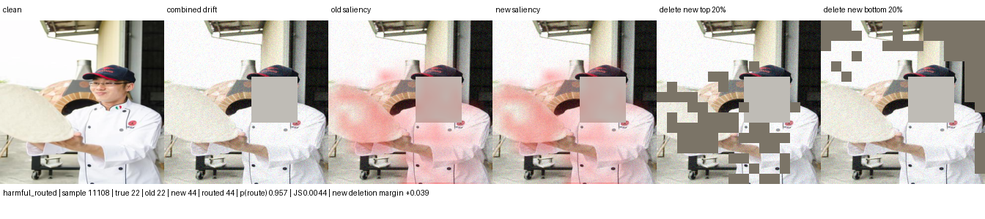
Figure 8. Harmful routed switch: correct historical class 22 is replaced by class 44
The harmful example shows why saliency change alone is insufficient: the historical model was already correct and its map had the stronger deletion response. Patch deletion is still an artificial intervention, so this result does not prove that the highlighted pixels caused the model update.

6.3 Scope of the method
The intended setting is covariate drift: the label keeps the same meaning while the image-forming process or context changes. Examples include camera replacement, compression, sensor noise, white balance, illumination, viewpoint, and partial obstruction. Saliency can help only when useful class evidence remains visible and the updated model learns to weigh it differently.
The source-separated results show the largest gains under motion blur and mixed drift. Viewpoint, occlusion, and digital degradation produce smaller gains, while mild colour and illumination shifts change little. The method is neither an occlusion-specific fix nor a general solution to every form of drift.
The method should not be expected to solve concept drift where the label meaning changes, new-class emergence, extreme occlusion, or systematic dataset errors. In those cases the saliency map may faithfully explain a wrong premise. A stronger next experiment should therefore add a matched random-mask control and an external temporal dataset, then compare confidence-only, saliency-only, and deletion-aware routers without tuning on the final horizon.

7. Discussion and limitations

7.1 What the experiment establishes
For RQ1, temporal adaptation improves the hardest 2014 CLEAR conditions while leaving mild shifts close to the historical score. Routed gains range from +0.11 points under illumination to +3.45 under motion blur. This conclusion is confined to CLEAR because the external experiments freeze the backbone and omit the update-and-route sequence. Their probe losses nevertheless confirm that all three external splits are harder than their in-distribution controls.
The class-level analysis narrows this claim further. Under the 2014 realistic mixture, explanation-guided routing provides its largest benefit in the weakest historical quartile (+5.91 points), but reduces mean F1 in the strongest quartile (-0.81 points). Relative to the matched no-auxiliary-loss router, saliency supervision adds 3.00 points in Q1 but is 0.37 points worse in Q4. This distribution matters more than the aggregate +0.84-point advantage: it indicates that the explanation objective changes which classes benefit, rather than shifting every class uniformly. The result agrees with the saliency literature's concern with irrelevant regions and shortcut features [11] [13] [15], but the data do not identify the learned shortcut or establish that map change caused the correction. The appropriate claim is that explanation supervision is associated with targeted recovery where historical performance is weak, together with residual negative transfer where it is strong.

7.2 Negative results and failure modes
The two-point benchmark was not met on the legacy combined condition: the enhanced updated model gained 1.40 points over the baseline and routed inference gained 1.51 points over historical XAI. It was met under motion blur and the realistic mixture, but not under mild shifts. For RQ3, auxiliary saliency objectives add only +0.23 routed points on combined drift and reduce clean routed performance by 0.18 points in one seed. This mixed result makes the router-feature ablation and repeated-seed analysis necessary.
The matched control clarifies why the result cannot be reduced to a claim that more saliency always produces better accuracy. XGD attributes gains through an explicit saliency ablation [12], and Saliency Guided Training tests explanation quality through controlled perturbation rather than visual appearance alone [13]. Applying the same logic here, the auxiliary-loss comparison is informative because both variants retain the same DINOv2 backbone, saliency-gated head, temporal windows, seed, and router form. Its class-stratified result is still observational at the class level: the losses, adapted weights, and routing features change together. It supports the auxiliary explanation objective as the source of the Q1 difference, but it does not separate improved representation learning from improved route selection. Confidence-only, saliency-only, and combined routing ablations are still required.
The route audit explains part of the gap. Helpful and harmful decisions overlap in saliency divergence and route probability, so the four features do not cleanly identify correctness. A map can change because the updated model has found better evidence, because it has shifted to a different shortcut, or because blur has redistributed all patch weights. The logistic router is deliberately simple and may underfit these interactions; a more expressive gate may improve accuracy but would weaken the direct coefficient-level explanation that motivates the design.

7.3 Validity threats and implemented correction
The main CLEAR evidence is limited by one random seed, one temporal dataset, synthetic stressors layered over natural chronology, and one fitted policy. The reported CLEAR runs also reuse 2011 labels for adapted-checkpoint selection and router calibration; the corrected code now separates those functions, but the archived result has not been rerun under that correction. External evidence remains deliberately small: Yearbook has one seed, CIFAR-10.1 tests recollection rather than time, and the Camelyon screen uses three rather than ten runs, a public mirror, and externally pretrained DINOv2 features. Patch-level observations are also correlated within patients and slides, so a confirmatory pathology study should resample and report uncertainty at the patient or slide level.

7.4 Feasible next evaluation
A confirmatory CLEAR run should use the corrected 2011 split, at least three matched seeds, and paired per-image bootstrap intervals. It should compare confidence-only, saliency-only, combined, and end-to-end selective gates at matched route coverage, while retaining always-historical and always-updated baselines. Each controlled source should first pass the MMD and classifier two-sample checks against the clean null, and a random-patch intervention should accompany saliency-guided deletion. The next external study should retain the three-seed CIFAR protocol and add a complex native temporal dataset. Full router replication should be attempted only where defensible update, calibration, and later test windows exist.
ACDC is the strongest next paired-condition dataset for this purpose. It contains 4,006 adverse-condition driving images distributed across fog, night, rain, and snow; each adverse image has a fine pixel annotation, an uncertain-region mask, and a corresponding normal-condition view of the same scene [33]. These correspondences permit per-scene comparisons that CLEAR cannot provide. They also match the normal-to-adverse model-adaptation setting studied by Contrastive Model Adaptation, which uses aligned image pairs to learn condition-invariant semantic features [34].
ACDC would complement rather than replace CLEAR. It is a semantic-segmentation benchmark organised by acquisition condition, not an eleven-year classification stream. The existing classifier can support a representation-only screen, but a task-level claim requires a ViT segmentation head over the benchmark's classes and native train, validation, and test protocol. Normal and adverse frames should be paired before calculating the mitigation tests above; saliency maps should be compared only after correspondence warping and exclusion of uncertain pixels. A favourable result would require lower residual MMD and domain AUC, preserved feature rank, improved adverse-condition segmentation, and bounded normal-condition loss. This design would test whether the model becomes less condition-dependent rather than merely more accurate on one corruption.

8. Conclusion

8.1 Answers to the research questions
RQ1 asked whether a saliency-gated ViT can improve classification when a historical ViT encounters later data. The answer is conditional. Adaptation produced routed gains of +3.45 points under motion blur and +2.03 points under the declared mixture. The corrected paired tests confirm that both stressors create large feature shifts, while the 300-sample natural CLEAR comparisons remain non-significant. The Yearbook linear probe improves in the later window even though the matched trained heads lose about seven points, and the other supplementary results are also mixed. The evidence supports predictive correction for selected CLEAR conditions, not representation invariance or a dataset-independent property of the saliency head.
RQ2 asked whether an asymmetric Siamese comparison can decide when to use the updated prediction. The router retained 87.1% of the always-updated gain under motion blur and 91.5% under the declared mixture, while recording the saliency change, confidence change, entropy change, class-evidence change, and final decision. In the realistic mixture it raises mean F1 by 5.91 points in the weakest historical class quartile but lowers it by 0.81 points in the strongest quartile. Always using the updated model remained 0.06 to 0.51 points more accurate in the source-separated tests. The router is therefore supported as an audit and fallback mechanism with class-dependent effects; the present run does not establish an accuracy advantage over the updated branch.
RQ3 asked whether explanation information adds value beyond prediction confidence. The aggregate auxiliary-loss ablation is mixed: it adds 0.23 routed points on combined drift and reduces clean routed performance by 0.18 points. The class-stratified mixture result is more specific. Saliency supervision gives a 3.00-point advantage over the matched control in the weakest historical quartile, but a 0.37-point disadvantage in the strongest quartile. The external matched-head screen is also mixed, from +0.30 +/- 0.11 points on CIFAR-10.1 to -0.07 +/- 0.12 on Camelyon and -0.33 on Yearbook. These findings support a targeted rather than universal role for explanation guidance, but they do not isolate routing information from prediction confidence. RQ3 therefore remains unresolved until confidence-only, saliency-only, and combined routers are compared on the same held-out calibration data and repeated seeds.

8.2 Contribution to drift-aware vision classification
The principal contribution is an explainability-guided update procedure whose evidence is tied to the prediction path, the adaptation loss, and a reconstructible routing rule. The paired architecture keeps a historical fallback, exposes how the updated branch redistributes patch evidence, and records helpful and harmful replacements rather than hiding them inside one score. The class-level results sharpen that contribution: correction is most valuable where the historical model has demonstrable headroom, while the strongest classes reveal the cost of unnecessary switching. The method therefore combines ideas from saliency-guided learning, asymmetric Siamese comparison, and selective prediction without claiming that any one component guarantees correctness. Its contribution is methodological and diagnostic as well as predictive: it states where the correction helps, where it gives up accuracy, and which mechanism claims remain untested.

8.3 Evidence boundary and next decision
The strongest positive result still concerns one CLEAR-100 seed and severe source-specific conditions. Gaussian noise, motion blur, compression, viewpoint change, and occlusion remain controlled approximations whose scientific role is to isolate failure mechanisms rather than reproduce a measured deployment frequency. Camelyon adds a real institutional acquisition shift, but its neutral result shows that verified drift is not sufficient evidence for the proposed correction. The paper therefore rejects the broad hypothesis that an embedded saliency head alone improves every shifted dataset.
The next acceptance decision should combine repeated-seed CLEAR results with disjoint selection and calibration data, paired bootstrap intervals, and confidence-only, saliency-only, and combined routing ablations. External confirmation should use each benchmark's standard protocol, including ten Camelyon runs without prohibited pre-training if leaderboard comparison is intended. ACDC should then test the paired representation-mitigation criteria and a native segmentation endpoint, with correspondence warping and uncertain pixels handled explicitly. A successful follow-up would show that the saliency term improves routing after controlling for confidence, reduces residual condition separability without feature collapse, preserves clean performance, and reports failure cases at the appropriate image, patient, slide, or scene unit.

Appendix A. Metric and routing glossary
Macro F1 calculates F1 independently for every class and then gives each class equal weight. It is the principal classification measure because a large class cannot dominate the reported result. Macro IoU applies the same equal-class principle to one-versus-rest intersection over union. It remains a classification-set measure in this project and must not be confused with spatial mask IoU.
Helpful route means that the historical prediction was wrong, the newer prediction was correct, and the policy selected the newer branch. Harmful route means that the historical prediction was correct but the selected newer prediction was wrong. Missed helpful case means that a correct newer prediction was available but the policy retained an incorrect historical answer.
Saliency Jensen-Shannon divergence measures the bounded difference between the old and new normalised patch-weight distributions. Confidence gain compares the selected class probabilities. Entropy reduction measures whether the newer predictive distribution is more concentrated. Class-evidence gain compares the evidence produced for the candidate class.
XAI guided. The explanation signal affects a model computation or routing decision and remains available for audit. In this prototype, learned patch weights affect the pooled representation, auxiliary losses, paired comparison, and deletion analysis. Saliency refers to the patch-weight distribution itself.
Realistic mixture. A deterministic synthetic composition of one, two, or three non-occlusion acquisition changes at severity levels one, two, or three. Occlusion appears in 10% of samples. The term does not claim measured real-world prevalence.
Retained gain measures how much of the always-new improvement survives routing: (routed - old) / (new - old). A value near one means routing preserves most of the candidate model's benefit. The ratio becomes unstable when the new and old scores are nearly equal, so the underlying scores must always be reported beside it.
These definitions are fixed across the report. They make clear which measures evaluate classification, which evaluate the decision policy, and which describe explanation change. None of the routing features is itself a ground-truth measure of drift.

References
1. Lin et al. (2021), CLEAR: A Benchmark for Continual Learning on Real-World Imagery. https://clear-benchmark.github.io/
2. Koh et al. (2021), WILDS: A Benchmark of in-the-Wild Distribution Shifts. Proceedings of the 38th International Conference on Machine Learning. https://arxiv.org/abs/2012.07421
3. Yao et al. (2022), Wild-Time: A Benchmark of in-the-Wild Distribution Shift over Time. Advances in Neural Information Processing Systems, 35. https://papers.neurips.cc/paper_files/paper/2022/hash/43119db5d59f07cc08fca7ba6820179a-Abstract-Datasets_and_Benchmarks.html
4. Hendrycks and Dietterich (2019), Benchmarking Neural Network Robustness to Common Corruptions and Perturbations. https://arxiv.org/abs/1903.12261
5. Hendrycks et al. (2019), AugMix: A Simple Data Processing Method to Improve Robustness and Uncertainty. https://arxiv.org/abs/1912.02781
6. Wang et al. (2021), Tent: Fully Test-Time Adaptation by Entropy Minimization. International Conference on Learning Representations. https://openreview.net/forum?id=uXl3bZLkr3c
7. Wang et al. (2022), Continual Test-Time Domain Adaptation. Proceedings of the IEEE/CVF Conference on Computer Vision and Pattern Recognition, 7201-7211. https://openaccess.thecvf.com/content/CVPR2022/html/Wang_Continual_Test-Time_Domain_Adaptation_CVPR_2022_paper.html
8. Niu et al. (2022), Efficient Test-Time Model Adaptation without Forgetting. Proceedings of the 39th International Conference on Machine Learning, 16888-16905. https://proceedings.mlr.press/v162/niu22a.html
9. Wu et al. (2025), Navigating Semantic Drift in Task-Agnostic Class-Incremental Learning. https://arxiv.org/abs/2503.11756
10. Geifman and El-Yaniv (2019), SelectiveNet: A Deep Neural Network with an Integrated Reject Option. Proceedings of the 36th International Conference on Machine Learning, 2151-2159. https://proceedings.mlr.press/v97/geifman19a.html
11. Yao and Gong (2020), Saliency Guided Self-attention Network for Weakly and Semi-supervised Semantic Segmentation. https://arxiv.org/abs/1910.05475
12. Nguyen et al. (2025), XGD: Explainable AI-Guided Knowledge Distillation with Feature Refinement for Semantic Segmentation. 38th Canadian Conference on Artificial Intelligence. https://www.researchgate.net/publication/389169277_XGD_Explainable_AI-Guided_Knowledge_Distillation_with_Feature_Refinement_for_Semantic_Segmentation
13. Ismail, Feizi, and Corrada Bravo (2021), Improving Deep Learning Interpretability by Saliency Guided Training. Advances in Neural Information Processing Systems. https://arxiv.org/abs/2111.14338
14. Zheng, Ghosh, and Narasimhan (2024), Saliency Guided Image Warping for Unsupervised Domain Adaptation. https://arxiv.org/abs/2403.12712
15. Ma et al. (2022), Rectify ViT Shortcut Learning by Visual Saliency. https://arxiv.org/abs/2206.08567
16. Cheng et al. (2026), Siamese-ViT: A Local-Global Feature Fusion Method for Real-Time Visual Navigation of UAVs in Real-World Environments. Remote Sensing, 18, 1556. https://www.mdpi.com/2072-4292/18/10/1556
17. Yang et al. (2021), Semantic Change Detection with Asymmetric Siamese Networks. https://arxiv.org/abs/2010.05687
18. Dosovitskiy et al. (2020), An Image is Worth 16 x 16 Words: Transformers for Image Recognition at Scale. https://arxiv.org/abs/2010.11929
19. Oquab et al. (2023), DINOv2: Learning Robust Visual Features without Supervision. https://arxiv.org/abs/2304.07193
20. Rudin (2019), Stop Explaining Black Box Machine Learning Models for High Stakes Decisions and Use Interpretable Models Instead. Nature Machine Intelligence, 1, 206-215. https://doi.org/10.1038/s42256-019-0048-x
21. Taori et al. (2020), Measuring Robustness to Natural Distribution Shifts in Image Classification. Advances in Neural Information Processing Systems, 33.
22. Lin (1991), Divergence Measures Based on the Shannon Entropy. IEEE Transactions on Information Theory, 37(1), 145-151. https://ieeexplore.ieee.org/document/61115
23. Shannon (1948), A Mathematical Theory of Communication. Bell System Technical Journal, 27, 379-423 and 623-656. https://ieeexplore.ieee.org/document/6773024
24. Niculescu-Mizil and Caruana (2005), Predicting Good Probabilities with Supervised Learning. Proceedings of the 22nd International Conference on Machine Learning, 625-632. https://doi.org/10.1145/1102351.1102430
25. Beery, Van Horn, and Perona (2018), Recognition in Terra Incognita. Proceedings of the European Conference on Computer Vision. https://doi.org/10.1007/978-3-030-01270-0_28
26. Gretton et al. (2012), A Kernel Two-Sample Test. Journal of Machine Learning Research, 13, 723-773. https://www.jmlr.org/papers/v13/gretton12a.html
27. Lopez-Paz and Oquab (2017), Revisiting Classifier Two-Sample Tests. International Conference on Learning Representations. https://arxiv.org/abs/1610.06545
28. Rabanser, Gunnemann, and Lipton (2019), Failing Loudly: An Empirical Study of Methods for Detecting Dataset Shift. Advances in Neural Information Processing Systems, 32. https://arxiv.org/abs/1810.11953
29. Seldon Technologies (2026), Alibi Detect: Algorithms for Outlier, Adversarial and Drift Detection. https://github.com/SeldonIO/alibi-detect
30. Recht, Roelofs, Schmidt, and Shankar (2018), Do CIFAR-10 Classifiers Generalize to CIFAR-10? https://arxiv.org/abs/1806.00451
31. Bandi et al. (2019), From Detection of Individual Metastases to Classification of Lymph Node Status at the Patient Level: The CAMELYON17 Challenge. IEEE Transactions on Medical Imaging, 38(2), 550-560. https://doi.org/10.1109/TMI.2018.2867350
32. WILDS (2026), Submission and evaluation guidance. https://wilds.stanford.edu/submit/
33. Sakaridis, Dai, and Van Gool (2021), ACDC: The Adverse Conditions Dataset with Correspondences for Semantic Driving Scene Understanding. Proceedings of the IEEE/CVF International Conference on Computer Vision, 10765-10775. https://openaccess.thecvf.com/content/ICCV2021/html/Sakaridis_ACDC_The_Adverse_Conditions_Dataset_With_Correspondences_for_Semantic_Driving_ICCV_2021_paper.html
34. Bruggemann, Sakaridis, Brodermann, and Van Gool (2023), Contrastive Model Adaptation for Cross-Condition Robustness in Semantic Segmentation. Proceedings of the IEEE/CVF International Conference on Computer Vision. https://openaccess.thecvf.com/content/ICCV2023/html/Bruggemann_Contrastive_Model_Adaptation_for_Cross-Condition_Robustness_in_Semantic_Segmentation_ICCV_2023_paper.html

