Student ID: 103475494

Name: Riki Choi

# Setup Screenshot

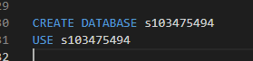

# Task 2 Screenshot

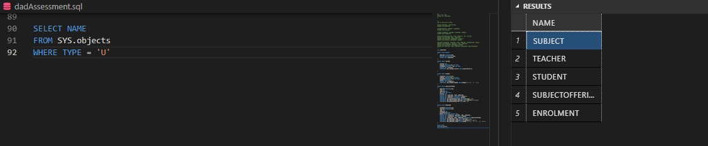

# Task 3 Screenshot

