IMG_256

**Tribhuvan University**

**Faculty of Humanities and Social Sciences**

**“Work Progress Tracker”**

**A PROJECT REPORT**

**Submitted to:**

**Department of Bachelor in Computer Application**

**Kathmandu Business Campus**

***In partial fulfillment of the requirements for the Bachelors in Computer Application***

**Submitted by:**

Salina Maharjan Rikin Tuladhar

BCA 4th Semester BCA 4th Semester

University SN : 6-2-1219-23-2020 University SN : 6-2-1219-21-2020

Roll no: 19 Roll no: 17

Under the Supervision of

Kabindra Koirala

IMG_256

**Tribhuvan University**

**Faculty of Humanities and Social Sciences**

**Kathmandu Business Campus**

# Supervisor’s Recommendation

I hereby recommend that this project prepared under my supervision by Salina Maharjan and Rikin Tuladhar entitled **“Work Progress Tracker”** in partial fulfillment of the  requirements for the degree of Bachelor of Computer Application is recommended for the final  evaluation.

**SIGNATURE**

**SUPERVISOR**

IMG_256

**Tribhuvan University**

**Faculty of Humanities and Social Sciences**

**Kathmandu Business Campus**

# LETTER OF APPROVAL

This is to certify that this project prepared by Salina Maharjan and Rikin Tuladhar entitled **“Work Progress Tracker”** in partial fulfillment of the requirements for the degree of Bachelor in Computer Application has been evaluated. In our opinion it is satisfactory in the scope and quality as a project for the required degree.

|  |  |
| --- | --- |
| **SIGNATURE of Supervisor** | **SIGNATURE of HOD/ Coordinator** |
| **SIGNATURE of Internal Examiner** | **SIGNATURE of External Examiner External** |

          Kathmandu Business Campus

Ref No:

Date:

   Subject: Approval of Project Proposal

The project entitled “**Work Progress Tracker**” proposed by Mrs. Salina Maharjan and Mr. Rikin Tuladhar for the partial fulfillment of the requirement for Bachelor in Computer Application (BCA), fourth semester has been approved for further development.

**Proposal Evaluation Committee**

**\_\_\_\_\_\_\_\_\_\_\_\_\_\_\_\_\_\_\_\_\_\_\_**

**\_\_\_\_\_\_\_\_\_\_\_\_\_\_\_\_\_\_\_\_\_\_\_**

**\_\_\_\_\_\_\_\_\_\_\_\_\_\_\_\_\_\_\_\_\_\_\_**

**\_\_\_\_\_\_\_\_\_\_\_\_\_\_\_\_\_\_\_\_\_\_\_**

 Mr.

Campus Chief (.)

# ABSTRACT

The purpose of “**Work Progress Tracker**” is to monitor and manage the progress of tasks and projects within an organization. It provides a systematic and organized approach to tracking the completion of work, and ensuring that tasks assigned to employee stay on schedule.

This website can be entered using login information, where the manager can directly login but the employee has to register and the manager has to approve the registration for employee to enter the website. This feature allows managers to assess the performance of their employees and provide feedback on their progress. Similarly, employee can view the task and feedback as well as update status.

The main objective of Work Progress Tracker is improving productivity, and ensuring the successful completion of tasks and projects within an organization. This website makes easier for employee to view the tasks assigned to them, submit their task progress report. Likewise it makes easier for manager to provide feedback according to their task progress report, manage task as well as manager employee.

**Keywords: PHP, Web Application,** **database.**

# ACKNOWLEDGEMENT

We would like to express our special thanks of gratitude to our supervisor **Mr. Kabrindra Koirala** who gave us the golden opportunity to do this wonderful project on the topic of Work Progress Tracker, which also helped us in doing a lot of research and we came to know about so many new tools and technologies.

We would like to express our special thanks to our Campus Principal **Mr. Naresh Prasad Shrestha** who gave us permission for doing this project.

I would like to express my special gratitude and thanks tour BCA Program Coordinator **Mr. Ram Prasad Subedi** for his support and help for our personal development and mainly for completion of this project.

I am highly indebted to Kathmandu Business Campus for their guidance and constant supervision as well as for providing necessary information regarding the Project and support in the completion.

We would also like to thank our parents and friends who helped us a lot in finalizing this project within the limited time frame.

In the end, we would also like to thank Tribhuvan University for giving us this opportunity via the course of Computer Application to help us understand the project ethics at this early stage and helped us to evaluate my knowledge and expand it a little more.

Yours sincerely,

Rikin Tuladhar

Salina Maharjan

**Table Of Contents**

[Supervisor’s Recommendation 1](#_Toc15929)

[LETTER OF APPROVAL 1](#_Toc30317)

[ABSTRACT I](#_Toc3414)

[ACKNOWLEDGEMENT II](#_Toc24762)

[LIST OF ABBREVATIONS IV](#_Toc23074)

[CHAPTER: 1 1](#_Toc8027)

[INTRODUCTION 1](#_Toc22226)

[1.1 Introduction 1](#_Toc2236)

[1.2 Problem Statement 2](#_Toc24826)

[1.3 Objectives 2](#_Toc27002)

[1.4 Scope and Limitations 2](#_Toc19137)

[1.4.1 Scope 3](#_Toc27466)

[1.4.2 Limitations 3](#_Toc24193)

[1.5 Report Organization 4](#_Toc24729)

[CHAPTER: 2 5](#_Toc30856)

[BACKGROUND STUDY AND LITERATURE REVIEW 5](#_Toc453)

[2.1 Background Study 5](#_Toc12256)

[2.2 Literature Review 6](#_Toc20811)

[CHAPTER: 3 7](#_Toc3647)

[SYSTEM ANALYSIS AND DESIGN 7](#_Toc18037)

[3.1 System Analysis 7](#_Toc6287)

[3.1.1 Requirement Analysis 8](#_Toc6716)

[3.1.2 Feasibility Analysis 10](#_Toc13493)

[3.1.3 Data Modeling (ER-Diagram) 12](#_Toc12414)

[3.1.4 Process Modeling (DFD) 13](#_Toc7798)

[3.2. System Design 15](#_Toc10178)

[3.2.1. Architectural Design 15](#_Toc27828)

[3.2.2 System Flowchart 15](#_Toc11280)

[3.2.3. Database Schema Design 18](#_Toc29011)

[3.2.4. Interface Design (UI Interface) 19](#_Toc19892)

[CHAPTER:4 24](#_Toc20870)

[IMPLEMENTATION AND TESTING 24](#_Toc25311)

[4.1. Implementation 24](#_Toc24923)

[4.4.1 Tools Used (CASE tools, Programming language, Database platforms) 24](#_Toc29567)

[REFERENCES 31](#_Toc25783)

[21 3 2023] 31](#_Toc26835)

# LIST OF ABBREVATIONS

CRUD Create, Read, Update and Delete

CSS Cascading Style Sheet

PHP Hypertext Preprocessor

DFD Data Flow Diagram

ERD Entity Relationship Diagram

HTML Hyper Text Markup Language

JS Java Script

MySQL My Structured Query Language

UI User Interface

OTP One Time Password

# CHAPTER: 1

# INTRODUCTION

## **Introduction**

Work Progress Tracker is a systematic and organized approach of tracking the completion of work, and ensuring that tasks assigned to employee stay on schedule. It can be accessed throughout the organization with the proper provided login information. This system helps employers or HR managers keep track of the employment work progress of their staff.

It can be used to monitor various aspects of an employee's work progress including performance evaluation of the employee, working capacity. This system has two types of accessing mode - “User/Employee” and “Administrator/Manager”.

Typically, a work progress tracker can be implemented on a website. This feature allows managers to assess the performance of their employees and provide feedback on their progress. Overall, a work progress tracker can help employees manage their workforce more effectively, while also providing employees with a transparent and fair way to track their progress and performance.

Overall, a work progress tracker can provide numerous benefits to both the organization and employees. By tracking various aspects of an employee's status and performance, it can help improve productivity and job satisfaction, while also providing employers with valuable insights into their workforce.

## **Problem Statement**

In context of Nepal, many companies do not use tracking apps for their employees which might decrease the productivity of that company. Without a system for tracking employee status and performance, it can be difficult for managers to keep track of who is doing what, how well they are doing it, and whether they are meeting their goals and objectives.

Without regular performance evaluations and feedback, employees may not know where they stand or what they need to improve. This can lead to low morale and decreased job satisfaction. In today's dynamic and fast-paced business environment, organizations face challenges in effectively tracking and managing the progress of work across various projects and teams. Without a centralized and efficient system in place, businesses often struggle to monitor and evaluate the status of tasks, and ensure timely completion of projects.

## **Objectives**

The main objective of this project is to build web applications to track work progress.

* To assign tasks to the employee with deadlines.
* To provide platform that enables efficient tracking of employee work dates and status on the assigned task.
* To provide feedback to employee from their supervisors after completion of task.

## **Scope and Limitations**

Every website has its own unique features and its limitations. This website offers following scope and limitation following things:

### Scope

* Companies of all sizes can use work progress trackers to help their employees stay on track of assigned task.
* This application can be used to meet deadlines and achieve their goals.

### Limitations

* This site is limited in providing resources like file sharing, chatting between manager and employees as it is only used for assigning tasks with deadlines.
* The representation of work status for task using a graph or bar not available.
* There is no OTP (One Time Password).
* There is no feature of team collaboration and assigning tasks to a group.

## **Report Organization**

**Introduction**

This chapter deals with the introduction of the system with its objectives and limitations along with the reason why the system is made.

**Background Study and Literature Review**

This chapter summarizes the work that has been carried out in the field of data mining and also describes the features about some existing applications related to the sponsorship management system.

**System Analysis and Design**

This chapter focuses on the different requirement of the system, which describes about the functional, non-functional, feasibility analysis, Entity Relational diagram, Data Flow Diagram, design of the system with system architecture, database schema, and interface design.

**Implementation and Testing**

This chapter emphasizes tools used in system development, implementing details and result of test performed.

**Conclusion and Future Recommendation**

This chapter highlights brief summary of lesson learnt, outcome and conclusion of the whole project and explain what have been done and what further improvements could be done.

# CHAPTER: 2

# BACKGROUND STUDY AND LITERATURE REVIEW

## **2.1 Background Study**

Firstly, it is essential to define the purpose of the tracker, whether it is tracking deadlines, or overall project progress. Evaluating existing work progress tracking systems or tools being used within the organization or industry provides valuable insights into their strengths, weaknesses, and limitations.

This analysis helps identify gaps and opportunities for improvement. Overall, a thorough background study lays the foundation for developing a robust work progress tracker tailored to the specific needs of the organization and its stakeholders.

A work progress tracker website is an online platform designed to help organization track and manage their work progress effectively. These websites typically provide a range of features and tools that allow managers to create and manage tasks, set deadlines, monitor progress, assign tasks and provide feedback to the employees. It also allows employee to view task, edit their profile, submit task and receive feedback from manager.

## **2.2 Literature Review**

There are many systems related to work progress tracker. We recently had studied about different system which works as like this website.

According to resource, Trello[1] is a popular project management tool that allows you to create boards, lists, and cards to track the progress of your work. It provides a visual interface where you can assign tasks, set due dates, add comments, and move cards across different stages of completion.

Jira[2] is a widely used project management and issue tracking tool, particularly popular among software development teams. It offers features like task management, agile project management, release planning, and extensive reporting. It provides a comprehensive view of work progress and allows for customization based on specific project requirements.

Basecamp[3] is a project management and team communication platform that facilitates tracking of work progress. It offers features such as task lists, project timelines, file sharing, and team collaboration. It provides a centralized hub for managing projects and monitoring progress.

Throughout the research, we found out that there are very few websites or applications related to work progress tracking websites. The duration of the work was not mentioned. The system is complex to use. The feedback option was not available for the manager for guiding employees on some of the websites that we reviewed.

Our approach is to achieve the limitation other system could not fulfill. Our system has the features like providing proper documentation on the performance of the employee, the manager can also give feedback as the feedback option is also available, also to archive task that has been completed.

# CHAPTER: 3

# SYSTEM ANALYSIS AND DESIGN

## **3.1 System Analysis**

This system is designed with the series of processes starting with requirement analysis, design, implementation, testing and deployment. During requirement analysis, all the functional and nonfunctional requirement are analyzed and system is developed according to the requirement then designing of the system is carried out. After the design process, coding and development part is started then after integrating the system there is testing of the system. After testing is positive then system is moved on to deployment phase.

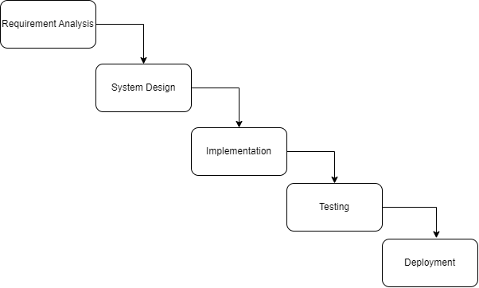

**Figure 3.1: Waterfall Methodology for Work Progress Tracker**

### 3.1.1 Requirement Analysis

The requirements are to be collected before starting projects’ development life cycle. To design and develop system, functional as well as non-functional requirement of the system has been studied.

1. **Functional Requirement**

Different functional requirement of the system has been identified and are listed as below:

* The system should allow the user to login and logout from the system.
* Manager can login to the system directly where the employee must register before logging in to the system.
* It allows manager to create and manage tasks, set deadlines, monitor progress, assign tasks and provide feedback to the employees.
* The system allows employee to view task, edit their profile, submit task and receive feedback from manager.

**USECASE DIAGRAM**

In work progress tracker, there are two actors such as employee and manager where manager can login, manage tasks, assign tasks, manage employee, give feedback and logout from the manager panel. Likewise, employee can register, login, view tasks, update task, view feedback given from manager and logout from the system.

**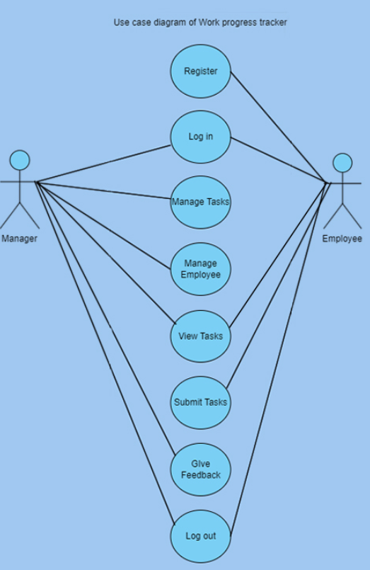**

**Figure 3.2: Use Case Diagram for Work Progress Tracker**

1. **Non-Functional Requirement**

Different non-functional requirement has been studied and identified and are listed as below:

* **Security: -**The system is secure from outside attacks as authorized user are allowed to access the data. This system uses at least 6-character passwords for security. Different validation process is used. The system uses md5 function for data security. Sensitive data, such as user credentials, should be encrypted to protect against unauthorized access.
* **Performance:** - The performance of the system is fast and accurate as in this system database is normalized so it provides fast operations. The system should be able to handle increasing user loads without significant performance degradation.

### 3.1.2 Feasibility Analysis

Feasibility analysis, also known as a feasibility study, is an assessment of the practicality and viability of a proposed project or initiative. The feasibility study concluded that the project is able to be implemented to success as it was carefully planned.

1. **Technical Feasibility Study**

The system is technically feasible as the requirement for the development of the system is easily accessible. The necessary hardware and software required for the development and implementation of the system is available. The basic programming language which is suitable for project is available and the libraries required for project is capable of achieving the result that we are aiming for. All the existing resources can be used for the development and maintenance system.

1. **Operational Feasibility Study**

The system is easy to operate with the basic knowledge of computer and internet and well-trained manpower is not necessary. User can also easily access the system as it is user friendly in many aspects with good User Interface (UI). This system includes all the requirements used for our website work progress tracker.

1. **Schedule Feasibility Study**

The system is completed within scheduled time and do not exceed the scheduled time.

**Table 3.1: Gantt chart Table for Work Progress Tracker**

|  |  |
| --- | --- |
| **Task name** | **Duration** |
| Planning | 1 week |
| Analysis | 1 week |
| Design | 2 weeks |
| Coding | 11 weeks |
| Testing | 1 week |
| Deployment | 1 week |

**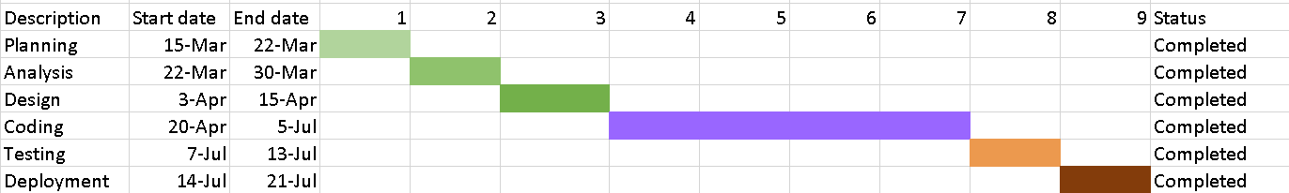**

**Figure 3.3: Gantt chart for Work Progress Tracker**

### 3.1.3 Data Modeling (ER-Diagram)

In Entity-Relationship diagram there are four entities named tasks, employee, manager and login. Likewise, tasks has task\_id, file\_name, start\_end\_date, task\_description, task\_title, feedback and employee has emp\_id, emp\_name ,emp\_email, emp\_img, location, experience, emp\_phone, e\_pw . Manager has attributes like m\_id, m\_name, m\_email, dep\_id, m\_pw and m\_phone. Login has id, pw, email, username.

**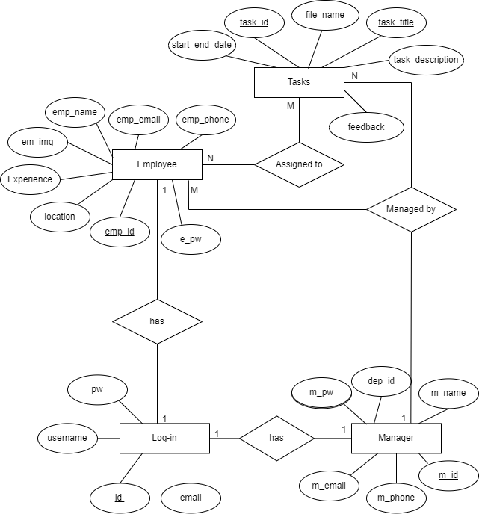**

**Figure 3.4: Entity Relational Diagram for Work Progress Tracker**

### 3.1.4 Process Modeling (DFD)

Data Flow Diagram of Work Progress Tracker consists of two levels of DFD context diagram and level one dfd. Both these levels are used for making data flow diagram of Work Progress Tracker.

In context diagram, Data Flow Diagram of Work Progress Tracker consists of two levels of DFD context diagram and level one DFD. Both these levels are used for making data flow diagram of Work Progress Tracker. In context diagram, Manager and Employee are the entity of Work Progress Tracker. Manager and Employee request for login where Employee has to register first in order to login to the system. Manager approves the employee login and provides them tasks and receive task report. Employee receives tasks and gives status of the tasks.

**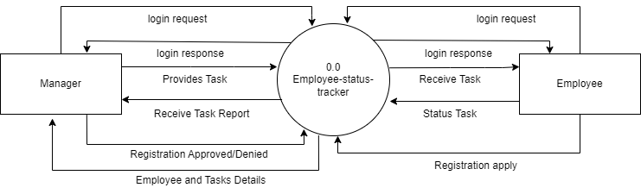**

**Figure 3.5: level 0 DFD for Work Progress Tracker**

In level 1 DFD, there are eight processes where for registration of employee, process 1 is responsible. For managing login process of employee, process 2 is responsible. For login to the system, process 3 is responsible likewise for managing tasks and employee, process 4 and 5.For View tasks and deadlines, process 6 and for reporting of completed task details and providing feedback, process 7 and 8 is responsible. For data storage, in this level of DFD such as login, employee, manager, tasks.

**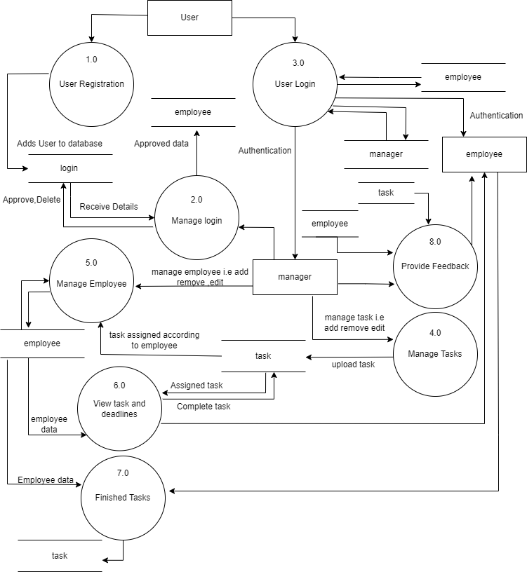**

**Figure 3.6: level 1 DFD for Work Progress Tracker**

## **3.2. System Design**

To realize the different functional requirement of the system in graphical form, different design diagram of the system has been prepared which are as follows:

### 3.2.1. Architectural Design

For this system, three tire architecture is used which includes user interface, web server and database. In architectural design, basic structure of the system is shown:

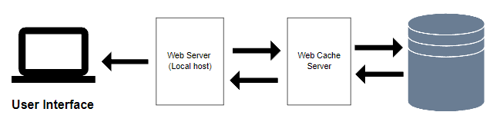

**Figure 3.7: Architectural Design of Work progress Tracker**

### 3.2.2 System Flowchart

Flow charts are an important tool for the improvement of processes. By providing a graphical representation, they help project teams to identify the different elements of a process and understand the interrelationships among the various steps.

The figure below is the flowchart of work progress tracker. Here, manager and employee login the system and if employee is not register then they need to register first. After login success, it redirects to employee side dashboard then the employee can view the tasks assigned to it, submit task after completion and also view the feedback received from the manager. Here, the

Manager can login to the system without registering. After login success the manager can view employee, task as well as assign tasks to the employee and provide necessary feedback to the employee. Then the employee and manager logout of the system.

**For manager**

**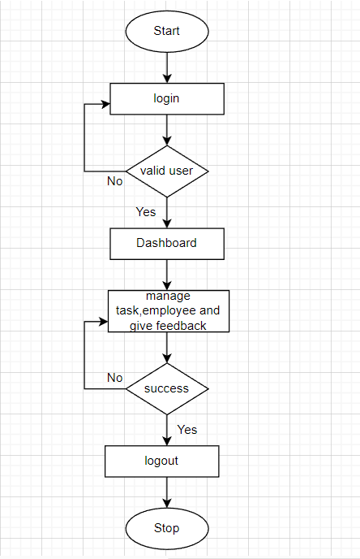**

**Figure 3.8: Flow chart of Work Progress Tracker for manager**

**For employee**

**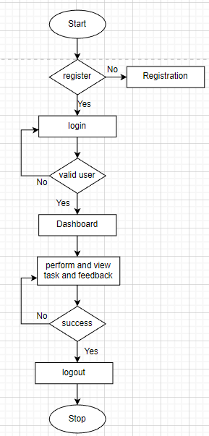**

**Figure 3.9: Flow chart of Work Progress Tracker for employee**

### 3.2.3. Database Schema Design

The figure below is the database schema design of work progress tracker. Database schema design is used to show basic structure of the system. In work progress tracker, there are four tables in the databases each of them has their own fields where their id is primary key and if that id is used in another table, it becomes foreign key and foreign key are connected to another table with a line.

**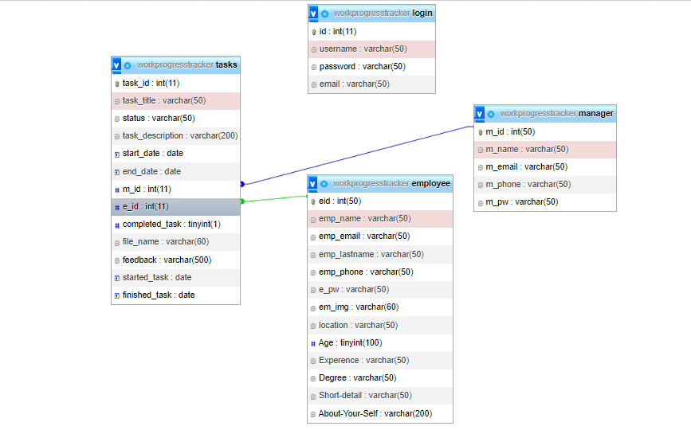**

**Figure 3. 10: Database Schema Design of Work Progress Tracker**

### 3.2.4. Interface Design (UI Interface)

Interface design is used to design how the work progress tracker system looks like and this design is shown to user that how the system will look and after finalizing the system development starts. The UI design of log-in page, register page, manager’s dashboard, manager’s task page, manager’s employee page, manager’s feedback page and employee’s dashboard, employee’s task page, employee’s update page, employee’s feedback page are shown below.

**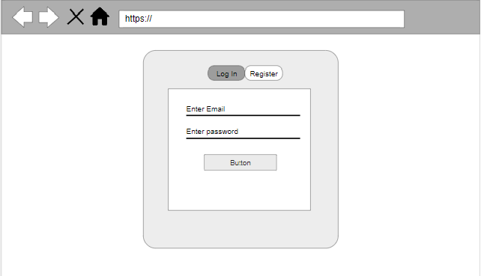**

**Figure 3.11:UI Log-in page of work progress tracker**

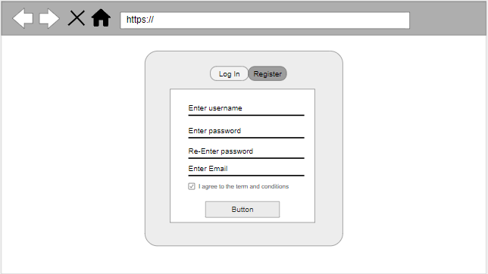**Figure 3.12: UI Register page of work progress tracker**

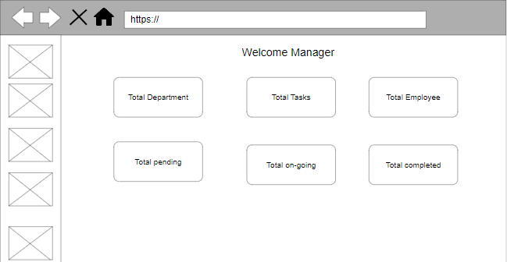

**Figure 3.13: UI manager’s dashboard of work progress tracker**

**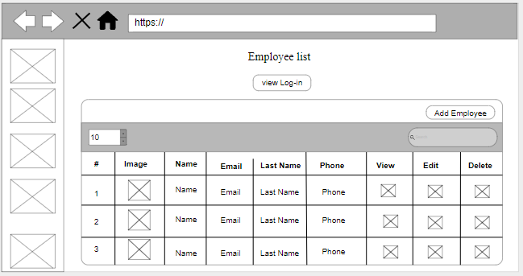**

**Figure 3.14: UI manager’s employee page of work progress tracker**

**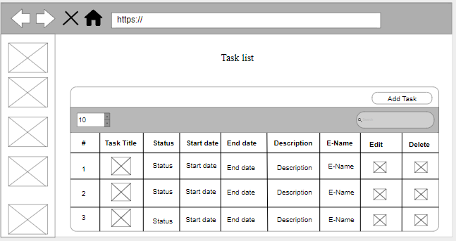**

**Figure 3.15: UI manager’s task page of work progress tracker**

**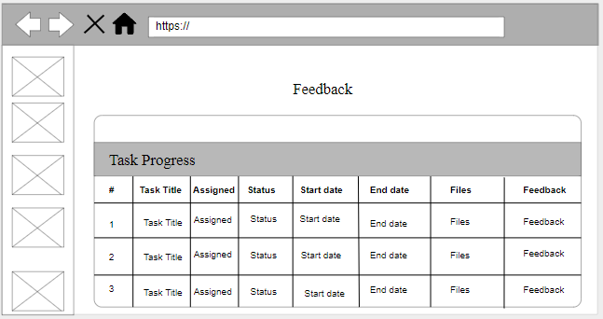**

**Figure 3.16: UI manager’s feedback page of work progress tracker**

**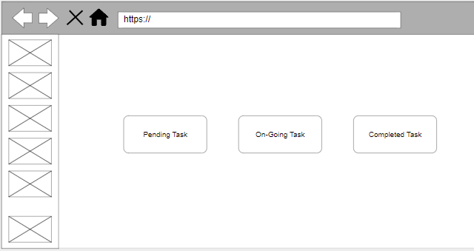**

**Figure 3.17: UI Employee’s dashboard page of work progress tracker**

**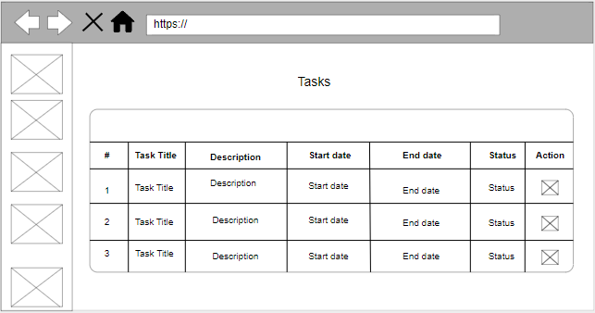**

**Figure 3.18: UI Employee’s tasks page of work progress tracker**

**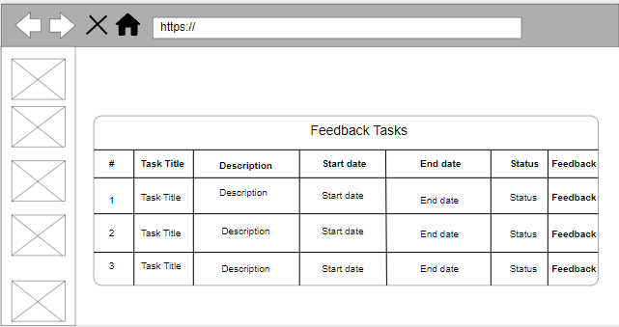**

**Figure 3.19: UI Employee’s feedback page of work progress tracker**

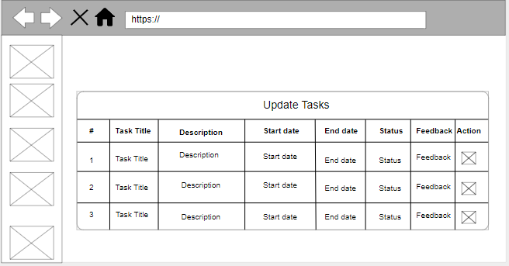

**Figure 3.20: UI Employee’s update page of work progress tracker**

# CHAPTER:4

# IMPLEMENTATION AND TESTING

## **4.1. Implementation**

### 4.4.1 Tools Used (CASE tools, Programming language, Database platforms)

Following are the tools and framework used for accomplishment this project:

**Front End Tools:**

* **HTML**

In Work Progress Tracker, html is used for creating different webpage and sites. We used HTML to structure the layout of web pages, define the elements (such as buttons, forms, text fields, and images), and present information to users. We also used elements such as <form>, <input>, <select>, and <button> to create forms and capture user data.

* **CSS**

In Work Progress Tracker, css is used for designing different tags of html. It is also used to design different component by the help of class and id. By using css, we can control the text color, font style, the spacing between paragraphs, sizing of columns, layout designs, and many more.CSS, or Cascading Style Sheets, is a crucial technology in web development that helps in enhancing the design and presentation of a system, especially web-based systems.

* **JavaScript**

In Work Progress Tracker, JavaScript is used for client-side validation and to make dynamic, interactive and responsive web pages. It is used to add dynamic behavior to the webpage and add special effects to the webpage.

**Back End Tools:**

* **PHP**

In Work Progress Tracker, PHP is used for the backend purpose and for making dynamic web pages. It is used for server-side scripting purpose to add connectivity to the database and also used to encrypt the data, validate the user data, confirm user to go to certain pages, login pages. It also includes add, update and delete the data from the database.

**Server**

* **APACHE SERVER**

In Work Progress Tracker, apache server is used to run php files and creating fast and dynamic web pages.

**Database**

* **MYSQL**

MySQL is use for storing all the information required to the database in Work Progress Tracker. It is used for performing CRUD operation such as create, delete and update data from the database as requested by the user.

**Documentation Tools**

* **MS Office**

We have used MS Office for writing and editing the documentation of work progress tracker.

* **Draw.io**

This is used to generate diagrams for system analysis and design of Diagrams in work progress tracker in order to save time since all components are available with drag and drop functions.

**4.1.2. Implementation Details of Modules (Description on procedures/functions)**

Different modules of this system are described as below:

**Manager Module**

* **Manager manage task**

In this module, the manager can manage the task. The manager can add, edit, delete the task that is assigned to the employee. This page displays all the list of tasks from the database and manager can view the list of tasks provided to the employee. Likewise, manager can perform edit and delete action by clicking edit and delete items button. And the admin then chooses the task they want to edit and delete by clicking on edit and delete items.

* **Manager Manage Employee**

Manager can manage the details and information about employee. Manager can manage the name, password, phone. The manager can add new employee into the existing system by entering their details and information by clicking on the add employee item button. Likewise, manager can view all the list of employees by clicking on the employee list item button. The page displays all the list of employees which are stored in database.

* **Manager View List of Task and Employee**

Manager can view all the list of task and employee. It includes all the details of the task like title, status, description, start date, end date, feedback, started task, finished task. Manager can also view the employee details like name, email, phone number, age location, degree, experience**.**

**Employee Module**

Employee first register into the system by entering all the details such as username, password and email required to register. And then can login to system with their username and password after they get approved by the manager. After login, they can view the task assign to them, their ongoing task and their completed task. They can also receive the feedback provided by the manager.

**Login Module**

In login module, we have implemented two sub modules they are manager login and employee login. Employee can log in after registering and getting approved by the manager. Manager and employees log into the system using their valid username and password.

**Register Module**

In register module, the employee register into the system by entering all the details such as username, password, email required to register. And then can log in to system with their valid username and password after getting approved by the manager.

## **4.2. Testing**

System testing is done by giving different training and testing datasets. This test is done to evaluate whether the system is providing accurate summary or not. During the phase of the development of the system, our system is tested time and again. The series of testing conducted are as follow:

### 4.2.1. Test Cases for Unit Testing

In unit testing, we designed the entire system in modularized pattern and each module is tested. Until we get the accurate output from the individual module, we work on the same module. The input forms is tested so that they do not accept invalid input

**Employee Registration**

**Table 4. 1: Test case for Registration of Employee**

|  |  |  |  |  |  |
| --- | --- | --- | --- | --- | --- |
| S.No | Test Name | Input | Expected Output | Actual Output | Test Result |
| 1 | Open Application | http://localhost/work-progress-tracker/Work-progress-tracker/login/login.html | Login page | Login Page | Pass |
| 2 | Enter Invalid username ,password ,confirmation password, Email,checkbox | username = suman ,Password = 123456 Re-type Password = 123456  Email = | Enter email | Registration Failed | Pass |
| 3 | Enter valid username ,password ,confirmation password, Email,checkbox | Username = suman Password = 123456  Email = [suman@gmail.com](mailto:suman@gmail.com)  Checkbox = checked | Registration Successful | Registration Successful | pass |

**Employee Login**

**Table 4. 2: Test case for Log in of Employee**

|  |  |  |  |  |  |
| --- | --- | --- | --- | --- | --- |
| S.No | Test Name | Input | Expected Output | Actual Output | Test Result |
| 1 | Open Application | http://localhost/work-progress-tracker/Work-progress-tracker/login/login.html | Login page | Login Page | Pass |
| 2 | Enter Email and Invalid Password | Email = suman ,Password = 123 | Log in success | Incorrect Email or Password | Pass |
| 3 | Enter valid username ,password ,confirmation password, Email,checkbox | Username = suman Password = 123456  Email = [suman@gmail.com](mailto:suman@gmail.com)  Checkbox = checked | Registration Successful | Registration Successful | pass |

**CHAPTER: 5**

**CONCLUSION AND FUTURE RECOMMENDATIONS**

**5.1. Lesson Learnt / Outcome**

Developing a project makes us to learn and gain the knowledge in different aspects. Developing a website can be a valuable learning experience, both in terms of technical skills and broader insights about project management, user experience, and business operations. In the following project, we have learned lots of problem-solving skills and learn things like team work, finding the solution on our own, proper use of guidelines, communication and writing skills and management of team.

* **Technical Skills:**

We gained knowledge in the programming languages and technologies used for web development, such as HTML, CSS, JavaScript, and potentially backend languages like PHP. We also acquired skills in testing and debugging to identify and fix issues in our code.

* **Project Management**:

We realized the importance of thorough planning, defining project scope, setting goals, and creating timelines. Effective communication with team members, stakeholders, and clients is critical for project success. We have also learned to divide the tasks and deal with the error.

* **Problem-Solving:**

We also developed problem-solving skills, as web development often involves tackling unexpected issues and finding solutions.

* **Manage time:**

The most important lesson learnt was management of time according to the complexity of the system components i.e. know which components to prioritize.

**5.2. Conclusion**

The work progress tracker has been successfully developed with predefined objectives. This system fulfills all the objectives that have been set to develop this system and this system can be viewed by employee and manager with the provided login information and the employee has to register before login in to the system. This system also provides easy and smooth user interface that can be used by non-technical users. This website makes easier for employee to view the tasks assigned to them, submit their task progress report. Likewise, it makes easier for manager to provide feedback according to their task progress report, manage task as well as manage employee.

**5.3. Future Recommendations**

The development project could have been more efficiently handled with regards to design and development. The documentation process might have been better programming the project prior to any documentation. The system can be updated based on the users’ requirements recommendation. The page load and server load speed might be improved.

Some of the future recommendations are given below:

* OTP (One Time Password) feature can be added.
* The representation of work status for task can be represented in a graph or bar not available.
* Feature of team collaboration and assigning group tasks can be added.

# REFERENCES

1. Student Projects Guide, “Task Management System DFD Diagram,”Student Projects Guide,[Online].Available:https://studentprojectguide.com/project-report/system-design/task-management-system-dfd-diagram/ [Accessed 21 3 2023].
2. Slide Share,”Employee Time and Task Tracking System,”Slide Share,[Online].Available:

https://www.slideshare.net/imranjdar/employee-time-and-task-tracking-system[Accessed

21 3 2023]

1. Project Manager,”Task Management,”Project Manager,[Online].Available: <https://www.projectmanager.com/guides/task-management> [Accessed 21 3 2023]