REPORT

Anastassiya Boiko

Group: BS 17-1

Innopolis University

**Plan:**

1) Exact solution

2) Numerical methods: solutions and errors

3) Program: how it looks

4) Structure of program

Exactsolution

Given differential equation $y^{'}=cosx-y$ with default initial values: x0=1, y0=1 and right border of X=9.5.

Exact solution of given expression is:

$$y\left(x\right)=C_{1}*e^{-1}+\frac{sinx_{0}}{2}+\frac{cosx_{0}}{2}$$

After making substitution with given IVP, we get:

$1=С_{1}*e^{-1}+\frac{\sin\left(1\right)}{2}+\frac{\cos\left(1\right)}{2}$, from which we get $C\left(x\right)=0,4336$.

In the application, the graph of exact solution is shown in the second plot.

Illustration of graph:

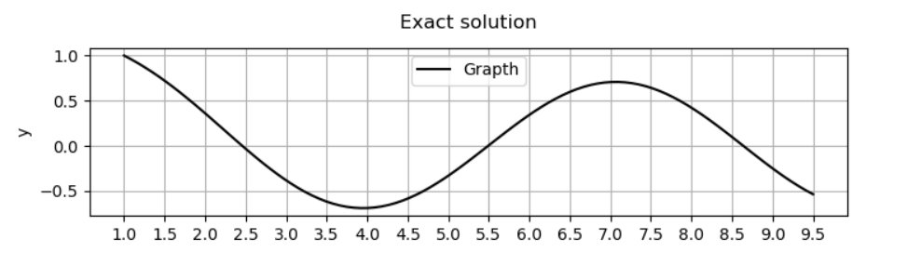

Numerical methods: solutions and errors

*Numerical solutions:*

Euler’s method, Improved Euler’s method and Runge-Kutta method are shown in the first plot. Step depends on the number of points and set by slider.

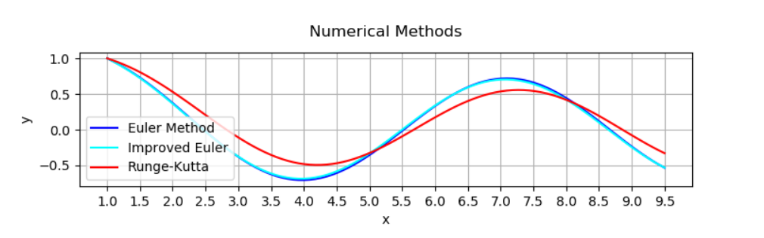

*Errors:*

We define error graphs by the difference between exact solution and numerical methods.

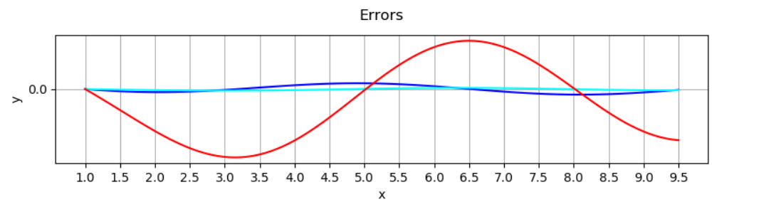

Program: how it looks

*Graphical representation:*

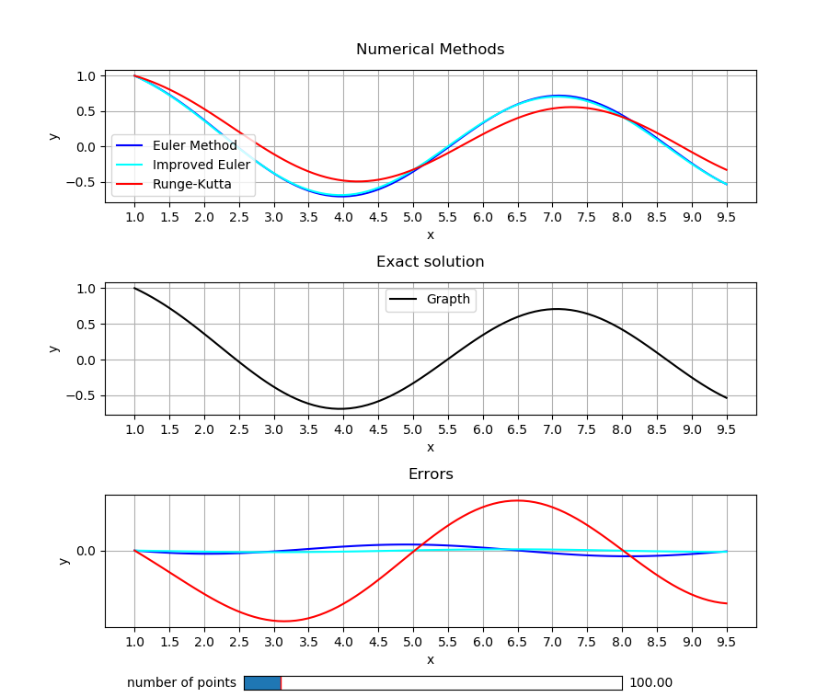

*Structure in diagram:*

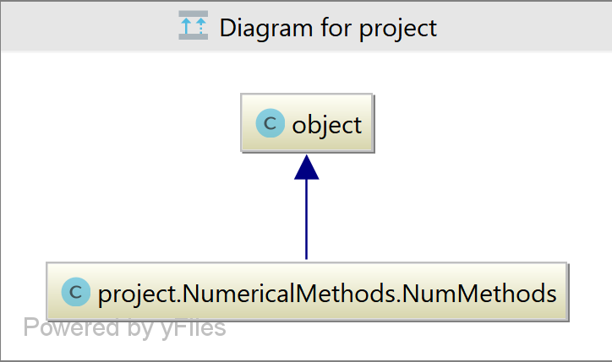

Structure of the program

Firstly, there is a need to import the class that contains necessary parameters for counting and plotting graphs. Program contains methods which count values for Euler’s method, Improved Euler’s method, Runge-Kutta, exact solution and errors.

*Class initialization:*

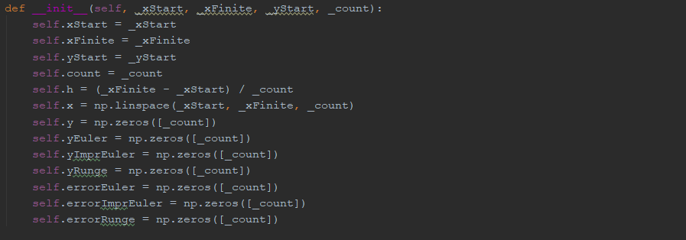

*Numerical methods:*

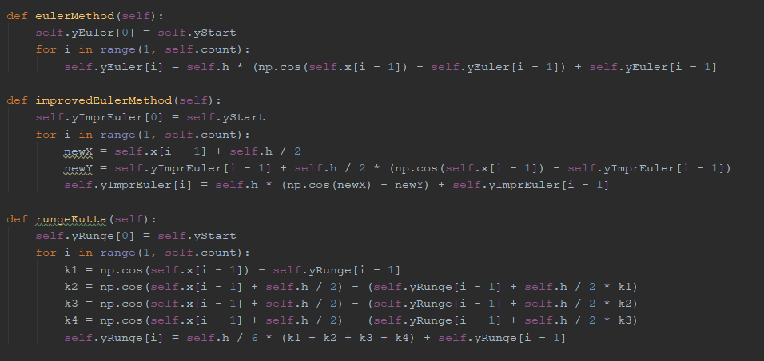

*Exact solution:*



*Errors*:

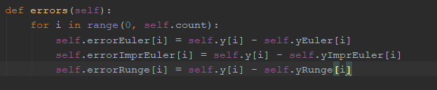

*Main program:*

Firstly, enter the necessary values and create figure. Secondly, check the state of the slider. If there is a change, there is a need to run the update() function.

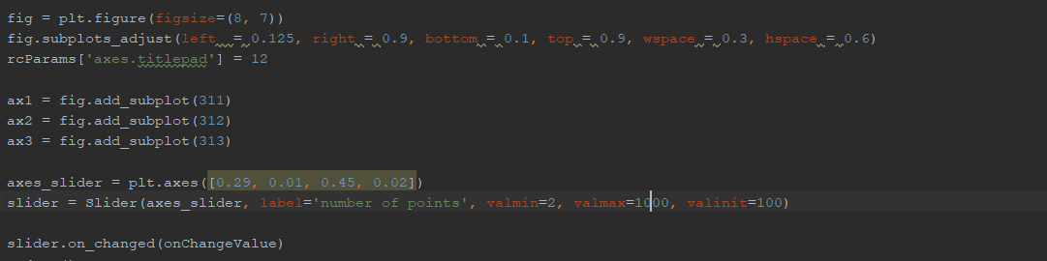

In this method, we create three subplots for numerical methods, exact solution, errors and new graphs that are built according to the new step.

