# Hobby Hub

|  |  |
| --- | --- |
| Groupmember: | Weipeng Cao |
|  | Lacey Conrad |
|  | Austin Linn |
|  | Dmytro Ryzhkov |

Project Tracker: Trello Link: <https://trello.com/b/kJQbwNqx>

VCS: Git/Githubs Link: <https://github.com/Rikka12580/group8>

### Group Distribution:

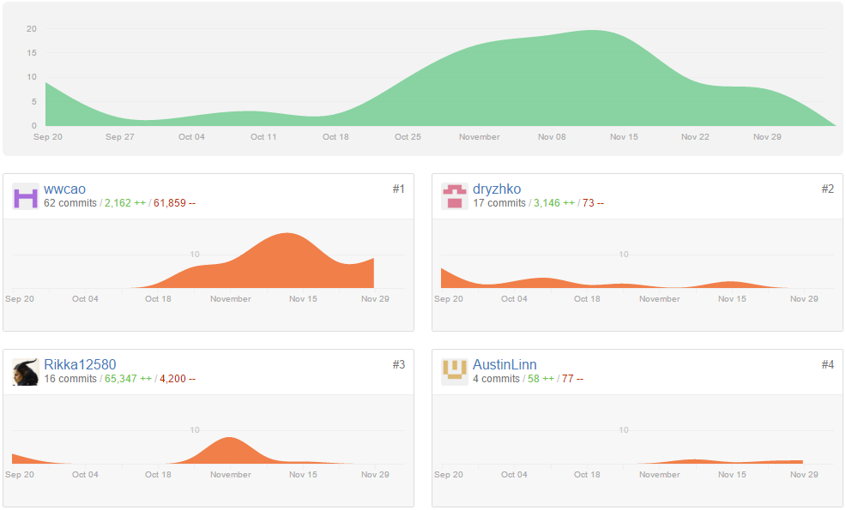

### Deployment:

Link: <https://github.com/Rikka12580/group8> (See README.md)

### Auto-doc:

Auto-doc tool: Doxygen  
Link: <https://github.com/Rikka12580/group8> @ autodoc