Presentation of Nanotechnology

Uses and Functions

The main goal of nanotechnology is to develop new substances, machines, and systems with special qualities and capabilities resulting from their tiny architectures. The following are some of the primary uses and applications of nanotechnology:

* Electronics and Computing: Nanotechnology has had a significant impact on electronics and computing. It has led to the development of smaller, faster, and more efficient electronic components, such as transistors, memory devices, and sensors. Nanoscale materials, such as carbon nanotubes and graphene, have unique electrical properties and are being explored for use in future generations of electronics.
* Energy: Nanotechnology is being used to improve energy production, storage, and efficiency. For example, nanomaterials are being explored for more efficient solar cells and energy storage devices, such as batteries and supercapacitors. Nanotechnology is also applied in developing more efficient catalysts for fuel cells and improving the energy efficiency of buildings.
* Biomedicine: The properties of some nanomaterials make them ideal for improving early diagnosis and treatment of neurodegenerative diseases or cancer. They are able to attack cancer cells selectively without harming other healthy cells. Some nanoparticles have also been used to enhance pharmaceutical products such as sunscreen.
* Environment: Air purification with ions, wastewater purification with nanobubbles or nanofiltration systems for heavy metals are some of its environmentally-friendly applications. Nanocatalysts are also available to make chemical reactions more efficient and less polluting.
* Food: In this field, nanobiosensors could be used to detect the presence of pathogens in food or nanocomposites to improve food production by increasing mechanical and thermal resistance and decreasing oxygen transfer in packaged products.
* Textile: Nanotechnology makes it possible to develop smart fabrics that don't stain nor wrinkle, as well as stronger, lighter and more durable materials to make motorcycle helmets or sports equipment.

Importance and Benefits

The impact of nanotechnology extends from its medical, ethical, mental, and environmental applications to fields such as engineering, biology, chemistry, computing, materials science, and communications. Major benefits of nanotechnology include improved manufacturing methods, water purification systems, energy systems, physical enhancement, nanomedicine, better food production methods, nutrition and large-scale infrastructure auto-fabrication. Nanotechnology's reduced size may allow for automation of tasks which were previously inaccessible due to physical restrictions, which in turn may reduce labor, land, or maintenance requirements placed on humans.

* Medical- Nanotechnology has extensive application as nanomedicine in the medical field. Some nanoparticles have possible applications in novel diagnostic instruments, imagery and methodologies, targeted medicinal products, pharmaceutical products, biomedical implants, and tissue engineering. Today treatments of high toxicity can be administered with improved safety using nanotechnology, such as chemotherapeutic cancer drugs.
* Ethical- Considering the significant risks associated with nanotechnology, it is crucial to thoroughly evaluate its potential repercussions. While it is possible that nanotechnology may not reach the level of advancement anticipated by its proponents, it is prudent to proactively address any ethical concerns that may arise before the technology becomes firmly established in society.
* Mental- Nanotechnology can potentially have both positive and negative impacts on mental health. On the positive side, nanotechnology-based advancements in diagnostics and treatment options can lead to more effective and personalized approaches for mental health disorders. However, it is essential to consider the potential risks and ethical implications associated with nanotechnology. The use of nanomaterials in brain interfaces or implants raises concerns regarding long-term safety, privacy, and the potential for unintended consequences.
* Environmental- The environmental impact of nanotechnology is the possible effects that the use of nanotechnological materials and devices will have on the environment. As nanotechnology is an emerging field, there is debate regarding to what extent industrial and commercial use of nanomaterials will affect organisms and ecosystems. Nanotechnology's environmental impact can be split into two aspects: the potential for nanotechnological innovations to help improve the environment, and the possibly novel type of pollution that nanotechnological materials might cause if released into the environment.

Literature Reviews and Supporting Information

Nanotechnology is a multidisciplinary field that includes a vast and diverse array of devices that derived from engineering, physics, chemistry, and biology leading to the development of structures, devices and systems that have novel functional properties by size ranging between 1 and 100 nm (Neethirajan and Jayas 2010; Borm et al, 2006; Ducan 2011). Nanotechnology involves the manipulation of materials at nanometer sizes leading to the fabrication of nanodevices to enhance their performance.

APPLICATIONS OF NANOPARTICLES

* Nanomaterials – used to describe materials with one or more components that have at least one dimension in the range of 1 to 100 nm and include Nanoparticles, nanofibres and nanotubes, composite materials and nano-structured surfaces. These include Nanoparticles (NP) as a subset of nanomaterials currently defined by consensus as single particles with a diameter < 100 nm. Agglomerates of NP can be larger than 100 nm in diameter but will be included in the discussion since they may break down on weak mechanical forces or in solvents. Nanofibres are a subclass of nanoparticles (include nanotubes) which have two dimensions < 100 nm but the third (axial) dimension can be much larger.
* Nanotools – tools and techniques for synthesizing nanomaterials, manipulating atoms and fabricating device structures, and very importantly for measuring and characterizing materials and devices at the nanoscale.
* Nanodevices – making devices at the nanoscale, important in microelectronics and optoelectronics at the present time, and at the interface with biotechnology where the aim is to mimic the action of biological systems such as cellular motors. This latter area is the most futuristic, and excites the greatest public reaction (Borm et al., 2006)

Technology Observations

This technological branch manipulates the molecular structure of materials to change their intrinsic properties and obtain others with revolutionary applications. This is the case of graphene — modified carbon harder than steel, lighter than aluminum and almost transparent — or nanoparticles used in areas such as electronics, energy, biomedicine or defense. There are bright and dark spots in the future of nanotechnology. On the one hand, the sector is expected to grow globally, driven by technological advances, increased government support, increased private investment and growing demand for smaller devices, to name a few. However, the environmental, health and safety risks of nanotechnology and concerns related to its commercialization could hamper market expansion. Nanotechnology is the manipulation of matter on a nearatomic scale to produce new structures, materials and devices. The technology promises scientific advancement in many sectors such as medicine, consumer products, energy, materials and manufacturing.

Surveys and Technology Evaluation

In 2005, the National Science Foundation (NSF) awarded a grant to the National Center for Manufacturing Sciences (NCMS) to poll over 6,000 senior-level executives in leading U.S. organizations with leadership, technology or strategic research and development (R&D) responsibility to assess the outcome of growing private and public investments made in nano-technology under the National Nanotechnology Initiative (NNI). The overarching objective in conducting this largest known cross-industry benchmark study was to determine whether surveyed organizations treat nanotechnology differently from any other generation of advanced science and technology. The metric established by NSF was 300 survey responses to develop a credible profile – the survey netted 594 completed responses, representing a response rate of 10%. The NCMS survey of nearly 600 industry executives indicates that the state of the U.S. Nanomanufacturing Industry is generally vital, innovative and competitive for demonstrated passive nanotechnology products with many two-dimensional (2D) product applications growing rapidly for end-uses across diverse industry sectors. The survey confirms that the U.S. has the best-developed and mature research facilities, entrepreneurial culture and governance infrastructure for promoting new nanotechnology driven economic development.

Status of Nanotechnology in the Philippines

The potential of nanotechnology has been acknowledged by the Philippines, as such a technology roadmap was established 10 years ago to guide the development of nanotechnology in the country. However, the presence of the COVID-19 pandemic has drastically affected the timeline of most technological roadmaps. Several barriers and constraints for the adoption of nanotechnology in the Philippines were identified. On the other hand, the facilitating factors that would enable the acceptance of the technology in the country was also explored. Moreover, the impacts brought about by the advancements in nanotechnology towards major sectors such as the economy, environment, and society were also discussed. From the gathered information on the trends, factors for adoption and impacts of the technology, policy recommendations were raised to help establish the roots of nanotechnology in the country and support it in its technological maturity.

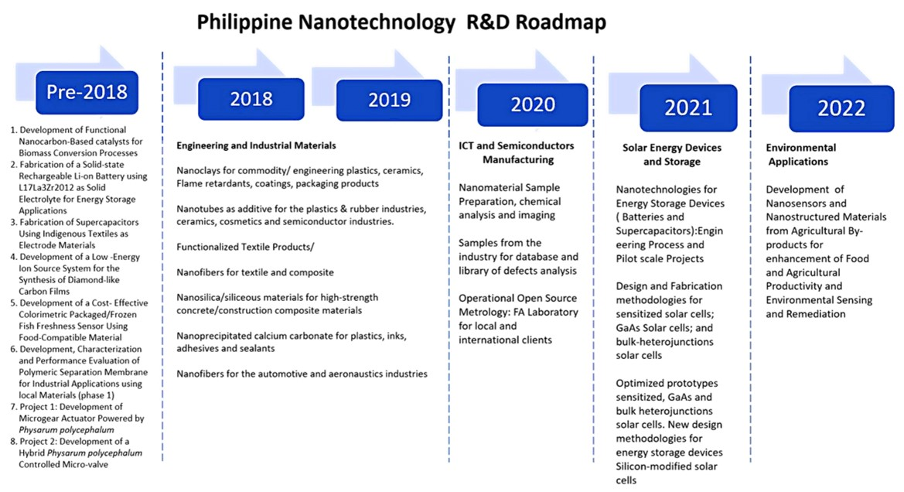

In the Philippines, the Department of Science and Technology-Philippine Council for Advanced Science and Technology Research and Development Council (DOSTPCASTRD) fronted extensive R&D initiatives for nanotechnology in the country by launching a 10-year strategic roadmap, crafted by a group of interdisciplinary local scientists in 2009.