**The Inn.**

**Exercise 1.**

Line up all requests to the software.

The software is expected to take care of :

1. working hours for staff
2. commodity storage
3. room reservations
4. meal orders
5. (Customer orders)
6. recipes
7. To be user friendly
8. Encourage the stay of customers
9. Encourage to eat at the Inn
10. Clear separation of staff role/work requirements (The Servant, The Chef, Himself, Wife?) - Able to request help

FURPS

**Functional** features, capabilities, security.

**Usability** human factors, help, documentation.

**Reliability** frequency of failure, recoverability, predictability.

**Performance** response times, throughput, accuracy

**Supportability** adaptability, maintainability, internationalization, configurability,  availability, resource usage.

**Exercise 2.**

Set up all Use Cases (Brief version) so every user expectation including the requests are covered

**Use Case 1: Staff**

**Scope:**

**Primary actors:** Mr. Brown, Mrs. Brown, The Servant, The Chef

**Stakeholders and interests:**Mr. Brown, Mrs. Brown, The Servant, The Chef,

**Precondition:** There must be staff at the Inn.

**Main Success Scenario:**

1. A person from the staff launch the software.
2. The user enters an unique logon.
3. gets into an unique page
4. Weekly/monthly working hours is visualised.
5. You’re able to see your job tasks compared to your working hours and role.
6. Staff is able to apply for shifts.
7. admin is able to make a monthly roster.

The program upholds all requests and the vision of the Staff

**Extensions:** The program fails aforementioned criteria of success, specified error

**Special requirement:** Vision(Soft requirements)

**Technology and Data Variations List:**

**Frequency of Occurrence:**

**Miscellaneous:**

**Use Case 2: Customers**

**Primary actors:** Customers

**Stakeholders and interests:** Focus on Mr. Brown - whole staff is interested.

**Precondition:** There must be customers at the Inn

**Main Success Scenario:**

1. Customer enter the website
2. Customers are able to reserve a room and decide a meal menu.

2a. Customer will be directed to a site, to choose a room

2b. Customer will be directed to a site, to choose a menu after their choice.

1. The customer will be directed to a site for payment
2. The customer gets the receipt

**Extensions:**

1. If something goes wrong, the website will specify an error code

**Special requirements**

**Technology and data variations**

Should be able to used on both PC and Mobile

**Frequency of occurrence**

Whenever staff or customers needs it

**Miscellaneous**

**Use Case 3: Storage**

**Primary actors:**

Staff

**Stakeholders and interests:**

Staff: they want to sure their inventory is correct and full to be able to sell products or supply their customers with services. Customers: Would of course like to be served not missing anything.

**Precondition:**

Clear list of what would be in storage and what would be taken on use

**Main Success Scenario:**

The storage is filled to the specified requirements and has the correct details of the number of commodities in storage, and the system will make sure of these specifics

**Extensions:**

1. save the information and refresh the site
2. Storage stocked in wrong space and must be physically looked after

**Special requirements:**

Suggested location of specific product or commodity in storage

Is there different locations for storage?

**Technology and data variations**

Under recipes kan det aflæses om ting er i stock

**Frequency of occurrence**

Whenever needed by Staff

**Miscellaneous**

Make the overview of things in stock clear,

User case name: Recipes

Scope: The full list of recipes used at the Inn and requirements

Level: User goal

Primary actor: Chef and Inn owner

Stakeholders and Interests: Chef and Inn owner: Want’s to know how to make the food. Customers: Want’s to know what the food they orders contain(For purposes of allergy)

Preconditions: Have a full list of recipes, possibly registered by time of date

Success Guarantee: Showing the recipes on list used by the Inn

Main success Scenario: When the program is opened by those with acces it shows the recipes

Extentions: Dosent shows the recipes(Shows wrong or missing recipes?)

Special requirements: (Possible work with list of things in storage?)

Technolgy and Data Variations List: Must be able to be used by device in kitchen

Frequency of occurence: Whenever needed

Miscellaneous: Must be able to change or add recipes over time

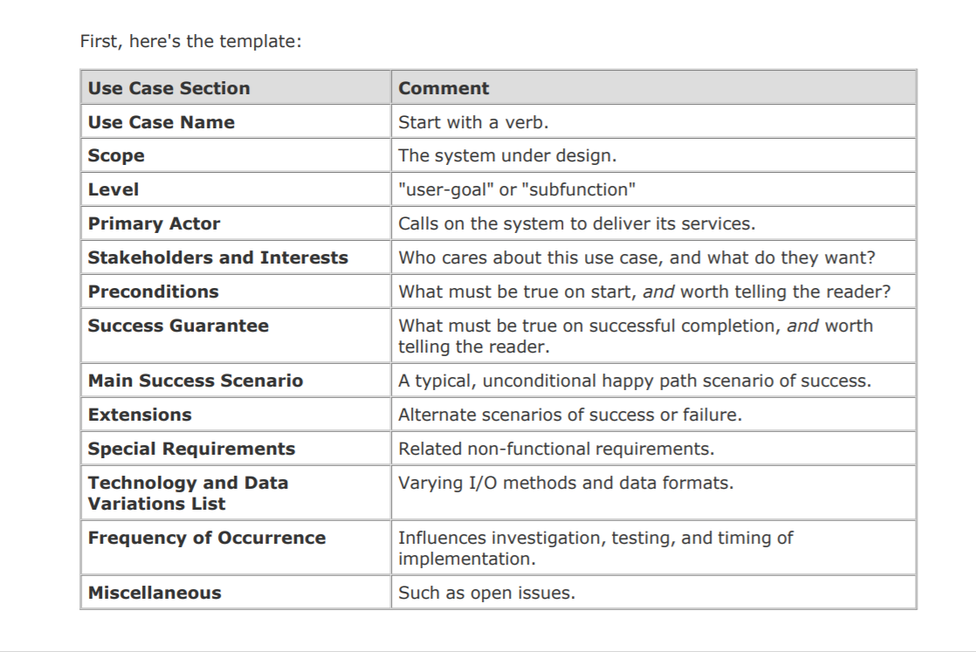

**Exercise 3.**

Make the corresponding Use Case Diagram

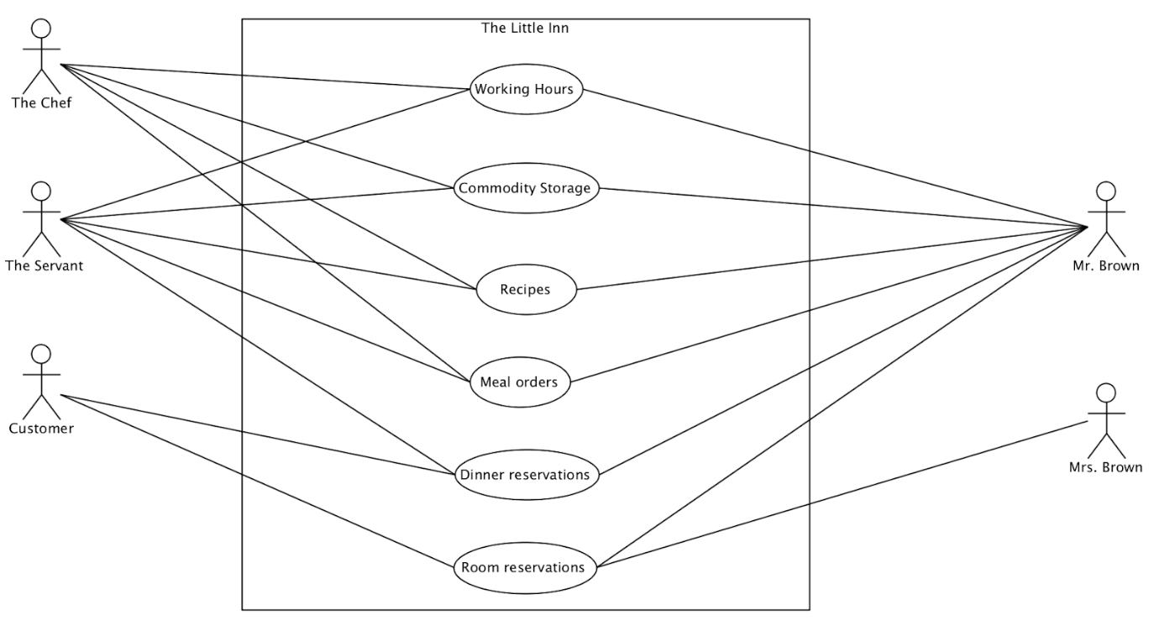

**Exercise 4.**

Make a Domain model that cover the accommodation part of this software.

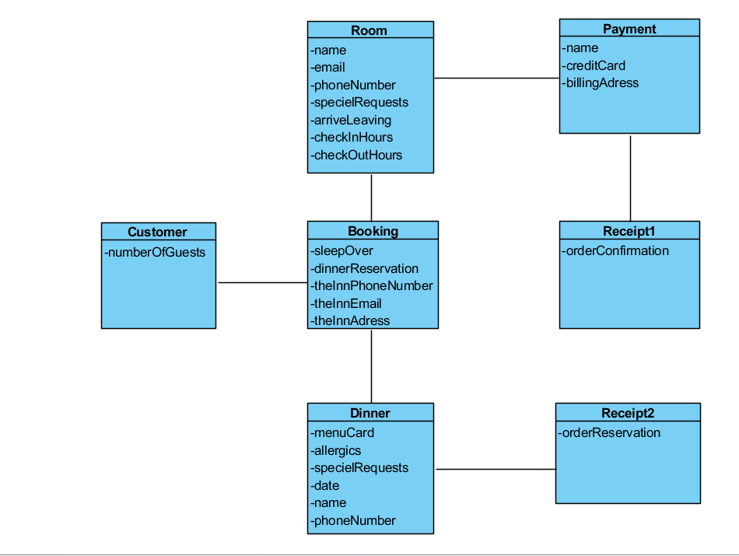

**Exercise 5.**

Make a Domaine model that cover the inn part of this software.

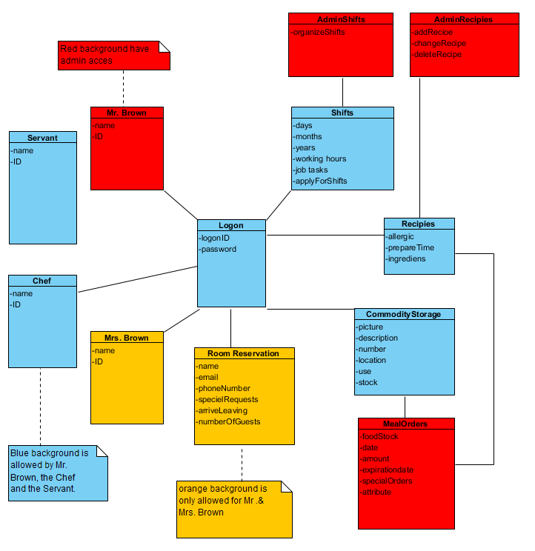

**Idé til vores lager:**

Bruger “if” til automatisk at tjekke lagerstatus så systemet kan bestille nye varer selv, når beholdningen når et lavt niveau.

**Domæne model TheInn:**

**Kok – hvorfor har han adgang til bordreservation og kunder?**

**Bordreservation til kunde?**

**Attributter under lager – hvad skal der stå ud fra f.eks. drikkelse?**

**Vagtplan: Hvem organiserer vagtplanen? Har alle adgang til dette?**

**Logon mangler?**

**Kroen TheInn der står pris i attributter?**

**Domæne model Accomodation:**

**Fra kunde til kontaktinfo?**

**Fra kunde til adresseb?**

**Pris på værelse?**

**Use case diagram???**

**--**

**Usercase 1**

**Ikke kun chef der laver mad**

**Alternet scenario, hvad med ejeren?**

**Hvorfor sammenligne med der mangler af råvarer?**

**Opskrifter efter råvarer?**

**Usercase 2**

**Rengør værelserne?**

**Gentag stage 2-4?**

**Usercase 3**

**Hvorfor kun touchscreen? - ikke under technology?**

**--**

**Accomodation little inn 2**

**Adresse og andre generelle stavefejl**

**Mrs. Brown?**

**Hvad med Mr. Brown ?**

**Værsels beskrivelse nødvendig?**

**Mangler attributer**

**Rent/Beskidt?**

**--**

**The Inn part 1**

**Attributer mangler**

**Forbindelse mellem kro og kunde og bordreservation**

**Stavefejl**

**The little Inn word document**

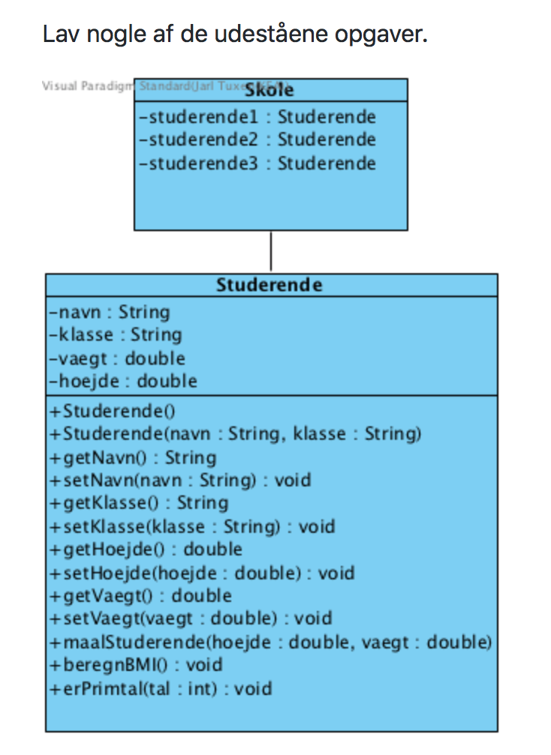

Bordreservation:

* antalPersoner : int
* dagBestilt : String
* Kundeinfo : String
* aflysning : boolean
* Bordreservation()

