Willson Financial Case Study - Milestone 1
(Did this on my own and tried to communicate with group no replies.)
Group Name: B
Team Members: Rikki Kratochvil, Edrian Becerra, Nazir Knuckles
Selected Case Study: Willson Financial
Date: 05/10/2026
Part: Milestone #1

Case Study Summary
Willson Financial is a financial management and advising business started by Jake and Ned Willson in a small New Mexico town. The company is registered with the SEC, has financial advisors, an office employee who handles appointments and office duties, and a part-time compliance manager. The business needs to better understand client growth, assets, transaction volume, and billing so it can serve clients effectively and stay profitable.
Assumptions
- Each client can have one or more investment accounts with Willson Financial.
- Each account is assigned to one advisor, but an advisor can manage many accounts.
- Jake and Ned are stored as advisors because they both acquired CFA licenses and provide financial advising services.
- Phoenix Two Star is stored as an employee who can schedule appointments and perform office duties.
- June Santos is stored as an employee with a compliance manager role and can complete compliance reviews.
- Assets are tracked as holdings within accounts, and each holding has a market value used to calculate total client assets.
- Transactions are recorded at the account level so the company can count clients with more than 10 transactions in a month.
- Billing can use different billing plans because the company is considering changing its billing structure.
- Invoices are generated for clients and can include one or more invoice line items.
- Client growth is measured using the client date_added field.
Business Rules
1. A client must have a unique client ID and may be an individual, rancher, farmer, retiree, or other client type.
2. A client may have zero or many appointments, but each appointment belongs to exactly one client.
3. An appointment must be scheduled by one employee and assigned to one advisor.
4. An advisor may manage many accounts, but each account is managed by exactly one advisor.
5. A client may own many accounts, but each account belongs to exactly one client.
6. An account may contain many asset holdings, but each asset holding belongs to exactly one account.
7. An asset holding must include an asset type, quantity, market value, and valuation date.
8. An account may have many transactions, but each transaction belongs to exactly one account.
9. Transactions must include a transaction date, transaction type, amount, and description.
10. A client may receive many invoices, but each invoice belongs to exactly one client.
11. Each invoice must use one billing plan, and one billing plan may be used by many invoices.
12. Each invoice may include one or more invoice lines, and each invoice line belongs to exactly one invoice.
13. An employee may complete many compliance reviews, but each compliance review is completed by exactly one employee.
14. The system must support reporting the number of clients added during each of the past six months.
15. The system must support calculating the average total assets across the client list.
16. The system must support identifying clients with more than 10 transactions in a month.
Initial ERD
The initial ERD below is based on the business rules and is designed to support client management, appointments, assets, transactions, billing, and compliance tracking.
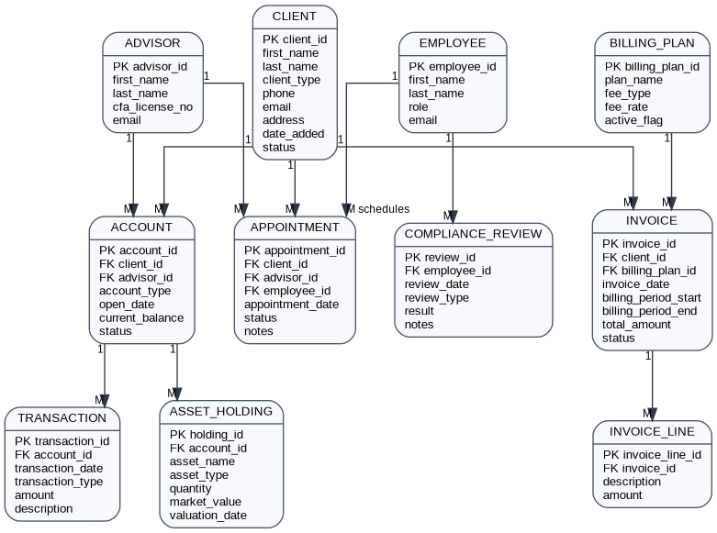

Entity Summary
Entity | Purpose | Important Fields
Client | Stores client profile information. | client_id, name, client_type, date_added, status
Advisor | Stores advisors who manage client accounts. | advisor_id, name, CFA license number
Employee | Stores office and compliance employees. | employee_id, name, role
Account | Stores investment account information. | account_id, client_id, advisor_id, current_balance
Asset_Holding | Stores assets owned in each account. | holding_id, account_id, asset_type, market_value
Transaction | Stores account transaction activity. | transaction_id, account_id, transaction_date, amount
Appointment | Stores client appointments. | appointment_id, client_id, advisor_id, employee_id
Billing_Plan | Stores billing structure options. | billing_plan_id, fee_type, fee_rate
Invoice | Stores client billing records. | invoice_id, client_id, billing_plan_id, total_amount
Invoice_Line | Stores detailed charges for invoices. | invoice_line_id, invoice_id, description, amount
Compliance_Review | Stores SEC compliance review activity. | review_id, employee_id, review_date, result

Source Used
Willson Financial case study PDF provided in the course materials.

