Rikki Kratochvil

Assignment: 5.2

Date:04/19/2026

Running of Script:
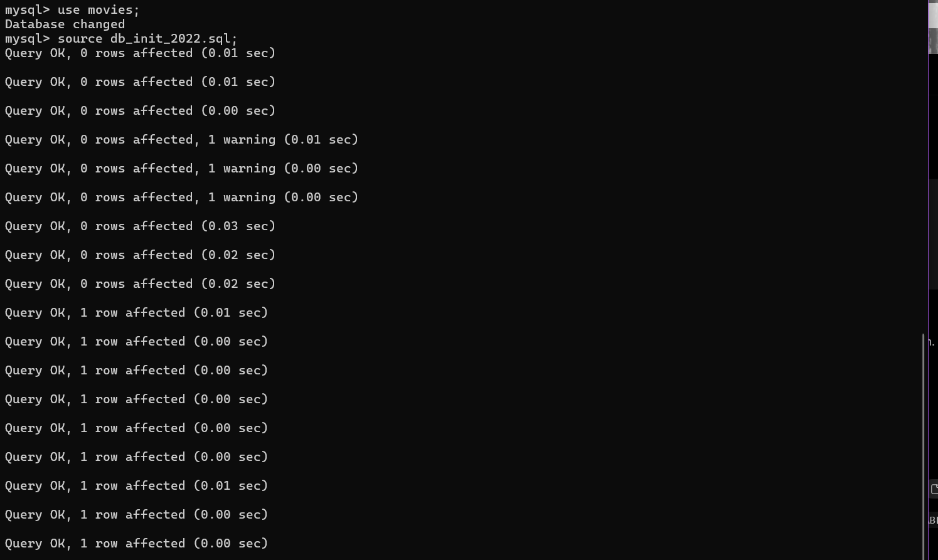

Tables:
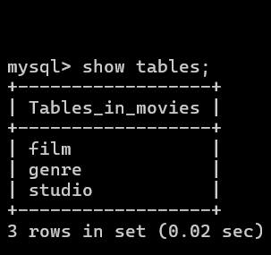

Python connected to MySQL:

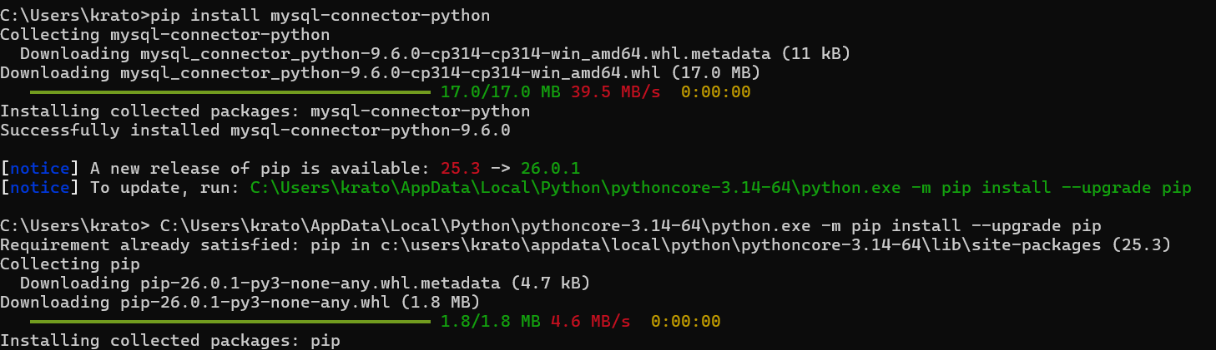

.env made and Mysql_test.py ran:

