Rikki Kratochvil
Assignment: 2.3
Date: 03/25/2026
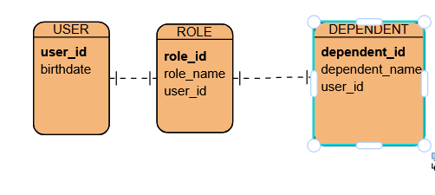
NoSQL data structure:
{
"user_id": 1001,
"birthdate": "1998-04-12",
"roles": [
{ "role_id": 1, "role_name": "Admin" },
{ "role_id": 2, "role_name": "Editor" }
],
"dependents": [
{ "dependent_id": 1, "dependent_name": "Sam" },
{ "dependent_id": 2, "dependent_name": "Taylor" }
]
}

