Rikki Kratochvil
Date: 04/08/2026
Assignment: 4.2

Flowchart Before program alterations
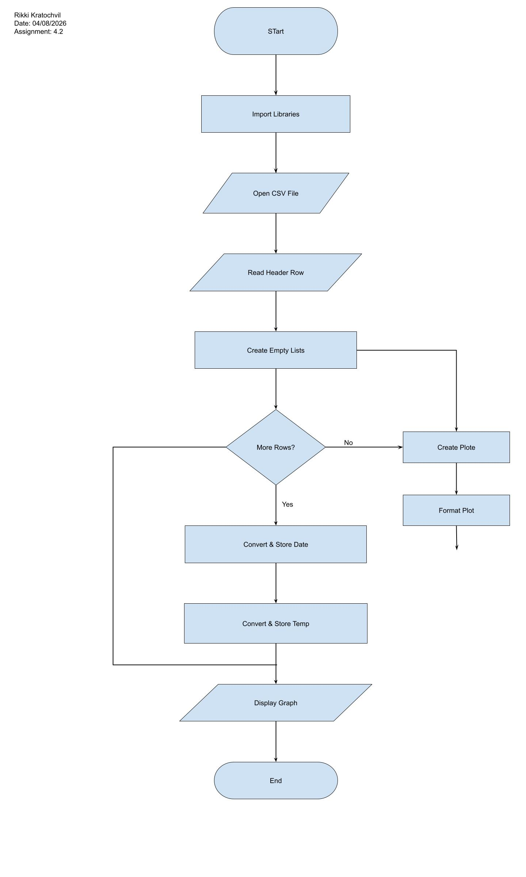

Flowchart after program alterations
