Rikki Kratochvil
Assignment: 7.2
Date: 05/01/2026

Test Passed – Initial City Country Function
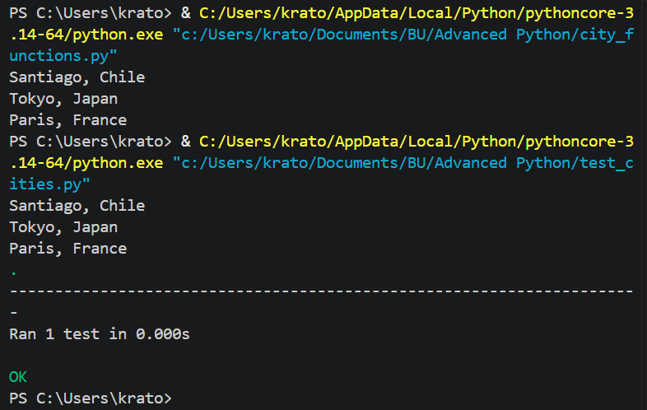

Test Failed – Population Required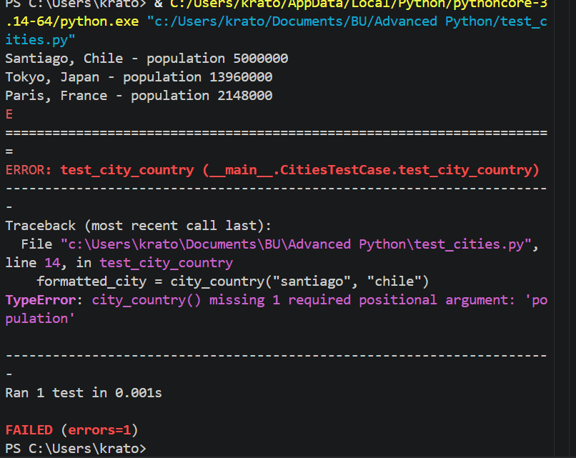
Test Passed – Population Optional
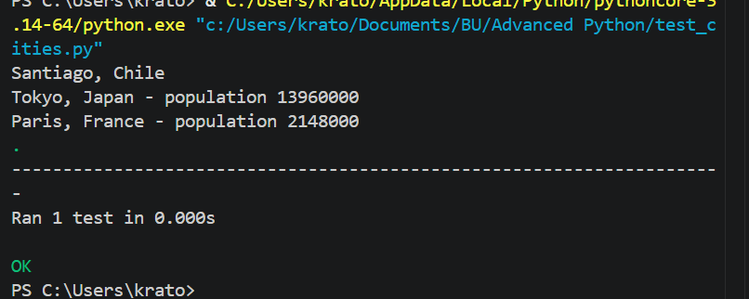

Test Failed – Language Required
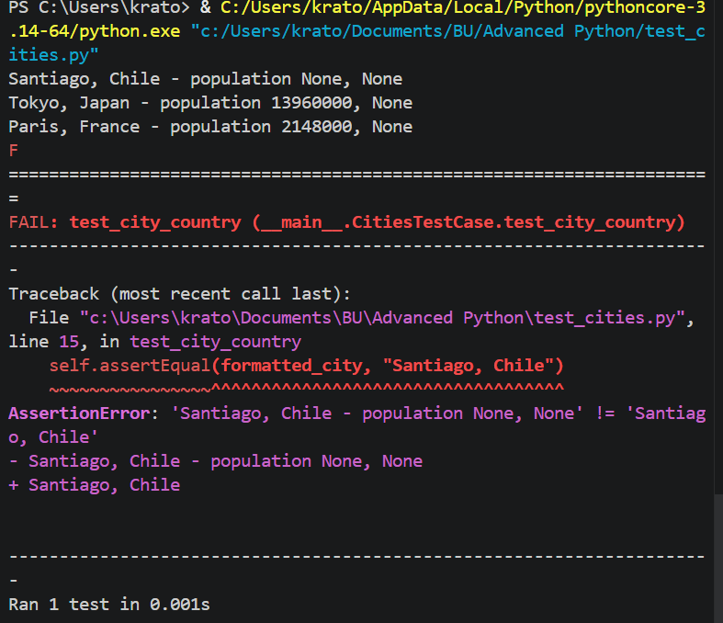

Test Passed – Language Optional