Rikki Kratochvil
Assignment 2.2
Date: 03/25/2026
Link to my github: https://github.com/Rikkikrat/csd-325.git
Breakpoint debug
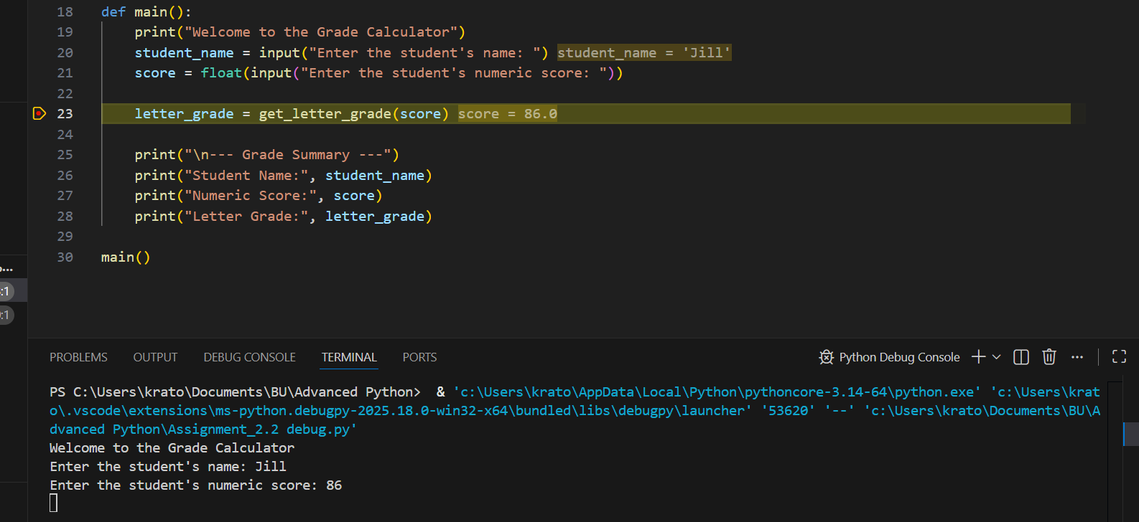
Stepped into function:
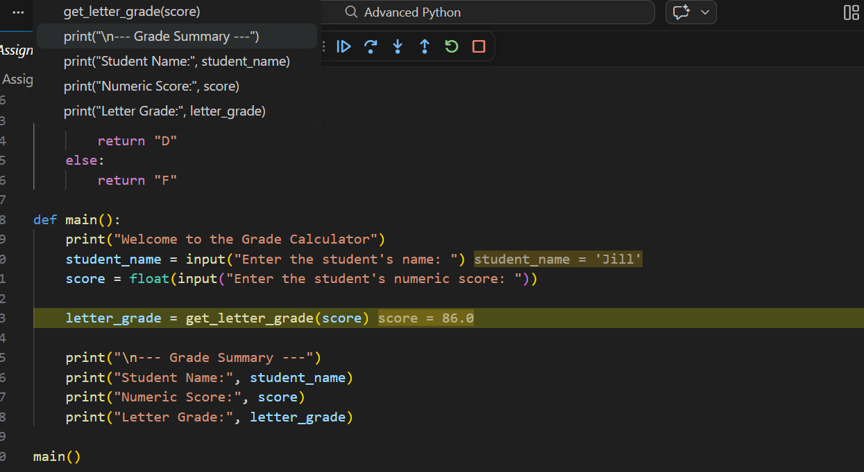

Last screenshot:
