Rikki Kratochvil
Assignment: 8.2
Date: 05/10/2026

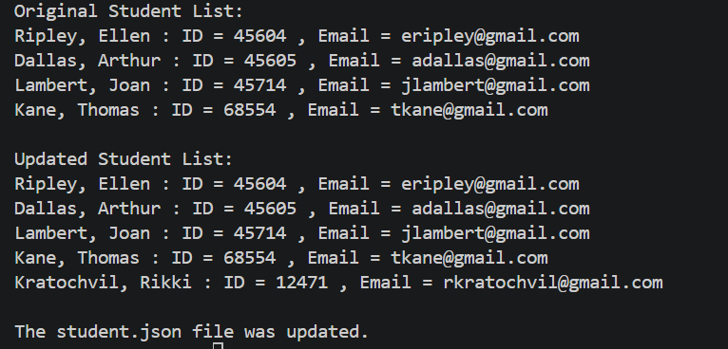

The student.json file was updated successfully. The reload notification did not appear because VS Code automatically refreshed the file.

