Credit Card Fraud Detection Using Random Forest:
A Machine Learning Approach to Imbalanced Classification

Research Paper / Technical Documentation
August 2026
Prepared by: Riktam Sarkar
Computer Science & Engineering specialization in Data Science

JIS University

Abstract
Credit card fraud causes substantial financial losses to banks, merchants, and consumers every year, and the highly imbalanced nature of transaction data makes automatic fraud detection a challenging classification problem. This paper presents an end-to-end machine learning pipeline for detecting fraudulent credit card transactions using the Random Forest ensemble algorithm. The study uses the publicly available European cardholders dataset containing 284,807 transactions, of which only 492 (0.173%) are fraudulent. We describe the complete workflow — data quality assessment, exploratory data analysis, stratified train/test splitting, and training of a class-weighted Random Forest classifier — and evaluate the model using accuracy, precision, recall, F1-score, ROC-AUC, and PR-AUC. The trained model achieves 99.95% accuracy, 96.05% precision, 74.49% recall, an F1-score of 0.8391, a ROC-AUC of 0.9529, and a PR-AUC of 0.8542 on a held-out test set, correctly identifying 73 of 98 fraudulent transactions with only 3 false positives. We further discuss the mathematical foundations of Random Forests, the class-imbalance problem, existing research gaps in fraud-detection literature, and directions for future improvement such as cost-sensitive learning, resampling techniques, and real-time deployment.
Keywords: Credit Card Fraud Detection, Random Forest, Class Imbalance, Machine Learning, Anomaly Detection, Ensemble Learning, ROC-AUC, Precision-Recall

Table of Contents
1. Introduction
2. Related Work / Literature Review
3. Research Gaps
4. Dataset Description
5. System Architecture and Project Workflow
6. Methodology
6.1 Data Preprocessing
6.2 Random Forest — Mathematical Formulation
6.3 Handling Class Imbalance
7. Exploratory Data Analysis
8. Experimental Results
9. Discussion
10. Technologies Used
11. Limitations
12. Future Work
13. Conclusion
14. References

1. Introduction
Electronic payment systems have made credit cards one of the most widely used instruments for both online and offline commerce. This convenience, however, has been accompanied by a steady rise in credit card fraud, resulting in billions of dollars in losses globally each year. Fraudulent transactions are rare, highly diverse in pattern, and constantly evolving as fraudsters adapt to detection systems, which makes rule-based and purely statistical detection methods insufficient on their own.
Machine learning offers a data-driven alternative: instead of relying on fixed rules, a model learns patterns that distinguish legitimate transactions from fraudulent ones directly from historical data. Among the many algorithms explored for this task, Random Forest — an ensemble of decision trees combined through bagging and majority voting — has proven particularly effective because it handles non-linear relationships, is robust to outliers, provides feature importance rankings, and resists overfitting better than a single decision tree.
This project implements a complete fraud-detection pipeline built around a Random Forest classifier. The objective is not only to build an accurate model but to document the reasoning behind every stage — data understanding, preprocessing, model design, and evaluation — so the work can serve as both a functioning system and a reference for future research. The remainder of this paper is organized as follows: Section 2 reviews related work; Section 3 identifies research gaps this project addresses and gaps that remain open; Section 4 describes the dataset; Section 5 presents the system architecture; Section 6 details the methodology and mathematical foundation of Random Forests; Section 7 presents exploratory data analysis; Section 8 reports experimental results; and Sections 9–14 discuss findings, technologies, limitations, future work, and conclusions.

2. Related Work / Literature Review
Fraud detection has been studied extensively using both classical statistical techniques and modern machine learning methods.

2.1 Statistical and Rule-Based Methods
Early fraud detection systems relied on manually crafted rules (e.g., transaction amount thresholds, velocity checks, geographic mismatches) and simple statistical outlier detection. These methods are interpretable but struggle to adapt to new fraud patterns and generate high false-positive rates.

2.2 Classical Machine Learning Approaches
Logistic Regression, Decision Trees, Naive Bayes, and Support Vector Machines have all been applied to fraud detection. Logistic Regression offers interpretability but assumes linear separability, which limits its performance on complex fraud patterns. Decision Trees capture non-linear interactions but are prone to overfitting on imbalanced datasets.

2.3 Ensemble Methods
Ensemble techniques such as Random Forest, Gradient Boosting (XGBoost, LightGBM, CatBoost), and stacked classifiers consistently outperform single-model approaches in published fraud-detection studies. Random Forest, in particular, is popular because it aggregates many weak, decorrelated decision trees to reduce variance while remaining computationally efficient and easy to tune.

2.4 Deep Learning Approaches
More recent work explores autoencoders for unsupervised anomaly detection, LSTM networks for sequential transaction modelling, and graph neural networks that exploit relationships between accounts, merchants, and devices. These methods can capture temporal and relational patterns that tree-based models cannot, at the cost of higher computational complexity and reduced interpretability.

2.5 Handling Class Imbalance
Because fraud constitutes far less than 1% of transactions in most public datasets, a large body of research focuses specifically on imbalance-handling strategies: random undersampling, SMOTE and its variants (Borderline-SMOTE, ADASYN), cost-sensitive learning, and ensemble-based resampling (e.g., EasyEnsemble, BalancedRandomForest). This project uses class-weighted learning as a lightweight alternative to synthetic oversampling.

3. Research Gaps
Based on the literature reviewed above and the scope of the current implementation, the following gaps are relevant to this project:

3.1 Gaps addressed by this project
- Most public tutorials evaluate fraud models using accuracy alone, which is misleading on a dataset that is 99.83% legitimate; this project explicitly reports precision, recall, F1, ROC-AUC, and PR-AUC to give an honest picture of performance.
- Many implementations apply synthetic oversampling (e.g., SMOTE) without validating that the synthetic minority samples reflect realistic fraud patterns; this project instead uses class-weighted learning, which avoids introducing synthetic data artifacts.
- A full, reproducible pipeline — from raw data quality checks through EDA to final evaluation — is documented end-to-end, which is often skipped in shorter demonstrations.

3.2 Open gaps for future research
- Concept drift: fraud patterns evolve over time, but this dataset (and this model) represents a static two-day snapshot; there is no mechanism here for online/incremental learning as new fraud patterns emerge.
- Feature interpretability: the V1–V28 features are PCA-transformed for privacy and cannot be mapped back to real-world merchant, device, or behavioural attributes, which limits explainability in a production setting.
- Real-time deployment: the current pipeline is a batch, offline experiment; latency, throughput, and streaming-inference constraints of a production fraud-detection API are not addressed.
- Cost-sensitive evaluation: false negatives (missed fraud) and false positives (blocked legitimate customers) carry very different business costs, but this study reports standard classification metrics rather than a monetary cost function.
- Comparative benchmarking: this study evaluates Random Forest in isolation; a systematic comparison against Gradient Boosting variants (XGBoost/LightGBM), deep learning models, and hybrid ensembles is left for future work.
- Adversarial robustness: the model is not tested against adversarial or adaptive fraud strategies designed specifically to evade a known detection model.

4. Dataset Description
The dataset used is the widely referenced European Cardholders Credit Card Transactions dataset, containing transactions made over two days in September 2013. It contains 284,807 transactions across 31 columns.
Property | Value
Total transactions | 284,807
Total features | 31 (30 input features + 1 target)
Legitimate transactions (Class = 0) | 284,315 (99.827%)
Fraudulent transactions (Class = 1) | 492 (0.173%)
Duplicate rows | 1,081 (0.3796%)
Missing values | None
Feature types | Time, Amount, V1–V28 (PCA-transformed), Class (target)
Amount — mean / median / max | $88.35 / $22.00 / $25,691.16
Time span | 0 – 172,792 seconds (≈ 48 hours)

The 28 features V1 through V28 are the output of a Principal Component Analysis (PCA) transformation, applied by the original data providers to protect cardholder confidentiality; only Time and Amount remain in their original scale. The target variable Class is binary: 0 for a legitimate transaction and 1 for a confirmed fraudulent transaction.

4.1 Data Quality Observations
- No missing values were found in any of the 31 columns.
- 1,081 duplicate rows (0.38% of the data) were identified during the data-quality audit.
- The dataset is severely imbalanced — a naive classifier that always predicts "legitimate" would already achieve 99.83% accuracy, which is why accuracy alone is not a meaningful metric here.
- Fraudulent transactions have a higher mean amount ($122.21) but a lower median amount ($9.25) than legitimate transactions ($88.29 mean / $22.00 median), indicating fraud amounts are more skewed/variable.

5. System Architecture and Project Workflow
The project follows a linear, reproducible data-science pipeline, from raw CSV ingestion to final model evaluation. Figure 1 summarizes the end-to-end workflow implemented in the accompanying Jupyter notebook.
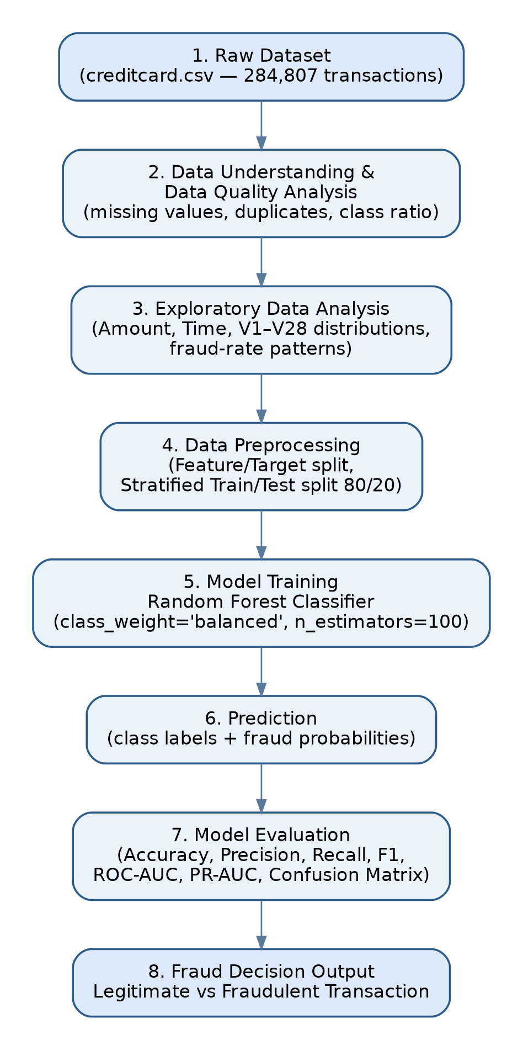
Figure 1. End-to-end project workflow, from raw dataset to fraud decision output.
Each stage is implemented as a discrete, auditable step in the notebook: Step 1 (Project Setup), Step 2 (Data Understanding & Data Quality Analysis), Step 3 (Exploratory Data Analysis), Step 4 (Data Preprocessing), and Step 5 (Random Forest Baseline Model). This modular structure makes the pipeline easy to extend — for example, inserting a resampling step between preprocessing and training, or adding a model-comparison stage after the baseline.

6. Methodology

6.1 Data Preprocessing
The preprocessing stage prepares the raw dataset for supervised learning:
- Feature/target separation: X contains all columns except Class; y is the Class column.
- Stratified train/test split: the data is split 80% / 20% using stratify=y so that the ~0.173% fraud ratio is preserved identically in both the training set (227,845 rows) and test set (56,962 rows).
- Train/test overlap check: index sets were verified to have zero intersection, confirming no data leakage between splits.
- Post-split missing-value check: both training and test sets were re-verified to contain zero missing values.
The stratified split is important given the severity of the imbalance: a non-stratified random split could, by chance, place a disproportionate number of the 492 fraud cases into either the training or test set, biasing the reported metrics.

6.2 Random Forest — Mathematical Formulation
A Random Forest is an ensemble learning method that constructs a collection of B decorrelated decision trees and aggregates their predictions. It combines two sources of randomness: bootstrap aggregation (bagging) over the training samples and random selection of a feature subset at every split.

6.2.1 Bootstrap Aggregation (Bagging)
For b = 1, …, B, a bootstrap sample D_b is drawn with replacement from the original training set D of size N:
D_b = { (x_i, y_i) drawn with replacement from D }, |D_b| = N (1)
A decision tree T_b is trained independently on each bootstrap sample D_b.

6.2.2 Split Criterion — Gini Impurity
At each node of a tree, the algorithm selects the feature and threshold that minimize impurity in the resulting child nodes. For a node containing samples from K classes, the Gini impurity is:
Gini(t) = 1 − Σ (k=1 to K) [ p_k ]² (2)
where p_k is the proportion of samples belonging to class k at node t. A split is chosen to maximize the impurity reduction (information gain):
ΔGini = Gini(parent) − [ (N_left / N) · Gini(left) + (N_right / N) · Gini(right) ] (3)
Random Forest adds an additional layer of randomness: at each split, only a random subset of m features (typically m ≈ √p for classification, where p is the total number of features) is considered, which decorrelates the individual trees and reduces the ensemble's overall variance.

6.2.3 Aggregation — Voting and Probability Averaging
For classification, the final predicted class ŷ for an input x is obtained by majority vote across all B trees:
ŷ(x) = mode { T_1(x), T_2(x), … , T_B(x) } (4)
scikit-learn's RandomForestClassifier instead averages the class probabilities predicted by each tree, which is the mechanism used to produce the fraud probabilities in this project:
P(y = k | x) = (1 / B) · Σ (b=1 to B) P_b(y = k | x) (5)
The predicted class is then the arg-max of the averaged probability vector.
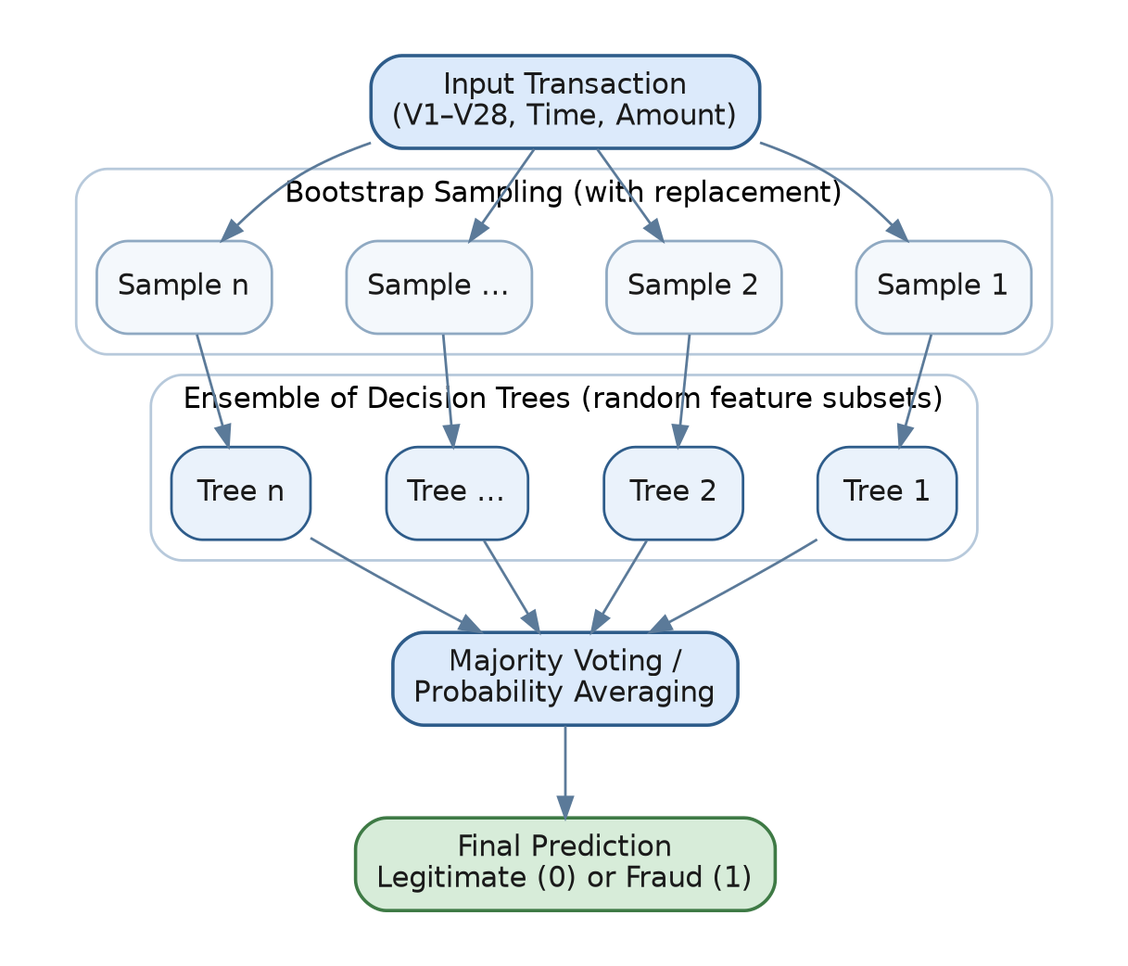
Figure 2. Random Forest architecture: bootstrap sampling, an ensemble of independently trained decision trees, and aggregation via majority voting / probability averaging.

6.3 Handling Class Imbalance
Given that fraud accounts for only 0.173% of the data, training a classifier without adjustment tends to bias predictions heavily toward the majority (legitimate) class. This project addresses the imbalance using class-weighted learning rather than synthetic resampling. Each class is assigned a weight inversely proportional to its frequency:
w_k = N / (K · N_k) (6)
where N is the total number of training samples, K is the number of classes, and N_k is the number of samples in class k. In scikit-learn this is implemented by setting class_weight="balanced" in the RandomForestClassifier, which effectively multiplies the Gini-impurity contribution of minority-class (fraud) samples so that misclassifying them is penalized more heavily during tree construction — without altering the underlying data distribution or introducing synthetic samples.
Model configuration used: n_estimators = 100, class_weight = "balanced", random_state = 42, n_jobs = -1.

7. Exploratory Data Analysis
Exploratory analysis was performed to understand class balance, feature distributions, and temporal patterns before model training. All figures below are generated directly from the project notebook.

7.1 Class Distribution
The dataset is extremely imbalanced: 284,315 legitimate transactions (99.83%) versus only 492 fraudulent transactions (0.17%).
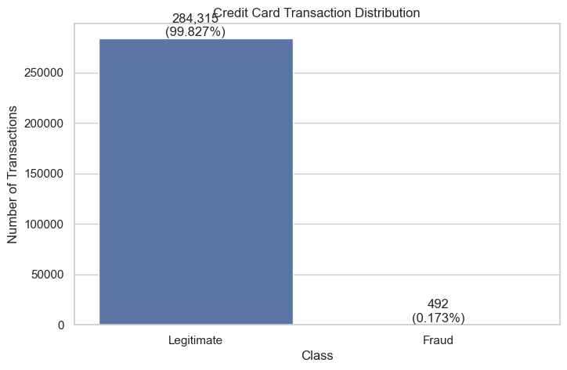
Figure 3. Class distribution of transactions — Legitimate vs. Fraud, with percentage labels.

7.2 Transaction Amount Analysis
Transaction amounts range from $0 to $25,691.16, with a mean of $88.35 and median of $22.00. Fraudulent transactions have a higher mean amount ($122.21) but a much lower median ($9.25) than legitimate transactions, suggesting fraud amounts are concentrated at small values with occasional large outliers.
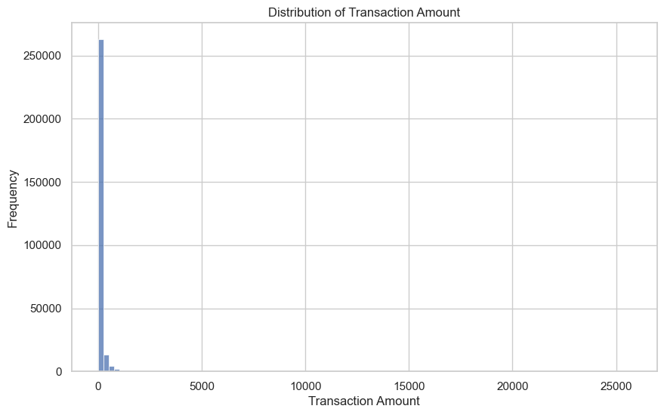
Figure 4. Overall distribution of transaction amount.
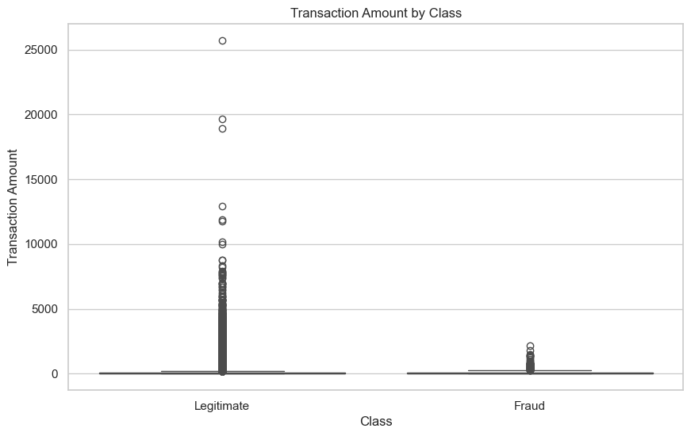
Figure 5. Transaction amount by class (boxplot) — outliers are more visible in the legitimate class due to volume.
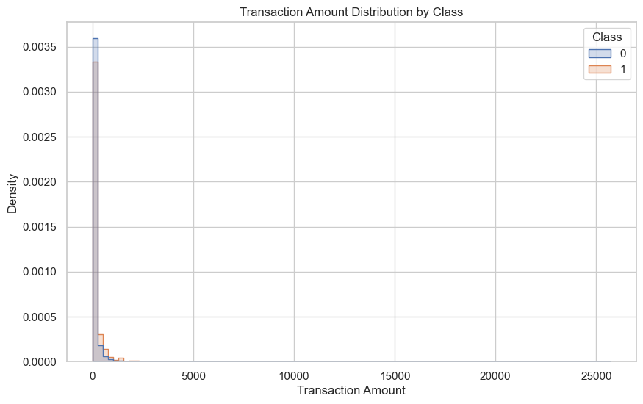
Figure 6. Transaction amount density distribution split by class.
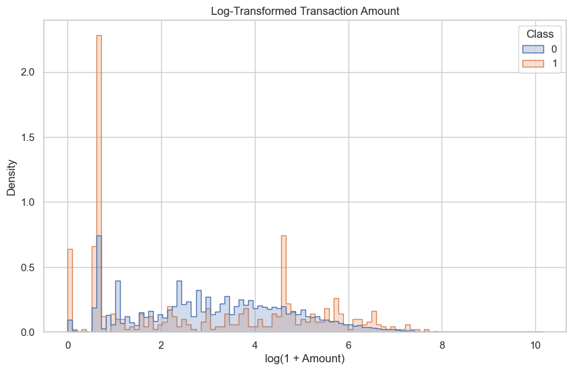
Figure 7. Log-transformed transaction amount (log(1 + Amount)) — improves visual separation between classes.

7.3 Transaction Time Analysis
The Time feature records seconds elapsed since the first transaction in the dataset, spanning roughly 48 hours.
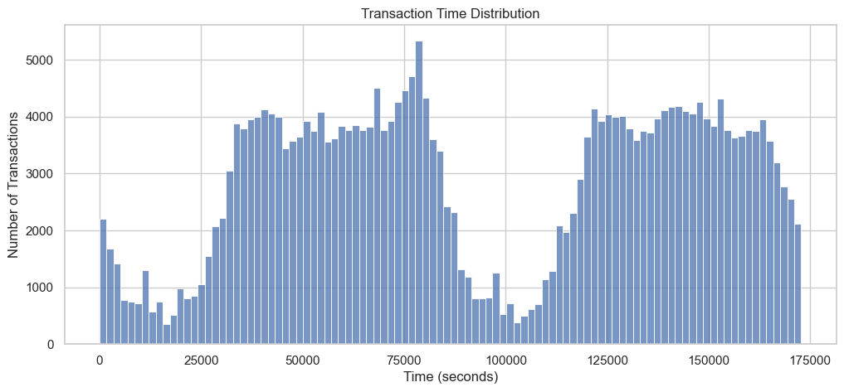
Figure 8. Distribution of transaction time (seconds since first transaction); the two-day cyclic pattern is visible as two humps corresponding to daytime activity.
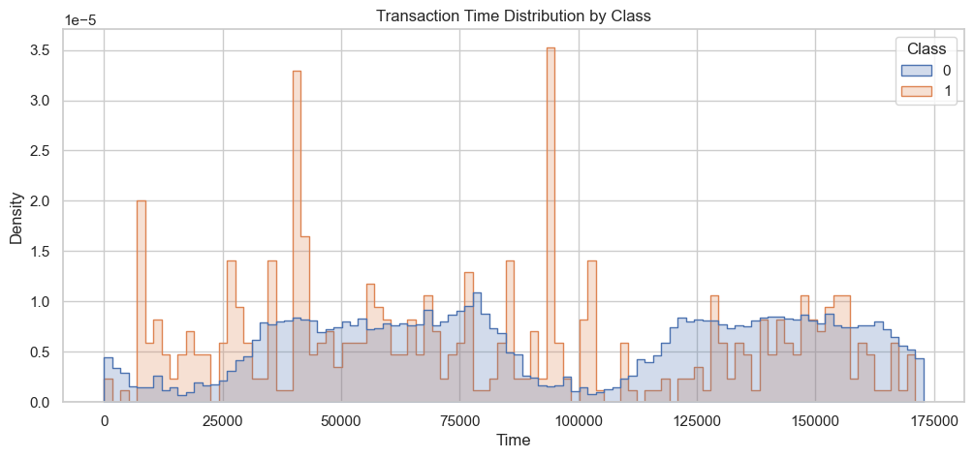
Figure 9. Transaction time distribution split by class.
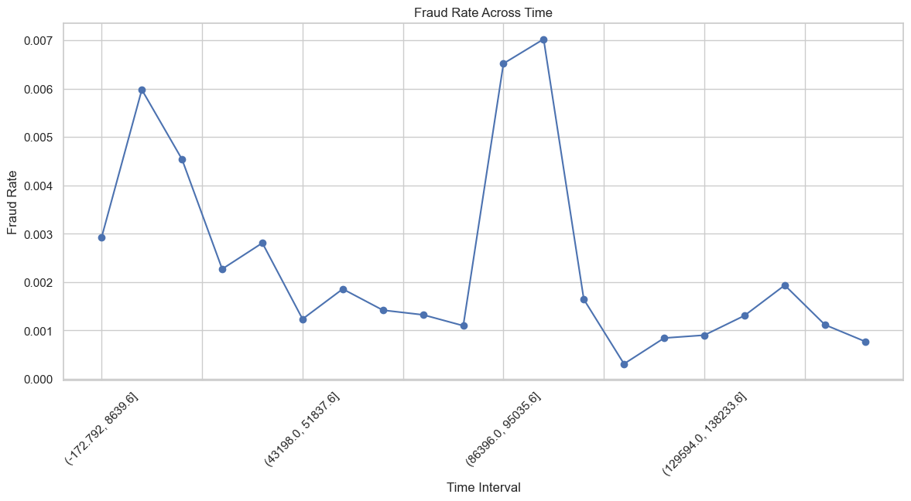
Figure 10. Fraud rate across 20 equal time intervals — fraud rate fluctuates and does not simply track overall transaction volume.

7.4 PCA Feature Distributions (V1–V28)
Since V1–V28 are anonymized PCA components, a representative subset (V1, V2, V3, V10, V12, V14, V17) was inspected to identify which components separate fraud from legitimate transactions most clearly. Components such as V14 and V17 show visibly different distributions between the two classes, indicating they carry strong discriminative signal, which is consistent with their high importance in the trained Random Forest model.
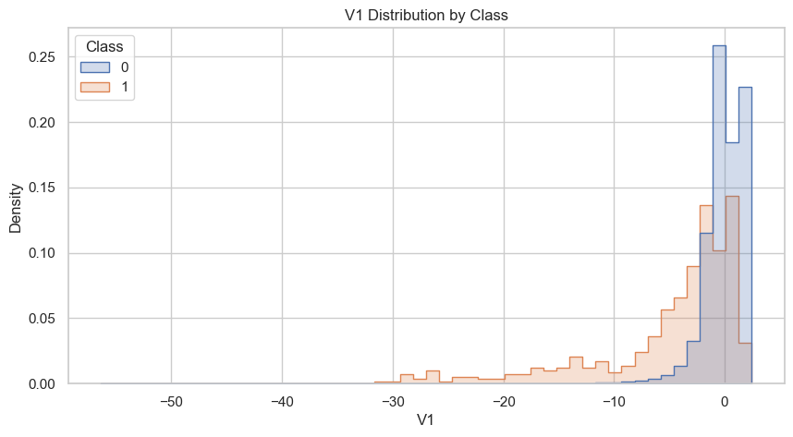
Figure 11. Distribution of V1 by class.
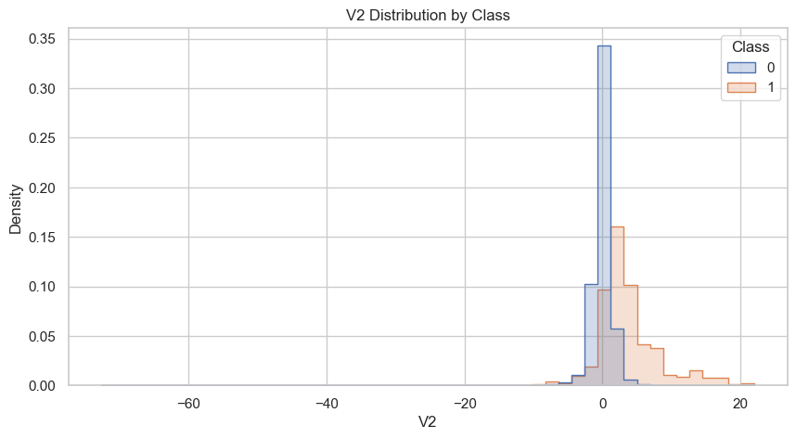
Figure 12. Distribution of V2 by class.
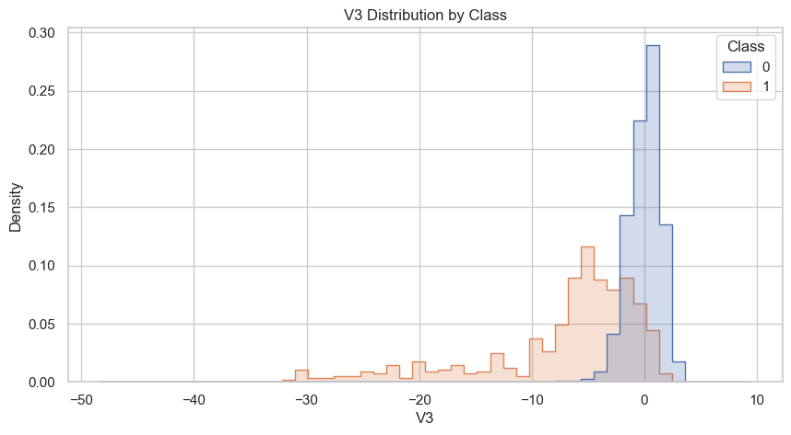
Figure 13. Distribution of V3 by class.
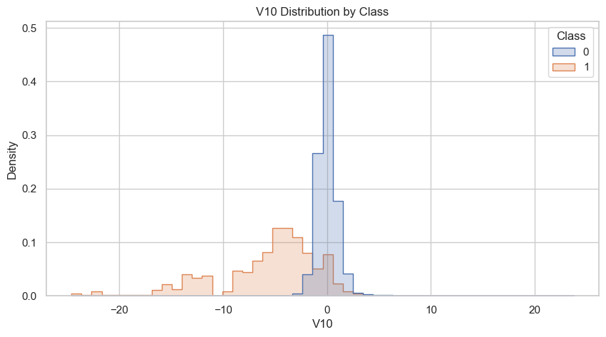
Figure 14. Distribution of V10 by class.
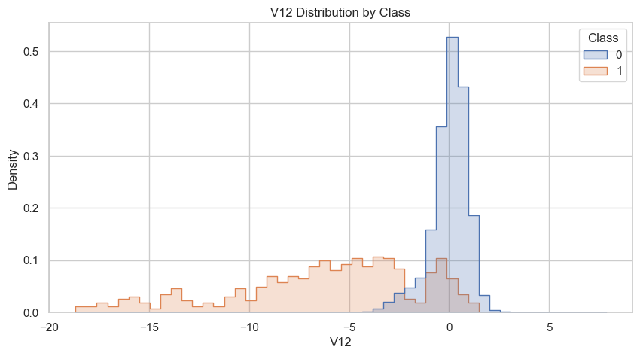
Figure 15. Distribution of V12 by class.
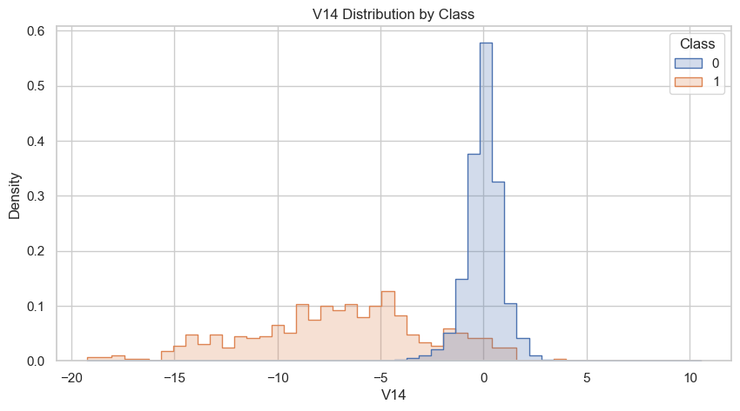
Figure 16. Distribution of V14 by class — one of the clearest fraud/legitimate separations among the PCA components.
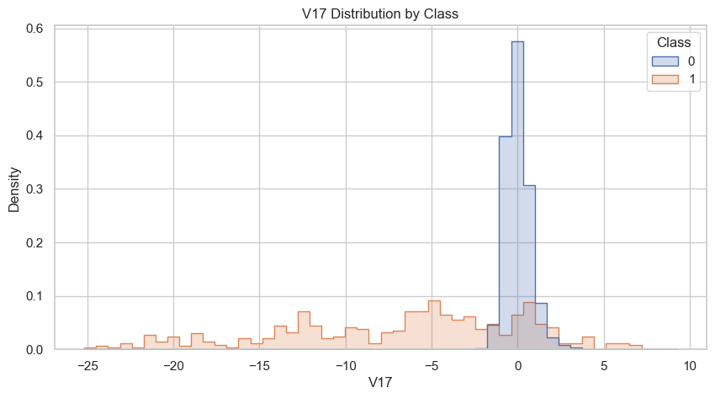
Figure 17. Distribution of V17 by class.

8. Experimental Results

8.1 Evaluation Metrics — Definitions
Given the class imbalance, the model is evaluated using a full suite of metrics rather than accuracy alone:
Precision = TP / (TP + FP) (7)
Recall = TP / (TP + FN) (8)
F1 = 2 · (Precision · Recall) / (Precision + Recall) (9)
Accuracy = (TP + TN) / (TP + TN + FP + FN) (10)
ROC-AUC measures the area under the Receiver Operating Characteristic curve (True Positive Rate vs. False Positive Rate across thresholds), while PR-AUC (average precision) measures the area under the Precision-Recall curve, which is generally more informative than ROC-AUC on highly imbalanced datasets since it focuses on performance for the minority (fraud) class.

8.2 Baseline Random Forest — Results on Held-Out Test Set
The model was evaluated on the 56,962-transaction stratified test set (98 fraud, 56,864 legitimate):
Metric | Score
Accuracy | 0.9995 (99.95%)
Precision | 0.9605 (96.05%)
Recall | 0.7449 (74.49%)
F1-Score | 0.8391
ROC-AUC | 0.9529
PR-AUC (Average Precision) | 0.8542

8.2.1 Confusion Matrix
 | Predicted: Legitimate | Predicted: Fraud
Actual: Legitimate | 56,861 (TN) | 3 (FP)
Actual: Fraud | 25 (FN) | 73 (TP)

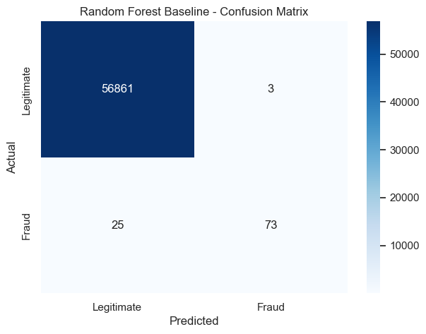
Figure 18. Confusion matrix heatmap for the Random Forest baseline model on the test set.
Of the 98 fraudulent transactions in the test set, the model correctly identified 73 (74.49% recall) while missing 25. Among all transactions flagged as fraud, 96.05% were true fraud (precision), with only 3 legitimate transactions incorrectly flagged. This reflects a precision-oriented model: it is very reliable when it does flag a transaction as fraudulent, at the cost of missing roughly a quarter of actual fraud cases — a trade-off directly influenced by the class_weight="balanced" setting and the default 0.5 probability threshold.
Average predicted fraud probability for true fraud transactions was 0.706, while 55,658 of 56,962 test transactions (97.7%) received a fraud probability of exactly 0.0, reflecting the model's strong confidence on the overwhelming legitimate majority.

9. Discussion
The results demonstrate that a class-weighted Random Forest, without any synthetic oversampling, can achieve strong fraud-detection performance on this dataset. A ROC-AUC of 0.953 and PR-AUC of 0.854 indicate the model separates fraud from legitimate transactions well across a range of decision thresholds, and the 96% precision means the model would generate relatively few false alarms if deployed.
At the same time, a 74.5% recall means roughly one in four fraudulent transactions is missed at the default threshold. In a production fraud system, this trade-off should be tuned according to business cost: lowering the classification threshold would recover more fraud cases (higher recall) at the expense of more false positives (lower precision), and vice-versa. Because Recall and Precision move in opposite directions as the threshold changes, teams typically select an operating point on the Precision-Recall curve that matches the relative cost of a missed fraud versus a wrongly blocked legitimate transaction, rather than relying on the default 0.5 cutoff used here.
The EDA also highlighted that several PCA components (notably V14 and V17) and the Amount feature carry strong discriminative signal, consistent with their contribution to the Random Forest's split decisions. The lack of any missing values and the confirmed absence of train/test leakage support the reliability of the reported metrics.

10. Technologies Used
Category | Tool / Library
Programming Language | Python 3
Notebook Environment | Jupyter Notebook (ipykernel)
Data Handling | pandas, numpy
Visualization | matplotlib, seaborn
Machine Learning | scikit-learn (RandomForestClassifier, train_test_split, StandardScaler, metrics)
Imbalance Handling | imbalanced-learn (installed; class-weighting used as primary strategy)
Model Persistence | joblib
Dataset | creditcard.csv — European cardholders dataset (284,807 transactions)

11. Limitations
- The dataset spans only ~48 hours of transactions, which limits the model's exposure to seasonal or longer-term fraud patterns.
- PCA-transformed features (V1–V28) prevent domain-level interpretation of what specifically drives a fraud prediction.
- Only a single algorithm (Random Forest) and a single class-imbalance strategy (class weighting) were evaluated; no comparative benchmarking against boosting or deep-learning models was performed in this iteration.
- Evaluation uses a single random train/test split (random_state = 42) rather than k-fold cross-validation, so reported metrics carry some sampling variance.
- The model was evaluated offline; latency and throughput under real-time transaction-streaming conditions were not measured.

12. Future Work
- Benchmark against Gradient Boosting variants (XGBoost, LightGBM, CatBoost) and a deep learning baseline (e.g., autoencoder-based anomaly detection).
- Apply k-fold or stratified repeated cross-validation to obtain confidence intervals on all reported metrics.
- Explore SMOTE/ADASYN-based oversampling and BalancedRandomForest as alternatives to class-weighting, with a controlled comparison.
- Perform hyperparameter tuning (tree depth, n_estimators, min_samples_leaf, max_features) via grid or Bayesian search.
- Add SHAP or permutation feature-importance analysis to explain individual fraud predictions.
- Move the classification threshold selection from the default 0.5 to a cost-optimized threshold based on estimated false-positive and false-negative business costs.
- Package the trained model behind a real-time scoring API and evaluate latency, throughput, and concept-drift monitoring in a streaming setting.

13. Conclusion
This project implemented a complete, reproducible pipeline for detecting credit card fraud using a class-weighted Random Forest classifier on a severely imbalanced, real-world-derived dataset. Through careful data-quality auditing, exploratory analysis, and evaluation across multiple imbalance-aware metrics, the model achieved 96.05% precision and 74.49% recall (F1 = 0.839, ROC-AUC = 0.953, PR-AUC = 0.854), correctly flagging 73 of 98 fraudulent test transactions with only 3 false positives. These results confirm that Random Forest, combined with simple class-weighting, is a strong and computationally efficient baseline for fraud detection. The identified research gaps — concept drift, feature interpretability, real-time deployment, cost-sensitive evaluation, and comparative benchmarking — outline a clear path for extending this work into a production-grade fraud detection system.

14. References
[1] Breiman, L. (2001). Random Forests. Machine Learning, 45(1), 5–32.
[2] Dal Pozzolo, A., Caelen, O., Johnson, R. A., & Bontempi, G. (2015). Calibrating Probability with Undersampling for Unbalanced Classification. IEEE Symposium Series on Computational Intelligence.
[3] Chawla, N. V., Bowyer, K. W., Hall, L. O., & Kegelmeyer, W. P. (2002). SMOTE: Synthetic Minority Over-sampling Technique. Journal of Artificial Intelligence Research, 16, 321–357.
[4] Pedregosa, F., et al. (2011). Scikit-learn: Machine Learning in Python. Journal of Machine Learning Research, 12, 2825–2830.
[5] Bhattacharyya, S., Jha, S., Tharakunnel, K., & Westland, J. C. (2011). Data mining for credit card fraud: A comparative study. Decision Support Systems, 50(3), 602–613.
[6] Machine Learning Group – ULB. (2013). Credit Card Fraud Detection Dataset. Kaggle / Université Libre de Bruxelles.
[7] Provost, F., & Fawcett, T. (2001). Robust Classification for Imprecise Environments. Machine Learning, 42, 203–231.

