Task 2

A. Use Case/ Activity Diagram
Requesting School Documents
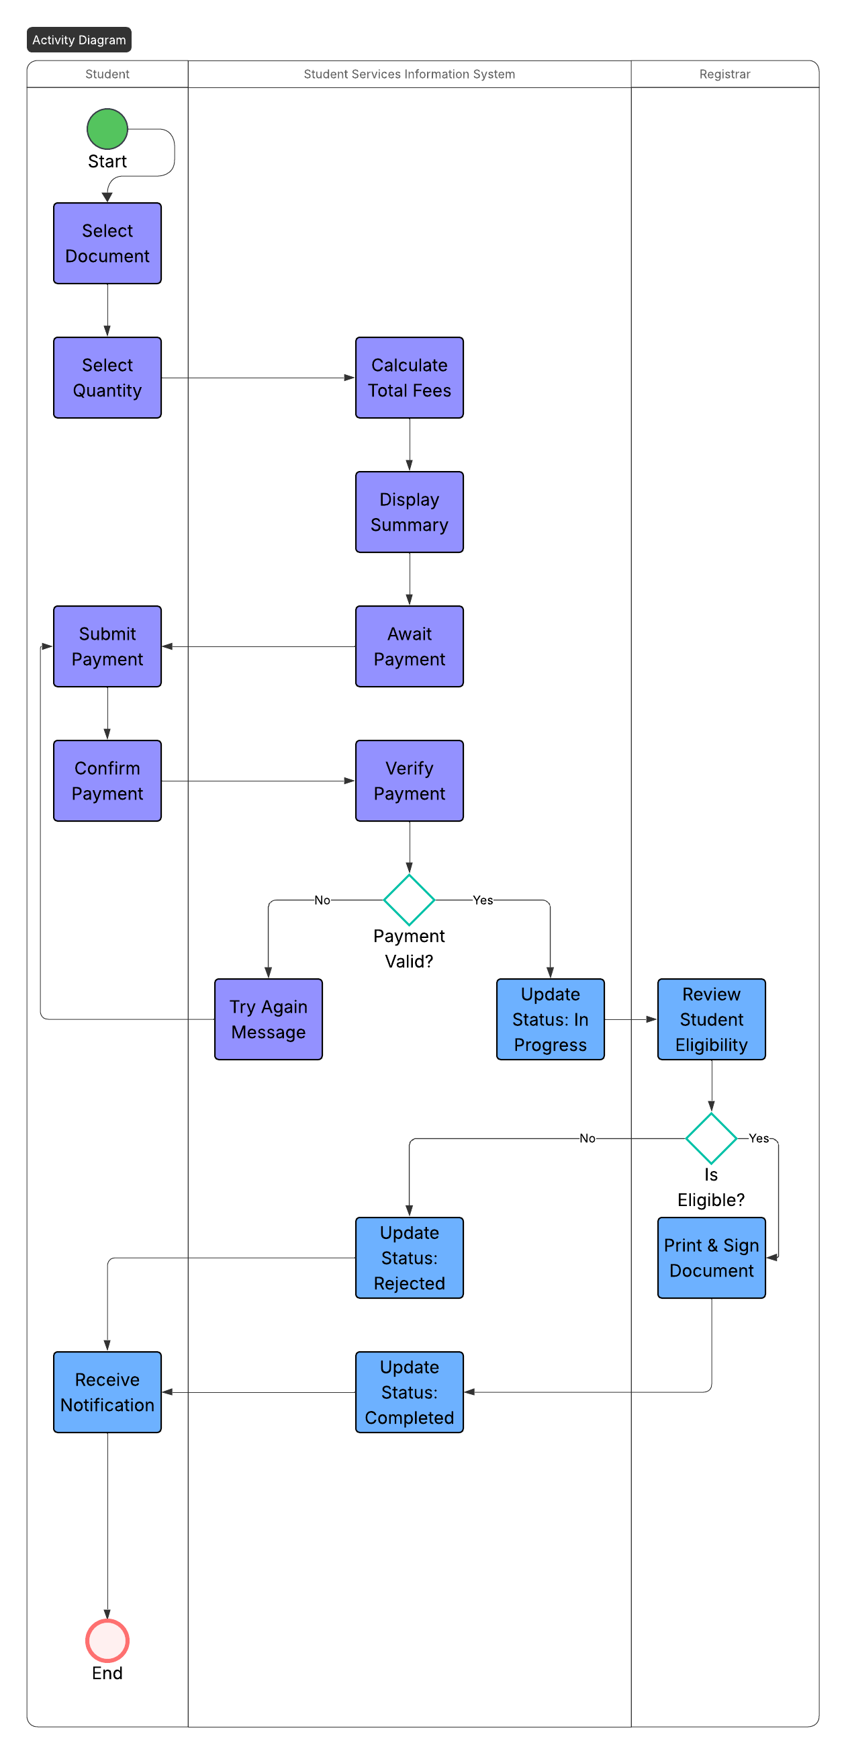

B. Data Flow Diagram (DFD)

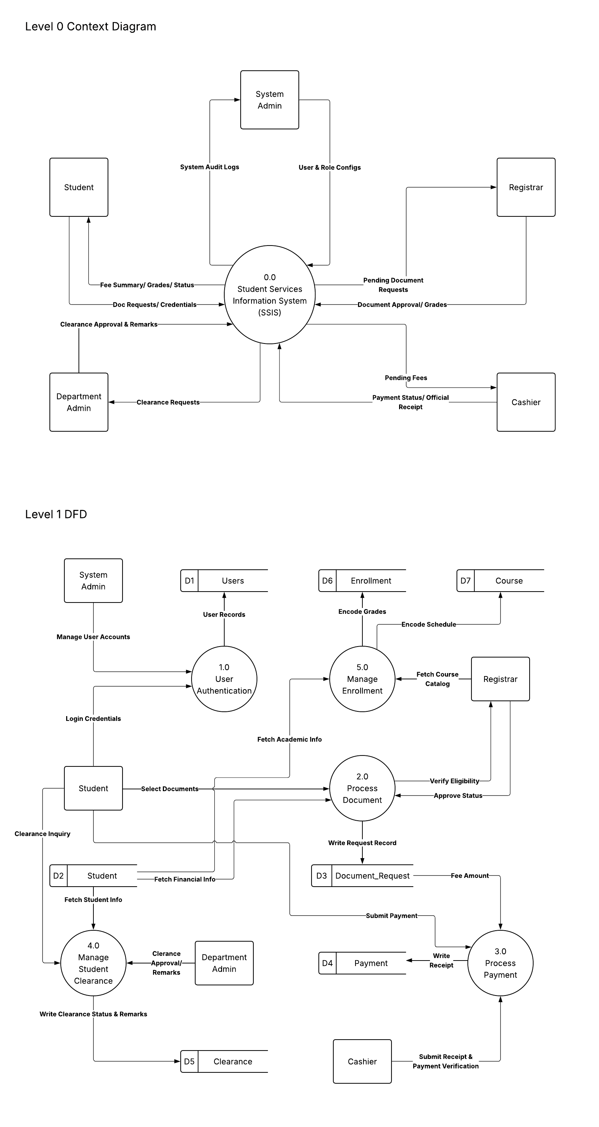

C. Class Diagram
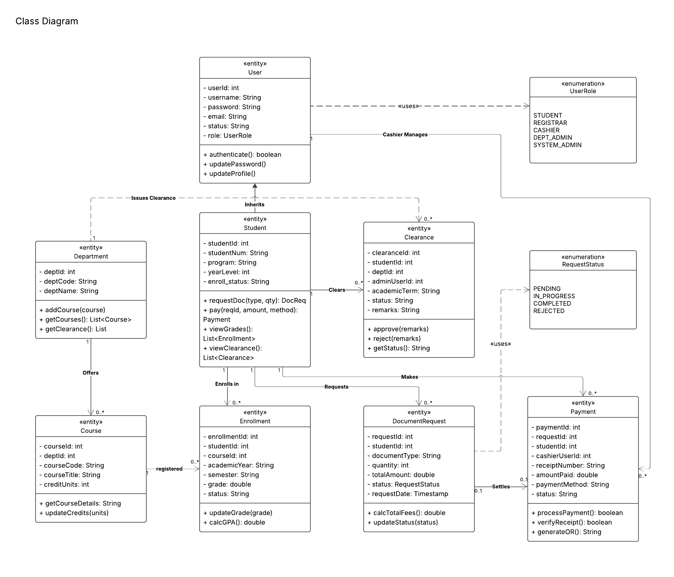

Task 3-B
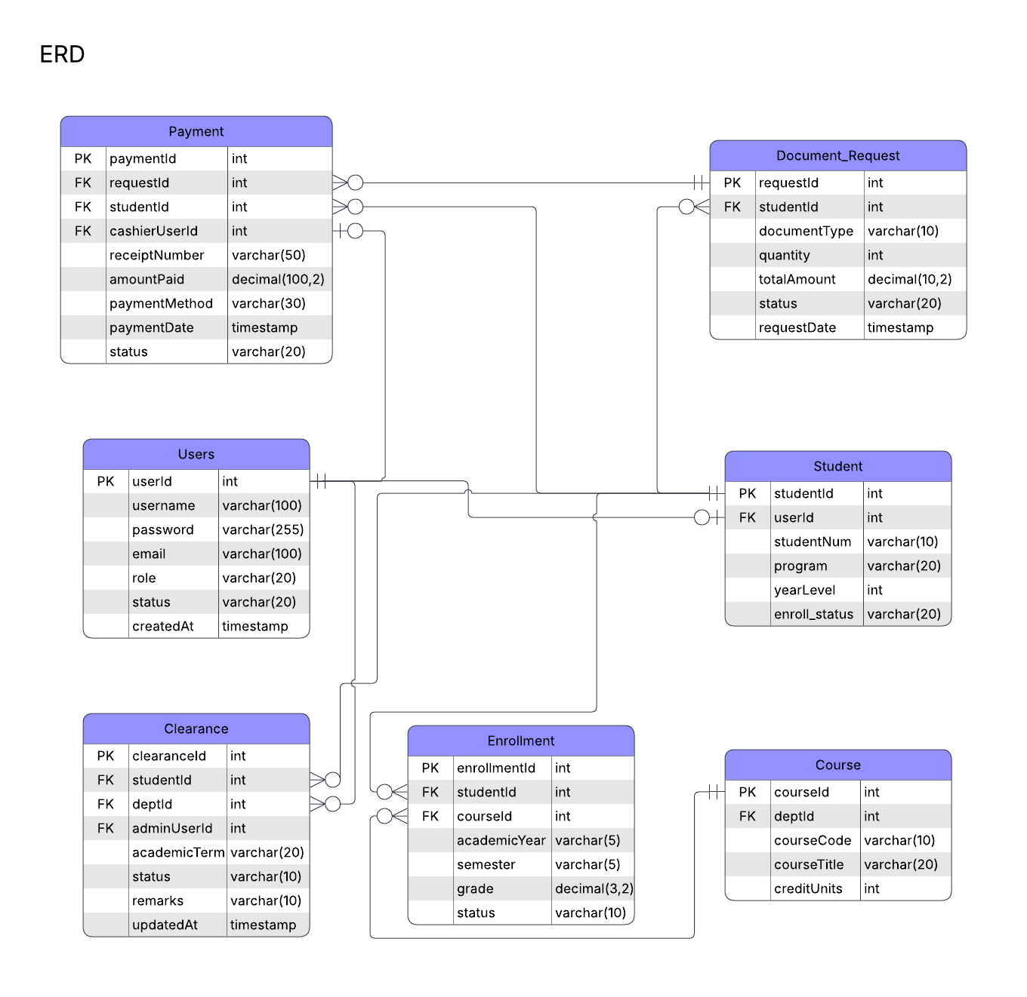
3NF Tables
CREATE TABLE Department (
deptId INT AUTO_INCREMENT PRIMARY KEY,
deptCode VARCHAR(10) NOT NULL UNIQUE,
deptName VARCHAR(100) NOT NULL
)
CREATE TABLE Users (
userId INT AUTO_INCREMENT PRIMARY KEY,
username VARCHAR(100) NOT NULL UNIQUE,
password VARCHAR(255) NOT NULL,
email VARCHAR(100) NOT NULL UNIQUE,
role VARCHAR(20) NOT NULL,
status VARCHAR(20) NOT NULL DEFAULT 'Active',
createdAt TIMESTAMP DEFAULT CURRENT_TIMESTAMP
)
CREATE TABLE Student (
studentId INT AUTO_INCREMENT PRIMARY KEY,
userId INT NOT NULL UNIQUE,
studentNum VARCHAR(10) NOT NULL UNIQUE,
program VARCHAR(20) NOT NULL,
yearLevel INT NOT NULL,
enroll_status VARCHAR(20) NOT NULL DEFAULT 'Enrolled',
CONSTRAINT fk_student_user FOREIGN KEY (userId)
REFERENCES Users(userId) ON DELETE CASCADE ON UPDATE CASCADE
)
CREATE TABLE Course (
courseId INT AUTO_INCREMENT PRIMARY KEY,
deptId INT NOT NULL,
courseCode VARCHAR(10) NOT NULL UNIQUE,
courseTitle VARCHAR(50) NOT NULL,
creditUnits INT NOT NULL,
CONSTRAINT fk_course_dept FOREIGN KEY (deptId)
REFERENCES Department(deptId) ON DELETE CASCADE ON UPDATE CASCADE
)
CREATE TABLE Enrollment (
enrollmentId INT AUTO_INCREMENT PRIMARY KEY,
studentId INT NOT NULL,
courseId INT NOT NULL,
academicYear VARCHAR(5) NOT NULL,
semester VARCHAR(5) NOT NULL,
grade DECIMAL(3,2) NULL,
status VARCHAR(10) NOT NULL DEFAULT 'Enrolled',
CONSTRAINT fk_enrollment_student FOREIGN KEY (studentId)
REFERENCES Student(studentId) ON DELETE CASCADE ON UPDATE CASCADE,
CONSTRAINT fk_enrollment_course FOREIGN KEY (courseId)
REFERENCES Course(courseId) ON DELETE CASCADE ON UPDATE CASCADE
)
CREATE TABLE Document_Request (
requestId INT AUTO_INCREMENT PRIMARY KEY,
studentId INT NOT NULL,
documentType VARCHAR(10) NOT NULL,
quantity INT NOT NULL DEFAULT 1,
totalAmount DECIMAL(10,2) NOT NULL,
status VARCHAR(20) NOT NULL DEFAULT 'Pending',
requestDate TIMESTAMP DEFAULT CURRENT_TIMESTAMP,
CONSTRAINT fk_docreq_student FOREIGN KEY (studentId)
REFERENCES Student(studentId) ON DELETE CASCADE ON UPDATE CASCADE
)
CREATE TABLE Payment (
paymentId INT AUTO_INCREMENT PRIMARY KEY,
requestId INT NULL,
studentId INT NOT NULL,
cashierUserId INT NOT NULL,
receiptNumber VARCHAR(50) NOT NULL UNIQUE,
amountPaid DECIMAL(10,2) NOT NULL,
paymentMethod VARCHAR(30) NOT NULL,
paymentDate TIMESTAMP DEFAULT CURRENT_TIMESTAMP,
status VARCHAR(20) NOT NULL DEFAULT 'Completed',
CONSTRAINT fk_payment_request FOREIGN KEY (requestId)
REFERENCES Document_Request(requestId)
ON DELETE SET NULL ON UPDATE CASCADE,
CONSTRAINT fk_payment_student FOREIGN KEY (studentId)
REFERENCES Student(studentId)
ON DELETE CASCADE ON UPDATE CASCADE,
CONSTRAINT fk_payment_cashier FOREIGN KEY (cashierUserId)
REFERENCES Users(userId)
ON DELETE RESTRICT ON UPDATE CASCADE )
CREATE TABLE Clearance (
clearanceId INT AUTO_INCREMENT PRIMARY KEY,
studentId INT NOT NULL,
deptId INT NOT NULL,
adminUserId INT NOT NULL,
academicTerm VARCHAR(20) NOT NULL,
status VARCHAR(10) NOT NULL DEFAULT 'Pending',
remarks VARCHAR(10) NULL,
updatedAt TIMESTAMP DEFAULT CURRENT_TIMESTAMP ON UPDATE CURRENT_TIMESTAMP,
CONSTRAINT fk_clearance_student FOREIGN KEY (studentId)
REFERENCES Student(studentId) ON DELETE CASCADE ON UPDATE CASCADE,
CONSTRAINT fk_clearance_dept FOREIGN KEY (deptId)
REFERENCES Department(deptId) ON DELETE CASCADE ON UPDATE CASCADE,
CONSTRAINT fk_clearance_admin FOREIGN KEY (adminUserId)
REFERENCES Users(userId) ON DELETE RESTRICT ON UPDATE CASCADE )

