**Out of Sample ARIMA forecasting**

Fit the model using the Box-Jenkins Approach

Ensure that all the assumptions have been met.  
From the next slide, we assume that we have met the above.

1. Fitting the model

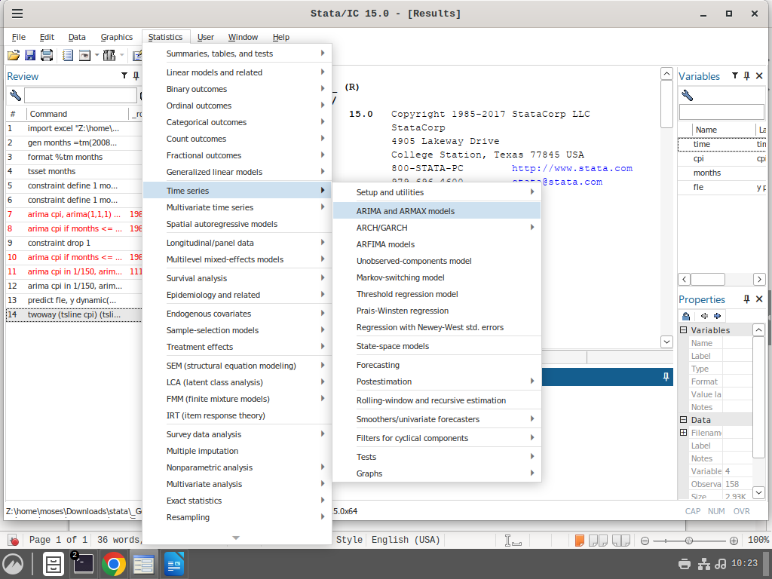

**This is the normal way of fitting an ARIMA model**

Now lets open the dialogue box

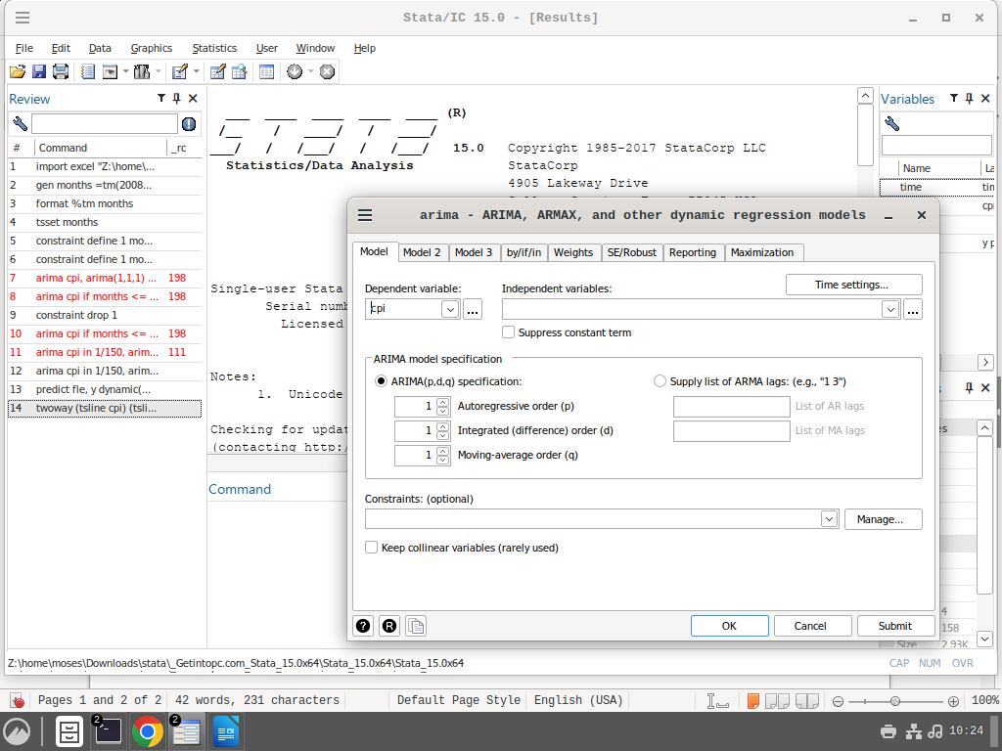

**Still the normal way.**

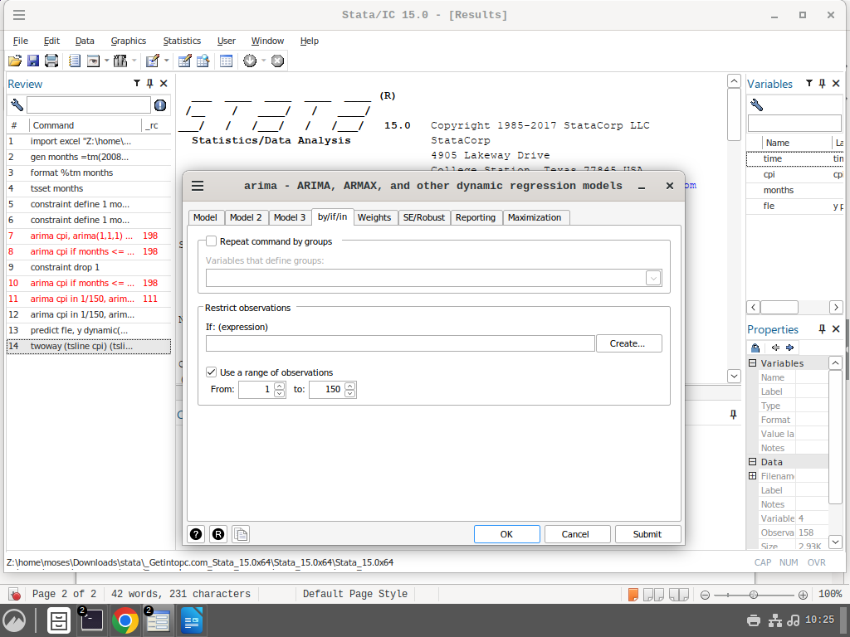

**Here I have selected observations 1 to 150 for the model fitting. We want to see how the model will work on new dataset**

**Remember to click this on the ARIMA Dialogue box**

Now click okay and the model will be fitted by the samples.

An output like the one shown below will appear

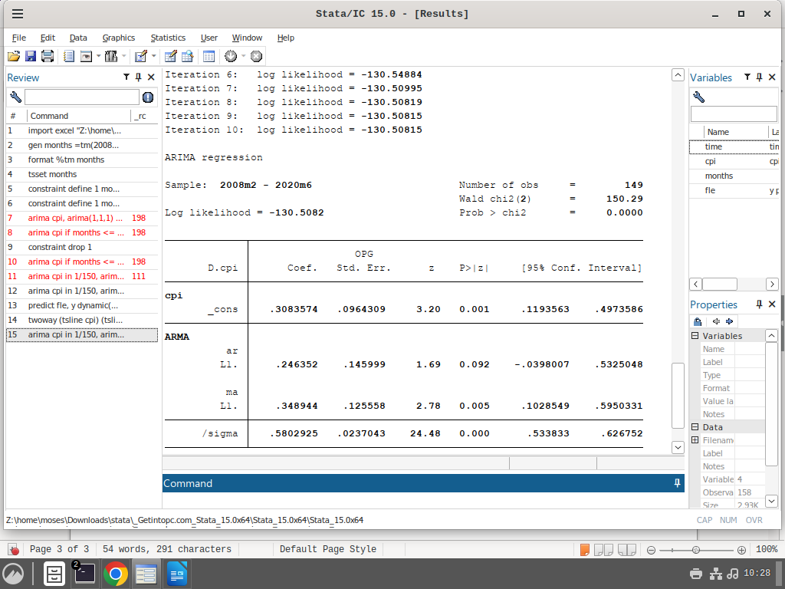

**Remember this. The time 2020m6 represents the end period for the sample.**

Now we have our model. Lets make the prediction

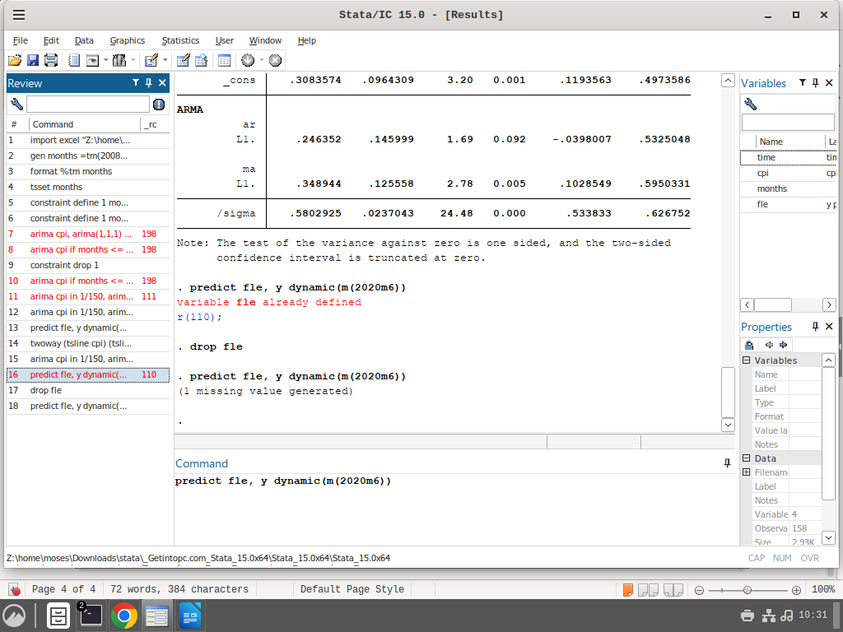

**This is the code that makes predictions,**

**Fle is the variable name. 2020M6 is the end month for our sample model. The m in the function represents months. For quartely data you might consider changing it to q.**

Lets plot the predictions together with the actual results.

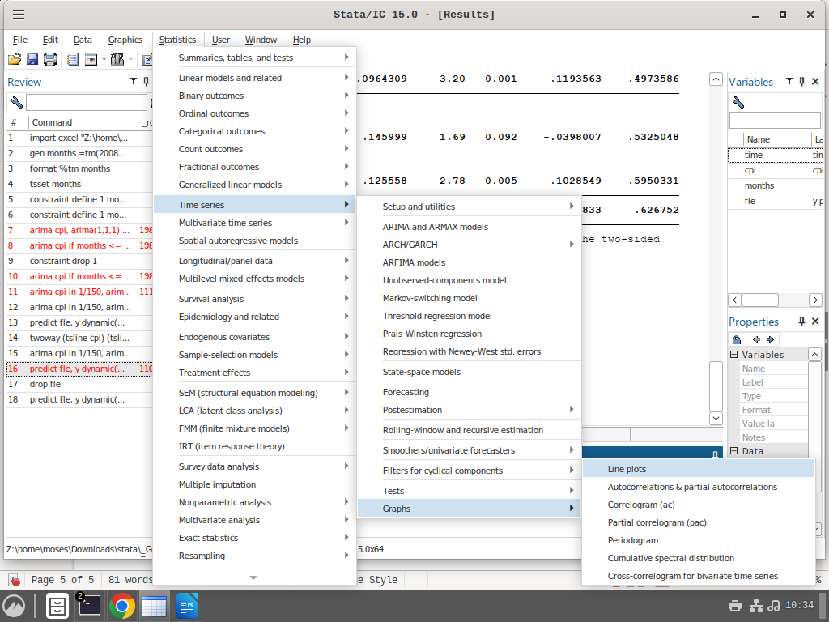

Now we make two plots

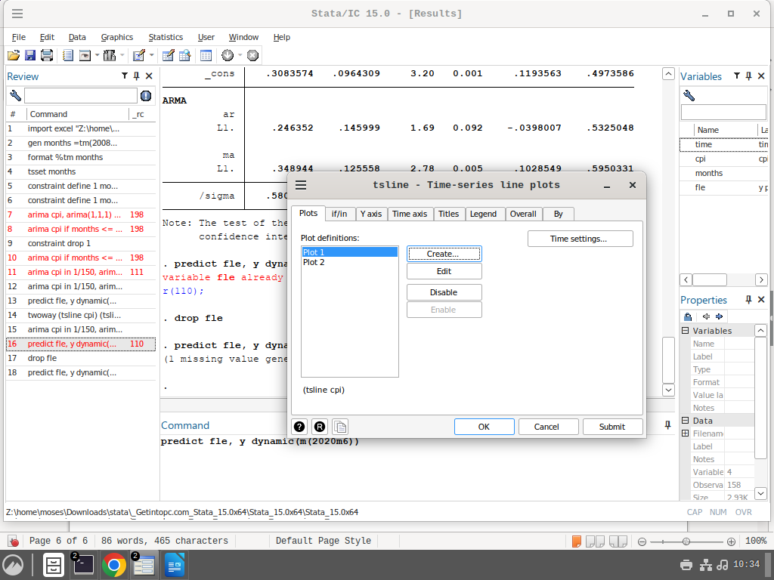

click okay

Here is the results

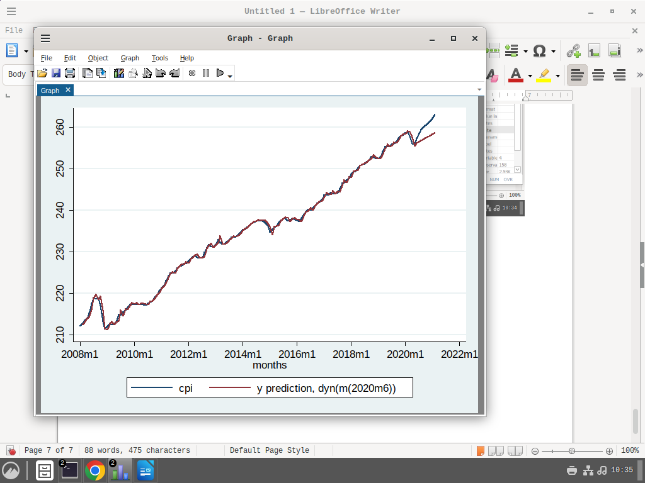not bad for the model. For most of the parts it has followed the pattern in the data.

Evaluation criterias

#### ****Step 1: Calculate Forecast Errors****

gen error = y - yhat // Calculate forecast errors

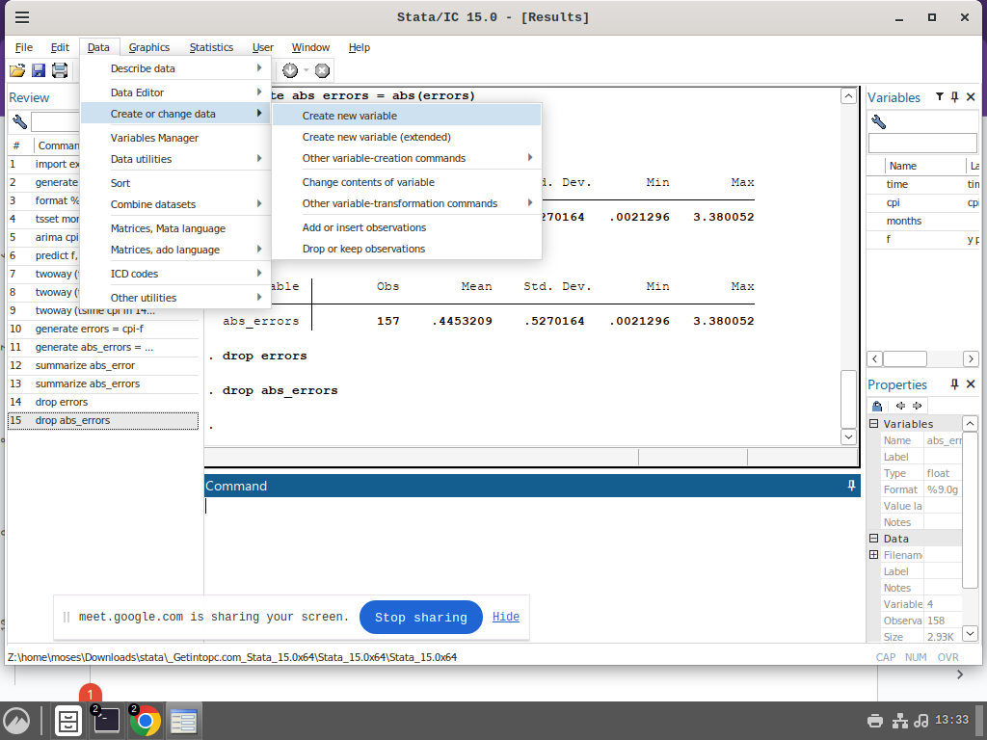

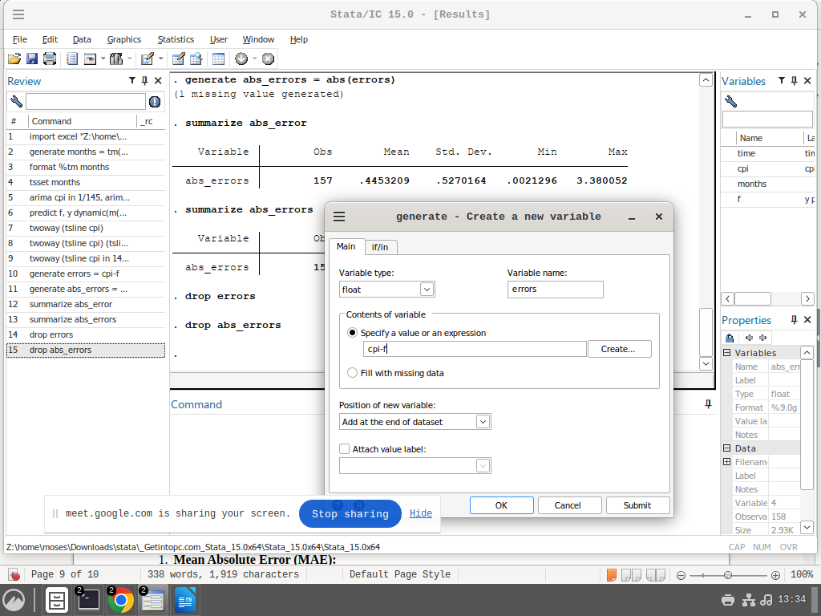

**Generate errors  
Its actual values less predictions**

#### ****Step 2: Compute Absolute Errors****

gen abs_error = abs(error) // Absolute errors

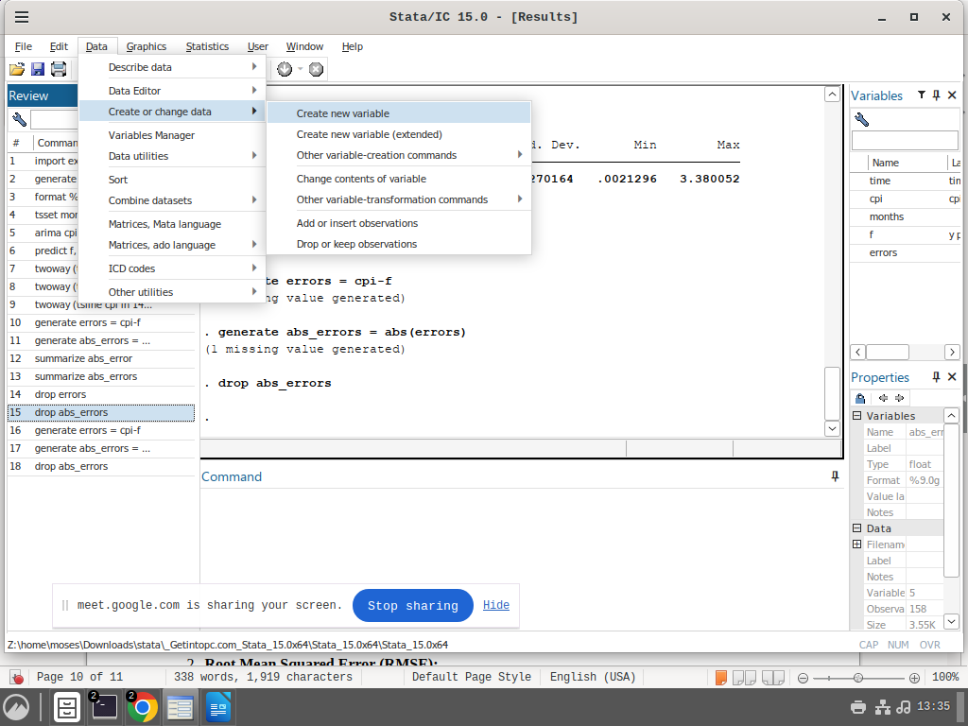

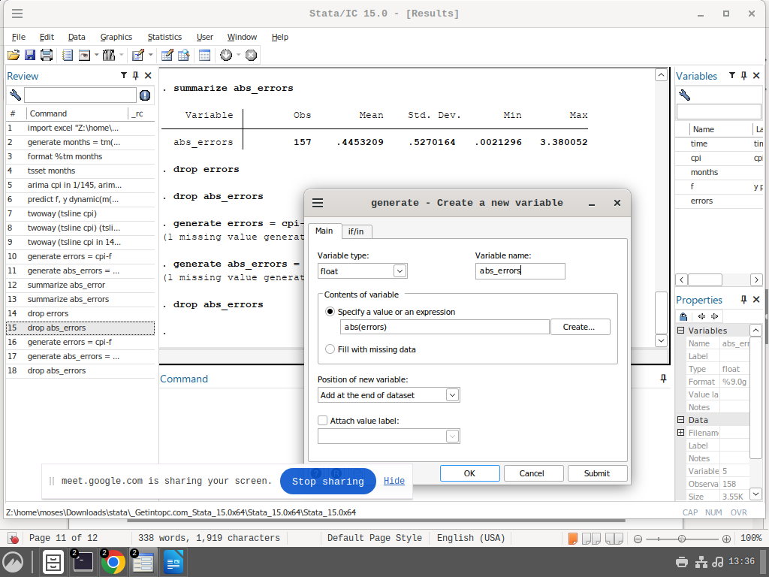

Generate absolute errors

#### ****Step 3: Compute Squared Errors****

gen squared_error = error^2 // Squared errors

#### ****Step 4: Calculate Evaluation Metrics****

1. **Mean Absolute Error (MAE):**

summarize abs_error // Display summary for MAE

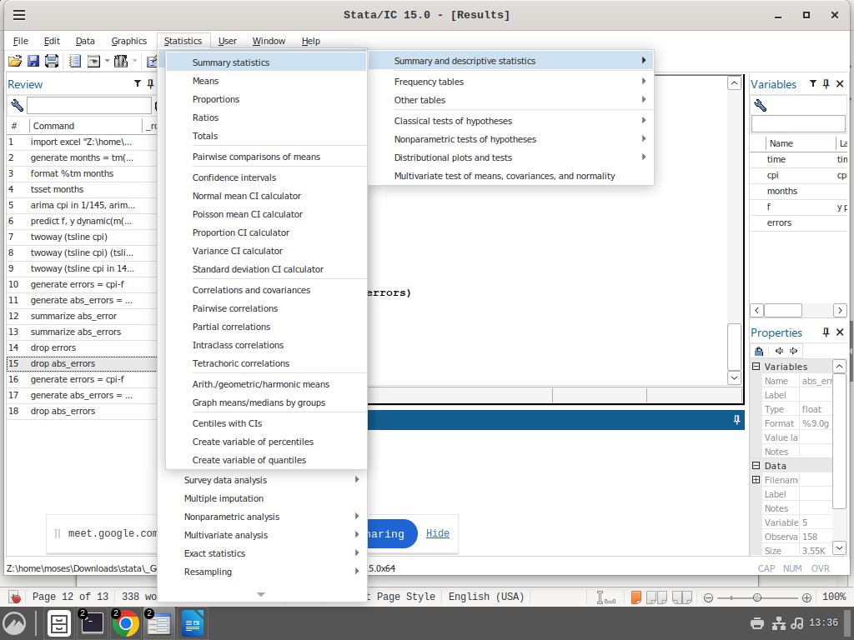

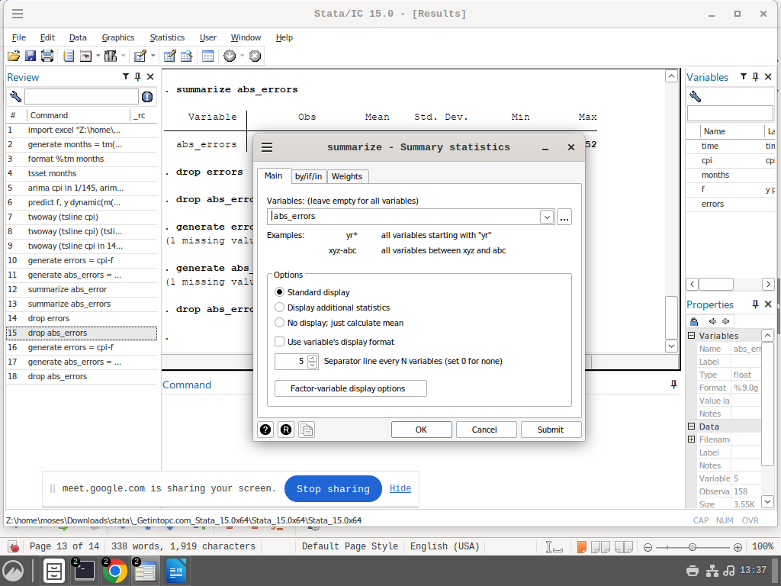

1. **Root Mean Squared Error (RMSE):**

summarize squared_error, meanonly // Get mean of squared errors

di sqrt(r(mean)) // Calculate RMSE

1. **Mean Absolute Percentage Error (MAPE):**

gen pct_error = abs(error / y) * 100 // Calculate percentage error

summarize pct_error // Display summary for MAPE

#### ****Key Evaluation Metrics****

* **MAE**: Average of absolute errors.
* **RMSE**: Square root of the mean of squared errors.
* **MAPE**: Mean percentage error relative to observed values.

**Practice**

**1. Generate the mean Squared errors for the Predictions**

**2. Generate the Mean percentage errors for the predictions**

**3. Generate the Root mean squared error for the predictions**