FITTING A DID model -Using the "basic" method

****Getting sample data.****

**use "https://dss.princeton.edu/training/Panel101.dta", clear**

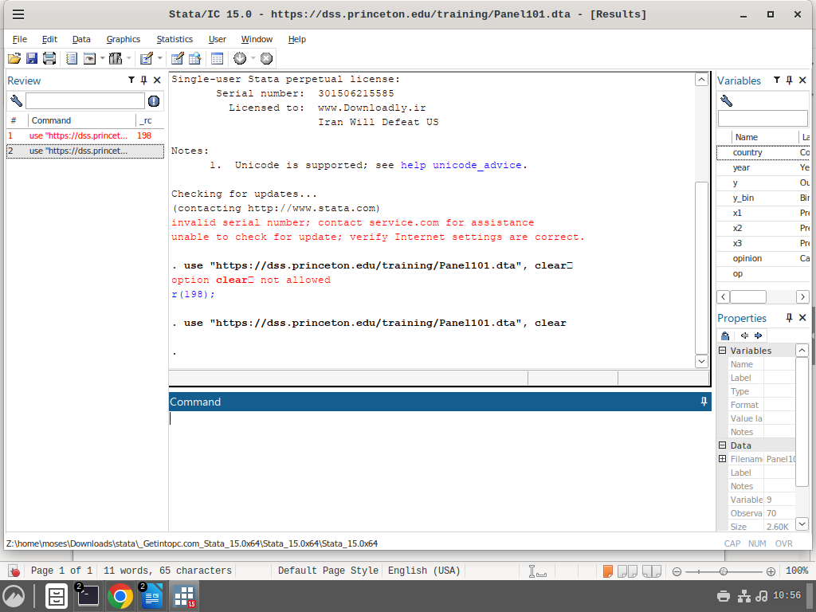

**The code loads the data from the internet.**

****Create a dummy variable to indicate the time when the treatment started. Let's assume that the treatment started in 1994. In this case, years before 1994 will have a value of 0, and years from 1994 onward a 1.****

gen time = 0  
replace time = 1 if year>=1994

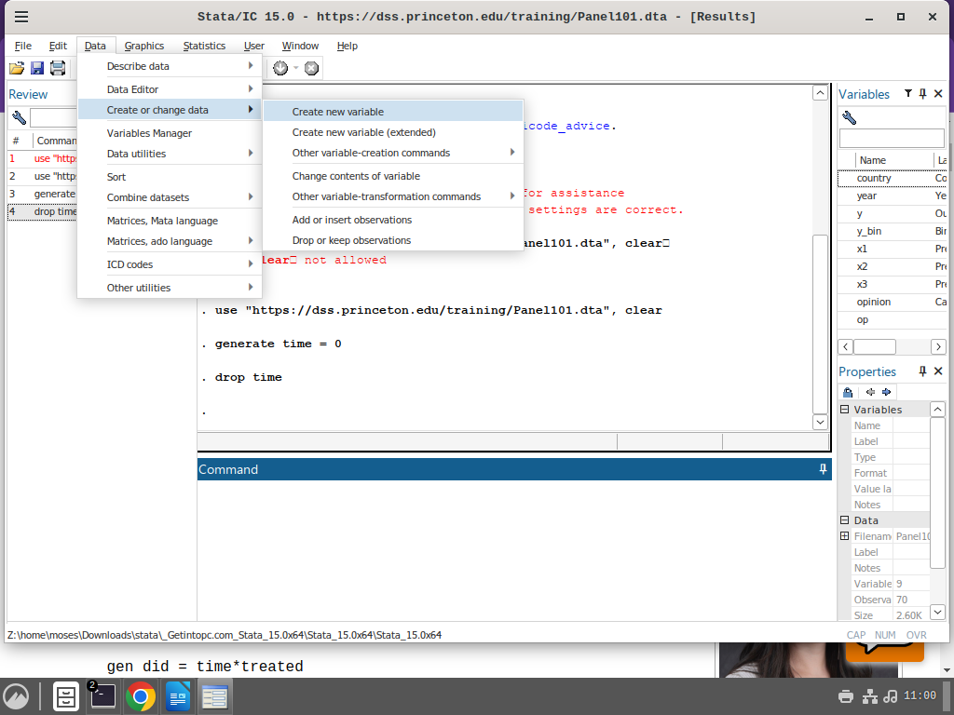

Note the editing made in the dialogue box

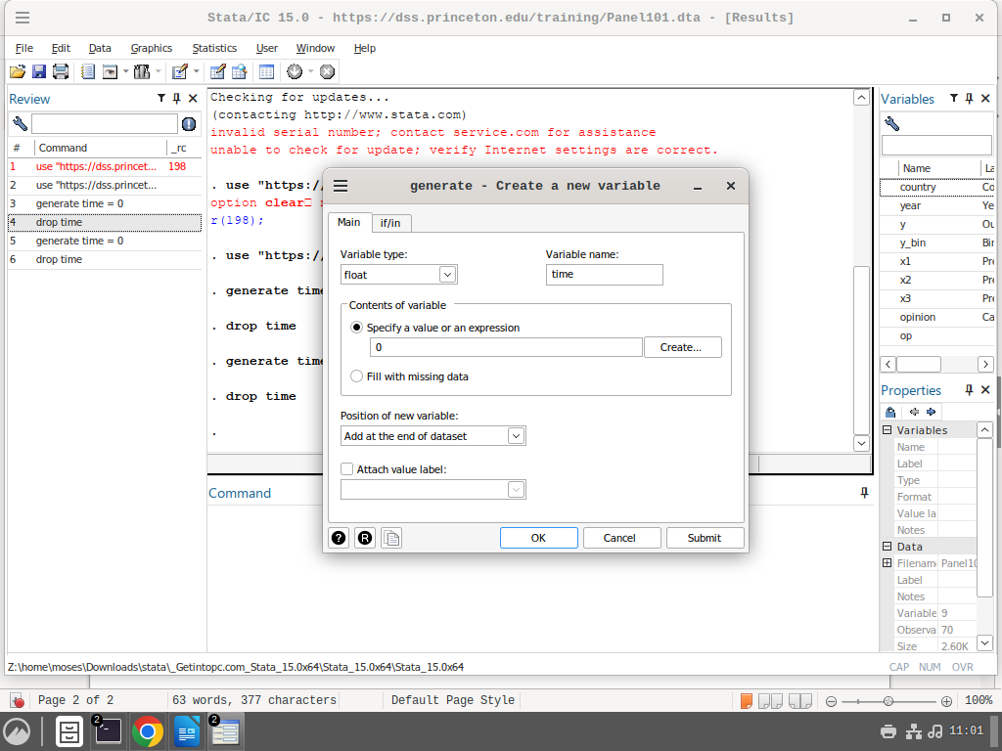

Not the variabel name is time and we have assigned value 0 to the whole column.

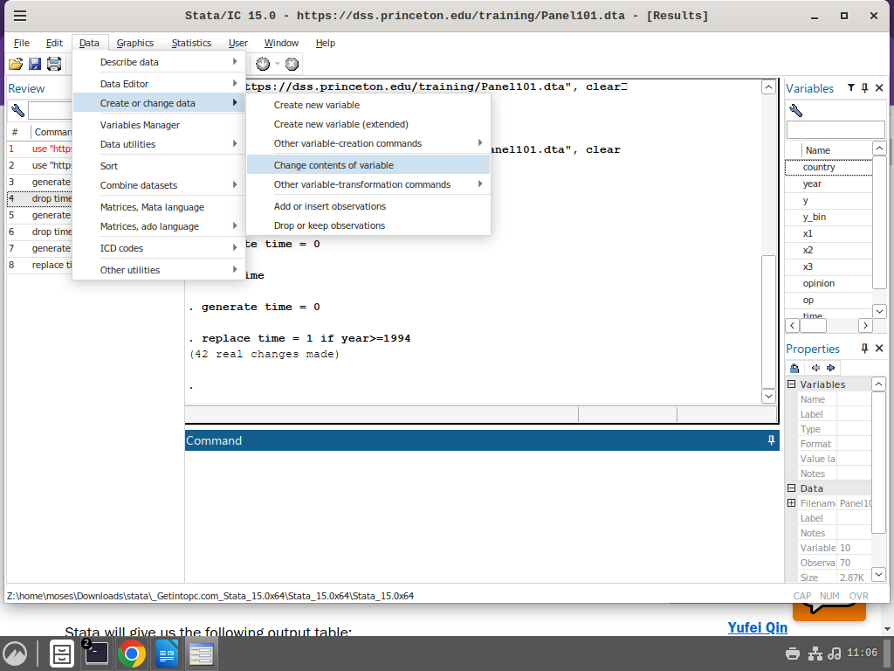

we want to replace as in the code above.

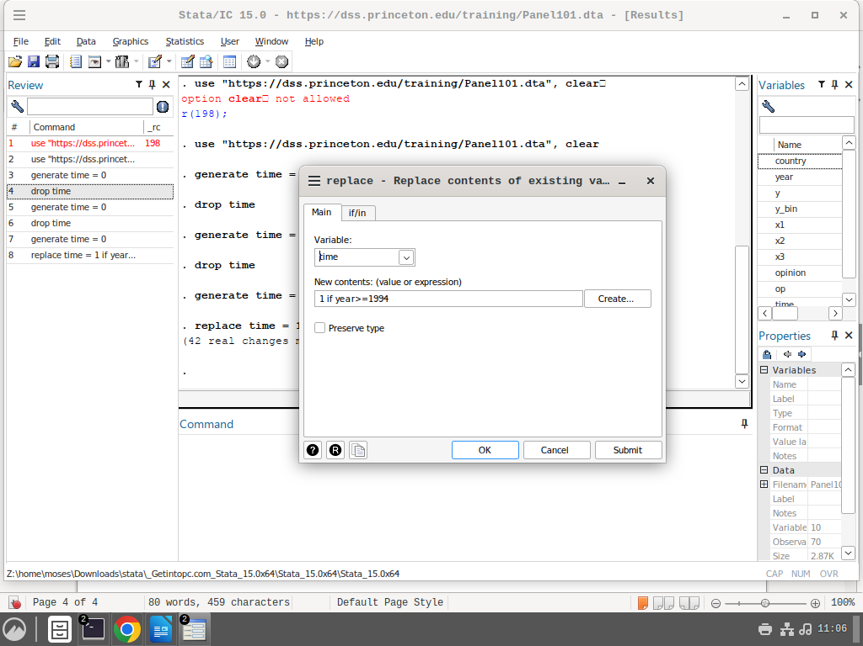

**Remember this condition. Its doing what is done in this code - replace time = 1 if year>=1994**

****Create a dummy variable to identify the group exposed to the treatment. In this example, let's assume that countries with codes 5, 6, and 7 were treated (=1). Countries 1-4 were not treated (=0).****

gen treated = 0  
replace treated = 1 if country>4

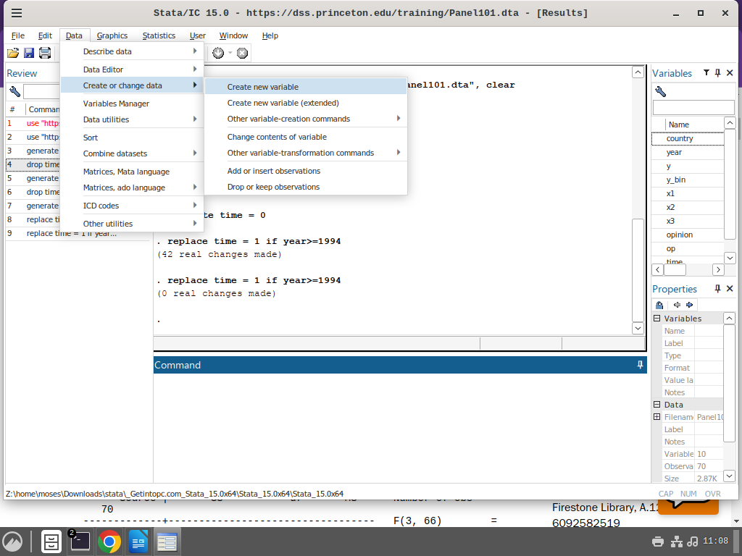

we create the treated variable

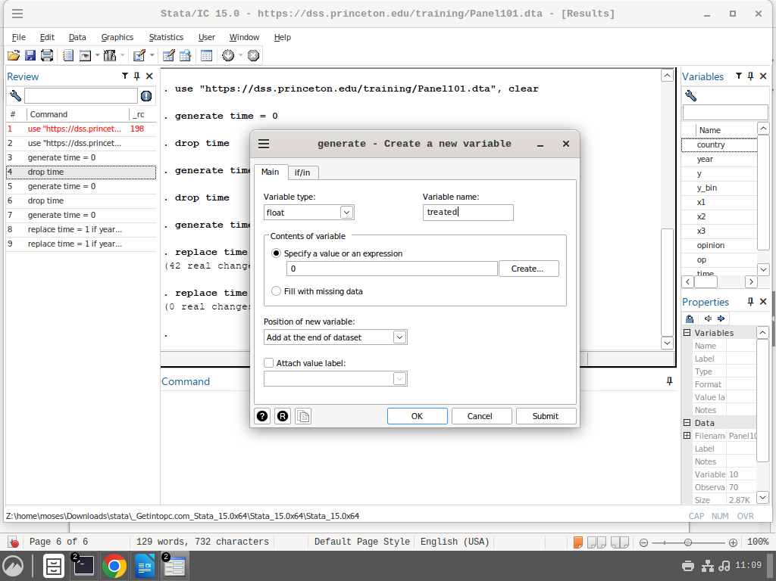

Remember its column of all zeroes column

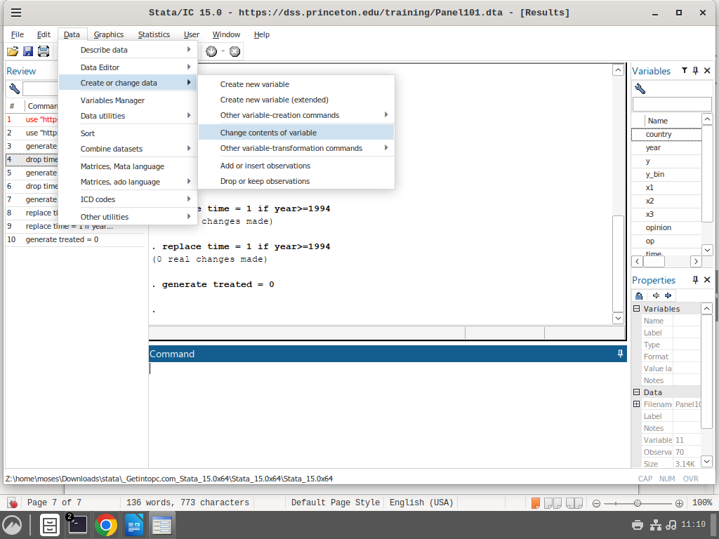

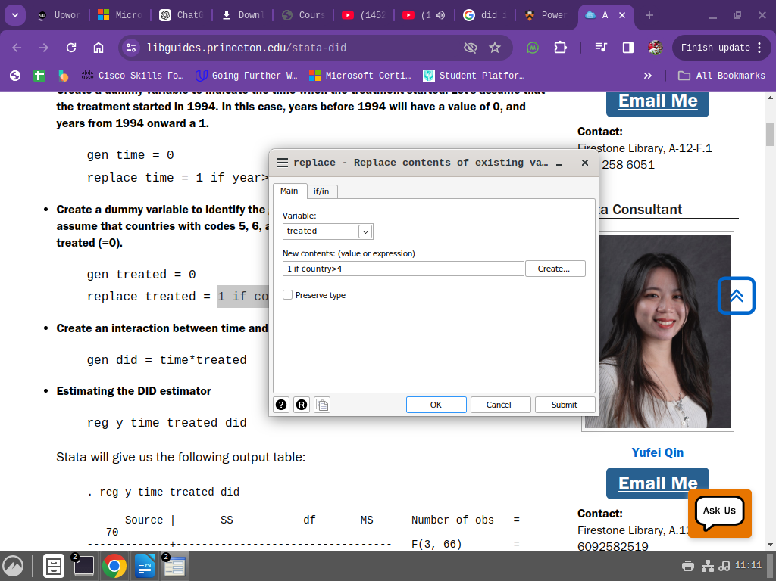

Remember the variable in the new contents and the change is made for treated variable

****Create an interaction between time and treated. We will call this interaction ‘did’****

**gen did = time*treated**

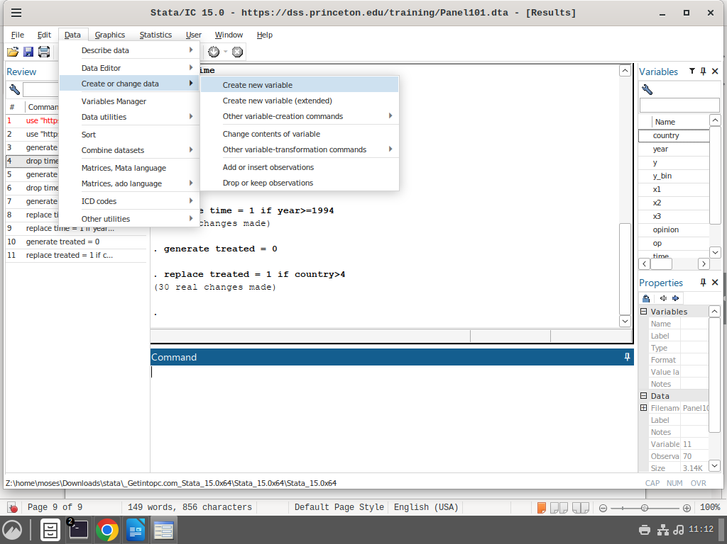

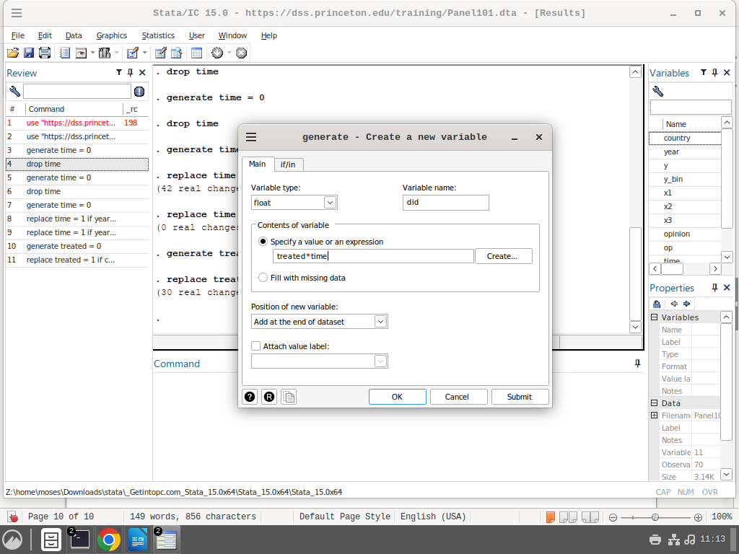

gen did = time*treated

****Estimating the DID estimator****

reg y time treated did

**Its linear regresssion**

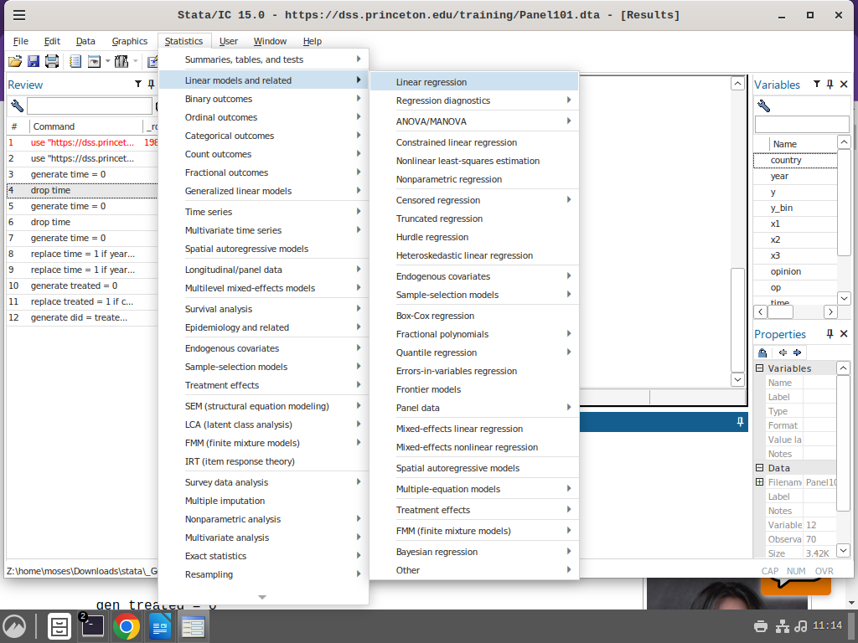

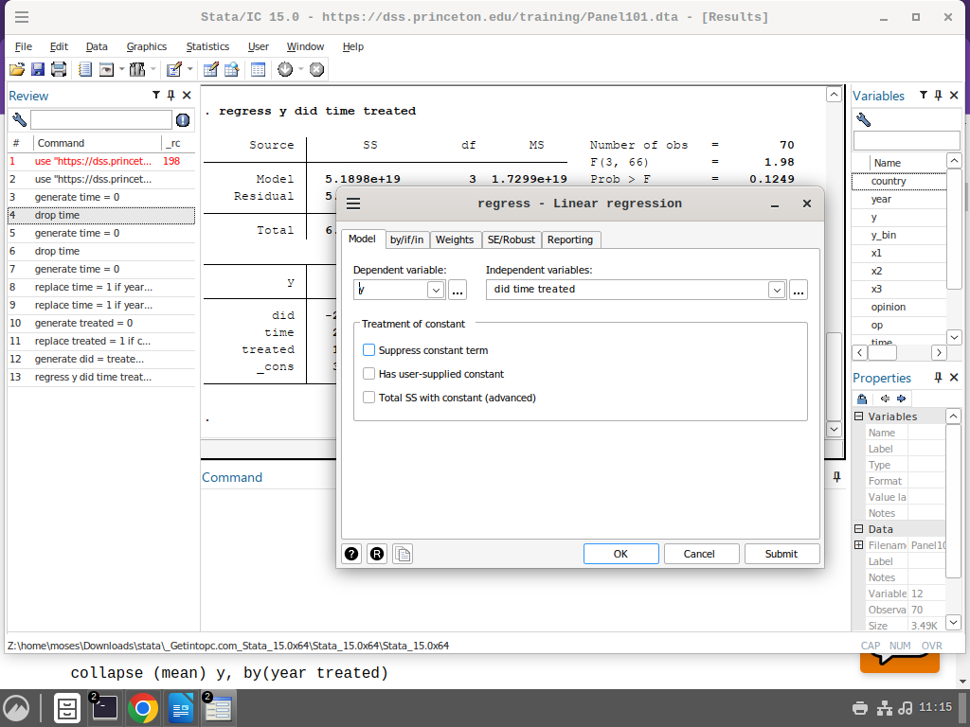

This is the output of the model

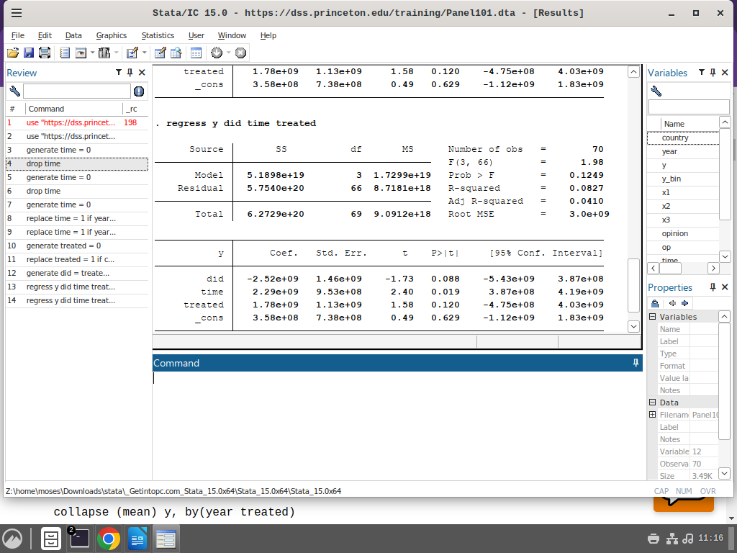The coefficient for ‘did’ is the average treatment effect on the treated. The effect is significant at 10% level, with the treatment having a negative effect.