|  |
| --- |
| **Table of Contents** |

Revision History 2

1. Introduction 2

2. Software overview 3

2.1 Surface System Components 3

● Computer monitors (x2) 3

● HMI monitors (x2) 3

● Base frame plate (x1) 3

● Frame extension parts (x2) 3

● Small monitor arms (x2) 3

● Big monitor arms (x2) 3

● Operator chair (x1) 3

6. Additional Info 4

2.2 System Network 4

2.3 Detailed Network Layout 5

2.4 Emergency Contacts 6

|  |  |  |  |
| --- | --- | --- | --- |
| **Approval** | | | |
| **Reviewer** | **Approver** | **Electronic Approval** | **Date Approved** |
| Name  Designation | Rikus Coetzee  Jnr Electronic Engineer | ID - |  |

|  |  |
| --- | --- |
| **Next Revision Date** |  |

|  |  |  |
| --- | --- | --- |
| Revision History | | |
| **Rev No** | **Changes** | **Date** |
|  |  |  |

|  |
| --- |
| Introduction |

This manual provides information regarding the remote drilling software code base. This manual is intended to be used by CIC Engineers for further software development, patching or debugging. Operators on site should not have access to this manual as far as possible.

|  |
| --- |
| 1. **Software overview** |

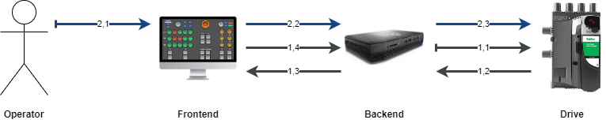

Table 1: Software Overview

* 1. **Surface System Components**
* Computer monitors (x2)
* HMI monitors (x2)
* Base frame plate (x1)
* Frame extension parts (x2)
* Small monitor arms (x2)
* Big monitor arms (x2)
* Operator chair (x1)

|  |
| --- |
| **6. Additional Info** |

* 1. **System Network**

* 1. **Detailed Network Layout**

* 1. **Emergency Contacts**

Contact Details

* Rikus Coetzee
* Software Engineer
* Email: [fcoetzee@masterdrilling.com](mailto:mheymans@masterdrilling.com)
* Mobile number: +27713319142