2015.9.10

dproc: nodal processing delay

dqueue: queueing delay

dtrans: transmission delay

if L = packet length, R = link speed, dtrans = L/R

ms – milliseconds

dprog: propagation delay

if d = length of physical link, S = propagation speed in medium, dprog = d/S

traceroute (跟踪路由) provides delay measurements

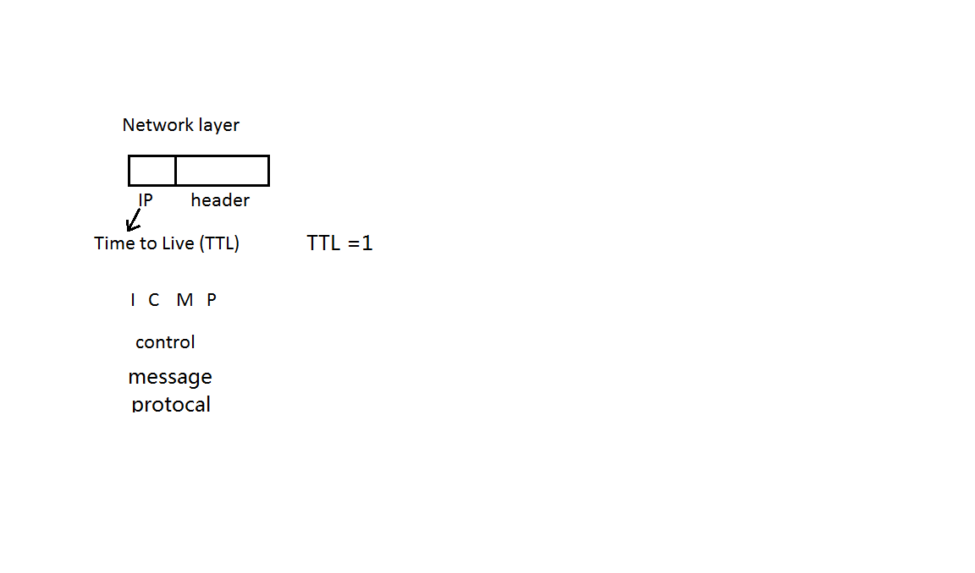

Tools for analyzing networks

Math analysis + computer simulation

---------

\ R bps

----------------> Queue ----------------||----------->

/ success/fail

---------

N : the average number pf packets in queue

Need to model | Possible model

Packet length | discrete uniform [1000 bits, 10000 bits]

Arrival process | Poisson process

Packet inter-arrival time | exponential distribution

Transmission success/fail like hood | Bernoulli

Number of transmissions before success | Geometric

Averages: Linearity

E[ax + b] = a\*E[x] + b

E[x1+x2+…+xn] = E[x1] + E[x2] + …+ E[xn]

Even if xis are dependent

Short cut Theorem

E[Y] = sum g(x)\* Px(x)

x S(x)