2015.9.3

The internet

196x Research

Supporting “Bursty Traffic”

* Packet switching
* Voice over military networks “VoIP”

Tier 2 ISP is customer of tier 1 provider

Access Networks

* Teleco (e.g Telus) DSL
* Cable (e.g Shaw) HFC

In building

Lab Ethernet

Cmput1------------------------------

|

Cmput2----------------------------------------------------Router

|

Cmput3------------------------------

Packet switching: statistical multiplexing

Basic Services:

* Connection-oriented reliable service (TCP)
* Connectionless unreliable service (UDP)

The layered architecture of the internet

Layering: key to understand complex systems

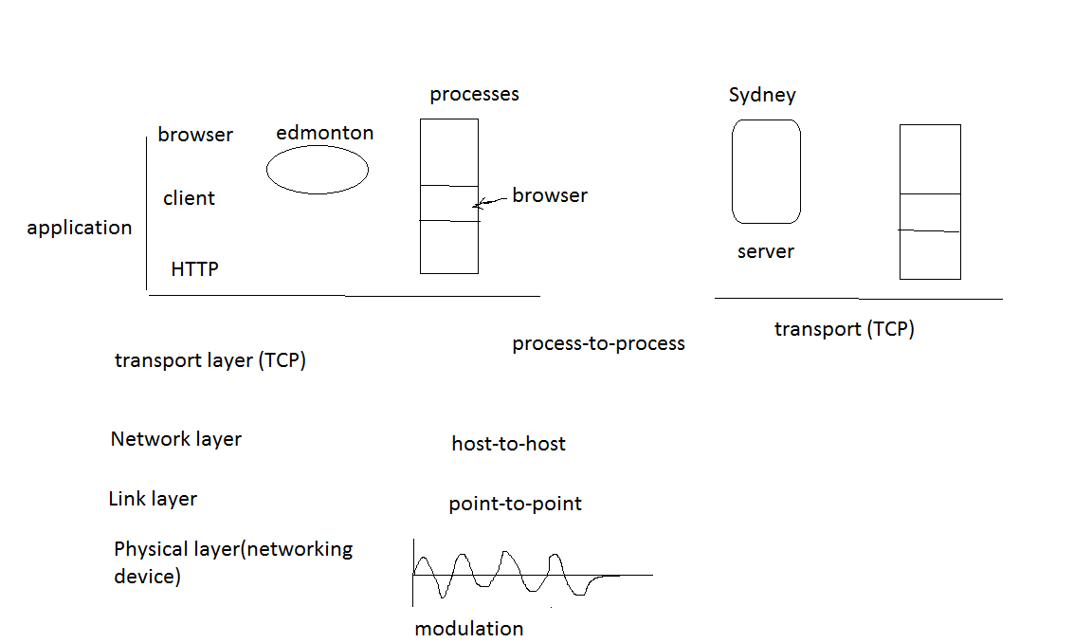

2015.9.8

Recap:

Application: Browser (HTTP)

Transport: Reliable Connection Oriented (TCP)

Network: Routing (IP)

Link: Point-to-Point

Physical: hardware

CNET

OPNET -- simulator