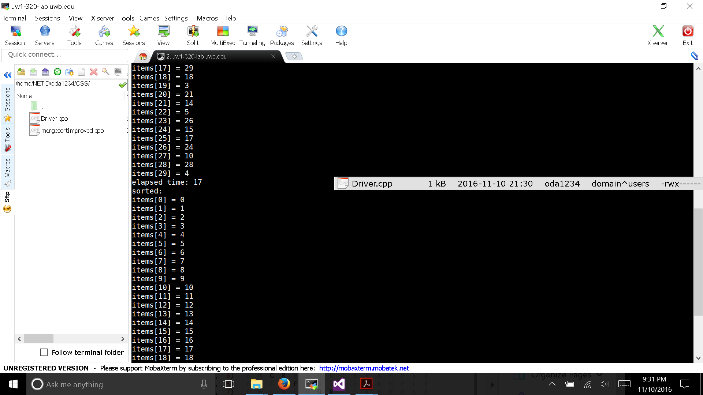

Part 2: Comparison

|  |  |  |  |
| --- | --- | --- | --- |
| Input | MergeImproved | Merge | Quick |
| 10 | 1 | 10 | 6 |
| 100 | 33 | 160 | 52 |
| 1000 | 359 | 4467 | 469 |
| 10000 | 2379 | 238357 | 2742 |

I have only included the input from 10 – 1000 into the graph because the input at 10000 for merge sort will cause the the graph to distant too much hence will be difficult to see the difference.

Reference

https://www.akawebdesign.com/2012/04/13/javascript-mergesort-top-down-vs-bottom-up/