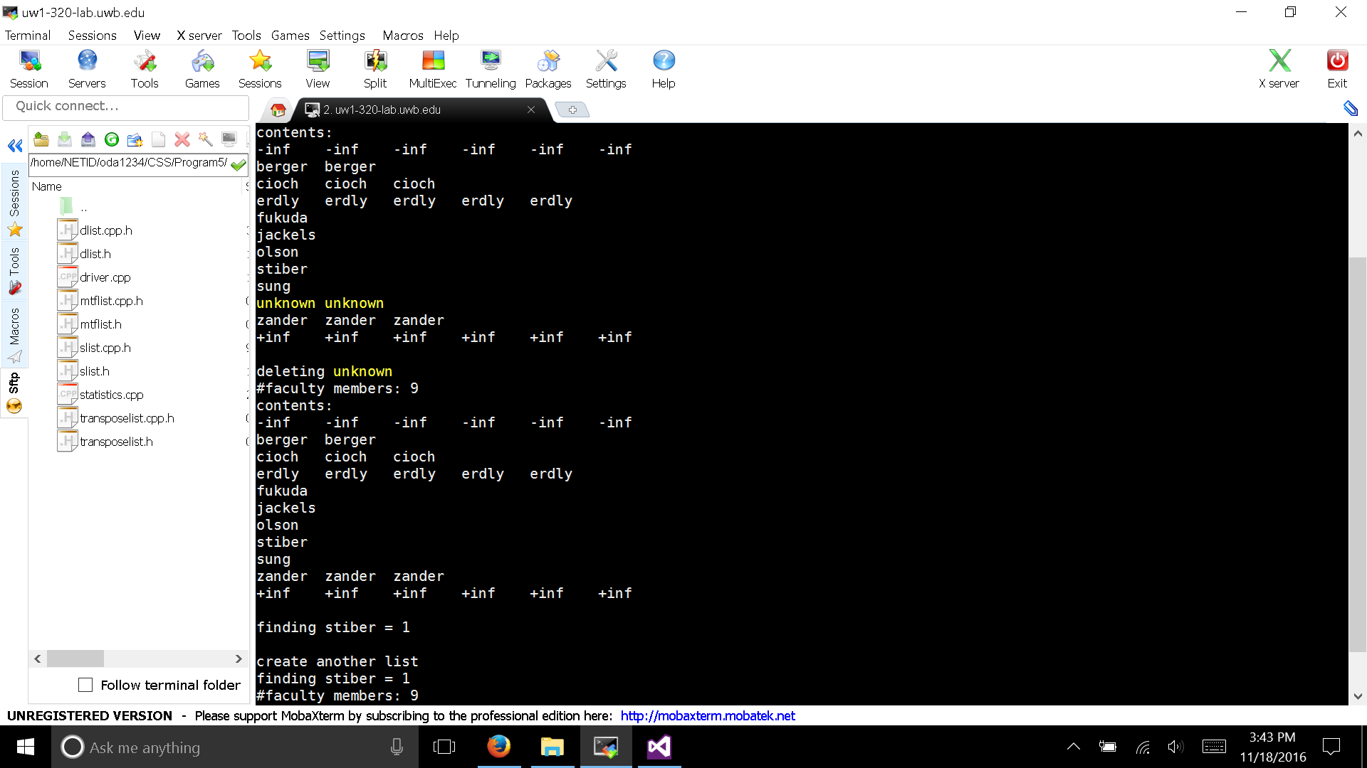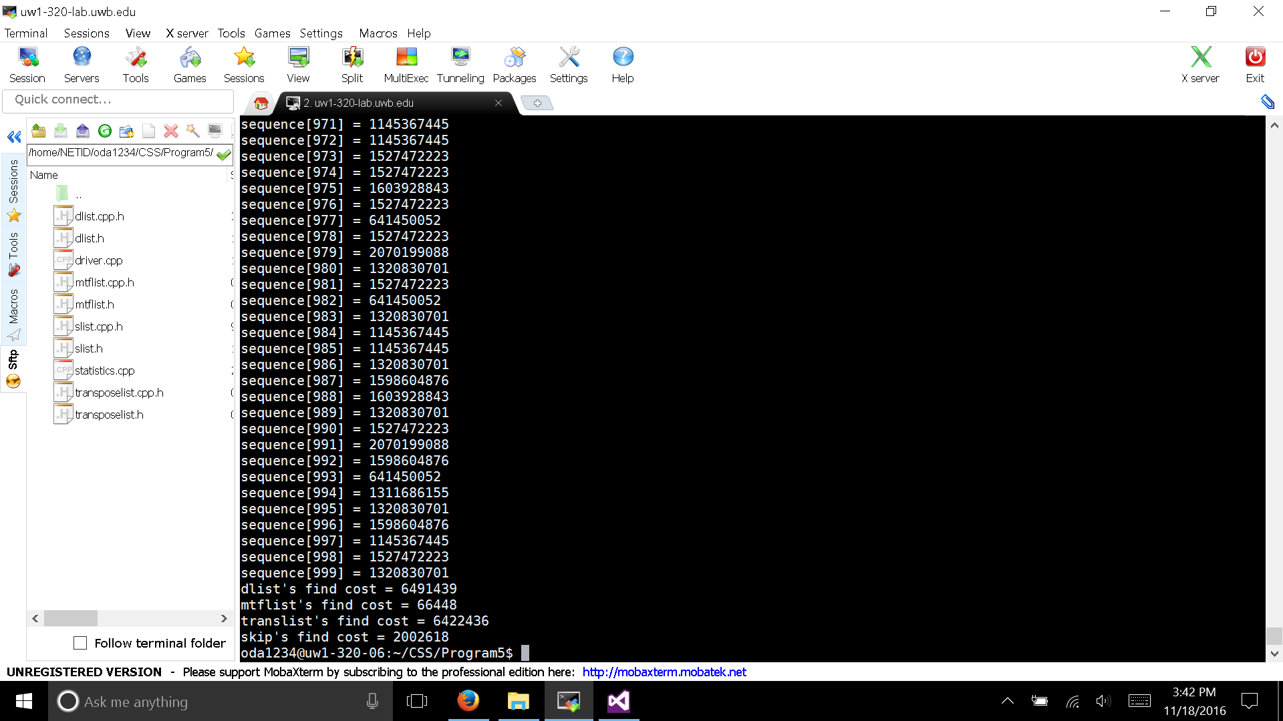

Performance Consideration:

Double Linked List: For 10000 items, we would have to traverse through the entire list each time we want to find something. So, it is not surprise to see the huge find cost

Transpose List: We can only swap 1 item to its previous 1 at a time. So, if we access randomly, we will still have to go through the entire list. Might be quicker than Double Linked List because elements we usually accessed is now 1 step before its old place

Skip List: Since we can traverse quickly by going through each level, we can get to the elements quickly by skipping some elements along each level. So, it is not a surprise to see it is 3 times less than double linked list

Move to Front List: The frequent access element will be move to the front. It is a surprise to see the cost of the MTF List this low. One consideration would be that the random access is not random at all. Those elements at the fronts are the one that is usually accessed “random”. Since it not very “random”, the element would already be at the front hence easier to find.