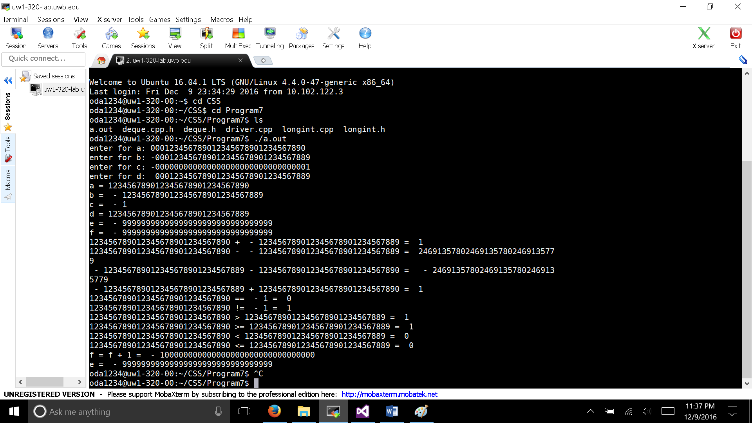

This is one of the most challenging homework I have ever done. Part of it because it require lab 7. The other part is that I though doing arithmetic operations will be easy, however, implementing them is not and easy to make mistake.

Assumption: interactions with 0 as a char should be avoided because 0 in char represent NULL and they cause a lot of problem. A minor tweak could be represent the Deque as Deque<int> instead