Name: Thuan Tran

Date: February 18, 2017

Home Work 3

1. Assumptions:

* Student number will be the Primary key of STUDENT
* Department Code will be the Primary key of DEPARTMENT

SQL Scripts: The first part of assignment I used SQL Server. They ran fine.

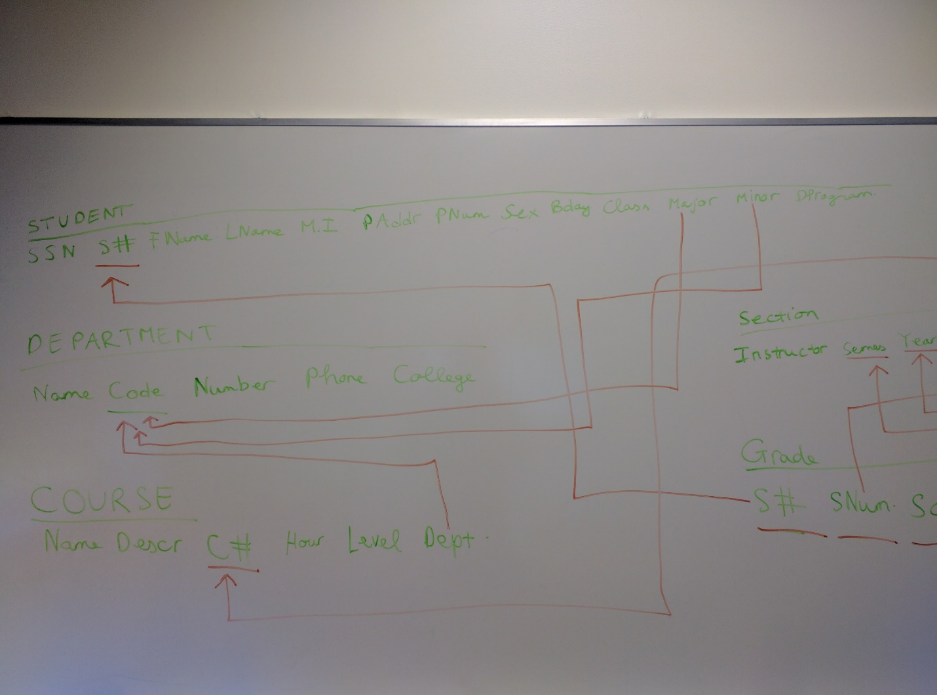

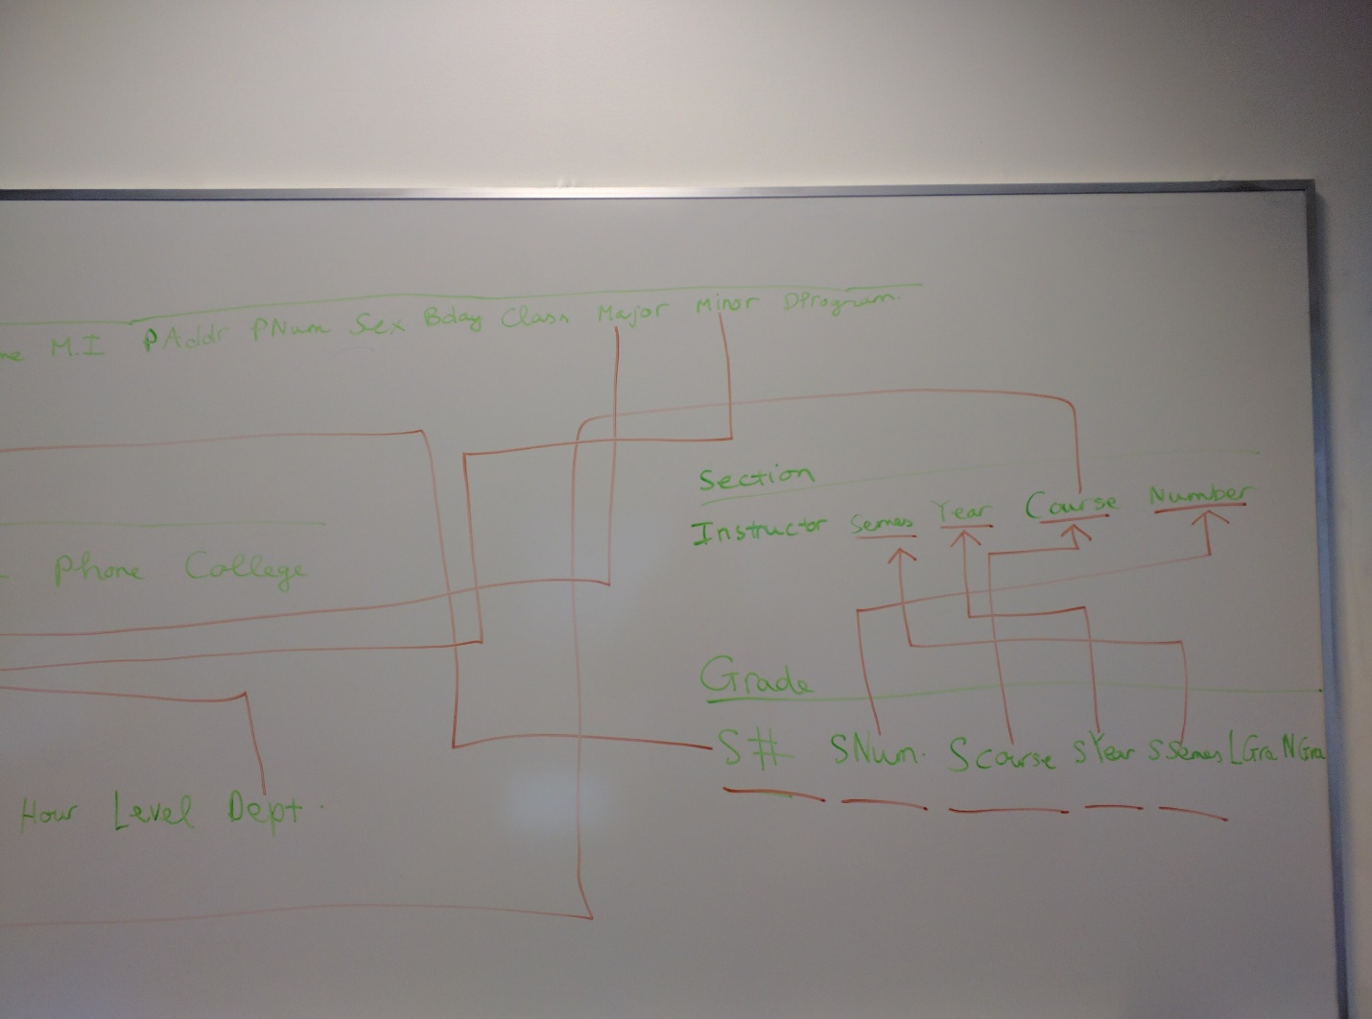

Create Table: I decided to add drop table to test the table multiple time with different insert

DROP TABLE GRADE;

DROP TABLE STUDENT;

DROP TABLE SECTION;

DROP TABLE COURSE;

DROP TABLE DEPARTMENT;

Go

CREATE TABLE DEPARTMENT

(

DCode INT NOT NULL,

DName VARCHAR(255) NOT NULL,

ONumber INT NOT NULL,

OPhone INT NOT NULL,

College VARCHAR(255) NOT NULL,

PRIMARY KEY(DCode) ,

UNIQUE(DCode, DName)

);

CREATE TABLE STUDENT

(

SSN INT NOT NULL ,

StudentNum INT NOT NULL ,

FNname VARCHAR(255) NOT NULL,

MiddleI CHAR(1),

LName VARCHAR(255) NOT NULL,

PAddress VARCHAR(255) NOT NULL,

PNum INT NOT NULL,

Sex CHAR(1) NOT NULL,

BDay DATE NOT NULL,

Class VARCHAR(255) NOT NULL,

Major INT NOT NULL,

Minor INT ,

Dprogram VARCHAR(255) NOT NULL

PRIMARY KEY(StudentNum),

UNIQUE (SSN, StudentNum),

FOREIGN KEY(Major) REFERENCES DEPARTMENT(DCode) ON DELETE NO ACTION,

FOREIGN KEY(Minor) REFERENCES DEPARTMENT(DCode) ON DELETE NO ACTION,

);

CREATE TABLE COURSE

(

Name VARCHAR(255) NOT NULL,

Descrip VARCHAR(255) NOT NULL,

C# INT NOT NULL,

CHour INT NOT NULL,

CLevel INT NOT NULL,

CDept INT NOT NULL,

PRIMARY KEY (C#),

FOREIGN KEY(CDept) REFERENCES DEPARTMENT(DCode) ON DELETE CASCADE

);

CREATE TABLE SECTION

(

INSTRUCTOR VARCHAR(255) NOT NULL,

Course INT NOT NULL,

SNumber INT NOT NULL,

SYear INT NOT NULL,

Semester VARCHAR(255) NOT NULL,

PRIMARY KEY(Course, SNumber, SYear, Semester) ,

FOREIGN KEY(Course) REFERENCES COURSE(C#) ON DELETE CASCADE

);

CREATE TABLE GRADE

(

Student# INT NOT NULL,

SNumber INT NOT NULL,

SCourse INT NOT NULL,

SYear INT NOT NULL,

SSemes VARCHAR(255) NOT NULL,

LetterGrade char(1) NOT NULL,

DecimalGrade DECIMAL(3,2) NOT NULL,

PRIMARY KEY(Student#, SNumber, SCourse, SYear,SSemes),

FOREIGN KEY (Student#) REFERENCES STUDENT(StudentNum) ON DELETE CASCADE,

FOREIGN KEY (SCourse, SNumber, SYear, SSemes) REFERENCES SECTION(Course, SNumber, SYear, Semester) ON DELETE CASCADE

);

Insert, update and delete the table: I decided to comment out the later part because I want to test the select first. It is better to use the select first before uncomment for better results

INSERT INTO DEPARTMENT VALUES(1,'CSS', 123,2065567845, 'STEM');

INSERT INTO DEPARTMENT VALUES(2,'Math', 456,234232342, 'STEM');

INSERT INTO STUDENT VALUES (123456789, 985866967, 'Thuan', 'H', 'Tran', 'Seattle', 456, 'M', CURRENT_TIMESTAMP, 'Junior'

, '1', '1', 'B.S');

INSERT INTO STUDENT VALUES (987654321, 123456789, 'John', 'H', 'SMITH', 'Seattle', 456, 'M', CURRENT_TIMESTAMP, 'Junior'

, '1', '1', 'B.S');

INSERT INTO COURSE VALUES ('Data Structures', 'Learn about Data Structure', 342, 5,300, 1);

INSERT INTO COURSE VALUES ('Software Engineering', 'Learn about SOftware Engineer', 360, 5,300, 1);

INSERT INTO SECTION VALUES ('John Smith', 342, 1, 2017, 'Winter');

INSERT INTO SECTION VALUES ('TT', 360, 2, 2017, 'Winter');

INSERT INTO GRADE VALUES (985866967, 1, 342, 2017,'Winter', 'A', 4.0);

INSERT INTO GRADE VALUES (123456789, 2, 360, 2017,'Winter', 'A', 4.0);

/*

UPDATE DEPARTMENT

SET College = 'CSSE';

UPDATE STUDENT

SET Sex = 'F';

UPDATE COURSE

Set CDept = 2;

UPDATE SECTION

SET INSTRUCTOR = 'Party All day long';

UPDATE GRADE

SET DecimalGrade = 0.0;

DELETE FROM DEPARTMENT

WHERE DCode = 2;

DELETE FROM GRADE

where Student# = 123456789;

DELETE FROM SECTION

where SNumber = 2;

DELETE FROM COURSE

where C# =342;

DELETE FROM STUDENT

where SSN = 123456789;*/

Query:

/*

Find out information about student 123456789

*/

select *

from STUDENT

where StudentNum = 123456789;

/*

SELECT statement providing all courses’ information

(including the number of sections they each have) for the university

*/

select COURSE.*, SNumber

from COURSE, SECTION

where Course.C# = SECTION.Course;

/*

SELECT statement providing all the students majored in a certain department

This time pick Department Code = 1

*/

select STUDENT.*

from STUDENT, DEPARTMENT

where DCode = 1 AND STUDENT.Major = DEPARTMENT.DCode;

/*

Find out which class Student 12456789 took

*/

select C#

from COURSE, STUDENT, GRADE, SECTION

where STUDENT.StudentNUM = 123456789 AND STUDENT.StudentNUM = GRADE.Student# AND GRADE.SCourse = SECTION.COURSE AND SECTION.COURSE = COURSE.C#;

/*

SELECT statement providing information on how many students a instructor teaches

(including all the sections that the instructor is teaching)

*/

select STUDENT.StudentNum AS Student

from STUDENT, SECTION, GRADE

where SECTION.INSTRUCTOR = 'John Smith' AND GRADE.Student# = STUDENT.StudentNum AND SECTION.Course = GRADE.SCourse

1. The second part of the assignement, I used SQL Lite (The GUI one)

a.

select Fname as FirstName, LName as LastName

from EMPLOYEE, PROJECT, WORKS_ON

where EMPLOYEE.SSN= WORKS_ON.essn AND EMPLOYEE.dno = 4

AND PROJECT.dnum = 4 AND PROJECT.pname='Computerization'

AND WORKS_ON.pno = PROJECT.pnumber AND WORKS_ON.hours < 20.

b.

select E.Fname , E.Lname, E.salary , S.Fname as SupervisorFName, S.Lname as SupervisorLName

from EMPLOYEE as E, EMPLOYEE as S, DEPARTMENT

where DEPARTMENT. dname = 'Research' AND DEPARTMENT.dnumber = E.dno

AND E.super_ssn = S.Ssn

c.

SELECT DNAME, Count(*)

FROM DEPARTMENT, EMPLOYEE

WHERE DNUMBER=DNO AND SALARY>32000

GROUP BY DNAME;

d.

select Dname , count(*)

from DEPARTMENT, EMPLOYEE

where dno = dnumber

group by Dname

having AVG(EMPLOYEE.salary) > 32000

e.

select pname, dname , count(*) , sum(works_on.hours)

from PROJECT, DEPARTMENT, EMPLOYEE, WORKS_ON

where Employee.Ssn = WORKS_ON.essn AND

WORKS_ON.pno = PROJECT.pnumber AND

PROJECT.dnum = DEPARTMENT.dnumber

group by pname

f.

select fname, lname

from EMPLOYEE

where dno = (select dno

from EMPLOYEE

where salary = (select max(salary) from EMPLOYEE)

)

e.

select fname, lname

from employee

where super_ssn in

(select ssn from Employee

where super_ssn = 888665555)

f.

select fname, lname

from employee

where salary >= 10000 + (select min(salary)

from EMPLOYEE)