**CSS 475A Database Systems**

**Homework 4 (25 possible points) [5% of final grade]**

Due by: March 4 (Saturday) 11:59 pm to Canvas

1. [15 points] An agency called Instant Cover supplies part-time/temporary staff to hotels within Scotland. The table shown in Figure 1 lists the time spent by agency staff working at various hotels. The NIN is unique for every member of staff. hNo is unique for each hotel and its location.

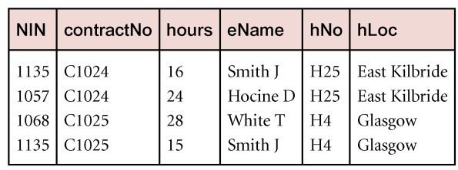

Figure 1: Instant Cover’s contracts

1. Thetable shown in Figure 1 is susceptible to update anomalies. Provide an example to show insertion anomaly. Provide another example to show deletion anomaly.
2. List the non-trivial functional dependencies in the table shown in Figure 1. State any assumptions you make about the data shown in this table.
3. Modify the table to be in Boyce-Codd normal form.
4. Display the data in Figure 1 using the tables in Boyce-Codd normal form.

2. [10 points] B+ tree

a) Assume we use B+ tree to index the relation Movie(m#, title, year, country) based on m#. if block size is 16 bytes, search key size is 2 bytes, tree pointer size is 4 bytes and data point size is 3, calculate the order of leaf node and internal node.

b) Assume the order of leaf node and internal node is 2 and 3, respectively. Build a B+ tree assuming the values of m#: 1, 7, 5, 8, 9, 6, 3, 12 are inserted sequentially.

.

1. Insertion: To add a new hotel, I will also need an employee as well

Deletion: Delete employee will also delete the hotel as well

b) Non- Trivial Dependencies :

* FD1: NiN → eName (unique for every member)
* FD2: hNo-→ hLoc (each hotel location associated with a hNo)
* FD3: contractNo → hNo, hLoc (each Contract is specific to a hotel)
* FD4: Nin, contractNo → hNo, hLoc, eName, hours (This will be the key)

c) All are in 1NF at first

FD1: Violate 2NF

FD3 : Violate 2NF

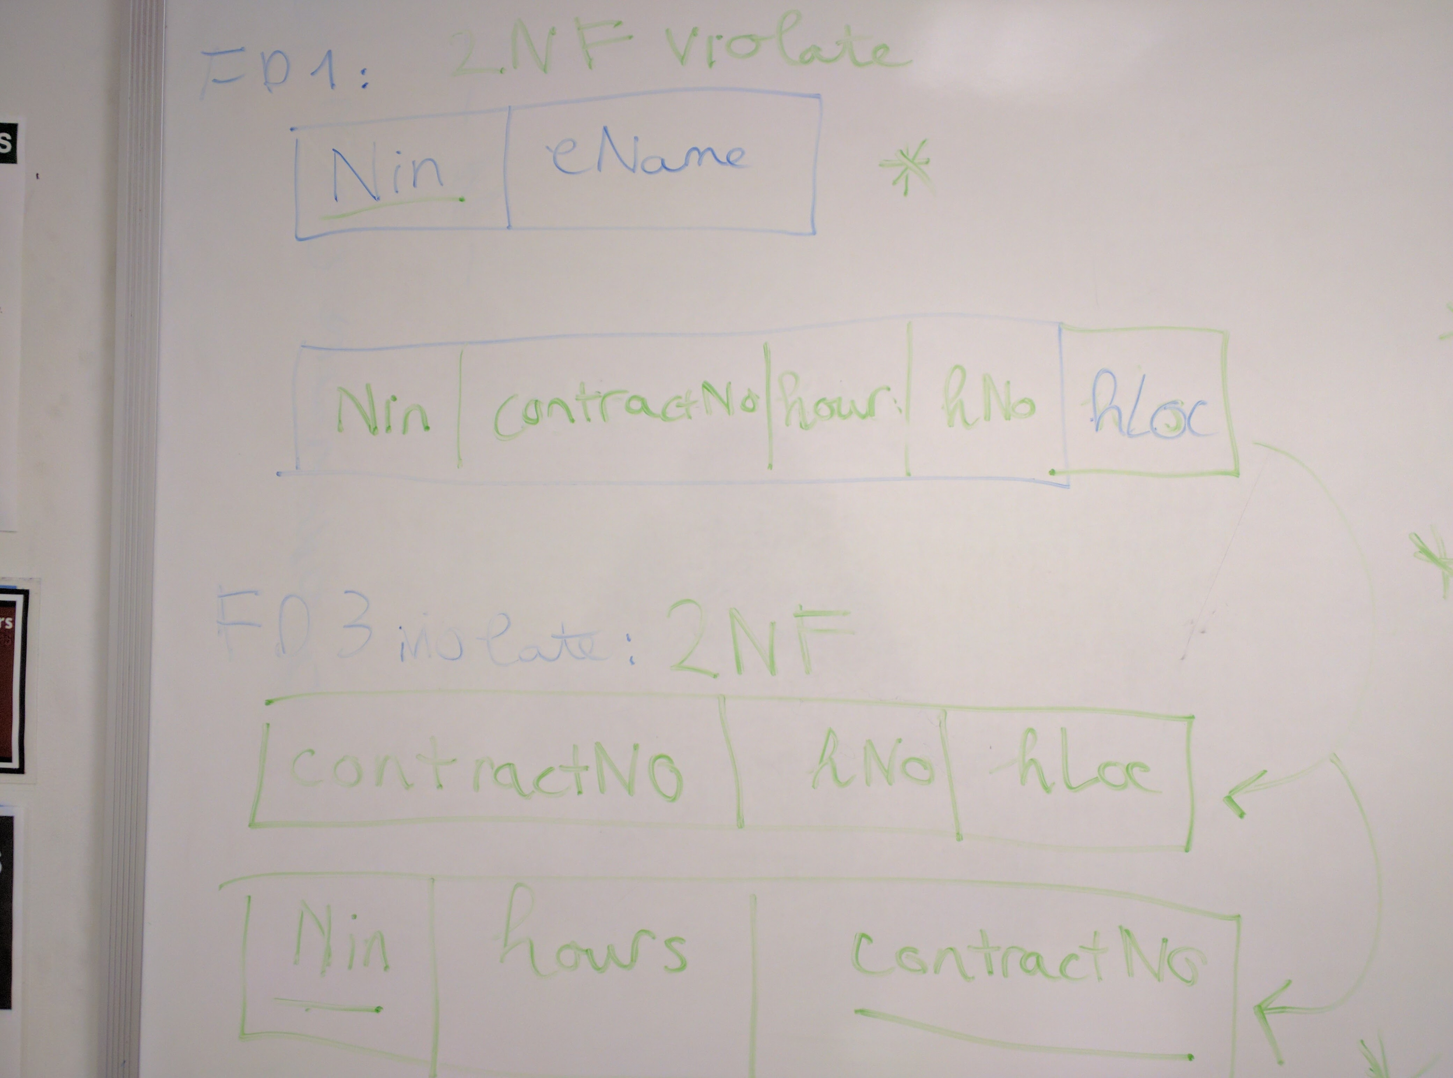

FD2: Violate 3NF/BCNF

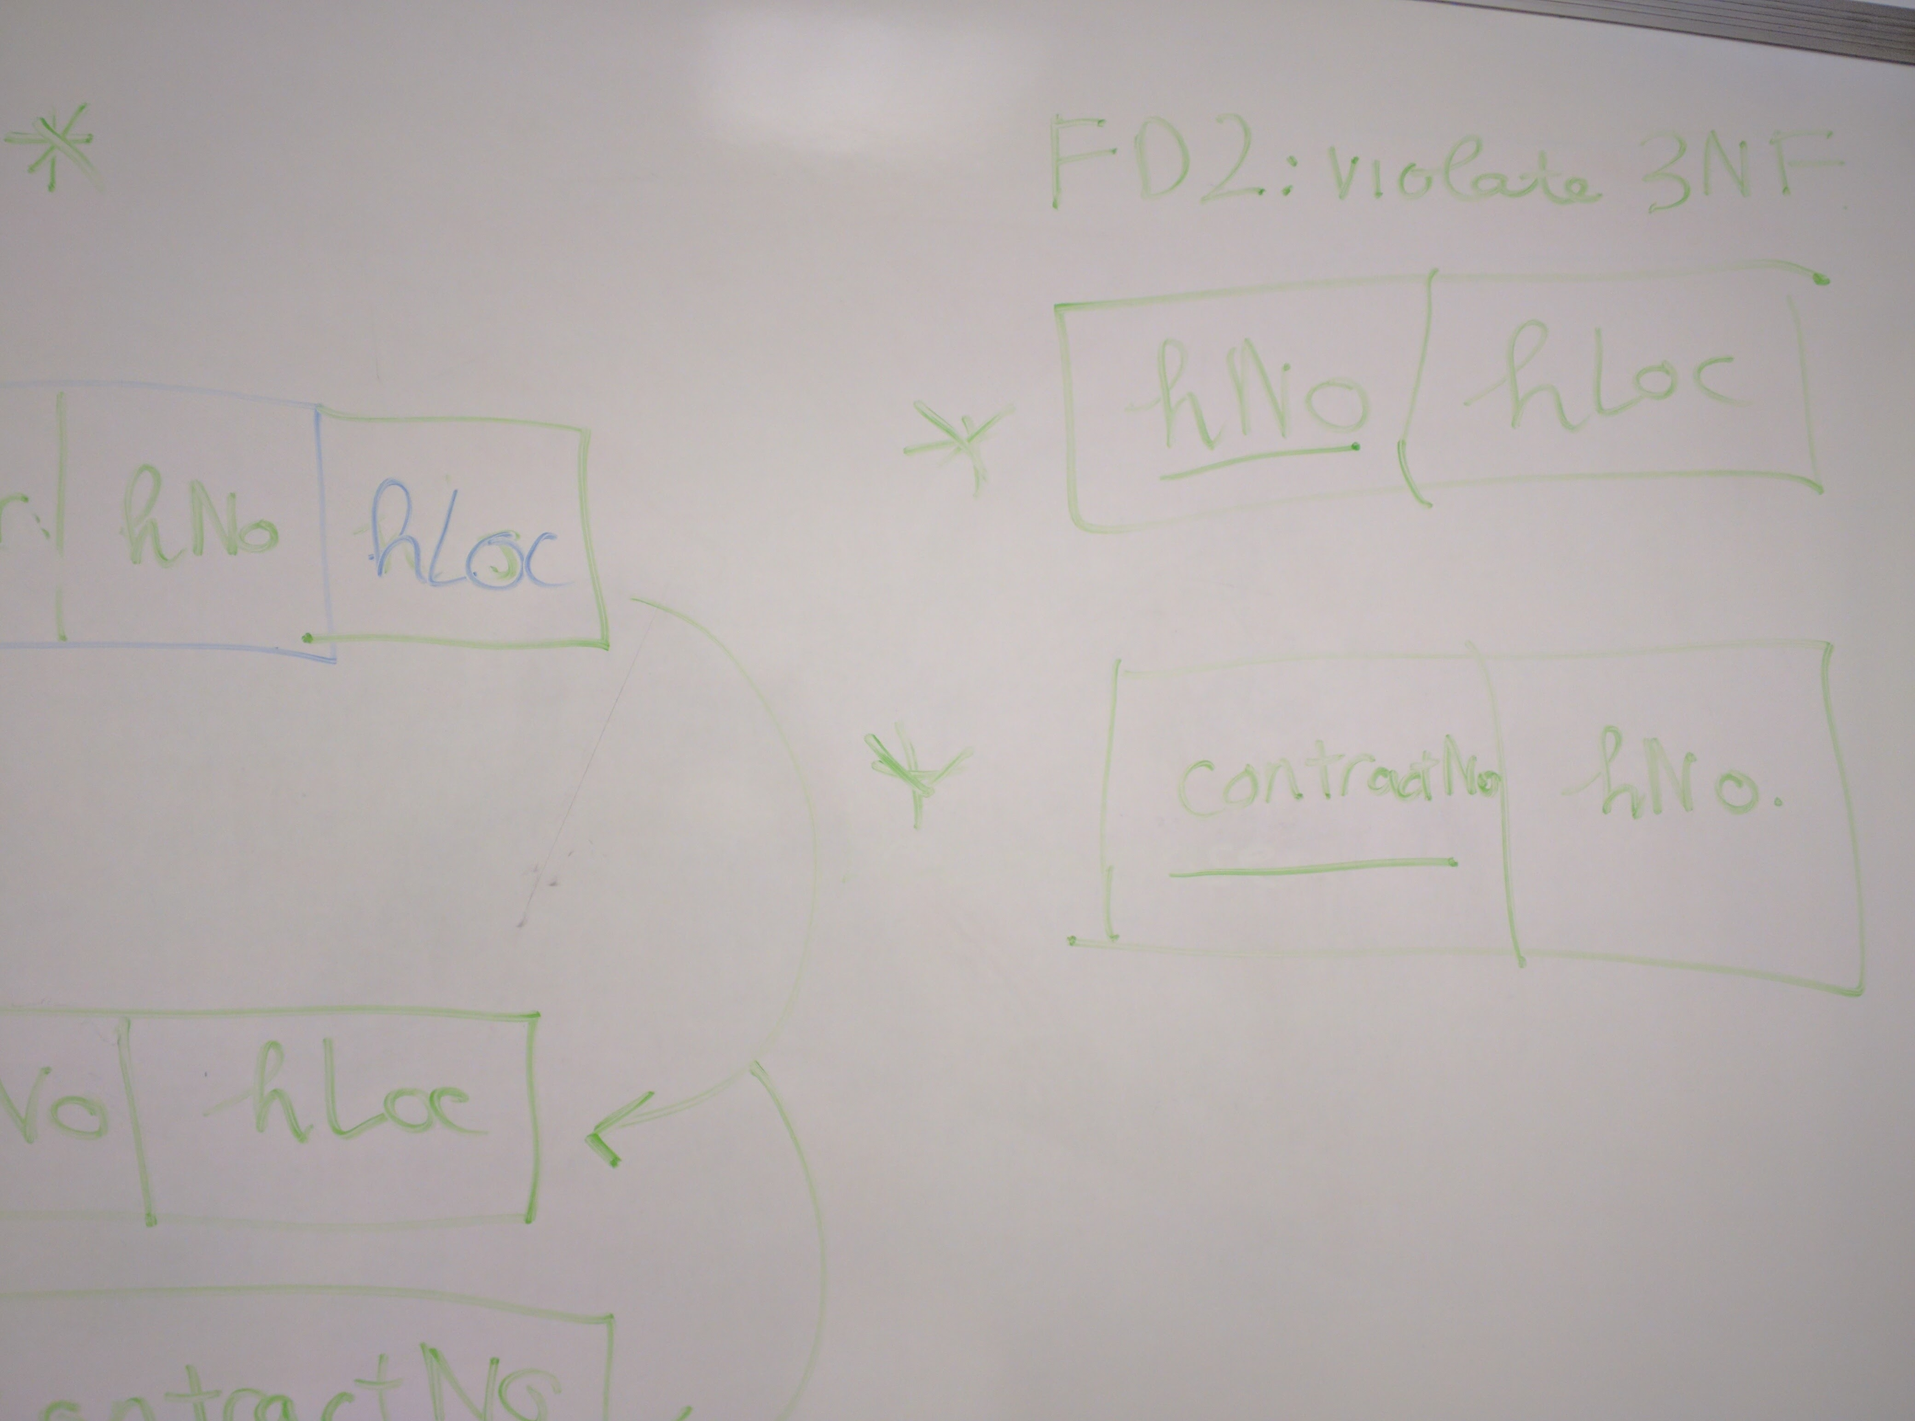

d)

|  |  |
| --- | --- |
| Nin | Ename |
| 1135 | Smith J |
| 1057 | Hocine D |
| 1068 | White T |

|  |  |  |
| --- | --- | --- |
| Nin | ContractNo | Hours |
| 1135 | C1024 | 16 |
| 1057 | C1024 | 24 |
| 1068 | C1025 | 28 |
| 1135 | C1025 | 15 |

|  |  |
| --- | --- |
| Hno | HLoc |
| H25 | East Killbridge |
| H4 | Glasgow |

|  |  |
| --- | --- |
| ContractNo | Hno |
| C1024 | H25 |
| C1025 | H4 |

2.

B = 16

SK = 2

TP = 4

DP = 3

a) Calculate P(int) and P(leaf)

P(int) * TP + (P(int) -1 ) * SK <= B

P(int) * 4 + (P(int) -1 ) * 2 <= 16

=> P(int) = 3

P(leaf) * (DP + SK) + TP <= B

P(leaf) * (3+2) + 4 <= 16

=> P(leaf) = 2

b)

