CSS 475 A Database Systems

Homework 1 (20 possible points) [4% of final grade]

Due BY: January 17 (Tuesday) 11:59:59 PM

1. (3 points) dentify at least 2 informal queries and 2 update operations that you would expect to apply to the database shown in Figure 1. (e.g. an example query can be: List the name of the student whose Student_number is 17; an example update can be: Insert a new course in the database whose Course_name = Algorithm, Course_number = CS4300, Credit_hours = 4, Department = CS. These 2 examples CANNOT be used as your answers)

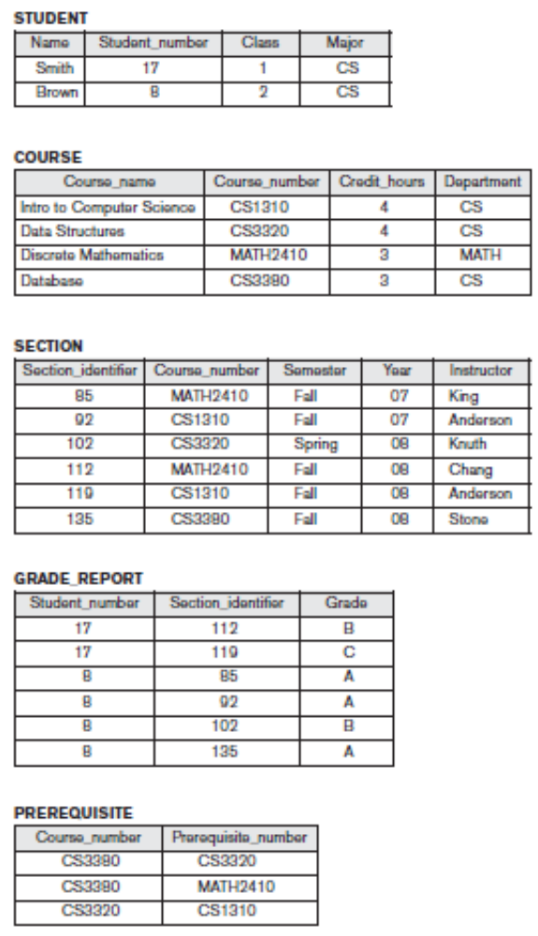
Figure 1. Example database (from the textbook: Fundamentals of Database Systems, by R. Elmasri & S. B. Navathe, Pearson.)

2. (3 points) Name all the relationships among the records of the database shown in Figure 1 (e.g., each SECTION record is related to a COURSE record. This example can be included in your answer).

3. (3 points) Cite at least 5 examples of integrity constraints that you think should hold on the database shown in Figure 1. The 5 examples of integrity constraints you pick should at least belong to 2 (and preferably 3) categories as discussed in class.

4. (11 points) Choose a database application (cannot be the same as the University or Company examples in the textbook) with which you are familiar and contains at least 3 entity types (tables). Design & draw the schema and show a sample database for that application, using the notation similar to Figures 1. List (or draw) all relationships and constraints you think are necessary for this schema. Think of at least 2 types of different users for your database, and design a view for each. Need to describe or draw the view and list what type of users the view is designed for.

ANSWER
- 2 Informal Queries:
- List all the course that has 3 credit hours
- List all the course that is taught by Anderson
2 Informal Update:
- Insert a new student called Thuan, CS major, 3rd yeard, SID: 1
- Update Student number 8 in section 92 grade to F

- Relationship, including example:
- Each prereq is related to a course
- Each grade report is related to a student
- Each grade record is related to a section
One minor detail: Should the prereq be related to a section ?

- Examples of integrity constrain:
- Every student mush have a unique Student Number
- Every student must have class standing represented by a number (1 for Freshman,…)
- Every course must have credit hours
- Every student must have a grade
- Every grade report of a student must be related to a section
- Every section must have an instructor.

- Database for a bookstore
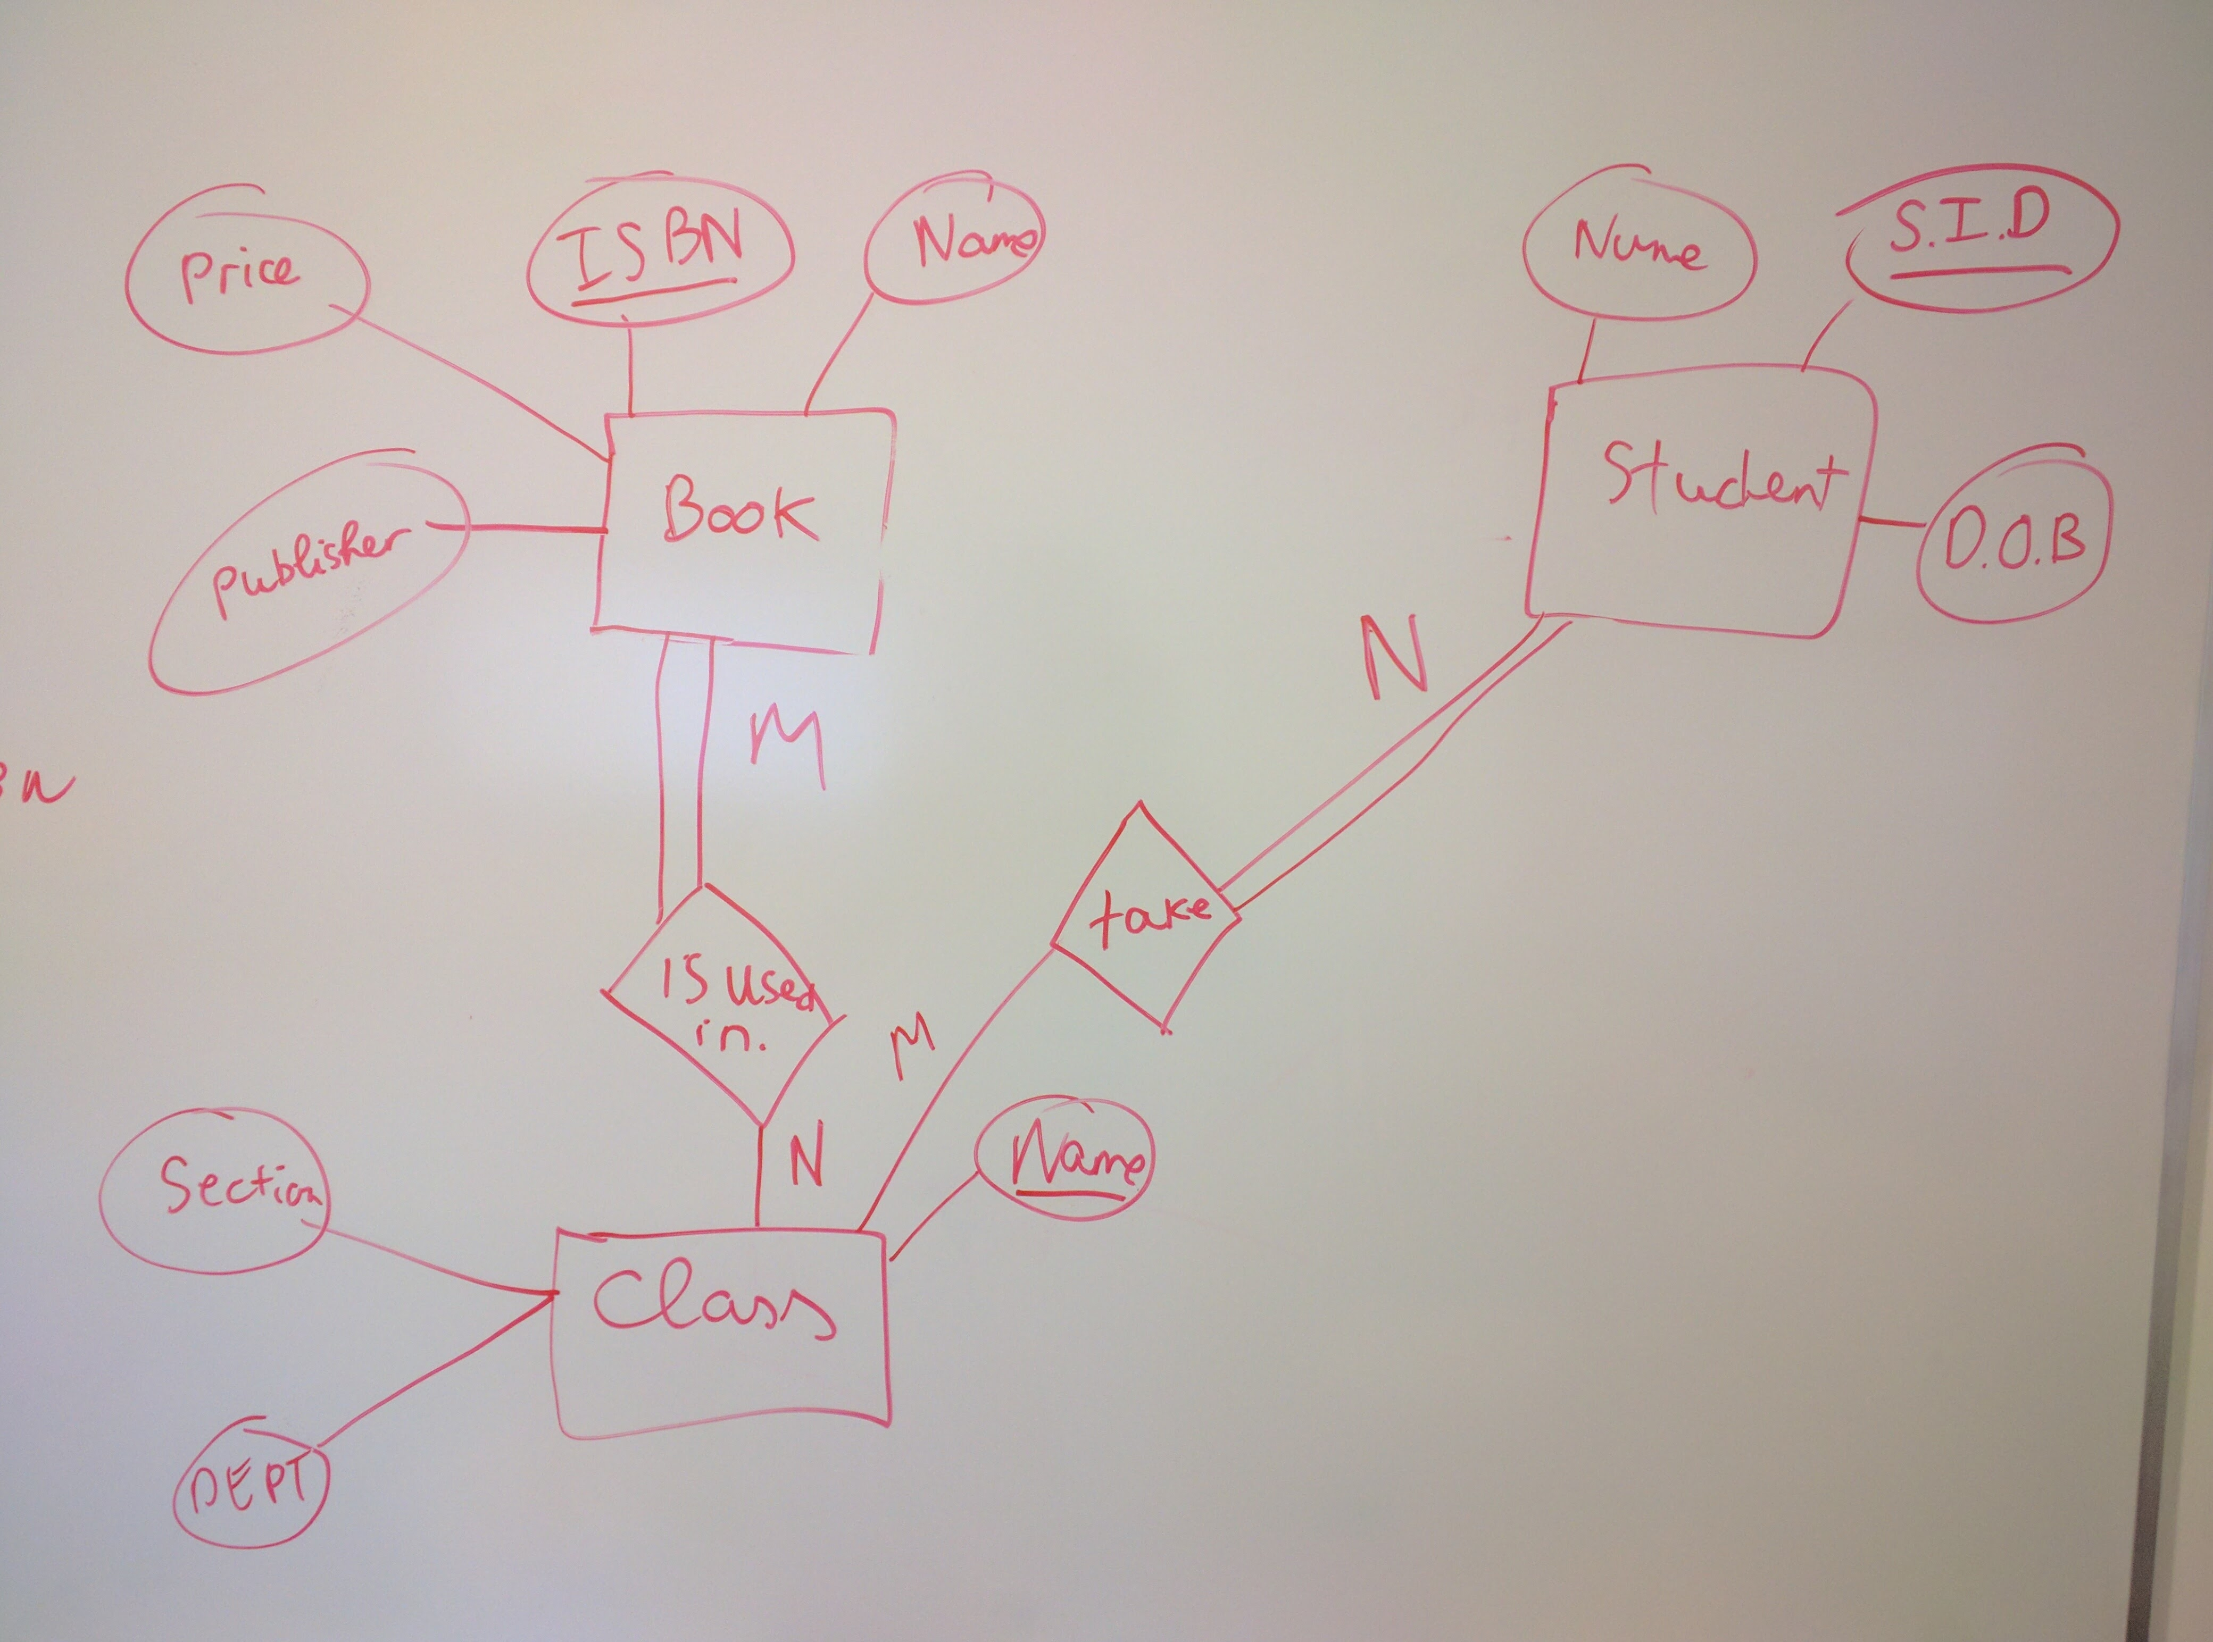

Assume that every book in the bookstore belong to a class. A class can use multiple books and the book can be used by multiple class. Some class might not require a textbook. A class can have multiple student and student join multiple class
Assume that every student take a class but not a class must have a student (Maybe that class is really boring and no one take it and therefore it is cancelled).
Each book can be identified by an ISBN. Each student can be identified by a student number. Each class can be identified by Name ( I don’t think there are any people has a name Database System)

Views for the Database: Users are students staff at the bookstore
Students: When the students login to system, they can see a list bulleted list of class for the quarter for that student only. For each class, they will see a list of book along with the price, ISBN, author
For the Staff: The staff will have a list of books that is ordered alphabetical. This include all the book that all the staff ordered. Each row will be a book name, ISBN, Price, Author, Publisher, the department, the class the book belong to and the section ( So the staff can look it up and know where to reshelf it)

I used to work at the bookstore so this came from my memory.
