CSS 475 A Database Systems

Homework 2 (30 possible points) [6% of final grade]

Submit: to Canvas

Due BY: January 31 (Tuesday) 11:59:59 PM
1. (8 points) Design an ER diagram for keeping track of information about votes taken in the U.S. House of Representatives during the current two-year congressional session. The database needs to keep track of each U.S. state’s name (e.g., ‘Texas’, ‘New York’, ‘California’) and include the region of the state (whose domain is {‘Northeast’, ‘Midwest’, ‘Southeast’, ‘Southwest’, ‘West’}). Each congress person in the House of Representative is described by his or her name, plus the district represented, the start date when the congressperson was first elected, and the political party to which he or she belongs (whose domain is {‘Republican’, ‘Democrat’, “Independent’, ‘Other’}). The database keeps track of each bill (i.e., proposed law), including the bill name, the date of vote on the bill, whether the bill passed or failed (whose domain is {‘Yes’, ‘No’}), and the sponsor (the congressperson(s) who sponsored – that is, proposed – the bill). The database also keeps track of how each congressperson voted on each bill (domain of vote attribute is {‘Yes’, ‘No’, ‘Abstain’, ‘Absent’}).
Additional information:
- There are 435 congresspersons in the U.S. House of Representatives.
- States have between one and 52 representatives.
- M represents number of bills during the 2-year session.
Draw an ER diagram for this application. Be sure to indicate the various attributes of each entity and relationship set; also specify the key and structural constraints for each relationship set. If you make any assumptions beyond everything stated above, explain clearly in your submission.
2. (3 points) Consider the ER diagram in Figure 1. Assume that an employee may work in up to two departments or may not be assigned to any department. Assume that each department must have one and may have up to three phone numbers. Additionally we have the following additional assumptions:
Each department can have anywhere between 1 and 10 employees.
Each phone is used by one, and only one, department.
Each phone is assigned to at least one employee, and may be assigned to up to 10 employees.
Each employee is assigned at least one, but no more than 6 phones.
Supply (min, max) constraints on this diagram. If you make any assumptions beyond everything stated above, explain clearly in your submission.

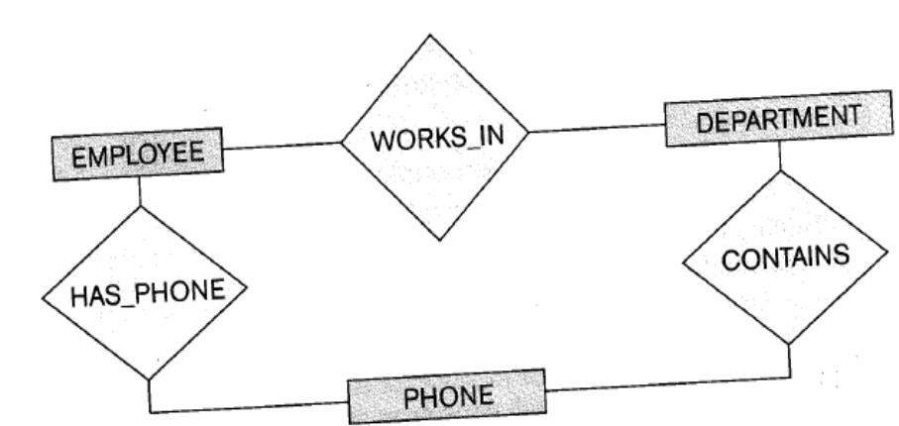
Figure 1

3. (5 points) Suppose that each of the following update operations is applied directly to the database shown in Figure 2. Discuss all schema-based constraints violated by each operation, if any, and at least 2 different ways to solve such issues (so that no constraint is violated).
- Insert <Robert', 'F', 'Scott', '943775543', '1972-06-21', '2365 Newcastle Rd, Bellaire, TX', M, 58000, '888665555',1> into EMPLOYEE.
- Insert <'ProductA', 4, 'Bellaire', 2> into PROJECT.
- Insert <'Production', 4, '943775543', '2007-10-01'> into DEPARTMENT.
- Insert <'677678989', NULL, '40.0'> into WORKS_ON.
- Insert <'453453453', 'John', M, '1990-12-12', 'spouse'> into DEPENDENT.
- Delete the WORKS_ON tuples with Essn = '333445555'.
- Delete the EMPLOYEE tuple with Ssn = '987654321'.
- Delete the PROJECT tuple with Pname = 'ProductX'.
- Modify the Mgr_ssn and Mgr_start_date of the DEPARTMENT tuple with Dnumber = 5 to '123456789' and '2007-10-01', respectively.
- Modify the Super_ssn attribute of the EMPLOYEE tuple with Ssn = '999887777' to '943775543'.
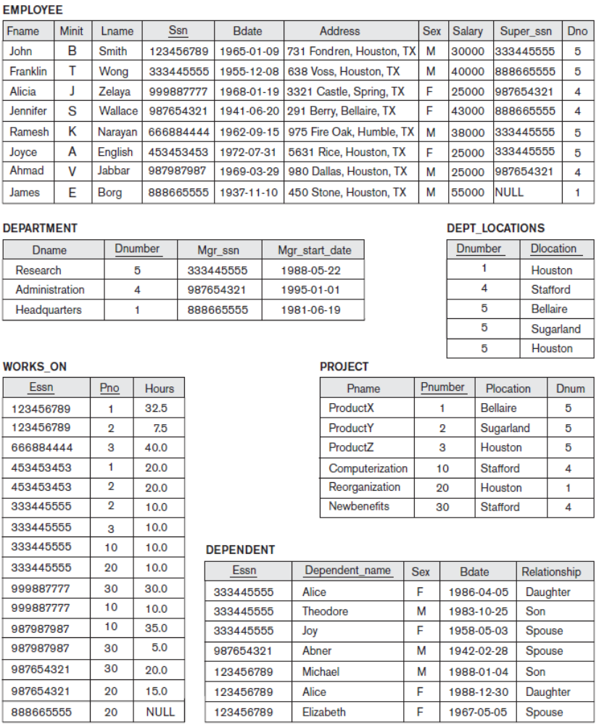
Figure 2

4. (7 points) Try to map the relational schema of Figure 3 into an ER diagram. This is part of a process known as reverse engineering, where a conceptual schema is created for an existing implemented database. State any assumptions you make.
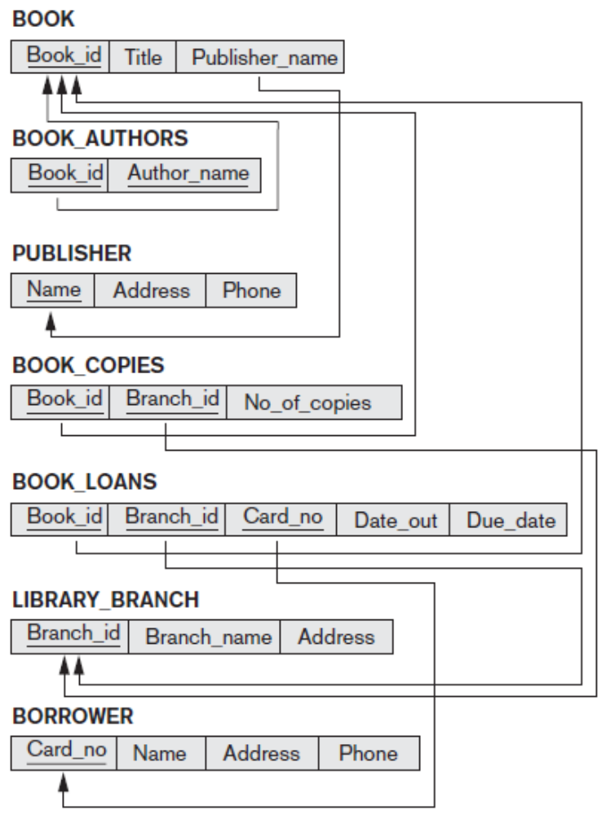
Figure 3

5. (7 points) Figure 4 shows an ER diagram for a database that can be used to keep track of transport ships and their locations for maritime authorities. Map this schema into a relational schema, and specify all primary keys and foreign keys.

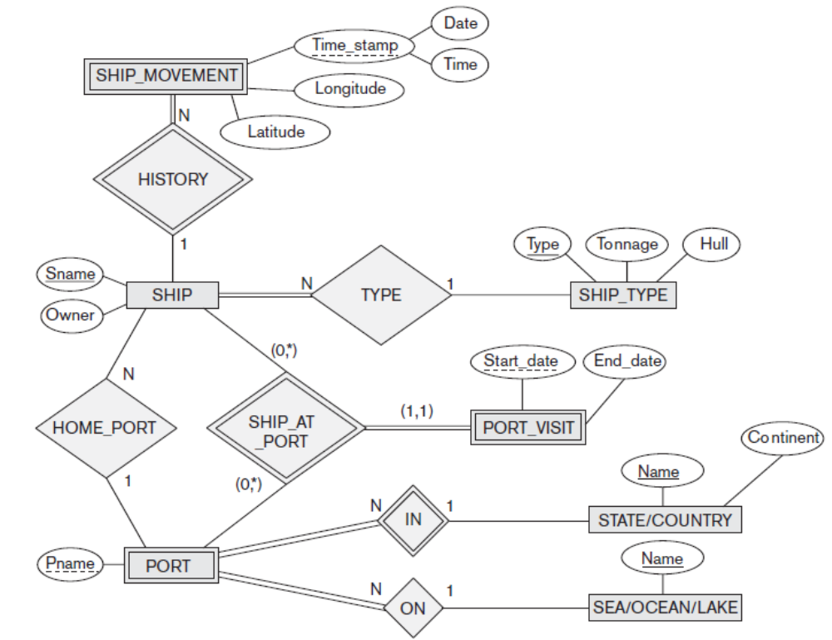
Figure 4

Answer
1.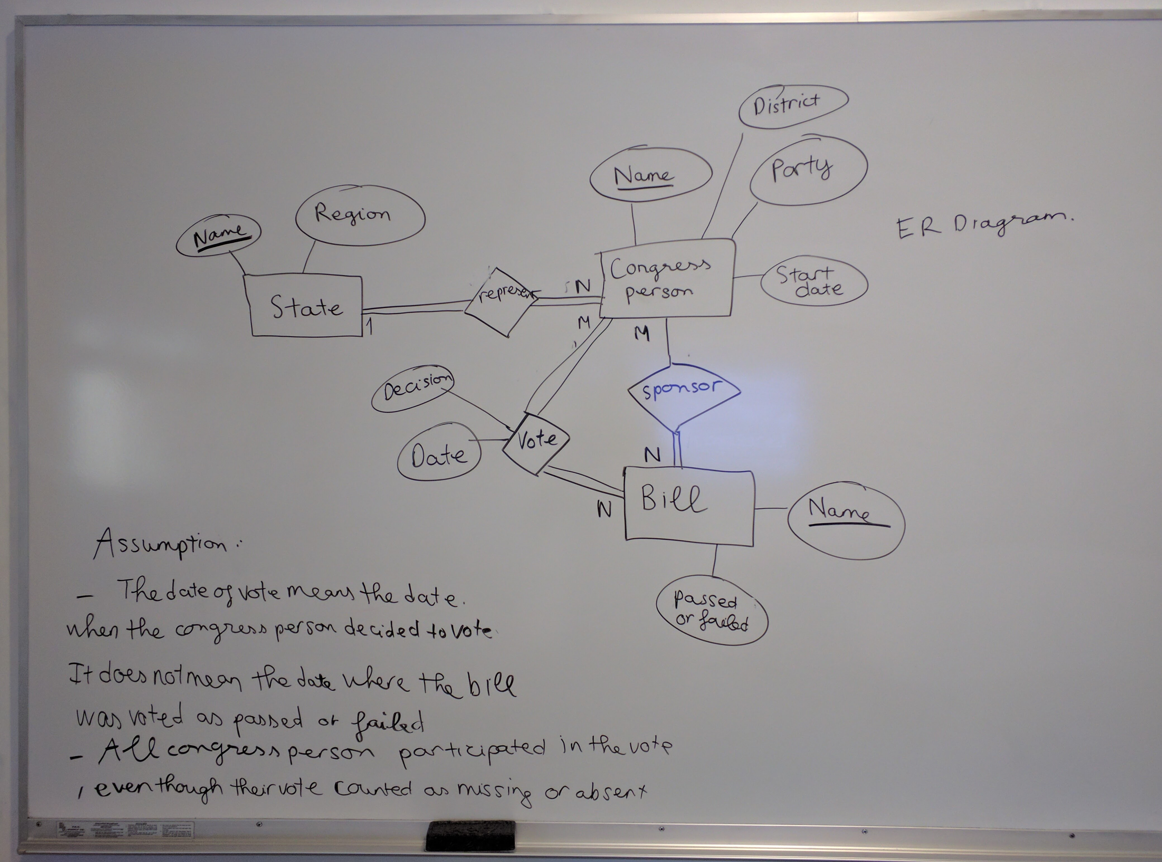

2.

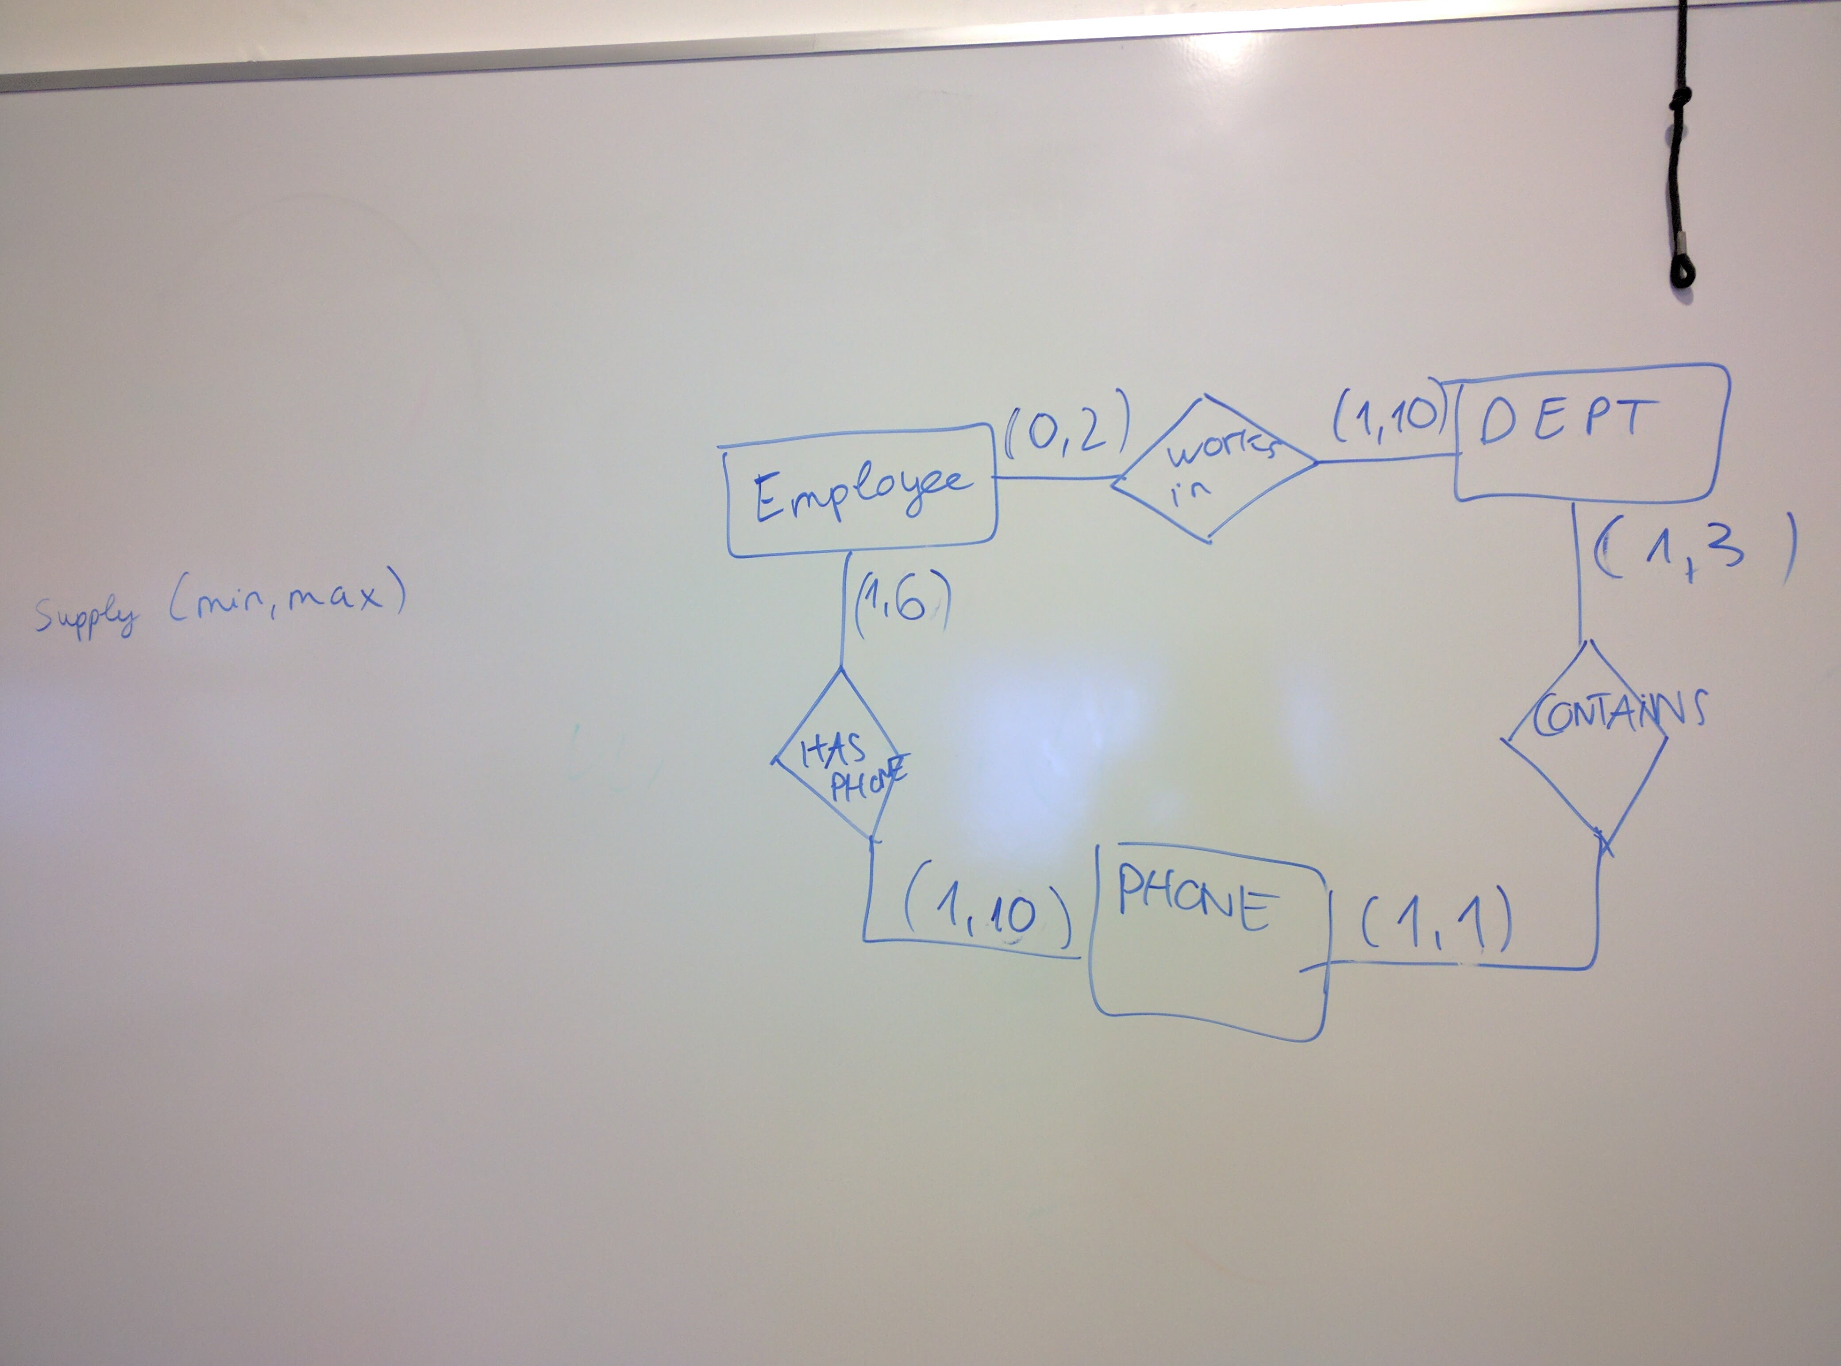

3.
- No violation
- No department number 2. Violate referential constrain. Reject or create a new department 2
- Violate Department Number key and Manger SSN. The superkey need to be unique and Manger SSN need to exit in other table. Referential and key constrain. Reject the operation or make sure the department number is unique and new SSN that exist.
- No such SSN in Employee. Referential constrain. Reject or update new employee in employee table to have that SSN
- No violation
- No violation
- Violate referential integrity constrain (the SSN is involve in another table). Reject or cascade (delete tuples that involves with it)
- Violate Referential Constrain (The product is involve with the Works on Table). Reject or cascade (delete tuples that involvs with it)
- No violation
- Violate Referential constrain. No SSN correspond. Reject, set Super SSN to NULL or make sure that the SSN the Super SSN refer to exist by create new employee.

4. Assumption:
- A publisher can have multiple books but a book can only have 1 publisher (must have publisher)
- A customer can borrow multiple books from multiple library branch but given 1 book and 1 branch , there can be only 1 customer borrow it at that time.
- Author is a weak entity that must belong to a book.
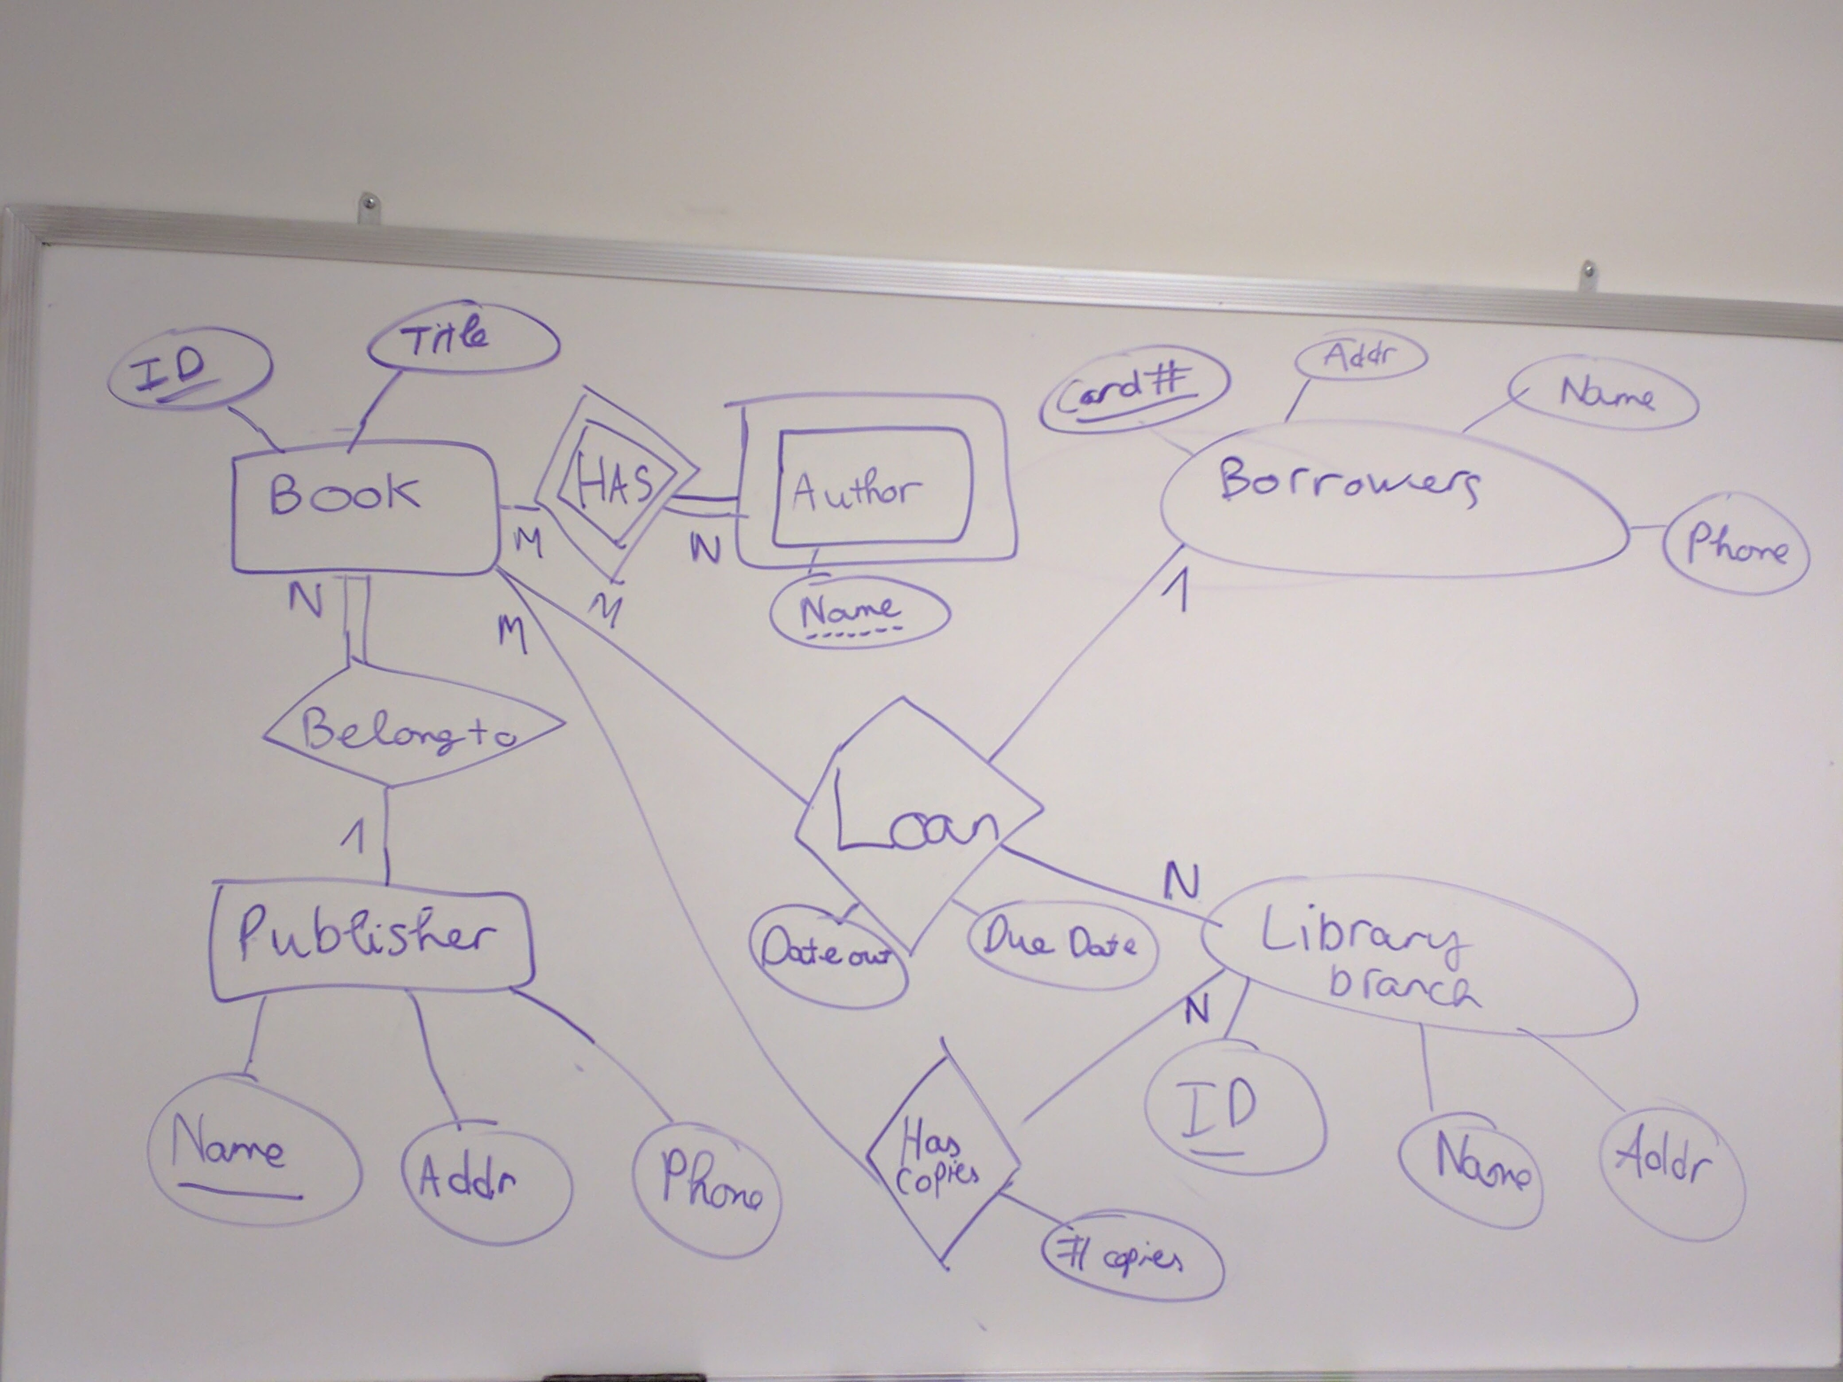

5.
