Name: Thuan Tran
CSS 490
Homework 2 Part 0

NOTE: Put the data set in the same folder or configure the directory path to load the data set ( I use Octave for this assignment)

I copied the script into this report but I will also attach the script to the submission

file = load('iris.mat')

#Seperate the file to a matrix to seperate the flower
newFormat = struct2cell(file)

# Get the individual flower. Still a cell 1x1 at this time
Setosa = newFormat(1)
Versicolor = newFormat(2)
Virginica = newFormat(3)

# Get the Matrix Representation . Now is the representation 50x4 of double data point
Setosa =cell2mat(Setosa)
Versicolor = cell2mat(Versicolor)
Virginica = cell2mat(Virginica)

# The index of the subplot
index = {1,4,5,7,8,9}

# The index of the attributes in each sub plot. ( 1 Correspond to Petal Sepal Width, 2 Sepal Length, 3 # # Petal Width, 4 Petal Length )
firstPart = {1,1,1,2,2,3}
secondPart={2,3,4,3,4,4}

# A counter variable to loop through all the matrix above and below
count = 1

# The axis label of each subplot
xAxisName = {'Sepal Width' , 'Sepal Width', 'Sepal Length','Sepal Width','Sepal Length', 'Petal Width'}
yAxisName = {'Sepal Length','Petal Width','Petal Width','Petal Length','Petal Length','Petal Length'}

for i = index
# Specify which subplot to get
subplot(3,3,cell2mat(i))

# Get the index of the data we want to plot in this subplot
firstIndex = cell2mat(firstPart(count))
secondIndex = cell2mat(secondPart(count))

# Plot 3 scatter plot in a single figure
scatter(Setosa(:,firstIndex),Setosa(:,secondIndex),'r')
hold on
scatter(Versicolor(:,firstIndex),Versicolor(:,secondIndex),'g')
hold on
scatter(Virginica(:,firstIndex),Virginica(:,secondIndex),'b')

# Create a legend
names = {'Setosa','Versicolor','Virginica'}
legend(names,'location','northeastoutside')

# Label x and y axis and the title
xlabel(xAxisName(count))
ylabel(yAxisName(count))
title('Distribution of 3 types of flower based on their attributes' )

# Prepare for next attribute
count = count +1

endfor

Interpret
Looking at the plot Illustration 4, I can see that it is easy to identify Setosa Flower. However, It is not easy to classify virginica and versicolor flower since they are clustered with each other.

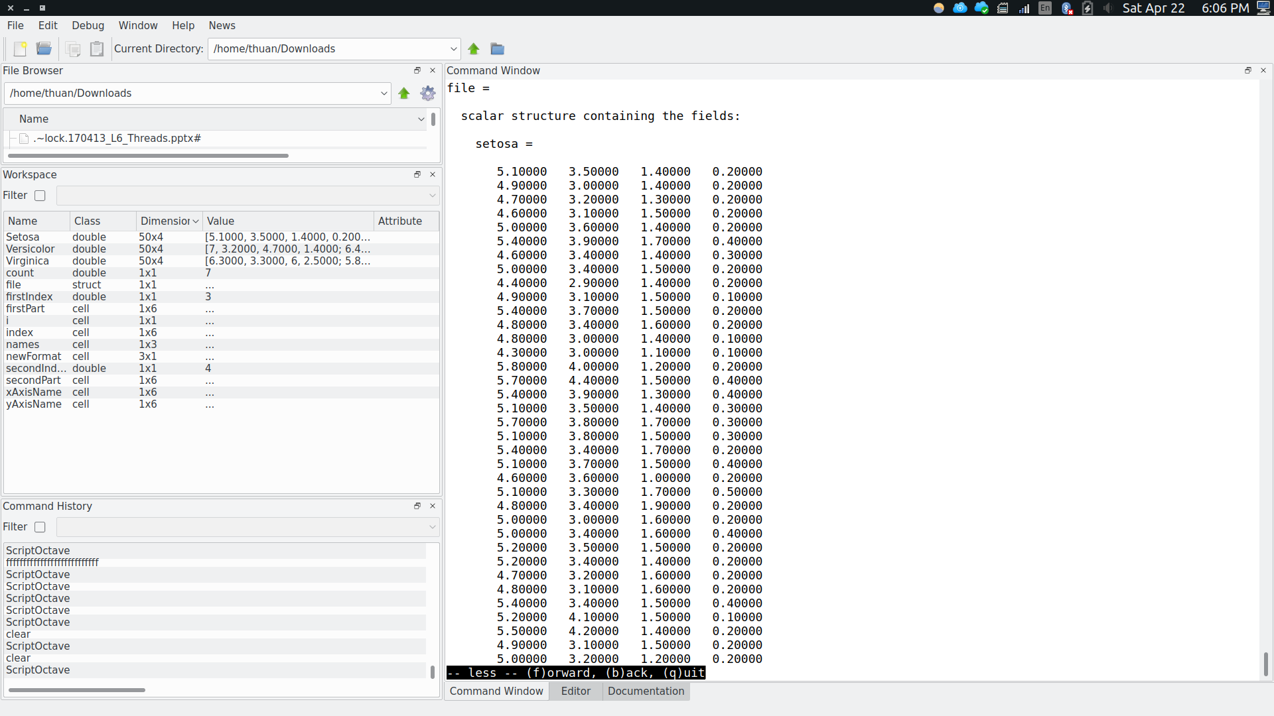Illustration 1: Output when running the script (Part 1)

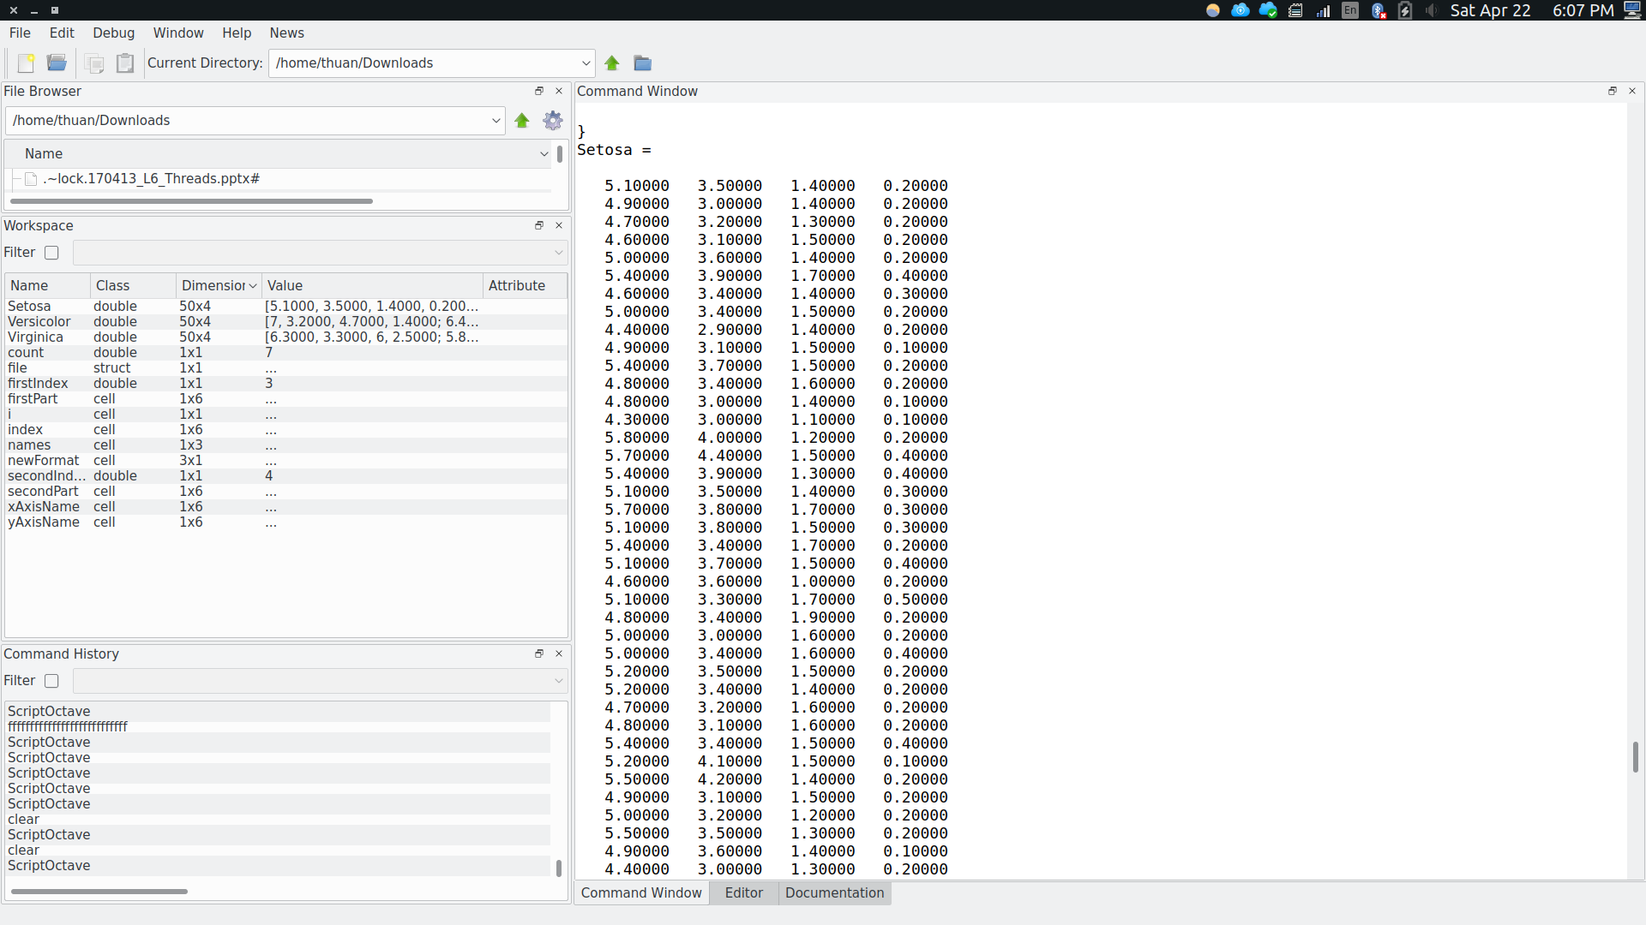Illustration 2: Output when running the script (Part 2)
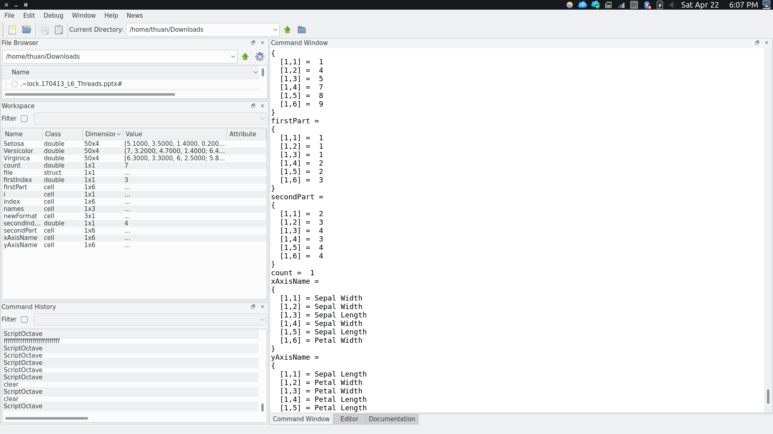Illustration 3: Output when running the script (Part 3)
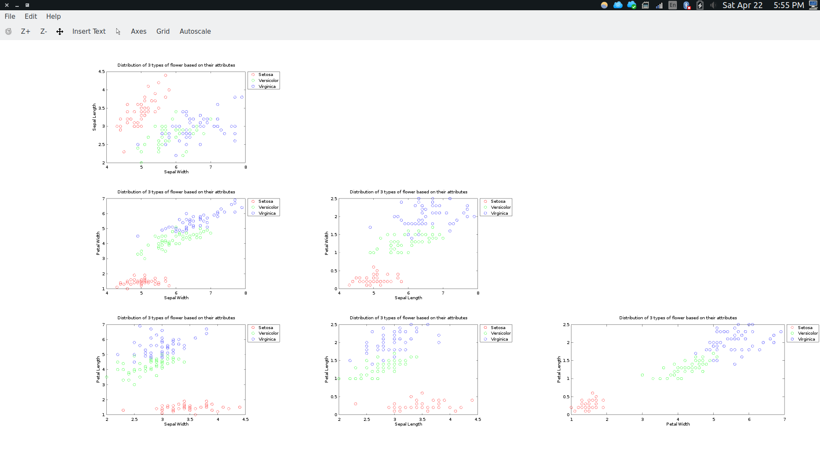Illustration 4: Output of the Plot

