NOTE: For this assignment, I used Matlab

The Discriminant belongs to case 2 where the E(i) = E . That is because for this example, every flowers have equal size and shape. However, their means are different (though same size and shape) since each flowers have different length and distributions

Here is my algorithm. In the .mat file, I did not include any comment for breviaty. But I will copy and paste the code here and add comment to it In this document

To plot the function, first I used the normfit function that return the mean and the standard deviation
of each flower
Then I calculated the x range by using the formula given in the OneNote
I then proceed to plot the curve in 1 figure and using different color, adding title, labels
Then for the Petal Length, I repeated the step above, just used data in the second column of each flower
that represent the Petal Length

Code Section

# These lines was used to load the dataset and put them in an appropriate format
file = load('iris.mat')

newFormat = struct2cell(file)

Setosa = newFormat(1)
Versicolor = newFormat(2)
Virginica = newFormat(3)

Setosa =cell2mat(Setosa)
Versicolor = cell2mat(Versicolor)
Virginica = cell2mat(Virginica)

# Get the mean and standard deviation of each type of following (Petal Width)
[SetosaMean,SetosaStd] = normfit(Setosa(:,1));
[VirginicaMean,VirginicaStd] = normfit(Virginica(:,1));
[VersicolorMean,VersicolorStd]= normfit(Versicolor(:,1));

# Get the variance of each flower
SetosaVar = var(Setosa(:,1))
VirginicaVar = var(Virginica(:,1))
VersicolorVar = var(Versicolor(:,1))

# There will be 2 figure to plot
figure()
hold on;
# Plot all three distribtuion on the same figure
# x variable indicate the length of the x axis
x= linspace(SetosaMean-3*SetosaStd,SetosaMean+3*SetosaStd,100);
plot(x,normpdf(x,SetosaMean,SetosaStd),'red');
x= linspace(VirginicaMean-3*VirginicaStd,VirginicaMean+3*VirginicaStd,100);
plot(x,normpdf(x,VirginicaMean,VirginicaStd),'green');
x= linspace(VersicolorMean-3*VersicolorStd,VersicolorMean+3*VersicolorStd,100);
plot(x,normpdf(x,VersicolorMean,VersicolorStd),'blue');
legend('Setosa','Virginica', 'Versicolor')
title('The PDF of 3 types of flower based on Petal Width')
xlabel('The length (cm)')
ylabel('Probability Density of the flower given the length')
hold off;

# The same with the second figure but in this time, we calculate the mean and standard deviation of Petal Length
figure()
[SetosaMean,SetosaStd] = normfit(Setosa(:,2));
[VirginicaMean,VirginicaStd] = normfit(Virginica(:,2));
[VersicolorMean,VersicolorStd]= normfit(Versicolor(:,2));
hold on;
x= linspace(SetosaMean-3*SetosaStd,SetosaMean+3*SetosaStd,100);
plot(x,normpdf(x,SetosaMean,SetosaStd),'red');
x= linspace(VirginicaMean-3*VirginicaStd,VirginicaMean+3*VirginicaStd,100);
plot(x,normpdf(x,VirginicaMean,VirginicaStd),'green');
x= linspace(VersicolorMean-3*VersicolorStd,VersicolorMean+3*VersicolorStd,100);
plot(x,normpdf(x,VersicolorMean,VersicolorStd),'blue');
legend('Setosa','Virginica', 'Versicolor')
title('The PDF of 3 types of flower based on Petal Length')
xlabel('The length (cm)')
ylabel('Probability Density of the flower given the length')
hold off;

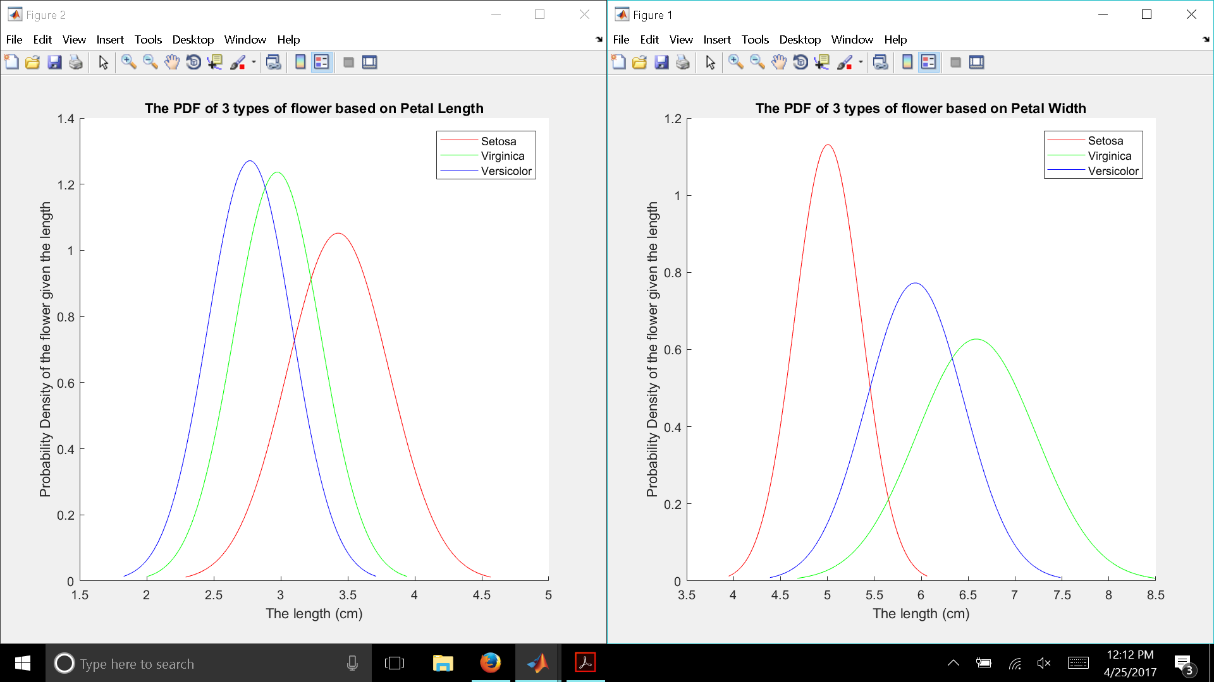Illustration 1: Normal Distribution of 3 types of flower
Interpretation:
Looking at the Petal Length, I can determine that Setosa generally have longer petal length than the other 2 flowers. The Versicolor flower is a bit slim so that indicate that it has low standard deviation, meaning that most of its value are close to its mean. And the Virginica is between those two (smaller mean than the setsosa but larger than versicolor and smaller standard deviation than the setosa and larger than versicolor)
For the Petal Width, The average length of setosa is smaller than the others two. However, most of its value are closer to its mean (meaning lower standard deviation compared to other two). Versicolor has bigger mean compared to Setosa and higher standard deviation. Virginica has the biggest average length and highest standard deviation. This indicate that the petal width of Virginica is generally bigger than the other two, however, it is also vary as well (Because of standard deviation)

