**Beat Lightsaber Proposal**

Beat Lightsaber is an interactive game in which you control a lightsaber with your hand movement in order to defeat enemies to advance in level. There will an aspect of customization in which the player can choose their lightsaber color in which they want to play the game with. The enemies will most likely be images of certain droids from Star Wars and you have to hit them with your lightsaber before they reach a certain point of the screen. The lightsaber you control can also be activated/deactivated whenever you close or open your hand, respectively.

**Some Sketches:**

Menu Screen:

Saber Choice Screen:

Game Screen (Lightsaber will change to a more rectangly object):

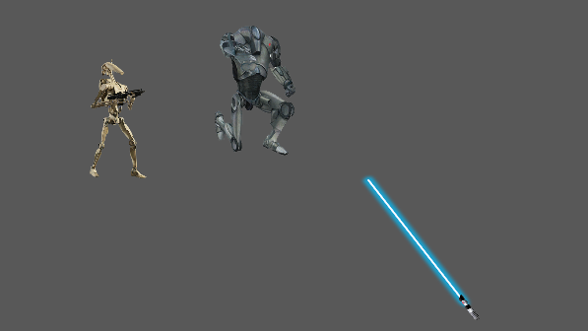

For this game, I would love to explore some of the finite state machine mechanics of pygame, if there are any. I want the game to look great and have really cool sound effects.

Jira Board:

