**Registration Process**

To create an account click the Sign Up link in the top right to open the registration view

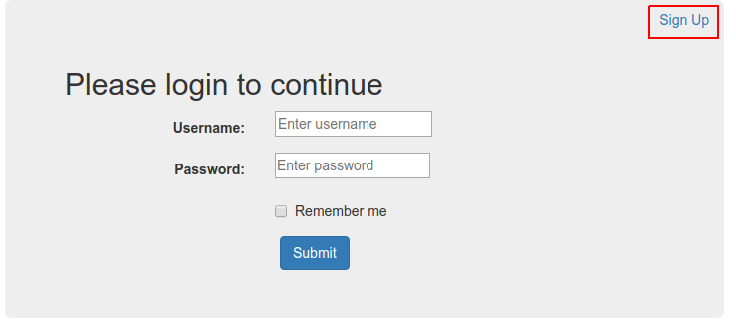

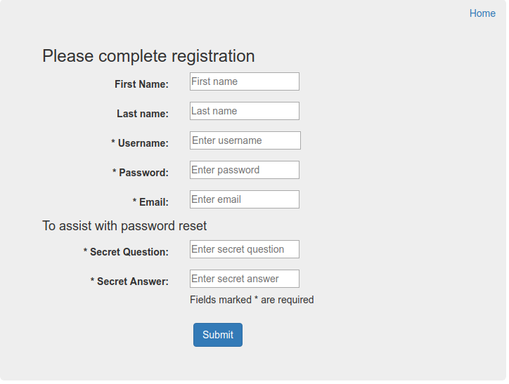

Fill out the required fields and click the submit button to be redirected back to the login view.

**Login Process**

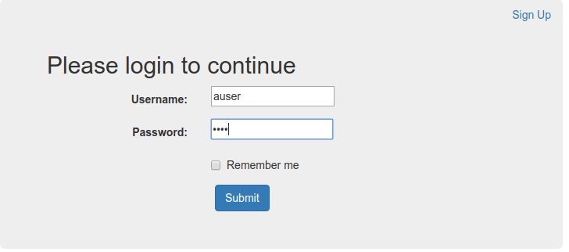Enter username and password and click submit to login to be redirected to the search view

**Search Functionality**

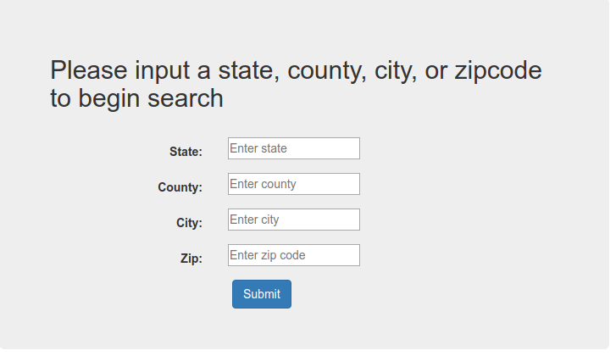

To perform a search, enter the information into the appropriate form element and click submit.

**Password Reset**

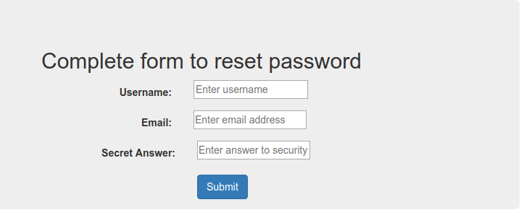

Fill out form and click submit to begin password reset process.

If your password is correct you will be redirected to reset your password.

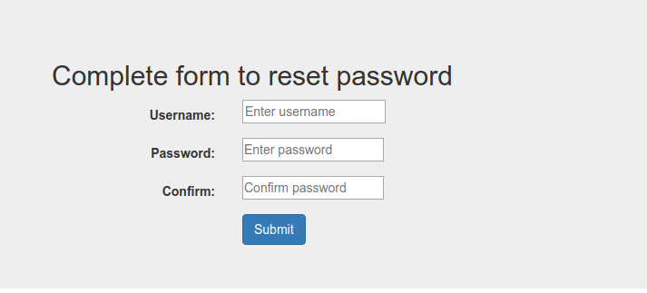Complete the form and click submit to be redirected to the login view.