[Answers]

Assignment 3
CPSC 351–07 FALL 2025
Due: 11/30/2025(Sunday) at 11:59 pm
Joshua Larracas
Matthew Choi
Affan Siddiqui
Moises Munoz
Luis E Aldana Jr
Riley Berry

Q1) Multithreading Using pthreads :

- Write a program using pthreads that:
- Declares a global variable:
int counter = 0;
- Creates 10 threads
- Each thread increments counter 100,000 times
- Do not use any mutex
- Print the final value after all threads finish

(B) Write another program using pthreads that:
- Declares the same global variable counter
- Creates 10 threads
- Each thread increments counter 100,000 times
- Protects the increment using a pthread mutex
- Print the final value after all threads finish

(C) Place the screenshots of the outputs you obtained for the programs in Section A and Section B.
Section A output: 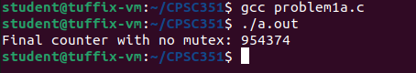
Section B output: 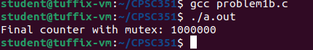

Answer the questions below :

- Why does the program in Section A not print the value 1,000,000?
The program in section A doesn't print the value 1,000,000 because multiple threads are modifying the counter variable without any kind of synchronization.
- What role does the mutex play in Section B?
In section B the mutex ensures that only one thread can execute the critical section at a time.
- Is counter++ an atomic operation? Explain briefly.
Counter++ is not an atomic expression because it compiles into 3 steps, it loads counter from memory then adds one and finally stores the new variable in memory.If 2 different threads were to do these steps at the same time they could overwrite the others update.

Q3) CPU scheduling

Consider the set of 5 processes whose arrival time and burst time are given below

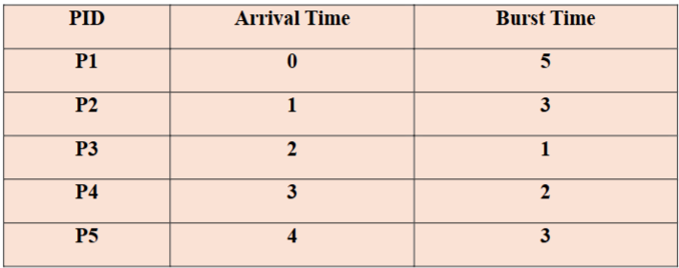

If the CPU scheduling policy is Round Robin with a time quantum of 2 units, draw the Gantt chart and calculate the average waiting time.

P1 | P2 | P3 | P1 | P4 | P5 | P2 | P1 | P5
0 2 4 5 7 9 11 12 13 14
AVG waiting time: (8 + 8 + 2 + 4 + 7) / 5 = 29 / 5 = 5.8

