COIT13146
System and Network Administration
Student ID: 12205529
Student Name: Sarah Brown

Unit Coordinator: Zhenglin Wang

Date Due:13/06/2025
Table of Contents
Project Summary 3
Project Implementation Plan 3
Network and Server Design 5
Network Topology Diagram 5
IP Address Plan 5
Server Installation and Configuration (rocky) 6
Server Installation and Configuration (adelaide) 7
Server Installation and Configuration (sydney) 8
Server Installation and Configuration (gladstone) 9
Server Installation and Configuration (bundaberg) 9
Design Justification 10
Assumptions 11
Constraints 11
Backup and Recovery Design 11
Backup Approach 11
Backup Mechanism 12
File Organisation and Storage 12
Automation 12
Recovery Instructions 12
Security Design 13
Password Policy 13
Access Instructions 13
Certificate Management 14
Access External Board of Management 14
Testing 15

Project Summary

Project Implementation Plan
Below is an overview of the project phases, including objectives, tasks, deliverables and deadlines. This structure ensures timely completion and comprehensive coverage of all assessment requirements.
Phase 1: Planning (Deadline: May 28, Completed: May 25)
- Objective: Define the network structure and required resources
- Tasks:
- Project progress report setup
- Network diagram creation
- IP address plan and justification
- Define assumptions and constraints
- Deliverables:
- Network diagram
- IP address plan
- Design justification
- Planning documentation
Phase 2: Virtual Environment Setup (Deadline: May 31, Completed: May 26)
- Objective: Prepare the virtual infrastructure for deployment
- Tasks:
- Configure VirtualBox
- Create VMs for server(s), router/firewall, client machine
- Network adapters setup (NAT/Internal)
- Deliverable:
- VM environment ready for configuration
Phase 3: Server Configuration (Deadline: June 2, Completed: June 1)
- Objective: Configure necessary server-side services
- Tasks:
- Set up Linux server
- Configure Apache web server
- Enable and secure SSH
- Set static IP address
- Deliverables:
- Functional Linux server
- Apache and SSH tested
Phase 4: Routing & Firewall Setup (Deadline: June 4, Completed: June 8)
- Objective: Control internal/external traffic
- Tasks:
- Enable IP forwarding
- Configure iptables firewall
- Set up routing between NAT and internal networks
- Deliverable:
- Verified internal network isolation and routing
Phase 5: Client Configuration (Deadline: June 5, Completed: June 1)
- Objective: Set up an example client machine
- Tasks:
- Assign IP
- Set default gateway
- Verify internet access
- Deliverable:
- Client machine able to access web services and internet
Phase 6: Automation (Deadline: June 7, Completed: June 8)
- Objective: Implement basic automation via cron jobs
- Tasks:
- Schedule backup or logging scripts
- Verify script execution
- Deliverable:
- Log showing working cron jobs
Phase 7: Testing and Reporting (Deadline: June 10, Completed: June 9)
- Objective: Validate the network set up and produce final documentation
- Tasks:
- Test internal and external connectivity
- Validate firewall and SSH access
- Compile report
- Deliverables:
- Final report
- Screenshots and config evidence
- Reflective notes
Phase 8: Presentation & Submission Prep (Deadline: June 12, Completed: June 10)
- Objective: To prepare and finalise all deliverables for presentation and submission
- Tasks:
- Review and proofread the full report
- Finalise progress reports
- Prepare presentation
- Run final check against marking guide
- Export all files into required formats
- Back up all final versions
- Submit on time
- Deliverables:
- Finalised project report
- Three progress reports (e.g. June 1, June 8, June 10)
- Back up copy of all project files

Network and Server Design

Network Topology Diagram
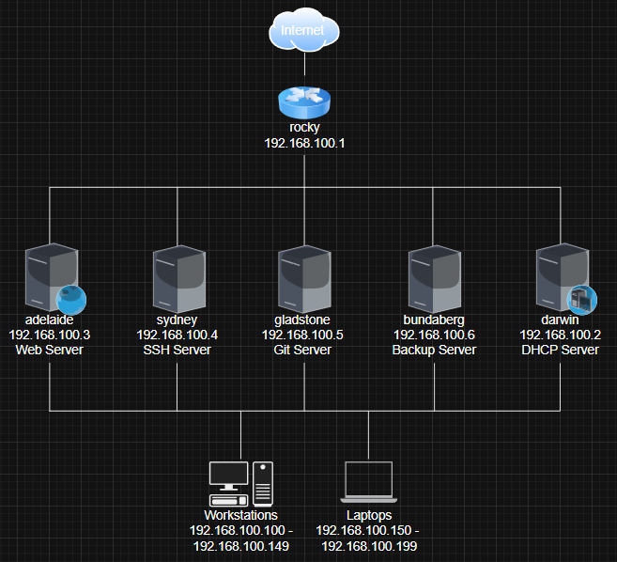

IP Address Plan
Device Name | Role | MAC Address | IP Address | Notes/Access | DHCP?
rocky | Router/Firewall | 0800270D80EE (internal)  09002750B779 (external) | 192.168.100.1 | Gateway, performs NAT, firewall, DHCP relay | Static
darwin | DHCP Server | 080027B5459E | 192.168.100.2 | Assigns dynamic Ips to workstations/laptops | Static
adelaide | Web Server | 0800273D52BB | 192.168.100.3 | Apache + DokuWiki, HTTPS only from WAN | Static
sydney | SSH Server | 08002745071E | 192.168.100.4 | SSH from LAN and WAN | Static
gladstone | Git Server | 080027C01E31 | 192.168.100.5 | SSH Git access from LAN/WAN | Static
bundaberg | Backup Server | 08002782607B | 192.168.100.6 | Internal only | Static
workstation-01 to workstation-50 | Workstations | 0800276E67EC | 192.168.100.100– 192.168100.149 | Assigned to office desktops | DHCP-assigned
laptop-01 to laptop-50 | Laptops | 0800275EEA6A | 192.168.150– 192.168.100.199 | Assigned to portable devices | DHCP-assigned

Server Installation and Configuration (rocky)
1. Purpose:
Acts as the router and firewall. Manages NAT and internal networking.
2. Operating System Installed:
Ubuntu Server 24.04 LTS (x64)
3. Network Configuration:
- NAT setup with VirtualBox Adaptor
- Internal network: intnet
- IP Address assigned: 192.168.100.1
4. Services Installed:
- iptables: Configured for basic firewall rules
- Routing enabled
5. Key Configuration Steps:
- Enabled IP forwarding in /etc/sysctl.conf
- Set up NAT using iptables
- Saved rules using iptables-save
6. Testing:
- Verified internet access from internal clients
- Traceroute from client to external confirms routing
7. Issues Encountered:
- NAT failed on VM, used Bridge Adaptor instead
Server Installation and Configuration (darwin)
1. Purpose:
Acts as the router and firewall. Manages NAT and internal networking.
2. Operating System Installed:
Ubuntu Server 24.04 LTS (x64)
3. Network Configuration:
- Internal network: intnet
- IP Address assigned: 192.168.100.2
4. Services Installed:
- isc-dhcp-server
5. Key Configuration Steps:
- Installed DHCP server via sudo apt install isc-dhcp-server
- Edited /etc/dhcp/dhcpd.conf with entries to assign static leases to avoid IP conflict
- Edited /etc/default/isc-dhcp-server to direct the internal interface:
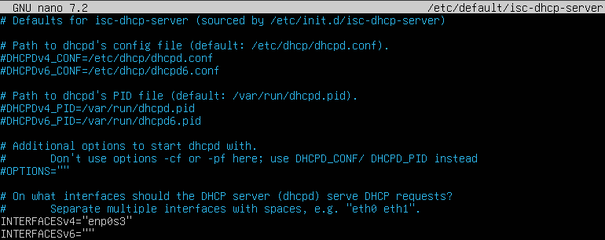
6. Testing:
- Confirmed WS01 and LP01 received correct IPs with ip a
- Verified lease allocation via /var/lib/dhcp/dhcp.leases
7. Issues Encountered:
- Initial IP assignments were out-of-range. Resolved by setting static MAC-to-IP mappings

Server Installation and Configuration (adelaide)
1. Purpose:
Hosts the internal web service, including the DokuWiki instance for internal documentation.
2. Operating System Installed:
Ubuntu Server 24.04 LTS (x64)
3. Network Configuration:
- Internal network: intnet
- IP Address assigned: 192.168.100.3
4. Services Installed:
- Apache2
- git
- openssl (for SSL certificate)
- DokuWiki (cloned from git)
5. Key Configuration Steps:
- Installed Apache and started the service
- Confirmed default Apache page available on external router IP (192.168.0.18)
- Generated a self-signed SSL certificate
- Configured Apache virtual host to serve HTTPS using the self-signed cert
- Cloned dokuwiki.git repo into /var/www/html
- Set permissions for www-data to serve content
6. Testing:
- Accessed Dokuwiki homepage at https://192.168.0.18
- Confirmed certificate warning (expected for self-signed)
- Verified content is served and editable
7. Issues Encountered
- Some permission errors initially when deploying via git. Resolved by adjusting ownership.
- SSL warning appears in browser, expected with self-signed cert.

Server Installation and Configuration (sydney)
1. Purpose:
Acts as a secure SSh server, enabling remote access for internal users via SSH key authentication
2. Operating System Installed:
Ubuntu Server 24.04 LTS (x64)
3. Network Configuration:
- Connected to intnet internal network
- IP Address assigned: 192.168.100.4
4. Services Installed:
- ssh
- openssh-server
5. Key Configuration Steps:
- Installed and enabled ssh and openssh-server service
- Created user accounts (riley, sarah)
- Created .ssh directories and copied authorized keys from clients
- Created automated script that returns successful and failed login attempts
6. Testing:
- Verified key-only login works from WS01 and LP01
- Verified script works as intended
- Verified cron job works to automate script
7. Issues Encountered:
- Some initial permission issues with .ssh directories, resolved by setting correct ownership and permissions
- Had to reconfigure key pairs after VM rebuild

Server Installation and Configuration (gladstone)
1. Purpose:
Hosts a private Git server used for collaborative development and synching project files (e.g., Dokuwiki)
2. Operating System Installed:
Ubuntu Server 24.04 LTS (x64)
3. Network Configuration:
- Internal network: intnet
- IP Address assigned: 192.168.100.5
4. Services Installed:
- Git
- openssh-server
5. Key Configuration Steps:
- Installed Git and SSH server
- Created user accounts for version control access
- Set up SSH key authentication
- Generated key pairs on client machines
- Used ssh-copy-id to copy public keys to gladstone
- Created a bare git repository for mobileapp, website, and DokuWiki
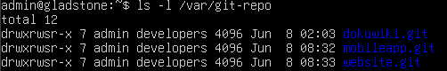
6. Testing:
- Confirmed git clone, add, commit, push and pull functionality from WS01 and LP01
- Verified SSH access using keys
7. Issues Encountered:
- SSH permission issues due to incorrect .ssh directory ownership. Fixed with proper chown and chmod.
- Needed to regenerate and redistribute keys are initial misconfiguration.

Server Installation and Configuration (bundaberg)
1. Purpose:
Acts as the central backup server, responsible for collecting and storing authorised SSH keys from all other servers and client machines, Git repository and web server.
2. Operating System Installed:
Ubuntu Server 24.04 LTS (x64)
3. Network Configuration:
- Internal network: intnet
- IP Address assigned: 192.168.100.6
4. Services Installed:
- openssh-server
5. Key Configuration Steps:
- Enabled SSH service
- Set up SSH key-based authentication and distributed public key to all required machines (WS01, LP01, sydney, adelaide, gladstone)
- Wrote and tested backup script:
- SSH into each machine as appropriate users
- Pull /.ssh/authorized_keys for each user
- Pull web server files
- Pull Git repository files
- Stored in appropriate directory
- Created timestamped directories
- Set up 700 permissions
6. Testing:
- Verified backup script successfully pulled keys and stored them in timestamped folders
- Checked for script errors
7. Issues Encountered:
- Initial permission issues accessing .ssh folders on other machines. Resolved by ssh in as user.
- Script would fail without SSH keys being fully configured per user. Resolved by regenerating keys and testing manually.

Design Justification
The network uses a Class C private IP range of 192.168.100.0/24. This offers 254 usable host addresses. This is an ideal size for a small-to-medium business setup with room for future growth.
- Logical Segmentation by Device Role:
- .1 reserved for the gateway (rocky) for consistent network routing.
- .2 - .6 assigned to core infrastructure servers (DHCP, Web, SSH, Git, Backup), making them easy to identify and consistently address.
- .100 - .149 allocated to workstations, providing a predictable, easily scannable range.
- .150 - .199 allocated to laptops, clearly separating mobile/remote devices from static workstations.
- Futureproofing:
- By leaving .7 - .99 open, there’s room for adding servers, printers, or IoT devices without renumber existing nodes.
- The generous allocation for workstations and laptops (50 each) ensures scalability without IP conflicts or renumbering.
- Simplicity in Administration:
- Grouping devices by IP makes troubleshooting, firewall rule writing, and DHCP reservations easier.
- Admins can quickly recognise device roles based on IP range alone, reducing human error.
- DHCP Optimisation:
- The DHCP server (Darwin) can be configured to dynamically allocate IPs within .100 - .199 while leaving .1 - .99 for static infrastructure, maintaining clarity and avoiding overlap.

Assumptions
- All devices in network will support IPv4 addressing.
- Network cabling (Ethernet) is already installed and tested.
- The office uses a single-floor layout with no significant physical barriers.
- Users will not require remote access during the setup phase.
- Laptops and workstations are configured with compatible network interfaces.
- The number of client devices won’t exceed current IP allocation during Phase 1.
- All hardware and software required are available and functional.

Constraints
- Only one subnet (192.168.100.0/24) is being used for the entire internal network.
- Must complete the project within the allowed timeframe and without team collaboration.
- Internet access is provided via a single router with basic firewall functionality.
- The project must comply with standard operating procedures (SOPs) from the course.
- Budget constraints prevent use of enterprise-grade firewalls of VLANs.
- The deployment must use static IP addressing for key infrastructure devices.

Backup and Recovery Design

Backup Approach
The backup strategy centres around the bundaberg server (192.168.100.6), designated as the central backup node responsible for safeguard essential data across the project infrastructure. The primary focus is on preserving critical authentication credentials, web content, git repositories, and client-specific private keys to ensure system resilience and rapid recovery in case of failure of data loss.
Scope of Backup:
- SSH Authentication Files:
The .ssh/authorized_keys files from all user accounts on the SSH server and client machines are backed up. These files are vital for maintaining secure, password-less SSH access between machines. The complements the functionality of the SSH audit script (ssh-audit.sh), which logs successful and failed login attempts to var/log/auth.log, enhancing security post-incident.
- Git Repositories:
All repositories hosted on the Git server (gladstone) are backed up to prevent any loss of source code or project history.
- Web Server Content:
The complete web content directory from the web server (Adelaide) is included to ensure website availability and integrity.
- Client Private SSH Keys:
Private SSH keys for each user on the client machines are backed up. These keys are necessary to authenticate and maintain secure communication channels.

Backup Mechanism
A dedicated shell script, full-backup.sh, runs on bundaberg, managing the entire backup process. It connects via SSH (using key-based authentication) to each target machine, retrieves the necessary files and directories, and stores them locally in a structure, timestamped archive directory. Each snapshot also includes metadata such as host name and backup time to improve traceability.

File Organisation and Storage
Backups are stored under /home/admin/backups in a directory hierarchy organised by timestamps and host machine. This systematic approach facilitates easy retrieval and auditability of backup snapshots.

Automation
To minimise manual intervention and ensure regular data protection, the full-backup.sh is scheduled to execute automatically every 12 hours via cron. This ensures at least two recent snapshots are always available for recovery purposes.

Recovery Instructions
The recovery process is designed to be straightforward, minimising downtime and complexity during data restoration.
- Determine the Data to Restore:
Clearly identify the specific file(s) or directory requiring restoration, be it a lost private key on a client machine, a corrupted git repository, or a compromised web server file.
- Access the backup server:
Log into bundaberg using SSH:
“ssh admin@192.168.100.6”
- Locate the Relevant Backup Snapshot:
Navigate to the backup directory and list available backups to identify the most recent of appropriate timestamp:
”cd /home/admin/backups
ls -lt
cd YYYY-MM-DD-HHMM/<target-server>/”
- Transfer the Backup to the Target Machine
Use scp to securely copy the required files or directories back to their original location on the target machine. For example:
- Git repository restoration:
“scp -r repo-name admin@192.168.100.3:/var/git-repo/”
- Restoring authorized_keys or private keys:
“scp authorized_keys riley@192.168.100.100:/home/riley/.ssh/”
- Restore Proper Permissions:
After restoring files, set correct ownership and permissions to maintain security best practices. For SSH keys:
“chmod 600 /home/riley/.ssh/authorized_keys
Chown riley:riley /home/riley/.ssh/authorized_keys”
- Verification:
Confirm restoration by testing access to the web server, Git repository, or SSH logins. Logs from ssh-audit.sh may assist in identifying any recurring issues.

The overall network integrity is also preserved by referencing the rocky-firewall-rules.sh script deployed on the router, which enforces iptables rules. These include NAT masquerading, port restrictions, and internal network segmentation, all of which should be verified as part of system recovery testing.

Security Design

Password Policy
A password aging policy has been enforced to ensure that user credentials are rotated regularly, reducing the risk of stale or compromised accounts. Each user account is configured with:
- Maximum password age (MAXDAYS): 90 days. Users much change their password every three months.
- Password warning period (WARNDAYS): 7 days. Users receive a warning one week before expiration.
- Account inactivity lock (INACTIVE): 30 days. Accounts are automatically locked after 30 days after password expiration if the user does not log in.
These settings were applied using the chage command, as shown in the below code, and apply to all users (riley, sarah, admin) across all machines. This policy reinforces the use of SSH keys for secure remote access and limits risk exposure from password-based authentication.

Access Instructions
Access across all systems is secured via SSH key-based authentication. Each user (riley and sarah) generated a key pair on their respective client machine (WS01 and LP01). The public keys were distributed to the following machines through use of ssh-copy-id:
- sydney (SSH server): For remote administration
- gladstone (Git server): For Git repository interactions
Once the public keys were installed, each user could securely SSH into the servers using their own credentials, without the need for shared passwords or elevated privileges. Access to server resources was handled by simply logging in as the correct users, no ACLs or sudo privileges were required beyond the admin user, who retained control over backup and system-level scripts.
The admin account was used to privileged tasks and has password-less sudo rights limited to specific operations when necessary (e.g., managing backups or SSH configurations).

Certificate Management
The adelaide web server was configured with a self-signed SSL certificate generated using OpenSSL. This was implemented to encrypt all traffic between client machines and the hosted DokuWiki site.
- Certificate and key stored in /etc/ssl/certs and /etc/ssl/private respectively.
- HTTPS enforced with redirection from HTTP
- Trusted internally for encrypted LAN communication
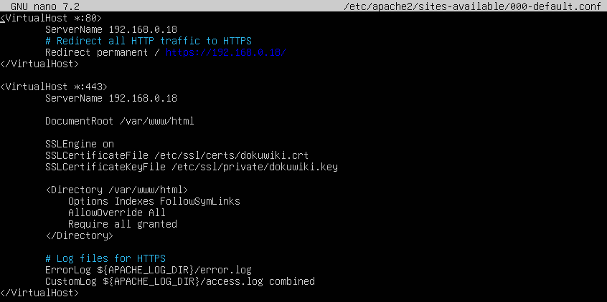
Given the isolated nature of the internal network and the limited user base, a self-signed certificate was a practical and secure solution.

Access External Board of Management
Read-only access is provided via HTTPS to the DokuWiki interface hosted on adelaide. No login is required for public documents, and no shell or backend access is granted to board members. This ensures compliance with the principle of least privilege while still enabling visibility into project documentation.
Password Files
Passwords are securely stored in the /etc/shadow file using SHA512 hashing. This file is readable only by root and has restrictive permissions.
- -rw------- 1 root root for /etc/shadow
- No plaintext passwords stored anywhere
- Password authentication is disabled for SSH connections, as all access is key based
- Login activity and password changes are tracked via system logs (/var/log/secure)

Testing
- Connectivity Tests
- Verified client machines (WS01 & LP01) can ping each server (rocky, darwin, adelaide, sydney, gladstone, bundaberg)
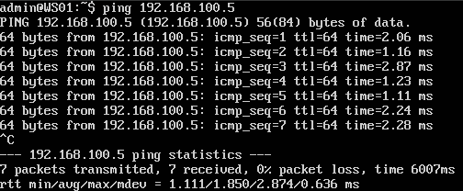
- Used ping and traceroute to test connectivity and route paths
- Confirmed Bridge Adaptor and internal networking are correctly configured on the router
- DHCP Server (darwin)
- Confirmed IP assignment to WS01 and LP01
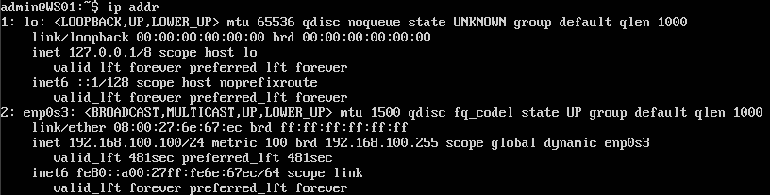
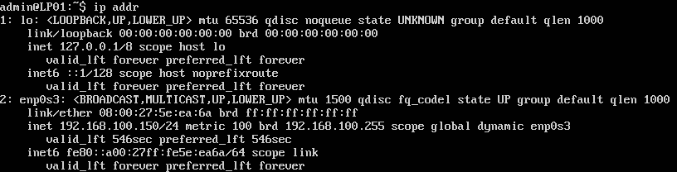
- Manually bound static IPs to MAC addresses to resolve conflicts.
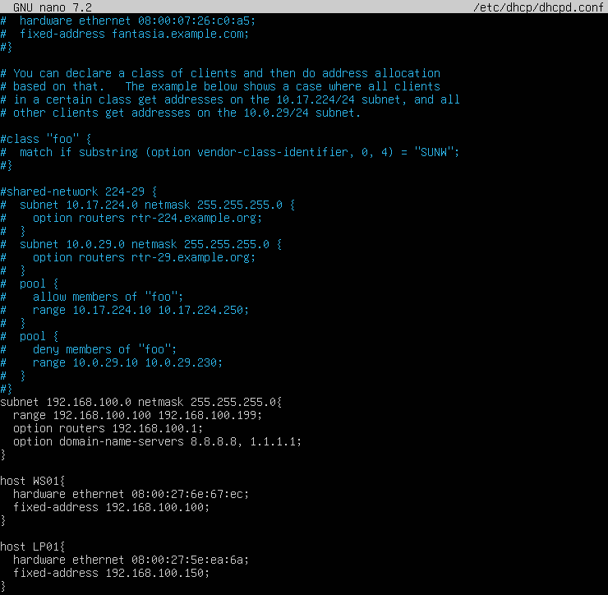
- Web Server (adelaide)
- Apace home page successfully loaded in browser from client machines.
- SSL certificate installed and verified via browser and certificate details.
- DokuWiki loaded over HTTPS and confirmed functional.
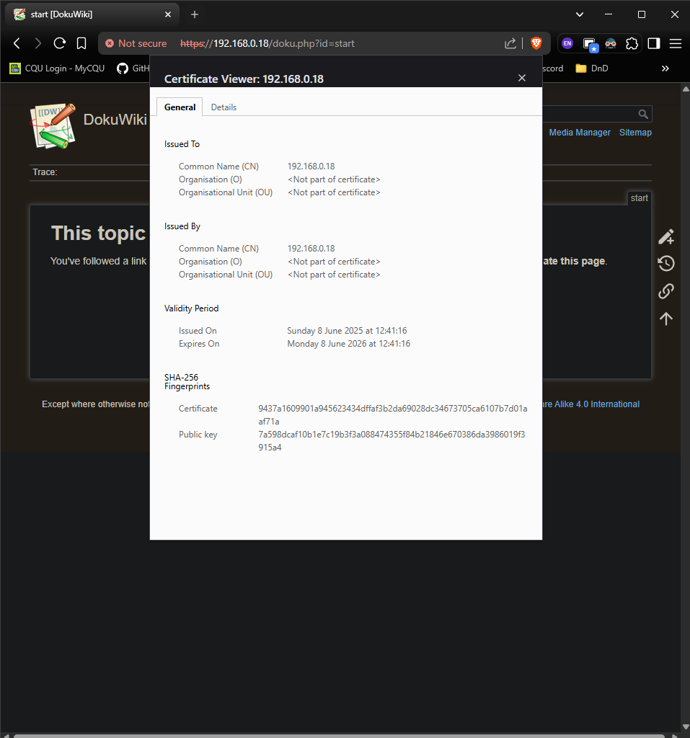
- SSH Server (sydney)
- Successfully connected via SSH from WS01 and LP01 using key-based authentication.
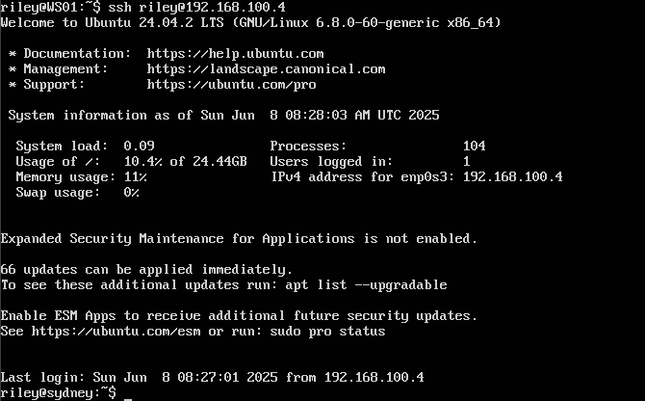
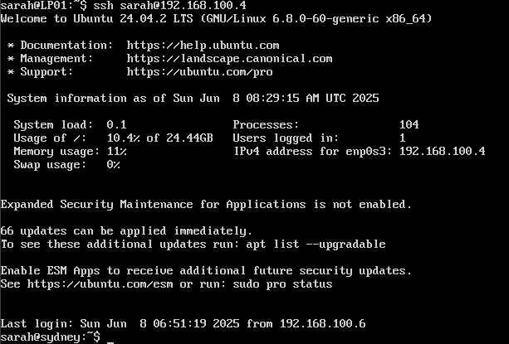
- Tested audit logging via audit.log and script. Verified timestamps and user activity.
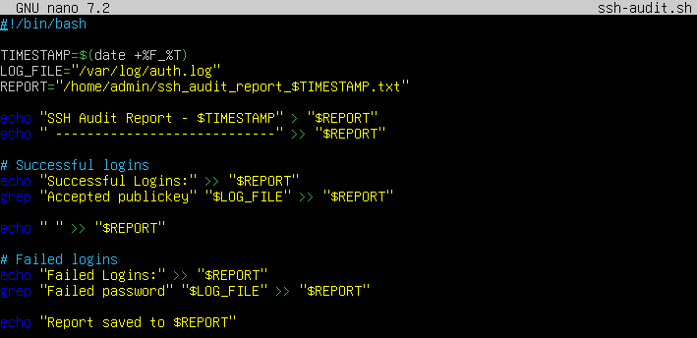
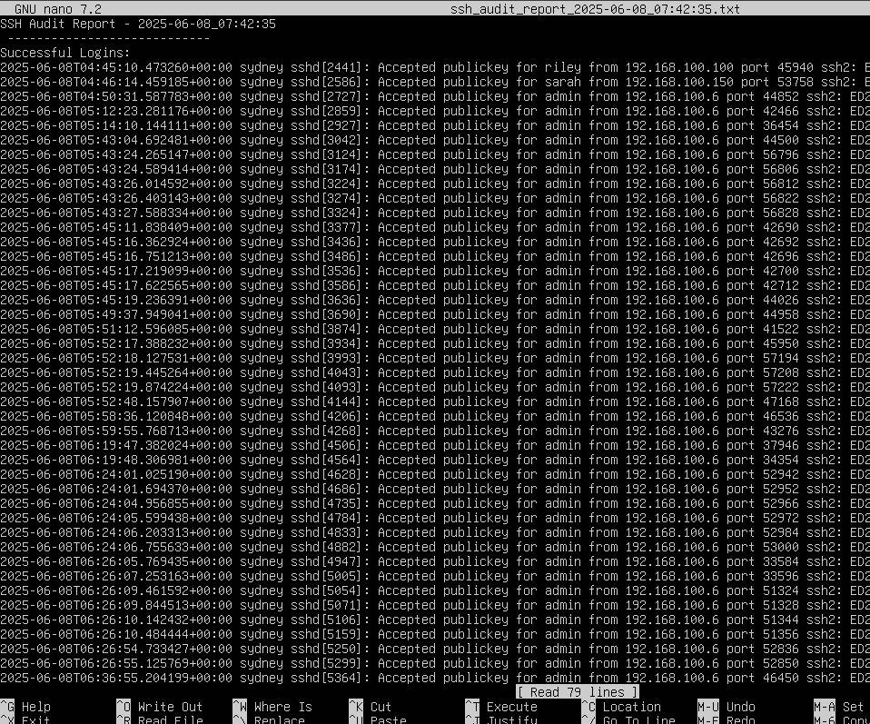
- Git Server (gladstone)
- Added, committed, pushed, and pulled changes to confirm Git functionality.
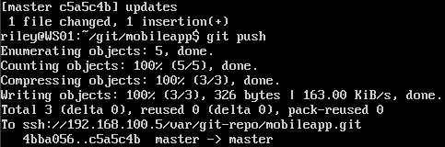
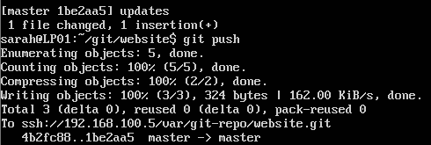
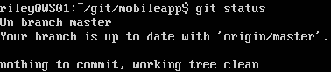
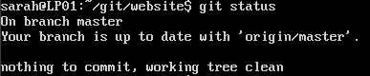
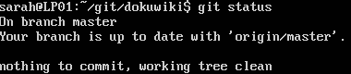
- Backup Server (bundaberg)
- Ran backup script manually as admin, which:
- SSHed into each server and pulled relevant riles.
- Archived and stored the backups locally under timestamped directories.
- Captured: authorized_keys, Web server files, Git repositories, and client private keys.
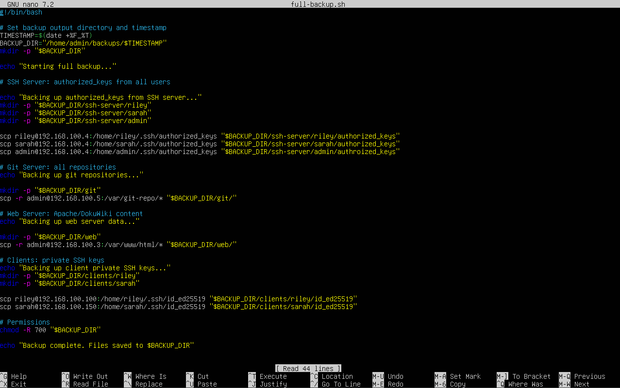
- Verified file structure and contents post-backup
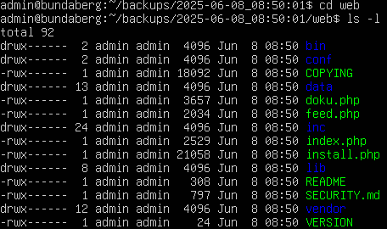
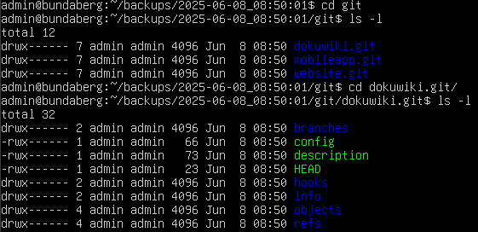
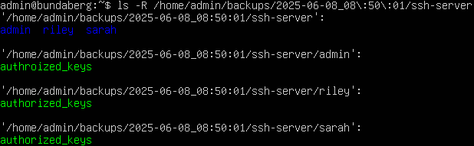
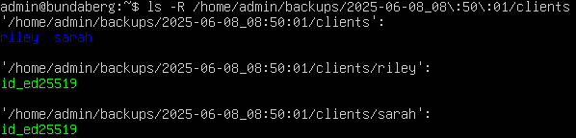
- Confirmed only the admin user can execute the script
- Backup script execution was tested multiple times, successful every run.
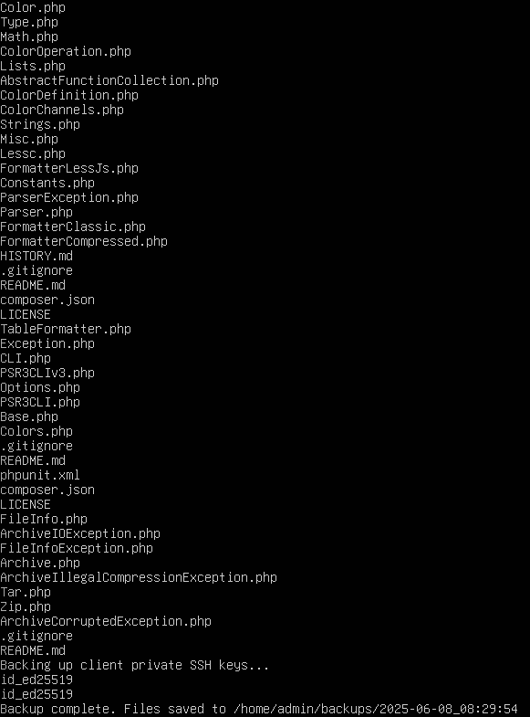
- Security Tests
- Password policy tested by checking chage -l username output.
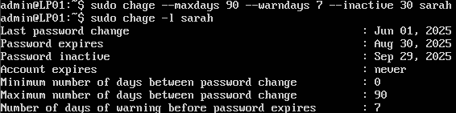
- Verified iptables NAT and SSH filtering rules on rocky.
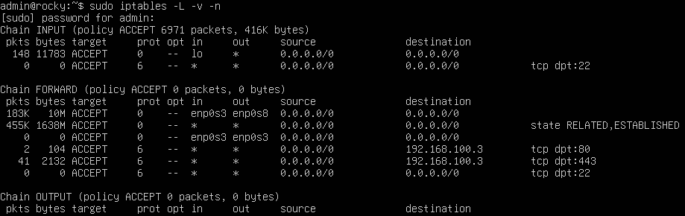
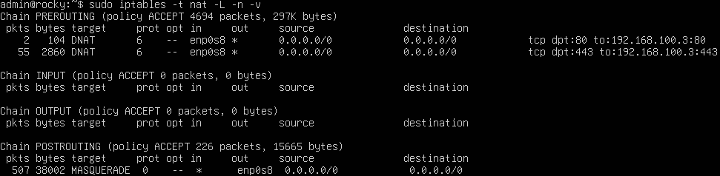
- Certificate presence and validity confirmed in browser.

