CVA LNG Transportation and Storage Standards for the Roanoke Valley Regional Peak Shaving and Storage Facility in Troutville Virginia, 24175.

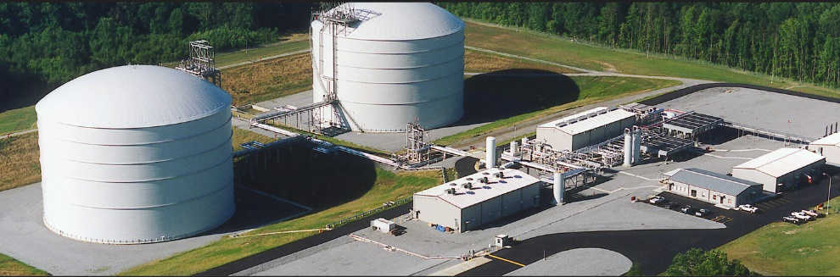  
Roanoke Valley Peak Shaving Storage Facility  
Troutville, Virginia (circa 2021)  
Built by Chicago Bridge and Iron in 2017

Industry Standard Initial Values and Terms:

LNG temp/pressure/volume will be calculated using the ideal gas law (PV=nRT) given a standardized molecular weight of natural gas.

Relationships between any variation will be determine by Charles Law, Gay-Lussacs Law, Boyles Law.

LNG Volume in transit measurements will use Standard Cubic Feet per Minute (SCFM) at standard conditions (0 degrees Celsius and 0 PSIG (Pressure per square in gauge)) to track volume in transit.

Standard Cubic Feet per Minute (SCFM)

Transit Pressure uses Pounds Per Square Inch Gauge (PSIG)

Molecular Weight for CVA LNG supplier Natural Gas 19.00

Individual Team Values:

Individual values will differ based on different temp readings from team equipment, but overall cross-team values should remain consistent in relationship to each other if each team uses the Standard Initial Values and relationship laws.

Values based on actual measurements will reflect the standardized initial values and the relationship laws as defined in this document.

Specific Ranges and Terms for Roanoke Valley CVA LNG Peak Shaving and Storage Facility, Troutville, Virginia 24175:

GEO Coordinates: 37°25'06.2"N 79°52'15.1"W  
Elevation: 1263ft above sea level  
Nominal Barometric Pressure: 97KPa  
Total LNG Storage Capacity: 120,000 gallons  
Approximately .02 Million Standard Cubic Feet per Day (MMSCFD) gas flow @ 15°C

Safe ranges for the listed variables are listed as below unless otherwise noted:  
Temp - Fahrenheit or Celsius  
Volume - Gallons  
Transit Pressures - PSIG or PSIA  
Flow Rates - SCFM

CVA LNG Roanoke Valley Peak Shaving Facility Storage Pressures:   
LNG storage temperature range is -265°F/-160°C at a nominal 55-75°F external temperature on average.  
CVA LNG Peak Shaving Facility storage tank size of 10,000 gallons for each of 4 double-sided cryogenic horizontal storage tanks and 40,000 gallons for each of 2 double-sided vertical storage tanks.

CVA LNG Roanoke Valley Peak Shaving Facility Transit Volume/Flow Rate/Pressure:  
Transit Volume SCFM maximum flow rate is 2000 cubic gallons/min thru the main incoming LNG supply line.  
CVA LNG Roanoke Valley Peak Shaving Facility transit pressure for LNG supply line valving is 15 PSIG

References:

Aisyah, R. (2018, December 18). Typical Process Diagram of Small LNG Regasification. Chemical Engineering Portal. <https://missrifka.com/energy/lng/typical-process-diagram-for-small-lng-regasification-part-1.html>

Ginter, A. (2021, July 21). The Top 20 Cyberattacks on ICS. Waterfall Security. <https://waterfall-security.com/top-20-cyberattacks-ics/>

Hajiw, M. (2015). Hydrate Mitigation in Sour and Acid Gases Image. Chemical and Process Engineering.Ecole Nationale Sup´erieure Des Mines de Paris. <https://www.researchgate.net/publication/278381290_Hydrate_Mitigation_in_Sour_and_Acid_Gases>

Industrial Heat Exchangers. (n.d.). Gas Flow Calculator | Xchanger. Xchanger Calculator. Retrieved March 2, 2022, from <https://xchanger.com/calculators/gas-flow-calculator/>

Libretexts. (2020, July 14). 5.2: The Gas Laws of Boyle, Charles, and Avogadro. Chemistry LibreTexts. <https://chem.libretexts.org/Bookshelves/General_Chemistry/Map%3A_Chemistry_(Zumdahl_and_Decoste)/05%3A_Gases/5.02_The_Gas_Laws_of_Boyle_Charles_and_Avogadro>

Lotte. (2021, October 22). LNG ISO tank: Features, specifications & costs [2022]. Container XChange. <https://www.container-xchange.com/blog/lng-iso-tank/>

LNG storage · Energy KnowledgeBase. (2021). Energyknowledgebase.Com. <https://energyknowledgebase.com/topics/lng-storage.asp>

Muttaqin, V. A. P. B. F. (2010, February 14). What is the difference between PSIG and PSIA? The Chemistry of LNG. <https://lngchemistry.wordpress.com/2010/02/14/what-is-the-difference-between-psig-and-psia/>

pdblowers. (n.d.). SCFM (Standard CFM) vs. ACFM (Actual CFM). Pdblowers.Com. Retrieved March 2, 2022, from <https://www.pdblowers.com/wp-content/uploads/2016/11/scfm_vs_acfm_2.pdf>

The Ideal Gas Law | Physics. (n.d.). Lumen Physics. Retrieved February 9, 2022, from <https://courses.lumenlearning.com/physics/chapter/13-3-the-ideal-gas-law/>

U.S. Energy Information Administration. (2022, February 24). Weekly Natural Gas Storage Report - EIA. Ir.Eia.Gov. Retrieved March 2, 2022, from <https://ir.eia.gov/ngs/ngs.html>

U.S. Energy Information Administration. (2016). Natural Gas Explained - U.S. Energy Information Administration (EIA). Eia.gov. <https://www.eia.gov/energyexplained/natural-gas/>

Wikipedia contributors. (2022, February 21). Standard temperature and pressure. Wikipedia. <https://en.wikipedia.org/wiki/Standard_temperature_and_pressure>

Wikipedia contributors. (2022, March 3). Chicago Bridge & Iron Company. Wikipedia. <https://en.wikipedia.org/wiki/Chicago_Bridge_%26_Iron_Company>