Logisim 4-bit Adder

James Riley Dorough

Liberty University

February 20th, 2021

This paper outlines the construction, functionality, research, and application of the full adder circuitry demonstrated through a full four bit adder with an initial carry. The circuitry designed uses a chained structure to clearly demonstrate modularization.

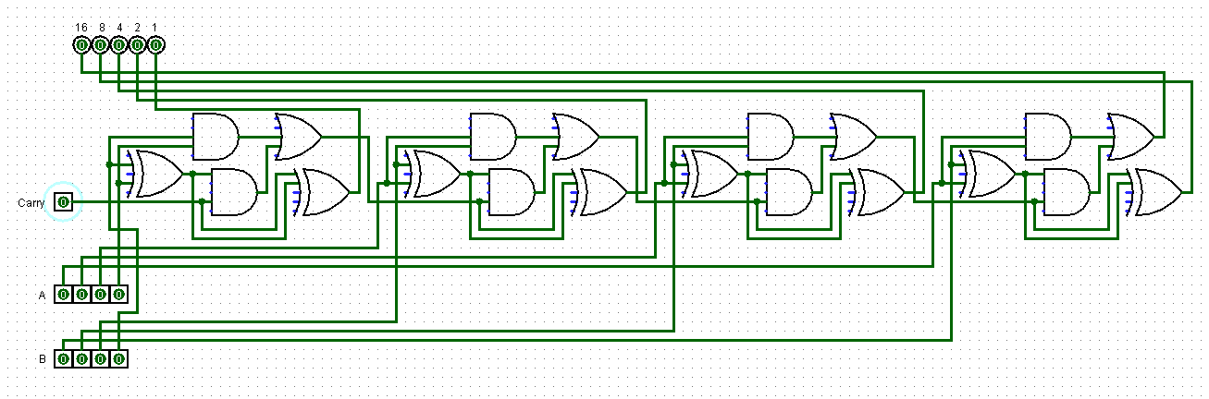

As seen in the first image, the entire four bit adder is completed using four full one bit adders with an initial carry that is passed through the entire circuit. I start testing the circuit by setting all input, including the carry to zero. Next I choose two numbers to add together, convert them to binary, enter the first number into the A input, enter the second number into the B input, and check to see if the output matches the sum of both numbers.

First I enter the number 13 into A’s input and check that the output matches. It does so I move on to B’s input.

Here I add the number four into B’s input and check the output again to see if it changes. It changed and it now contains 17. We see the math functions properly between the A and B inputs. now we need to test the carry’s functionality.

Adding in the carry increases the output by the decimal one. Here we see that in addition to the earlier numbers, now A, B, and the carry are summed for a total of 18. This manual carry input only exists to simulate a continuation of full adders, but also allows for a five bit output with the two four bit inputs. Diagram, schematic
Activating every input allows the circuit to output a total of 31. To reach higher numbers, we simply need to add on another module of full adder and make space for the inputs. The carry easily connects to the next or previous module. This works due to the fact that if two or three input pins are active, the carry output is activated and is accepted as the carry input for the next module. If only one input is active the gates accept the value and pass it to the output, but as nothing is being added to the value of one, there is no value to carry into the consecutive modules.

While being based on such a simple concept as adding two binary numbers together, the adder is an incredibly important component in computational devices. Primarily adders are used in devices which need to accumulate total values, even if the data is not directly numerical to the device user (Margulies, Melman, and Shannzer, 2006). While the four bit full adder designed for this lab was designed in a linear modular fashion, this can pose problems when applied to scale. Circuits require time to process data to do this they need to be optimized, the circuity in this lab almost certainly is not the best option to implement in functional devices, but simply shows that the circuit works albeit quite slowly (Balasubramanian, Padmanabhan, Mastorakis, 2009). Adders can be used effectively to handle more complex operations such as multiplication when incorporated into more complex and versatile chips and circuits (Intel Corporation, 1990). Overall, I believe that I have gained a decent understanding of the purpose of adders. Through my Logisim work I became aware of how the logic gates work to allow specific outputs based on combinations of the previous gates.

**References**

Intel Corporation. (1990). 8086 16-BIT HMOS MICROPROCESSOR. http://datasheets.chipdb.org/Intel/x86/808x/datashts/8086/231455-005.pdf

Margulies, D., Melman, G., & Shanzer, A. (2006). A Molecular Full-Adder and Full-Subtractor, an Additional Step toward a Moleculator. *Journal of the American Chemical Society*, *128*(14), 4865–4867. https://doi.org/10.1021/ja058564w

Balasubramanian, Padmanabhan & Mastorakis, Nikos. (2009). High Speed Gate Level Synchronous Full Adder Designs. *WSEAS Transactions on Circuits and Systems*, *8*. 290-300. https://www.researchgate.net/publication/234773872_High_Speed_Gate_Level_Synchronous_Full_Adder_Designs