**PKI Lab – Dorough**

**Task 1:**

Created initial certificate authority private and public keys

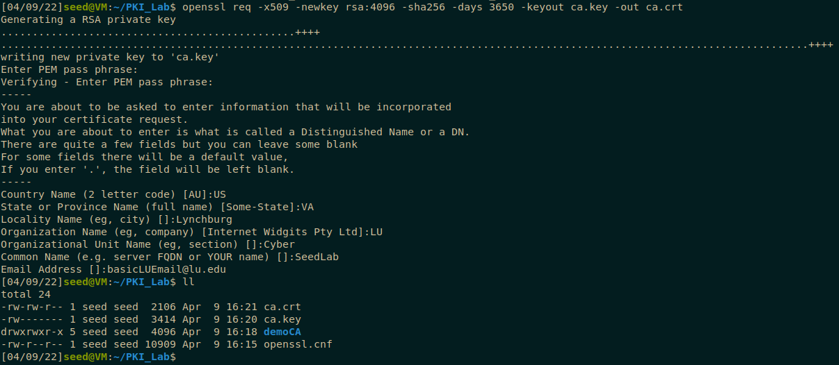

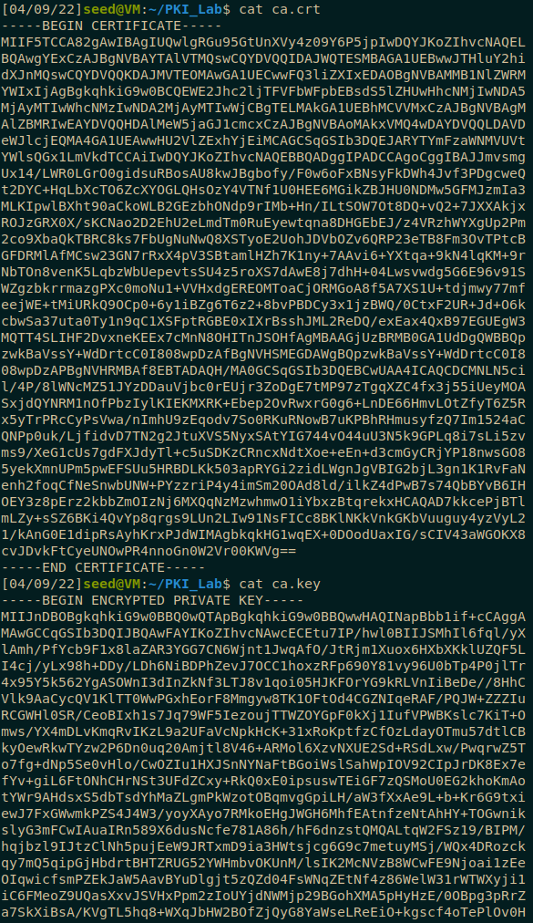

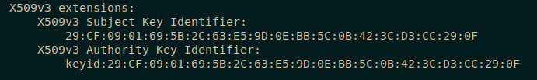

You know the cert authority is also the signer when both the authority and subject have the same hash.

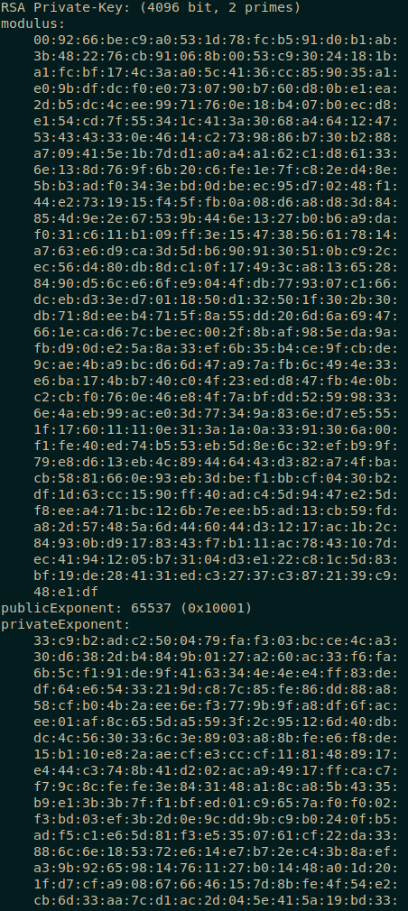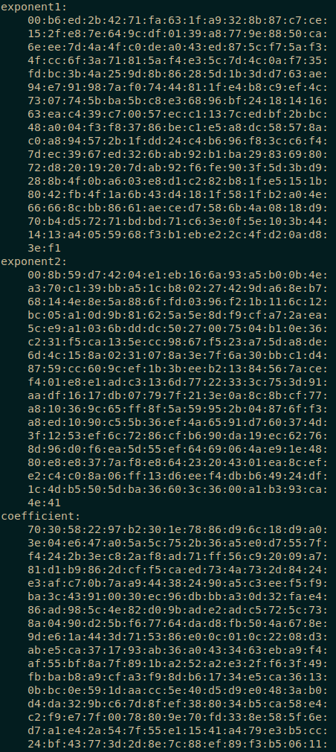

Here are the mod (m), public (e), private (d), p, q, and n values for the excryption

**Task 2:**

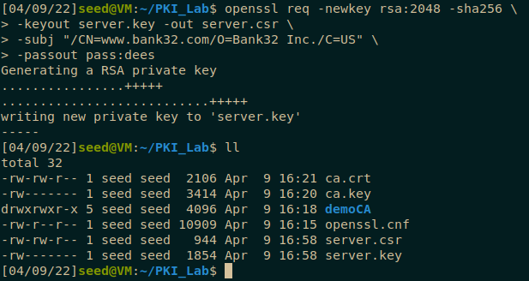

Here are the web server certificates and key.

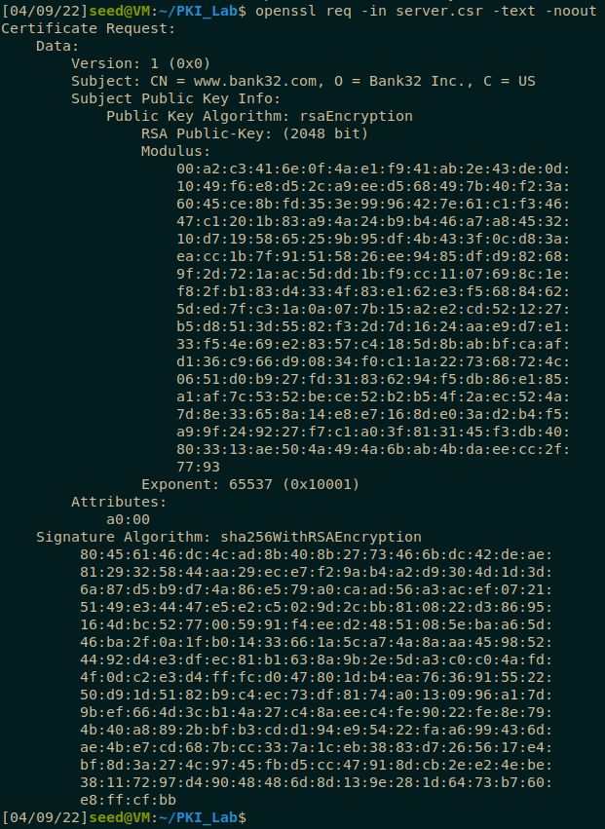

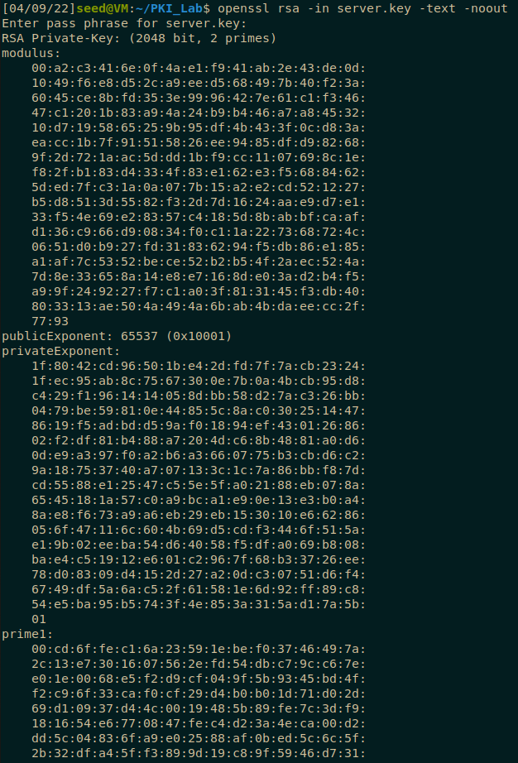

**Task 3:**

Signing the web certificate with the certificate authority’s keys

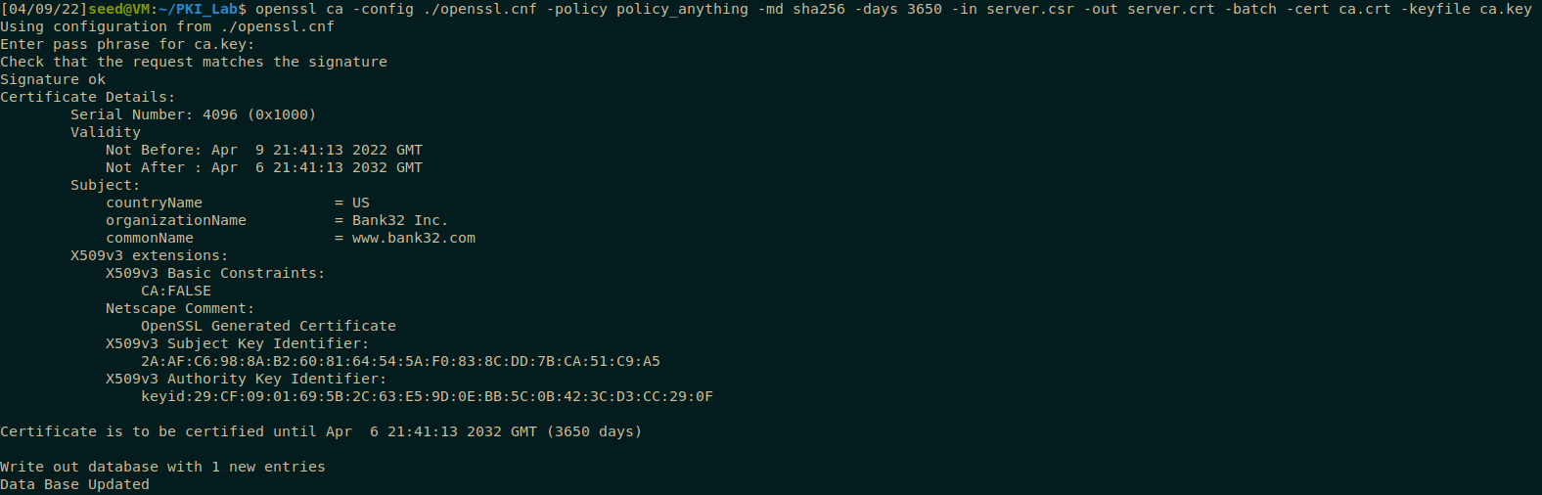

**Task 4:**

Running web side from the Apache2 docker container.

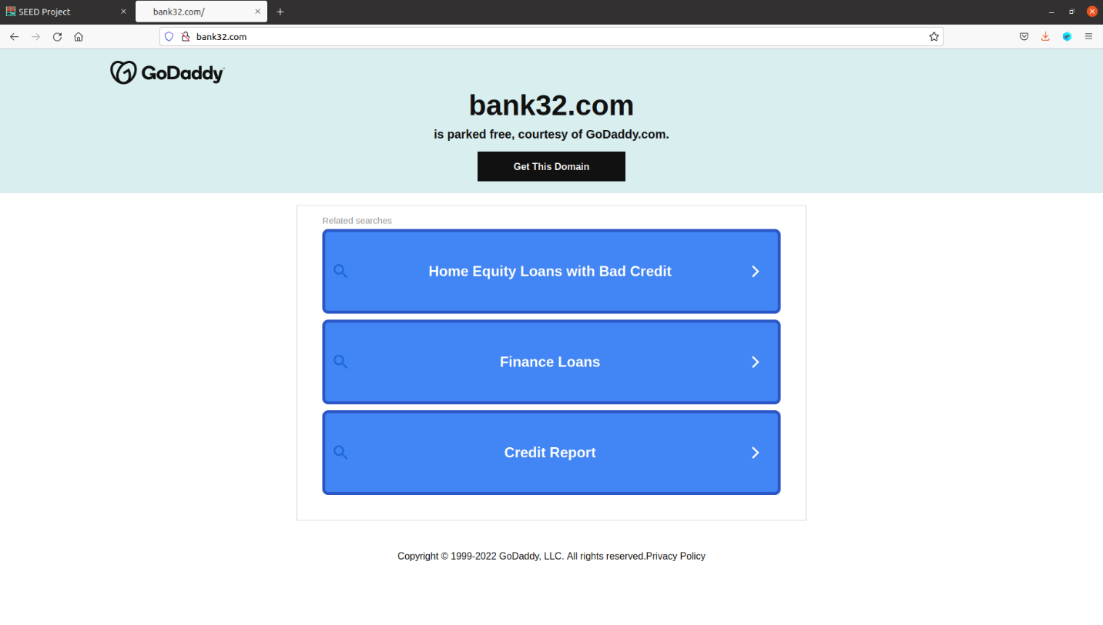

**Task 5:**

Editing the /etc/hosts file to redirect traffic to a different website.

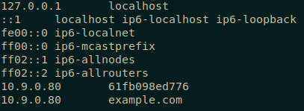

**Task 6:**

The “instructions” for this lab include about 5% of the commands and tools you need to properly complete this lab and absolutely no explanation of any information needed to understand what the lab is, what its purpose is, or what they want you to accomplish. To complete this lab correctly, you would need direct instruction from a person who already understands all the concepts before being expected to design a man in the middle attack from scratch. All additional research done to understand the topics of the lab return completely different commands, tools, and procedures to complete different web certificate lab tasks.