AW Chapter 7 Template

Web pages in new system. Web page structure started for you below. Finish the diagram.

Mockups (create at least 2 mockup screens):
- Technician menu screen:
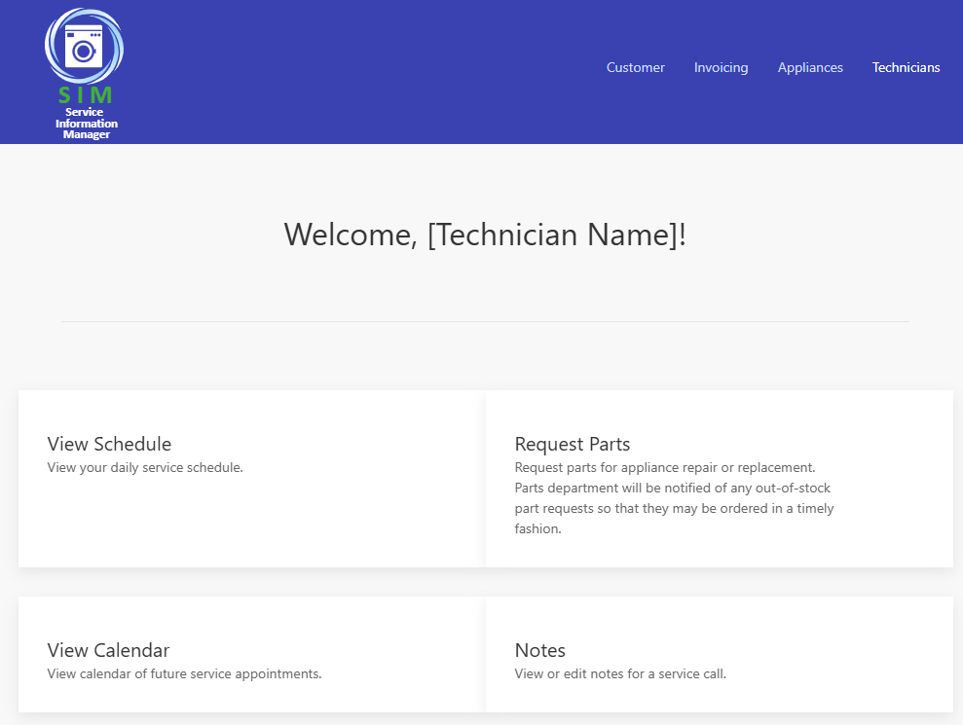

Hovering over menu option:
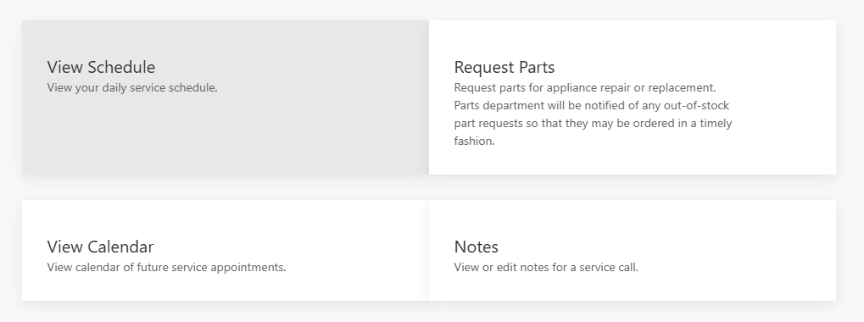

- Request a Service Call screen:

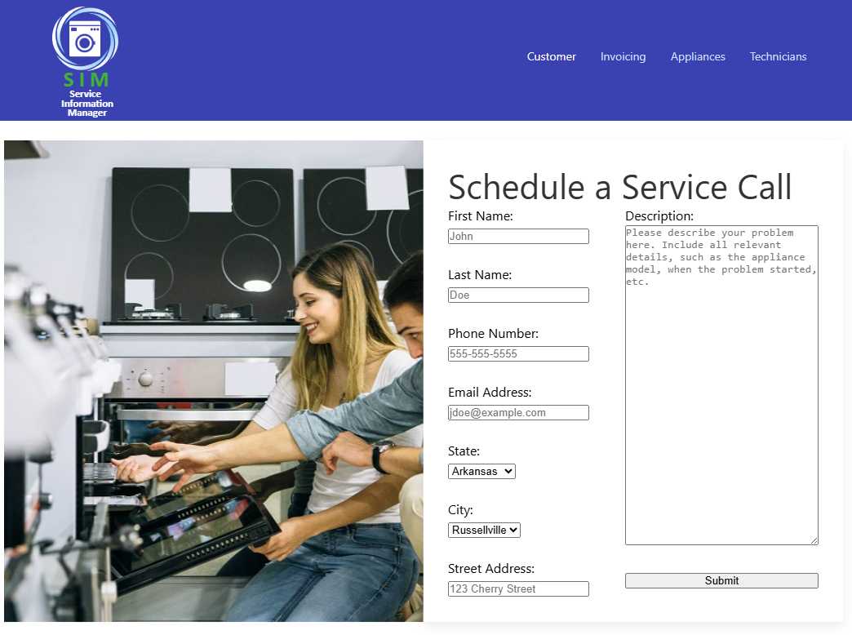
Validation rules:
  - No field may be empty.
  - Phone number must be in the form DDD-DDD-DDDD, where D is any digit 0-9.
  - Email address must be in the form username@domain, where domain must have a top-level domain extension, such as .com.
  - State may only be chosen from a finite list of states where service is available, which is selected from a dropdown list. The user may not define options outside of those provided.
  - Cities may only be chosen from a finite list of cities where service is available, which is selected from a dropdown list. The user may not define options outside of those provided.

- Contact us screen:

- Informational screen:

Note that for these mockups we have chosen to largely reuse UI elements from the main Appliance Warehouse website for a unified and consistent look and feel.

Mobile Platform? Responsive web design?

Prototyping?
Advantages: | Disadvantages:
Report Mockups:
- Mae’s summary report:

- Maddox’s parts detail report:

- Exception report:

