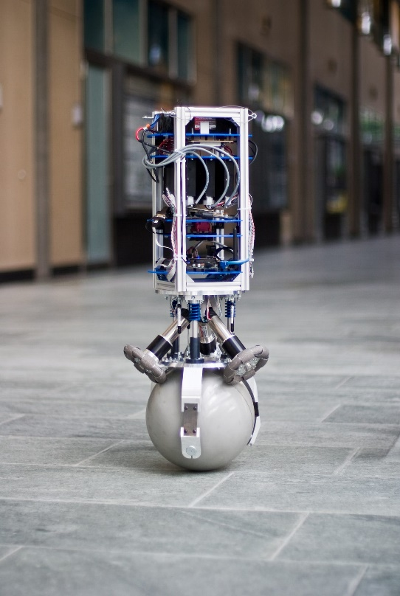

<https://www.google.com/url?sa=i&url=https%3A%2F%2Fmedium.com%2F%40MahanFathi%2Fhow-rezero-made-me-want-to-pursue-a-career-in-robotics-57100fa784a2&psig=AOvVaw3x27xskm3GAIovDJFc3NZ9&ust=1719118445778000&source=images&cd=vfe&opi=89978449&ved=0CBUQjhxqFwoTCJDFpLy17oYDFQAAAAAdAAAAABAD>

<https://idsc.ethz.ch/research-dandrea/research-projects/archive/cubli.html>  
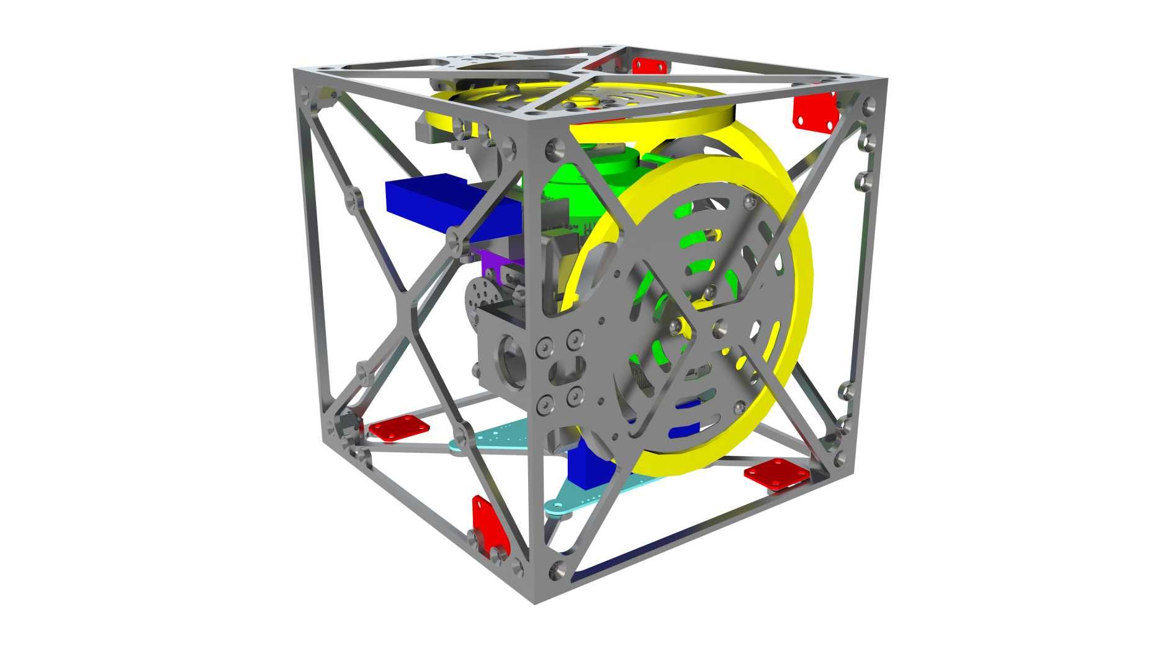

<https://www.youtube.com/watch?v=n_6p-1J551Y>

https://store.tmotor.com/product/mn3508-motor-navigator-type.html

This motor might be better for the full thing ^

As of now though it is too expensive while I am still experimenting