

Title of Dissertation
Author’s Name

June 8, 2007

MSc in High Performance Computing
The University of Edinburgh
Year of Presentation: 2007

Abstract
This is the bit where you summarise what is in your dissertation.
Contents
Chapter 1 Introduction 1
Chapter 2 Background Theory 2
2.1 The easy bits 2
2.2 The more difficult bits 2
2.2.1 Hard bits 3
2.2.2 Even harder bits 3
Chapter 3 Experimental design 5
Chapter 4 Results and Analysis 6
4.1 Some results 6
4.1.1 More results 6
Chapter 5 Conclusions 8
Appendix A Stuff which is too detailed 9
Appendix B Stuff which no-one will read 10
References 11
List of Tables
Table 1: This is a simple table. More complicated tables can have headings which pass over more than one column. 5
List of Figures
Figure 1: The University Crest 4
Figure 2: Simple Gnuplot example 6

Acknowledgements
This template is based on David Henty’s LaTeX template, which in turn was based on a LaTeX template created by Prof. Charles Duncan for MSc students in the Dept. of Meteorology. His acknowledgement follows:
This template has been produced with help from many former students who have shown different ways of doing things. Please make suggestions for further improvements.

Introduction
This should contain a description of your project and the problem you are trying to solve. Where appropriate you should also include references to work which has already been done on your topic and anything else which lets you set your work in context.
One of the things you will need to do is to ensure that you have a suitable list of references. Details of the preferred citation style can be found in the MSc Handbook [1]. Here is another reference [2] for good measure. Note that, unlike LaTeX, Word does not automatically order your references in the order that they appear in the text. You should therefore do this manually. When you wish to insert a cross reference to a reference, you should choose Insert > Reference > Cross-reference and select the item you wish to reference.
You will also want to make sure you have no spelling or grammatical mistakes. To help idwentify spelling mistukes you caan use Word’s spell check. See the built-in help for more details. Remember that spelling mistakes are not the only errors which can occur. Spelling checkers will not find errors which are, in fact, valid words such as there for their, nor will they find repeated words which sometimes occur if your concentration is broken when typing. There is no substitute for thorough proof reading!

Background Theory

The easy bits
This is just to show how to break things into sections.
Some paragraphs in this demonstration document are here to provide some padding so that sections last for more than one page to illustrate what happens on subsequent pages. Note that the page numbering style is usually different on the first page of a new chapter than on subsequent pages.
Here is a padding paragraph. Rhubarb. More rhubarb. Yet more rhubarb. Rhubarb. More rhubarb. Yet more rhubarb. Rhubarb. More rhubarb. Yet more rhubarb. Rhubarb. More rhubarb. Yet more rhubarb. Rhubarb. More rhubarb. Yet more rhubarb. Rhubarb. More rhubarb. Yet more rhubarb. Rhubarb. More rhubarb. Yet more rhubarb. Rhubarb. More rhubarb. Yet more rhubarb. Rhubarb. More rhubarb. Yet more rhubarb. Rhubarb. More rhubarb. Yet more rhubarb. Rhubarb. More rhubarb. Yet more rhubarb. Rhubarb. More rhubarb. Yet more rhubarb. Rhubarb. More rhubarb. Yet more rhubarb. Rhubarb. More rhubarb. Yet more rhubarb. Rhubarb. More rhubarb. Yet more rhubarb. Rhubarb. More rhubarb. Yet more rhubarb. Rhubarb. More rhubarb. Yet more rhubarb. Rhubarb. More rhubarb. Yet more rhubarb. Rhubarb. More rhubarb. Yet more rhubarb. Rhubarb. More rhubarb. Yet more rhubarb.

The more difficult bits
Some bits are hard.
Here is a padding paragraph. Rhubarb. More rhubarb. Yet more rhubarb. Rhubarb. More rhubarb. Yet more rhubarb. Rhubarb. More rhubarb. Yet more rhubarb. Rhubarb. More rhubarb. Yet more rhubarb. Rhubarb. More rhubarb. Yet more rhubarb. Rhubarb. More rhubarb. Yet more rhubarb. Rhubarb. More rhubarb. Yet more rhubarb. Rhubarb. More rhubarb. Yet more rhubarb. Rhubarb. More rhubarb. Yet more rhubarb. Rhubarb. More rhubarb. Yet more rhubarb. Rhubarb. More rhubarb. Yet more rhubarb. Rhubarb. More rhubarb. Yet more rhubarb. Rhubarb. More rhubarb. Yet more rhubarb. Rhubarb. More rhubarb. Yet more rhubarb. Rhubarb. More rhubarb. Yet more rhubarb. Rhubarb. More rhubarb. Yet more rhubarb. Rhubarb. More rhubarb. Yet more rhubarb. Rhubarb. More rhubarb. Yet more rhubarb. Rhubarb. More rhubarb. Yet more rhubarb. Rhubarb. More rhubarb. Yet more rhubarb.

Hard bits
You might want to include an equation here:
- δN_{ν}=(δN_{ν})_{ex}+(δNν)_{au}
Note that when you format an equation using the Equation style (as illustrated above), the equation is automatically numbered, and can be referred to using a cross-reference.
Here is a padding paragraph. Rhubarb. More rhubarb. Yet more rhubarb. Rhubarb. More rhubarb. Yet more rhubarb. Rhubarb. More rhubarb. Yet more rhubarb. Rhubarb. More rhubarb. Yet more rhubarb. Rhubarb. More rhubarb. Yet more rhubarb. Rhubarb. More rhubarb. Yet more rhubarb. Rhubarb. More rhubarb. Yet more rhubarb. Rhubarb. More rhubarb. Yet more rhubarb. Rhubarb. More rhubarb. Yet more rhubarb. Rhubarb. More rhubarb. Yet more rhubarb. Rhubarb. More rhubarb. Yet more rhubarb. Rhubarb. More rhubarb. Yet more rhubarb. Rhubarb. More rhubarb. Yet more rhubarb. Rhubarb. More rhubarb. Yet more rhubarb. Rhubarb. More rhubarb. Yet more rhubarb. Rhubarb. More rhubarb. Yet more rhubarb. Rhubarb. More rhubarb. Yet more rhubarb. Rhubarb. More rhubarb. Yet more rhubarb. Rhubarb. More rhubarb. Yet more rhubarb. Rhubarb. More rhubarb. Yet more rhubarb.
Here is a padding paragraph. Rhubarb. More rhubarb. Yet more rhubarb. Rhubarb. More rhubarb. Yet more rhubarb. Rhubarb. More rhubarb. Yet more rhubarb. Rhubarb. More rhubarb. Yet more rhubarb. Rhubarb. More rhubarb. Yet more rhubarb. Rhubarb. More rhubarb. Yet more rhubarb. Rhubarb. More rhubarb. Yet more rhubarb. Rhubarb. More rhubarb. Yet more rhubarb. Rhubarb. More rhubarb. Yet more rhubarb. Rhubarb. More rhubarb. Yet more rhubarb. Rhubarb. More rhubarb. Yet more rhubarb. Rhubarb. More rhubarb. Yet more rhubarb. Rhubarb. More rhubarb. Yet more rhubarb. Rhubarb. More rhubarb. Yet more rhubarb. Rhubarb. More rhubarb. Yet more rhubarb. Rhubarb. More rhubarb. Yet more rhubarb. Rhubarb. More rhubarb. Yet more rhubarb. Rhubarb. More rhubarb. Yet more rhubarb. Rhubarb. More rhubarb. Yet more rhubarb. Rhubarb. More rhubarb. Yet more rhubarb.

Even harder bits
This might be one of the places where you might want to refer to equation (1). When the numbering of equations changes (for example, if you insert an additional equation between two existing equations), the cross-references will not automatically update. You can either update the relevant cross-reference by right clicking and choosing Update Field or you can update all fields in a document by doing a Select All (Ctrl+A), and then pressing F9.

Numbering
You can keep subdividing but eventually you will get to a level where the numbering stops. This text is in outline level 4 which is not numbered by default.

Experimental design
You might sometimes want to include equations without numbering them.
E = mc²
You might also want to include diagrams. To insert a figure, choose Insert > Picture > From File… A caption will be created automatically, and will include a figure number. You should centre the figure, and ensure that the Caption style is applied to the caption.

Figure 1: The University Crest
You can use a label on a figure to refer to it later. The university crest is in Figure 1. Note that you should not use phrases like “the figure above” or “the following figure” since later formatting changes can affect the relative position of the image with respect to the text.

Results and Analysis

Some results
Here are some results.

More results
When showing results you are likely to use tables and graphs. You can create tables easily in Word. To insert a caption for a table such as the one in Table 1, place your cursor in the table, and then choose Insert > Reference > Caption. From the Label menu in the dialog box that appears, choose Table.

File names | Satellite | Resolution
worldr | Meteosat | 5km
worldg | Meteosat | 5km
worldb | Meteosat | 5km
Table 1: This is a simple table. More complicated tables can have headings which pass over more than one column.
From many MS Windows programs you can simply cut and paste images into your document. You can select a caption in a similar way to the caption in the table above (but choose Figure instead of Table).
One way to produce simple graphs is to use gnuplot which can produce output in various formats. You can output in png format and use Insert > Picture > From File… as described above. Figure 2 was produced using gnuplot. For more details, see gnuplot’s internal help system (try, help display and help output).
Another approach is to draw simple ﬁgures using xﬁg which allows you to export your results in many formats including jpeg and png.
Word can also import graphics in eps format.
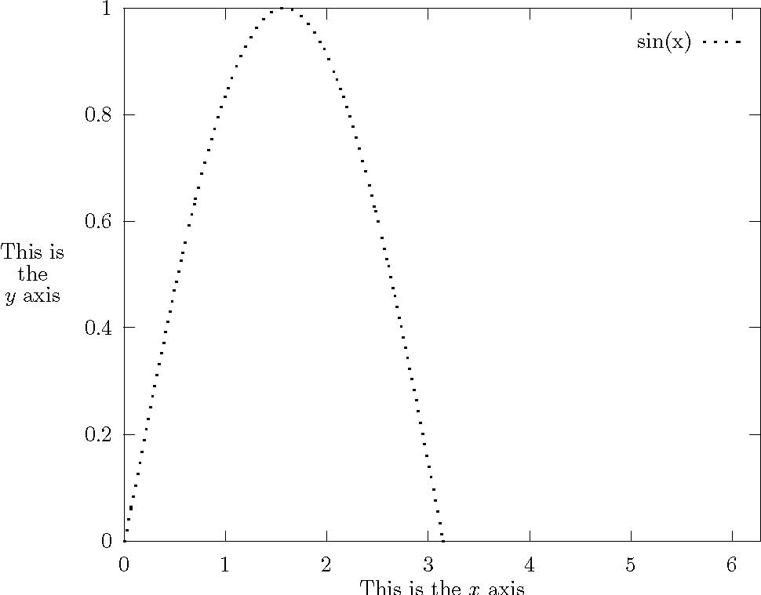
Figure 2: Simple Gnuplot example

Conclusions
This is the place to put your conclusions about your work. You can split it into different subsections if appropriate. You may want to include a subsection of future work which could be carried out to continue your research.

- Stuff which is too detailed
Appendices should contain all the material which is considered too detailed to be included in the main body but which is, nevertheless, important enough to be included in the thesis.
- Stuff which no-one will read
Some people include in their thesis a lot of detail, particularly computer code, which no-one will ever read. You should be careful that anything like this you include should contain some element of uniqueness which justifies its inclusion.
References
- MSc Handbook. Online at http://www.epcc.ed.ac.uk/msc/handbook/ (referenced 06/12/2006).
- F.Bloggs. 1993 Latex Users do it in Environments Int. Journal of Silly Findings. pp 23-29.

