Software mentions in the scientific literature: Problems with visibility, findability, and accessibility.

**James Howison and Julia Bullard**

University of Texas at Austin

Author note

James Howison, University of Texas at Austin, School of Information, 1616 Guadalupe Street, Austin, Texas, 78701. Phone: 512-232-9219. Email: jhowison@ischool.utexas.edu

Julia Bullard, University of Texas at Austin, School of Information, 1616 Guadalupe Street, Austin, Texas, 78701. Phone: 512-574-0479. Email: julia.a.bullard@gmail.com

Correspondence concerning this article should be addressed to James Howison.

# Abstract

Software is increasingly crucial to scholarship, yet the visibility and usefulness of software in the scientific record is in question. Just as with data, the visibility of software in publications is related to incentives to share software in re-usable ways, and so promote efficient science. In this paper we examine the visibility of software through content analysis of a random sample of 90 biology articles, stratified by journal impact factor. We develop a coding scheme to identify software “mentions,” and classify them according to their characteristics and ability to realize the functions of citations. Overall we find diverse and problematic practices: among our findings are that only between 31 and 43%of mentions involve formal citations. While between 72 and 80% of mentions attempt to credit authors, only between 22 and 35% provide any version information, between 15 and 29%of the software mentioned is inaccessible in any form, and only between 14 and 27% is available as source code form with permission to modify. Between 10 and 20% of software packages could not be found at all and only for 2 to 10% of software packagers could the specific version be found. We provide recommendations to improve the practice of software citation, highlighting recent nascent efforts towards improvement. Software plays an increasingly great role in scientific practice; it deserves a clear and useful place in scholarly communication.

Software mentions in the scientific literature: Software is inconsistently visible, findable, and accessible.

# Introduction

Software is increasingly crucial to scholarship; it is a key component of our knowledge infrastructure (Edwards et al., 2013). Software underlies many scientific workflows and incorporates key scientific methods; increasingly software is also key to work in humanities and the arts, indeed to work with data of all kinds (Borgman, Wallis, & Mayernik, 2012). Yet the visibility of software in the scientific record is in question, leading to concerns, expressed in a series of NSF and NIH funded workshops, about the extent that scientists can understand and build upon existing scholarship (e.g., Katz et al., 2014; Stewart, Almes, & Wheeler, 2010). In particular, the questionable visibility of software in the key instantiation of science scholarship—the scientific paper—is linked to concerns that the software underlying science is of questionable quality. These quality concerns are not just technical but extend to the appropriateness of software for wide sharing, and its ability to facilitate the community coalescence and co-development that would make efficient use of limited scholarly funding (Howison & Herbsleb, 2013; Katz et al., 2014).

The link from visibility in publications to these aspects of quality is two-fold: first, when software is not visible it is often excluded from peer-review; second, its lack of visibility, or the particular form of visibility, means that appropriate incentives to produce high quality, widely shared, and co-developed software may be lacking. A well-functioning system for the visibility of software in scientific papers would assist not only the goals of understanding and transparency, but also the goals of aiding replication (Stodden et al., 2010) including going beyond repetition to the extension of existing scientific results, complementing the availability of publications themselves to such that “the second researcher will receive all the benefits of the first researcher’s hard work” (King, 1995, p. 445).

The situation with software is broadly analogous (but not identical) to that of data in publications, an area of recent focus in scholarly communications and the study of scientific practice. Indeed the questions of the visibility of data in publications and as a “first class” research contribution are closely linked to questions of software in scientific practice and scholarly communication, since almost all data is processed by software in some form (Borgman et al., 2012). Nonetheless, as we will discuss below, there are relevant differences. Accordingly our inquiry into the visibility of software in scholarly communication is complementary (and perhaps necessary) to recent interest in data citation. In sum, then, the relationship of software to the scholarly publication ought to be of key concern to those interested in scholarly communication, data in scholarship, and, indeed, the overall functioning of scholarship, knowledge infrastructures, and innovation.

In this paper we examine how software is currently visible in the scientific literature. Citations to a formal bibliography are an important form of visibility, yet formal citations are not the only form of visibility: software is also visible in less formal ways, including footnoted URLs to webpages maintained by software projects, parenthetical notes akin to those used for purchased scientific consumables and discussed in the text in passing. Thus, in this paper, we write of software “mentions,” intentionally choosing a word with casual and wide-ranging connotations, including the full spectrum of formal to informal visibility. As discussed below, we were interested in cases where it was apparent that software was used but not mentioned at all, such as statistical analyses; indeed some software authors claim this to be a very common problem as reported in Howison and Herbsleb (2011) but, for this study, focused only on explicit mentions.

We ask how software is currently mentioned and the extent to which these mentions contribute to achieving the normative ideals of scientific practice. Specifically, we undertake a content analysis of a random sample of 90 journal articles from Biology, stratified by journal impact factor to weight more important publication venues. We develop a reliable content analytic scheme to identify mentions of software in the literature. We develop an additional content analysis scheme to understand how well these mentions achieve desirable functions, such as identification of an artifact, providing credit to its creators, and assisting others to build on the scholarship. We use this scheme to examine each identified software mention for its ability to realize these functions. Overall, we aim to provide a systematic basis for the pressing task of designing improved systems of visibility for software in the scientific literature.

**Literature Review**

Much of the foundational literature on scholarly citation is concerned with unpacking the practice of citing, particularly the relationship indicated between scholarly publications (Cano, 1989; Lipetz, 1965; Moravcsik & Murugesan, 1975). Studies in the meaning of citation have attempted to clarify the possible relationships between citing and citing works, providing typologies of credit-giving (Moravcsik & Murugesan, 1975), associating the location of the citation with the type of credit given (Cano, 1989) and identifying the relevant element of the cited work (Lipetz, 1965). Recently, the typologies developed in this line of research have been applied to automatic classification in scholarly work, with an aim to build citation maps to facilitate the identification of relevant works (Pham & Hoffmann, 2003) and to augment impact factor calculations (Teufel & Tidhar, 2006).

In general, the scholarship on traditional forms of citation is a “practice literature” that examines the nuances of an established practice to inform how we ought to interpret these acts and thus improve our understandings of how science works or our information retrieval systems for science. For example, studies that clarify the types of credit indicated by citations are valuable for facilitating discovery of relevant related works (Pham & Hoffmann, 2003). These findings can also be leveraged towards more nuanced interpretations of citation counts and impact factor (Teufel & Tidhar, 2006). This literature has extended our understanding of the ways in which citations can embody “credit,” placing this function at the center of citation practice.

More recently, though, changes in publication technology have returned the discussion of citation from credit and meaning, to other basic functions such as identification and assistance in finding cited objects. Achieving these functions, long since addressed in standardized citation formats for print publications, require new methods for digital works. A familiar example of this trend is the citation of online works and the phenomenon of “link rot” (Klein et al., 2014; Koehler, 1999).To the extent that the location of online works is not fixed, citations cannot reliably facilitate access to cited works (Lawrence, 2001; Sellitto, 2005) undermining the verifiability and replicability integral to the scientific method (Goh & Ng, 2007). As publication technology changed, the literature shifted back from studying the meaning of citations to addressing questions of design: how ought scholars reference other scholarly works?

This paper thus continues the traditions of citation scholarship, seeking to contribute to both a literature of practice (“How do scientists mention software?”) and a literature of design, in assessment (“How well do the current practices do their job”, and “How do current practices influence other areas of scientific conduct, including collaboration”?) leading to proposals for improvement (“How ought scientists mention software?”). Finally, since achieving improvement requires knowing not only a desired endpoint but understanding how to achieve change, we seek to raise, even if we cannot yet answer them, questions of change (“How best can the practices relevant to software visibility be altered?” and “How might proposed citation practices influence other areas of scientific conduct”?).

**Data Citation**

Design questions are at the heart of the literature on data citation, especially concerns of how citations can provide identification of, location of, and access to, cited works. The discussion of how data citation can support data sharing as well as the verification and replicability of studies using large datasets dates back at least to the 1970s (Mooney & Newton, 2012). Recently, the discussion has gained more urgency given the possibilities of data sharing online, the present “data deluge” of available datasets (Borgman et al., 2012), the possibilities of the linked data movement (Mayernik, 2012), and the adoption of data sharing policies by many granting agencies and journals (Borgman et al., 2012, p. 1060). Borgman et al. (2012) notes that while all scholarly disciplines need to address these issues, the most prominent problems and solutions are found in the sciences and social sciences.

The practices of data citation and data sharing are intertwined; data sharing is motivated by the credit-giving apparatus of data citation, but data citation practices can only develop in a scholarly culture of data sharing (Mooney & Newton, 2012). The “practice literature” of data citation has examined how this dilemma is playing out in contemporary publications, finding that data citation is still an “emergent practice”, neither pervasive nor consistently applied (Simons, Visser, & Searle, 2013). Findings such as these have lead scholars to call for cultural change in scholarly communication (Mayernik, 2012) and institutional mandates for data sharing (Simons et al., 2013).

A second body of studies around data citation explores the possibility that, even if the need for citation of shared data were clear, the mechanisms to do so are not yet available. Studies of the technical apparatus of data citation seek to identify the necessary criteria of adequate citation, such as specificity regarding the version and granularity of what is being cited (Borgman et al., 2012; Simons et al., 2013). In particular, scholars are concerned that data citation include the elements necessary to provide adequate identification and access to the dataset, emphasizing verification and replication as central to science (Altman & King, 2007; Konkiel, 2013).

From these discussions of the necessary criteria for functional data citations, a “design literature” emerges. Unlike studies of traditional citation, which largely sought to interpret established practices in scholarly communication, the design literature of data citation seeks to identify the criteria necessary to data citations, assesses to what extent these are used in contemporary practice, and proposes design improvements. Criteria include specificity regarding versions and granularity (Borgman et al., 2012; Simons et al., 2013) and findability supported by stable locators (Konkiel, 2013). Empirical studies of data citation in contemporary scholarship find that data citations tend to be minimal and incomplete when present at all (Mooney & Newton, 2012).

Suggestions to improve current practice include both cultural and technological changes. For example, technical proposals such as digital object identifiers (DOIs) for datasets (Simons et al., 2013) as well as new citation standards (Altman & King, 2007; CODATA-ICSTI Task Group on Data Citation Standards and Practices, 2013) will allow those authors who practice data citation to do so in a way that supports the findability of datasets. Design improvements in the cultural arena include integrating data citation counts into altmetrics to add incentive to data sharing practices (Konkiel, 2013).

**Software Citation**

Software citation likely has many of the same challenges as data citation, and requires both a practice and a design literature of its own. Software use and reuse is important for contemporary scientific methods and scholarly communication, and the verifying, replicating, and building upon these studies requires adequate and consistently adopted modes of software citation. The practice literature of software citation enumerates a number of challenges for meeting the criteria for credit and location. The barriers to software citation include all of those identified for data citation—such as difficulty with versioning and lack of citation standards—along with complications specific to this form. For example, Howison and Herbsleb (2013) report that the constant incremental improvements typical to software development are incongruent with structures of recognition and credit in academia. As with the chicken and egg dilemma in data citation identified by Mooney and Newton (2012), software citation suffers from a mismatch between the incentives for software development and sharing and science outcomes (Howison & Herbsleb, 2011). To the extent that software development is often proprietary rather than open, distribution models often run counter to the ideals of the “Republic of Science,” endangering the verification and replication functions of citation (Gambardella & Hall, 2006; Ince, Hatton, & Graham-Cumming, 2012).

Some design improvements have been proposed. As with data citation, proposed solutions are both cultural and technological in nature; an example of a cultural change is the push towards adoption of permissive, open licenses for scientific software (Gambardella & Hall, 2006; Ince et al., 2012), while technological solutions include infrastructure for code sharing and metrics for software contributions (e.g., Goble, Roure, & Bechhofer, 2013; Katz, 2014; Stodden, Hurlin, & Perignon, 2012). We will return to suggestions for improvement in our discussion.

One mode of assessing both current practice and proposed solutions is to compare them against the criteria for citation identified in the above bodies of literature. Such a set of criteria can also be used to inform new design improvements and assess the state of current practice. Extending the criteria for data citation to software citation is appropriate since the practices share technological challenges and the relative novelty in scholarly communication. The practices are also intertwined: a full reference to data reuse requires mention of the software transformations applied to the set (Borgman et al., 2012, p. 1073). From these similarities and the foundational criteria from traditional citations, we include credit, identification (including versioning) and access (the ability to obtain the software). The requirement for identification, in the case of scientific software, also involves the configuration settings applied to the program—answering the question of which elements of the program were used.

Software also introduces some novel requirements for citations in order to support verification, replication, and building on others’ work. Verification and replication, in the case of scientific software, requires not only the ability to locate the referenced material, but also access and permission to run the program. In particular, even special purpose descriptions of algorithms in papers have been found to be insufficient to replicate analyses; direct access to source code is vastly preferred (Ince et al., 2012; Stodden et al., 2010). Further, to build on others’ work requires not just access to the source code but permission to extend the work, particularly to modify the program or combine it with other code in particular ways (as is specifically granted by licenses approved by the Open Source Initiative). We develop these characteristics into a specific coding scheme below.

# Method

We identified a balanced and representative sample of the biology literature and undertook classic content analysis based on our development of two reliable content analytic schemes.

Choosing a sample of the literature to study is a complex question, particularly when seeking to study a previous unstudied phenomenon. The overall aim of our work is to inform a process of policymaking, a “design” literature in our language above, to improve the treatment of software in science. We chose to confine our analysis to a single domain, trading off broad scientific coverage against achieving a larger sample size. Biology is a key and leading domain for the importance of software in science, given the importance of computerized data analysis and the rise of bioinformatics. Some of the most well cited papers of any kind in any science are biology software related (Science Watch, 2003). Since we are interested in contemporary practices, we further confined our sample frame to articles published between 2000 and 2010 (the last complete year when we took the sample). We are seeking to understand the diversity of software mentions in the literature, hoping eventually to influence practice towards better practices. Overall we think it likely that scientists are influenced by what they read and the perceived status of what they read. Scientific attention is concentrated towards certain journals, albeit different journals in different fields (and subfields); overall the hierarchy of scientific journals forms a non-normal, exponential-like distribution, such as in Bradford’s law (Bradford, 1934; Brookes, 1985). Such distributions are difficult to sample from: there is no “typical” item in such a distribution. It would be problematic to only study widely read (“top”) journals, but equally problematic to study only less well-read journals. In the end we sought to study a sample balanced for overall coverage and likely influence.

We identified a set of 18 biology-related subject headings in biology using the 2010 ISI Web of Science..We took all of the 1,455 journals included in these headings and sorted them by their journal impact factor. Previous research has found differences in practices between higher and lower impact factors (e.g., Stodden, Guo, & Ma, 2013) and journal impact factor seemed an appropriate proxy for overall influence or breadth of readership. While there are many criticisms of journal impact factor, particularly for assessing influence of specific articles or authors, the journal unit of analysis is well suited for our study since the policies of journals seem likely to affect the form of articles. Thus, in order to weight the sample towards more widely read journals we divided our journal list into three groups: the first group of journals included those ranked 1 through 10 (10 journals), the second had those ranked 11-110 (100 journals), and the third had the rest those ranked 111-1455 (1,345 journals). We combined the journals with the years (2000-2010) and weeks (1-51) to yield a sampling frame that covered each of the journals across the whole time period (2000-01 through 2010-52). We then randomly selected 90 journal-year-week tuples for each strata. We worked through this list taking the first 30 issues listed that appeared to be from journals that publish original research, as opposed to review journals.

We then manually retrieved the issue from the journal website that was current in the year and week number. When an issue was dated during or after the chosen week, we chose the issue that came out prior to that week. We found two journals in the sample (one in the 10-100 stata and one in the 101-1455 strata) that we did not have library access to and discarded these, taking the next journal-year-week tuple. We also found 12 tuples that were prior to the first published volume of the journal (e.g., we sought a 2001 article from a journal that began publishing in 2006), in those cases we discarded that tuple and used the next from the list of 90, rather than taking the first issue of the journal on the basis that first issues might be systematically different.

We assessed the content of the chosen issue, identifying research articles (as opposed to letters, editorials, perspectives, review/survey articles, and other publications, such as “plant registrations”). In two cases where our chosen issue did not have any research articles we went to the issue immediately following. From the research articles in the selected issue, we used a random number generator to choose one. We continued this process until we had 30 research articles from each strata for a total dataset of 90 biology research articles, as shown in Table 1.

Table : Summary of sample and sample frame

|  |  |  |  |
| --- | --- | --- | --- |
|  | Strata 1 | Strata 2 | Strata 3 |
| Journals in Sample Frame | 10 | 100 | 1,345 |
| Articles in Sample | 30 | 30 | 30 |
| Journals in Sample | 5 | 23 | 30 |

We obtained PDFs of the articles and of any supplemental materials (these were often “methods and materials” online supplements with their own text and references lists). We initially attempted to convert the PDFs into text for ease of coding in content analysis tools, but abandoned this due to difficulties in conversion; we worked with the PDF articles directly. During coding we found one article that was not a biology article (it was a pure mathematics article) and we replaced it with an article derived from the next tuple in the original random selection for that strata. Appendix 1 includes a full list of categories in our sample frame and journals in our sample; Table 2 shows a distribution of articles from well-known journals in the top strata by impact factor (we did not intend to only choose articles from 5 of the top 10, that was simply a result of the method of randomization).

Table : Numbers of articles included from Strata 1 journals

|  |  |
| --- | --- |
| **Journal Name** | **Article Count** |
| Science | 7 |
| Nature | 5 |
| Cell | 7 |
| Nature Biotechnology | 5 |
| Nature Genetics | 5 |

Our random selection of articles enables us to use our sample to make estimates about software mentions in the overall biology literature, because undertaking random sampling means it is reasonable to believe that sampling errors resulting from our specific sample are normally distributed. Accordingly we are able to present 95% confidence intervals, for the population around the characteristics of the sample we report, providing upper and lower bounds for the results we report in the population of biology articles. We conducted the statistics with the R functions prop.test and chisq.test (based on Hope, 1968; Newcombe, 1998). Full analysis scripts available at <anonymized>.

In the analysis below we present results both in aggregate and broken out by journal impact factor strata. We break the results out by strata to help the reader assess the success of our effort to achieve a balanced sample, rather than to compare statistically across strata. In many cases our statistical analysis show no statistically significant differences between strata, but we do not rely on those results for our conclusions. Indeed the contribution of this paper is towards informing policy-making and prompting the emergence of a design literature for software mentions in scientific articles; in that context it is unclear that any specific size of difference (effect size) between strata would matter and without that it is hard to estimate the statistical power needed for reliable between strata comparisons.

## Coding scheme development

Our coding scheme development proceeded in three rounds: identifying software mentions, coding their characteristics, and coding their functions. In each case we developed our coding scheme by iterating between reading the text of the articles and the existing literature described above.

### Identifying software mentions

In round one we analyzed the full text of the articles to identify mentions of software within an article. We were exhaustive in seeking locations of possible mentions, including not only the main text of the article, but also table and figure captions, reference list, and supplemental materials. We considered coding for situations where it was apparent that software was used but not mentioned at all, such as when a paper presents statistics or figures but with no mention of the software almost definitely used to create them. Unfortunately, while this would be very interesting we concluded that this would be too speculative and difficult to achieve reliability in coding; accordingly we confined our coding to identifying explicit mentions of software.

We tested reliability of our ability to recognize software mentions by having two coders independently code sub-sets of articles and comparing their coding. Reporting agreement is complicated in this case because the coding units are not predefined, rather the coders are picking them out from the text of the articles; these are thematic coding units that may be whole paragraphs, sentences, or phrases. Coders are thus only identifying units they think mention software, not identifying those they think are not and software mentions are sparse in the dataset. In this sense using agreement statistics on, say, a sentence level, would substantially inflate agreement due to the many sentences coded as not mentioning software. Given the sparseness of the thematic units it is also not necessary to adjust for the very unlikely case of chance agreement, and therefore we report straight percentage agreement (and not, say, Cohen’s kappa), calculated using the “irr” package for the R statistics program (Gamer, Lemon, Singh, & Fellows, 2012). We tested the reliability in this way twice: once at the beginning of coding, and once when we trained a new coder.

The first test included 12 articles in the sub-sample. Both coders agreed that there were no software mentions in 7 of the 12 articles. In the remaining 5 articles coders achieved percentage agreement of 68.2%. We identified the reasons for disagreement in discussion and resolved them with coding rules (e.g., sentences with two citations for one software package should be coded as two mentions). The most complex source of disagreement revolved around whether a sentence referred to a piece of software or the abstract scientific model; we discussed rubric to determine the difference, including brief online searching.

The second test occurred when we trained a third coder, using a new sub-sample of 8 articles. There was agreement by both coders that 6 articles contained no software mentions. Agreement in the two remaining articles was 83.3%, with a single instance where one coder failed to identify a mention; on inspection we ascribed this to coder fatigue and not conceptual disagreement. The high agreement in this second round of training provides confidence that the issues discussed in the first round were adequately resolved.

### Software mention characteristics

Our second coding scheme identified characteristics of software mentions. These codes are shown in Table 3. We tested the reliability of this scheme by applying them to the mentions coded in the 12 article sub-sample discussed above; this set included 32 mentions drawn from the 5 articles that mentioned software. Since this coding involved applying codes to a pre-agreed set of mentions we report inter-coder reliability using Cohen kappa. Specifically we use “Byrt’s kappa” because it adjusts for unbalanced prevalence (i.e., when one value, negative or positive, is rarely used) (Byrt, Bishop, & Carlin, 1993).

Table : Coding scheme for mentions of software

|  |  |  |
| --- | --- | --- |
| Code | Definition | Agreement (kappa) |
| software name | The name of the software package | k = 1 |
| url | A web address for the software or project | k = 1 |
| version number | A version number (or source code label) identifying a specific version of the software | k = 1 |
| date | A date used to indicate a version of the software (not date of paper or reference) | k = 1 |
| configuration details | Any mention of configuration of the software. | k = 0.75 |
| software used | For mentions of software that was used in the research | k = 0.875 |
| software not used | For mentions of software that the authors didn't use (e.g., they discuss why they didn't use particular software, or the method realized in the software) | k = 1 |
| creator | A mention of the creator of the software (could be applied to in text mention or reference) | k = 1 |

Since many mentions come as in-text citations with references in the bibliography, we linked the in-text citation and the reference in the dataset. We then applied codes to each element separately. For references we used the additional codes shown in Table 4, but for comparison in reporting purposes we treat a citation+reference pair as a single mention which has all of the codes applied to either element. For example, if one mention included a creator name in-text, while another included the creator name in the reference, this distinction is retained in the dataset but in the analysis reported in this paper both would be reported as a single mention that included a creator name.

We standardized the software names by clustering the raw names using Jaro-Winkler distance, as implemented by the R stringdist package (van der Loo, 2014), and manually inspecting the clusters (e.g., standardizing “Image J” and “ImageJ” and components of a single package, such as BLAST, BLASTP, BLASTN etc.)

Table : Additional codes for references in software mentions

|  |  |
| --- | --- |
| software publication | Formal publication primarily describing software |
| domain publication | Formal publication primarily describing mainline domain science |
| users guide/manual | Project documentation, typically online but not published in a journal/conference proceeding or similar |
| project name | Reference with just project name |
| project page | Reference to URL of project |

### Functions of software mentions

In the third round we coded to assess the extent to which the mention performed the functions of citation identified above (e.g., location, credit-giving). We were generous in seeking relevant information across the full paper when assessing the functions of citations. That is, we combined all the information supplied across all mentions of a piece of software in the article in order to find the software. Once we had sufficient identifying information we went outside the article text and used web searching to attempt to locate the software and assess the possibility of access (for reproducibility), access type (free or for purchase), source code availability (for transparency) and ability to modify the code (for building on the work of others).

Table : Codes for functions

|  |  |
| --- | --- |
| Code | Explanation |
| identifiable | Can we identify which software has been mentioned (e.g., Is there a name used at all, beyond “a program we wrote”? Can we find references to that software, even if we cannot find the software itself.) |
| findable | Given an identifiable piece of software, can we find an online source that details the software (not necessarily the software itself, but any official presence) (e.g., A project page or online manual) |
| findable version | Can we find the specific version listed in the paper, if there was one. |
| access | Can we access the software now? Can take three values: No Access, Purchase Access, Free Access. |
| source available | Can we access the source code in any way? |
| permission to modify | Do the creators give permission to modify the program (if no mention of modification, assume no); if permission only by contact, then no |
| matches preferred citation | If the project page lists a preferred citation, does the mention match it? |

### Examples of software mentions with codes

From the article:

Muthuthantri, S., Maelzer, D., Zalucki, M. P., & Clarke, A. R. (2010). The seasonal phenology of Bactrocera tryoni (Froggatt) (Diptera: Tephritidae) in Queensland. *Australian Journal of Entomology*, *49*, 221–233. doi:10.1111/j.1440-6055.2010.00759.x

we identified this sentence:

*The DYMEX model we used was as described and parameterised by Yonow et al. (2004).*

Which we coded as follows:

This mention was coded as an in-text mention to software used by the authors, with a reference. The software name was “DYMEX”; there were no configuration details (in the focal text) and no version number, date, or URL given. The reference was coded as a domain publication that cited a creator (the authors of the reference). We found this software to be identifiable and a web search showed it to be findable. The software is accessible in that it is available for purchase. The source code is not available and there is no permission to modify the code. The project does not make a request for a specific citation.

From the article:

Abrescia, N. G. a, Cockburn, J. J. B., Grimes, J. M., Sutton, G. C., Diprose, J. M., Butcher, S. J., … Bamford, J. K. H. (2004). Insights into assembly from structural analysis of bacteriophage PRD1. *Nature*, *432*(7013), 68–74.

We identified this mention:

*Data were analysed with DENZO [41] and the resolution limit was determined with TRIM_DENZO (D.I.S., unpublished program).*

Which was coded as follows:

This sentence was coded as two software mentions, one for “DENZO” (with a reference), and one for “TRIM_DENZO”. Both were coded as software used by the authors, neither included version numbers, configuration details, dates or URLs. Both were coded as providing creator information (For TRIM_DENZO, the initials D.I.S. match the author’s initials, the reference provides creator information for DENZO). DENZO was found to be identifiable and findable, but there was no access to the software (which also implies no source code or permission to modify). TRIM_DENZO was coded as identifiable but unfindable (implying no source access or permission to modify).

From the article:

Colman-Lerner, A., Chin, T. E., & Brent, R. (2001). Yeast Cbk1 and Mob2 activate daughter-specific genetic programs to induce asymmetric cell fates. *Cell*, *107*(6), 739–50. Retrieved from http://www.ncbi.nlm.nih.gov/pubmed/11747810

We identified this sentence as mentioning software:

*We captured and analyzed images using a SPOT2e CCD camera (Diagnostic Instruments, Inc., Sterling Heights, MI) coupled to MetaMorph imaging software (Universal Imaging Corporation, Downingtown, PA).*

Which was coded as follows:

This was coded as a software mention of software used by the authors. The software name was “MetaMorph.” There were no configuration details and no url, version_number or date but the mention included a creator (“Universal Imaging Corporation, Downingtown, PA”). Second round coding showed the software to be identifiable and findable. Access was possible through purchase, but the source was unavailable and modifications were prohibited.

# Results

## Overview

From the 90 articles total, we identified 59 articles that mentioned software and 31 that did not (65% of articles mention software overall). Articles in higher impact factor strata were more likely to mention software (77% in strata 1, 63% in strata 2 and only 57% in strata 3). In total we found 286 distinct mentions in the 59 articles that mentioned software. The distribution of mentions across articles is shown in Figure 1, showing that most articles that mentioned software had relatively few mentions. The two articles with the highest number of software mentions have over 20 mentions. We retained these within our dataset.

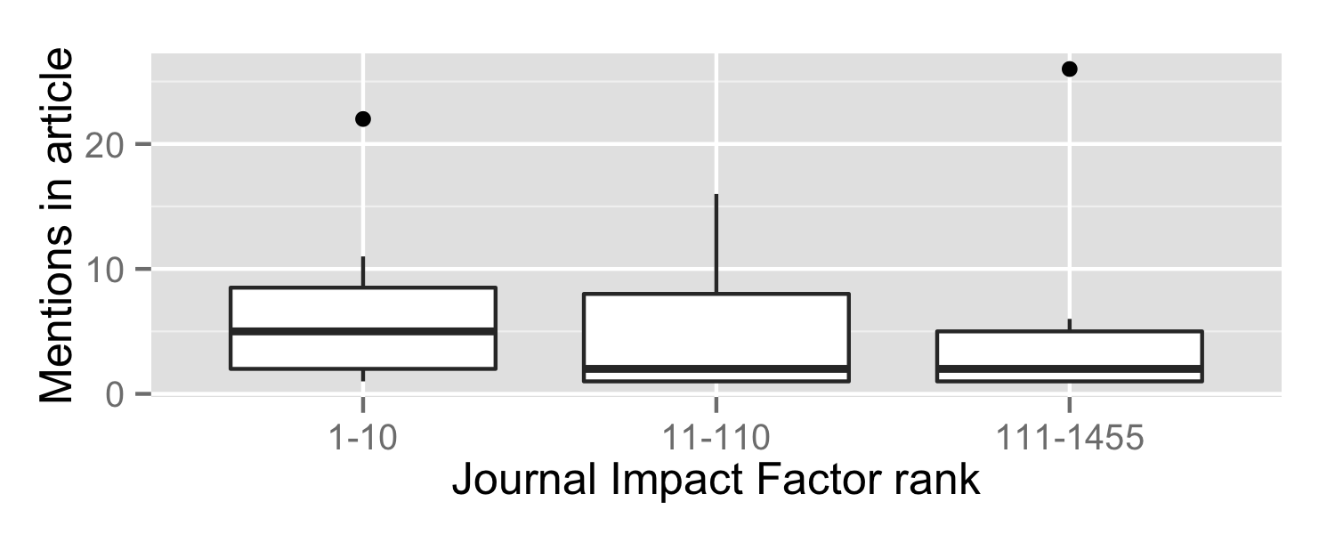

Figure : Counts of mentions in articles, broken down by Impact Factor strata

### Classification of Mentions

We classified references according to the scheme described above. In our sample, the mentions range in form quite widely. Only 44% of software mentions involve an entry in a references list, with only 37% being a citation to a formal publication (Another 7% are informal entries in a reference list, including either the name or website of the project). Of the 56% of mentions that don’t include references, 31% mention only the name of the project. Another 18% mention software in a manner similar to scientific instruments or materials, typically mentioning the name in text followed by the author or company and a location in parentheses. Finally some 5% of mentions provide a URL in the text or in a footnote and 1% mention using some software but provide no additional details. Our categorizations, with examples are shown in Table 6. We provide 90% confidence intervals for the likely proportion of these types of mentions in the population of biology articles. These estimates treat each mention as independent, not adjusting for the reality that ways of mentioning software may be influenced by authors and journals (i.e., within articles). This is not ideal but since authors are not necessarily consistent (even within articles) and, more importantly, readers read widely across journals and articles by different authors, readers are going to encounter many varying ways of mentioning software, even if there is some consistency within specific journals or authors.

Table : Types of software mentions in publications

|  |  |  |  |
| --- | --- | --- | --- |
| **Mention Type** | **Count (n=286)** | **Proportion (95% CI)** | **Example** |
| Cite to Publication | 105 | 0.37 ­ (0.31–0.43) | *… was calculated using biosys (Swofford & Selander 1981).* |
| Cite to Users manual | 6 | 0.02  (0.01—0.50) | *… as analyzed by the BIAevaluation software (Biacore, 1997).*  Reference List has: Biacore, I. (1997). BIAevaluation Software Handbook, version 3.0 (Uppsala, Sweden: Biacore, Inc) |
| Cite to Project Name or Website | 15 | 0.05  (0.03–0.09) | … *using the program Autodecay version 4.0.29 PPC (Eriksson 1998).*  Reference List has: *ERIKSSON, T. 1998. Autodecay, vers. 4.0.29 Stockholm: Department of Botany.* |
| In-text name mention only | 90 | 0.31  (0.26–0.37) | … *were analyzed using MapQTL (4.0) software.* |
| Instrument-like | 53 | 0.19  (0.14–0.24) | … *calculated by t-test using the Prism 3.0 software (GraphPad Software, San Diego, CA, USA).* |
| URL in text | 13 | 0.05  (0.03–0.08) | *… freely available from http://www.cibiv.at/software/pda/ .* |
| Not even name mentioned | 4 | 0.01  (0.00–0.04) | *… was carried out using software implemented in the Java programming language.* |

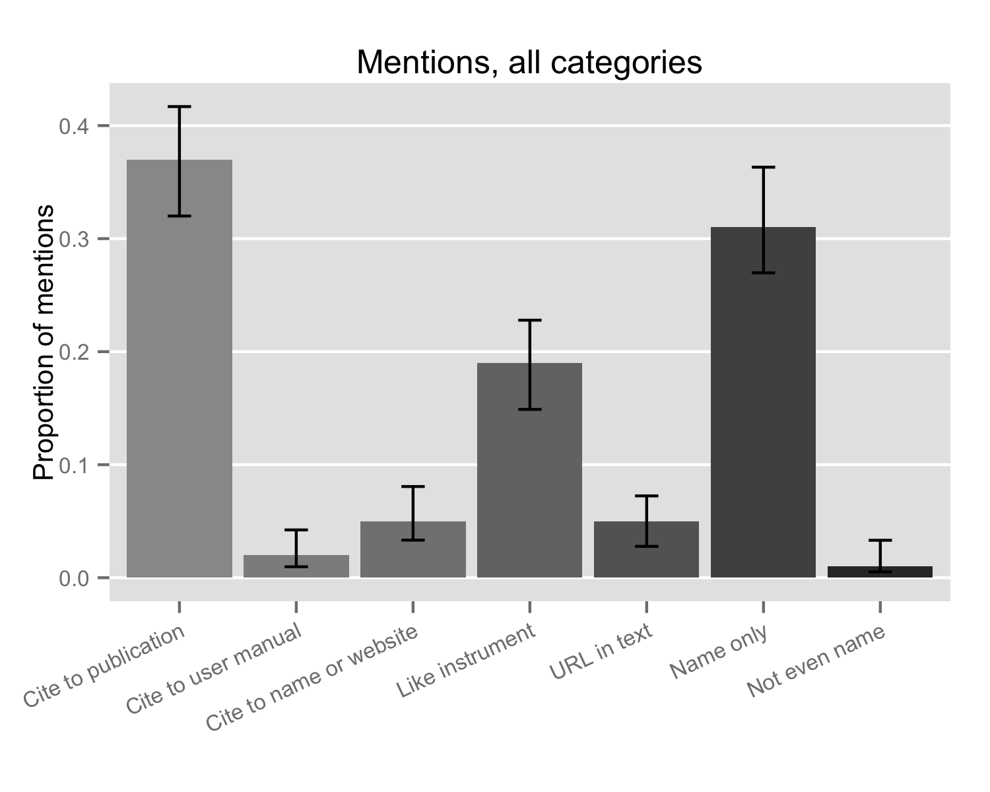

Figure : Types of software mentions. Errorbars show 95% confidence intervals.

These categories of mentions are useful for understanding the overall diversity of practice, but somewhat fine-grained for further analysis. Accordingly, we collapsed these categories into three: Cite to publication (including cite to user manual), Like Instrument, and Other (including Cite to name or website, URL in text, Name only, or Not even name). These categories correspond well to two formalized forms of mentioning in the literature and a collection of informal techniques that scientists are using. The results are shown in Figure XXXX.

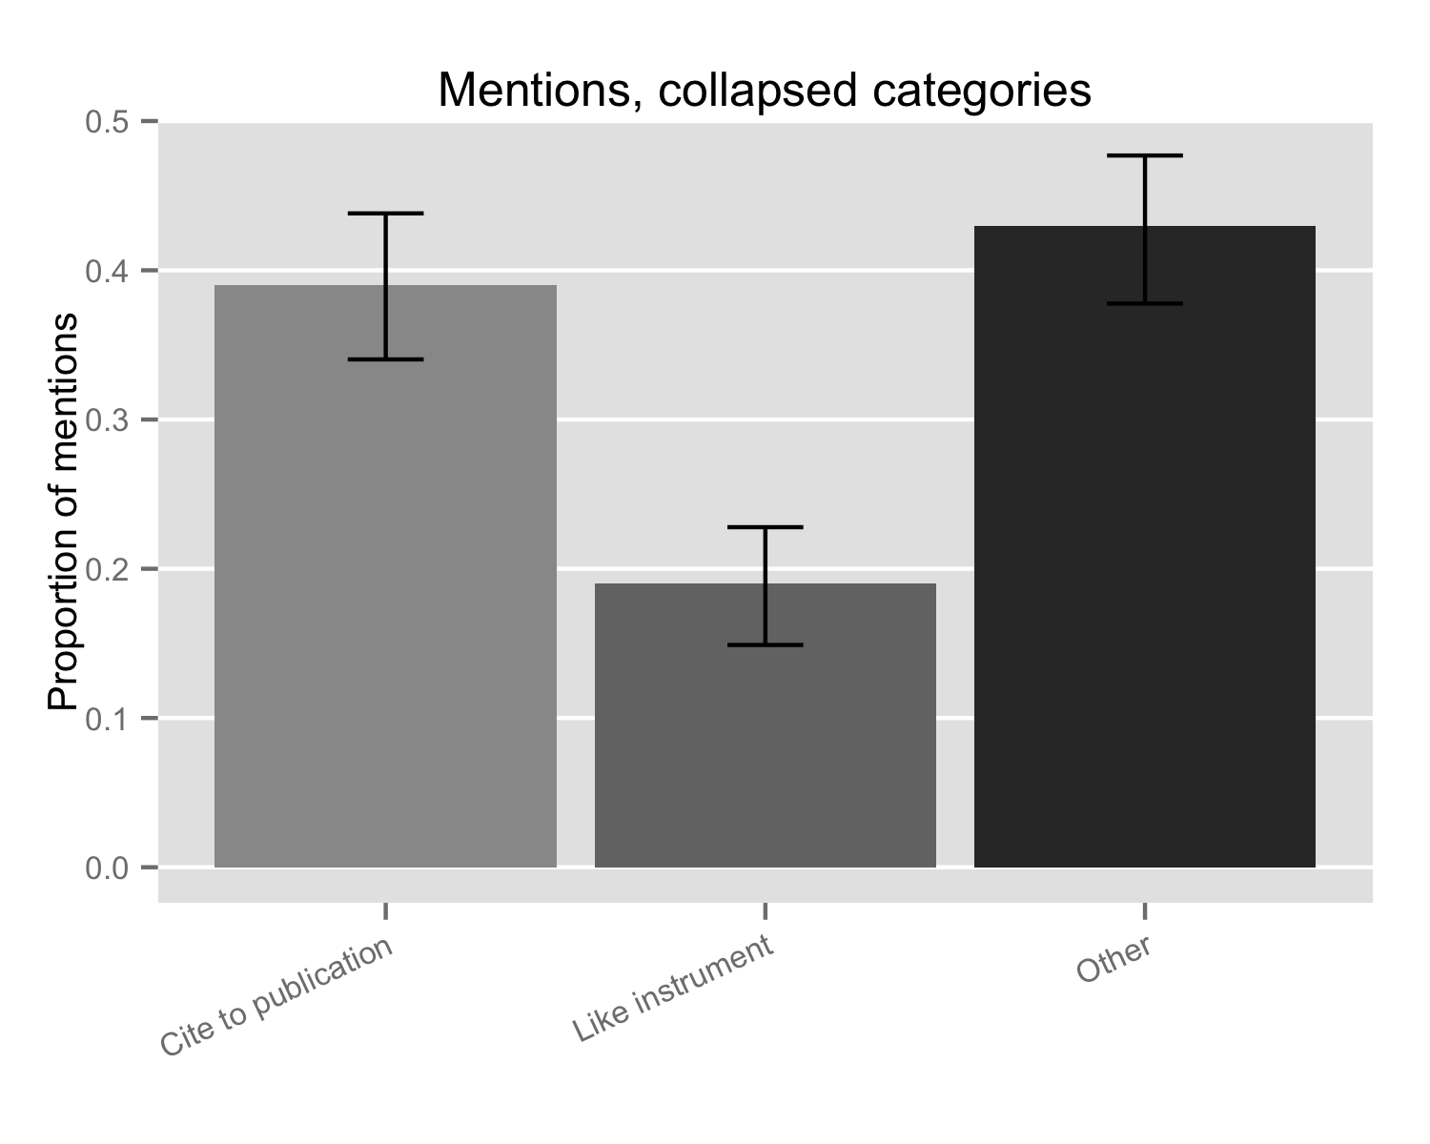

Using these categories, 39% (90% CI: 0.34–0.44) of mentions cite a publication, 19% (90% CI: 0.15–0.23) refer to software following the guidelines for instruments and 43% (90% CI: 0.38–0.48) use some form of other, informal, way of mentioning software.

Figure XXXX shows these categories of mention broken out by strata. While there are no differences in the use of cites to publications, we can see that there are significantly fewer mentions that look like instruments in the low journal impact strata. The data tends to show higher use of informal citations in lower journal impact strata, but the 90% confidence intervals overlap. These results are consistent with the idea that journals in higher strata have more formalized mention styles; nonetheless even in the top strata alone 36% (90% CI: 0.29–0.44) of mentions were informal (categorized as “other).

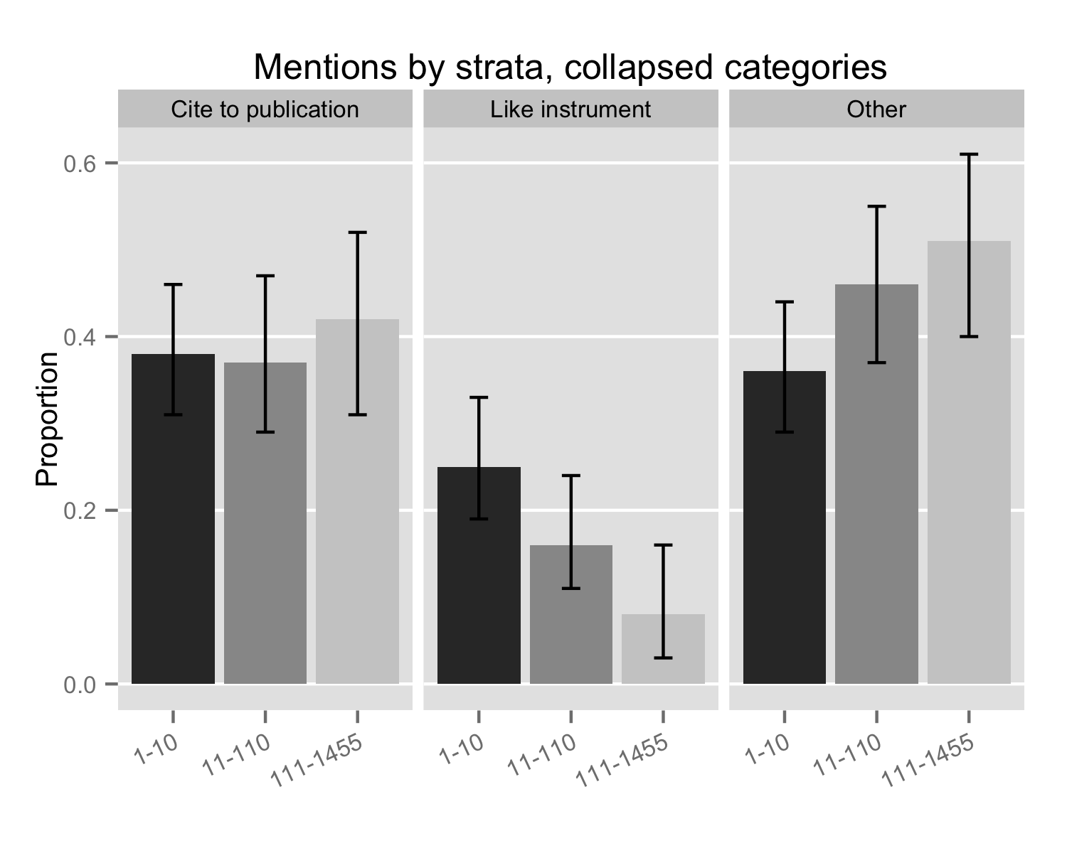

Figure : Major software mention types by journal strata. Error bars show 90% confidence intervals.

### Characteristics of Software mentioned

Figure : Commercial software is more likely to be cited "like instrument"

The mentions we found were to 146 distinct pieces of software. The majority of pieces of software were only mentioned in a single article, with the most mentioned software being mentioned in only 4 articles. We provide the full list of software mentioned in papers in Appendix 2, but given the broad distribution of software in the literature our sample size does not allow us to claim representativeness sufficient to create a “league table” of software use in science; we include the appendix to help readers assess the face validity of our content analysis results.

We classified the type of software using the codes described above (the result of seeking the software online, using data provided with any mention within an article): whether the software was accessible, whether one has to pay money for a license, whether the source code is available, and whether the software provides explicit permission to modify and extend the source code (i.e., a free software or open source license). As illustrated in Figure XXXX, we were able to access only 79% (90% CI: 0.72–0.84) of the software mentioned. 47% of the software mentioned was available without payment (90% CI: 0.40–0.54), while only 32% had source code available (90% CI: 0.25–0.38) and only 20% gave explicit permission for others to modify or extend the source code (90% CI: 0.15–0.26).

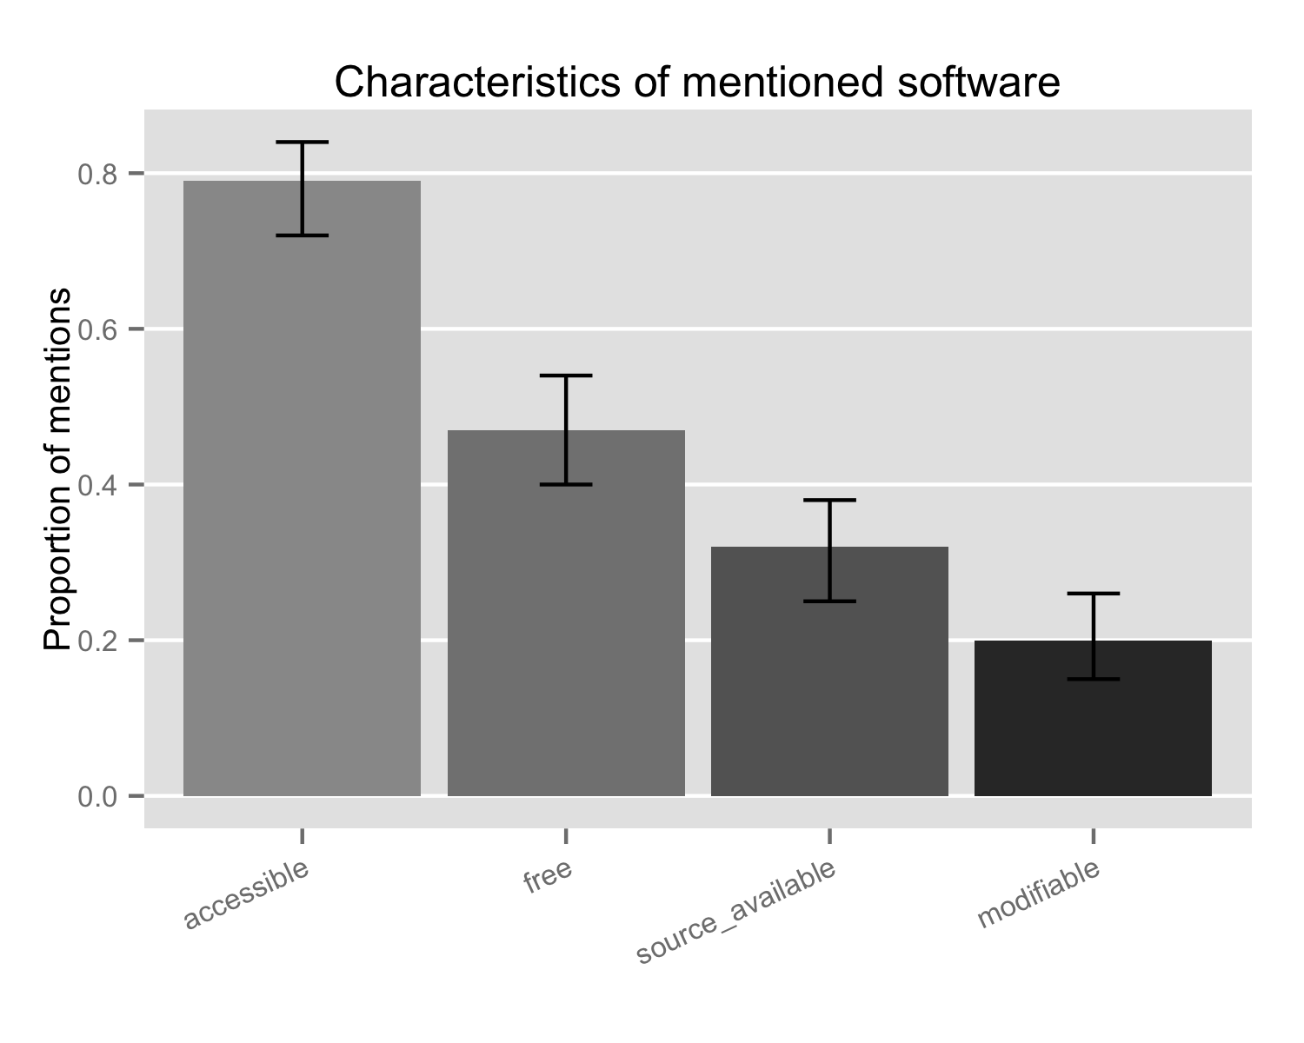

The characteristics of software are important results because they reflect the usefulness of software to other scientists, but they do not provide intuitive labels to discuss types of software. Accordingly, we combine these categories to produce intuitive labels. The first reflects those mentions of software that we were not able to access (and so could not code further); these we call “Not accessible”. The second reflects software that is not accessible without paying money and for which the source code is held as a proprietary secret. It is common to refer to this as “commercial,” yet some open source software also makes money, so we refer to this as “Proprietary” software, emphasizing the unavailability of source code. At the other end we place “Open Source” software that is available without payment, provides access to the source code and provides explicit permission to modify the code. Falling between Proprietary and Open Source software is a category we have named “Non-commercial” software because it is available without payment but does not provide explicit permission to modify the code; most, but not all, provide access to source code. Falling into this category are many packages written by scientists and made available for other scientists, but either without specifying license conditions or specifying licenses that restrict modification. As illustrated in Figure XXXX, we found 21% of software to be Not accessible (90% CI: 0.16–0.28), 32% to be Proprietary (90% CI: 0.25­–0.38), 27% to be Non-commercial (90% CI: 0.21–0.34) and 20% to be Open Source (90% CI: 0.15–0.26). We did not break this out by strata because software packages are mentioned in multiple articles across strata.

## Macintosh HD:Users:howison:Documents:UTexas:Projects:SoftwareCitations:softcite:output:fig-5-Proportion of Software.png

## Citation functions

### Identifying and finding software

We assessed our dataset to see whether the mentions gave sufficient information for identifying and finding software, addressing the question of how well authors do in providing sufficient information for readers to locate the software mentioned. We also assessed how well authors do in providing credit to the authors of software. As discussed above, for these codes, we drew on data in any mention in an article, reasoning that a reader of a mention has immediate access to the other mentions in the article to help locate the piece of software, thus the unit of analysis here is pieces of software mentioned in an article. Since pieces of software are mentioned in multiple articles our dataset for this section is larger than the overall number of pieces of software; a single piece of software could be mentioned in a functional way in one paper, but without the same functionality in another paper. Accordingly, there are 182 unique combinations of software and articles

Of these 182 unique combinations of software and articles, overall 77% (95% CI: .70-.82) provided some information about the creators of the software. Crediting did not vary much by strata, with 78% of combinations mentioning creators in the top strata, 75% in the middle and 79% in the third strata; Conference intervals overlapped implying no statistically significant differences.

Almost all the combinations of software and articles were identifiable, 94% overall (95% CI: .87-.95); there were no statistically significant differences between strata.

Overall 86% of packages mentioned in papers provided sufficient information to find the software (95% CI: 0.80–0.90). Again, there were no statistically significant differences between the strata (84% in Strata 1, 85% in Strata 2, and 91% in Strata 3.) In the dataset, 14% of packages mentioned in papers were not findable at all (95% CI: 0.10–0.20).

Version information was rarely provided. Of the 182 combinations of software mentioned in articles, only 51 (28%, 95% CI 0.22–0.35) provided any version information (either a version number or a date on which the software was obtained or compiled). For those where version information was provided we were able to see if we could find the specific version used. In only 10 (5%, 95% CI: 0.02–0.10) of those cases were we successful, primarily because the version information was insufficient or older versions of the software were not available.

### 

### Accessibility and reusability

Finally, we analyzed each of the software packages that were findable to assess the extent to which that software could be accessed and potentially reused by readers. Since this is a characteristic of the software itself (or at least the manner in which it is hosted and licensed), rather than the software mention, our unit of analysis here was the 146 distinct pieces of software used across the papers in our sample.

Overall we were able to access 115 (79%, 95% CI: 0.71–0.85) of the pieces of software mentioned, in either binary, source, or other form (e.g., web service). Of these, 69 (47%, 95% CI: 0.39–0.57) offered access without payment, while the rest offered access only after purchase. We were able to access the source code of 47 (32%, 95% CI: 0.25–0.40) of software, but only 29 (20%, 95% CI: 0.14–0.27) gave explicit permission to modify that code. Typically that explicit permission for modification came because the software used an open source license or expressly placed the software in the public domain.

Viewed by strata, as shown in Figure 4, we can see that there is no systematic variance across strata on these features, meaning that there is no evidence that articles published in journals with higher impact factors systematically tend to use software that offers greater utility for replication and extension (or, that our sample is not sufficiently large to see differences).

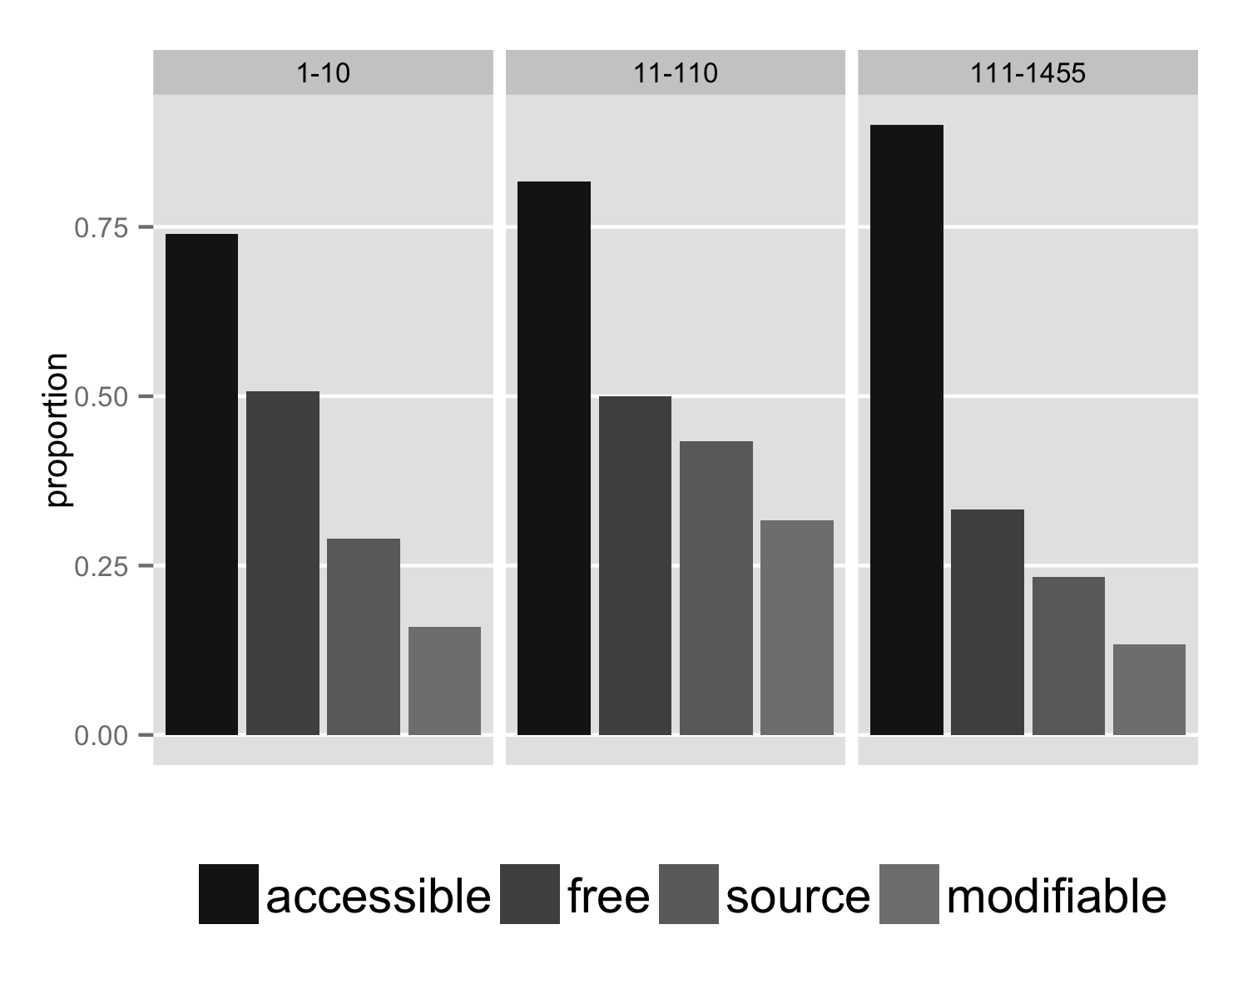

Figure : Accessibility and reusability of software by strata

# Discussion

The evidence presented in this paper clearly shows that the practices of software citation are diverse, varying across publications and, indeed, sometimes even within individual publications. It seems that scientists are addressing software primarily by analogy with other elements that appear in publications, sometimes treating software as though it were an instrument or material commercially purchased, sometimes as akin to a scientific protocol, sometimes treating software as a pair with a published paper, and sometimes simply including whatever is at hand, from user-manuals to URLs and the names of projects.

These diverse ways of mentioning software are, from a scholarly communications perspective, certainly better than nothing, but they do fail to accomplish many of the functions of citation.

While almost all mentions allow for identification of the software discussed, but only between 80 and 90%provide sufficient information to find that software (meaning 1 in 10 software packages are could not be found). Yet software, unlike almost all articles, typically changes over time, the ability to find a particular version is more important, and only between 22 and 35% of software mentions provide that information; moreover only between 2 and 10% of cases can that specific version be found (meaning that 9 out of 10 times a specific version cannot be found).

Turning to the second, but no less important, function of providing credit for scientific contribution, and thus rewarding the effort required to build re-usable software, we find that between 72 and 80% of mentions attempt to give credit in some form, primarily through reference to accompanying publications or parenthetical mentions of authors or companies.

As we move further up the list of attributes necessary for reproducibility and for efficient innovation through building on the work of others, the situation declines even further. Only between 71 and 85% of software is available in any form, while only between 25 and 40% of the software mentioned is available in source form, facilitating inspection by those interested in replicating the research. Finally, only between 14 and 27% of the software mentioned provides the most basic condition for extension: permission to re-use and/or modify the software provided.

## What is to be done?

Improving the situation presented in this paper requires action across a number of domains of scientific practice, both in design and then in driving change. Certainly one area is to design and standardize improved forms for describing software use in scientific papers, tackling the functions of identification and findability (at the level of specific versions) as well as giving credit in a manner that motivates excellent software work. Yet moving beyond those basic functions requires change not in how papers are written but in how software is made available, changes that have to occur outside the process of writing papers, at the projects that build software.

In this section we move code by code, considering the causes of the issues, potential solutions, techniques to encourage uptake of the solutions and describing “green shoots” indicating progress in these areas.

**Improving identification and findability.** The most basic function of mentioning software in a paper is to allow readers, including reviewers, to identify and locate the software used. This function is directly analogous to the ability to identify and find a specific publication, or the ability to identify and find a specific material or instrument. In the case of software, which unlike a typical publication continues to change after its initial release, this also involves specific version numbers. While we do not have specific data on authors intentions, given that they mentioned the software at all, the problem in this area appears not to be motivation but a lack of clear standards and norms for mentioning software. The way forward, then, seems fairly straightforward: First, we need clear and consistent practices for citing software, and second, we need to disseminate, encourage and enforce their use.

We are, of course, not the first to make this point. Indeed many citation style guides offer forms for citing software, including APA. Recent efforts in this space include work analogous to data citation, such as that undertaken by DataOne (Mayernik, 2012) and the ESIP organization (ESIP, 2012). For software, a promising way to incorporate version information is to link directly to the source code repositories that development teams use to track their development, and automating the creation of a Digital Object identifier or other Handles. Systems with this approach have been developed at CERN (Purcell, 2014) and by the Mozilla Science Project, Github and Figshare (http://mozillascience.github.io/code-research-object/).

The way forward here clearly involves journals and conferences adopting specific forms of citation and enforcing them as a condition of publication. We examined the “instructions to authors” for the journals in our sample, and found that only 24% had specific policies on citing software. Unsurprisingly journals in higher stratas seemed more likely to have such policies (3 of 5 journals in 1st strata (60%), 10 of 23 in 2nd strata (43%) and 1 of 30 in the third strata (3%), with strata 3 showing statistically significant differences from strata 1 and strata 2 (p=0.005). It may be that with clearer standards that are more broadly expected by authors, reviewers, editors and readers that journal’s provision of relevant policies will improve. On the other hand it may be appropriate to build systems that automatically check the form of software citations, ensuring that they follow the required styles and that they correctly resolve to a specific version in a repository.

**Improving crediting.** As with identification and findability, authors appear committed to providing information about the origins of software. As discussed above, for authors seeking to make scientific contributions credit is vital; it may be less so for those selling their software (although those writing software relevant to science may also value involvement in science, keeping costs low for scientific use). Yet some forms of mentions offer more potential than others. Ironically, the “like instrument” citation form preferentially used with commercial software (see Figure 4) is effective in ascribing credit, at least to the level of the company selling the software. In particular, citations to accompanying publications most directly enable contributors to demonstrate their scientific impact, reusing existing bibliographic analysis systems. Yet using citations to papers can run counter to the need to identify and find the software itself, particularly because the publication citations remain static. More, these citations can “fix” the contributor list at a particular time, creating a disincentive for later potential participants to contribute their changes to a project and thus leading to competing forks (Howison & Herbsleb, 2013). Finally because software is typically constructed by integrating code of others, it is not clear that simply citing the immediate authors actually credits those who have provided the functionality; indeed a desire to be recognized might encourage authors of software to avoid having their code integrated.

Thus there is a need for a form of crediting that identifies and rewards contributors in a manner most useful to them and least likely to undermine desirable collaboration and integration. The proposals discussed above, linking to software repositories, offer advantages in this area, potentially facilitating tracing contribution to specific versions by post-hoc examination of commits and their authorship in the source code repository. Katz (2014) addresses the question of integration by suggesting a system of indirect credit, dividing citation credit accruing to top-level projects between their developers and the developers of the components they draw on. Other approaches take an altmetrics approach and focus not on the appearance of code in publications but on metrics such as download or use, including analysis of traces such as downloads and analysis of workflow repositories (e.g., McConahy, Eisenbraun, Howison, Herbsleb, & Sliz, 2012; McLennan & Kennell, 2010; Piwowar & Priem, 2013; Stodden et al., 2012).

One approach achievable in the short term is for projects themselves to specify the manner in which they would like to be mentioned; with journals or styles providing “fall-back” guidelines to be used when the software does not. Many of the projects in our sample indeed did this, providing “preferred citations” which were themselves a mix of citations to domain and software papers and forms with corporate authorships (e.g., “The R project Team”). Most of these requests were contained on the homepage of the project or, in a few cases, in a “splash screen” or other part of the software interface. We recorded whether a project made such a request and coded, at the article level, whether authors appeared to follow the request. We found that only 27 of our 146 software packages (18%, 95% CI: 0.13–0.30) made a specific request to be mentioned in some way. These packages were mentioned in 15 articles, resulting in 31 combinations of these packages and articles. We found 21 cases where the requested citation was used (68%, across 11 articles, 95% CI: 0.49–0.83), leaving 10 cases where the request was not followed (32%, occurring across 8 articles, 95% CI: 0.17–0.51). We can only speculate but this may be a combination of not being aware of the request, publisher’s style guides, or simple inattention on the author’s behalf. Certainly the paucity of specific requests for citation, combined with their inconsistent usage, suggests that measuring the research impact of software solely by searching for specific citations has serious validity concerns.

One possibility to improve the situation is for authors to make correct acknowledgement a requirement of permission to use the software; all but one of the examples we observed were phrased as requests and not as requirements. In our interviews and discussions with producers of scientific software (reported in <anonymized>) there is hesitancy to make such requirements, both in fear of losing users and in a belief that such requirements violate principles of scientific sharing. Certainly authors of papers don’t have to make such requests, but publishers often do, backed by requirements of copyright law and the quite intense threat of punishment for plagiarism by incorrect attribution. Moreover, there is precedent for using licenses (and thus contract law) to require specific acknowledgements within the domain of open source software and open cultural production, although such requirements are controversial. The GNU GPL and the Apache license requires software users to retain all attribution notices in the code, and the original BSD license required acknowledgement of the University of California; the Open Source Initiative approves licenses requiring attribution (e.g., the “Common Public Attribution License”[1] used for the code behind Reddit). All Creative Commons licenses require attribution (other than the Public Domain Dedication, CC0) as a condition of use, and the project provides guidelines on appropriate forms of attribution, including tools to automate attributions.[2] Nonetheless, as with any system, end-users may not follow the license; indeed in our dataset one package used a license that required users to cite a specific article, but the mention of that software in our dataset did not.

Finally, it seems likely that any standards should address the question of whether to address commercial software differently from software written for academic credit. The prevalence of “instrument-like” citations suggests that authors see software as similar to other equipment; this may be appropriate, especially if those writing the software are merely interested in selling software and not in earning academic reputation. However, a standard that differentiated in this way would need to help authors know when to use which form and our suggestion of packages themselves providing this information seems relevant. Either way, information relevant to replication and extension would need to be included.

**Improving Accessibility.** One approach for improving the availability of software associated with a paper is to require that it be deposited with the publication itself. This approach often combines a requirement for depositing data and analysis code, sometimes in the form of “workflows” (e.g., Goble et al., 2013; Roure et al., 2009; Stodden et al., 2012) or perhaps “virtual machines” replicating the entire analysis execution environment. An extension of this approach is the “executable paper,” (Strijkers et al., 2011) which calls for bundling all the data and software needed to produce the results and the paper, right through to plots and, ultimately, the article PDF. These are promising approaches, avoiding the reproducibility issue from incomplete software and workflow descriptions demonstrated by failed attempts at replication by Ince et al. (2012) and they have been quite successful in some fields; in increasing number of journals and conferences have these requirements. Yet as with citations standards, such repositories have compliance, monitoring, and maintenance issues as described in Econometrics by McCullough et al. (2006). The Journal of Money, Banking, and Finance has had a data and software repository for many years, yet an attempt to use the contents of the repository for replication showed that only 69 of the 193 articles that should have had entries actually did, and the authors were only able to use code to successfully replicate the analysis in 14 cases. Clearly a policy is only as good as its enforcement. Finally, this approach assumes that authors have the right to redistribute the software code they used, something that is not always the case.

In fact, much of the question of accessibility depends not on the actions of authors of papers that use the software, but on the behavior of a much larger group, including software component producers and intermediaries, such as software publishers and repositories. This is particularly true when one seeks to access source code and to integrate it or modify it.

A series of workshops and publications, however, have argued that nothing less than software that is developed and made available as fully open source software is sufficient for the aims of science policy (Ince et al., 2012; Katz et al., 2014). This means choosing and using a specific open source software license and committing to continually making software available through public repositories. Just as in data advocates for openness have reasoned “public money, public data” so to comes advocacy for “public money, public code”.

The advantages of openness, these requirements, however, need to interact with requirements for software sustainability. In some cases openness and sustainability are well aligned: if the project chooses to seek sustainability through open source community production, then the source and permission to modify are well aligned. If, however, the project chooses to pursue sustainability through commercial sales then the situation is more complex. For example, some code of great usefulness to scientists is supported by sales to the commercial market, in effect cross-subsidizing scientific use and making greater resources available to science. Blanket policies such as “public money, public code” preclude models like this. Nonetheless, hybrid models are possible, such as is common with Matlab code: a for-profit, closed source engine, but a great deal of open sharing of analysis code.

# Conclusion and Future research

In summary we have examined and analyzed the manner in which software is mentioned in scientific papers, and we conclude that the practices are varied and appear relatively ad-hoc. It is not too surprising, then, that we also find that the way that software is mentioned and the way that it is made accessible to users of the scientific literature fails to accomplish many of the intended functions of citations in scholarly communication. Certainly it is clear that studies of software in publications, or efforts to assess the impact of software through bibliometrics, must look beyond formal citations or reference lists since the data in this paper provide evidence that these, at least in the biology literature, constitute only between 31 and 43% of software mentions.

There are a great number of interesting research questions that ought to be pursued. Certainly efforts are needed in the design of improved software citation approaches. This is especially true with regards to such approaches potential influence on collaboration. For example, how does the re-use of the publication system through “software papers” as requested citations influence the willingness of developers to cooperate? How might a software citation system acknowledge the many contributors to software dependencies on which user-facing components are built (in-direct crediting)? Can scholarly articles bear the sheer amount of citations that such a system would call for, or are systems outside papers themselves called for? Who might provide, and fund, such systems? Further, we know little about how scientists reason about what ought to be cited and how they make these decisions; in particular we know little about when scientists choose not to mention software they have used at all. Such behavioral questions are crucial and closely related to the open questions of how best to influence scientists and therefore make useful change in the diverse and often inadequate practices reported in this paper.

Software is both similar and different to other elements mentioned in scientific papers: it is at once an artifact, an instrument, a protocol, sometimes a publication, and the focus of ongoing activity. In short software is both an artifact and a practice. This varied nature renders the question of how software ought to be mentioned in publications surprisingly complex. Yet it also provides an opportunity: addressing the issues reported in this paper, and advancing the open research questions outlined above, would go a great distance to improve the efficacy of not only scholarly communications but scientific practice as well.

# Acknowledgments

The graphs in this paper were created using ggplot2 software (Wickham, 2009), version 1.0.0) running in the R statistics environment (R Development Core Team, 2009), version 3.1.1. Data storage and manipulation was done with the Apache Jena software (version 2.11.1) (https://jena.apache.org/, written by the Apache jena team, https://jena.apache.org/about_jena/team.html) and the spin framework (version 1.4.0) (http://spinrdf.org/spin.html, written by Holger Knublauch), supported by the Hamcrest Library (version 1.3) and JUnit (version 4.11) (credit information for both at https://github.com/junit-team/junit/blob/master/acknowledgements.txt) Jena and R were linked using the rrdf library (Willighagen, 2013), version 2.0.2. Additional data manipulation used the dplyr (version 0.2.0.99) and reshape2 (version 1.4) R libraries, both written by Hadley Wickham.

The full dataset and analysis code for this paper is available online at https://github.com/jameshowison/softcite/

The authors wish to thank Catherine Grady for her assistance with content analysis.

This material is based upon work supported by the National Science Foundation under Grant No. SMA-1064209.

# References

Altman, M., & King, G. (2007). A proposed standard for the scholarly citation of quantitative data. *D-Lib Magazine*, *13*(3/4). Retrieved from http://papers.ssrn.com/sol3/papers.cfm?abstract_id=1081955

Borgman, C. L., Wallis, J. C., & Mayernik, M. S. (2012). Who’s Got the Data? Interdependencies in Science and Technology Collaborations. *Computer Supported Cooperative Work (CSCW)*, *21*(6), 485–523. doi:10.1007/s10606-012-9169-z

Bradford, S. C. (1934). Sources of Information on Specific Subjects. *Engineering*, *137*, 85–86.

Brookes, B. C. (1985). “Sources of information on specific subjects” by S.C. Bradford. *Journal of Information Science*, *10*(4), 173–175. doi:10.1177/016555158501000406

Byrt, T., Bishop, J., & Carlin, J. B. (1993). Bias, prevalence and kappa. *Journal of Clinical Epidemiology*, *46*(5), 423–429. doi:10.1016/0895-4356(93)90018-V

Cano, V. (1989). Citation behavior: Classification, utility, and location. *Journal of the American Society for Information Science*, *40*(4), 284–290.

CODATA-ICSTI Task Group on Data Citation Standards and Practices. (2013). Out of cite, out of mind: The current state of practice, policy, and technology for the citation of data. *Data Science Journal*, *12*(September).

Edwards, P. N., Jackson, S. J., Chalmers, M. K., Bowker, G. C., Borgman, C. L., Ribes, D., … Calvert, S. (2013). *Knowledge Infrastructures: Intellectual Frameworks and Research Challenges* (Working Paper). Retrieved from http://deepblue.lib.umich.edu/handle/2027.42/97552

ESIP. (2012). Data Citation Guidelines for Data Providers and Archives. *ESIP Working Document*. doi:10.7269/P34F1NNJ

Gambardella, A., & Hall, B. H. (2006). Proprietary versus public domain licensing of software and research products. *Research Policy*, *35*(6), 875–892. doi:10.1016/j.respol.2006.04.004

Gamer, M., Lemon, J., Singh, P., & Fellows, I. (2012). *irr: Various Coefficients of Interrater Reliability and Agreement*. Retrieved from http://CRAN.R-project.org/package=irr

Goble, C., Roure, D. D., & Bechhofer, S. (2013). Accelerating Scientists’ Knowledge Turns. In A. Fred, J. L. G. Dietz, K. Liu, & J. Filipe (Eds.), *Knowledge Discovery, Knowledge Engineering and Knowledge Management* (pp. 3–25). Springer Berlin Heidelberg. Retrieved from http://link.springer.com/chapter/10.1007/978-3-642-37186-8_1

Goh, D., & Ng, P. (2007). Link decay in leading information science journals. *Journal of the American Society for Information Science and Technology*, *58*(2002), 15–24. doi:10.1002/asi.20513

Hope, A. C. (1968). A simplified Monte Carlo significance test procedure. *Journal of the Royal Statistical Society. Series B (Methodological)*, 582–598.

Howison, J., & Herbsleb, J. D. (2011). Scientific software production: incentives and collaboration. In *Proceedings of the ACM Conference on Computer Supported Cooperative Work* (pp. 513–522). Hangzhou, China. doi:10.1145/1958824.1958904

Howison, J., & Herbsleb, J. D. (2013). Incentives and integration in scientific software production. In *Proceedings of the ACM Conference on Computer Supported Cooperative Work* (pp. 459–470). San Antonio, TX. doi:10.1145/2441776.2441828

Ince, D. C., Hatton, L., & Graham-Cumming, J. (2012). The case for open computer programs. *Nature*, *482*(7386), 485–488. doi:10.1038/nature10836

Katz, D. S. (2014). Transitive Credit as a Means to Address Social and Technological Concerns Stemming from Citation and Attribution of Digital Products. *Journal of Open Research Software*, *2*(1), e20. doi:10.5334/jors.be

Katz, D. S., Choi, S.-C. T., Lapp, H., Maheshwari, K., Löffler, F., Turk, M., … Venters, C. (2014). Summary of the First Workshop on Sustainable Software for Science: Practice and Experiences (WSSSPE1). *Journal of Open Research Software*, *2*(1). doi:10.5334/jors.an

King, G. (1995). Replication, Replication. *Political Science & Politics*, 444–452.

Klein, M., Van de Sompel, H., Sanderson, R., Shankar, H., Balakireva, L., Zhou, K., & Tobin, R. (2014). Scholarly Context Not Found: One in Five Articles Suffers from Reference Rot. *PLoS ONE*, *9*(12), e115253. doi:10.1371/journal.pone.0115253

Koehler, W. (1999). An analysis of web page and web site constancy and permanence. *Journal of the American Society for Information Science*, *50*(2), 162–180. doi:10.1002/(SICI)1097-4571(1999)50:2<162::AID-ASI7>3.0.CO;2-B

Konkiel, S. (2013). Tracking citations and altmetrics for research data: Challenges and opportunities. *Bulletin of the American Society for Information Science and Technology*, *39*(6), 27–32. doi:10.1002/bult.2013.1720390610

Lawrence, S. (2001). Online or Invisible? *Nature*, *411*(6837).

Lipetz, B. (1965). Improvement of the Selectivity of Citation Indexes to Science Literature Through Inclusion of Citation Relationship Indicators. *American Documentation*, *16*(2).

Mayernik, M. S. (2012). Data citation initiatives and issues. *Bulletin of the American Society for Information Science and Technology*, *38*(5), 23–28. doi:10.1002/bult.2012.1720380508

McConahy, A., Eisenbraun, B., Howison, J., Herbsleb, J. D., & Sliz, P. (2012). Techniques for Monitoring Runtime Architectures of Socio-technical Ecosystems. In *Workshop on Data-Intensive Collaboration in Science and Engineering (CSCW 2012)*.

McCullough, B. D., McGeary, K. A., & Harrison, T. D. (2006). Lessons from the JMCB Archive. *Journal of Money, Credit, and Banking*, *38*(4), 1093–1107.

McLennan, M., & Kennell, R. (2010). HUBzero: A Platform for Dissemination and Collaboration in Computational Science and Engineering. *Computing in Science & Engineering*, *12*(2), 48–53. doi:10.1109/MCSE.2010.41

Mooney, H., & Newton, M. (2012). The Anatomy of a Data Citation: Discovery, Reuse, and Credit. *Journal of Librarianship & Scholarly Communication*, *1*(1). Retrieved from http://search.ebscohost.com/login.aspx?direct=true&profile=ehost&scope=site&authtype=crawler&jrnl=21623309&AN=81282417&h=KyFyGvBtN1pUxKw268SjCV8MjJr6S95LPW0W5IUyE2UbpAfhmb2UQEdO7j2QXMwHK1XVdxKSNa5SIyrCV3Bf%2FA%3D%3D&crl=c

Moravcsik, M. J., & Murugesan, P. (1975). Some Results on the Function and Quality of Citations. *Social Studies of Science*, *5*(1), 86–92. doi:10.2307/284557

Newcombe, R. G. (1998). Interval estimation for the difference between independent proportions: comparison of eleven methods. *Statistics in Medicine*, *17*(8), 873–890.

Pham, S., & Hoffmann, A. (2003). A new approach for scientific citation classification using cue phrases. *AI 2003: Advances in Artificial Intelligence*. Retrieved from http://link.springer.com/chapter/10.1007/978-3-540-24581-0_65

Piwowar, H., & Priem, J. (2013). The power of altmetrics on a CV. *Bulletin of the American Society for Information Science and Technology*, *39*(4), 10–13. doi:10.1002/bult.2013.1720390405

Purcell, A. (2014). Tool developed at CERN makes software citation easier. Retrieved from http://www.isgtw.org/spotlight/tool-developed-cern-makes-software-citation-easier

R Development Core Team. (2009). R: A Language and Environment for Statistical Computing. Retrieved from http://www.R-project.org

Roure, D. D., Goble, C., Aleksejevs, S., Bechhofer, S., Bhagat, J., Cruickshank, D., … Poschen, M. (2009). Towards Open Science: The myExperiment approach. *Concurrency and Computation: Practice and Experience*, *22*(17), 2335–2353.

Science Watch. (2003). Twenty Years of Citation Superstars. *Science Watch*, *14*(5). Retrieved from http://www.sciencewatch.com/sept-oct2003/sw_sept-oct2003_page1.htm

Sellitto, C. (2005). The impact of impermanent Web-located citations: A study of 123 scholarly conference publications. *Journal of the American Society for Information Science and Technology*, *56*(7), 695–703. doi:10.1002/asi.20159

Simons, N., Visser, K., & Searle, S. (2013). Growing Institutional Support for Data Citation: Results of a Partnership Between Griffith University and the Australian National Data Service. *D-Lib Magazine*, *19*(11/12). doi:10.1045/november2013-simons

Stewart, C. A., Almes, G. T., & Wheeler, B. C. (Eds.). (2010). NSF Cyberinfrastructure Software Sustainability and Reusability Workshop Report. Retrieved from http://hdl.handle.net/2022/6701

Stodden, V., Donoho, D., Fomel, S., Friedlander, M., Gerstein, M., LeVeque, R., … Wiggins, C. (2010). Reproducible Research. *Computing in Science and Engineering*, *12*(5), 8–13.

Stodden, V., Guo, P., & Ma, Z. (2013). Toward Reproducible Computational Research: An Empirical Analysis of Data and Code Policy Adoption by Journals. *PLoS ONE*, *8*(6), e67111. doi:10.1371/journal.pone.0067111

Stodden, V., Hurlin, C., & Perignon, C. (2012). RunMyCode.org: A novel dissemination and collaboration platform for executing published computational results. In *2012 IEEE 8th International Conference on E-Science (e-Science)* (pp. 1–8). doi:10.1109/eScience.2012.6404455

Strijkers, R., Cushing, R., Vasyunin, D., de Laat, C., Belloum, A. S. Z., & Meijer, R. (2011). Toward Executable Scientiﬁc Publications. *Procedia Computer Science*, *4*, 707–715. doi:10.1016/j.procs.2011.04.074

Teufel, S., & Tidhar, D. (2006). Automatic classification of citation function. *Computational Linguistics*, (July), 103–110.

Van der Loo, M. P. J. (2014). The stringdist package for approximate string matching. *The R Journal*, *6*(1), 111–122.

Wickham, H. (2009). *ggplot2: Elegant Graphics for Data Analysis*.

Willighagen, E. (2013). Accessing biological data with semantic web technologies. *Peer J Pre-Prints*.

# Appendix 1: Details of Sampling Frame and Journals in sample

The sampling frame included all journals in the 2010 edition of the ISI Web of Science, using the Journal Citation Reports tool. We included these categories:

|  |  |
| --- | --- |
| Biochemistry & Molecular Biology | Biology |
| Biotechnology & Applied Microbiology | Cell Biology |
| Developmental Biology | Entomology |
| Evolutionary Biology | Genetics & Heredity |
| Marine & Freshwater Biology | Mathematical & Computational Biology |
| Microbiology | Multidisciplinary Sciences |
| Mycology | Ornithology |
| Parasitology | Plant Sciences |
| Reproductive Biology | Zoology |

Table : All Journals in Sample

|  |  |  |
| --- | --- | --- |
| **1-10** | **11-110** | **111-1455** |
| Nature Genetics | Nucleic Acids Research | Applied Biochemistry and Biotechnology |
| Science | Nature Cell Biology | BMC Plant Biology |
| Nature Biotechnology | Molecular Systems Biology | Academie des Sciences. Comptes Rendus. Biologies |
| Cell | Molecular Ecology | American Journal of Botany |
| Nature | The FASEB Journal | Israel Journal of Plant Sciences |
|  | Genome Research | Advances in Complex Systems |
|  | Molecular Therapy | Biochimica et Biophysica Acta. Proteins and Proteomics |
|  | Nature Structural and Molecular Biology | Journal of Molecular Neuroscience |
|  | Developmental Cell | BMC Molecular Biology |
|  | Cladistics | Turkish Journal of Biochemistry |
|  | The Plant Journal | Phytomedicine |
|  | Systematic Biology | Molecular Diagnosis and Therapy |
|  | Acta Crystallographica. Section D: Biological Crystallography | Zoological Studies |
|  | Human Molecular Genetics | Journal of Molecular Catalysis B: Enzymatic |
|  | Stem Cells | Australian Journal of Entomology |
|  | Nanomedicine | Journal of Computer - Aided Molecular Design |
|  | New Phytologist | Waterbirds |
|  | Cell Research | The Journal of Parasitology |
|  | PLoS Biology | Acta Parasitologica |
|  | National Academy of Sciences. Proceedings | Biochimica et Biophysica Acta. General Subjects |
|  | The Journal of Infectious Diseases | Journal of Thermal Biology |
|  | The Journal of Cell Biology | Protoplasma |
|  | Molecular Psychiatry | Aquatic Ecosystem Health & Management |
|  |  | Turkish Journal of Zoology |
|  |  | Arthropod Structure & Development |
|  |  | Cytotechnology |
|  |  | Undersea & Hyperbaric Medicine |
|  |  | Systematic Botany |
|  |  | Nucleosides, Nucleotides and Nucleic Acids |
|  |  | Journal of Integrative Plant Biology |

# Appendix 2: Software packages mentioned in articles

|  |  |
| --- | --- |
| CCP4 | 4 |
| ClustalW | 4 |
| Excel | 4 |
| PAUP | 4 |
| Adobe Photoshop | 3 |
| BLAST | 3 |
| HKL | 3 |
| ImageJ | 3 |
| MetaMorph | 3 |
| NIH Image | 3 |
| O | 3 |
| SPSS | 3 |
| CNS | 2 |
| ModelTest | 2 |
| R | 2 |
| REFMAC | 2 |
| SAS | 2 |
| SOLVE | 2 |
| Stereo Investigator | 2 |
| Treeview | 2 |
| Adobe INDesign CS | 1 |
| Agilent 2100 Expert Software | 1 |
| AMoRe | 1 |
| AMOVA | 1 |
| Autodecay | 1 |
| BeadStudio | 1 |
| BIAevaluation | 1 |
| BioDataFit | 1 |
| BioEdit | 1 |
| BioNJ | 1 |
| BIOSYS | 1 |
| BLAT | 1 |
| BOXSHADE | 1 |
| cactus online smiles translator | 1 |
| CAD | 1 |
| Calcusyn | 1 |
| CALPHA | 1 |
| Chart 5 | 1 |
| CHIMERA | 1 |
| ChipViewer | 1 |
| Cluster | 1 |
| COLLAPSE | 1 |
| COOT | 1 |
| DatLab | 1 |
| DENZO | 1 |
| DYMEX® | 1 |
| EIGENSTRAT | 1 |
| Ensembl | 1 |
| EnzFitter | 1 |
| EPMR | 1 |
| ESCET | 1 |
| GAP | 1 |
| GDE | 1 |
| Gelworks 1D Advanced | 1 |
| GenePix | 1 |
| GENESPRING | 1 |
| Genome Analyser II | 1 |
| geNorm | 1 |
| GoMiner | 1 |
| Grafit | 1 |
| Graph Pad Prizm | 1 |
| GraphPad Prism | 1 |
| GRASP | 1 |
| GRID | 1 |
| GRIN | 1 |
| IDEG6 | 1 |
| Jalview | 1 |
| JAZZ | 1 |
| JMP(R) | 1 |
| jMRUI | 1 |
| Kodak Digital Science 1D | 1 |
| KS300 | 1 |
| limma R package | 1 |
| LSM510 | 1 |
| LSQKAB | 1 |
| MacClade | 1 |
| MapMaker | 1 |
| MapQTL | 1 |
| MATLAB | 1 |
| Mfold | 1 |
| Minitab | 1 |
| MitoProt | 1 |
| MOLREP | 1 |
| MOLSCRIPT | 1 |
| MorphoCode | 1 |
| MrBayes | 1 |
| NeuroZoom | 1 |
| NormFinder | 1 |
| NTSYS-pc | 1 |
| Opticon Monitor 2 | 1 |
| OPUS | 1 |
| PC-ORD | 1 |
| PHASE | 1 |
| PHASER | 1 |
| Phred/Phrap/Consed | 1 |
| PHYLIP | 1 |
| PHYML | 1 |
| PONDR | 1 |
| POST | 1 |
| PREDATOR | 1 |
| Prism | 1 |
| PROCHECK | 1 |
| PSORT | 1 |
| qBasePlus | 1 |
| QUANTA | 1 |
| Quantity One | 1 |
| RACE | 1 |
| RASTER3D | 1 |
| RESOLVE | 1 |
| RIBBONS | 1 |
| SCALEPACK | 1 |
| SCAMP | 1 |
| Sedfit | 1 |
| Sednterp | 1 |
| Sequence Navigator | 1 |
| SHELLSCALE | 1 |
| SHP | 1 |
| SIGMAA | 1 |
| Sigmaplot | 1 |
| Software for Zeiss LSM 510 | 1 |
| software-Unknown-a2003-22-CR_BIOL-C01-mention | 1 |
| software-Unknown-a2003-44-SCIENCE-C09-mention | 1 |
| software-Unknown-a2003-44-SCIENCE-C10-mention | 1 |
| software-Unknown-a2006-05-SYST_BIOL-C05-mention | 1 |
| software-Unknown-a2006-05-SYST_BIOL-C08-mention | 1 |
| software-Unknown-a2006-47-SYST_BIOL-C02-mention | 1 |
| software-Unknown-a2007-11-GENOME_RES-C09-mention | 1 |
| software-Unknown-a2008-06-NAT_GENET-C04-mention | 1 |
| Staden | 1 |
| STATA | 1 |
| Statistica | 1 |
| Statview | 1 |
| Swiss-Model | 1 |
| SYSTAT | 1 |
| TargetP | 1 |
| TIMAT2 | 1 |
| TMHMM | 1 |
| TRIM_DENZO | 1 |
| tRNAScan-SE | 1 |
| TRUNCATE | 1 |
| Useq | 1 |
| WinNONLIN | 1 |
| X-PLOR | 1 |
| X-Score | 1 |
| XPREP | 1 |
| Zeiss LSM Image Browser | 1 |

1. See discussion at: http://oss-watch.ac.uk/resources/cpal
2. http://wiki.creativecommons.org/Best_practices_for_attribution