EIE4432 Web Systems and Technologies

Miniproject Report

(Web application of Piece of Cake)

Members:

Bai Zhi Yan (16098056D)

Chan Hoi Sze (16058074D)

Fung Ching Tung (16078599D)

Lin Han (16078325D)

Xue Yuxi (16097547D)

**Part A - Site map**

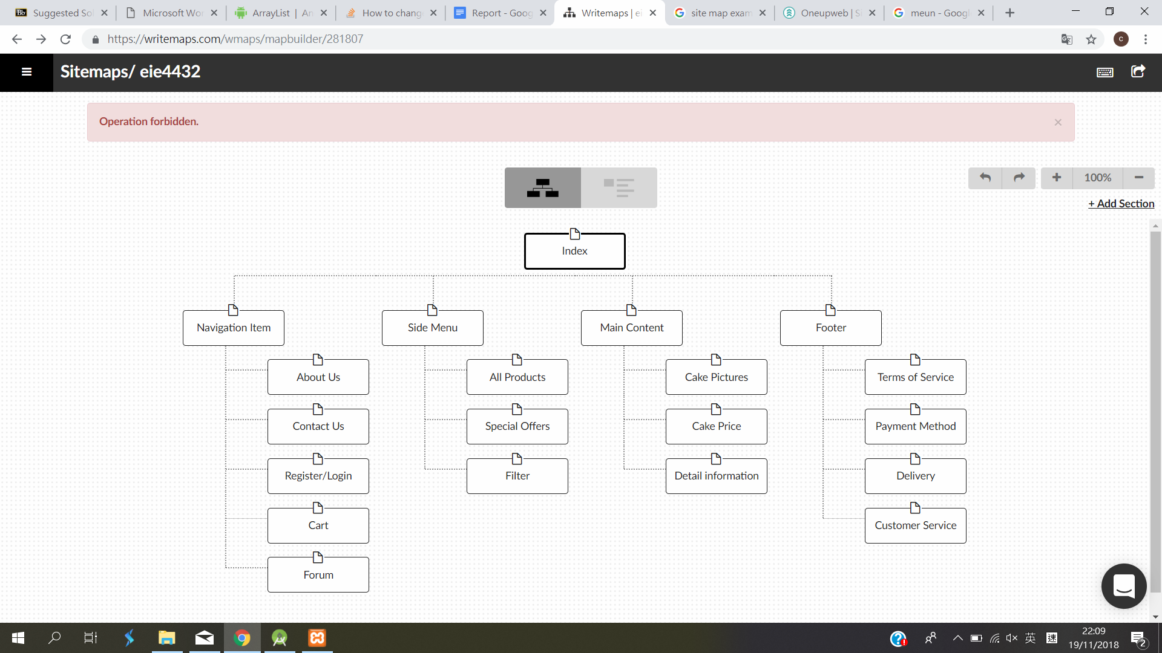

**Part B - Functions of the web application**

1. Introduction

This web application is created for a cake shop. It aims at providing convenience for customers to shop online. This website contains detailed information of all kinds of cakes. Customers can choose from more than 60 cakes from the online shop. For security issues, customers are required to login first before they make an order. Customers can enjoy online shopping conveniently with this web application.

2. Main Functions of the web application

Login/Logout

Users are required to Login in before adding products to cart. When users register the account, the information will be insert to SQL database. When users Login, the username and password will be searched in SQL database to check if there any match and setting cookie to identify if users have already login. If customers don’t login in, there is not cookie, when they click the button “Add to cart”, the page will go to “Login/Register” page automatically. When users logout, the cookie will be clear.

Forum

A forum is added to let customer share comments and opinions. When a new comment is send, an AJAX function is used to display the comment on the top part of the page which groups and displays users’ opinion. For an admin account, comments can be deleted and corrected. For guest account or member of the webpage, they can post comments in the forum. The comments will be connected to database for management. It is composed of the add_forum.php, save_forum.php, forum_guest.php, forum_admin.php, and the forum database. The javascript, Ajax, php techniques are used within the structure of forum. add_forum.php is a small window for users to type in their comments and the latter one is a table displaying all the comments. Forum_admin.php is based on forum_guest.php with extra delete function. Save_forum is used to pass the information users typed in to the forum database.

Cart

The shopping cart is used to store order information, user can select products and add them into shopping cart, the order information as well as user information will be stored in database. When user need to check the content in cart, the information will be provided directly database.User can also manage their orders, delete or add products, the information in database would also change correspondingly.

Filter

A filter is added to the side menu of the web page. When User would like to filter out the type, price or issuing time of cakes, they can use the filter to choose cakes. This filter made use of AJAX function so that user do not need to wait for the whole page to reload when they choose cakes of their favors.

Pages

Pages are generated and showed in the bottom of each page. The pages are generated with a JavaScript function and shown by AJAX function. In each PHP file of the displayed cakes, page numbers are included. Pages are generated by the id of the pages so that each PHP pages have different number of pages. Also, the swapping of page uses AJAX function. This provides a fast change of page.

**Part C - Technologies used**

1. HTML5

* Display main content of webpage

Handle multimedia and graphical content, such as images.

2. CSS

* Display and design of the webpage

The font styles, colors and size are uniform in the webpage. The graphic and color of the webpage are identical throughout the whole web application as well. Graphics are added to the webpage so that clients can view the cakes before buying them.

3. JavaScript

* Sign up/Login checking function

In the form of Sign up/Login page, a checking function is implemented to check if users’ input is validate. Javascript checking function with regular expression is used to check the mismatched length, matched pairs, or blank inputs. Error messages are shown in red to show invalidations and green for validations.

4. PHP

* Display each single item in new page after clicking the item icon in the index page. PHP function can hold the item index and display the corresponding images and content in the new page.

5. AJAX

* Filter

Filter is provided for customers to choose different cakes they are interested in according to type, price and issuing time. AJAX is used to provide a fast switching pages in the main content without reloading the whole web.

* Pages

swapping pages used AJAX to provide a partial refresh of the webpage. Clients can go to their desired page quickly without waiting for the whole page to refresh.

6. Database Connectivity

* Register

When user register accounts, the information will be insert to SQL database.

* Shopping cart

When user add or delete orders in cart, the information will also change in database, when user need to get the order details, the information is also provided by database directly

**Part D - Contributions of team member**

|  |  |  |
| --- | --- | --- |
| Name | Contributions | Percentage |
| BAI Zhi Yan | check.php: check if user login | 100% |
| cookie.php:Set Cookie for login and check if login information has match in SQL database | 100% |
| cusinfo.php: Insert register information to SQL database | 100% |
| cake1.php: Details of cake | 100% |
| All.php which display different kinds of cake: Display of cake pictures (eg. cakebox.php) | 100% |
| Research for cake pictires | 100% |
| Chan Hoi Sze | Login.php: Javascript validation of form | 100% |
| Index.php: check if login is true and forward to Index_log.php/index_nolog.php | 100% |
| logout.php: Logout funtion | 100% |
| AJAX filter | 100% |
| Pages | 100% |
| CSS of the webpage | 40% |
| aboutus.html, ContactUs.html | 100% |
| Fung Ching Tung | index.php: main content display | 100% |
| cake1.php: show image of cakes | 50% |
| Storing and classification of images | 100% |
| CSS of the webpage | 20% |
| Lin Han | add_forum.php: for guest to leave their comments  forum_guest.php: combined with add_forum.php by Ajax where guests can see all the comments | 100% |
| forum_admin.php: for administrator to manage the forum | 100% |
| save_forum_php: save the comments to the forum database | 100% |
| DB.txt: forum database and  The connection between the cake website with the forum by cookie | 100% |
| picture automatic carousel.html | 100% |
| CSS of the webpage | 40% |
| Xue Yuxi | addtodb.php:add the order information to database,display the order and user information | 100% |
| showcart.php:show all order information and total price that user has made,give user a choice to delete order or checkout | 100% |
| checkout.php:let user confirm orders and prompt to send email | 100% |
| deleteorder.php:user can delete order and start new one | 100% |
| sendemail.php:user can send email to us. The comfirmed order information will automatically attached in the email. | 100% |
| Build database: info.sql | 100% |

**Part E - Peer grading**

|  |  |  |  |  |  |  |
| --- | --- | --- | --- | --- | --- | --- |
|  |  | Member 1 | Member 2 | Member 3 | Member 4 | Member 5 |
| 1 | BAI Zhi Yan | - | A+ | A+ | A+ | A+ |
| 2 | Chan Hoi Sze | A+ | - | A+ | A+ | A+ |
| 3 | Fung Ching Tung | A+ | A+ | - | A+ | A+ |
| 4 | Lin Han | A+ | A+ | A+ | - | A+ |
| 5 | Xue Yuxi | A+ | A+ | A+ | A+ | - |