Referencias:
- color sólido → todo junto
- cruz → de una por vez
- color sólido y cruz → entreno con todos menos 1 y sobre ese testeo
- color solido y circulo: entreno con uno y testeo sobre ese
- código al lado del título: nombre del csv donde se guardó la prueba. “S” de small, 001 porque son locales, 001 por nro de prueba
Prueba 1: S_001_001
 | training |  |  | testing
 | 0.15 | 0.25 | 0.35 | 0.15 | 0.25 | 0.35
-0.1 |  |  |  | x | x | x
-0.25 |  |  |  | x | x | x
-0.5 |  |  |  | x | x | x
-0.75 |  |  |  | x | x | x
-1 |  |  |  | x | x | x

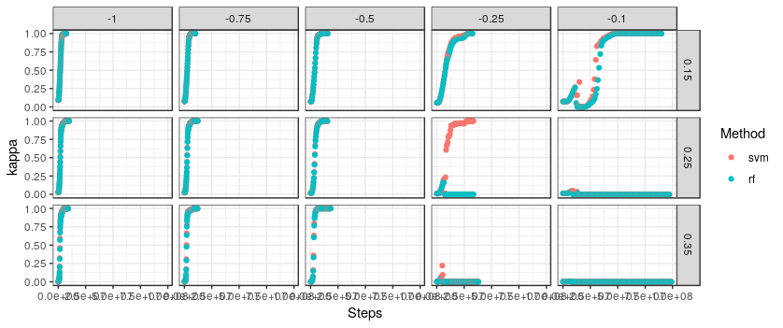

Prueba 2:S_001_002

 | training |  |  | testing
 | 0.15 | 0.25 | 0.35 | 0.15 | 0.25 | 0.35
-0.1 |  |  |  | x | x | x
-0.25 |  |  |  | x | x | x
-0.5 |  |  |  | x | x | x
-0.75 |  |  |  | x | x | x
-1 |  |  |  | x | x | x

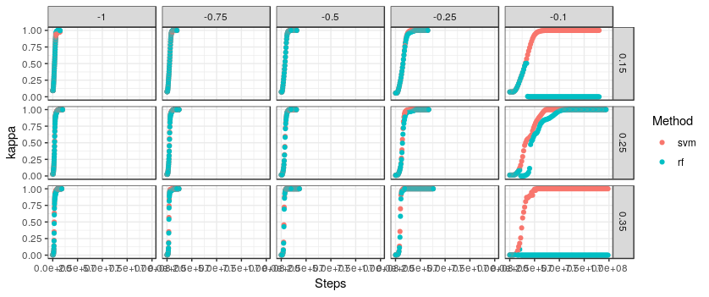

Prueba 3: S_001_003

 | training |  |  | testing
 | 0.15 | 0.25 | 0.35 | 0.15 | 0.25 | 0.35
-0.1 |  |  |  | x | x | x
-0.25 |  |  |  | x | x | x
-0.5 |  |  |  | x | x | x
-0.75 |  |  |  | x | x | x
-1 |  |  |  | x | x | x

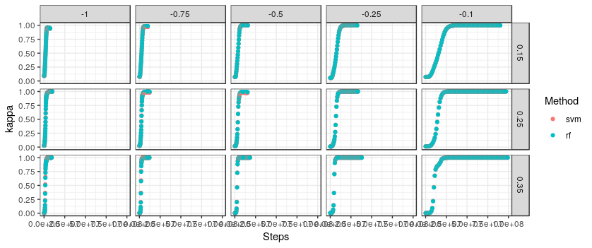
Prueba 4: S_001_004

 | training |  |  | testing
 | 0.15 | 0.25 | 0.35 | 0.15 | 0.25 | 0.35
-0.1 | x |  |  | x
-0.25 | x |  |  | x
-0.5 | x |  |  | x
-0.75 | x |  |  | x
-1 | x |  |  | x

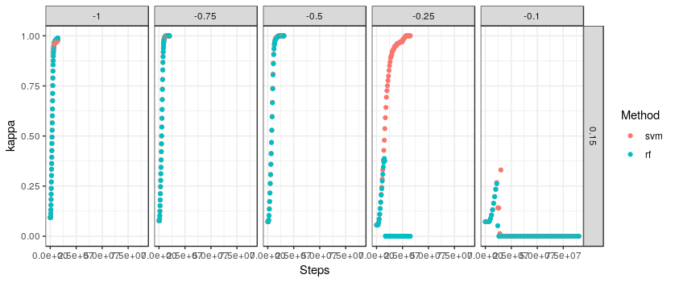
Prueba 5:S_001_005

 | training |  |  | testing
 | 0.15 | 0.25 | 0.35 | 0.15 | 0.25 | 0.35
-0.1 |  | x |  |  | x
-0.25 |  | x |  |  | x
-0.5 |  | x |  |  | x
-0.75 |  | x |  |  | x
-1 |  | x |  |  | x

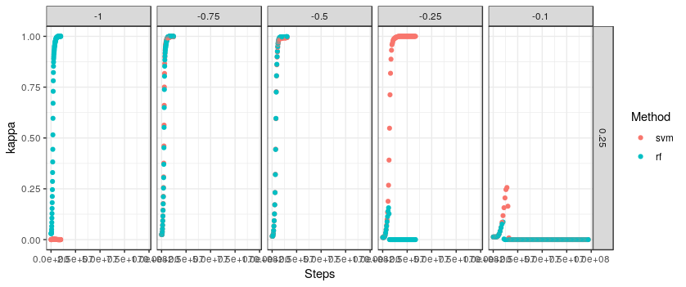
Prueba 6:S_001_006

 | training |  |  | testing
 | 0.15 | 0.25 | 0.35 | 0.15 | 0.25 | 0.35
-0.1 |  |  | x |  |  | x
-0.25 |  |  | x |  |  | x
-0.5 |  |  | x |  |  | x
-0.75 |  |  | x |  |  | x
-1 |  |  | x |  |  | x

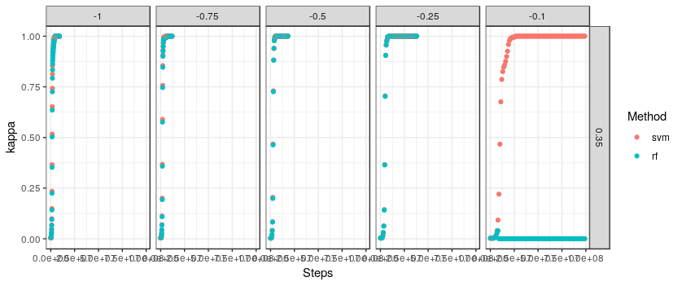

Prueba 7: NO PUEDO HACERLA, MI COMPU NO SE BANCA ESTA

 | training |  |  | testing
 | 0.15 | 0.25 | 0.35 | 0.15 | 0.25 | 0.35
-0.1 |  |  |  | x | x | x
-0.25 |  |  |  | x | x | x
-0.5 |  |  |  | x | x | x
-0.75 |  |  |  | x | x | x
-1 |  |  |  | x | x | x

Prueba 8 NO PUEDO HACERLA, MI COMPU NO SE BANCA ESTA

 | training |  |  | testing
 | 0.15 | 0.25 | 0.35 | 0.15 | 0.25 | 0.35
-0.1 | x | x | x | x | x | x
-0.25 | x | x | x | x | x | x
-0.5 | x | x | x | x | x | x
-0.75 | x | x | x | x | x | x
-1 | x | x | x | x | x | x

Prueba 9:S_001_009

 | training |  |  | testing
 | 0.15 | 0.25 | 0.35 | 0.15 | 0.25 | 0.35
-0.1 |  |  |  | x | x | x
-0.25 |  |  |  | x | x | x
-0.5 |  |  |  | x | x | x
-0.75 |  |  |  | x | x | x
-1 |  |  |  | x | x | x

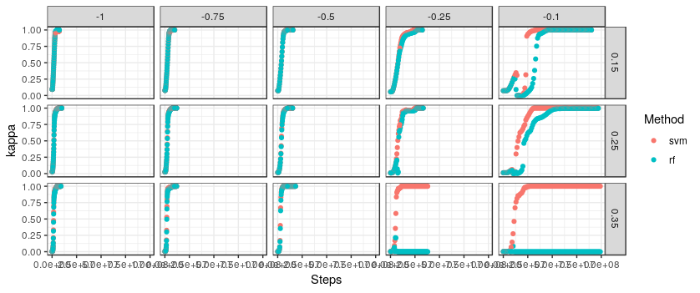

Prueba 10:S_001_010

 | training |  |  | testing
 | 0.15 | 0.25 | 0.35 | 0.15 | 0.25 | 0.35
-0.1 |  |  |  | x | x | x
-0.25 |  |  |  | x | x | x
-0.5 |  |  |  | x | x | x
-0.75 |  |  |  | x | x | x
-1 |  |  |  | x | x | x

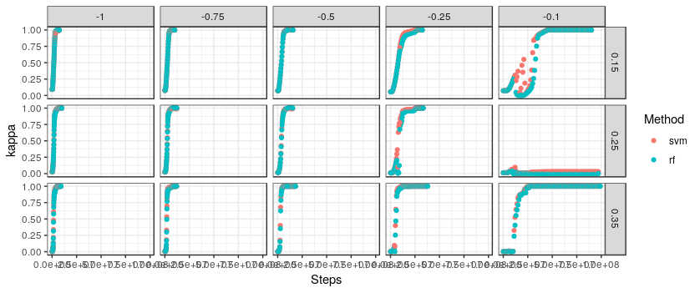
Prueba 11:S_001_011

 | training |  |  | testing
 | 0.15 | 0.25 | 0.35 | 0.15 | 0.25 | 0.35
-0.1 |  |  |  | x | x | x
-0.25 |  |  |  | x | x | x
-0.5 |  |  |  | x | x | x
-0.75 |  |  |  | x | x | x
-1 |  |  |  | x | x | x

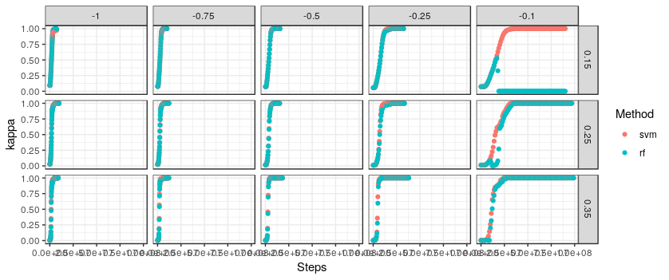
Prueba 12:S_001_021

 | training |  |  | testing
 | 0.15 | 0.25 | 0.35 | 0.15 | 0.25 | 0.35
-0.1 | o | o | o | x | x | x
-0.25 | o | o | o | x | x | x
-0.5 | o | o | o | x | x | x
-0.75 | o | o | o | x | x | x
-1 | o | o | o | x | x | x

