Performance Evaluation

1. CPU:

Floating point operations:

Observation 1:

Here the CPU performance is measured in form of Gigabits floating point operations for threads like 1 thread, 2 thread and then for 4 thread.

|  |  |
| --- | --- |
| No of GFlops | No of threads |
| 9.00 | 1 |
| 9.17 | 2 |
| 8.60 | 4 |

Observation 2:

|  |  |
| --- | --- |
| No of GFlops | No of threads |
| 10.5 | 1 |
| 9.12 | 2 |
| 8.989 | 4 |

Observation 3:

|  |  |
| --- | --- |
| No of GFlops | No of threads |
| 9.96 | 1 |
| 8.9 | 2 |
| 8.078 | 4 |

Integer Operations:

Observation 1:

Similarly integer operations are performed in operations per second which is changed with a variation.

|  |  |
| --- | --- |
| No of GIops | No of threads |
| 11.23 | 1 |
| 11.12 | 2 |
| 10.1 | 4 |

Observation 2:

|  |  |
| --- | --- |
| No of GIops | No of threads |
| 12.58 | 1 |
| 10.96 | 2 |
| 8.91 | 4 |

Observation 3:

|  |  |
| --- | --- |
| No of GIops | No of threads |
| 13.999 | 1 |
| 10.97 | 2 |
| 10.01 | 4 |

600 sample

Linpack

GFlops:

Here the 600 samples are generated for CPU performance verses seconds to obtain float operations per second in Gigabits.

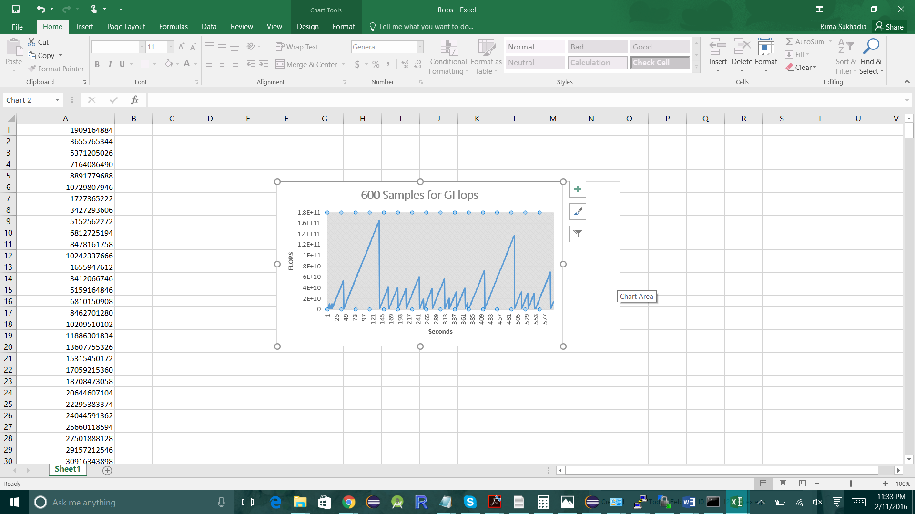

IOFlops:

Here the 600 ssamples are generated for CPU performance verses seconds to obtain input operations per second.

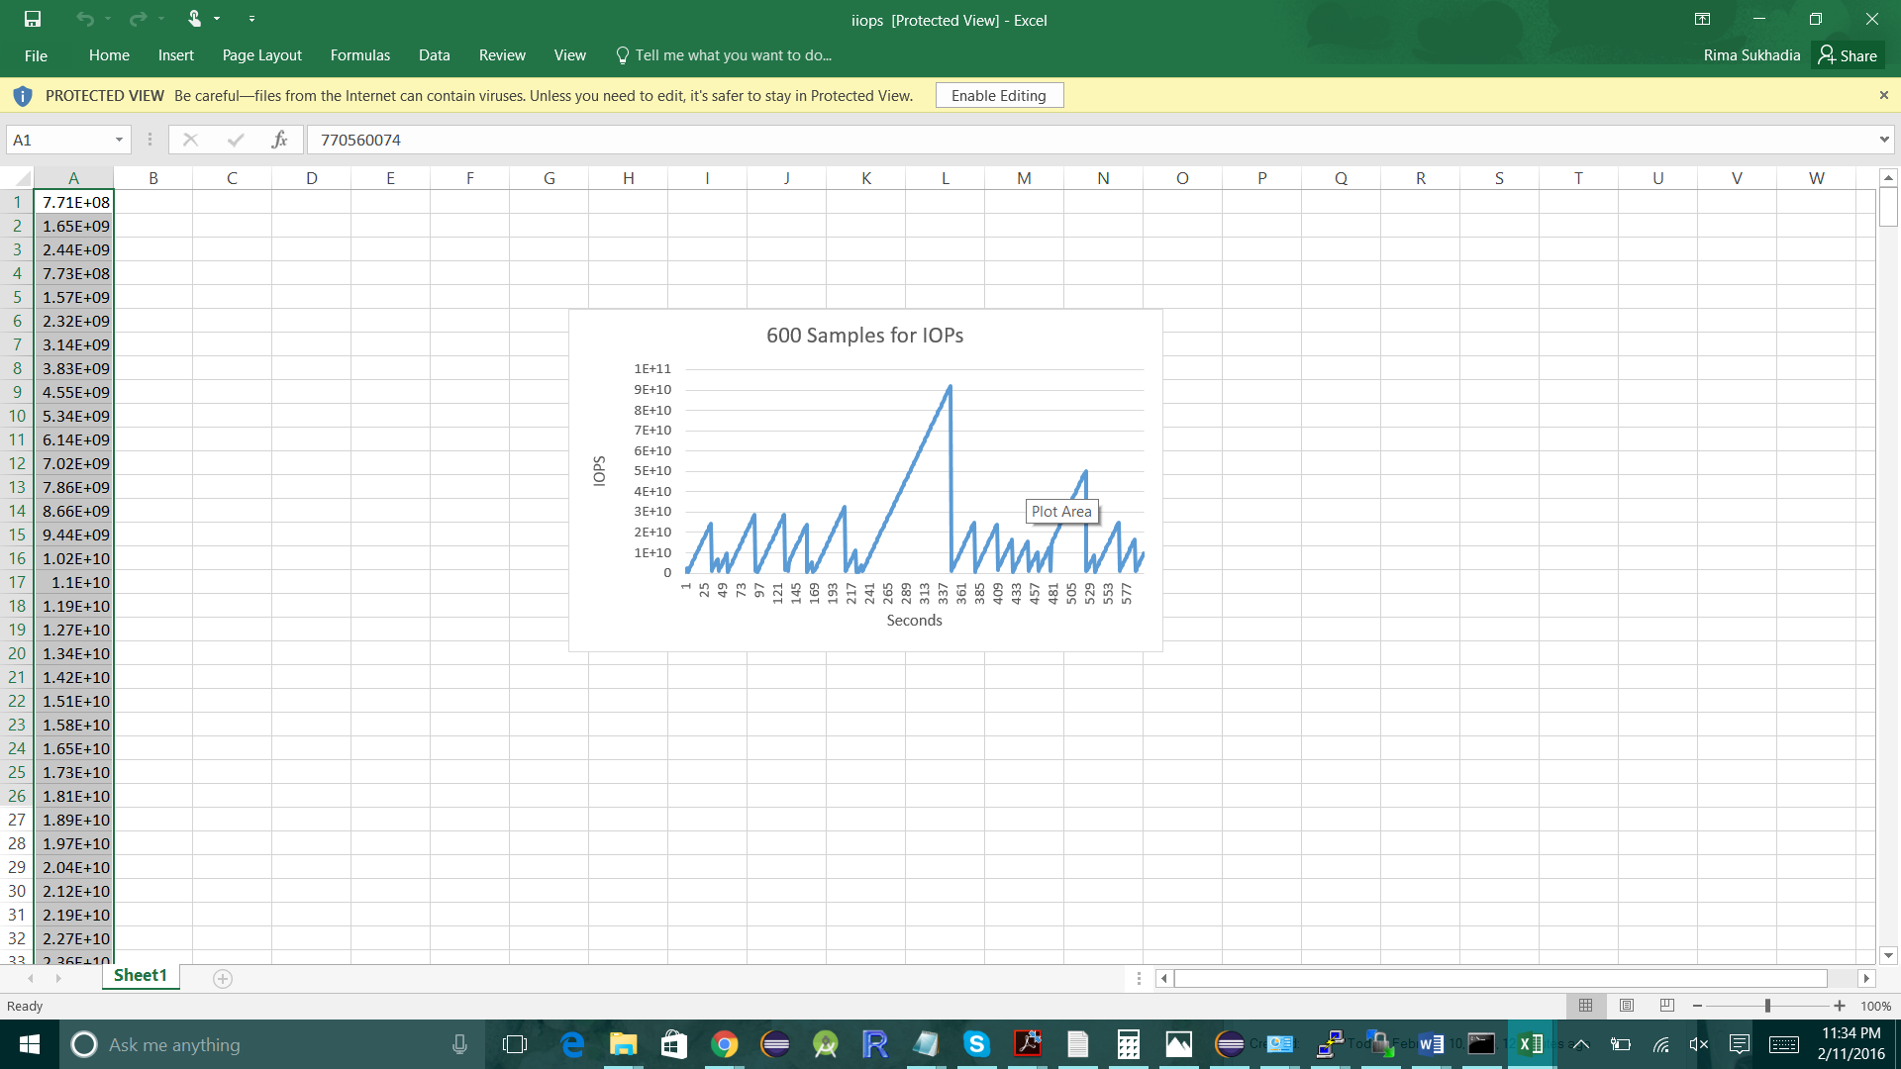

Explanations:

The cpu performance is measured through this software in order to obtain better performance as shown below:

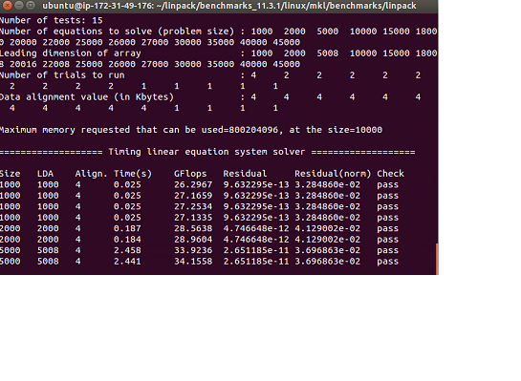

1. DISK:

Sequential Read:

File sequential read is performed with the following readings for different file sizes:

|  |  |  |  |
| --- | --- | --- | --- |
| Data Size | Throughput (MB/s) | Latency (ms) | Threads |
| 1 B | 1.290 | 0.071 | 1 |
| 1 KB | 62.04 | 0.186 | 1 |
| 1 MB | 3562.67 | 0.194 | 1 |
| 1 B | 4.659 | 0.0265 | 2 |
| 1 KB | 66.59 | 0.16 | 2 |
| 1 MB | 5030.86 | 0.4084 | 2 |

Sequential Write:

File is written sequentially to obtain throughput and latency in Mega Bytes per second and milliseconds respectively:

|  |  |  |  |
| --- | --- | --- | --- |
| Data Size | Throughput (MB/s) | Latency (ms) | Threads |
| 1 B | 0.013 | 0.0884 | 1 |
| 1 KB | 14.27 | 0.723 | 1 |
| 1 MB | 836.41 | 0.981 | 1 |
| 1 B | 4.644 | 0.0459 | 2 |
| 1 KB | 64.53 | 0.359 | 2 |
| 1 MB | 916.79 | 0.5811 | 2 |

|  |  |  |  |
| --- | --- | --- | --- |
| Data Size | Throughput (MB/s) | Latency (ms) | Threads |
| 1 B | 0.74 | 0.098 | 1 |
| 1 KB | 40.84 | 1.12 | 1 |
| 1 MB | 1071.87 | 171.8 | 1 |
| 1 B | 2.25 | 122.4 | 2 |
| 1 KB | 46.74 | 22.4 | 2 |
| 1 MB | 1257.87 | 191 | 2 |

Random Read:

Random access files are read with following performance:

Throughput has increased consequently in 1KB file but the 1MB has has very high rate of transferring data of Block size in Mega Bytes per second.

|  |  |  |  |
| --- | --- | --- | --- |
| Data Size | Throughput (MB/s) | Latency (ms) | Threads |
| 1 B | 1.54 | 0.0564 | 1 |
| 1 KB | 301.45 | 0.198 | 1 |
| 1 MB | 963.18 | 162.9 | 1 |
| 1 B | 2.076 | 180.7 | 2 |
| 1 KB | 236.61 | 10.6 | 2 |
| 1 MB | 970.39 | 191.2 | 2 |

Random Write:

Random access files are write with following performance:

iOzone is used as a benchmarking tool to measure performance for both client and server on disk.

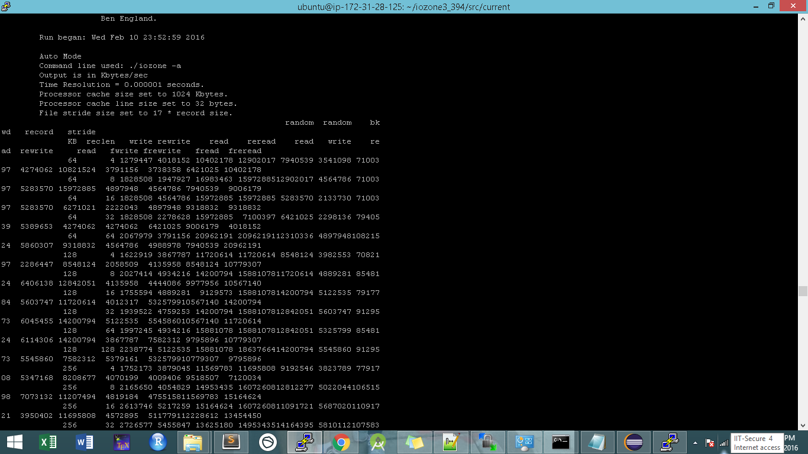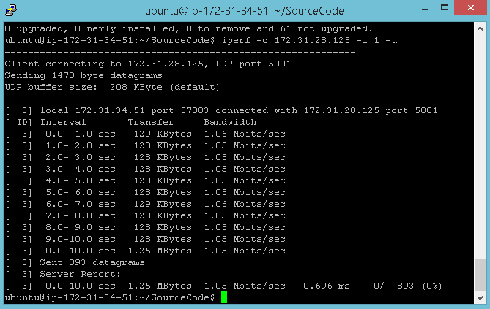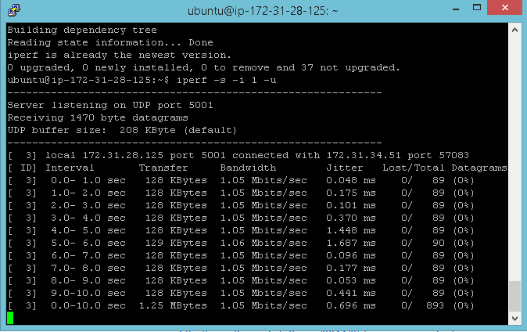

1. Network:

TCP:

Connectionless protocol performance for both throughput is used.

|  |  |  |  |
| --- | --- | --- | --- |
| Data Size | Throughput (Mbits/s) | Latency (ms) | Threads |
| 1 B | 4.086 | 0.023 | 1 |
| 1 KB | 16.97 | 0.581 | 1 |
| 64 KB | 897.03 | 2.801 | 1 |
| 1 B | 5.12 | s | 2 |
| 1 KB | 237.61 | 0.912 | 2 |
| 64 KB | 971.37 | 6.519 | 2 |

UDP:

|  |  |  |  |
| --- | --- | --- | --- |
| Data Size | Throughput (Mbits/s) | Latency (ms) | Threads |
| 1 B | 5.186 | 0.019 | 1 |
| 1 KB | 21.99 | 0.481 | 1 |
| 64 KB | 2602.03 | 2.173 | 1 |
| 1 B | 7.18 | 0.104 | 2 |
| 1 KB | 26.60 | 0.612 | 2 |
| 64 KB | 2106.39 | 5.513 | 2 |

iPerf is used in order to measure the system performance for the network.

