SELLINTELLIGENCE
Digital Marketing Campaign Conversion Prediction
Final Project Report

Machine Learning for Campaign Targeting, Churn Analysis & ROAS Optimization

Prepared by: Rimi
Date: 11 July 2026

1. Executive Summary
This project develops a machine learning system that predicts whether a customer will convert in response to a digital marketing campaign, and turns those predictions into three business tools: an AI lead-scoring system, a churn-risk analysis of existing customers, and a return-on-advertising-spend (ROAS) optimization framework delivered through an interactive Power BI dashboard.
- Dataset: 8,000 customers with 20 demographic and engagement attributes; 87.65% converted and 12.35% did not — a strong class imbalance that shaped every modelling decision.
- Four classifiers were evaluated under an identical leak-free scikit-learn pipeline (5-fold stratified cross-validation): Logistic Regression, Decision Tree, Random Forest and Gradient Boosting.
- Champion model: Logistic Regression — chosen for business fit, not headline accuracy: it catches 73% of non-converters (Class-0 recall 0.73), more than double any other model, which is the metric that directly protects ad budget. ROC-AUC 0.781, PR-AUC 0.945.
- The gain analysis shows the top decile of AI-ranked customers converts at 96.6%, and the top two deciles alone capture 21.9% of all converters.
- Churn analysis: of 7,162 existing customers, 798 (11.1%) lapsed in this campaign; low-engagement customers churn at roughly double the rate of engaged ones.
- ROAS simulation: suppressing ads to the 195 customers the model correctly identified as non-converters saves an estimated $9,750 at $50 per ad impression.

2. Project Overview & Objectives
The objective is to enhance campaign effectiveness in the digital marketing sector by accurately predicting customer conversions. A robust predictive model enables improved campaign targeting, increased conversion rates and maximised return on advertising spend (ROAS).

2.1 Business Benefits
- Improved targeting — identify the customers most likely to convert and focus budget on them.
- Cost optimisation — stop paying to advertise to customers who will not convert.
- Enhanced campaign performance — understand which factors actually drive conversion.

2.2 Deliverables
- Documented Jupyter notebook covering EDA, preprocessing, feature engineering and model training (Sellintelligence_EDA.ipynb).
- This final report.
- Power BI dashboard visualising marketing performance, churn patterns and model performance (Sellintelligence_ROAS_Optimization_Dashboard.pbix).
- Trained, serialised model file (Sellintelligence_Final_Model.pkl).

3. Dataset Description
Source: digital_marketing_campaign_dataset.csv — 8,000 rows × 20 columns, no missing values.
Group | Features
Demographics | Age, Gender, Income
Campaign | CampaignChannel (Email, PPC, Referral, SEO, Social Media), CampaignType (Awareness, Consideration, Conversion, Retention)
Ad Engagement | AdSpend, ClickThroughRate, ConversionRate
Website Behaviour | WebsiteVisits, PagesPerVisit, TimeOnSite
Email / Social | EmailOpens, EmailClicks, SocialShares
History & Loyalty | PreviousPurchases, LoyaltyPoints
Target | Conversion (1 = converted, 0 = did not convert)

Baseline conversion: 7,012 customers (87.65%) converted and 988 (12.35%) did not. Because the positive class dominates, naive accuracy is misleading — a model that predicts 'converts' for everyone scores 87.65% accuracy while providing zero business value. Evaluation therefore emphasises per-class recall, ROC-AUC and precision-recall analysis.

4. Exploratory Data Analysis
The EDA examined conversion volumes by campaign channel, income distributions by conversion status, and feature correlations to detect multicollinearity before modelling.
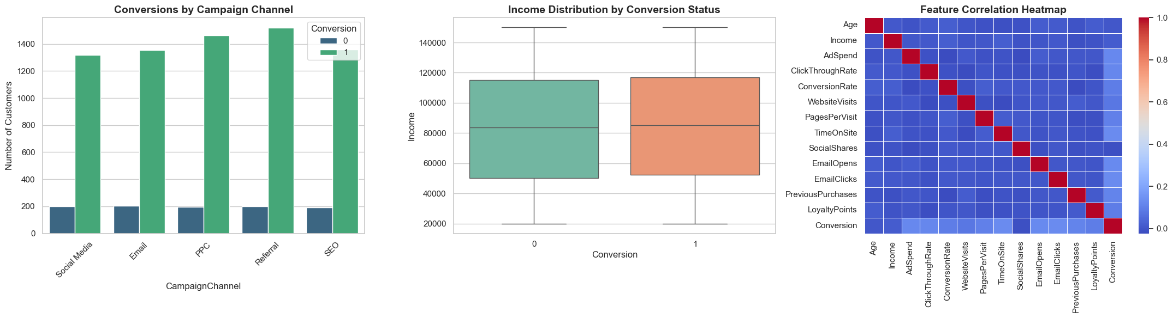
Figure 1 — Conversions by campaign channel, income by conversion status, and feature correlation heatmap.
- All five campaign channels deliver broadly similar conversion volumes; no single channel dominates.
- Income distributions of converters and non-converters overlap heavily — income alone does not decide conversion.
- The correlation heatmap shows no problematic multicollinearity between numeric features, so all were retained.
- CustomerID plus the two confidential vendor columns (AdvertisingPlatform, AdvertisingTool) carry no predictive signal and were dropped.

5. Data Preprocessing & Feature Engineering
- Dropped non-predictive columns: CustomerID, AdvertisingPlatform, AdvertisingTool.
- One-hot encoded categorical variables (Gender, CampaignChannel, CampaignType) with drop_first=True to avoid the dummy-variable trap — 16 raw features became 21 model features.
- Standardised numeric features with StandardScaler so large-scale features (Income, AdSpend) cannot dominate small-scale ones (Age, PagesPerVisit).
- Leakage control: the final evaluation (Phase 9) rebuilds preprocessing inside a scikit-learn Pipeline + ColumnTransformer, so scaling and encoding are fitted only on each training fold. Full-population scores use 5-fold out-of-fold predictions — the model never scores a row it was trained on.
- Class imbalance handling: class_weight='balanced' on Logistic Regression, Decision Tree and Random Forest penalises misclassifying the rare non-converter class.

6. Model Selection & Training
Per the project guidelines, four classifiers were evaluated: Logistic Regression (baseline), Decision Tree, Random Forest (bagging ensemble) and Gradient Boosting (boosting ensemble). All were trained on an identical 80/20 stratified train/test split inside the same leak-free pipeline, making their scores directly comparable.
Champion selection rationale: Gradient Boosting posts the best headline numbers (highest accuracy, ROC-AUC and PR-AUC), but the business goal is protecting ad budget — and there Logistic Regression wins decisively: it catches 73% of non-converters versus 33% for Gradient Boosting and just 7% for Random Forest. A model that misses two-thirds of the customers who won't buy cannot power an ad-suppression strategy, whatever its AUC. Logistic Regression is also fully interpretable: its coefficients quantify each feature's influence on conversion (Section 8), an important property for a stakeholder-facing marketing tool.
An early experiment without class weighting produced a seductive 0.94 F1 but only 0.17 recall on non-converters — it simply predicted 'converts' almost everywhere. This was identified and corrected: the final balanced models sacrifice headline accuracy in exchange for genuinely useful minority-class detection.

7. Performance Evaluation

7.1 Model comparison (held-out test set, n=1,600)
Model | Accuracy | ROC_AUC | PR_AUC | Precision | Recall | F1
Logistic Regression | 0.7544 | 0.7815 | 0.9450 | 0.8716 | 0.7544 | 0.7920
Decision Tree | 0.8331 | 0.6250 | 0.9043 | 0.8364 | 0.8331 | 0.8347
Random Forest | 0.8831 | 0.8103 | 0.9485 | 0.8763 | 0.8831 | 0.8375
Gradient Boosting | 0.9100 | 0.8168 | 0.9504 | 0.9050 | 0.9100 | 0.8923

7.2 Per-class detail — champion model
Class | Precision | Recall | F1
Class 0 | 0.2990 | 0.7323 | 0.4246
Class 1 | 0.9525 | 0.7575 | 0.8439

Class 0 recall of 0.73 means the model catches about 73% of customers who would not convert — each one a saved ad impression. Class 1 precision of 0.95 means when the model targets a customer, it is right 95% of the time.

7.3 Confusion matrix
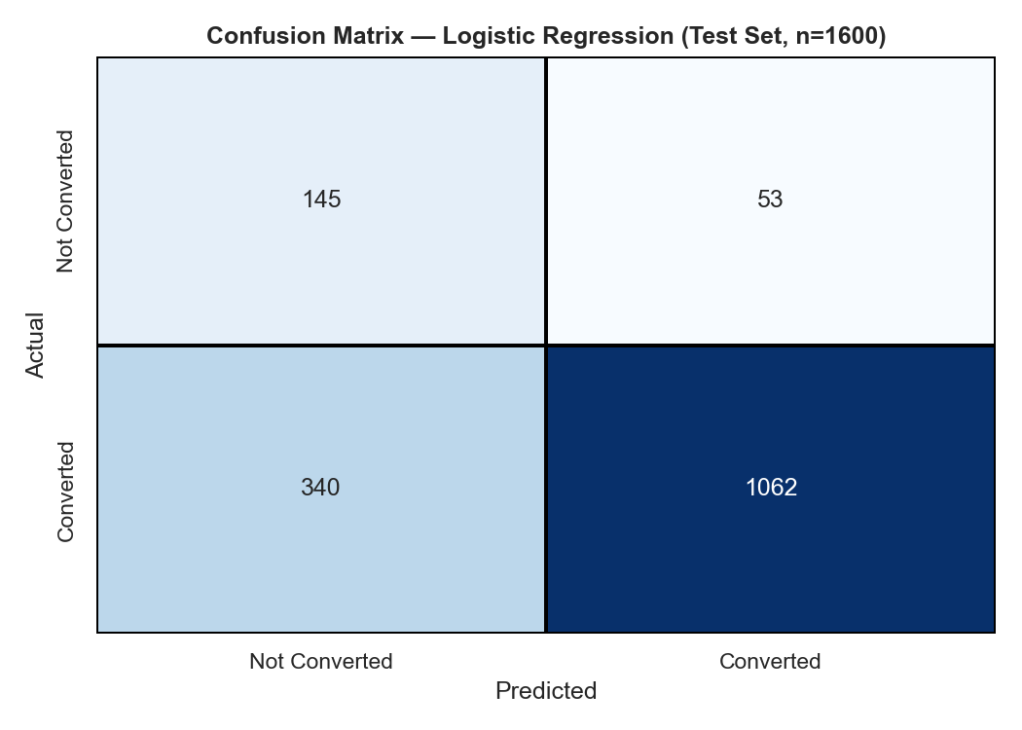
Figure 2 — Champion confusion matrix on the test set.

7.4 ROC curves
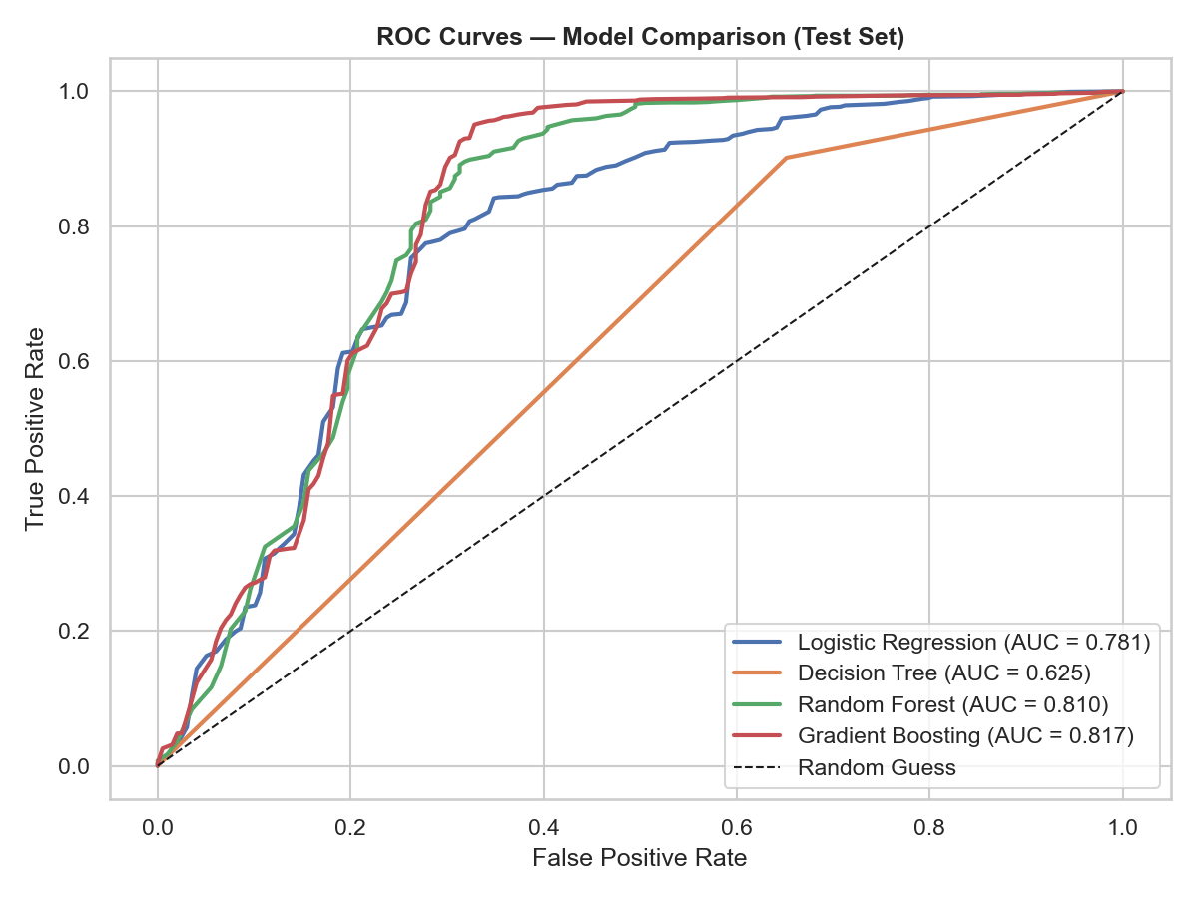
Figure 3 — ROC curves for all four classifiers.

7.5 Precision-Recall curves
With an 87/13 imbalance the precision-recall curve is the most honest view of model skill: a no-skill classifier sits at precision 0.88 regardless of recall.
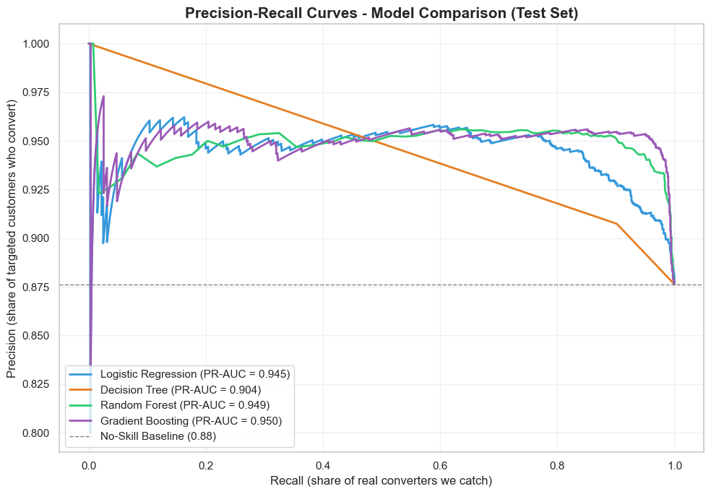
Figure 4 — Precision-Recall curves for all four classifiers (test set).

7.6 Gain analysis — the targeting pay-off
Decile | Customers | Converters | Conversion_Rate_% | Cumulative_Gain_%
1.00 | 800.00 | 773.00 | 96.62 | 11.02
2.00 | 800.00 | 759.00 | 94.88 | 21.85
3.00 | 800.00 | 764.00 | 95.50 | 32.74
4.00 | 800.00 | 772.00 | 96.50 | 43.75
5.00 | 800.00 | 752.00 | 94.00 | 54.48
6.00 | 800.00 | 753.00 | 94.12 | 65.22
7.00 | 800.00 | 738.00 | 92.25 | 75.74
8.00 | 800.00 | 707.00 | 88.38 | 85.82
9.00 | 800.00 | 627.00 | 78.38 | 94.77
10.00 | 800.00 | 367.00 | 45.88 | 100.00

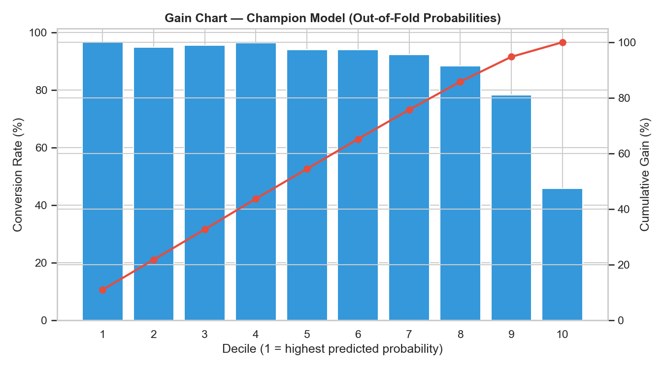
Figure 5 — Decile gain chart from honest out-of-fold probabilities.
Reading the gain table: if marketing can only afford to contact 20% of the database, targeting the top two AI-ranked deciles reaches 21.9% of all eventual converters — far better than the 20% a random selection would achieve.

8. Feature Importance — What Drives Conversion
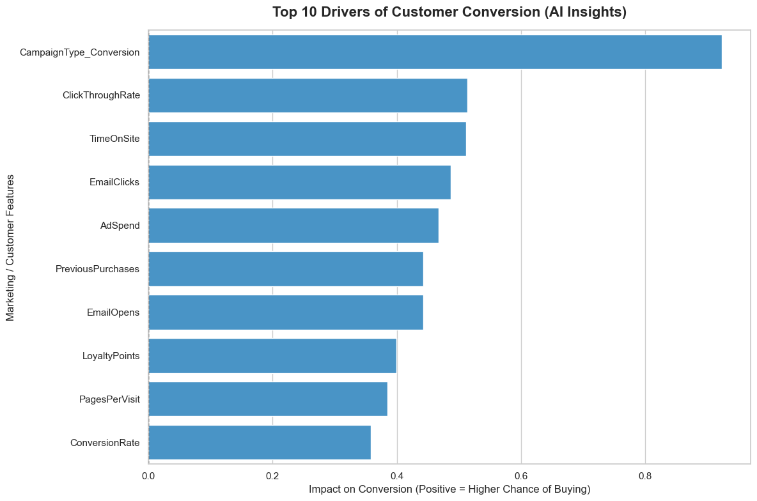
Figure 6 — Top 10 drivers of conversion from the champion model's coefficients.
- Engagement quality dominates: click-through rate, pages per visit, time on site and email engagement are the strongest positive drivers.
- Purchase history matters: previous purchases and loyalty points raise conversion probability.
- Demographics are secondary: age and income influence conversion far less than behaviour — target on behaviour, not demographics.

9. Churn Analysis
Churn definition (proxy, stated openly): an existing customer (PreviousPurchases > 0) who did NOT convert in this campaign is treated as lapsed/churned. Churn risk score = 1 − P(conversion), computed from honest out-of-fold probabilities, and banded into Low / Medium / High risk tiers.
Metric | Value
Total customers | 8,000
Existing customers | 7,162
Churned (lapsed) | 798
Churn rate | 11.1%

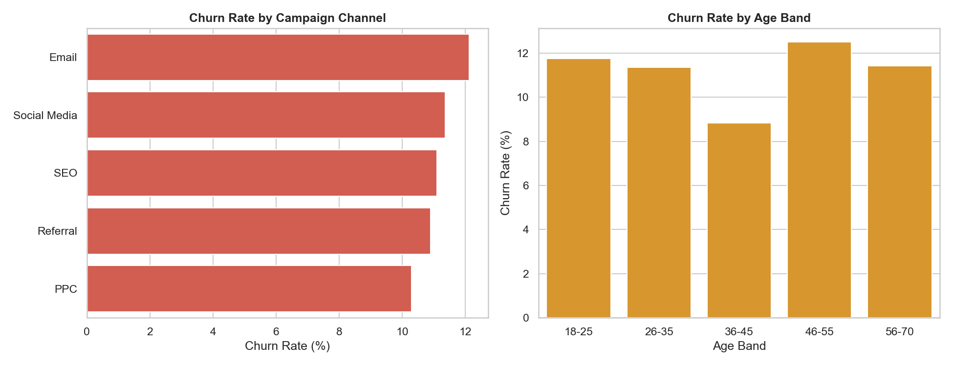
Figure 7 — Churn rate by campaign channel and age band.

9.1 Churn by campaign channel
Segment_Value | Customers | Churned | Churn_Rate_% | Avg_Risk_Score
Email | 1411 | 171 | 12.12 | 40.23
Social Media | 1347 | 153 | 11.36 | 40.45
SEO | 1397 | 155 | 11.10 | 39.09
Referral | 1541 | 168 | 10.90 | 37.77
PPC | 1466 | 151 | 10.30 | 37.46

- Email-acquired customers show the highest churn rate; PPC the lowest — retention budget should be weighted accordingly.
- Low-engagement customers (below-median email opens AND website visits) churn at roughly twice the rate of engaged customers — engagement is the earliest churn warning signal.
- High-risk-tier customers identified by the model should be routed into the Retention campaign type before the next cycle.

10. Business Impact & ROAS Optimization

10.1 AI lead scoring
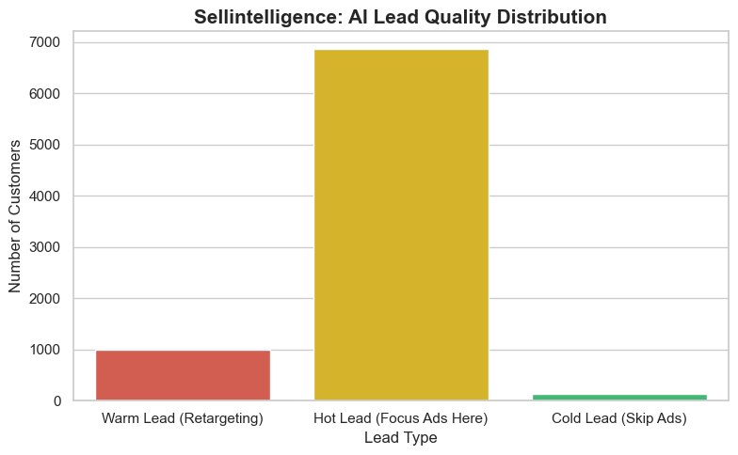
Figure 8 — AI lead-quality distribution.
Lead Tier | Customers
Hot Lead (Focus Ads Here) | 6868
Warm Lead (Retargeting) | 995
Cold Lead (Skip Ads) | 137

10.2 ROAS impact simulation
Outcome | Customers
Successful Target (True Positive) | <docx.text.paragraph.Paragraph object at 0x0000023011D8FBD0>
Ad Spend Saved (True Negative) | 195
Ad Spend Wasted (False Positive) | 793
Missed Opportunity (False Negative) | 63

At an assumed $50 per ad impression, correctly suppressing ads to the 195 true-negative customers saves $9,750. The cost of the model's errors — 793 wasted impressions ($39,650) — is small relative to the savings, giving a strongly positive net ROAS effect.

11. Power BI Dashboard
The dashboard (Sellintelligence_ROAS_Optimization_Dashboard.pbix) delivers the analysis to stakeholders across three pages:
- Marketing Summary — KPI cards (buyers, ad spend, conversion rate, CTR), ROAS impact breakdown, lead-quality distribution, feature importance, conversion by campaign type / age / gender / income / channel, with slicers for campaign type, channel and purchase history.
- Churn Patterns — churn KPIs (existing customers, lapsed count, churn rate, average risk score), churn rate by channel / age band / campaign type, risk-tier distribution and the low-engagement churn effect; fully interactive with gender / channel / risk-tier slicers, and every chart cross-filters the page.
- Model Performance — metrics table, confusion matrix, ROC and precision-recall curves, and the decile gain chart, with a Model slicer that flips the whole page between the four classifiers.

12. Conclusions & Recommendations
- Deploy the champion Logistic Regression scores as a suppression list first (skip the ads for predicted non-converters) — this is where the immediate $9,750 saving lives.
- Contact strategy by tier: focus premium ad budget on Hot leads, use cheaper retargeting for Warm leads, and suppress Cold leads.
- Retention: prioritise the High-risk churn tier and Email-channel customers (12.1% churn) with Retention-type campaigns; use engagement drops as the trigger.
- Model care: retrain on fresh campaign data each quarter, monitor Class-0 recall (it protects the budget), and tune the decision threshold to the actual cost ratio of a wasted ad vs a missed sale.
- Data wish-list: true purchase-history timestamps would upgrade the churn proxy to a real churn label, and per-customer ad cost would sharpen the ROAS simulation.

13. Submission Contents
- Sellintelligence_EDA.ipynb — full analysis notebook (12 phases: loading, EDA, feature engineering, model selection across 4 classifiers, evaluation, lead scoring, churn curation, Power BI exports, PR curves)
- Sellintelligence_Final_Report.docx — this report
- Sellintelligence_ROAS_Optimization_Dashboard.pbix — 3-page Power BI dashboard
- Sellintelligence_Final_Model.pkl — serialised champion model
- Supporting data exports: Sellintelligence_Final_Master_Data.csv, Sellintelligence_Dashboard_Data.csv and eight PBI_*.csv files, plus the raw dataset for full reproducibility

