Geographic Transportability of Genome-Based Antibiotic Resistance Prediction in Mycobacterium tuberculosis: A South Asian Evaluation
Rimjhim Dey · Thesis Course, 8th Semester · October 2026
Code and data pipeline: github.com/RimjhimD/Genome-Based-Antibiotic-Resistance-Prediction-TB
Abstract. Machine learning models predict antibiotic resistance in M. tuberculosis from the genome in days rather than the weeks laboratory testing needs, but they are trained mostly on lineage 2 and 4 strains, while lineages 1 and 3 dominate South Asia. Using the public CRyPTIC dataset of 12,287 isolates with laboratory-confirmed resistance, we built a binary feature matrix of 1,021 mutations in 23 WHO-catalogue resistance genes and trained logistic regression, random forest, gradient boosting and a shallow neural network for eight drugs. Models were evaluated with a random split, a South Asia holdout (trained only on non-South-Asian isolates, tested on 2,162 isolates from India, Pakistan and Nepal) and leave-one-country-out, with transmission clusters kept on one side of every split, and benchmarked against the WHO 2023 mutation catalogue. Aggregate performance transferred well: AUC on South Asian isolates fell by at most 0.018 when South Asian data were withheld from training. Stratifying by lineage told a different story. Resistant lineage 1 and lineage 3 isolates were detected less often than lineage 2 isolates, with non-overlapping 95% confidence intervals for isoniazid, rifampicin, levofloxacin and moxifloxacin (for example levofloxacin sensitivity 53.6% on lineage 1 against 93.8% on lineage 2), and this deficit was shared by models that had seen South Asian data and by the WHO catalogue, which uses no training data at all. The weakness is therefore in what is known about resistance in these lineages, not only in where the training data came from. Region-specific failures were also found: ethambutol resistance in a South Asian lineage 2 group carrying embC A387V and embB Q445R, mutations absent or nearly absent among resistant training isolates, was missed in 36 isolates.
Keywords: antimicrobial resistance · tuberculosis · whole-genome sequencing · machine learning · lineage · model generalisation · South Asia
Summary in plain language. Tuberculosis (TB) bacteria can become resistant to antibiotics through small changes (mutations) in their DNA. Computer models can read these mutations and say which drugs will fail, in days instead of the weeks a laboratory test takes. TB bacteria come in families called lineages. Most models were built from lineages 2 and 4, common in Europe and East Asia, while South Asia (including Bangladesh) has mostly lineages 1 and 3. We asked: do these models still work on South Asian TB? We trained four kinds of model only on isolates from outside South Asia (5,479–7,595 per drug) and tested them on 2,162 isolates from India, Pakistan and Nepal. Overall they worked about as well as usual. But for lineage 1 and lineage 3 bacteria they missed many more resistant cases — for levofloxacin, about half of resistant lineage 1 cases were missed, against about 6% for lineage 2. The official WHO mutation list misses the same cases, so the problem is that the resistance mutations of these South Asian lineages are not yet well known. Missing a resistant case means a patient may get a drug that will not work, so South Asia needs resistance knowledge built from its own lineages.

1. Introduction
Tuberculosis remains among the leading infectious causes of death, and drug resistance is the main obstacle to treating it. Culture-based drug-susceptibility testing takes weeks. Whole-genome sequencing offers a faster route: resistance in M. tuberculosis arises almost entirely from chromosomal mutations, so a model that knows which mutations matter can read resistance off the genome. The WHO mutation catalogue (2021, updated 2023) [2] and machine learning classifiers built on large collections such as CRyPTIC [1] report high accuracy for first-line drugs [11].
That accuracy is measured on strains like those the models were built from. The M. tuberculosis complex is divided into lineages with distinct geography: lineages 2 and 4 dominate East Asia, Europe and the Americas, while lineages 1 and 3 predominate in South Asia, including India [8]. Resistance knowledge is biased toward the globally dominant lineages [8], and China built a national catalogue because the global one under-performed locally [6]. No comparable evaluation exists for South Asia.
Research question. Do genome-based resistance models still work on South Asian strains, and if not, which resistance cases do they miss? This report presents the full pilot study: data preparation, feature construction, leakage-controlled evaluation under three protocols, a WHO catalogue benchmark and an error analysis by lineage.

2. Related work
First-line prediction is mature: published models reach AUC of about 0.99 for rifampicin and 0.98 for isoniazid, and most report at least 90% sensitivity for isoniazid [11]. The WHO catalogue [2] is the clinical reference, implemented in tools such as TB-Profiler and Mykrobe. MIC regression on CRyPTIC has been published for 13 drugs [7]. The Farhat group's GenTB [3] and their study of geographic heterogeneity [4] are the closest prior work on cross-region transfer. Lineage dependence has been addressed by feature reweighting (FW-RF) [5] and by China's national catalogue [6]. Recent benchmarks [9, 10] name second-line and newer drugs as the open problems. What remains untested is a lineage-resolved evaluation on South Asian isolates with transmission-aware splits, and that is the contribution here.

3. Data
Source. CRyPTIC consortium, release June 2022 [1], public EBI FTP. We used the reuse table of 12,287 isolates with binary resistant/susceptible phenotypes from UKMYC microtitre plates, the per-isolate mutation table (MUTATIONS_GPI), sample metadata for country, Mykrobe lineage calls and the consortium's precomputed pairwise SNP distances.
Labels. Phenotypes with LOW reading quality, intermediate (I) calls and missing values were excluded per drug. Eight drugs had enough resistant isolates in both regions: isoniazid (INH), rifampicin (RIF), ethambutol (EMB), ethionamide (ETH), levofloxacin (LEV), moxifloxacin (MXF), kanamycin (KAN) and amikacin (AMI). Bedaquiline, delamanid, linezolid and clofazimine were dropped for too few resistant cases.
Country. Country of sampling was taken from the sample table, falling back to the collecting site where that site only serves its own country. Isolates collected by the multi-country reference laboratories in Gauting and Milan without a recorded country (1,137) were excluded from every protocol, leaving 11,150. The South Asian test set is 2,162 isolates: India 1,476, Pakistan 489 and Nepal 197.
Correction to the topic form. The topic form quoted 5,907 South Asian isolates. That figure counted every South Asian sample in the CRyPTIC metadata, including samples with no resistance phenotype. The isolates with laboratory resistance labels number 2,162, and all results here use that set.
Lineage shift. The two populations differ sharply (Figure 1). Lineages 1 and 3 make up 13% and 37% of South Asian isolates, against 4% and 2% of the rest; lineage 4 is 56% of the rest but 14% of South Asia.
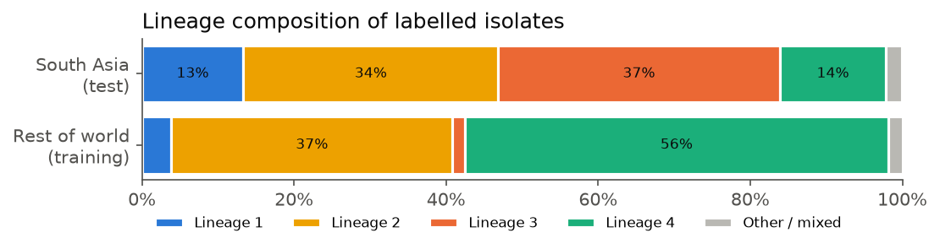
Figure 1. Lineage composition of labelled isolates with a known country.

4. Methods

4.1 Features
Candidate genes were the WHO 2023 catalogue tier 1 and 2 genes for the eight drugs (23 genes: rpoB, rpoA, rpoC, katG, inhA, fabG1, ahpC, mshA, ndh, kasA, embB, embA, embC, embR, ubiA, ethA, ethR, gyrA, gyrB, rrs, eis, whiB7, tlyA, including promoter regions). Calls failing the variant filter, null calls and heterozygous calls were removed, as were synonymous changes except in fabG1, where L203L is a graded resistance mutation. Each remaining mutation became one binary feature, with indels encoded by position, direction and length, plus one loss-of-function feature per gene (any frameshift or premature stop). Mutations seen in fewer than three isolates were dropped, giving 1,021 features. No raw reads were processed.

4.2 Leakage control
Closely related isolates on both sides of a split inflate accuracy. Isolates within 12 SNPs of each other were linked using CRyPTIC's precomputed distances, and transmission clusters were taken as connected components. Links were only allowed between isolates of the same single Mykrobe lineage: with mixed-lineage samples acting as bridges, single linkage had chained lineage 2 and lineage 4 into one 2,539-isolate component, which cannot be a transmission chain. The final grouping has 7,875 clusters (6,721 singletons, largest 562). In every protocol whole clusters are kept on one side; in the holdout protocols any training isolate sharing a cluster with a test isolate is removed.

4.3 Models
Four classifiers were trained per drug: L2 logistic regression (class-balanced), random forest (300 trees, class-balanced), gradient-boosted trees (XGBoost, 300 trees, depth 4, positive-class weighting) and a shallow neural network (two hidden layers of 64 and 32 units, early stopping). Hyperparameters were fixed in advance, not tuned on test data, and the decision threshold was 0.5. All training ran on a CPU.

4.4 Evaluation protocols
- Random split. Five-fold cross-validation over all 11,150 isolates with a known country, stratified by label and grouped by transmission cluster. Out-of-fold predictions are scored on all isolates and on the South Asian subset. This is the setting in which South Asian strains are represented in training.
- South Asia holdout. Train only on non-South-Asian isolates and test on the South Asian isolates. Comparing this with the South Asian subset of protocol 1 gives the cost of never having seen the region, measured on the same isolates.
- Leave-one-country-out. Each country with at least 150 labelled isolates is held out in turn.
The best model per drug was chosen by random-split AUC on all isolates, so the choice never looks at the holdout. Metrics are sensitivity (share of resistant isolates detected; its complement is the very major error rate, the clinically dangerous miss), specificity, AUC and F1.

4.5 WHO catalogue benchmark
The WHO 2023 catalogue [2] (v2, in the GARC grammar maintained by the Oxford group behind CRyPTIC) was applied to the same mutation calls: an isolate is called resistant if it carries any mutation graded group 1 or 2 for that drug, including codon wildcards, gene-level frameshift and stop rules, and indel rules. Applied to all isolates, our implementation gives sensitivity/specificity of about 96%/95% for rifampicin and 93%/98% for isoniazid, in line with published CRyPTIC figures.

5. Results

5.1 Aggregate performance transfers
Table 1 compares, on the same South Asian isolates, models that saw South Asian data in training (random split) with models that did not (holdout). AUC moved by at most 0.018. Sensitivity dropped most for ethambutol (6.0 percentage points) and ethionamide (5.6 points), and by two points or less for isoniazid, rifampicin and the fluoroquinolones. For kanamycin and amikacin the holdout models raised sensitivity but lost about 10 points of specificity with unchanged AUC: the ranking of isolates stayed the same while the operating point shifted, a calibration effect rather than lost knowledge. Against the WHO catalogue, the models were within 1.5 points of its sensitivity for isoniazid, rifampicin and the fluoroquinolones (the catalogue slightly ahead), and clearly more sensitive for ethambutol, ethionamide, kanamycin and amikacin (by 1.5 to 14 points), at a cost in specificity for the aminoglycosides.
Table 1. Performance on South Asian isolates. "Random" = random split (South Asian isolates represented in training); "holdout" = trained only on non-South-Asian isolates. Best model per drug chosen on random-split AUC.
Drug | Model | Test isolates | Resistant | Sens. random | Sens. holdout | Spec. random | Spec. holdout | AUC random | AUC holdout | Sens. WHO | Spec. WHO
INH | LR | 1927 | 1281 | 94.9% | 94.1% | 96.0% | 96.0% | 0.968 | 0.966 | 94.5% | 95.7%
RIF | LR | 1893 | 1215 | 95.1% | 94.7% | 92.3% | 92.8% | 0.964 | 0.963 | 96.0% | 90.1%
EMB | LR | 1314 | 615 | 94.0% | 88.0% | 85.7% | 87.1% | 0.945 | 0.944 | 86.5% | 86.1%
ETH | XGB | 1692 | 337 | 81.6% | 76.0% | 86.7% | 89.4% | 0.909 | 0.891 | 69.4% | 92.0%
LEV | XGB | 1569 | 656 | 87.3% | 86.0% | 90.1% | 92.8% | 0.925 | 0.928 | 87.3% | 92.2%
MXF | XGB | 1527 | 507 | 92.3% | 90.3% | 85.4% | 84.7% | 0.930 | 0.928 | 91.5% | 83.2%
KAN | RF | 1914 | 147 | 73.5% | 80.3% | 86.5% | 76.5% | 0.864 | 0.862 | 66.0% | 96.9%
AMI | RF | 1940 | 124 | 66.9% | 74.2% | 92.5% | 81.0% | 0.865 | 0.859 | 61.3% | 98.8%
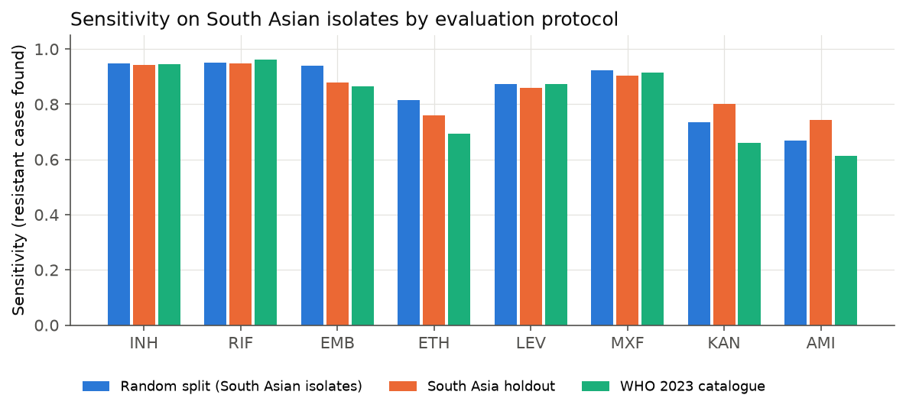
Figure 2. Sensitivity on South Asian isolates under the three settings.
Figure 3 gives the full confusion matrices for the holdout. The clinically dangerous cell is true resistant predicted susceptible (top right): 5% to 6% of resistant isolates for isoniazid and rifampicin, rising to about a quarter for ethionamide and amikacin. For kanamycin and amikacin the larger error by count is the opposite one, susceptible isolates called resistant (bottom left), which is the specificity loss described above.
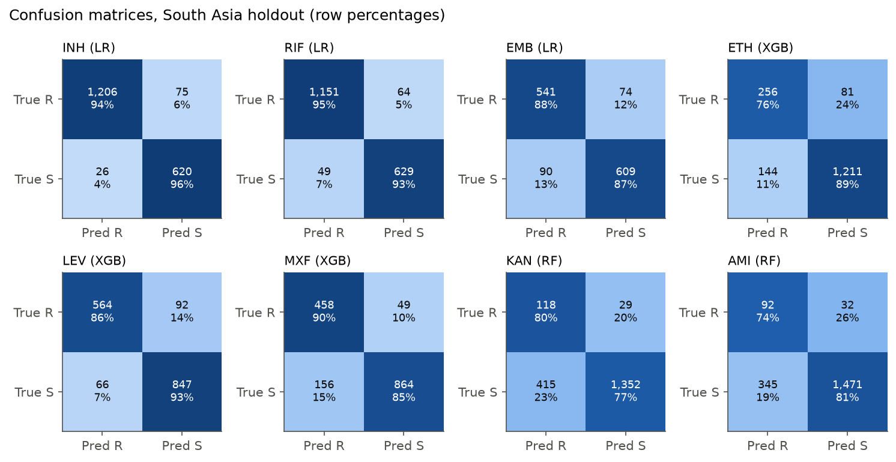
Figure 3. Confusion matrices for the South Asia holdout, best model per drug. Counts with row percentages.

5.2 Lineages 1 and 3 are where resistance is missed
The aggregate hides a consistent pattern (Table 2, Figure 4). For every drug the worst-detected lineage was lineage 1 or lineage 3, and for six of the eight drugs lineage 2 was detected best. In the holdout, isoniazid sensitivity was 83.6% on lineage 1 against 99.2% on lineage 2; levofloxacin 53.6% against 93.8%; moxifloxacin 53.8% against 95.2%; ethionamide 61.1% on lineage 3; and amikacin 65.6% on lineage 3. Some of these groups are small, so Table 2 gives 95% confidence intervals (Wilson score). For isoniazid, rifampicin, levofloxacin and moxifloxacin the interval for the worst lineage does not overlap the lineage 2 interval, so the gap is clear. For ethambutol, ethionamide, kanamycin and amikacin the gap points the same way but the intervals overlap, so it is suggestive rather than established.
The deciding comparison is between the three columns. If the deficit came from training on foreign strains, the random-split models, which did see South Asian lineage 1 and 3 isolates, should recover it. They mostly do not: lineage 1 levofloxacin sensitivity is 60.7% with South Asian data in training, and the WHO catalogue, which has no training step, reaches 53.6%. The low sensitivity on lineages 1 and 3 is shared by all three, so it reflects the resistance mutations that are known, not only the origin of the training data. Training on foreign strains adds a smaller, drug-specific loss on top: moxifloxacin on lineage 1 (+15.4 points, but only 13 resistant isolates), and ethambutol and ethionamide on lineage 2 (+8.7 and +11.4 points).
Table 2. Sensitivity on resistant South Asian isolates by lineage (lineages with at least 10 resistant isolates). "Random − holdout" is the loss from withholding South Asian isolates from training.
Drug | Lineage | Resistant isolates | Sens. random | Sens. holdout | 95% CI (holdout) | Sens. WHO | Random − holdout
INH | L1 | 73 | 87.7% | 83.6% | 73%–90% | 86.3% | +4.1 pp
INH | L2 | 616 | 99.2% | 99.2% | 98%–100% | 99.0% | +0.0 pp
INH | L3 | 414 | 92.8% | 91.1% | 88%–93% | 91.8% | +1.7 pp
INH | L4 | 154 | 94.2% | 94.2% | 89%–97% | 94.2% | +0.0 pp
RIF | L1 | 58 | 84.5% | 87.9% | 77%–94% | 89.7% | -3.4 pp
RIF | L2 | 629 | 99.0% | 99.0% | 98%–100% | 99.4% | +0.0 pp
RIF | L3 | 372 | 92.7% | 90.9% | 87%–93% | 94.4% | +1.9 pp
RIF | L4 | 135 | 97.0% | 97.0% | 93%–99% | 97.0% | +0.0 pp
EMB | L1 | 23 | 73.9% | 78.3% | 58%–90% | 65.2% | -4.3 pp
EMB | L2 | 401 | 99.3% | 90.5% | 87%–93% | 88.5% | +8.7 pp
EMB | L3 | 113 | 85.0% | 82.3% | 74%–88% | 86.7% | +2.7 pp
EMB | L4 | 66 | 92.4% | 92.4% | 83%–97% | 90.9% | +0.0 pp
ETH | L1 | 43 | 86.0% | 88.4% | 76%–95% | 86.0% | -2.3 pp
ETH | L2 | 202 | 89.1% | 77.7% | 71%–83% | 72.3% | +11.4 pp
ETH | L3 | 36 | 52.8% | 61.1% | 45%–75% | 52.8% | -8.3 pp
ETH | L4 | 48 | 79.2% | 77.1% | 63%–87% | 64.6% | +2.1 pp
LEV | L1 | 28 | 60.7% | 53.6% | 36%–70% | 53.6% | +7.1 pp
LEV | L2 | 371 | 94.6% | 93.8% | 91%–96% | 94.6% | +0.8 pp
LEV | L3 | 171 | 80.7% | 77.8% | 71%–83% | 80.1% | +2.9 pp
LEV | L4 | 73 | 83.6% | 84.9% | 75%–91% | 87.7% | -1.4 pp
MXF | L1 | 13 | 69.2% | 53.8% | 29%–77% | 69.2% | +15.4 pp
MXF | L2 | 352 | 96.9% | 95.2% | 92%–97% | 94.9% | +1.7 pp
MXF | L3 | 70 | 81.4% | 78.6% | 68%–87% | 84.3% | +2.9 pp
MXF | L4 | 63 | 90.5% | 90.5% | 81%–96% | 92.1% | +0.0 pp
KAN | L2 | 80 | 88.8% | 91.2% | 83%–96% | 72.5% | -2.5 pp
KAN | L3 | 36 | 58.3% | 75.0% | 59%–86% | 58.3% | -16.7 pp
KAN | L4 | 20 | 80.0% | 85.0% | 64%–95% | 80.0% | -5.0 pp
AMI | L2 | 66 | 77.3% | 86.4% | 76%–93% | 66.7% | -9.1 pp
AMI | L3 | 32 | 59.4% | 65.6% | 48%–80% | 56.2% | -6.2 pp
AMI | L4 | 16 | 81.2% | 81.2% | 57%–93% | 75.0% | +0.0 pp
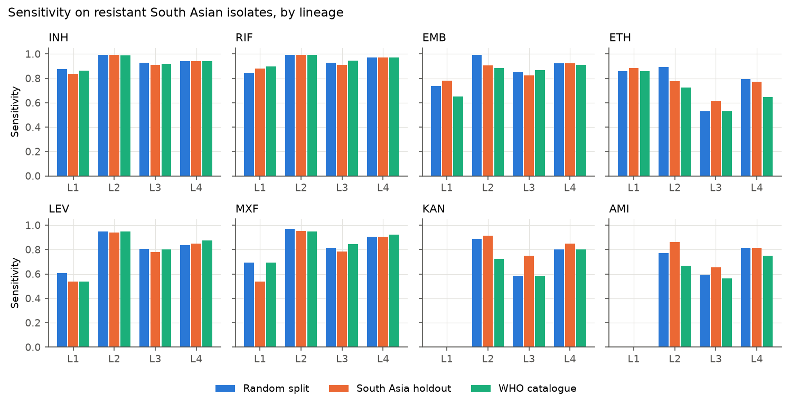
Figure 4. Sensitivity on resistant South Asian isolates by lineage under each setting.

5.3 Leave-one-country-out
Holding out one country at a time (Table 3, Figure 5) shows the same geography of failure. Isoniazid and rifampicin transfer to every country at 0.83 or above, while ethambutol falls to 0.52 for Peru. Second-line sensitivity collapses for Vietnam (levofloxacin 0.50, moxifloxacin 0.46, amikacin 0.10), which also has a sizeable lineage 1 population, and is weak for China, Pakistan and India on the injectable drugs. The South Asian countries sit in the middle: India and Nepal transfer well for first-line drugs, while Pakistan loses ground on ethionamide, the fluoroquinolones and the aminoglycosides. Small held-out sets (for example amikacin in Brazil) give unstable estimates.
Table 3. Leave-one-country-out sensitivity of the best model (blank: fewer than 10 resistant isolates).
Held-out country | INH | RIF | EMB | ETH | LEV | MXF | KAN | AMI
BRA | 0.86 | 0.86 | 0.96 | 1.00 |  |  |  | 0.20
CHN | 0.83 | 0.85 | 0.78 | 0.52 | 0.69 | 0.71 | 0.62 | 0.48
DEU | 1.00 | 0.99 |  | 0.84 | 1.00 |  | 0.85
IND | 0.95 | 0.95 | 0.88 | 0.83 | 0.89 | 0.93 | 0.70 | 0.59
ITA | 0.99 | 0.94 | 0.95 | 0.95 | 0.86 | 0.84 | 0.75 | 0.92
NPL | 1.00 | 1.00 |  |  | 0.95
PAK | 0.91 | 0.93 | 0.95 | 0.73 | 0.77 | 0.75 | 0.76 | 0.69
PER | 0.93 | 0.94 | 0.52 | 0.79 | 0.65 | 0.69 | 0.83 | 0.85
SWE | 1.00 | 0.99 | 0.96 | 0.95 | 0.94 | 0.92 | 0.94 | 0.88
VNM | 0.94 | 0.89 | 0.84 | 0.74 | 0.50 | 0.46 |  | 0.10
ZAF | 0.87 | 0.89 | 0.92 | 0.84 | 0.86 | 0.88 | 0.78 | 0.92
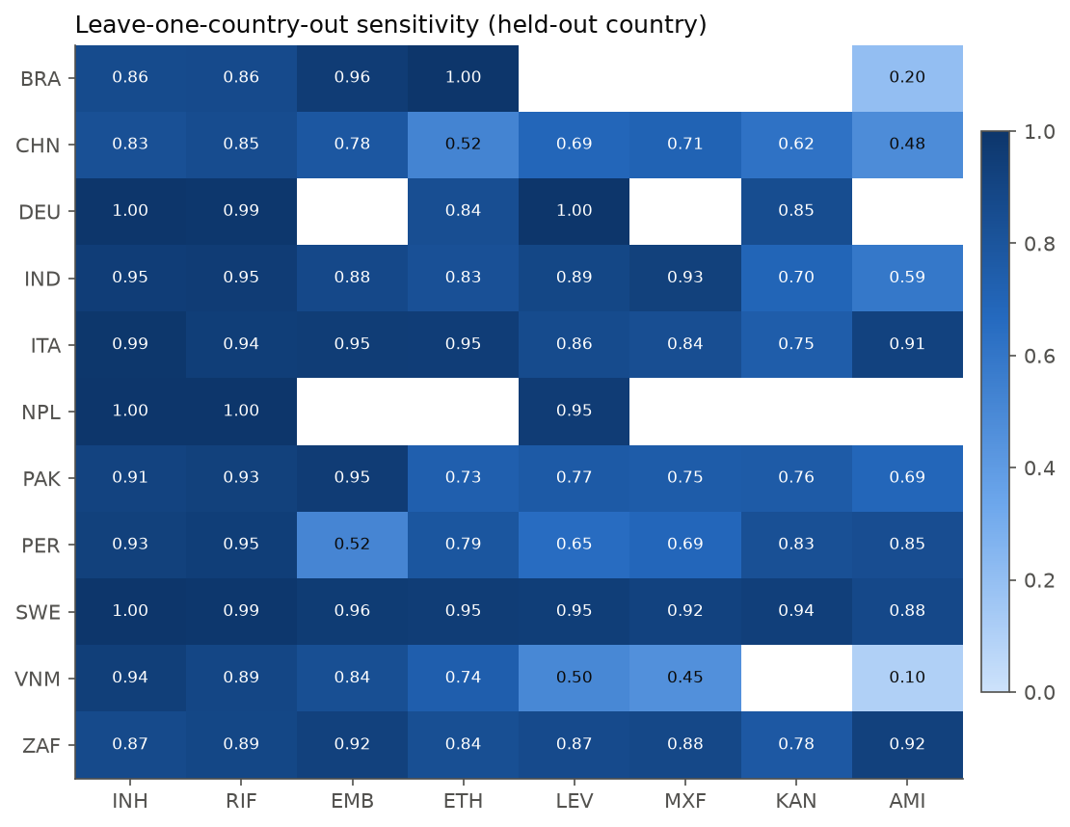
Figure 5. Leave-one-country-out sensitivity.

5.4 What the missed isolates carry
Most resistant South Asian isolates the models missed were also missed by the WHO catalogue (Table 4), which again points to a gap in known determinants rather than a modelling failure. For kanamycin and amikacin, about 70% of missed isolates carried no mutation at all in the drugs' candidate genes, consistent with mechanisms outside these genes or with phenotyping error near the breakpoint.
Table 4. Resistant South Asian isolates missed by the best model in the holdout.
Drug | Resistant, missed | Resistant, found | Missed with no mutation in the drug's genes | Missed that WHO also misses
INH | 75 | 1206 | 8 | 69
RIF | 64 | 1151 | 18 | 45
EMB | 74 | 541 | 9 | 65
ETH | 81 | 256 | 21 | 79
LEV | 92 | 564 | 0 | 82
MXF | 49 | 458 | 0 | 37
KAN | 29 | 118 | 21 | 26
AMI | 32 | 92 | 22 | 30
Table 5 lists mutations carried by at least three missed isolates but by fewer than ten resistant training isolates. Two are clearly regional. embC A387V (36 missed isolates) and embB Q445R (34) occur in a South Asian lineage 2 group and are absent or near-absent among resistant training isolates; they likely account for much of the ethambutol loss on lineage 2. embB Q445R is carried by only four resistant and no susceptible training isolates. Lineage 1 fluoroquinolone misses carry gyrA A384V and gyrB M291I, which appear in hundreds of susceptible training isolates: these are lineage 1 markers, not resistance mutations. The WHO catalogue also misses 82 of the 92 levofloxacin-resistant isolates the model missed, so for most of them no graded resistance mutation is present. Isoniazid misses in lineages 1 and 3 include ahpC t-76a and katG T380I, unseen in training.
Table 5. Mutations in missed South Asian isolates that are rare among resistant training isolates.
Drug | Mutation | Missed SA isolates carrying it | Lineage(s) | Resistant training carriers | Susceptible training carriers
EMB | embC_A387V | 36 | Lineage 2 | 0 | 0
EMB | embB_Q445R | 34 | Lineage 2 | 4 | 0
EMB | embC_R738Q | 20 | Lineage 3 | 3 | 83
EMB | embA_V206M | 3 | Lineage 1 | 2 | 161
ETH | ethA_C137R | 3 | Lineage 2 | 0 | 1
INH | ahpC_t-76a | 5 | Lineage 3 | 0 | 0
INH | katG_T380I | 3 | Lineage 1 | 0 | 0
LEV | gyrA_A384V | 13 | Lineage 1 | 7 | 270
LEV | gyrB_M291I | 13 | Lineage 1 | 7 | 266
LEV | gyrA_c-34t | 6 | Lineage 1 | 3 | 33
LEV | gyrB_N499T | 3 | Lineage 2,Lineage 4 | 3 | 0
MXF | gyrA_A384V | 6 | Lineage 1 | 4 | 228
MXF | gyrB_M291I | 6 | Lineage 1 | 4 | 225
RIF | rpoC_P601L | 6 | Lineage 1,Mixed | 8 | 222
RIF | rpoB_S441L | 3 | Lineage 3,Mixed | 3 | 0

5.5 Robustness: lineage as a feature
If the models were using strain family as a shortcut, or if knowing an isolate's lineage let them correct for it, adding lineage as an explicit feature should change the results. It barely does (Table 6): holdout AUC moves by at most 0.006, and lineage 1 sensitivity is unchanged for every drug. Lineage 3 sensitivity moves a few points either way, up for the fluoroquinolones and down for ethionamide, kanamycin and amikacin. Telling the model the lineage does not close the gap, which supports the reading that the missing piece is the resistance mutations themselves.
Table 6. Best model per drug with and without lineage as a feature (South Asia holdout; L1/L3 = resistant isolates of that lineage, shown where at least 10).
Drug | Model | Features | AUC random (all) | AUC holdout | Sens. holdout | Spec. holdout | Sens. holdout L1 | Sens. holdout L3
INH | LR | mutations only | 0.974 | 0.966 | 94.1% | 96.0% | 83.6% | 91.1%
INH | LR | mutations + lineage | 0.976 | 0.968 | 94.2% | 95.5% | 83.6% | 91.3%
RIF | LR | mutations only | 0.976 | 0.963 | 94.7% | 92.8% | 87.9% | 90.9%
RIF | LR | mutations + lineage | 0.977 | 0.964 | 95.1% | 92.5% | 87.9% | 90.9%
EMB | LR | mutations only | 0.964 | 0.944 | 88.0% | 87.1% | 78.3% | 82.3%
EMB | LR | mutations + lineage | 0.965 | 0.944 | 88.0% | 86.6% | 78.3% | 82.3%
ETH | XGB | mutations only | 0.950 | 0.891 | 76.0% | 89.4% | 88.4% | 61.1%
ETH | XGB | mutations + lineage | 0.954 | 0.897 | 76.6% | 88.9% | 88.4% | 58.3%
LEV | XGB | mutations only | 0.944 | 0.928 | 86.0% | 92.8% | 53.6% | 77.8%
LEV | XGB | mutations + lineage | 0.947 | 0.930 | 87.0% | 92.2% | 53.6% | 79.5%
MXF | XGB | mutations only | 0.938 | 0.928 | 90.3% | 84.7% | 53.8% | 78.6%
MXF | XGB | mutations + lineage | 0.942 | 0.930 | 91.7% | 84.4% | 53.8% | 80.0%
KAN | RF | mutations only | 0.931 | 0.862 | 80.3% | 76.5% |  | 75.0%
KAN | RF | mutations + lineage | 0.936 | 0.865 | 81.0% | 74.9% |  | 69.4%
AMI | RF | mutations only | 0.933 | 0.859 | 74.2% | 81.0% |  | 65.6%
AMI | RF | mutations + lineage | 0.935 | 0.862 | 72.6% | 84.4% |  | 56.2%

6. Discussion
The study set out to test whether genome-based resistance models trained outside South Asia transfer to South Asian strains. On aggregate they do: for every drug, AUC on South Asian isolates was essentially unchanged when South Asian data were withheld, and isoniazid and rifampicin sensitivity stayed near 95%. A study reporting only aggregate metrics would conclude that transportability is not a problem.
The lineage breakdown contradicts that conclusion where it matters. Resistant lineage 1 and 3 isolates, which make up half of the South Asian isolates here but only a few percent of the training population, are detected 11 to 41 percentage points less often than lineage 2 isolates, depending on the drug; the gap is statistically clear for isoniazid, rifampicin, levofloxacin and moxifloxacin. Because the deficit appears with and without South Asian training data and in the WHO catalogue alike, more training data from the same genes alone is unlikely to fix it. The resistance mechanisms of these lineages are less well characterised. That is the same reasoning that led China to build a national catalogue, and these results argue for a lineage-aware South Asian equivalent. The relevance to Bangladesh follows from lineage rather than from local sampling, since lineages 1 and 3 are also reported to predominate in Bangladesh.
Two practical points follow. Evaluations of resistance predictors should report sensitivity by lineage, because aggregate figures are dominated by lineages 2 and 4. And region-specific mutations such as embC A387V and embB Q445R show that some failures do come from geography: a model never shown a local resistant clade cannot learn its mutations.

7. Limitations
- Lineage 1 resistant counts are small for some drugs (13 for moxifloxacin, 23 for ethambutol), so those per-lineage estimates carry wide 95% intervals (Table 2), and for ethambutol, ethionamide, kanamycin and amikacin the lineage gap is not statistically established.
- South Asian isolates come mainly from one Mumbai referral centre and from referral laboratories, and are enriched for drug resistance; they are not a population sample.
- Features are restricted to 23 known resistance genes. Resistance outside them cannot be learned, which is part of what is being measured but also caps the models.
- Transmission clusters were derived from distances over CRyPTIC's gene panel, and single linkage was restricted to same-lineage pairs; other thresholds could change the grouping.
- Hyperparameters were fixed rather than tuned, and the 0.5 threshold was not recalibrated per setting, which explains the kanamycin and amikacin specificity shift.
- Phenotypes come from a single plate-based method; errors near the breakpoint count as model errors.
- No Bangladeshi isolates were used: public Bangladeshi genomes carry no paired laboratory phenotype.

8. Conclusion and future work
Genome-based resistance prediction in M. tuberculosis transfers to South Asian isolates on aggregate, but systematically under-detects resistance in lineages 1 and 3, the families that dominate the region, and this weakness is shared by the WHO catalogue. Next steps for the thesis semester: larger lineage 1 and 3 samples to settle the drugs where the gap is not yet statistically clear; genome-wide features to look for determinants outside the candidate genes in missed lineage 1 and 3 isolates; lineage-aware reweighting (as in FW-RF); threshold recalibration per region; and, if a paired Bangladeshi genome and phenotype set becomes available through collaboration, direct validation.

Reproducibility
All code is in the repository. bash scripts/fetch_data.sh --mutations downloads the data; pip install -r requirements.txt installs the exact library versions; scripts 01_prepare.py to 07_report.py run in order on a CPU (under 15 minutes of training on a 15 GB laptop), and check_results.py runs 31 checks on the outputs (counts, train/test leakage, WHO accuracy, report tables). Seeds are fixed, and a run from a fresh clone reproduced every result. Data: CRyPTIC release June 2022, ftp.ebi.ac.uk/pub/databases/cryptic/release_june2022/; WHO catalogue v2 (GARC), github.com/oxfordmmm/tuberculosis_amr_catalogues.

References
- The CRyPTIC Consortium. A data compendium associating the genomes of 12,289 Mycobacterium tuberculosis isolates with quantitative resistance phenotypes to 13 antibiotics. PLOS Biology 20(8): e3001721, 2022. doi:10.1371/journal.pbio.3001721
- World Health Organization. Catalogue of mutations in Mycobacterium tuberculosis complex and their association with drug resistance, 2nd edition, 2023. GARC version: github.com/oxfordmmm/tuberculosis_amr_catalogues
- GenTB, genome-based TB resistance predictor (Farhat lab). Genome Medicine, 2021. https://link.springer.com/article/10.1186/s13073-021-00953-4
- Geographic heterogeneity impacts drug resistance predictions in Mycobacterium tuberculosis. bioRxiv, 2020. https://www.biorxiv.org/content/10.1101/2020.09.17.301226
- FW-RF, lineage-dependent feature weighting. Bioinformatics 39(7): btad428, 2023. https://academic.oup.com/bioinformatics/article/39/7/btad428/7222183
- National catalogue of M. tuberculosis resistance mutations, China. Lancet Microbe, 2024. https://www.thelancet.com/journals/lanmic/article/PIIS2666-5247(24)00131-9/fulltext
- MIC prediction on CRyPTIC isolates. PLOS Computational Biology, 2024. doi:10.1371/journal.pcbi.1012260
- Lineage distribution of M. tuberculosis in India. https://www.ncbi.nlm.nih.gov/pmc/articles/PMC9241780/
- TB-Bench, second-line resistance benchmark. bioRxiv, April 2026. https://www.biorxiv.org/content/10.64898/2026.04.08.717138v1
- Translational benchmark of genome-based TB resistance prediction. bioRxiv, July 2026. https://www.biorxiv.org/content/10.64898/2026.07.03.736369v1
- Systematic review of machine learning for TB drug resistance. BMC Infectious Diseases, 2026. https://link.springer.com/article/10.1186/s12879-026-14318-y

Appendix A. All models
Table A1. Every model on South Asian isolates under the random split and the South Asia holdout.
Drug | Model | auc (random) | auc (sa_holdout) | sensitivity (random) | sensitivity (sa_holdout) | specificity (random) | specificity (sa_holdout)
INH | LR | 0.968 | 0.966 | 0.949 | 0.941 | 0.960 | 0.960
INH | MLP | 0.967 | 0.968 | 0.962 | 0.961 | 0.949 | 0.955
INH | RF | 0.964 | 0.967 | 0.959 | 0.948 | 0.941 | 0.955
INH | WHO |  |  | 0.945 | 0.945 | 0.957 | 0.957
INH | XGB | 0.966 | 0.968 | 0.957 | 0.945 | 0.949 | 0.958
RIF | LR | 0.964 | 0.963 | 0.951 | 0.947 | 0.923 | 0.928
RIF | MLP | 0.960 | 0.956 | 0.951 | 0.932 | 0.922 | 0.928
RIF | RF | 0.962 | 0.962 | 0.950 | 0.928 | 0.903 | 0.916
RIF | WHO |  |  | 0.960 | 0.960 | 0.901 | 0.901
RIF | XGB | 0.961 | 0.965 | 0.952 | 0.956 | 0.922 | 0.920
EMB | LR | 0.945 | 0.944 | 0.940 | 0.880 | 0.857 | 0.871
EMB | MLP | 0.937 | 0.941 | 0.876 | 0.859 | 0.881 | 0.907
EMB | RF | 0.939 | 0.942 | 0.950 | 0.940 | 0.801 | 0.827
EMB | WHO |  |  | 0.865 | 0.865 | 0.861 | 0.861
EMB | XGB | 0.942 | 0.943 | 0.940 | 0.948 | 0.853 | 0.850
ETH | LR | 0.910 | 0.881 | 0.786 | 0.730 | 0.889 | 0.892
ETH | MLP | 0.900 | 0.791 | 0.608 | 0.516 | 0.958 | 0.944
ETH | RF | 0.899 | 0.890 | 0.849 | 0.813 | 0.804 | 0.751
ETH | WHO |  |  | 0.694 | 0.694 | 0.920 | 0.920
ETH | XGB | 0.909 | 0.891 | 0.816 | 0.760 | 0.867 | 0.894
LEV | LR | 0.919 | 0.918 | 0.881 | 0.854 | 0.878 | 0.923
LEV | MLP | 0.909 | 0.912 | 0.843 | 0.608 | 0.912 | 0.946
LEV | RF | 0.908 | 0.915 | 0.928 | 0.855 | 0.725 | 0.862
LEV | WHO |  |  | 0.873 | 0.873 | 0.922 | 0.922
LEV | XGB | 0.925 | 0.928 | 0.873 | 0.860 | 0.901 | 0.928
MXF | LR | 0.930 | 0.928 | 0.913 | 0.895 | 0.836 | 0.852
MXF | MLP | 0.906 | 0.901 | 0.783 | 0.600 | 0.906 | 0.923
MXF | RF | 0.913 | 0.918 | 0.919 | 0.886 | 0.755 | 0.817
MXF | WHO |  |  | 0.915 | 0.915 | 0.832 | 0.832
MXF | XGB | 0.930 | 0.928 | 0.923 | 0.903 | 0.854 | 0.847
KAN | LR | 0.880 | 0.890 | 0.673 | 0.680 | 0.950 | 0.962
KAN | MLP | 0.867 | 0.884 | 0.510 | 0.531 | 0.992 | 0.993
KAN | RF | 0.864 | 0.862 | 0.735 | 0.803 | 0.865 | 0.765
KAN | WHO |  |  | 0.660 | 0.660 | 0.969 | 0.969
KAN | XGB | 0.876 | 0.879 | 0.667 | 0.667 | 0.969 | 0.980
AMI | LR | 0.849 | 0.859 | 0.653 | 0.661 | 0.935 | 0.929
AMI | MLP | 0.858 | 0.843 | 0.492 | 0.508 | 0.997 | 0.990
AMI | RF | 0.865 | 0.859 | 0.669 | 0.742 | 0.925 | 0.810
AMI | WHO |  |  | 0.613 | 0.613 | 0.988 | 0.988
AMI | XGB | 0.851 | 0.866 | 0.621 | 0.629 | 0.950 | 0.979

